Yerba Mate Matcher Site Plan

Kaleb Andelin

WDD 130

Overview

Link to Photos (Must access with BYU-I account)

https://drive.google.com/drive/folders/1vFQnao-HJEGKDgt2sK-UNTxn2sCZInqv?usp=sharing

Purpose
Yerba mate is herbal tea drink native to South America but rising in popularity outside of its native region. Yerba Mate Matcher is an unbiased guide that helps users learn what mate is and what the best yerba is for them. This will include a gallery of brands categorized by price, bitterness, grind, and origin. Users will be able to contribute to the site by adding their own opinion about each brand a yerba mate

Audience
My audience is the English-speaking category of yerba mate drinkers. While the site welcomes all users, its purpose is to attract users that already know about yerba mate and have a desire to learn more about it and start drinking it as a hobby or for other purposes, but lack the knowledge to do so.

Branding

Website Logo


Style Guide

Color Palette
Primary | Secondary | Accent 1 | Accent 2
#2D5A27 | #C4956A | #A8C97F | #F5EFE6

Typography

Heading Font: Fraunces

https://fonts.google.com/specimen/Fraunces?query=nunito

Paragraph Font: Nunito

https://fonts.google.com/specimen/Nunito?query=nunito

Navigation
Home What is Yerba Mate The Matcher

Content

Home
Heading: Welcome to Yerba Mate Matcher

I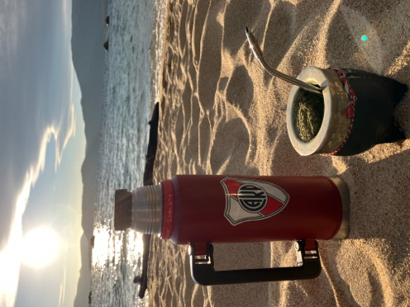

Welcome Message: Whether you’re new to yerba mate or a seasoned veteran, we’re here for you every step of the way. Check out our What is Yerba Mate page to get caught up on the culture, or spend some time on the Mate Matcher to find the best yerba for you.

Heading: Find your match in the Gallery
SAMPLE CARD: use the image and description from the first card in the mate matcher.

Heading: Contribute to the Community (Contains content on the wireframe)

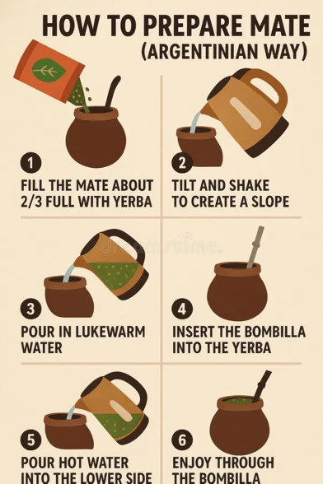
What is Yerba Mate
What is Yerba Mate? Yerba mate is a traditional South American drink made by steeping the dried leaves of the Ilex paraguariensis plant in hot water. It was first consumed by the Indigenous Guaraní people, who valued it for its energizing and medicinal properties. When Spanish colonists arrived in the 1500s, they adopted the drink, helping spread it throughout Argentina, Uruguay, Paraguay, and southern Brazil.
Today, yerba mate is deeply tied to social culture. It’s usually prepared in a hollow gourd called a mate and sipped through a metal straw called a bombilla. Friends often share the same gourd, passing it around while talking and relaxing together.
With its bold, earthy flavor and smooth caffeine boost, yerba mate offers more than just energy—it’s a centuries-old tradition that brings people together.

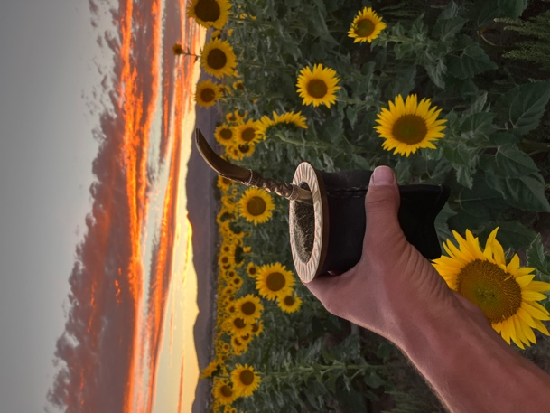
Our Purpose: Our mission is to introduce people to the world of yerba mate by providing clear reviews, helpful information, and honest comparisons. We aim to make it easier for beginners and enthusiasts alike to explore different varieties, understand their flavors, and decide which mates they enjoy most while discovering the culture behind this unique drink.

The Matcher

Header: Welcome to the Yerba Mate Matcher

P: Find out more about different brands and flavors of yerba mate to find the right one for you! Our rating system takes into consideration price, bitterness, grind, country of origin, and includes a short description of each mate.

Grid For the matcher
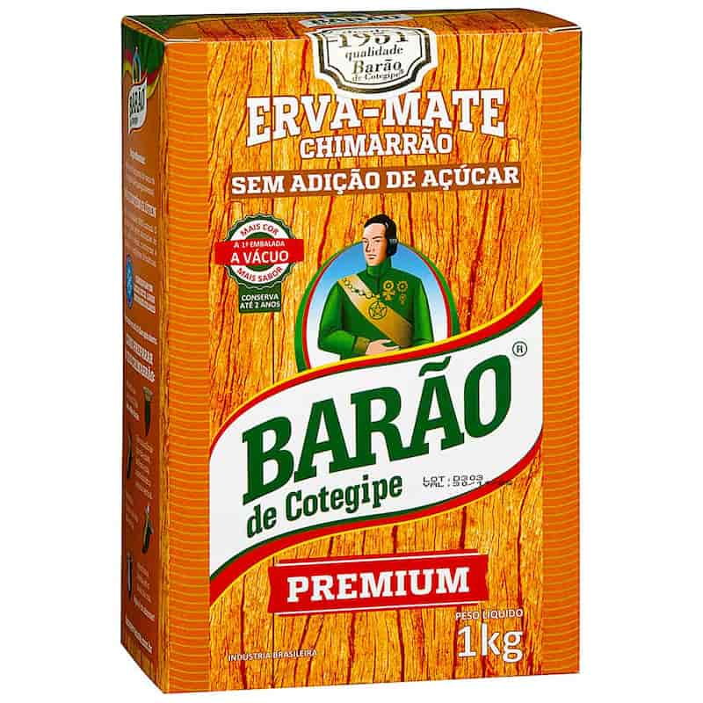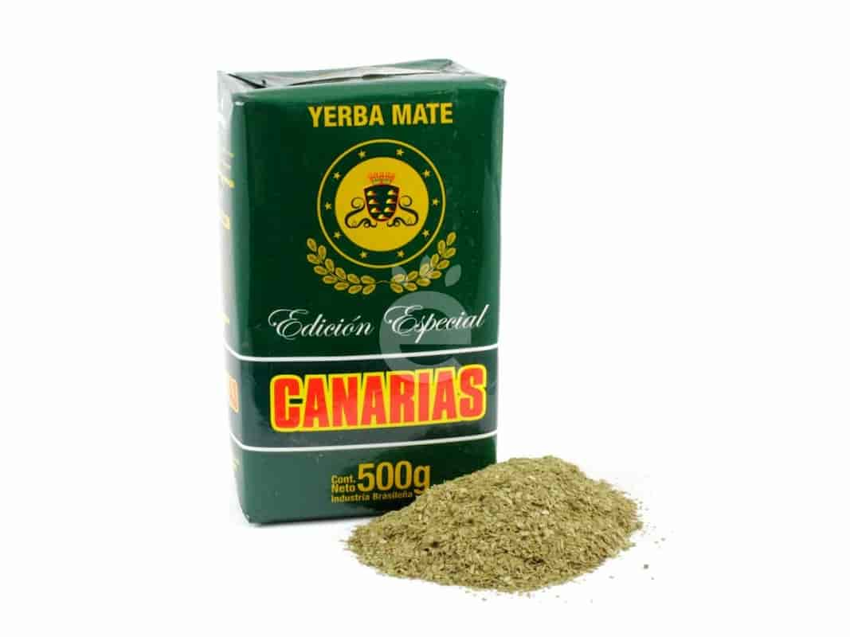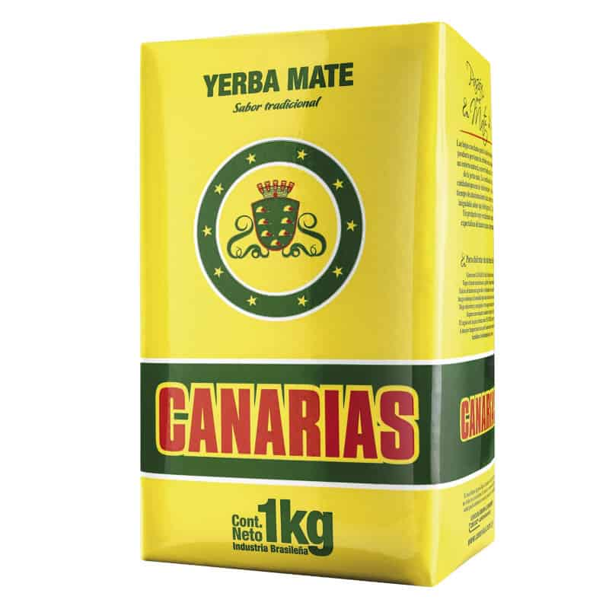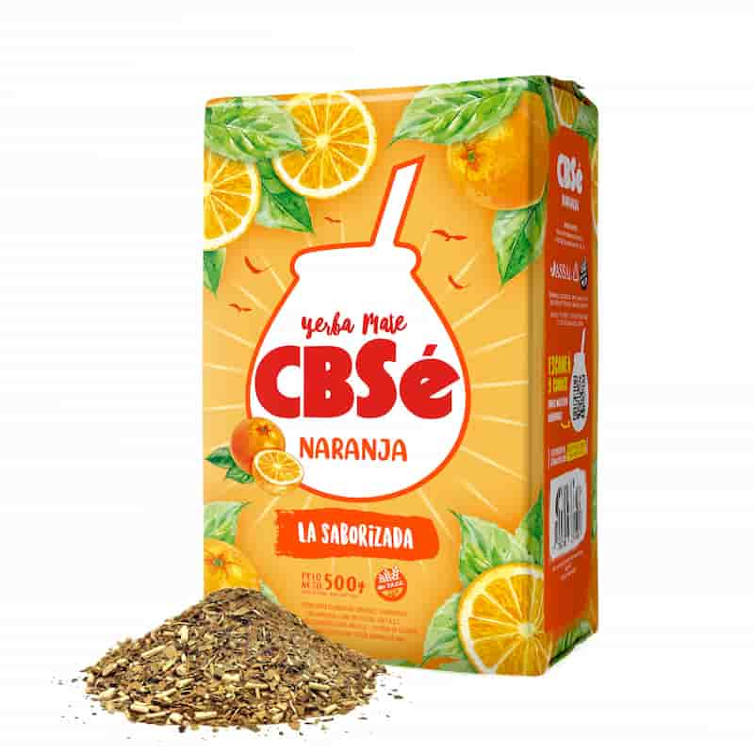
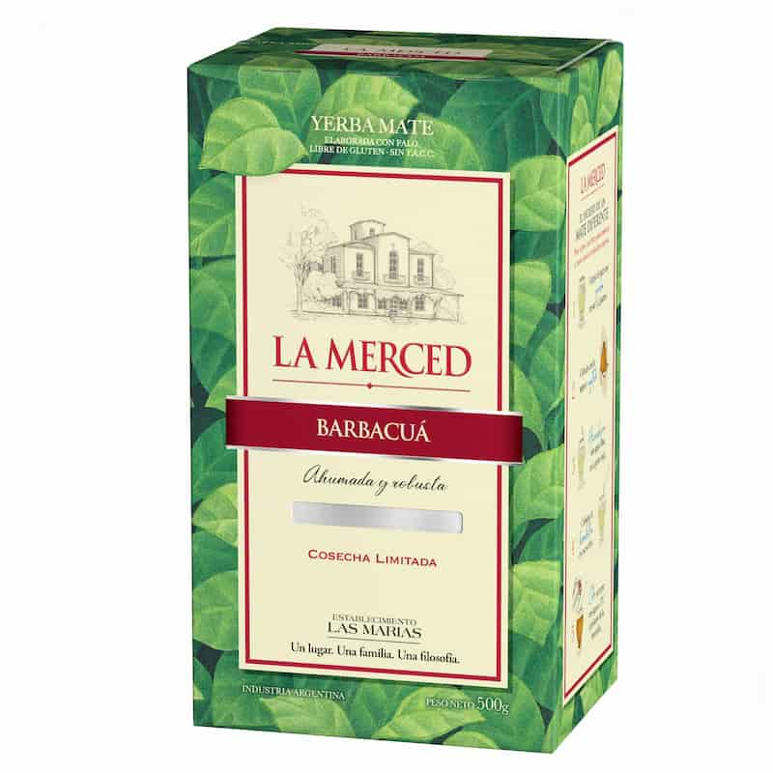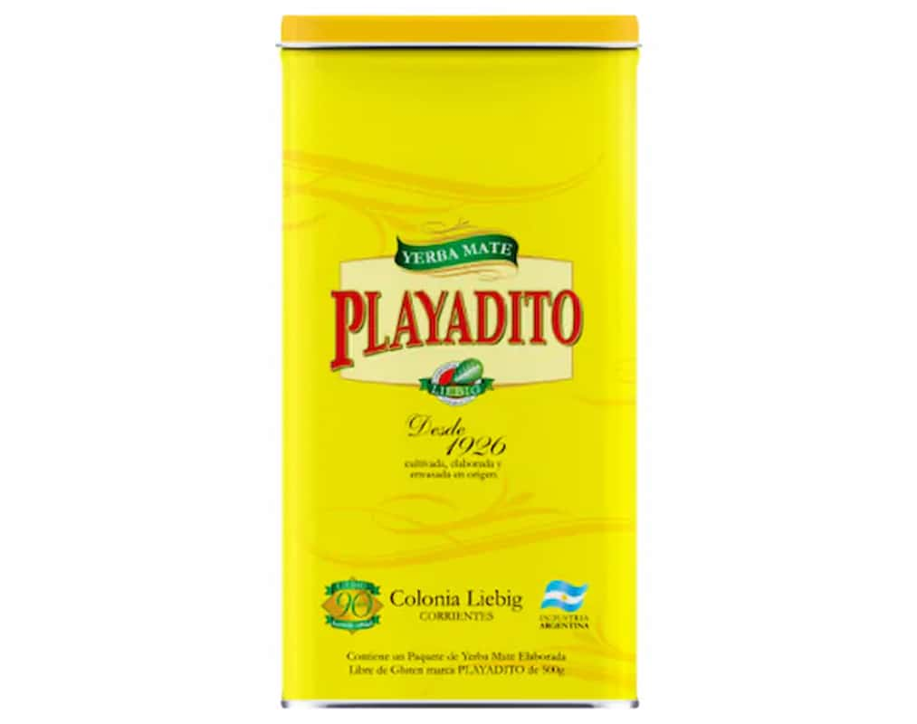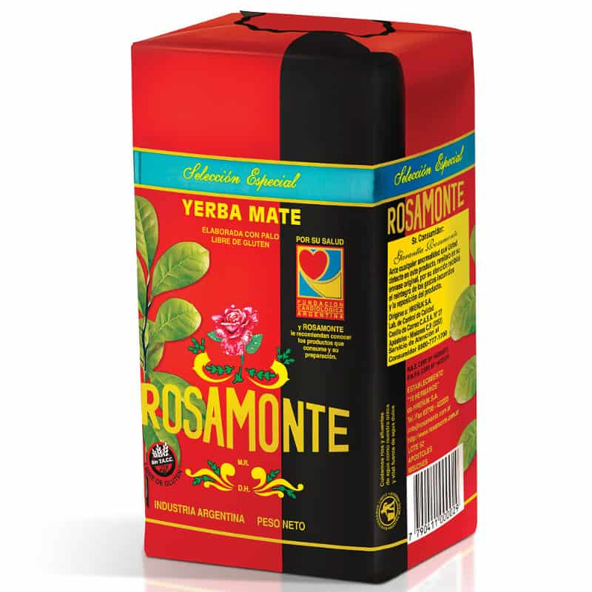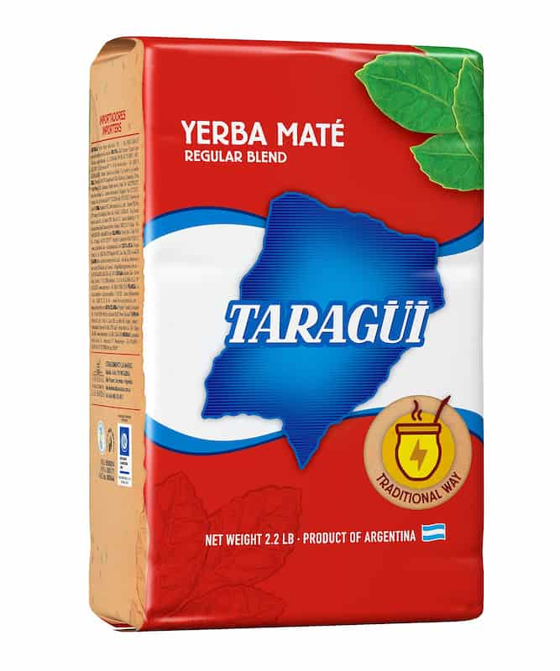

Barão de Cotegipe  Price: $$$  Bitterness: 4/5  Grind: very fine  Country of Origin: Brazil  Description: A very fine ground yerba vacuum-sealed to preserve a fresh, green taste. The perfect mix between bitter and smooth | Canarias Edición Especial  Price: $$$$  Bitterness: 4/5  Grind: very fine  Country of Origin: Uruguay  Description: A premium version of Canarias with a smoother and more balanced flavor profile. Still strong and creamy, but slightly less bitter, making it easier to drink for long sessions.
Canarias  Price: $$$$  Bitterness: 5/5  Grind: very fine  Country of Origin: Uruguay  Description: A strong, full-bodied yerba with an extremely fine grind and almost no stems. Known for its intense bitterness and long-lasting flavor, it’s a favorite among experienced mate drinkers. | CBSe Naranja  Price: $$  Bitterness: 2/5  Grind: medium with stems  Country of Origin: Argentina  Description: A flavored yerba infused with natural orange notes. Light, refreshing, and slightly sweet, it’s a good choice for beginners or for those who prefer a softer mate.
La Merced Barbacuá  Price: $$$$  Bitterness: 4/5  Grind: medium with stems  Country of Origin: Argentina  Description: A traditional barbacuá-style yerba dried slowly over wood smoke. It has a deep, smoky aroma and a rich, complex flavor that feels rustic and authentic. | Playadito  Price: $$  Bitterness: 2/5  Grind: medium with stems  Country of Origin: Argentina  Description: A smooth and mellow yerba with mild bitterness and a slightly sweet finish. Very easy to drink, making it a popular choice for beginners or all-day mate sessions.
Rosamonte  Price: $$$  Bitterness: 5/5  Grind: medium with stems  Country of Origin: Argentina  Description: A bold and robust yerba with a strong bitterness and long-lasting flavor. Rosamonte is known for its powerful kick and consistent strength throughout many pours. | Taragüi  Price: $$  Bitterness: 3/5  Grind: medium with stems  Country of Origin: Argentina  Description: A classic everyday yerba with a balanced flavor and moderate bitterness. Reliable, approachable, and widely available, it’s one of the most recognizable Argentine brands.

Wireframes

Home Page Wireframe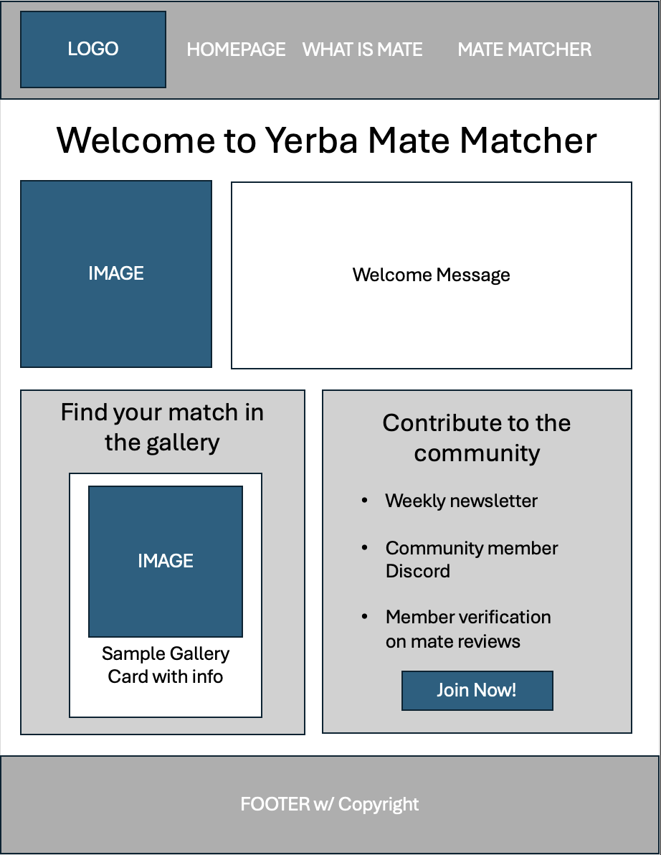

What is Mate Wireframe

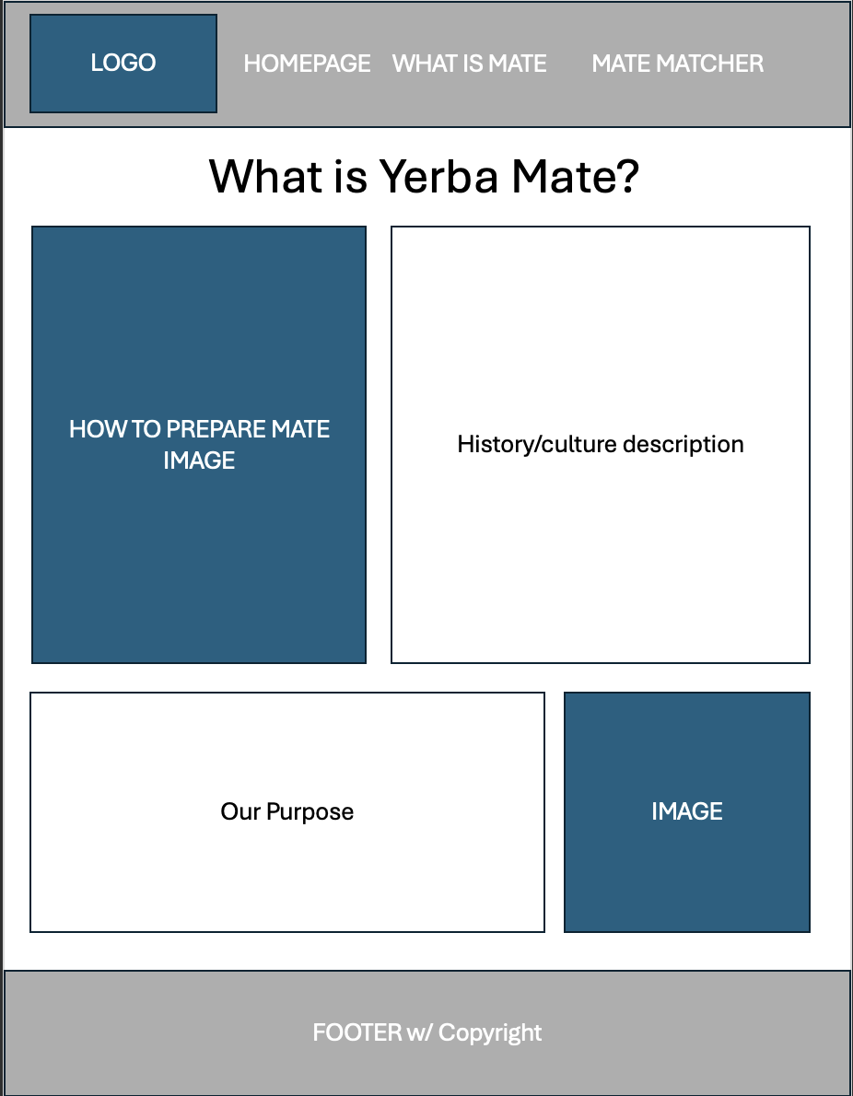

Mate Matcher Wireframe
