Detecting Pneumonia in Chest X-Rays Using Deep Learning
A Machine Learning Capstone Project
Adam Philips
- Introduction
Pneumonia is a severe respiratory infection and a leading cause of hospitalization and mortality worldwide, particularly among children under five and older adults. Diagnosis typically relies on radiologist interpretation of chest X-ray images, a process that can be time-consuming, subjective, and limited by the availability of trained specialists. In resource-constrained settings, delays in diagnosis can significantly worsen patient outcomes.
This project investigates whether deep learning models can accurately classify chest X-ray images as Normal or Pneumonia, with the goal of supporting clinicians through automated, reliable, and scalable diagnostic tools.
- Problem Statement
The central question of this project is:
Can we develop a deep learning classifier that predicts whether a patient has pneumonia based on their chest X-ray image?
The problem is framed as a binary image classification task, where the model must distinguish between Normal chest X-rays and Pneumonia chest X-rays (bacterial or viral)
The primary objective is to minimize false negatives, as missing a pneumonia diagnosis poses significant clinical risk.
- Data Description
The dataset used in this project is the Chest X-Ray Pneumonia dataset, originally sourced from Guangzhou Women and Children’s Medical Center and made publicly available on Kaggle.
Dataset Characteristics
- Total images: ~5,000+
- Classes: Normal, Pneumonia
- Format: Grayscale JPEG images
- Population: Pediatric patients
- Train/Test split: Pre-defined by dataset authors
- Class imbalance: ~74% Pneumonia, ~26% Normal in the training set
- Image variability: Significant variation in resolution, brightness, and contrast
Implications
- Pediatric-only data limits generalization to adult populations
- Class imbalance requires careful evaluation of recall and precision
- Variability in image quality necessitates preprocessing and augmentation
- Exploratory Data Analysis
4.1 Image Resolution
Images vary widely in height and width, requiring resizing to a consistent input shape (128×128×1) for model training.
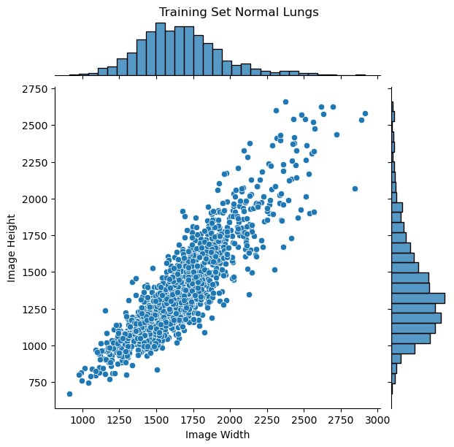
4.2 Pixel Intensity Distributions
- Normal X-rays tend to have more dark pixels (air-filled lungs).
- Pneumonia X-rays show more bright regions due to lung opacities.
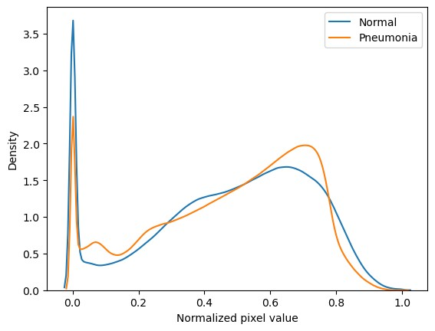
These differences confirm that pixel-level patterns contain meaningful diagnostic signal.
- Methodology
The modeling pipeline consists of:
5.1 Preprocessing
- Resize all images to 128×128
- Convert to NumPy arrays
- Normalize pixel values
- Apply on-the-fly data augmentation:
  - Random horizontal flip
  - Random rotation (±2%)
  - Random zoom
  - Random contrast adjustments
Augmentation helps reduce overfitting and improves generalization.
  - Models Evaluated
(1) Multilayer Perceptron (MLP) Baseline
A simple, convolution-free neural network:
- Flattened input
- Two dense layers (512 units each)
- Dropout + L2 regularization
- Sigmoid output
Purpose: establish a baseline and test whether raw pixel intensities alone carry enough signal.
- Custom Convolutional Neural Network (CNN)
A standard CNN architecture with:
    - Convolution + ReLU
    - Max pooling
    - Dense layers
    - Sigmoid output
Purpose: leverage spatial feature extraction for improved performance.
- Transfer Learning Model: DenseNet121
A pretrained DenseNet121 model with:
    - Frozen convolutional base
    - Custom classification head
    - Fine-tuning of top layers
Purpose: evaluate the power of transfer learning on medical imaging tasks.
5.3 Evaluation Metrics
Given the clinical context, the following metrics were prioritized:
    - Recall (Sensitivity): ability to detect pneumonia cases
    - Precision: reliability of positive predictions
    - Accuracy: overall correctness
    - Confusion matrices: error pattern analysis
Recall is the most important metric because false negatives are clinically dangerous.
- Results
6.1 Model Comparison
Model | Recall | Precision | Accuracy
MLP | 96% | 74% | 76%
CNN | 96% | 85% | 87%
DenseNet121 | 99% | 83% | 87%

Key Findings
- DenseNet121 achieved the highest recall (99%), minimizing false negatives.
- The CNN significantly improved precision over the MLP, confirming the value of convolutional feature extraction.
- Transfer learning provided the strongest overall performance, despite similar accuracy to the CNN.
7.1 Model Interpretability
Grad-CAM visualizations were used to understand where the DenseNet121 model focuses when predicting pneumonia.
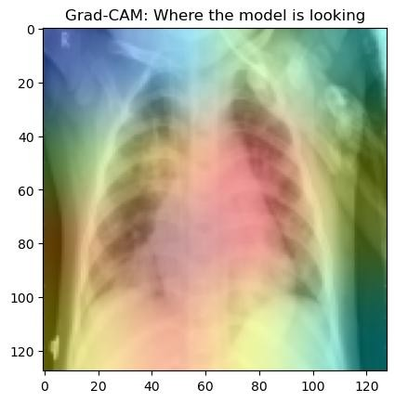

    - The model often highlights lung regions consistent with radiological signs of pneumonia.
    - Some heatmaps show attention outside the lungs, suggesting potential reliance on spurious features (e.g., image borders, text markers).
This motivates future work in lung segmentation to constrain the model’s attention to clinically relevant regions.
8. Discussion
8.1 Strengths
- High recall across all models
- Strong performance from transfer learning
- Effective use of augmentation to combat overfitting
- Grad-CAM interpretability analysis supports model trustworthiness
8.2 Limitations
- Dataset consists entirely of pediatric patients
- Single-institution data limits generalizability
- Class imbalance may inflate recall
- No external validation performed
- Model calibration not yet assessed
9. Recommendations
Use the DenseNet121 model as a high-recall screening tool
Because DenseNet121 achieved 99% recall, it is well-suited for initial triage. A client can deploy it to automatically flag X-rays that may show pneumonia so radiologists can prioritize those cases first.
Integrate the model into radiologist workflows as a decision-support aid
The model should not replace radiologists, but it can highlight suspicious regions (via Grad-CAM) and provide a second opinion.
Use the findings to guide future data collection and validation
Results show strong performance but limited generalizability due to pediatric, single-institution data. A client can begin collecting adult and multi-institution X-rays to perform external validation and strengthen the model for real-world deployment.

10. Future Work
  - External Validation
Test the model on an independent dataset from a different hospital or adult population to assess real-world generalization.
  - Lung Segmentation
Use a U-Net or similar model to isolate lung fields and reduce spurious correlations.
  - Larger and More Diverse Datasets
Incorporate multi-institution, multi-age datasets to improve robustness.
11. Conclusion
This project demonstrates that deep learning models — particularly transfer learning architectures like DenseNet121 — can effectively detect pneumonia in pediatric chest X-rays. DenseNet121 achieved 99% recall, minimizing false negatives, which is the most critical metric in clinical diagnosis.
While the results are promising, real-world deployment requires additional steps, including external validation, and improved interpretability. Nonetheless, this work highlights the potential of deep learning to support radiologists and improve diagnostic workflows in healthcare.

