**COGS 102C**

**Caliandra Harmon**

**Adam Powers**

**Adi Singer**

**Sydney Shera**

**Patrick Trinh**

**Aaron Yoshitake**

**Abstract**

Everyone studies differently. Students’ study styles are a function of resources that are available for the class, class assignments that are the immediate cause of studying, and individual styles. We sought out to improve one resource that many UCSD students use - the podcast system - by integrating it with a resource mostly unknown to UCSD students: Anoto digital pens.

As we are students enrolled in Professor James Hollan’s Cognitive Design Studio (Cognitive Science 102C), we were required to follow the Rapid Contextual Design framework outlined by Karen Holtzblatt’s “Rapid Contextual Design: A How-to Guide to Key Techniques for User-Centered Design.”1 At the end of the Rapid Contextual Design process, we had designed a system of multiple interconnected, customizable modules we call “widgets,” generated storyboards and visions for each widget and for the system as a whole, created and tested paper prototypes for each widget, and generated a demonstration of our design employing data from the paper prototype interviews.

1. **Introduction**
   1. **Podcast System**
   2. **Digital Pens**
   3. **The Problem**
2. **Methods**
3. **Results and Models**
   1. **Variance in Podcasting Styles**
   2. **Lack of Synchronicity in Discrete Media**
   3. **Low Resolution Podcast Navigation**
   4. **Notetaking Styles and Individualistic Tendencies**
   5. **Suitability of Podcast Platform to Myriad Lecture Styles**
4. **Data-Driven Design and the Prototype Process**
   1. **Widget: Podcast**
   2. **Widget: Annotations**
   3. **Widget: Grabs**
   4. **Widget: Slide Display**
   5. **Widget: Chat**
   6. **Widget: Games**
   7. **Widget Customizability**
   8. **Modular Platform**
   9. **Synchronicity Between Media**
   10. **Podcast Segmentation**
5. **Discussion**
   1. **Modularity**
   2. **Synchronization**
   3. **Group Study**
   4. **Digital Pens**
6. **Conclusion**
7. **Works Cited**

**Podcast System**

The podcast system at UCSD provides audio recordings of lectures for particular courses. Lecturers may elect to participate in the system for those classes which are held in podcast-enabled lecture halls. The lecturers wear a lapel microphone to record their speech and, at the end of the lecture, the recording is automatically uploaded to the class’s podcast listing at [podcast.ucsd.edu](http://www.google.com/url?q=http%3A%2F%2Fpodcast.ucsd.edu&sa=D&sntz=1&usg=AFQjCNHfJ-kxXFo0JY8wwK9NSTTr6MuJxg). At this site, users can listen to and download podcasts. In our recent survey, 80% of respondents (current UCSD students) claimed that, at least “occasionally,” they use this system to listen to recordings of classes.

**Digital Pens**

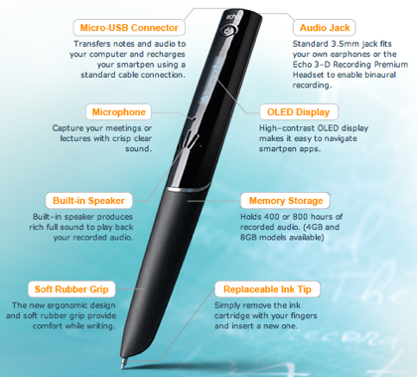Anoto digital pens are devices that function primarily as writing tools, but which, when used on paper printed with a specialized dot pattern, can also record the exact strokes that the user makes. Each Anoto pen uses an infrared camera to record the position of tiny dots relative to the pen tip. Anoto pens also come with microphones, which can be used to record audio and synchronize it to the captured pen strokes.

Currently, the only Anoto pens for sale to the general public are sold by Livescribe. Once a Livescribe pen is connected to a computer via USB cable, it uploads its pen-stroke and audio data to Livescribe Desktop, a piece of software with which the user can view and/or export the data.

**The Problem**

The initial goal for this project was to design an improved class podcast system integrated with digital pens. Having personal experience utilizing UCSD podcasts, we were aware of some possible issues regarding the system, and sought to investigate class podcast use in the process of incorporating digital pen notes into the setup. Despite the scarcity of Anoto pen users, we attempted to examine digital note-taking practices in order to knowledgeably establish a digital pen + podcast system.

During our data collection, we determined that any attempt at designing an upgraded podcast system integrated with other study resources like notes would - by definition - be an attempt at designing a study system. As a result, we shifted course to focus on students’ overall study systems.By centering the contextual interviews around active study practices and related tool use, we were able to collect data on which elements might enhance the podcast system and on points of usage in which a user could incorporate a digital pen.

**Methods**

The methods used in the data gathering and product redesign closely followed the process outlined in “Rapid Contextual Design.”1 To begin with, subjects from our user pool had to be identified and contacted. The user base was determined to be University students, as these are the target users of the podcast system and are expected to have experience note-taking. A variety in styles and practices was desirable to accurately capture the scope of use, therefore users of differing academic divisions, extracurricular involvement, and grade level were selected. Each group member interviewed 2-3 users as they studied, and in total 14 contextual interviews were conducted.

Over the two weeks during which these interviews took place, several all-group meetings were held to interpret the separate contextual interviews. Work models were delineated, tracing user tasks of note recording and podcast playback manipulation. Many of these represented the flow of users playing, pausing, typing or writing, slide viewing, and resuming the podcast, while others focused on use of slides, collaboration with classmates, or consolidation of class notes with podcast review annotations. Several such work models were created for each interview interpretation, and it became clear that a sufficient subsection of users had been interviewed when the captured task flows were highly similar and the work models became apparently repetitive.

In addition to drafting work models, affinity notes of breakdowns, design ideas, and insights were generated by the interpretation of contextual interviews and were captured on color-coded Post-It notes. The method used to amalgamate these notes into a collective representation of the data was affinity diagramming. The notes were placed on the wall and rearranged continuously and deliberately until categorical distinctions emerged. These groupings were represented by high level notes, which were in turn clustered and described by higher level titles. The result of this physical arrangement process was a hierarchical display of the data points.

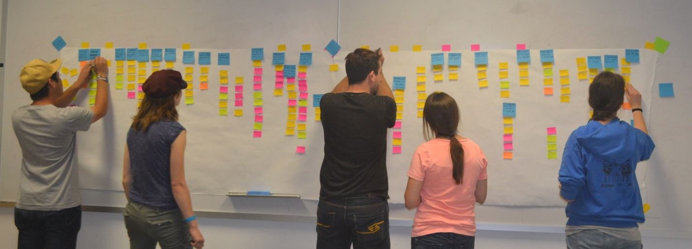

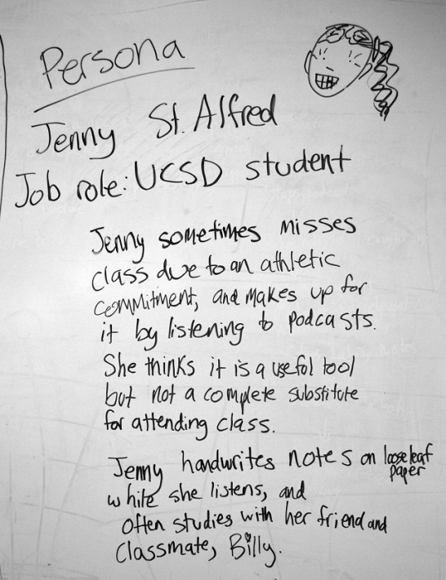In order to focus on designing for typical users based on the contextual details gathered, a fictional but data-based persona named Jenny was created. Jenny’s use patterns and personal traits and circumstances were actually a blend of about four real users. Combined, the attributes form a fairly representative user of the podcast/note-taking system. Jenny was an athlete (based on User #5) who took advantage of podcasts for classes she had to miss (as most of our users claimed to use the podcasts), took handwritten notes (as we witnessed many of our users do), and studied with a classmate. Having this character proved helpful later on as a reference for how the design should be implemented to optimally facilitate user interaction, and for describing potential specific use cases.

Several days following the creation of the affinity wall, the diagram was “walked” by the group members, examining the data array from top level to bottom and noting additional design ideas and holes of missing or insufficient information. None of the holes we observed were significant enough to necessitate additional data gathering, but the lacking areas were nonetheless considered and recorded. Immediately following the affinity and work model walks, high level ideas and issues were brainstormed by the group. These became the basis for our collaborative conceptualization method, visioning. A big picture idea was culled and collectively expanded into a high level design through illustration and text points.

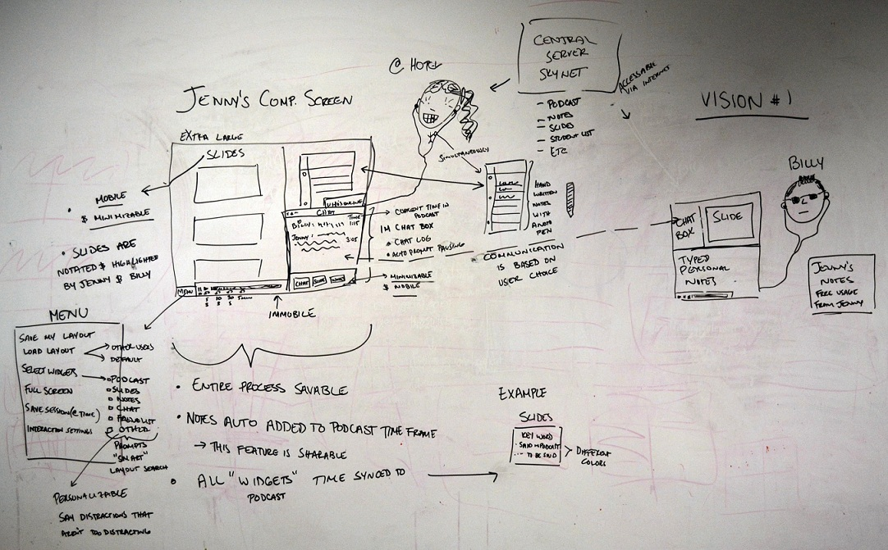

We repeated this process three times, resulting in three distinct visions. To consolidate these visions into one, the pluses and minuses for each were elucidated and the best parts of every vision were extracted and combined. Merging the ideas was unexpectedly simple, as one of the visions was based on the concept of a modular platform. This idea made it straightforward to introduce tools and features developed in the other visions. The final consolidated vision, which was itself a hand-drawn diagram of the high-level design functionality, was accepted as the basis of our result product.

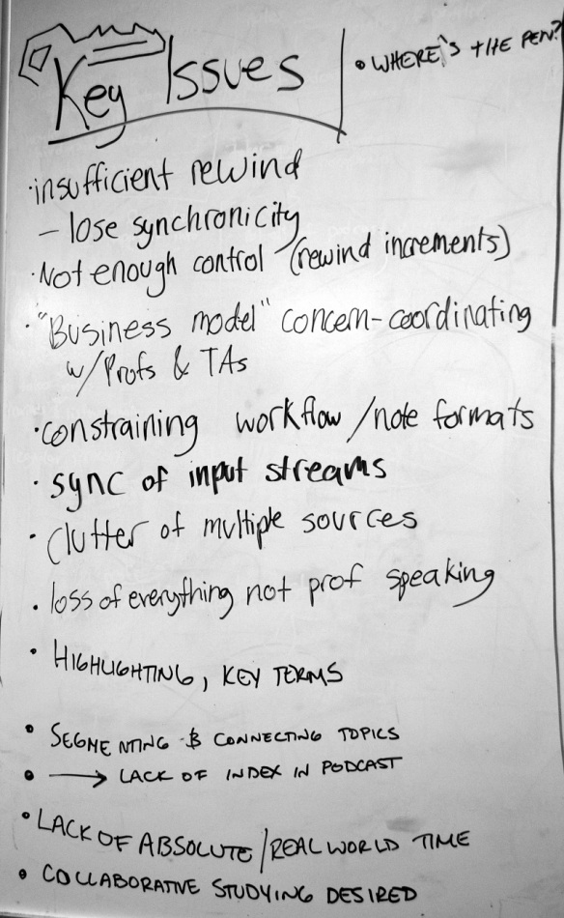The group then split into pairs to formulate low-level visions for components of the consolidated vision, and then sketch storyboards for their possible use. The pairs then constructed paper prototypes of the elements to be tested with another set of user interviews. A new group of test users (all university students) was gathered and each was interviewed by two group members, one actively investigating their interaction with the paper prototype and the other recording notes about the interaction. The users were asked to interact with the paper prototype as they actually would study with it, though no podcast was actually playing and the device was procedurally modified by the interviewer with paper pieces and pen, not electronically.

The notes from each of the paper prototype interviews were reviewed by the whole group in a series of interpretation sessions. Suitable improvements were identified and used to inform the following changes to the design. The updated prototype was transitioned to digital form through the use of Adobe Fireworks graphics editor. Though not yet a functional product, this wireframe presented a higher fidelity prototype, a still-malleable but more refined representation of the design, and the final step in the production process.

**Results and Models**

Though the contextual interviews focused on observing the user interact with study tools and informed much of the physical structure of the design elements through the work tasks observed, it was also important to gain information pertaining to the situational use of podcasts.

We could not observe users in every instance of their podcast interaction, but we could record the variance in use circumstances between people interviewed and enquired as to preferences and common cases of use. What we found was that most users utilized podcasts as a supplement and not an alternative to attending class. While a few users relied solely on podcasts and did not find additional value in being physical present in the classroom, most found the recordings to be an inadequate substitute to frequenting lectures. The podcast system was therefore mainly used as a back-up for missed classes, as a study tool to review before tests, or as a reference for unclear topics or key words.

What we found particularly interesting was that podcasts also affected students’ study habits not only out of class, but in it as well. Knowing that the podcast of a lecture would be available afterwards allowed students to comfortably engage in the lecture rather than frantically taking notes so that no information would be lost. This positive change could be taken into consideration by professors hesitant to diminish class presence, as in-class participation might actually be increased as a result of podcasting.

As the contextual interview, interpretation and sequence modeling processes were initiated, driven, and completed, the standout observation from each stage was the enormous variability between individual students’ study habits and review practices. Unlike the more “typical” corporate-centered applications of the Contextual Design process as described in the text, where institutionally-prescribed job roles provided a solid framework for the types of actions performed by often numerous users filling each role, the population queried for this process held a similar job role but exhibited a broad array of differences in how they accomplished the task of solidifying the retention of information.

**Variance in Podcasting Styles**

The breakdowns encountered in this process seemed, at first, to be as numerous and unique as the users who experienced them, but over time there emerged commonalities in the types of complaints that were recorded. Few breakdowns involved the concept of review itself - users, on the whole, seemed comfortable with learning and studying styles - and most revolved around lapses in functionality of the various tools that were used to facilitate the entire experience. Addressing these difficulties soon became the focus of the creative processes, and the potential solutions served as the core of the data-driven design.

The first area of variation among students, and an important one, was the environment in which the review process took place. Of the contextual interview participants, three podcast-centered review types emerged: those who reviewed the podcast in a single, mostly uninterrupted session, similar to as if they were attending the class the recording came from; those who finished the review in a single session, but frequently interspersed breaks and user-initiated distractions of various lengths; and those whose review was split over multiple sessions and often across multiple days for the material comprising the same lecture.

Another, also significant portion of users attempted to recreate a similar learning environment to what they would have received in the classroom, sequestering themselves to a single area and playing back the podcast of the lecture they did not attend or required additional review for. These sessions were largely continuous, with only minor breaks; these users considered their time spoken for, and were finished only when they had fully reviewed and consolidated the information from the lecture. These users tended to focus more heavily on the quality of the recording, discrepancies between the provided audio and the actual content of the lecture, and the difficulty of manipulating multiple information sources (such as podcasts, presentation slides, and handwritten notes) to recreate the classroom experience.

An even larger subset of users created learning environments similar to the first, but exhibited more flexibility regarding the continuity of the process. These students frequently paused the audio to take breaks, acquire food, or converse with friends who were in the area about topics both related and unrelated to the material being learned. At times, they left the audio running as they attended to other tasks. As neither the learning environment nor computer state were reset at any time, the process was considered as spanning a single session, though the attention of the user seemed distributed among many different things. These users’ major breakdowns tended to revolve around the loss of contextual information between the lecture and the podcast, such as board drawings and gestural content, leading to spaces in the audio that were considered effectively dead air for the purposes of learning.

A slightly smaller (in our dataset) but nonetheless important population of users were those whose reviews were spread across multiple, shortened sessions, sometimes spanning different days. These students were most frequently athletes, who regularly endure the rigors of travel throughout the quarter and, when away, must opportunistically claim small portions of time for study and review. These users were most inconvenienced by the discontinuity between sessions, as their frequent interruptions added a high overhead cost to regaining the previous configuration of their study tools such as the podcast, slides, and notes.

Despite these differences, significant commonalities were prevalent amongst the user base. Podcast usage itself was the main shared feature, and the convenience of anytime listening to archived class lectures was consistently cited as the primary reason for podcast usage. In addition to the podcast archival, users also appreciated the ability to manipulate the podcast itself and rewind or fast forward. In fact, even the simple act of pausing granted users a reprieve from information gathering, provided a moment to catch up on note writing, and just generally seemed to allowed users to more easily grasp complicated and high detail information that would otherwise be lost in a traditional lecture setting.

**Lack of Synchronicity in Discrete Media**

Aside from notes and podcasts, several other study tools were utilized by students. While most users listened to the podcast directly from the UCSD site, others downloaded the podcast on iTunes and would access it on portable MP3 players. Several users played simple computer games while listening to the podcast so as to focus their visual attention on a controlled distraction and maintain primary focus on the audio. In many more cases, lecture slides were viewed simultaneously with podcast listening. Some users printed out the slides and thereby created an additional platform for note-taking. The different media used to study class material varied depending on the user; however, one issue pervaded all user systems- the media were all discrete, meaning that they operated independently. This meant that there was no way for an artifact to communicate with the others, so a significant amount of time was wasted updating the state of each platform so that they stayed synchronized. From the users’ standpoint, this was extremely undesirable because it interrupted the work flow of the activity and required the application of concerted physical or mental resources. Users often cited concerns and breakdowns involving changing the slides and switching attention from the slides to the notes, or keeping up with note-taking while attempting to listen to the podcast. For example, a rough work model of which we saw several close variants was to go to the podcast bar of the browser, click the pause button, go to the word processor, type, go back to the podcast and press play, then click back to the slides. Clearly, this method is inefficient.

**Low Resolution Podcast Navigation**

Users had difficulty maneuvering the podcast itself. The most common navigation complaint was the lack of resolution present when manipulating the podcast - users could not steer to the specific section they wanted, and instead had to aim a few seconds before the desired section. This forced them to listen to unrelated or previously reviewed material before being able to listen to the desired material, wasting time, breaking concentration, and making it more difficult for users to retain information. Even more importantly, the solid and unindexed block of audio presented a challenge for the many users who stated their desire to locate a particular topic or keyword. One user who no longer uses podcasts claimed that attempting to find the description given for a certain concept within an eighty minute podcast was simply too daunting a task and not an efficient use of study time. This and other noted breakdowns related to this issue are indicative of an area with significant room for improvement.

**Notetaking Styles and Individualistic Tendencies**

While, as mentioned previously, users displayed a high degree of variance in their individual notetaking and studying styles, there were noted preferences and habits regarding the medium in which users took their notes as well as the degree to which they collaborated.

Regarding the medium preferred by students to fulfill their note-taking needs, we found a slight majority preference for handwritten notes, but students also often typed their notes as well. There did not appear to be significant difference in the way or reason that handwritten verse typed notes were used, however there was an additional benefit noted by handwritten note writers. Several users commented on the act of writing itself being a tool in memorizing or mastering class information. Though only handwritten note users mentioned this incentive for their study habits, we cannot definitively conclude whether it is the physical action of writing or simply note-taking which affords this advantage.

As for inter-user participation, we expected to see a significant amount of collaboration between classmates while studying. However, what we found was that students invariably prefer studying off their own notes. Much like the podcast itself, users usually treated their classmates’ notes as a fallback for gaps in the notes that they themselves took. The discourse we observed between classmates was almost entirely verbal, with each student referencing their materials, sometimes in connection to the podcast or to other shared class study materials such as slides. Some users stated that they preferred their own notes even to those offered by the professor, TA, or AS lecture notetaker.

**Suitability of Podcast Platform to Myriad Lecture Styles**

A great number of contextual interviews highlighted breakdowns in the process of podcasting a class that were specific to the type of material being disseminated. As the root of the concerns appeared largely related to the audio-only nature of the medium, focused attempts were made to ensure the final design alleviated the issues by incorporating and synchronizing multiple information streams to replace the lost contextual information. To aid this process, special attention was paid to the types of complaints users had about the medium.

The largest and perhaps most obvious concern was the lack of visual information in the post-lecture review material. Many contextual interviewees bemoaned the relative scarcity of video podcasts, as well as the narrow camera focus (centered on the projector screen, not the professor or board) in the classes that did produce video. All participants who expressed an opinion would have rather had a view comparable to the middle of the lecture hall, with the professor, board, and projector screen visible.

The style of lecture matters too: in the one-way transfer of information common to most lecture classes, the content may be time-delayed without the overall value of the material being affected. In discussion-style classes, however, the podcasting student does not have the opportunity nor technological means to engage in discourse with the professor or ask questions as they arise. As podcasts are recorded and distributed after the period has finished, rather than streamed live, this general breakdown also exists even for typical lecture classes. This led to many interviewees feeling as if they were isolated in their educational environment due to their inability to attend class as a result.

A related concern to the lack of video was the specific breakdown of an inability to see gestural expressions made by the professor while lecturing. As is discussed in many classes throughout the department, deictic gestures carry a great deal of contextual information and their loss impacted the overall clarity of the spoken information presented to the student.

And finally, some disciplines simply do not convey information in a format that is conducive to either time-delayed review or the audio modality: notably mathematics, visual arts, art history, musicianship, speech and communication, and other highly symbolic, interactive or visually-focused fields.

**Data-Driven Design and the Prototype Process**

From the beginning of the contextual interview process and throughout each step of refinement, one theme asserted itself repeatedly in a multitude of fashions: that all users learn, review and study differently, and a product that was designed without the aim to encompass and enable the widest possible array of styles would prove mostly insignificant for a many in the target population. This level of ambiguity would normally present an enormous design challenge, but the data fortuitously offered the solution along with the problem. Commonly-used artifacts emerged along the affinity diagramming process, especially in the breakdowns regarding their attempted use; it showed that while no two user’s experiences were the same, they all appeared to be improved by certain tools that facilitated studying.

From that, the data strongly suggested implementing the most common review tools - the podcast bar; presentation slides; one’s own notes; annotations to those notes; and key terms to make review cards from - but to allow for highly-flexible customization and personalization of the user interface. This naturally led to a “widget/canvas”-type design that enables infinite placement combinations of finite tools, modularized so that the user makes the final decision about what is necessary for his or her work flow.

A secondary focus, derived from the same data that brought about the primary focus, was to limit assumptions and enable the user to create their own semantic associations at every stage possible. In many of the individual widgets, which will each be described in greater detail, this took the form of refraining from the creation of default categories or simplifying the interface such that categorization is strictly optional. These principles guided the design of the essential set of widgets, each of which were designed to be interoperable.

**Widget: Podcast**

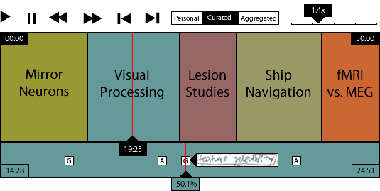

The podcast widget serves as the functional hub of the design -- it is the only time-based media that the platform operates with, allowing us to center our widgets around the podcast and create the time-synced nature that surrounds the entire product.

The two largest breakdowns resolved by the podcast bar redesign were most users’ inability to easily identify which parts of the podcast contained information pertaining to a particular topic, and the relative difficulty in reliably time seeking (as becomes necessary for repeated review of the same material) when several minutes of speech might be localized to only a few pixels width of clickable space on a timeline.

The first of these was resolved by envisioning a user-driven indexing system in which users create “semantic delineations” that serve to indicate transitions between areas of lecture comprising different topics. These distinctions may be made at the time of podcast review by using a simple time-selection system, or, assuming the user is taking notes with a smart pen, a predetermined pen gesture (such as a line of predetermined style and length, drawn across the page) that would initiate a delineation at that timestamp. The sections of related content defined by the space between those markers would be clickable and initiate a jump to the beginning of that section; furthermore, if the user chooses, they may label each section with a brief summary of its content. A system has also been devised wherein the professor, TA or an AS Lecture Notetaker with the hypothetical duty of maintaining such outlines might login with special credentials and provide their own semantic distinctions that the user may opt to view over their own as their studying style allows.

To anticipate and overcome the real-world technical challenge of university resources being required for instructor-initiated podcast indexing, an aggregation mode was discussed in which users may share their delineations with a central server that statistically extracts the most common distinction points and uses them to build a crowdsourced section index that should be “good enough” given a sufficient quantity of active users. As the user data gathered supported individualism over collectivism in notetaking styles, this feature was not actively developed; however, the overall pervasive use of forums and peer networks to garner class assistance, and the success of crowdsourced audio indexing systems such as SoundCloud2 suggest that the concept could remain viable if more specifically tested and refined, and especially if solutions to the former technical challenge are not found.

The second important breakdown resolution addresses the difficulty in returning to a specific segment of audio by splitting the overall timeline into the original, indexable version previously discussed, and a second timeline - the entire width of the first one - that pertains purely to the individual semantic delineation currently being explored. For example, should a delineated section exist between 20:00 and 25:00 minutes, the five minutes would spread out on the secondary timeline over the same space that the entire 50 minute lecture would occupy on the primary timeline - a tenfold increase in clickable area and thus more easily navigable.

The third and final major breakdown this widget addresses is the desire, expressed through user data, for more granular and specific options regarding objective time seeking. In addition to the “play” and “pause” that are already standard, new toolbar buttons (and corresponding hotkeys) would allow the user to skip between sections, as well as forward or back a user-defined number of seconds such as 1, 5, and 10.

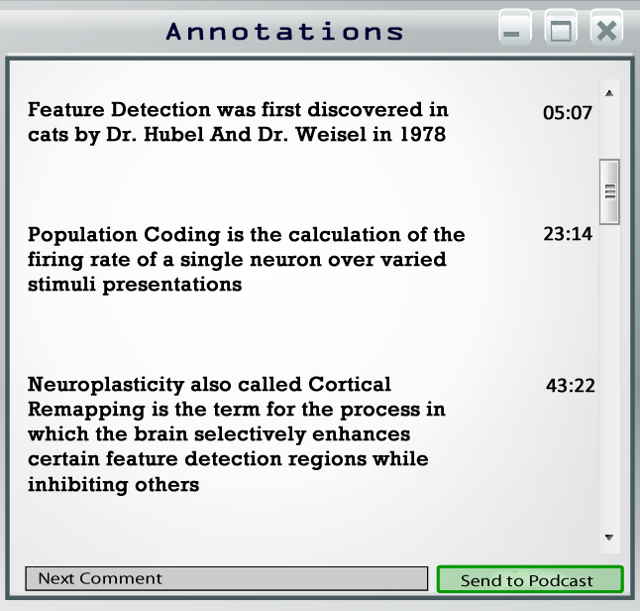**Widget: Annotations**

One practice that is featured in the users’ study methods is the process through which they augment their study materials. Often, users will clarify or enhance the information presented with their own synopses or descriptive text. For these purposes, and as an application for on-screen note-taking, the annotation widget was created. The widget will appear as a text box with the basic formatting features of common text editors, such as bullets and highlighting.

In addition, the annotations widget will be digital-pen-compatible so users can either type or utilize the Anoto pen to write their notes. As the users’ notes are entered, they will be synchronized to the time in the podcast audio file. Therefore all the material will be chronologically organized and consolidated with the podcast audio. The podcast time during which the annotation is made will appear within the annotation widget screen. In addition, a symbol (denoting the temporal location of an annotation) will be placed on the high-resolution podcast bar. Clicking the symbol on the podcast bar widget will re-orient the annotations screen to the time-relevant notes. The main benefit of this feature is that the notes created while listening to the podcast become a synchronized component of podcast-centric studying, addressing the issue of asynchronous discrete media platforms.

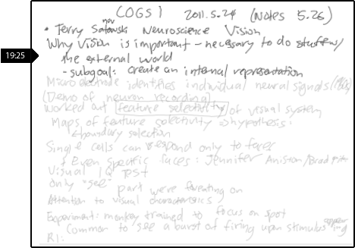**Widget: Notes**

Note taking was an activity that every interviewee took part in, whether the notes were handwritten or typed. We wanted to use digital pens to bridge the gap between paper and computer notes, but because of the relative obscurity of digital pens, it was difficult to come up with a solution that users would be able to adopt immediately. Because of this, we decided to provide helpful additional functionality to encourage (but not necessitate) the use of digital pens. The note widget allows the user to upload notes taken during the initial in-class recording of the podcast.

This widget, like the annotations widget, is compatible with both typed and handwritten notes. Though many current users do not utilize digital pens, the notes widget will not interfere with users’ current routines. The user uploads a digital copy of the notes they took in class and every element of the user’s personalized note style is conserved. If they choose to opt into a system using digital pen notes, they will simply need to take notes with a digital pen on digital pen paper. If the user chooses to not opt into the digital pen user population, they can still use the notes feature with a set of typed notes.

The first benefit of digital pen use underlies the primary research interest in this project itself, the premise of creating a link between handwritten notes and podcast audio so that the two media are synchronized. Though the pen's technology already includes a mechanism that time synchronizes its writing to its recorded audio, the audio quality is poor. Replacing the audio file with a high quality recording, such as the podcast, might enhance the value and frequency of use of the digital pens. Though this is not an easy feat, there are two ways the group envisioned producing this: firstly, by overlaying the two audio tracks and syncing them based on areas of overlap in the audio file (similar to the current practices of ChronoViz); as a second option, by synchronizing all the clocks for podcast recording and digital pens. Both options are valid and could be pursued in the future.

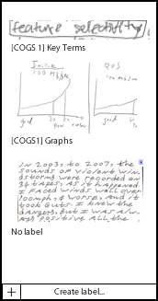**Widget: Grabs**

The last feature derived from user data but facilitated by digital pen use is the “grabs” feature. The grabs feature is a hierarchical organizing tool created to enhance student's learning. Many of the contextual interviews showed a desire or even a current practice on the part of the users to create methods of identifying and classifying important concepts in their notes. Users performed a variety of tasks, from making flashcards, to highlighting key terms, and even to adjusting their note formatting style to highlight or differentiate important information. Though the notes widget allows users to maintain their current methods, the grabs feature allows the user to categorize all information into a digital list, thus potentially enhancing their practices, as well as integrating the user-generated list into the podcast for organization and synchronicity.

The grabs feature would work by having the user simply box anything in their notes using their Anoto pen. The gesture of boxing would trigger the notes widget to "grab" an exact copy of the image within the box’s perimeter and cause it to appear in the display of the grabs widget.

In addition, these image files would also be visually linked to the podcast time bar. If the user decides to view their "grabs" on the podcast time bar, symbols will appear that mark the points in time where the user created the image files. The user can then mouse over the symbol and view the exact image extracted from their personal notes. The user can also select the image file on the podcast time bar and all widgets will move to the point in time that the image file created.

Prototype testing of this feature added some very useful user input. Students responded positively to the concept of grabs, but some expressed an interest in performing the boxing action after the lecture, citing a concern for whether there would be enough time to deem material important enough to grab. This concern would be addressed by having the widget recognize the timestamp of the area being boxed, regardless of the time the box was drawn, and adjust placement appropriately.

Another change was that the grabs feature was presented with pre-established categories, such as images, key term, highlights, and so on. In alignment with user data suggesting a desire for simplicity, many prototype test users rejected the pre-organization. Therefore, a shift was made towards a labeling, rather than categorizing system where incoming grabs by default had no label, and the user could designate one only if desired.

Finally, the grabs feature also solves a large problem experienced by users: the inability to represent visuals using typed notes or with an auditory medium, such as the podcast. The grabs feature allows the user to excerpt anything from their notes as a direct image copy, so the user can grab images as well as text. Every grab would have the same functionality, be it text or image. Thus the grabs feature allows users to categorize and store visuals as well as pertinent information.

The grabs and segmentation features, as well as the overall synchronicity of the system, allows the user to seek and segmented the podcast time bar in the same way that they segment their notes. Therefore the system organizes and conjoins all forms of necessary media for the student through the use of the students’ existing notation style; the student will change very little of their work process, but still receive an organized and synchronized, yet personalized study system.

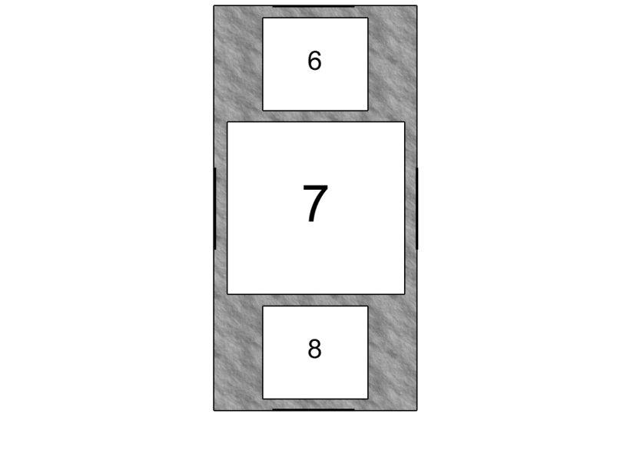 **Widget: Slide Display**

Many users tried to assemble the resource of class slides along with the podcast. However, users often became frustrated when they could not locate the slide that the professor was currently referring to in the podcast. This problem of asynchronicity is exacerbated during instances in which professors use one PDF file that contains all the slides for an entire week. In this case, the beginning of a podcast in the series does not align with the beginning of the slides file.  
 Even if users locate the correct starting point and are able to sync themselves initially, it was difficult for some to maintain this synchronization since users do not necessarily know when to switch to the next slide. Guessing and checking, and the subsequent frustrations, disrupted the study flow. Despite these frustrations, most users still chose to use slides. This informed our group that it would be an important widget to include and improvements concerning synchronicity would be valuable and appreciated by the user base.  
 To address this asynchrony, the slides display widget will automatically scroll as the podcast progresses. This eliminates confusion. Users do not have to devote resources to maintaining synchronicity and can focus their efforts on information gathering and retention.  
 Through our paper prototype testing, we found that in some cases users wanted to only see the current slide being addressed in the podcast while others wanted the ability to preview past and upcoming slides. Our slides display widget allows the user to choose the amount of slides displayed and the orientation of said slides since users had varied preferences to this dimension as well. The podcast widget has darkened bars in the middle of each side. In the case of a vertically oriented slides display widget pulling on the bars above will cause more past slides to appear, while pulling on the bottom darkened bar will display upcoming slides. Pulling on the side bars or corners will scale the whole widget. Also, the slides can be individually resized. Generally, if a user chose to view multiple slides, they wanted the current slide to be the most enlarged. This helps utilize space by allowing the most relevant information to be the most prominent. Small peripheral slides are visible for reference, but do not overconsume the precious resource of screen space.

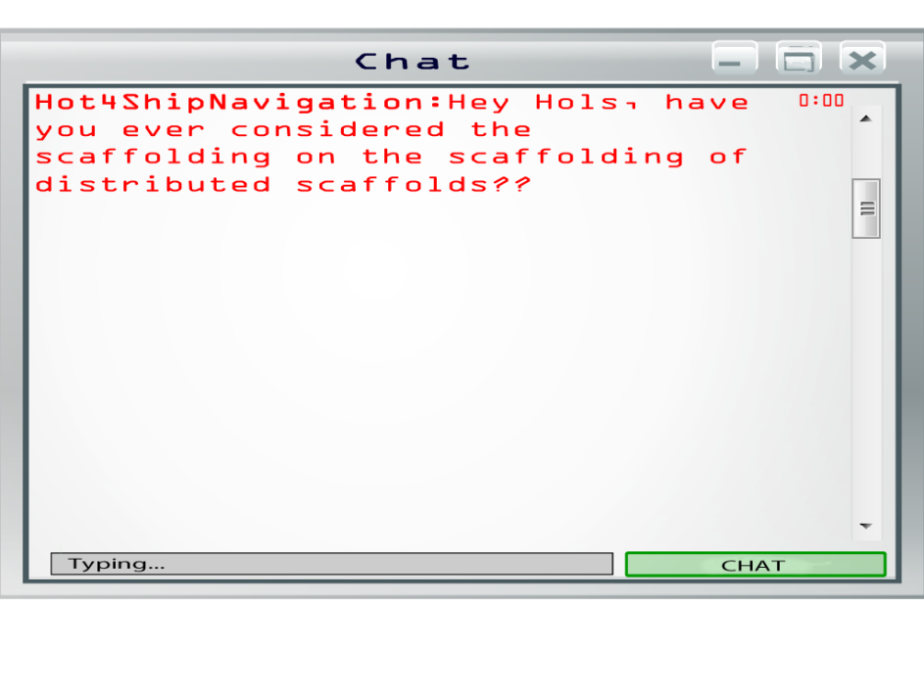**Widget: Chat**  
 Some of our users choose to integrate the social aspect into their study process, either through online means (such as speaking with others on Facebook chat) or by studying with others in a group. The issue with Facebook and other similar communication platforms is that the discrete, highly stimulating interface screen can cause a user to become distracted for longer than they originally intended to be. By including a simple chat box within our study interface, users can socialize with classmates or seek the help of peers and ask pertinent questions regarding the class material without becoming unduly sidetracked.

**Widget: Games**  
 We included a games widget that features such low key games as pong and snake. In our contextual interviews, we had found that some users played games as a form of controlled distraction during times when the podcast had a part deemed unimportant. Sometimes the information itself was not relevant, while other times the podcast featured inaudible student discussion or unviewable media presentation such as a video.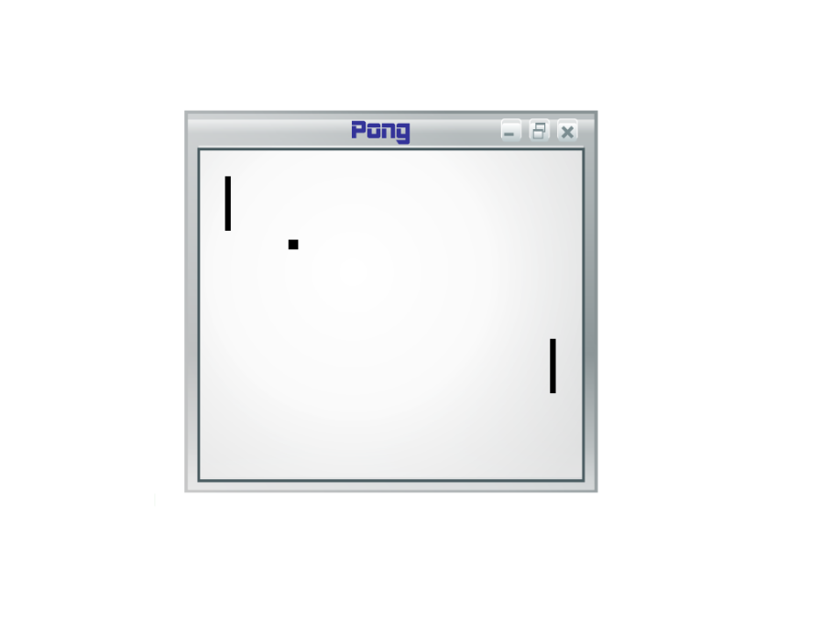

During these times, information was completely unattainable. A user specifically noted that the distractions he chose to alleviate such frustrations needed to be purely visual. For his controlled distraction, he visited a web forum that featured amusing pictures. He claimed that looking at pictures instead of reading articles was ideal, since pictures does not tie up linguistic resources. Linguistic distractions make it more difficult to simultaneously assess whether or not the podcast has resumes playing relevant information. Including games that occupy attention, but don’t demand it entirely, would be ideal for our users. Games like “Pong” are simple visual games that do not require full attention of the user and do not impose a time commitment. For these reasons, providing games is not only fun, but potentially expedient for studying.  
**Widget Customizability**

In keeping with the extensive theme of empowering the user to create their own environment, the widgets were designed with customizability in mind; they should allow for resizing, themeing, and the rearrangement of constituent user interface elements such as toolbars and buttons. A real-world implementation of this open design could easily see benefit in the form of improvements to individual widgets without the need to rewrite the platform, and community-generated enhancements as befits emergent needs, greatly furthering the facilitation of tailored educational environments.

As the form and function of the widgets remains customizable, so too does the environment in which they are presented. The user may decide to include any number of available widgets, placed in the fashion they desire on an open digital canvas, and adjusted to fit together. The user may then save that configuration of widgets, their placement and sizes, and recall it at any time to suit their needs.

Just as the data bred these design decisions, they continued to reinforce them at every turn. During the paper prototype stage, each user was presented not only with the available widgets for placement, but with the constituent parts of the widgets available for customized assembly. More than one user “broke” our design in useful ways by manually folding, rearranging and reconstituting widgets to suit their whims even beyond our anticipation, and in doing so drove home the importance of that overarching principle of facilitation.

**Modular Platform**

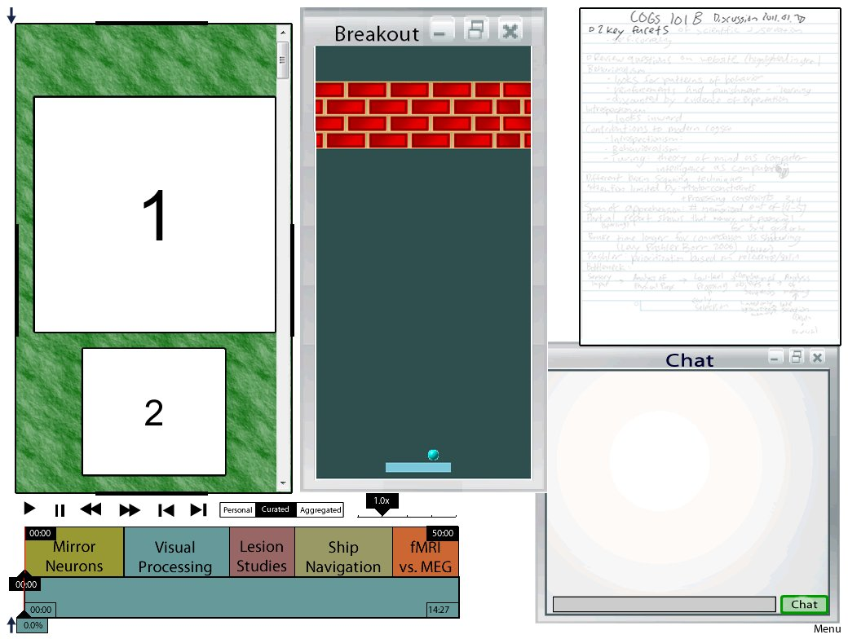 The data we collected in the contextual and paper prototype interviews displayed the need for a modular platform. In the contextual interviews conducted, all users assembled different supplementary media resources in addition to the podcast. Our platform does not constrain the users as to what they may or maynot include in their workspace. With the click of a button, each widget can be added or removed from the visible work space. During the paper prototype phase, potential users selected and organized their work space. After becoming familiar with the selection and approximate location of the widgets, we asked our users to draw their ideal layout. The recorded variance in user-dictated inclusion, size, and location of the widgets further supported the design for a platform that features highly customizable widgets. Instead of forcing the user to conform to a particular type of study style, the user can adhere to their own. Seamless integration is important for new technology. Even if a technology has added efficiency, forcing the user to adopt an entirely new method may cause it to be rejected. Instead, this platform allows users to continue their previous method, but changes the ease of access of resources by localizing them all to one platform. There is no need to switch tabs or alternate between physical resources, which eliminates a previously common disruption to the work flow.

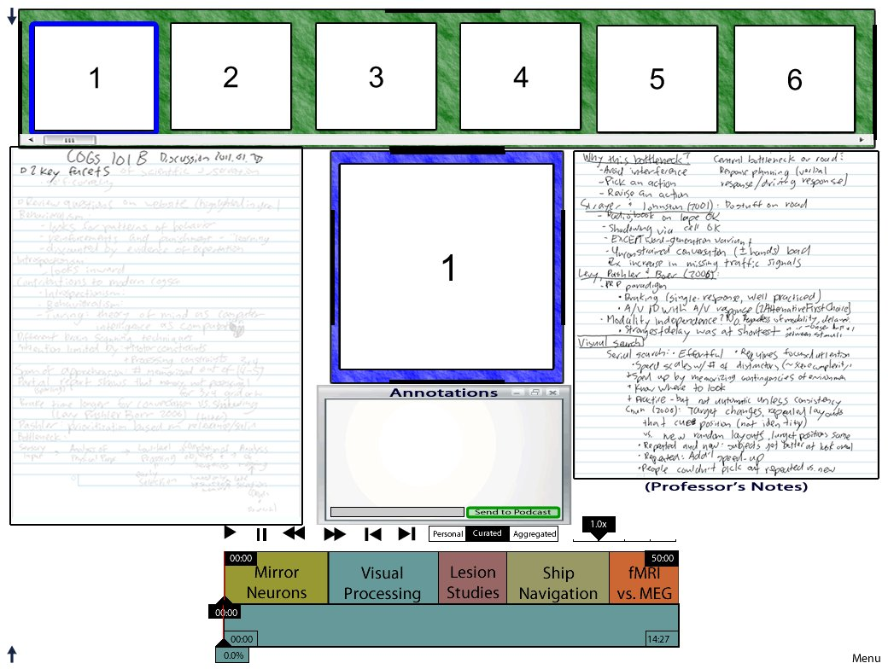

We have created a demonstration of the resizing and repositioning functionality that our system would support. Within this demonstration, we built in three of the layouts that our paper-prototype users drew, each of which could be recreated using our system’s widget-window controls.

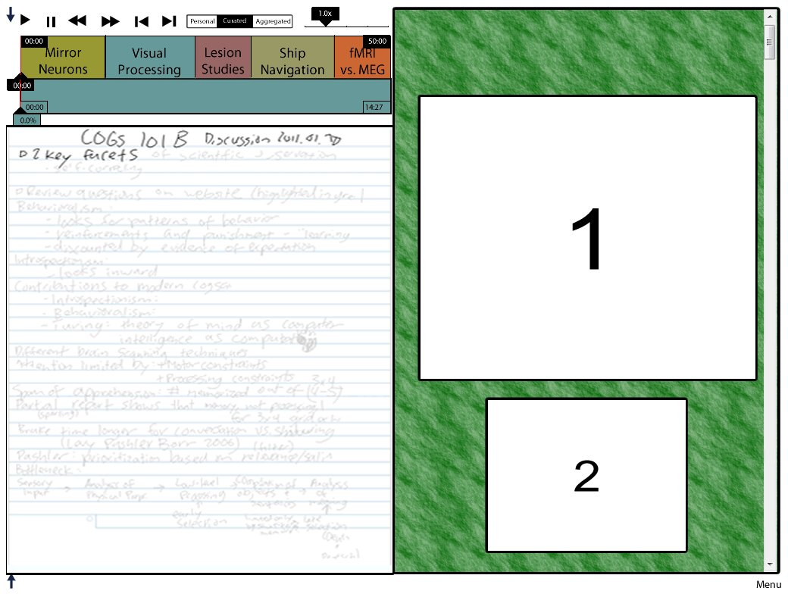

The demo is located in the included CD under the “Layout Demo” folder. More detailed instructions and information can be found in the file README.txt.

**Discussion**

So far, the results of this design process have been conceptual prototypes for each widget and for the overall system framework. We made a demonstration of what the system might look like (included in the “Demo” folder). We have given some thought to how its implementation may work, in addition to future expansion on our initial design.

**Podcast Segmentation**

Allowing for podcast segmentation was a simple feature that yielded significant benefits. Breaking up the podcast by subject solves the auditory location/identification difficulty which many users experience by meaningfully subdividing the podcast’s solid audio block. The click-and-listen guesswork and scrambling to pinpoint the narrative description of specific terms or topics was alleviated by the clear breakdown and mapping of subtopics within the lecture. Moreover, observing the divisions from a high level view provides a resolute index of the topics contained. Users gain a visual representation of the over-view of subjects which comprise each podcast lecture, and finding a certain desired explanation within the podcast becomes a quick visual search rather than an tedious listening task.

**Modularity**

The system’s modular nature has significant ramifications for its implementation. After developing the framework, one would be able to develop each widget independently, allowing for the expansion of functionality for each widget as well as the overall functionality of the platform. This flexibility allows widgets to be developed independently of each other, making it so that individuals can improve each widget without having to rely on previous or upcoming work.

**Synchronization**

The synchronization of digital pen notes, slides, and the podcast are a central part of our system.

We have thought of two methods for synchronizing the podcast and slides:

* 1. Software running on the lecturer’s computer can record and timestamp changes between slides. If the same computer is used to record audio, then synchronizing the audio recording and slides will be a simple matter of lining up the timestamps. There are two main barriers to this implementation, the first being the fact that UCSD uses a dedicated computer - not a lecturer’s computer - to record audio for podcasts. The second is the general difficulty inherent in garnering “buy-in” from a large enough segment of the faculty.
  2. Someone in the audience - either an individual student, an “official” notetaker like an AS notetaker or a TA - can record changes between slides using a smartpen. A smartpen app could support this recording using gestures (a circled arrow or a horizontal line drawn in the notes), special “next slide” and “previous slide” buttons, or even a printout of the slides onto dot paper, on which the notetaker would simply tap the current slide.

We have also thought of three methods for synchronizing the podcast and digital pen notes:

* 1. Notetakers could eliminate the difference between the digital pen’s time setting and the podcast timestamp by modifying the digital pen’s time setting.
  2. Notetakers could infer the difference between the digital pen’s time setting and the podcast timestamp by determining a common reference point, such as the lecture start time. Our interview data suggests that this synchronization method could take advantage of some students’ current practice of writing down times that they want to refer to later; while this practice was not particularly useful for users with regular notes, it might be co-opted for synchronization purposes.
  3. Notetakers could record a second audio recording with the digital pen (as discussed previously, Livescribe pens support such recording). Synchronizing the two audio recordings (manually or through software) would also result in synchronizing the podcast recording and the notes.

**Group Study**

Our system provides very basic chat features as a means of communication with classmates and staff. The platform does not explicitly support group study, but its nature as a centralized study platform will facilitate future forays into supporting group study. Our interview data suggested that very few people study using podcasts in groups. However, it is questionable whether this lack of group use reflects user desire or is merely evidence for the need for a social studying platform. In either case, more data needs to be gathered on whether users would adopt a social study system.

Regardless, we envisioned a platform that supported group studying through the integration of the second podcast group’s commenting feature based on SoundCloud and digital pen delineations aggregated over a large population of users. The addition of social features is always challenging when the previous platforms have not supported or facilitated group study. In order to solve this, any additional social media should integrate seamlessly without much additional input from the user. We believe that both the commenting system and the aggregation algorithm for the podcast bar are features that would integrate in such a way, but again, more data must be gathered in order to show that these features are actually what users desire.

**Digital Pens**

As stated earlier, we were unable to get a significant amount of data regarding how students use digital pens to take notes because digital pens are not yet commonly used by students. In asking students why they didn’t use a digital pen, a few key issues came up:

* 1. Most students did not even know that digital pens existed, or what they are capable of. This lack of widespread awareness of digital pens may diminish over time, depending on the general public’s reaction to digital pens.
  2. Digital pens are costly, though their price is decreasing. Livescribe recently began selling the 2GB version of its most advanced pen, the Echo3, for $99. This is still too expensive for most students, but digital pens are getting cheaper, making it easier for students to afford them.
  3. Digital pens come with little out-of-the-box functionality from a student’s perspective. The types of functionality that digital pens allow are note and audio recording, which are currently supported by regular notetaking (paper notes only) and podcasts, respectively.

Until these digital pens become more ubiquitous, they will remain relatively unused by students. Fortunately, as described in this paper, the system as designed would serve to both increase student awareness of digital pens and grant additional functionality for digital pen users.

**Conclusion**

Our project began with a focus on digital pens and how we could integrate them into the current podcast system. We hoped to find a way to bridge the gap between paper and typed notes, creating a system that would not only facilitate the use of digital pens, but also improve students’ learning and informational retention. However, we realized during our data-gathering process that the real usability issues rested primarily with the fact that the students we interviewed had widely varying study methods across different media due to personal preferences and constraints. We decided to broaden our focus to a platform-centered design and adopted a modular design that would solve the most common recorded usability problems while allowing users to redesign the workspace to fit their needs. Our final design places very little emphasis on any medium; the system requires no widget in particular, and could be expanded to support any resource - and, thus, any study style.

**Works Cited**

1Holtzblatt, Karen, Jessamyn Burns. Wendell, and Shelley Wood. *Rapid Contextual Design: a How-to Guide to Key Techniques for User-centered Design*. San Francisco: Elsevier/Morgan Kaufmann, 2005. Print.

2SoundCloud - Your Sound, At The Heart. Retrieved June 7, 2011, from <http://soundcloud.com>

3Livescribe Echo Smartpen. Retrieved June 7, 2011, from [http://www.livescribe.com/en-us/smartpen/echo/](http://www.google.com/url?q=http%3A%2F%2Fwww.livescribe.com%2Fen-us%2Fsmartpen%2Fecho%2F&sa=D&sntz=1&usg=AFQjCNFNlmetOdEVEw6rCeA6q3uor1KclQ)