GestureMath: An Embodiment-Grounded Approach to Gesture-Enhanced Math Learning on Tablets
Adam Powers  UC San Diego  9500 Gilman Dr.  La Jolla, CA 92093  powers@ucsd.edu | Myoung Lah  UC San Diego  9500 Gilman Dr.  La Jolla, CA 92093  mlah@ucsd.edu | Alan Tran  UC San Diego  9500 Gilman Dr.  La Jolla, CA 92093  att009@ucsd.edu

ABSTRACT

Permission to make digital or hard copies of all or part of this work for personal or classroom use is granted without fee provided that copies are not made or distributed for profit or commercial advantage and that copies
bear this notice and the full citation on the first page. To copy otherwise, or republish, to post on servers or to redistribute to lists, requires prior specific permission and/or a fee.
CHI’12, May 5–10, 2012, Austin, Texas, USA.
Copyright 2012 ACM 978-1-4503-1015-4/12/05...$10.00.
What does the future of education look like? Inexpensive computers, mobile broadband and free online curricula have democratized distance learning, but there remains a need for educational software that does more than replicate the lecture experience on a screen. We partnered with Dr. Susan Goldin-Meadow, a cognitive scientist whose research into the link between gesture and math suggests that young children could be given a better understanding of algebraic concepts by manipulating their hand gestures, and re-implemented her study on an Android tablet in the hopes of preserving the experimental effects while redesigning the interaction to obviate the need for a live instructor.

ACM Classification Keywords
Android; tablets; design; gestures; education; children; algebra; embodied cognition; mathematics

INTRODUCTION
The advent of commodity computing devices and ubiquitous high-speed Internet has paved the way for a nascent paradigm shift in conceptualizations of the American classroom experience [10]. Experiments and contributions from Stanford and MIT have made entire university courses from leading minds freely available online, and disruptive web-based educational platforms like Khan Academy [11] offer free, easily-digestable short video lessons on a wide variety of topics from all grade levels.
These advances have impacted the primary/secondary school systems as well, with an increasing number purchasing laptops and tablets for their students and assigning Khan Academy videos as homework. No longer the sole gatekeeper of knowledge, it would seem as if the role of instructor is being redefined as less about instruction, and more about curation, mentorship, and fostering discussion about commoditized material that follows students through the cloud and across devices.
It is important, then, that software design for the educational sector reflects these changing values, incorporating the latest research into learning theory and attempting to measure qualitative, rather than quantitative aspects of a student's progress. In a world where interaction with a trained instructor is intended to be relatively brief, yet high-quality and targeted, the tools students employ should serve as teaching assistants more than mere homework platforms, recording and reacting not just to what students have done, but what they know.
To contribute to this effort, we developed a proof-of-concept tablet application for Android that implements recent research by University of Chicago cognitive scientist Dr. Susan Goldin-Meadow into the link between gesture and math learning in children aged 9-10. While the original study required that a human researcher be present to guide students through a series of steps designed to improve their cognition about algebraic concepts, we translated the crucial interactive elements into digital equivalents, taking advantage of the multitouch display capabilities of modern tablets to preserve the experimental effects observed while reducing the need for a live instructor.
This paper describes the theoretical groundwork of our development, the process of partnership with the existing research team, the design choices we made, and preliminary results and iteration from testing with a small pool of users. We then discuss further opportunities for improvement, and future directions such research could take.

RELATED WORK
Our work fits into a long tradition [9] of software applications designed to promote learning, though we believe ours is the first handheld gesture promotion tool designed for the educational sector and grounded in embodied cognition literature. Below, we briefly summarize the tenets of embodied cognition and gesture studies, and detail the study which we’ve attempted to replicate.

Embodied Approaches to Math Cognition
Embodied cognition is a conceptual framework that views cognitive processes - and what we would consider the “mind” of an individual - as shaped and defined by the specific sensory hardware (the body) used to interact with the world. Proponents such as Lakoff [8] and Núñez [4] posit that the entirety of our ability to reason about mathematics, while socially constructed in many senses, is not arbitrary; that fundamental principles such as enough, not enough, and not balanced are crucially rooted in our sensations of our own physical needs and the capabilities of our bodies. It’s in this manner that a link is established between the interaction of our bodies with the environment, and our mind’s capability to comprehend culturally-constructed models based on those interactions.

Gesture Studies
When examining embodied cognitive effects, gesture is often studied, as the combination of its close interrelation with the brain’s speech, motor, and reasoning centers and culturally-situated meanings make it ideal for inferring certain mental processes by the gestures they produce. Serving as the basis for our work, Dr. Susan Goldin-Meadow suggests that the brain’s tight coupling between bodily awareness and mathematical reasoning (using the premises described previously) may be exploited by promoting gestures in children who are struggling to grasp the algebraic concepts involved in balancing a simple equation [1, 2].

Gesturing Gives Children New Ideas About Math
Dr. Goldin-Meadow’s experiment, which we’ve attempted to replicate digitally, was split into four phases - pretest, pretraining, training, and posttest - where the pretest was a set of problems (of the general form “3 + 9 + 7 = x + 7”) given to all the potential subjects, and only students who got none of the problems correct (showing that they did not already understand this type of addition problem) were selected for the study. The students in the experiment were split into groups: one group was taught gestures corresponding to what was termed the equalizer strategy, and the other group was not taught the gesture as a control.
During the pretraining phase, the experimenter showed the students in the experimental condition a set of problems on a whiteboard, and asked them to mimic their words and motions: “we want to make one side...” - indicating the left half of the equation with a two-fingered pointing gesture, specifically the addends that would solve for x - “...equal to the other side”, while specifically indicating, with a one-fingered pointing gesture, the blank space in the right side of the equation (the equalizer strategy). In this fashion, the experimenter was able to communicate, non-verbally, the correct strategy for solving the equation. No solutions to the specific problems were given in this stage.
During the training phase, the experimenter explained how to solve an example problem, and then gave the student a new problem, asked them to repeat the gestures or words learned in the pretraining phase, and then solve it themselves. The posttest had the same format as the pretest, and the number of correct answers on the posttest was used as a measure of learning.
The experiment showed that the children who were taught to gesture performed significantly better on the posttest than children who hadn’t; and surprisingly, so did children in a separate condition who were taught to gesture, but primed by an experimenter who indicated the wrong numbers on the problem, suggesting that the gestures themselves had the power to convey solution strategies without necessarily indicating specific addends to consider.
By recording the gestures produced by the children and coding them along with the speech they accompanied, Goldin-Meadow’s researchers were also able to indicate whether or not a child was on the cusp of learning the correct strategy - a state called “transitional knowledge” by other researchers [3] - as suggested by an incorrect answer being observed along with the correct gesture strategy, soon to be followed by the correct answer on all counts.
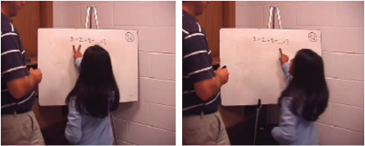
Figure 1: A child demonstrates the equalizer gesture.

RESEARCH INTEGRATION PROCESS
Once we decided on the basic goal of translating the teaching phases of the Goldin-Meadow study to a tablet, we began by doing a literature review. Initially, the only information we had about the experimental design was in the Methods section of the papers, as well as some brief video clips shown in Dr. Goldin-Meadow’s TEDx talk [5]. Even though we had incomplete knowledge, we began by implementing the basic elements of the application in Android. In our first prototype, we mocked up a single grouping problem, and demonstrated the following features: 1) recognizing two simultaneous touches, 2) entering an answer using the on-screen keypad, and 3) storing information about the interaction in the database on answer entry.

Expert Opinion
Dr. Piper was able to arrange for us to speak with Dr. Goldin-Meadow about our research project, and she gave us valuable feedback on the design of our application and the interaction demonstrated in our demo application. Our primary concerns were, as designers, which aspects of the experiment were sacrosanct, and which could be reworked for aesthetics and ease-of-use; we were, after all, translating an experimental effect which is still undergoing study, and it was difficult to ascertain precisely which aspects were crucial. The summary of decisions made will follow.
Dr. Goldin-Meadow also put us in contact with two of her graduate students, Miriam Novack and Eliza Congdon, who were designing an updated study based on her research. Eliza and Miriam provided us with a written script detailing the exact experimental protocol, as well as a video showing a full run of the experiment as outlined in the script. This provided the specification we needed to implement the entire experimental flow for the pretraining and training phases.
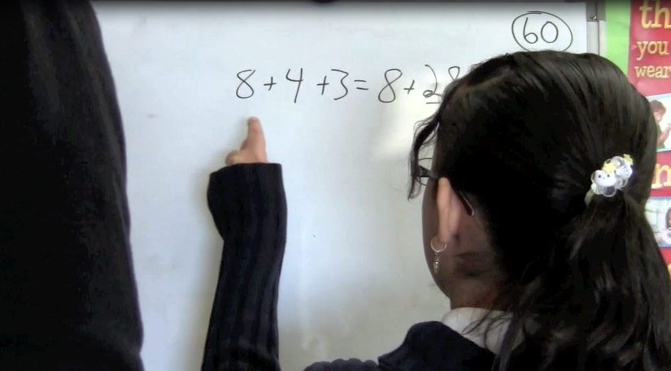
Figure 2: A child explains her reasoning process to the experimenter in an updated video obtained from more current research.

FINAL PROTOTYPE AND DESIGN METHODOLOGY
Our application implements the retraining and training modules for both the gesture and non-gesture conditions. This allows us to run an experiment where we test if the learning effect shown in Dr. Goldin-Meadow’s work exists when the instruction is shown to students in an electronic form on the tablet. We will give the pretest and posttest on paper as in the previous work.
At each step, we display the same words as in the script, and recorded a voiceover that speaks those same words aloud. When demonstrating the gesture, we fade in an outline of a hand showing the proper grouping hand shape, as well as highlight the numbers that the animated hand “touches”. This perceptual highlighting is an important addition to the application, as it provides a clear cue to the student that the numbers are being touched during the animation. When the student is asked to repeat the gesture, the numbers light up in the same way, only if the student touches the numbers in the same sequence as in the animation.

Design Decisions
As mentioned, we had various design decisions to make, with the added stipulation that they not interfere with the experimental effects we were attempting to preserve. Below are the areas we made decisions around, and our rationale behind them.

Audio Feedback
It was a relatively easy decision to include spoken voiceovers, as our overarching goal was to be as true as possible to the original experiment design, which included a live experimenter speaking instructions to a student. The final prototype contains a clear female voice, recorded by a person, which we felt would be soothing, and encourage compliance with the instructions.
We initially considered audio feedback during button presses in the pretraining and training stages, for purposes of usability, but decided against it; sounds tend to have character, and as the experiment did not give the student feedback on how well they’d done, we did not want any sound being associated with success or failure in the context of any particular problem. If we had implemented a sound, we would have opted for a light and neutral “click” as can be found in many operating systems and application interfaces.

Visual and Touch Feedback
For usability purposes, we wanted as much visual feedback as possible during the stages coded in the prototype. During all stages where instructions are given to the student, the words spoken in the voiceover appear on-screen so that they may be read at the same time. When the instructions refer to specific parts of the screen (“we want to make one side...”), those areas light up in time with the words, and our representation of the equalizer fades in with them.

Gesture promotion
The most important part of the experiment was showing and promoting the gestures used by the experimenters to improve strategy inference among the students. We had many options: a video file showing a portion of the experiment, or an actor replicating the gesture for the benefit of the user; interactive sliders and buttons around the interface that force the user’s hand into the required shapes; a small, realistic hand that makes the handshapes required; a cartoonish hand in the required shapes.
Upon reconvening with Eliza and Miriam, we asked whether it was the handshape itself that conferred the experimental effects, or simply attention being paid to the numbers. We were given feedback that the gestures themselves should be construed by the student as being in relation to the numbers, rather than simply “near” or “over” them. For that reason, we retreated from the idea of using interactive sliding widgets to promote the handshapes, and settled on modeling via the cartoonish hand seen in the final prototype. We felt that the hand used should unambiguously resemble a human one, but not of any particular size or ethnicity.
We fade the hand onto the screen while the voiceover instructions play, illustrating what we want the child to do; when the hand moves, it quickly fades out, then fades in at the proper location. We did not want to suggest that the child move their hand in any specific fashion, as might be inferred by an animated hand motion, and felt that not showing the hand’s direct transition from A>B would not impact the student’s ability to ascertain what to do.

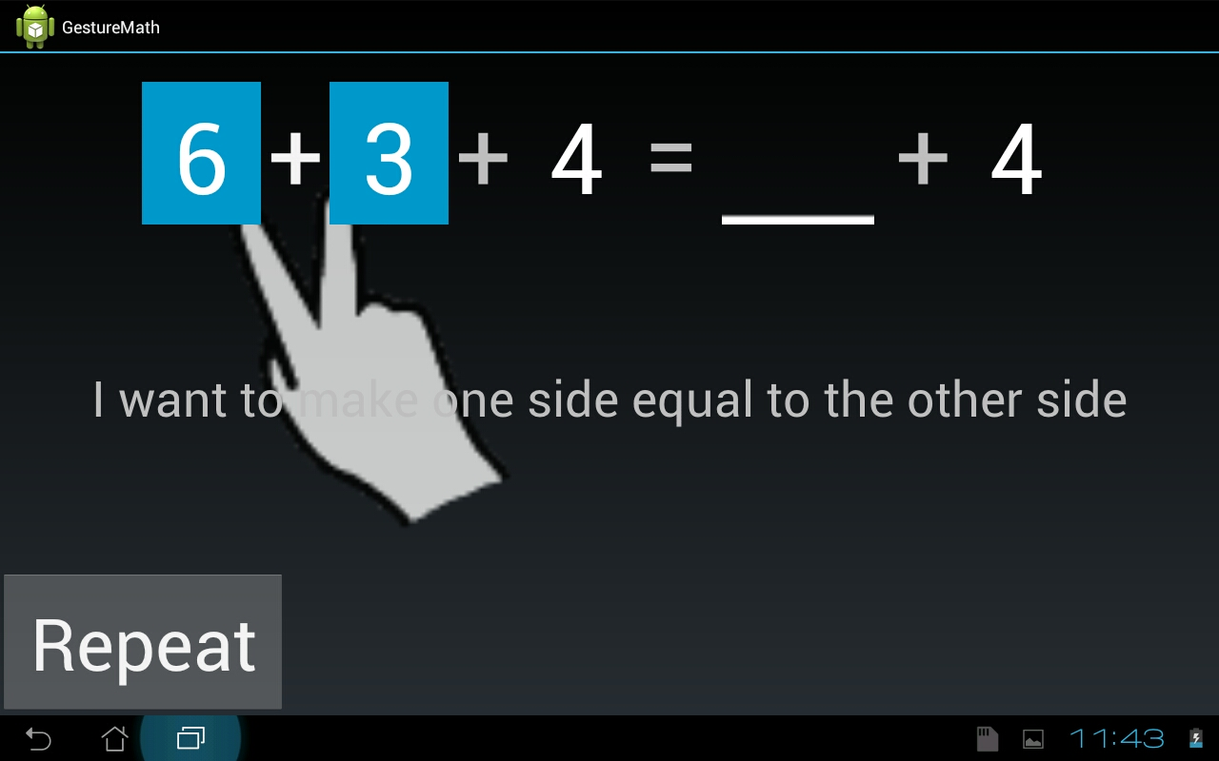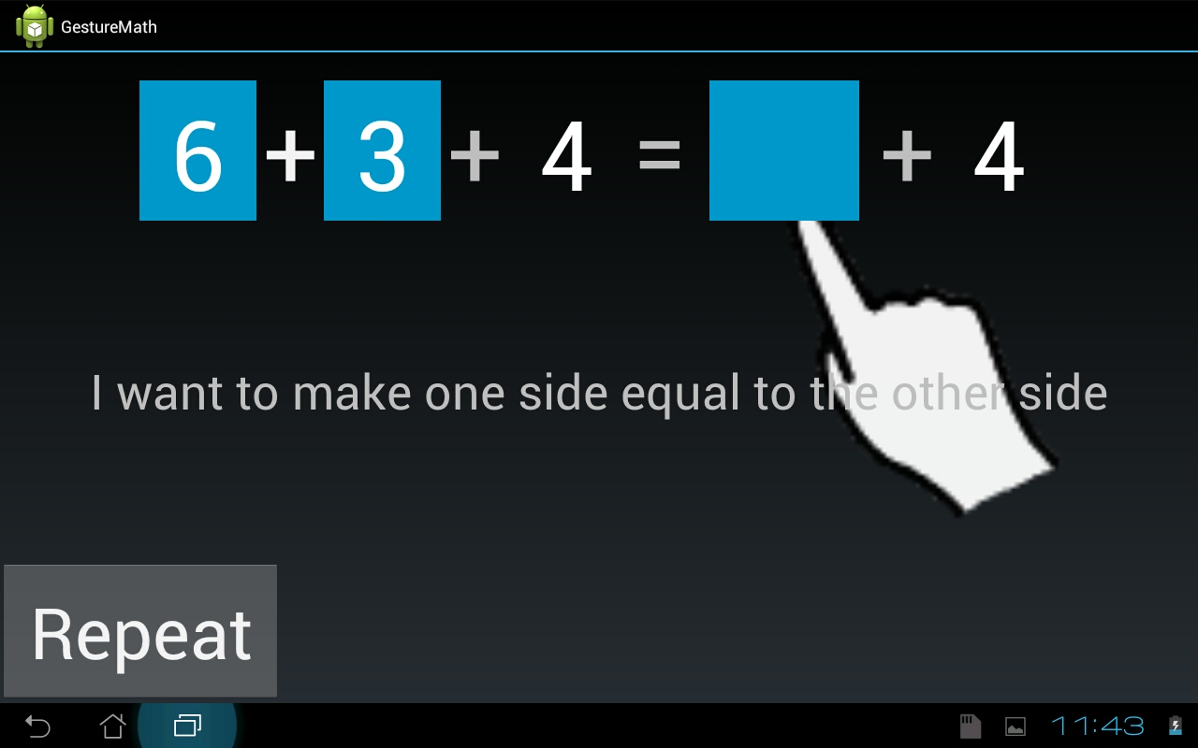
Figure 3: The pretraining phase, showing the implementation of the equalizer gesture in the tablet interface.

Number Highlighting
There are multiple ways one could indicate the numbers and blank spots as they are touched or indicated by the application; underlines, glowing highlights, and a colored square background behind the number were all options considered. For ease of development, the lattermost option was chosen, though if given time, a glowing effect would be preferred.

Speech Detection
A part of the experiment script involves the instructor asking the child to repeat words after them at the same time they’re being shown the equalizer gesture. We wanted to include this interaction, as it’s vital for detecting speech-gesture mismatches (where the child says one strategy, but uses another via gesture), but had no easy way to check for the correct words, or even to pause for the appropriate amount of time - too little or too long of a delay would break usability.
The other alternative, detecting speech programmatically, is exceptionally difficult as it is, much less for a team our size and with our time constraints. While we still ask the child to “repeat after me”, there is no detection or feedback if they do not. We were concerned this would have an impact on the final result, but preliminary testing suggested that the prompts are enough; users surveyed still spoke when asked by the application.

Number Input
The application currently relies on the default installed Android keyboard for numeric input, which presents itself when the user touches the blank space designed to hold the answer to the equation. Rather than allow a potentially-unknown keyboard to dictate design, we wanted to include our own method of inputting numbers that would remain consistent across releases.
We considered a number row with draggable glyphs, much like refrigerator magnets, but advice from the researchers suggested we reduce all swipe-like motions in an effort to protect the experimental effects.
We did not wind up with enough time to implement our own number system, but we had previously settled upon a phone-like button layout similar to the on-screen keyboard (fig. 4); our main concern was merely that it be an interface we designed, rather than one provided by another party.

Handedness Detection and Promotion
It was an early question, before our interviews with the researchers, whether the specific hand used in gesturing - dominant or non-dominant - was significant to the final results. As it turned out, it wasn’t, but we had considered how one might force a child to hold a tablet with their non-dominant hand and gesture with their dominant one (as we guessed the children were doing). Had we implemented the feature, we hypothesized that two independently-functioning “start” buttons, appearing near both the extreme right and left edges of the screen, would ensure a relatively good probability that even with the tablet resting on a table, the button activated would correspond to the child’s dominant hand. A silhouette would then appear on the opposite side in the next screen, in roughly the shape left by a young child’s hand gripping that edge of the display, and voice instructions would ask the child to hold the tablet in that hand.
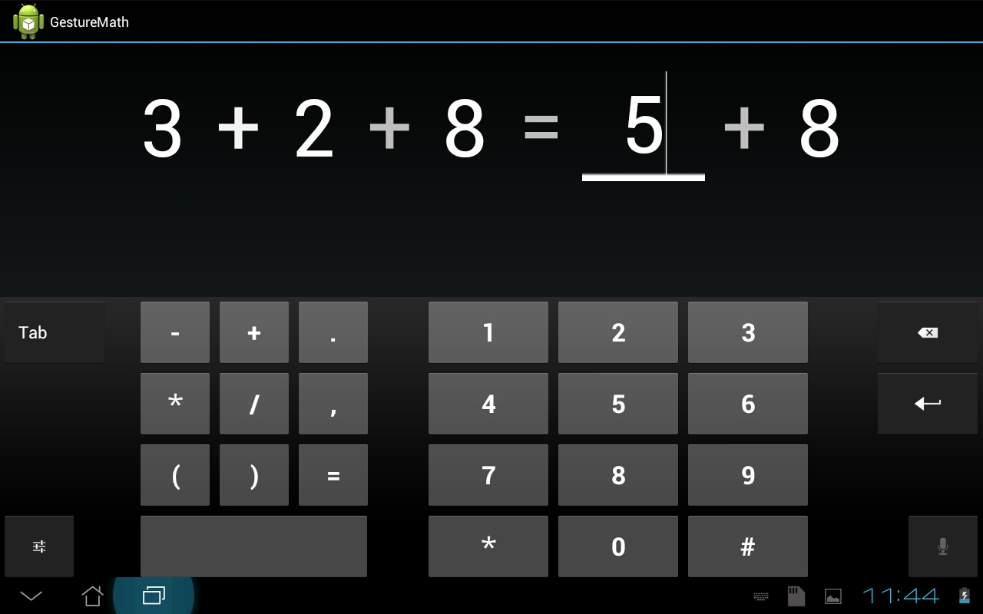
Figure 4: The answer input screen (with updated answer box) and Android keyboard default to that particular installation.

TESTING AND ITERATION
We arranged another meeting with Eliza and Miriam to get their feedback on the latest application that showed the complete pretraining and training interaction. They provided a very important insight: while adding the perceptual highlighting on the numbers was important to make the desired interaction clear within the table interface, it was also important to isolate the effect of the highlighting in the experiment. Therefore, we implemented a third gesture condition where we do not show the gesture, but do show the highlighting of the numbers. This “highlight only” gesture condition was added as an option in the application.

(Adult) User Testing
As we were unable to secure IRB approval for testing with our target age group, we performed some brief user testing with adults, to see if the instructions were clear and if users would be able to understand and repeat the gesture shown in the animation. For testing, we chose users who were not familiar with Dr. Goldin-Meadow’s research, and told them only that we were testing an application that provided math instruction to third- and fourth-grade students. We asked them to go through the experiment flow while talking aloud, and did not answer any questions until they had finished.
We noticed that the gesture demonstration animation was clear, and users quickly understood how to repeat the gesture. We also noticed that while our application does not recognize user speech, users repeated the words as requested, and one user asked afterwards if the application did speech recognition. This is a promising result, as we were unsure if we would be able to get students to repeat the words without doing speech recognition. This preliminary adult user testing will be considered when moving onto user testing with children.

DISCUSSION
We believe that our application contains all the necessary features to make it a usable research tool and minimum viable product. We have implemented the complete experimental flow for all gesture conditions, both in the original research and an additional one as suggested by the researchers. We also provided some important features for future research such as generating a random student ID number for each run of the application, and providing export of gathered data to an easily-accessible database.
It’s our hope that this application, and others in a similar vein that might follow, allow researchers and designers to start thinking about how best to approach the matter of distance education from a situated, human-centric perspective. While Khan Academy has received accolades for providing a free, high-quality alternative to classic lectures, it does not represent the highest potential possible for such an entry: consuming a lecture in front of one’s computer is scarcely different from consuming it in a lecture hall, and the time-shifting affordances of web-based video - pause, rewind - offer only minimal improvements to recorded notes.
Instead, we believe that should ubiquitous computing play a central role in the educational infrastructure of the future, it should add, rather than detract from the importance of a live instructor. Far from hoping to replace talented educators with robotic equivalents, they should be provided tools with the intelligence to evaluate a far-flung cadre of curious minds, the capabilities to extend their mentorship into the cloud, and designs that reflect the most modern understandings of cognition, learning, and development.

FUTURE WORK
The most obvious and pressing next step would be to test the application with the children for whom the original experiment was designed, and measure for the hypothesized experimental effects using the pre- and post-tests. Should they match up with the results seen by Dr. Goldin-Meadow and her team, we would move on to refinement and addition of features and beautification of UI; otherwise, we would examine and tweak every aspect of interaction, testing and iterating, until we’d determined with sufficient confidence whether a translation of the study was entirely possible.
Assuming success, the first refinements would be the addition of customization options for interested researchers to modify settings such as the app background, highlight colors, instruction content and timing, voiceover files, bitmap assets, and student ID assignment, should they devise experiments where those factors become variables they wish to manipulate. The code would also be revised to work on a variety of devices, as testing on anything other than the main development tablet (a Transfer TF101) was not always reliable.
Given more time, a good deal more iterative testing and prototyping would have been in order; we were not entirely comfortable having the “final word” on many of the design decisions we’d made, and additional iterations would hopefully have revealed strong preferences in our testing base.
And finally, a highly desirable feature addition would be the true detection and recording of the “transitional knowledge” state as mentioned in the literature. This would enable a truly revolutionary usage scenario wherein a primary school teacher, logging in to her classroom’s dashboard, could get detailed feedback not only about which homework modules her students had completed in their free time, but which students were closest to grasping the concepts behind the material and required only minimal extra assistance to “get it”. Empowered with this data, she could effectively help greater numbers of her charges across the threshold of understanding - using methods and talents that are uniquely hers, and that no amount of technology could replace.

ACKNOWLEDGEMENTS
We’d like to thank Dr. Anne Marie Piper, Dr. Susan Goldin-Meadow, Eliza Congdon, and Miriam Novack for their mentorship and assistance, as well as Tyler Marghetis for his initial opinion on the feasibility of the project and some good starting advice.

REFERENCES
1. Goldin-Meadow, S., Cook, S. W., & Mitchell, Z. A. Gesturing gives children new ideas about math. Psychological Science, 2009, 20(3), 267-272.
2. Broaders, S., Cook, S. W., Mitchell, Z., & Goldin-Meadow, S. Making children gesture reveals implicit knowledge and leads to learning. Journal of Experimental Psychology: General, 2007, Vol. 136, No. 4, 539-550.
3. Perry, M., Church, R. B. & Goldin-Meadow, S. Transitional knowledge in the acquisition of concepts. Cognitive Development, 1988, 3, 359-400.
4. Núñez, R., Edwards, L., & Filipe Matos, J. Embodied cognition as grounding for situatedness and context in mathematics. Educational Studies in Mathematics, 1999, Vol. 39, No. 1, 46-65.
5. Goldin-Meadow, S. (2011, May 13). Susan Goldin-Meadow: What our hands can tell us about our minds. [Video file]. Retrieved from http://www.youtube.com/watch?v=tPPaJrhluS4.
6. Novack, M. and Congdon, E. Recorded video of embodied math research experiment. [Video file].
7. Graham, T. The Role of Gesture in Children’s Learning to Count. Journal of Experimental Child Psychology, 1999, Vol. 74, No. 4, 333-355.
8. Lakoff, G. & Núñez, R. The Metaphorical Structure of Mathematics: Sketching Out Cognitive Foundations for a Mind-Based Mathematics. Mathematical Reasoning: Analogies, Metaphors, and Images, 1997, 21-89.
9. Dondlinger, M. Educational Video Game Design: A Review of the Literature. Journal of Applied Educational Technology, 2007, Vol. 4, No. 1, 21-31.
10. Choi, Y., Abbott, T., Arthur, M., & Hill, D. Toward a future wireless classroom paradigm. International Journal of Innovation and Learning, Vol. 4, No. 1, 14-25.
11. Khan Academy. Retrieved June 12, 2012 from http://khanacademy.org.

