DevOps

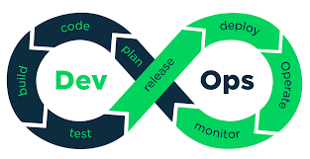

* DevOps (portmanteau combination of two word)
* Development
  + Design
  + Testing
  + Implementation
* Operations
  + Deploying the application (making it available to users)
  + Maintenance
* Three levels of DevOps
  + Continuous Integration
    - You are your fellow developers will share a remote repository
    - You **CONTINOUOUSLY** will push up your code and **INTEGRATE** it into the repository
    - The repository will be configured so that when you push your code the application is tested and you can get feedback
      * Allows you to quickly see if what you have written works and can be added
  + Continuous Delivery
    - Continuous Integration + A **DELIVERABLE**
      * A deliverable is some completed artifact/version of the application
        + .jar file, compiled .exe, anything read to use
  + Continuous Deployment
    - Continuous Delivery + **DEPLOYING** the deliverable
      * Executing that .jar file so that your application is available for end users
      * Usually you deploy the application on a separate computer than you build it on
* Web Server
  + Computer that you can interact with over the internet
  + By default most home computers are pre-configured so that your computer cannot be accessed over the internet
    - Security feature
  + Public ip addresses that anyone can find it
* EC2 (Elastic Compute Cloud)
  + A virtual machine that AWS can create for us
  + This virtual machine can be a web server if we want