Module 14 Final Assignment

1. Provide a screenshot of your Docker desktop to show that there are no *containers* running.

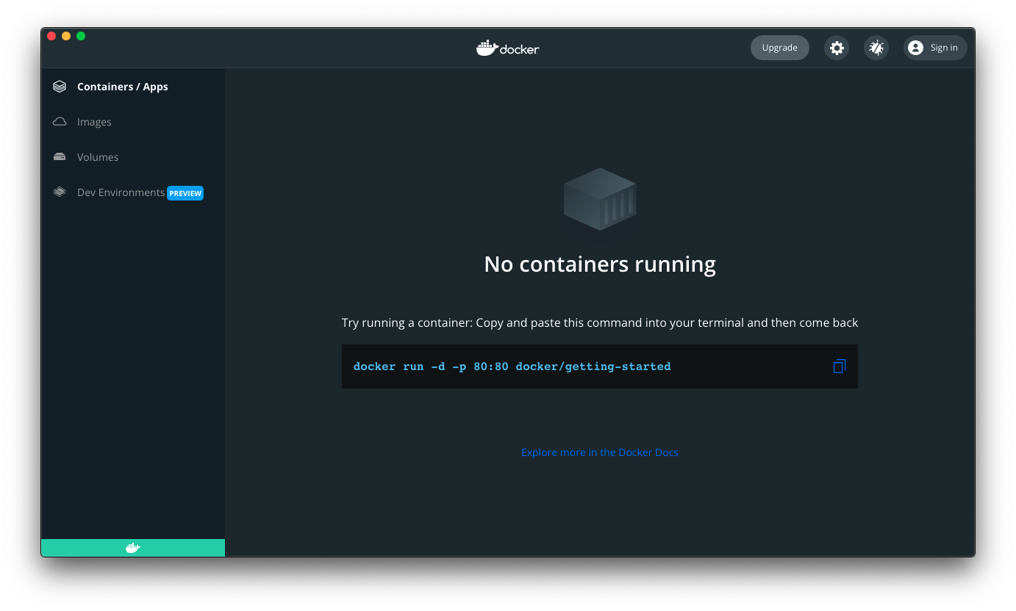

1. Provide a screenshot to show that you successfully ran the command to create the CDCFinalAssignmentDocker network.

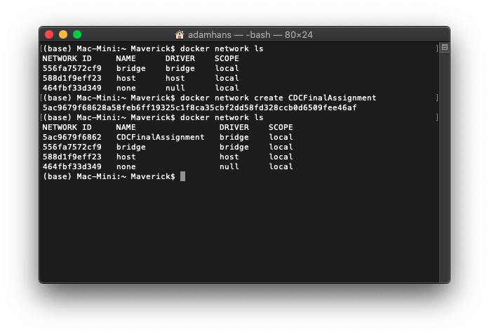

1. Provide a screenshot to show that you successfully created the Module14FinalAssignment folder and the two files (Dockerfile and employee.sql) in VS Code.

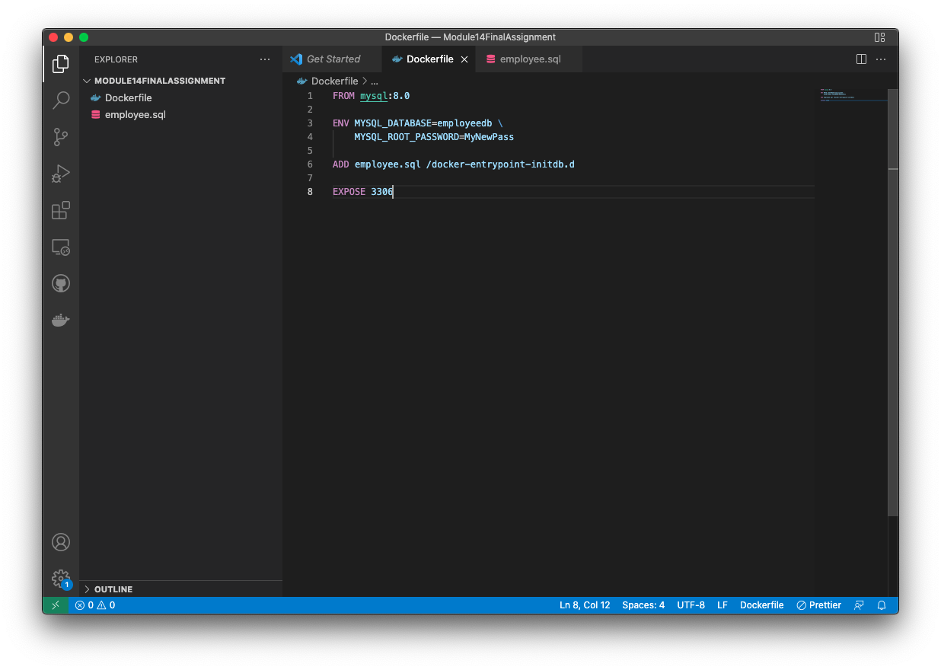

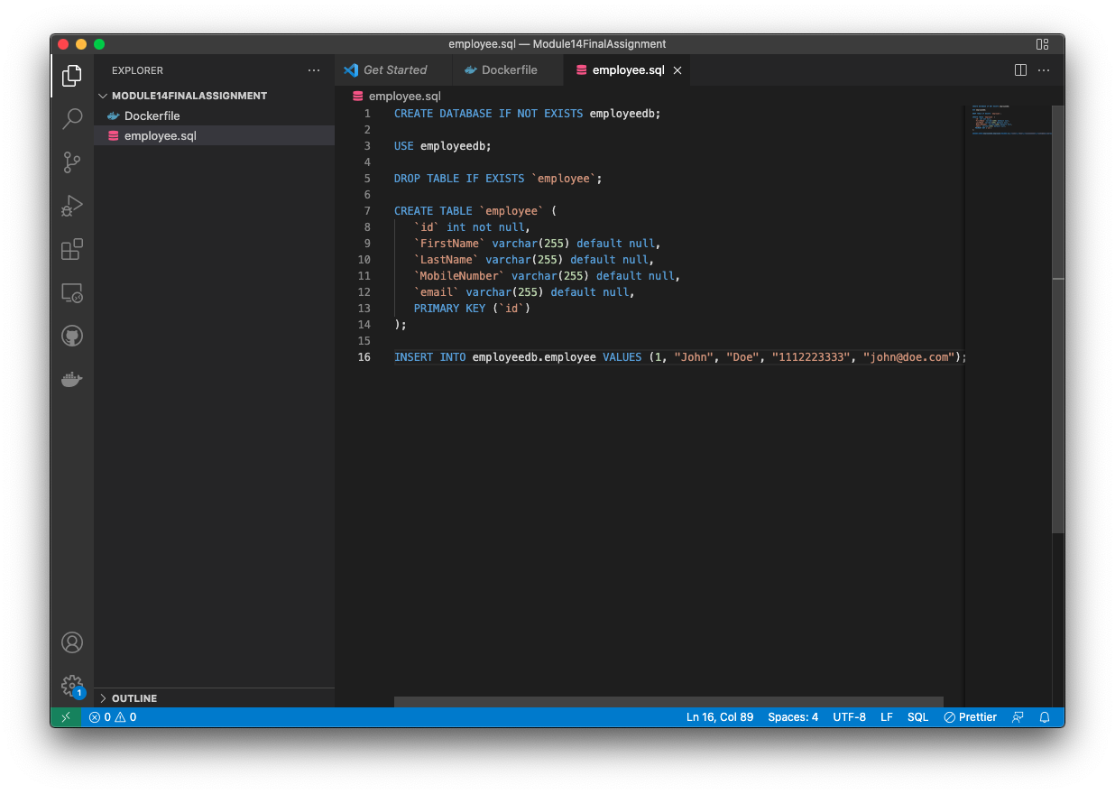

1. Provide a screenshot to show that you successfully ran the Docker command to create the MySQL Docker*image* mysqlmasterimg.

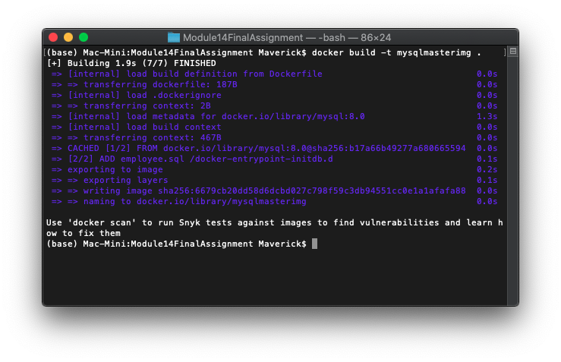

1. Provide a screenshot to show that you successfully ran the command to create the mysqlmasterdb MySQL Docker *container*.

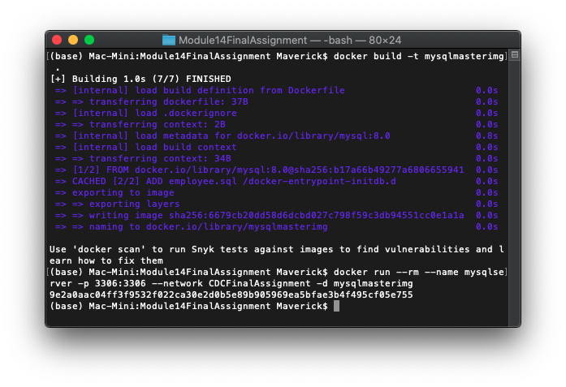

1. Provide a screenshot of your Docker desktop to show the MySQL Docker *container* named mysqlserverrunning.

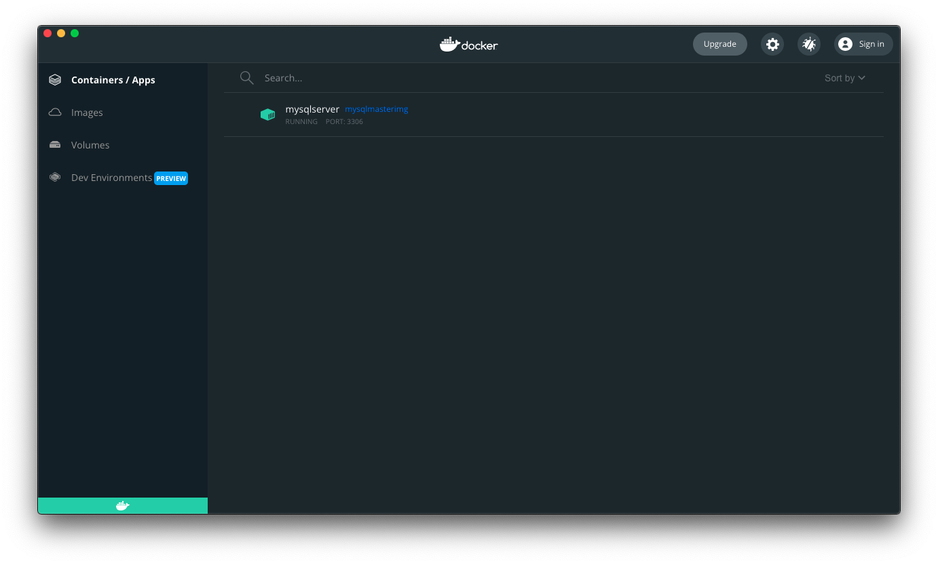

1. Provide a screenshot of the unzipped content from the Debezium folder.

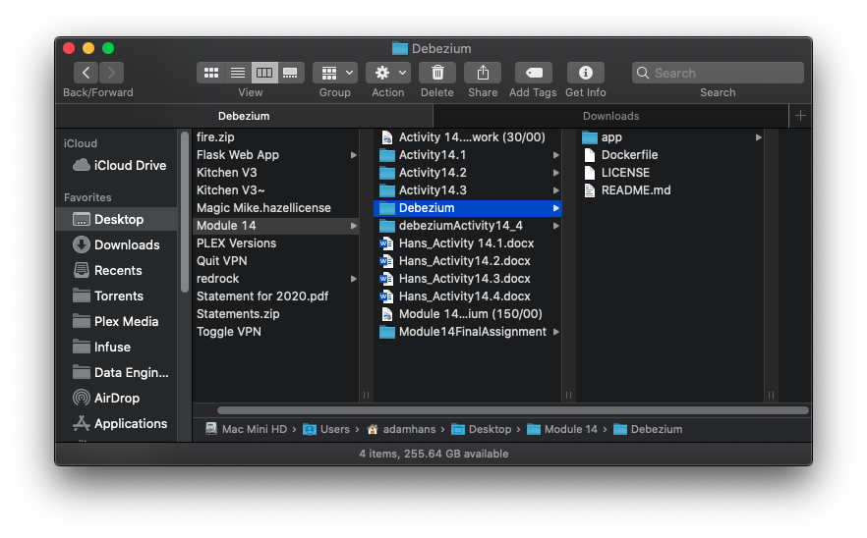

1. Provide a screenshot to show that you successfully created the debeziumimg *image.*

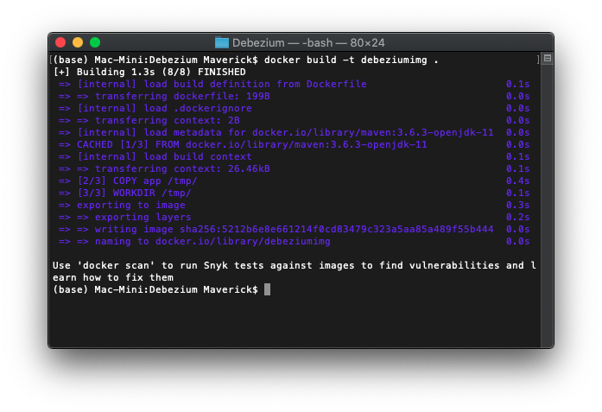

1. Provide a screenshot to show that you successfully created the debeziumserver Docker *container* and associated it to the CDCFinalAssignment network.

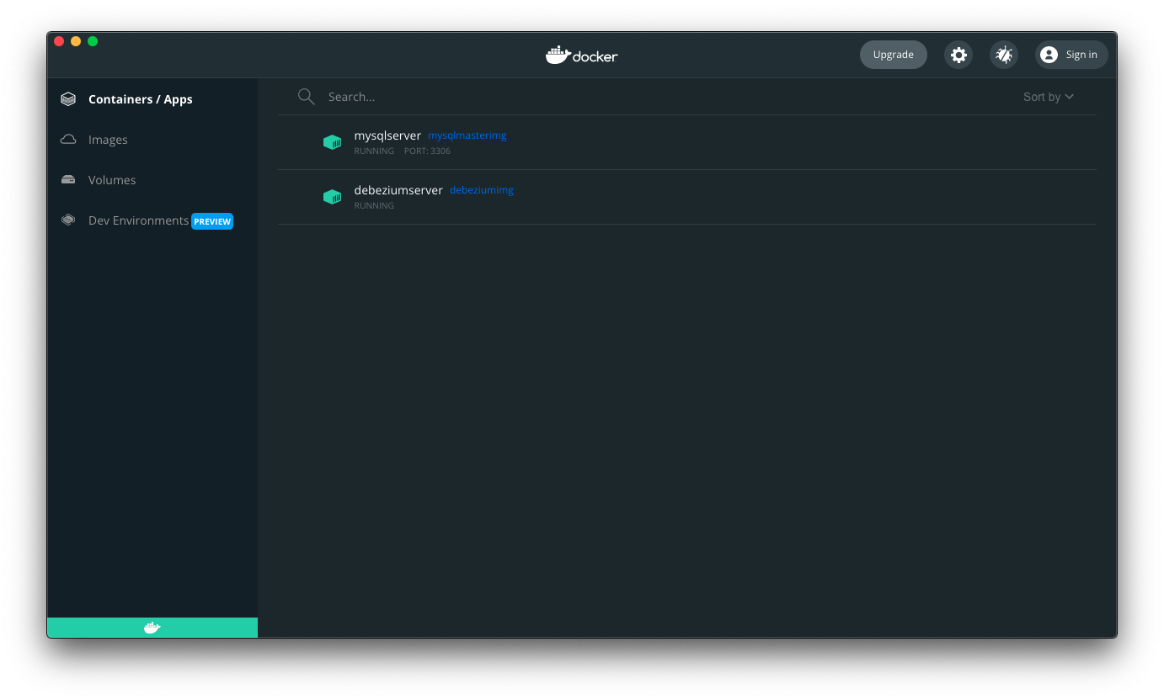

1. Provide a screenshot of the nano installation on the Debezium *server* CLI.

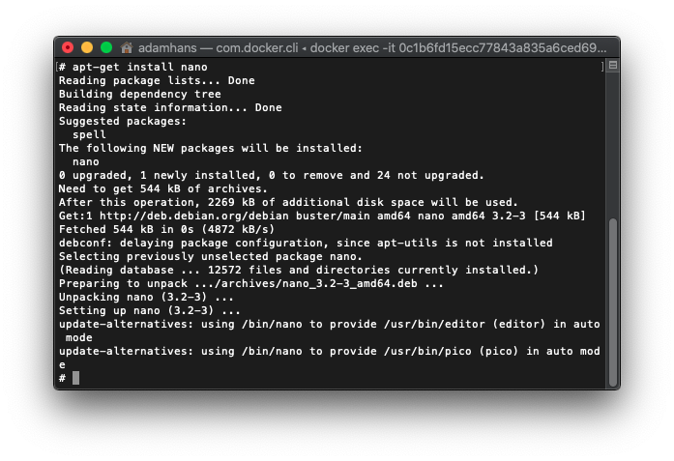

1. Provide a screenshot to show that you successfully changed the database name in the DebeziumConnectorConfig.java file.

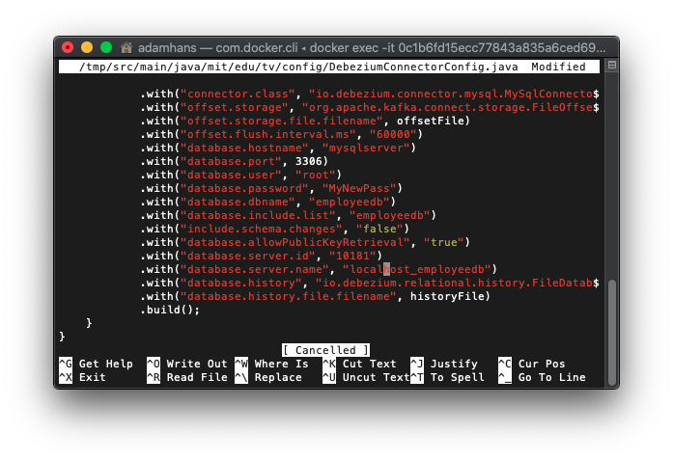

1. Provide a screenshot to show that your application ran correctly. In your Terminal window, you should see FirstName=John as the first entry.

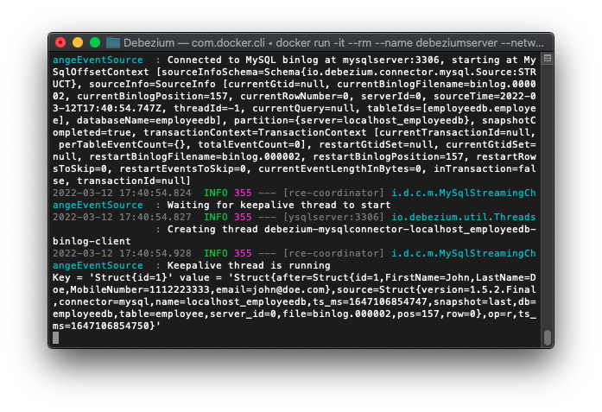

1. Provide a screenshot to show that you successfully started the MySQL connection.

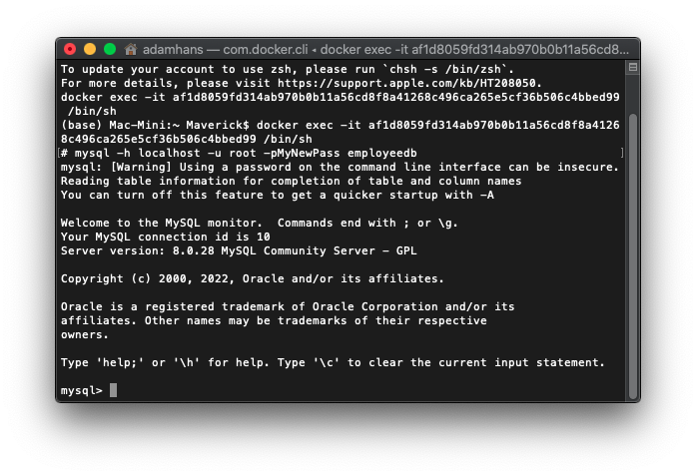

1. Provide a screenshot of the new INSERT *query* executed successfully with the First Name Mary.

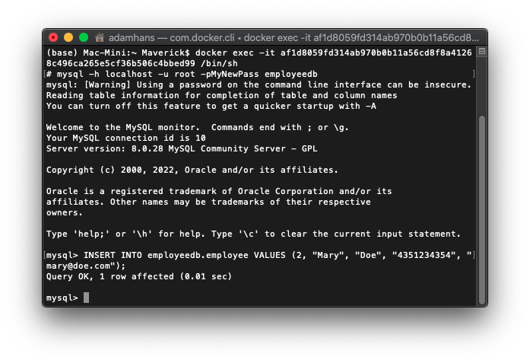

1. Provide a screenshot to show that the CDC has been performed correctly, and you now see FirstName=Mary as the first entry.

