Systems Administration

Year 2 // Semester 1

**Project Document**

**Name:** *Adam Romanowicz*

**Student Number:** *C00297492*

**Link to screencast:** <https://www.youtube.com/watch?v=jL64fPioz_Q>

[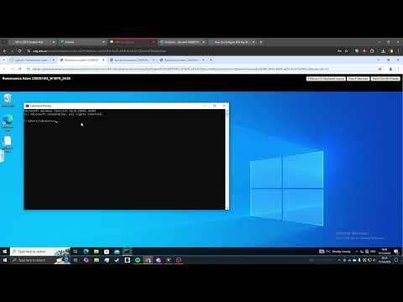](https://www.youtube.com/watch?v=jL64fPioz_Q)

|  |
| --- |
| **INSTRUCTIONS FOR COMPLETION:**   * **Rename** this document by replacing "FirstNameLastName" with your own name. * **Enter** your name, student number, and the link to your screencast in the fields provided on pg1. * Complete all tasks using the **labuser** account (NOT root). * **Screenshots only**: You are not required to write detailed descriptions or step-by-step guides.   + Paste **only relevant screenshots** for each task.   + **Add captions** where necessary to clarify the VM, file paths, or configurations shown. * Ensure **VM name** and **file paths** are clearly visible in screenshots. If not, include the file path or configuration location in a caption (e.g., /etc/vsftpd/vsftpd.conf). * **Submit** this project document via the project submission link on Blackboard before the specified deadline. * **Important:** Do not access or modify your virtual machines **after submitting** your document. Accessing VMs after submission may result in a grade of **zero**. |

**Samba Configuration and File Sharing:**

In the box below, paste relevant screenshots showing:

* **Samba configuration files** after you edited them.
* Evidence that file sharing is working between the Linux Server and Windows Client, using the allusers shared directory.

Ensure the **VM name** is visible in the screenshots.

|  |
| --- |
|  |

**SSH Configuration and Secure Remote Access:**

In the box below, paste relevant screenshots showing:

* **SSH configuration files** after you edited them.
* Evidence that secure remote access is working between:
  + Windows Client -> Linux Server
  + Linux Client -> Linux Server

Ensure the **VM name** is visible in the screenshots.

|  |
| --- |
| **Caption: /etc/ssh/sshd_config**    **Caption: /etc/ssh/sshd_config** |

**Shell Script for Task Automation:**

In the box below, paste relevant screenshots showing:

* **Your BASH Shell Script** (full script).
* Evidence of the script’s functionality in action (or your attempt at it).

Ensure the **VM name** is visible in the screenshots.

|  |
| --- |
| **Caption: .userman.sh** |

**Miscellaneous VM Screenshots:**

In the box below, paste screenshots showing the results of the following commands, per VM.

Ensure that both the command you entered and the VM name are clearly visible in each screenshot.

These screenshots should be taken after you’ve finished configuring your services and script.

**On the Linux Server:**

Command: sudo firewall-cmd –-list-all

**On the Linux Client:**

Command: sudo firewall-cmd -–list-all

|  |
| --- |
|  |