Direct Projection Digiscoping Tips

# Adjusting Image Brightness with Shutter Speed and ISO Settings

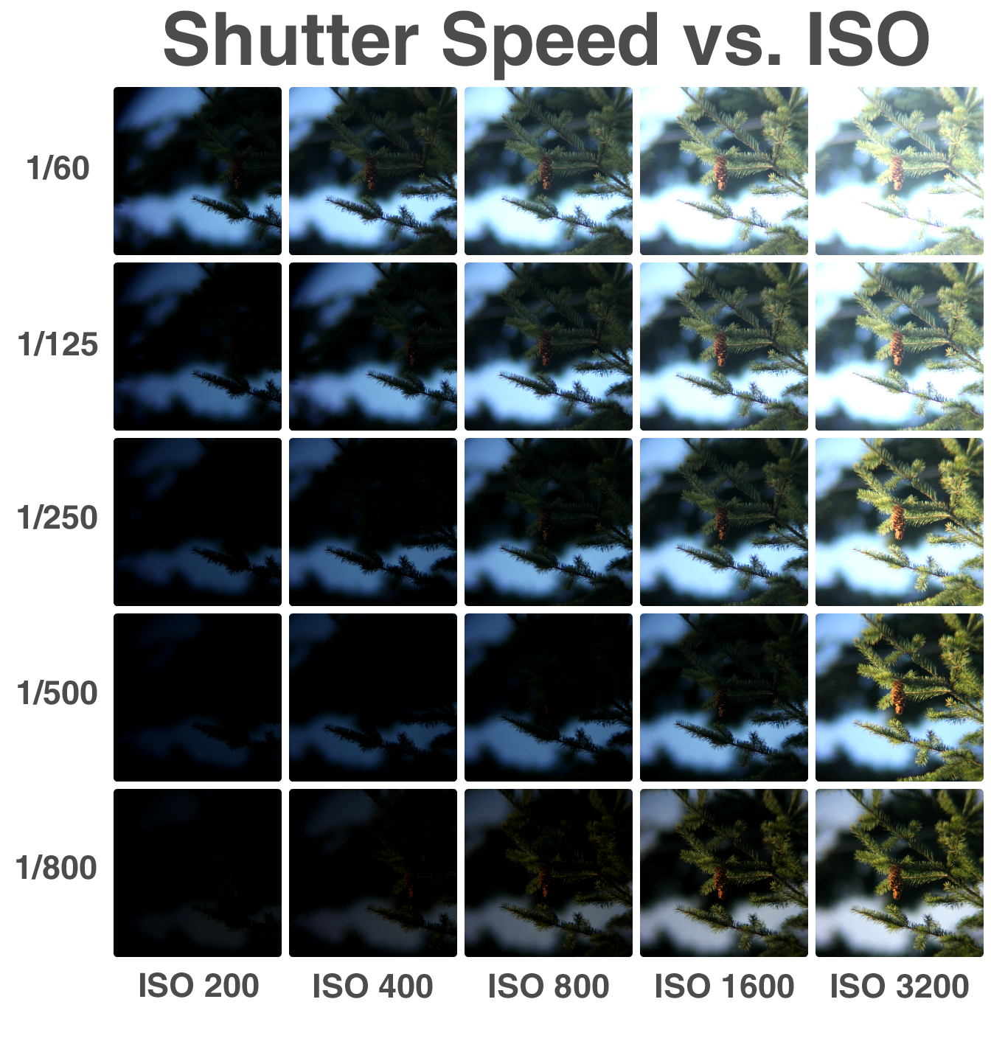

Because less light reaches your camera’s sensor when using a large lens (or a spotting-scope, in this case) your camera will need to be adjusted to compensate. The table above shows the effect of various shutter speed and ISO settings on the brightness of the picture.

These settings can be adjusted by setting your camera to “Manual.” Refer to the camera’s instruction manual for further details.

All pictures were taken at dusk, using a Canon EOS Rebel T3 mounted on a 20-60x80mm spotting scope.

# Understanding the Side effects of Eyepiece Zoom

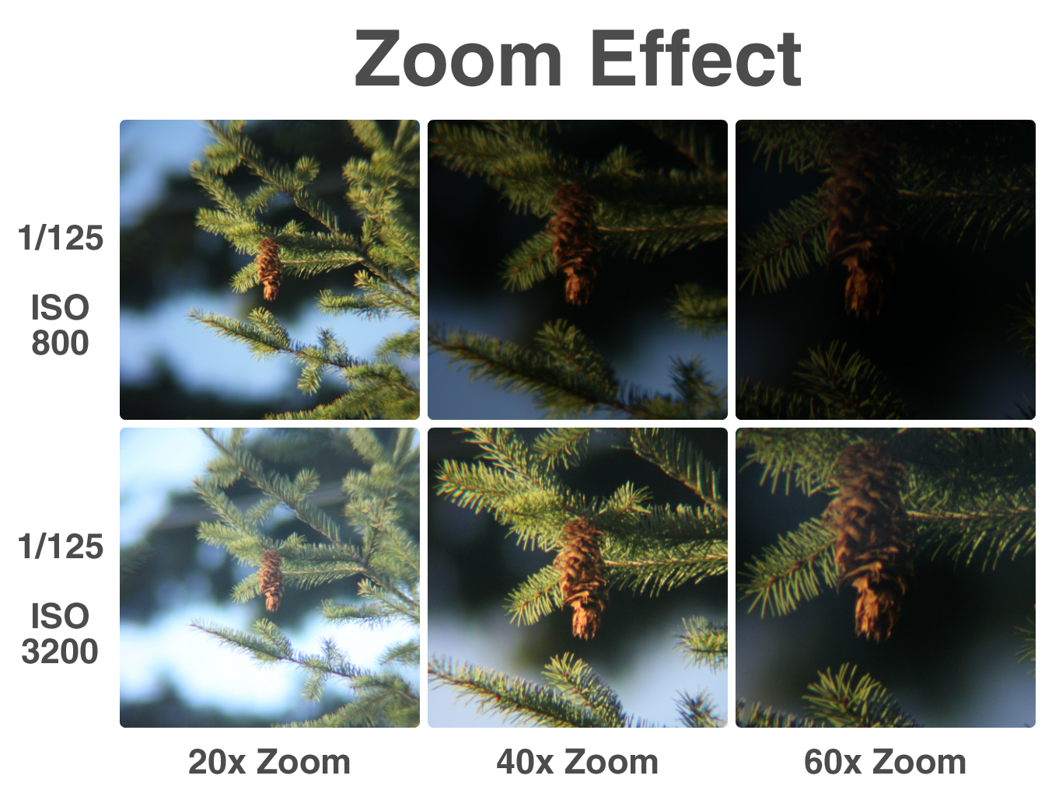

Many spotting-scopes have eyepieces that can be adjusted to add zoom. In addition to magnifying the image, changing the zoom will alter the focus and brightness of the image, as well as remove vignetting. The table above shows how zoom affects images taken at two different ISO settings, with focus corrected.

It should also be noted that too much zoom can cause visual aberrations around the edges of the image, depending on the performance of the eyepiece.

All pictures were taken at dusk, using a Canon EOS Rebel T3 mounted on a 20-60x80mm spotting scope.