**BIS 425 – Information Systems Development Project**

Assignment 1

* Pet Class OOP

Dude Date: September 7, 2017

By: Austin Adams

1. Design View
   1. PetForm

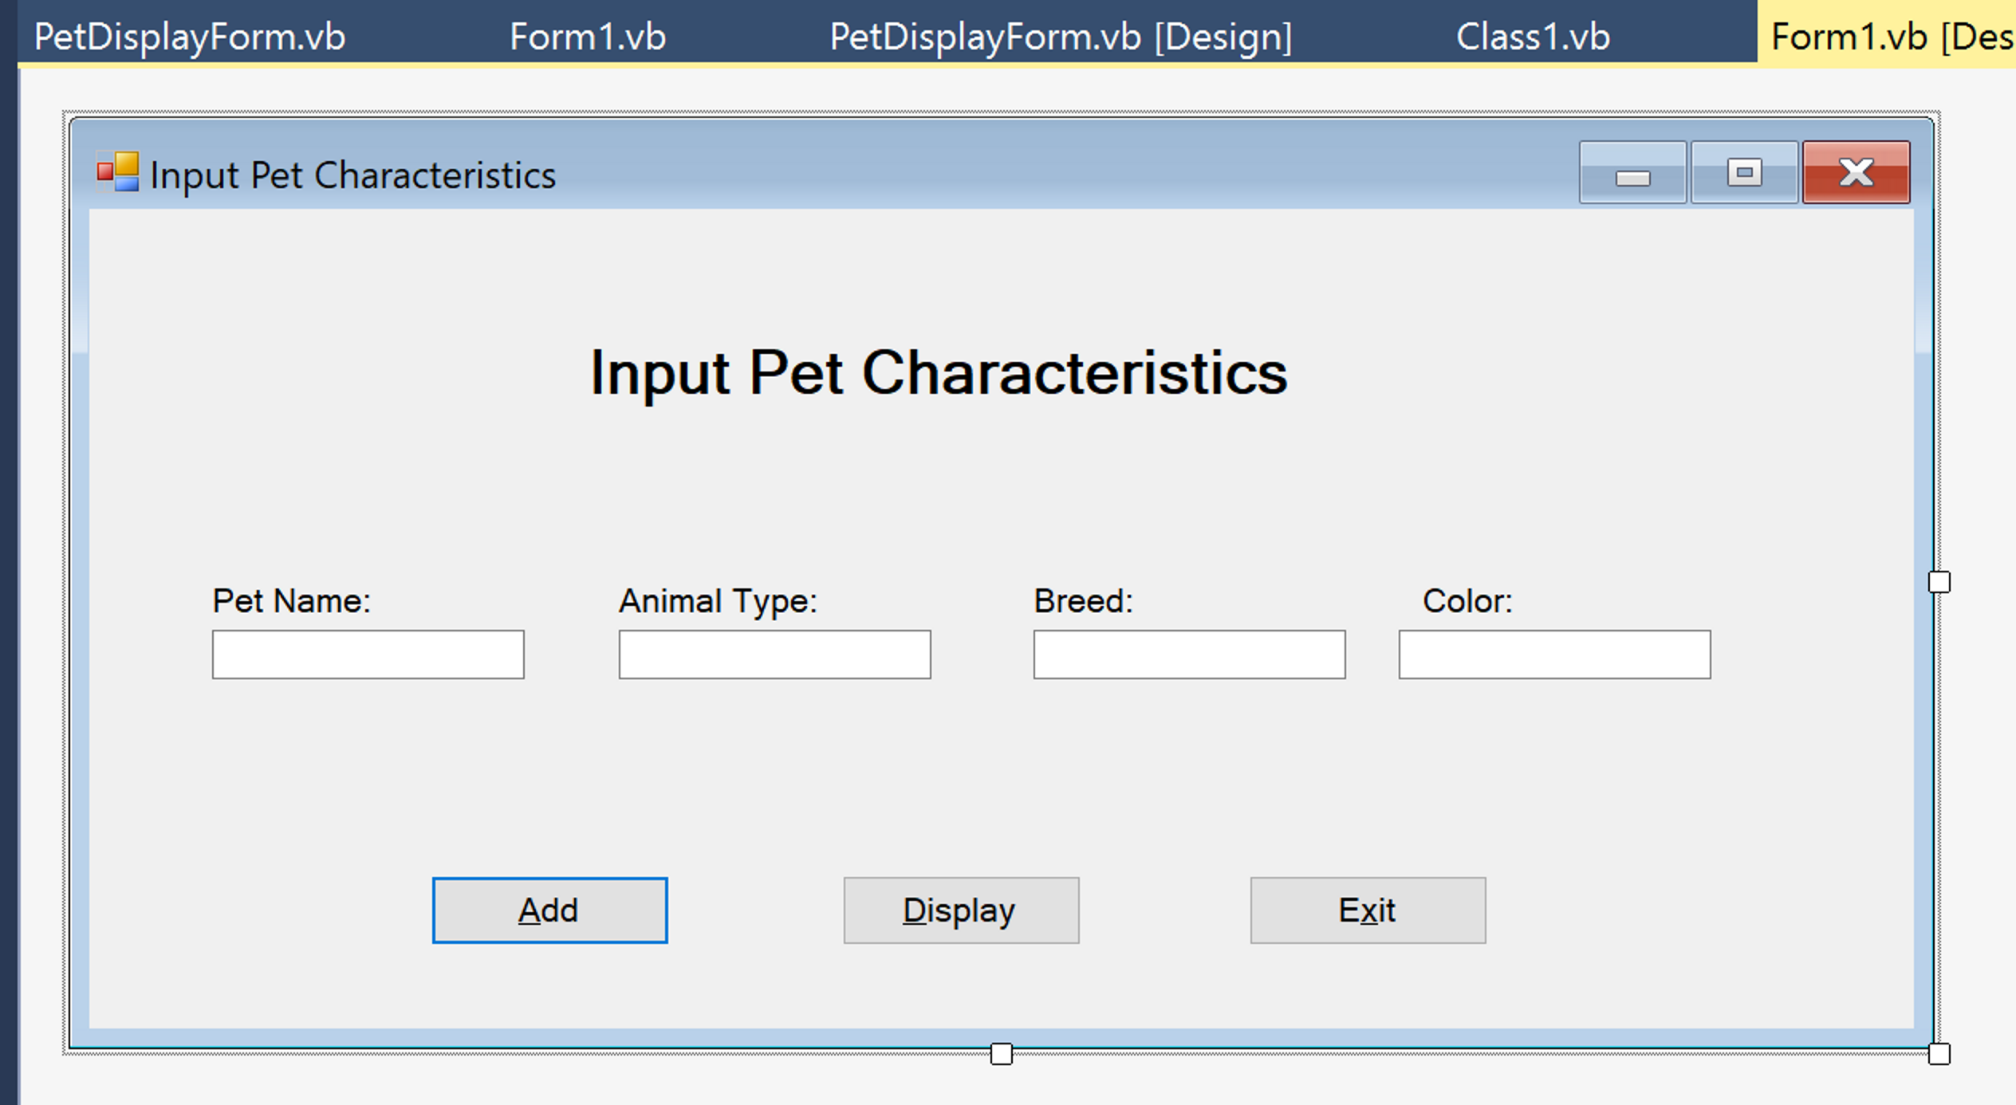

* 1. PetDisplayForm

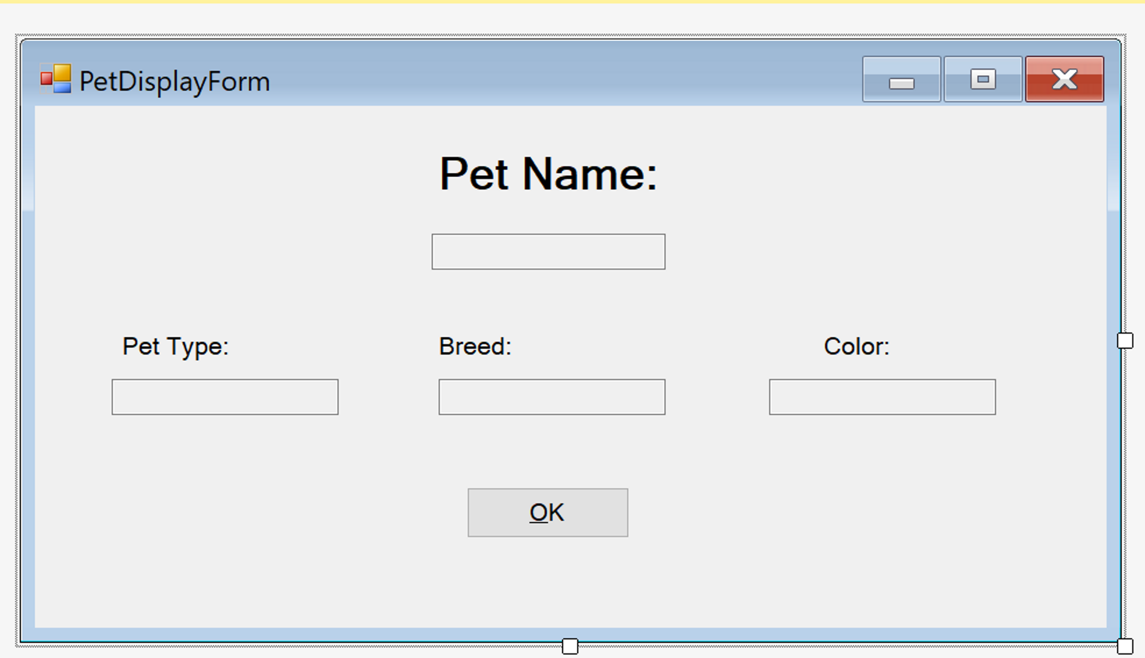

* 1. Solution Explorer

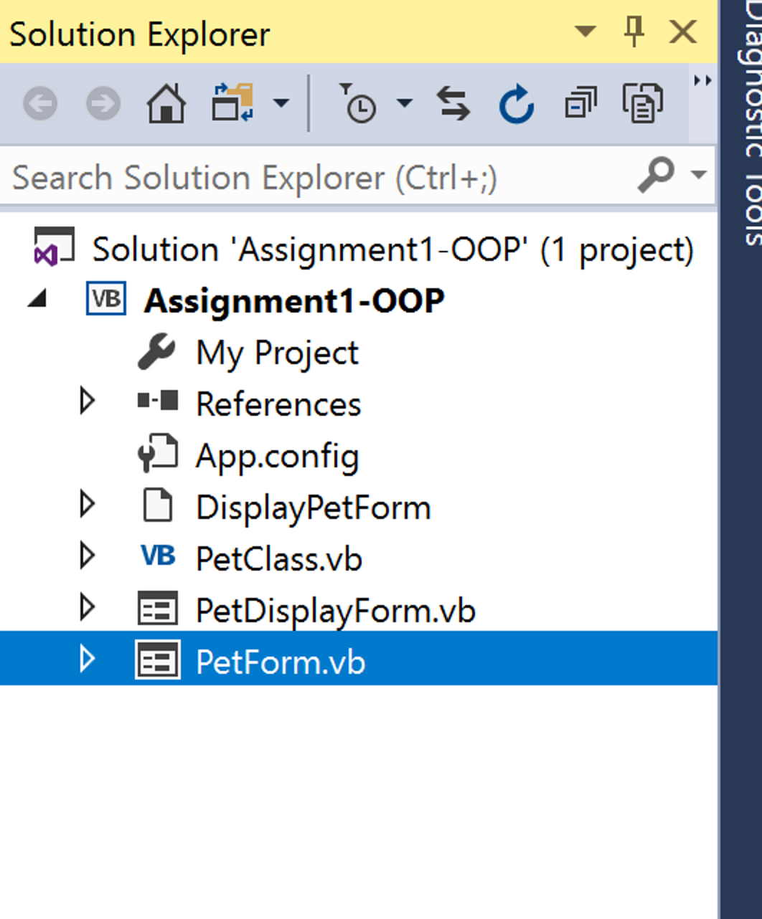

1. Execution Views
   1. Input values into PetForm

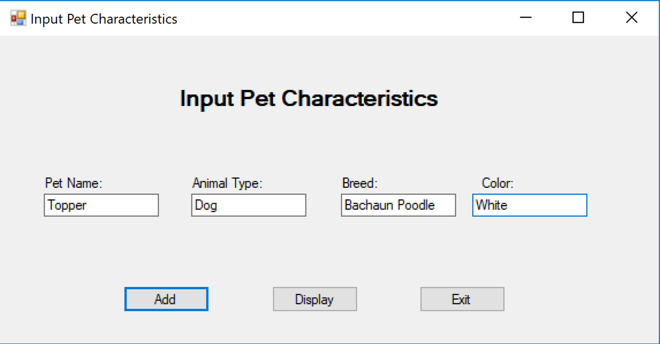

* 1. Execute “Add” button

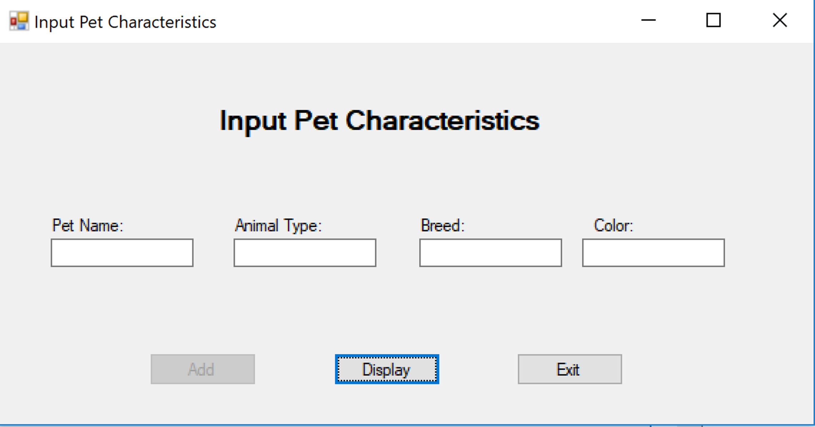

* 1. Execute “Display” button

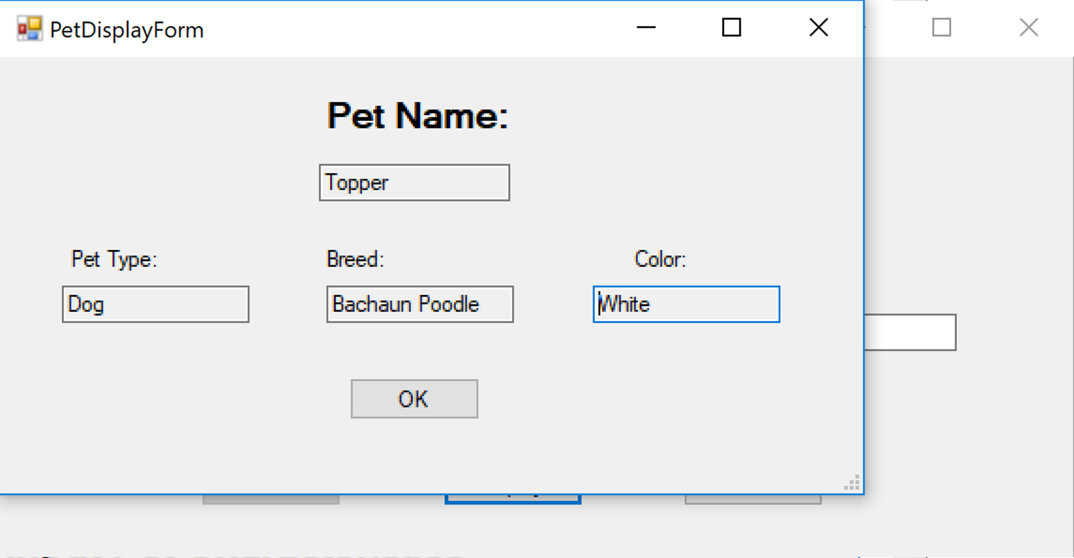

1. Codes

**Pet Class**

'Project: PetCharacteristics

'Programmer: Austin Adams

'Date: September 3, 2017

'Class: Pet Class

'Description: this class contain all the properties of your Pet. This is the class that contains all business logic. Private variables/constants are available to and used by this class only. Properties are used to communicate with other objects outside of the class.

Public Class PetsClass

Private NameString As String

Private TypeString As String

Private BreedString As String

Private ColorString As String

Sub New(ByVal NameIn As String, ByVal TypeIn As String, ByVal BreedIn As String, ByVal ColorIn As String)

'Set the property values

Name = NameIn

Type = TypeIn

Breed = BreedIn

Color = ColorIn

End Sub

Property Name() As String

Get

Return NameString

End Get

Set(ByVal Value As String)

If Value <> "" Then

NameString = Value

Else

Dim ex As New ApplicationException("Please enter a name for your pet.")

ex.Source = "Name"

Throw ex

End If

End Set

End Property

Property Type() As String

Get

Return TypeString

End Get

Set(ByVal Value As String)

If Value <> "" Then

TypeString = Value

Else

Dim ex As New ApplicationException("Please enter your pet's type.")

ex.Source = "Type"

Throw ex

End If

End Set

End Property

Property Breed() As String

Get

Return BreedString

End Get

Set(ByVal Value As String)

If Value <> "" Then

BreedString = Value

Else

Dim ex As New ApplicationException("Please enter your pet's breed.")

ex.Source = "Breed"

Throw ex

End If

End Set

End Property

Property Color() As String

Get

Return ColorString

End Get

Set(ByVal Value As String)

If Value <> "" Then

ColorString = Value

Else

Dim ex As New ApplicationException("Please enter your pet's color.")

ex.Source = "Color"

Throw ex

End If

End Set

End Property

End Class

**Pet Form**

'Project: PetCharacteristics

'Programmer: Austin Adams

'Date: September 3, 2017

'Class: Pet Class

'Description: this class contain all the properties of your Pet.

Public Class PetsForm

Private ThePet As PetsClass

ReadOnly Property completedPet() As PetsClass

Get

Return ThePet

End Get

End Property

Private Sub AddButton_Click(sender As System.Object, e As System.EventArgs) Handles AddButton.Click

'Set the properties for pet

Try

ThePet = New PetsClass(PetNameTextBox.Text, TypeTextBox.Text, BreedTextBox.Text, ColorTextBox.Text)

clear()

DisplayButton.Enabled = True

AddButton.Enabled = False

Catch ex As Exception

Select Case ex.Source

Case "Name"

ErrorProvider1.SetError(PetNameTextBox, ex.Message)

With PetNameTextBox

.SelectAll()

.Focus()

End With

End Select

End Try

End Sub

Private Sub DisplayButton_Click(sender As Object, e As EventArgs) Handles DisplayButton.Click

'Display the properties of the pet object in the display form

PetDisplayForm.ShowDialog()

AddButton.Enabled = True

DisplayButton.Enabled = False

End Sub

Private Sub ExitButton_Click(sender As Object, e As EventArgs) Handles ExitButton.Click

Me.Close()

End Sub

Sub clear()

PetNameTextBox.Clear()

TypeTextBox.Clear()

BreedTextBox.Clear()

ColorTextBox.Clear()

End Sub

End Class

**Pet Form Display**

'Project: PetCharacteristics

'Programmer: Austin Adams

'Date: September 3, 2017

'Class: Pet Class

'Description: This form will display the output from the input form.

Public Class PetDisplayForm

Private APetClass As PetsClass

Private Sub PetDisplayForm_Acvtivated(ByVal sender As Object, ByVal e As System.EventArgs) Handles Me.Activated

'Display the values from the input form

APetClass = PetsForm.completedPet

Colortextbox.text = APetClass.Color

BreedTextBox.Text = APetClass.Breed

TypeTextBox.Text = APetClass.Type

NameTextBox.Text = APetClass.Name

End Sub

Private Sub OKButton_Click(sender As Object, e As EventArgs) Handles OKButton.Click

'Close the Form

Me.Close()

End Sub

Private Sub PetDisplayForm_Load(sender As Object, e As EventArgs) Handles MyBase.Load

End Sub

End Class