
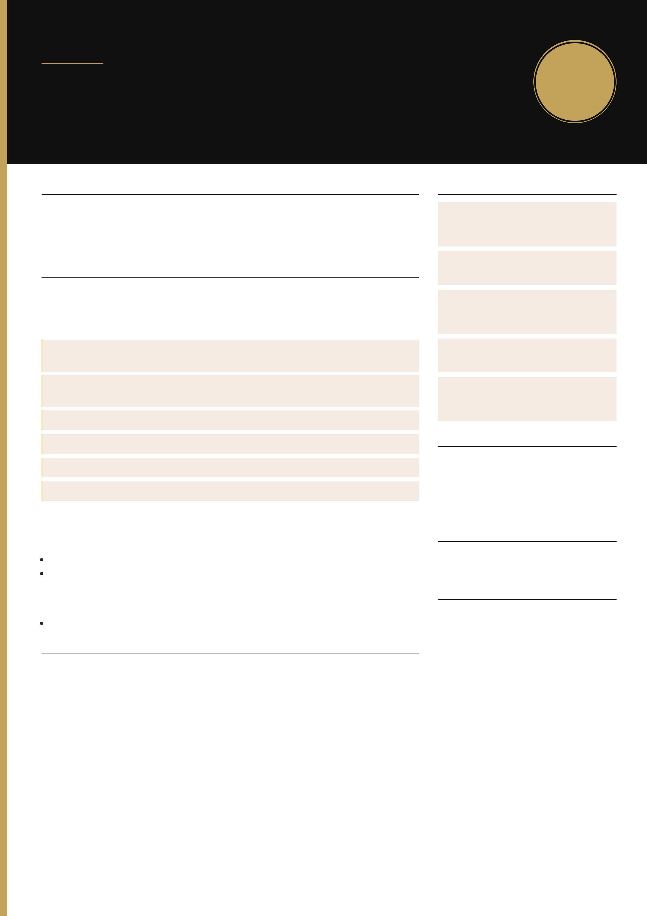
C U R R I C U L U M V I T A E
Adams Dexter Tchatchoua
Software Engineer — Full-stack
Founder of Flow · 2 years of experience
Mantes-la-Ville, France (78711) · Open to relocate · Remote / hybrid
· +33 7 49 17 83 91
·
P R O F I L E  Software engineer with a CTI-accredited French engineering degree (3iL) and founder of Flow. I design and ship web products end-to-end: websites, business apps and platforms (payments, subscriptions, e-learning, admin). 4 products in production. Stack: Next.js, React, TypeScript, Node.js.  E X P E R I E N C E |  | S K I L L S  PRODUCT  Next.js · React · TypeScript · Node.js ·Stripe · e-learning · admin back-office  DATA  PostgreSQL · SQL · Python  DELIVERY  Docker · Kubernetes · Ansible · GitHub Actions · Vercel · AWS
Software Engineer — Flow | September 2024 – Present
Mantes-la-Ville · France
Design and production delivery of websites, business apps and platforms. Single counterpart: scoping, build, deployment, maintenance.

Objectif TCFE-learning platform: subscriptions, Stripe, simulations, admin. In production.objectif-tcf.org

WAYS OF WORKING
Git · Scrum · Jira · client scoping · UAT

BAI Consulting & TrainingMulti-role B2B platform, chatbot. In production,  maintenance.bai-consultingetformation.com  Drivin & ChillBooking, Stripe, QR codes. In production, maintenance.drivinnchill.fr Finance trackerFinance and expense tracking, delivered to production.  H&S ServicesCompany website, SEO, conversion.hsservices-ci.com  PaymentsIdempotent Stripe webhooks and payment-to-access reconciliation. |  | AI  Prompt engineering · chatbot · daily AI-assisted delivery  C E R T I F I C A T I O N S  Prompt Engineering — 2025  DevOps CI/CD — Udemy, November 2024 (pipelines, infrastructure as code)  React.js & Redux — Udemy, October –December 2023 (Hooks, Router, Context)  L A N G U A G E S
Software Engineer & Business Analyst — Orange | January 2024 – July 2024
Toulouse · End-of-studies internship

Migration of Plazza to Microsoft 365 (Teams, SharePoint, Viva Engage). Community mapping, M365 recommendation engine, Zip & Go app.
Releases across integration / UAT / production. Selenium tests.

French — fluent (DELF B2)
English — professional (Linguaskill B2)

Full-stack Developer — Data Driven France | May 2023 – September 2023 | I N T E R E S T S

Clichy · Internship
Internal web modules, recruitment data integration, dashboard data quality.
E D U C A T I O N

Music (piano, guitar, drums) · Football ·Coaching / mentoring

Diplôme d’ingénieur (CTI-accredited Master’s-level) — 3iL Ingénieurs, Limoges September 2019 – April 2025
Web & mobile development, databases, security, AI, networks, project management.

