Report : Homework 1 (Distributed Systems)

Modelling and designing
Collaborative text editor is a program that enables 2 or more users to work on one document simultaneously. The plan was to make a collaborative editor with different user groups and rights to documents with included file server. Unfortunately there was not enough time for that and a bare-bones collaborative editor was delivered.
Currently ready editor enables different users to work on the same document over network. Server saves one document which will be available on the next session.

Architecture
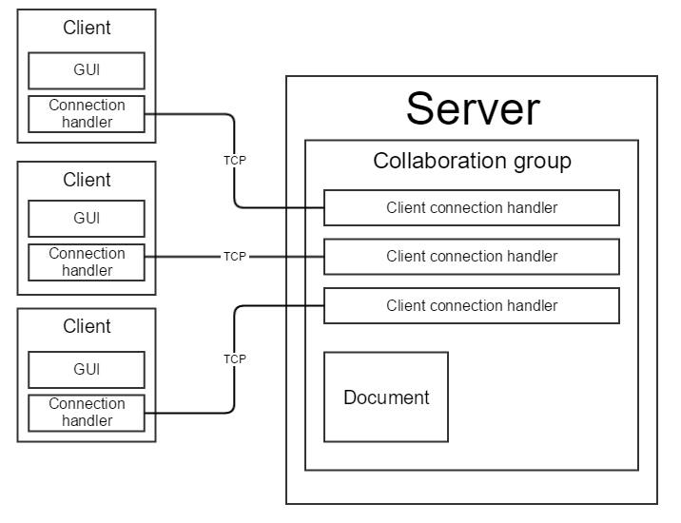
Each box represents separate thread or a couple of them working as one except for „Document“.
Conenction between clients and server is implemented using TCP sockets.
The picture shows only one possible state of the program – server may have as many clients as needed, not only 3.

Protocol
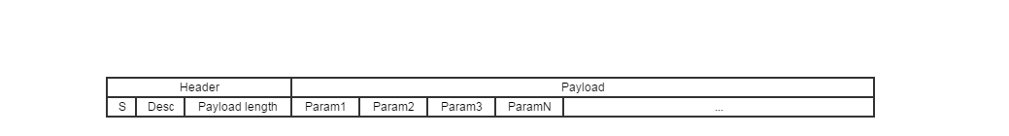
Protocol consists of packets.
Each packet has a fixed length header which starts with a distinct character so that the parser understands that next to come is a possible header. Then knowing the fixed length of the header it is parsed and checked whether it truly fits a header profile.
Header has 2 fields – packet descriptor (what type of packet is this) and the length of the payload (maximum of 999).
Now that the length of the follwing payload is known, parser can read a specific amount of characters for a full packet.
Payload consists of separate fields for needed parameters separated by a specific character. This field separator may only appear on the last parameter of the packet and not in any of the others.

Given protocol design is very flexible and expandable. Just adding new packet descriptor is adding a new packet. The payload may have any number of parameters and they are not fixed in length as long as the whole size of the payload does not exceed 999 characters. Even this number can be changed in the future if needed.
This design does not require a delimitor nor a fixed length payload which makes it less prone to parsing errors.

The communication between server and client is completely asynchronous. Only part is the initial document download request that waits for a response but which can be eliminated easily. Client and server may pass packets to each other at any time they feel the need to. Thanks to event-based processing, all of the packets get processed as soon as they arrive and required actions will be taken.

GUI
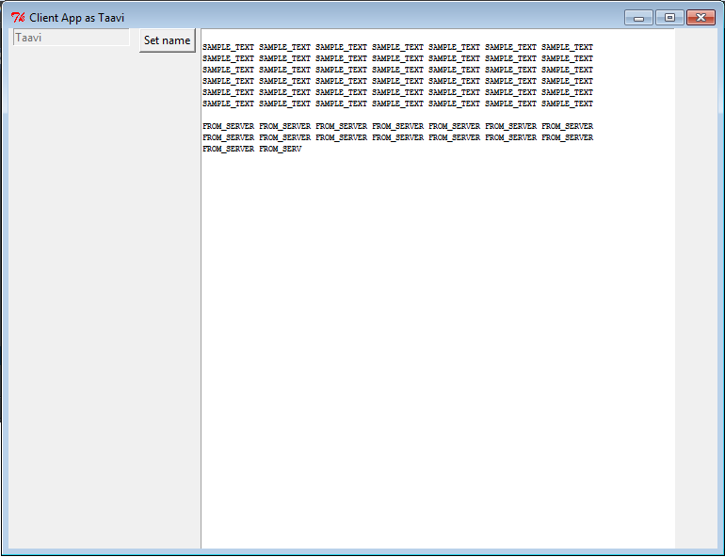
The graphical user interface is very simple in its design, it has one field for specifying the user name and a text field where to write the collaborative text. Both of the fields are disabled until client manages to connect to server. It doesn’t matter which one is started first.

The text box is disabled until user sets his or her user name which sends the introduction to the server. After the introduction, the text box is enabled and current document is downloaded from the server. At this point everything is initialized and ready to go. Document is saved automatically on the server.

If the server happens to disconnect while editing then the application goes to the not connected state where user name and text box are both disabled. As soon as the server comes back online the user can reset their name and continue editing.

Code design
Code was designed with expandability, thread safety and convenient usability in mind. Code is written using object oriented programming principles.

The most important underlying architectural concept is the actor model. Every distinct part with its own assignments is a separate actor running in its own thread. The communication and data movement between actors is done by using message queues where one actor posts a message with data parameters into another one’s queue. If there are new messages then the actor processes them by running them in its own thread. This gurantees thread safety and separation of assignments in code while enabling concurrency. Additionally each actor has a so-called ticker that runs its internal state machine if needed.

Another structural part is the use of delegates. Each separately active actor has a set of delegates which it will invoke whenever a certain event happens. This enables conveneient use of the code and makes it asynchronous. This means that there is no need for polling in the code and all the events get handled when they happen.

The main part – concurrent text editing is implemented very simply. Each time a change is made in a client editor whoke text is published to the server and sent to all of the clients. During the course of the project much smarter designs were tried but all failed due to causing some unacceptable bug. Time ran out and the simplest version was resorted to. Replacing whole text gurantees synchronization between clients although it may cause disruptions if changes from different clients happen very quickly.

Whole project can be separated into 3 main parts – client, server and common part
Client:
- GUI
Interface for user to edit the document. Consists of a simple text box where to write the text and a user name field to specify the identity of the user.
- Connection actor
Main logic that handles all the required packet processing and message passing. It also handles connection losses and reconnections. Gets its packets from the packet parser thread and processes them accordingly.
Common:
Defines modules and functions needed by both, server and client. Protocol parsing and packet definitions must both be same common knowledge. Having a one common part also makes it easier to introduce changes to protocol for example because then the changes occur in server and client code.
Server:
- Main thread
Accepts new connections and assigns them to collaboration group. Initializes and opens the collaborative document.
- Connection
A definition of a single client, not a separate thread by itself, but includes a packet parser which is run in it’s own thread. There is a connection object for each of the connected clients.
- Collaboration group
New connections are assigned to a collaboration group which manages them, accepting packets and processing them. It also holds the concurrently edited document and sends it to collaborators when required.

Testing strategies
The project code was written bearing in mind test-driven development process.
This means that all of the individual parts were tested as they were written. This enabled mostly bug-free development process where time is not unnecessarily spent of finding bugs from the code.

Testing
As stated before atomic tests were carried out on all of the parts separately as they were created. For example sending different packets and checking whether or not they reach their destination intact.
Final product was tested using real life usage.

Reflection
What was hard?
The most difficult part of the project was definitely the merging of changes in the document. This is what took most of the time and did not actually reach the hoped result in the end.
What was confusing?
The requirement of how well the editor actually must work? The specifications could have been clearer and more concrete.
What was easy?
Concurrency and protocol design.
What would you do differently if you had the chance to do it again?
Maybe find a team ☺

