

**Bernoulli**

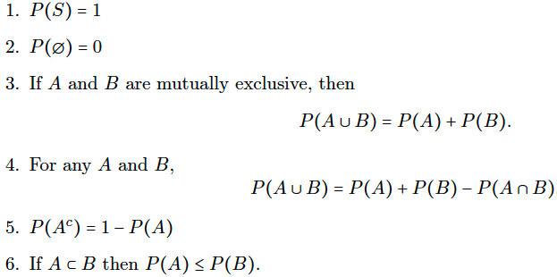

**Rule of Probability**



**Binomial: total # of successes**



**Poisson: # of events occurs in a fixed time interval or space**





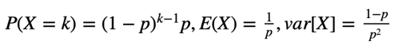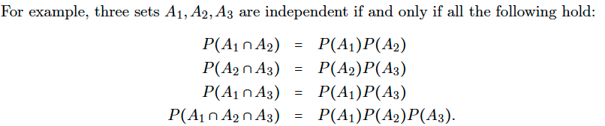

**Geometric: # of Bernoulli trails required to get a first success (memoryless)**



**Negative Binomial: # of success Bernoulli trails before r number of failures**



**Permutation: Given AABCCC, total # of permutations**

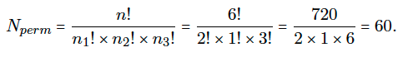

**Uniform**

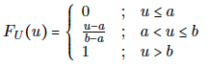

**CDF**

**Exponential (memoryless)**

**CDF Approach (Y =)**

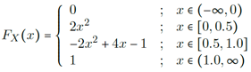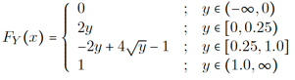

g(x) = $x^{2}$



**Normal**

**Y = g(X)**



**Covariance**

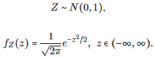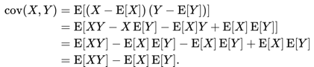

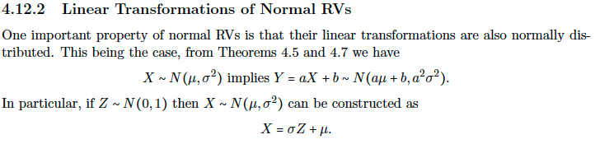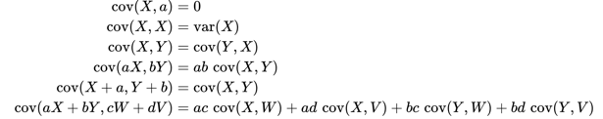

**Sum and Average of RV**



**Z-score**

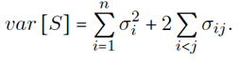



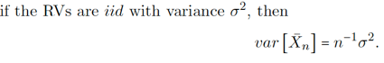



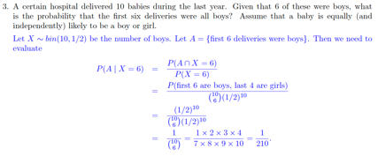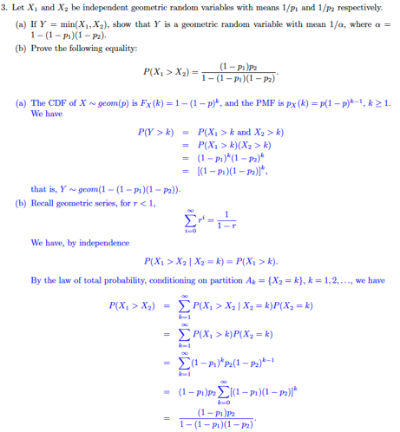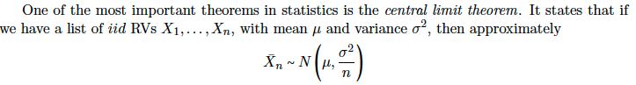

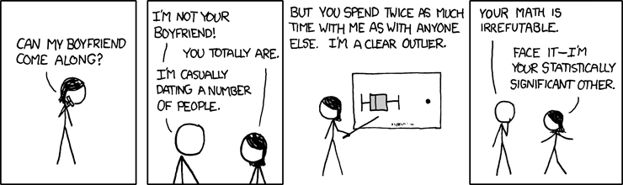

**Central Limit Theorem**