Solutions and Strategies for My Beauty VIP Medical Spa

Name and ID
Course Number and Name
Instructor’s Name
Section
University Canada West
Date

Solutions and Strategies for My Beauty VIP Medical Spa

Introduction
The beauty and wellness industry in Victoria, Canada, is rapidly evolving as the use of advanced technology is helping competitors shape consumer expectations and their success. The use of advanced disruptive technology is an opportunity for My Beauty Secrets VIP Medical Spa to position itself as a leader in the Victoria market through the introduction of an AI-powered skin and body analysis system. Integration of AI-driven diagnostics by My Beauty Secrets VIP Medical Spa will help the small business attract new customers, retain existing ones and establish itself as a disruptive force in the beauty and wellness industry in Canada.

Innovative Offering for My Beauty Secrets VIP Medical Spa
Introducing the AI-powered skin and body analysis system such as the A6 professional skin analyzer shown in Figure 1 below, will help Fahima’s small business have precision and personalized service. This solution is unmatched by conventional facial treatments such as laser facial solutions used by competitors such as Sunrise Day Spa (Sunrise Day/Laser Spa, 2025). The analysis by Kings Research (2025) shows that in the global beauty and cosmetic industry, which was valued at USD 3,537.0 million in 2023, the use of AI technology will be a key determining factor to increase the market size to $14,051.5 million by 2031, translated to grow at a rate of CAGR of 19.14% from 2024 to 2031 as shown in Figure 2 below. In just under 15 seconds, Amazon (2025) shows that the use of A6 AI Intelligent 3D system will help Fahima do a comprehensive fast skin analysis for her customers to deliver a thorough assessment on issues relating to pores, acne, and wrinkles. Introducing disruptive technology in this case the A6-AI Intelligent system is a key market differentiator by creating the need quickly position the company as a market leader in Victoria (Mookerjee & Rao, 2021). Therefore, with this advanced technology, Fahima will be able to provide the customers with more personalized treatment plans, enhance customer satisfaction and foster long term customer relationship. As the business also relies on this advanced technology, the use of data analytics and tracking skin care progress will help Fahima to make continuous adjustments and improve on the effectiveness for the skin treatment (Ricci et al., 2022).
Figure 1: A6 AI Intelligent 3D Skin Analyzer
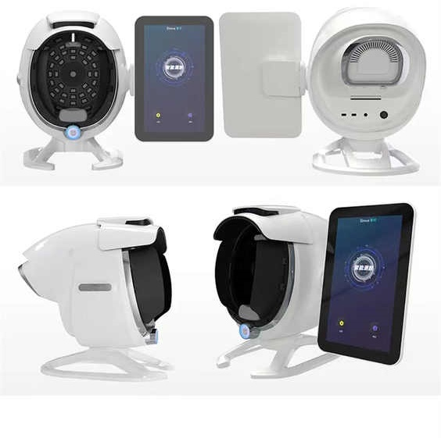
(Alibaba, 2025).
Figure 2: AI technology in the global beauty and cosmetic industry
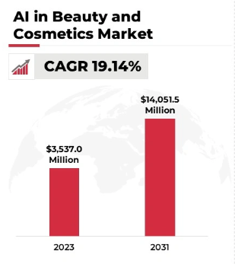
(Kings Research, 2025)
The use of AI technology as shown in Figure 2 below by My Beauty Secrets, will help Fahima offer her clients a real-time skin assessment, mapping concerns such as fine lines, acne, pigmentation, and elasticity levels to unparalleled accuracy. The analysis by Ricci et al (2022), show that by the business using this AI technology, Fahima will be able to recommend to her clients customized treatment plans that are all tailored to address their unique needs and thus establish trust and satisfaction.
Figure 3: A6 AI Intelligent 3D Skin Analyzer in use with microscopic detector
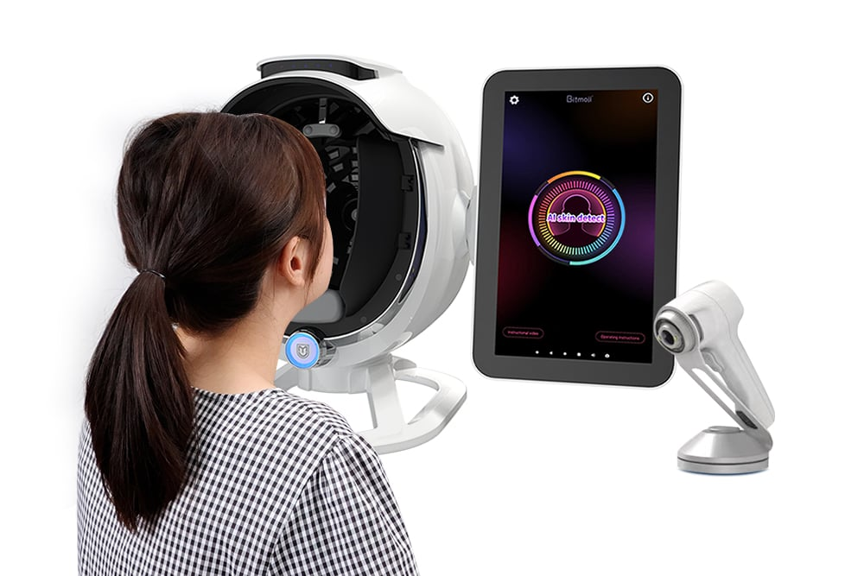
(Alibaba, 2025).

Implementation Timeline
Table 1 and Figure 4 below show the Gantt chart, which details the three stages used as the implementation timeline for My Beauty Secrets, introducing the AI-powered skin and body analysis system as a key market disruptor in Victoria's beauty industry.
Table 1: Implementation Timeline for My Beauty Spa Implementing the AI technology system
Stage | Duration | Key Activities
Start | 13 March 2025 to 23 July 2025 | Fahima will do market research for AI software selection, train the necessary staff needed to operate this system and conduct the initial marketing campaign for her existing customers through email marketing.
Complete | 2 August 2025 to 31 December 2025 | Complete system integration to the beauty shop, where Fahima will conduct the initial beta testing and offer client trials
Maintain | Ongoing | The system will require regular AI updates. Fahima will address the customer feedback for system improvement and rely on a long-term marketing strategy to attract new customers. Additional costs by the Fahima will be on installing new updates for the AI Intelligent 3D skin analyzer or getting a better technology that competitors are not using thus remaining competitive in the market.

Figure 4: Gantt Chart for implementing the proposed solution

Budget for AI Implementation
Table 2 below shows the budget expected for Fahima to be spent for implementing the proposed AI-powered skin and body analysis system in the beauty spa.
Table 2: Budget allocation by My Beauty Spa implementing the AI solution
Cost Component | Estimated Cost (USD)
A6 AI Intelligent 3D skin analyzer | $2,000 (free shipping) (Alibaba, 2025).
Staff Training (1 staff) plus recruitment. The new staff will learn the three steps for doing 3D skill analysis and getting personalized skin analysis. | $5,000
Salaries (Recurrent expenditure) | $1,500
Marketing and Branding (BDC, 2025). | $2,000
Total Investment | $4,500

Financial Goals and Forecast
Table 3 below shows the financial projection for Fahima’s beauty spa using the A6 AI intelligent 3D skin analyzer to offer cutting-edge personalized facial solutions in Victoria. The goal for Fahima is not just to increase the revenue for the business based on the online meeting but to increase the flow of customers into the VIP spa (My Beauty Secrets, 2025). Industry benchmark shows that OneWelbeck Clinic is among the companies that is using this technology where a full appointment costs £595 ($750) for first time clients in a 45 minutes session and £495 ($625) for returning clients which is a fixed price package as shown in Figure 5 below (OneWelbeck, 2025). Having this technology introduced for My Beauty Secrets and setting the pricing according to these industry standards will generate revenue needed to support operations. This means that introducing the A6 AI intelligent 3D skin analyzer will not only differentiate the spa from competitors such as Sunrise Day/Laser Spa, who rely on laser solutions but position the small business as the ideal customer destination across Victoria, offering personalized solutions.
Table 3: Financial and business forecasts
Year | Customer Acquisition Rate | Revenue Growth Rate
2025 | 10% | 15%
2026 | 20% | 20%
2027 | 50% | 25%
Note: These financial projections are purely assumption-based
Figure 5: OneWelbeck use of AI technology for mole mapping price listing
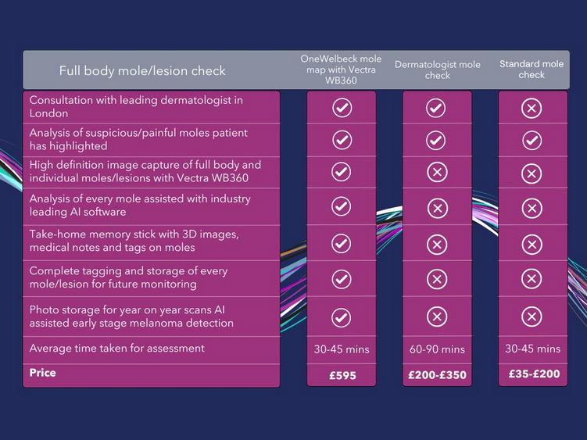
(OneWelbeck, 2025).

Conclusion
In summary, Fahima introducing the A6 AI intelligent 3D skin analyzer at My Beauty Secrets demonstrates the strategic move towards the use of disruptive technology to position the small business as a leader in the Victoria beauty industry. The innovative technology helps to grow the business by Fahima addressing the growing consumer demand the need for personalized care, and address the competitive challenges. Through the more accurate skin solution diagnostic benefit by the A6 AI Intelligent 3D system, personalized treatment plans, and data-backed process, My Beauty Secrets will attract new customers and retain existing ones, thus strengthening brand loyalty.

References
Alibaba. (2025). Free Shipping Cost A6 Ai Intelligent 3D Skin Analyzer Machine Professional Skin Analysis 36 million HD Pixels. Alibaba. https://www.alibaba.com/product-detail/Free-Shipping-Cost-A6-Ai-Intelligent_1601173996169.html
Amazon. (2025). A6 AI Professional Skin Analyzer - High-Resolution Facial Detection Machine with 8-Spectrum Imaging for Precise Skin Assessment. Amazon. https://www.amazon.com/Professional-Skin-Analyzer-High-Resolution-8-Spectrum/dp/B0DH3MBKNX#:~:text=Comprehensive%20%26%20Fast%20Skin%20Analysis%3A%20In,UV%20light%2C%20etc.
BDC. (2025). What is the average marketing budget for a small business? https://www.bdc.ca/en/articles-tools/marketing-sales-export/marketing/what-average-marketing-budget-for-small-business
Mookerjee, J., & Rao, O. (2021). A review of the impact of disruptive innovations on markets and business performance of players. International Journal of Grid and Distributed Computing, 14(1), 605-630. https://www.researchgate.net/profile/O-R-S-Rao-2/publication/352135134_A_Review_of_the_Impact_of_Disruptive_Innovations_on_Markets_and_Business_Performance_of_Players/links/60ba74bb92851cb13d7981b5/A-Review-of-the-Impact-of-Disruptive-Innovations-on-Markets-and-Business-Performance-of-Players.pdf
My Beauty Secrets (2025). My Beauty Secrets VIP Medical Spa. My Beauty Secrets https://mybeautysecretsvictoria.ca
OneWelbeck. (2025). Mole mapping. https://onewelbeck.com/tests-diagnostics/mole-mapping/#overview
Ricci, L., Villegente, J., Loyal, D., Ayav, C., Kivits, J., & Rat, A. C. (2022). Tailored patient therapeutic educational interventions: A patient‐centred communication model. Health Expectations, 25(1), 276-289. https://pmc.ncbi.nlm.nih.gov/articles/PMC8849242/pdf/HEX-25-276.pdf
Sunrise Day/Laser Spa. (2025). SHINE FROM Head to Toe. Sunrise Day/Laser Spa https://www.sunrisedayspa.ca

