Cross-Domain Portfolio Optimization on Polymarket
Adam Thomson, Allen Xia, Xinkai Yu
STAT 4830 Final Project
April 2026
Second Draft

Abstract
This paper studies whether a differentiable portfolio optimizer can outperform a simple equal-weight allocation across Polymarket prediction contracts. Prediction markets are attractive for optimization because prices encode real-time event probabilities, but they are difficult because payoffs are binary, returns are non-Gaussian, and apparently distinct contracts often share a small number of latent event drivers. We construct a reproducible pipeline that pulls active Polymarket events, filters to binary Yes/No markets, maps contracts to event domains, builds token-level price histories, and evaluates online portfolio strategies on held-out bars.
We benchmark the original fee-aware equal-domain YES-token baseline against constrained mean-downside optimization, macro and stock-market overlays, and an expected-log-wealth Kelly model with a dynamic Gaussian copula. Our main finding is that equal weight is a surprisingly strong null: most mean-variance variants raise volatility or drawdown without improving risk-adjusted return. The most promising direction is the Kelly/copula family, which improves net gain in selected holdout windows but remains sensitive to turnover fees and single-seed instability. Recent fee-aware experiments show that a Week 17 optimized PM sleeve can generate extreme short-window gains relative to baseline, but attribution and data checks indicate that these gains are resolution-driven and not yet evidence of a deployable stock/PM trading edge. The project therefore supports a cautious conclusion: log-wealth objectives and dynamic dependence modeling are directionally useful, but robust deployment requires fee-aware training, multi-seed validation, richer equity data, and stronger controls for resolution-driven outliers.

1 Introduction
Prediction markets convert beliefs about future events into tradeable prices. A Polymarket YES contract priced at \(p\) behaves like a probability-weighted binary asset: it pays one dollar if the event resolves true and zero otherwise. This creates a natural portfolio problem. At each time step, an investor can allocate wealth across many contracts, observe price changes, and rebalance. The central question in our project is whether an optimizer can do better than the simplest possible benchmark: split capital evenly across a balanced set of active markets.
The question is not trivial. Traditional stock portfolios benefit from smooth returns, many independent sectors, and decades of historical data. Prediction-market portfolios instead face event clustering: a single political poll, AI product announcement, sports injury, or crypto shock may move many contracts together. A portfolio can look diversified by count while being concentrated in one latent driver. This motivates our original goal: build a cross-domain optimizer that caps exposure to individual event domains and improves risk-adjusted return relative to equal weight.
Over the semester, the project evolved from a constrained mean-variance optimizer into a broader investigation of why equal weight is hard to beat. We tried domain caps, covariance penalties, macro and ETF features, stock-market regime overlays, momentum pre-screening, learnable market selection, and finally a Kelly criterion objective with a dynamic Gaussian copula. The final draft below follows the reference report structure: data, methods, experiments, results, and limitations.

2 Data and Preprocessing

2.1 Polymarket Market and Price Data
The data pipeline begins with Polymarket event metadata from the Gamma API and token-level historical prices from the CLOB price history endpoint. Each event is flattened into individual markets, and the pipeline keeps binary Yes/No contracts with valid YES token identifiers. We filter administrative or rewards-related slugs, rank candidate domains by liquidity, require sufficient price history, and use a round-robin selection procedure to avoid letting one topic dominate the universe.
The mature Week 17 experiments use a 40-market universe with 40 event domains and a 20% holdout split. The Week 17 diagnostics record 48,474 tuning steps and 12,119 holdout steps, with 24 days of minimum history after backoff. This 40-market scale is a compromise: it is small enough for repeated online optimization, but broad enough to test domain concentration and diversification.

2.2 Domain Labels and Balanced Sampling
Each market is tagged to a domain such as `crypto-prices`, `formula1`, `best-of-2025`, congressional races, AI releases, or sports leagues. The domain labels are noisy but useful because they approximate the latent event clusters that a pure token-level optimizer might miss. Equal weight is implemented as equal total allocation per domain, split across the markets inside that domain. This makes the baseline stronger than naive per-token weighting when the number of markets per category is uneven.

2.3 Macro, Equity, and Fee Data
Several experiments attach outside data to the Polymarket book. The macro layer uses listed equity and volatility proxies such as SPY, VIX, XLE, XLV, XLF, QQQ, XLK, and defensive stocks to infer risk-on or risk-off conditions. The topic-aligned layer maps Polymarket domains to equity proxies, although the Week 17 run ultimately mapped all topics to SPY for stability. We also added a fee-aware accounting layer. A transaction fee rate \(f\) is charged per unit of L1 turnover:
\[
\text{cost}_t = f \lVert w_t - w_{t-1}\rVert_1.
\]
In the latest runs we use \(f = 0.001\), or 10 basis points per unit L1 turnover.

2.4 Data Limitations
The main limitations are data availability, non-stationarity, and resolution effects. Prediction-market prices can jump sharply near settlement, causing short-window returns that are mechanically large. In addition, the live stock/oil refresh failed for the Week 17 timestamp range; the available SPY/USO hedge series had no non-zero stock leg in the selected 7-day window. Therefore, the stock/PM comparison should be interpreted as an optimized Polymarket sleeve with stock-sleeve logic present but inactive, not as proof that a stock overlay generated alpha.

3 Methods

3.1 Fee-Aware Equal-Weight Baseline
The baseline is deliberately simple. For each available time step, it assigns equal total capital to each domain and equal market weights within each domain. In the main experiments this benchmark uses the original YES-token side of each Polymarket binary market, because the processed pipeline stores YES token identifiers and all optimizer comparisons are built on the same YES-token price histories. If some markets are unavailable at a step, weights are renormalized over the available set. The realized portfolio return is
\[
R_t = w_t^\top r_t.
\]
To make the benchmark realistic, we now compute both gross and net returns, where net return subtracts transaction costs from dynamic-universe rebalancing:
\[
R_t^{\text{net}} = R_t^{\text{gross}} - f\lVert w_t - w_{t-1}\rVert_1.
\]

3.2 Constrained Mean-Downside Online Optimization
Our first optimizer is an online projected-gradient portfolio strategy. It maintains weights on the probability simplex, updates using rolling windows, and evaluates out of sample by continuing to adapt during holdout. The objective rewards mean return while penalizing variance, downside semivariance, domain overexposure, covariance concentration, and per-asset concentration. In simplified form:
\[
J(w) =
\mathbb{E}[R]
- \alpha \operatorname{Var}(R)
- \beta \mathbb{E}[\max(-R,0)^2]
- \lambda_d \sum_d \max(0,S_d(w)-L_d)^2
- \lambda_c \sum_i \max(0,w_i-w_{\max})^2
- \lambda_\Sigma w^\top \Sigma w.
\]
Weights are kept on the simplex by projection rather than softmax in later runs, allowing exact zero weights while enforcing nonnegative full investment. Hyperparameters are selected by Optuna QMC/Sobol search and evaluated on a walk-forward holdout.

3.3 Stock/Prediction-Market Combined Strategy
The combined stock/PM strategy has two roles for listed equities. First, equity and volatility indicators adjust concentration rules, so risk-off conditions tighten domain exposure. Second, an optional stock/oil hedge sleeve can blend lagged SPY and oil proxy returns with the Polymarket sleeve.
We recently added fee-aware sleeve accounting. When the PM-vs-stock allocation \(\alpha_t\) changes, the strategy pays \(f \cdot 2|\alpha_t - \alpha_{t-1}|\) because the two sleeve weights are \([1-\alpha_t, \alpha_t]\):
\[
R_t^{\text{combined, net}}
= (1-\alpha_t)R_t^{\text{PM, net}}
+ \alpha_t R_t^{\text{hedge}}
- f \cdot 2|\alpha_t-\alpha_{t-1}|.
\]

3.4 Kelly Objective and Dynamic Gaussian Copula
The most important methodological pivot is the Kelly model. Instead of optimizing a mean-variance surrogate, Kelly maximizes expected log wealth. For binary settlement outcomes \(y\), price \(p\), and portfolio weights \(w\), the objective is
\[
J_{\text{Kelly}}(w)
= \mathbb{E}_y[\log(1+w^\top \pi(y))],
\]
where \(\pi_i(y_i)\) is the per-share binary payoff relative to price. This is better aligned with compounded wealth than Sortino or Sharpe.
Dependence between binary markets is modeled using a dynamic Gaussian copula. A small MLP reads macro features such as SPY, QQQ, and BTC returns and emits a time-varying correlation matrix. Bernoulli outcomes are sampled through a straight-through estimator so that gradients can flow through the binary payoff simulation. The model jointly updates portfolio weights and copula parameters with Adam-OGD and projects weights back onto the simplex.

3.5 Evaluation Metrics
We report cumulative gain, log wealth, Sortino ratio, maximum drawdown, turnover, and transaction cost. Gain and log wealth measure growth; Sortino measures mean return per unit downside volatility; maximum drawdown measures worst peak-to-trough loss; turnover measures how much the strategy trades and therefore how fragile it is to fees. Because Polymarket frictions can be meaningful, net-of-fees comparisons are more important than gross comparisons.

4 Experiments and Results

4.1 Baseline vs Constrained Mean-Downside Optimizer
The Week 17 constrained optimizer did not beat the equal-weight baseline on risk-adjusted terms. On the aligned holdout segment, baseline Sortino was 0.1798 and constrained Sortino was 0.1538. The constrained optimizer achieved a higher mean step return, 0.000282 versus 0.000188, but it did so with higher volatility and deeper drawdown. This is a mean-risk trade rather than a clean improvement.
Metric | Fee-Aware / Equal-Weight Baseline | Constrained / Optimized | Interpretation
Week 17 holdout Sortino | 0.1798 | 0.1538 | Optimizer lags baseline
Week 17 holdout max drawdown | -5.45% | -9.40% | Optimizer has deeper losses
Week 17 holdout mean return | 0.0001879 | 0.0002824 | Optimizer earns more mean return
Week 17 top contributor share | n/a | 98.2% | One resolution-driven market dominates
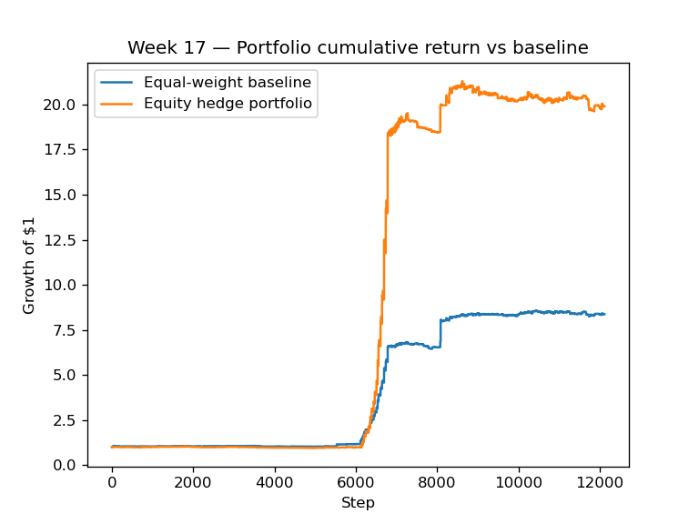
**Figure 1:** Week 17 equity curve comparison for the constrained stock/PM experiment.

4.2 Stock/PM Combined Strategy With Fee Awareness
The latest stock/PM comparison was rerun over the past 7 calendar days available in the Week 17 data, from `2026-04-10T06:21:59+00:00` to `2026-04-17T06:21:59+00:00`. The fee-aware baseline charges 10 bps per unit L1 turnover. The optimized PM leg also pays token-weight turnover fees, and the stock/PM sleeve now pays additional allocation-change fees.
In this window, however, the stock/oil leg had no non-zero SPY/USO data, so the optimizer selected `alpha_stock_hedge = 0.0`. The result is therefore an optimized PM net-of-fees strategy rather than an active stock hedge.
7-Day Metric | Fee-Aware Baseline | Optimized Stock/PM Net of Fees
Gain | +825.79% | +13020.43%
Max drawdown | -5.45% | -13.70%
Sortino | 0.0661 | 0.1531
PM transaction cost | included in baseline | 0.0166
Stock sleeve transaction cost | n/a | 0.0000
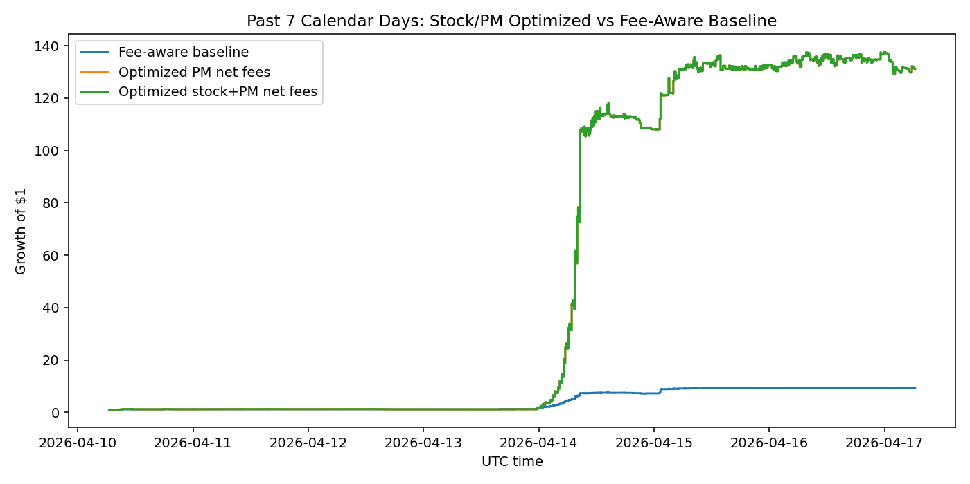
**Figure 2:** Past 7-calendar-day comparison between the fee-aware baseline, optimized PM net-of-fees sleeve, and stock/PM combined strategy. Because `alpha_stock_hedge = 0`, the optimized PM and stock/PM curves overlap.
The return magnitude in Figure 2 is too large to treat as a stable deployable edge. The Week 17 attribution report shows that resolution-driven events can dominate portfolio contribution. This plot is useful evidence that the optimizer can capture short-run PM jumps, but it also motivates stronger outlier controls and more realistic execution assumptions.

4.3 Kelly Model Experiments
The Kelly experiments are the most promising part of the project because they optimize the objective that best matches prediction-market wealth dynamics: expected log wealth. Rather than treating return variance as the main risk object, the Kelly model asks which allocation maximizes compounded growth under simulated binary outcomes. We tested this idea using `src/kelly_copula_optimizer.py`, which combines projected-simplex portfolio weights, Adam updates, and a dynamic Gaussian copula whose correlations are driven by macro features.

4.3.1 Fee-Aware Kelly Holdout Comparison
We compared five completed Kelly runs against newly generated fee-aware equal-domain YES-token baselines at the same 10 bps turnover fee. The cleanest result is `week14_M_seed7`, covering `2026-04-14T21:00:47+00:00` to `2026-04-22T10:10:04+00:00`. This is the comparison we emphasize because the return scale is plausible, both curves are net of transaction costs, and the model still shows a clear growth edge over the baseline.
The selected Kelly model parameters are stored in `data/processed/week14_M_seed7_kelly_best_metrics.json`, and the source holdout returns are stored in `data/processed/week14_M_seed7_kelly_best_timeseries.csv`. The fee-aware aligned comparison is summarized in `data/processed/kelly_feeaware_comparison_summary.json`, with plotted rows in `data/processed/kelly_feeaware_comparison_week14_M_seed7_timeseries.csv`.
Kelly Run | Kelly Net Gain | Baseline Gain | Excess Gain | Kelly Sortino | Baseline Sortino | Kelly Turnover Cost
`week14_M_seed7` | +47.01% | +20.18% | +26.82 pp | 0.0577 | 0.0218 | 0.0171
`week10_kelly_D` | +56.17% | +50.39% | +5.78 pp | 0.0308 | 0.0208 | 0.2319
`week14_MF_seed7` | +27.59% | +37.84% | -10.25 pp | 0.0385 | 0.0316 | 0.0180
`week14_M_smoke` | -1.91% | +10.01% | -11.93 pp | 0.0032 | 0.0137 | 0.0533
`week10_kelly_C` | -29.99% | +50.39% | -80.38 pp | -0.0166 | 0.0208 | 1.2243
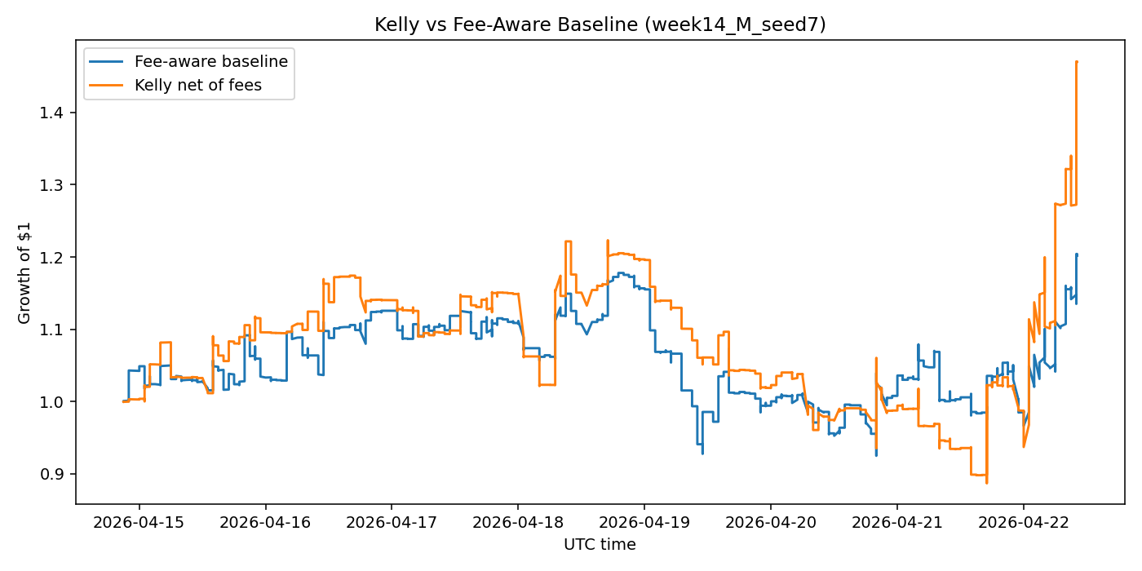
**Figure 3:** Fee-aware Dynamic-Copula Kelly versus the fee-aware equal-domain YES-token baseline for `week14_M_seed7`. Kelly compounds faster after fees, but it also takes a larger drawdown, so the improvement is growth-oriented rather than uniformly risk reducing.

4.3.2 Log-Wealth Dynamics in the Selected Kelly Run
The cumulative log-wealth plot for `week14_M_seed7` shows why the Kelly model is attractive despite the drawdown caveat. Kelly does not win every local segment, but it compounds more aggressively after favorable repricing events and preserves enough of that growth to finish above the baseline. This is more informative than a single terminal gain number because it shows when the edge appears and when the model gives back wealth.
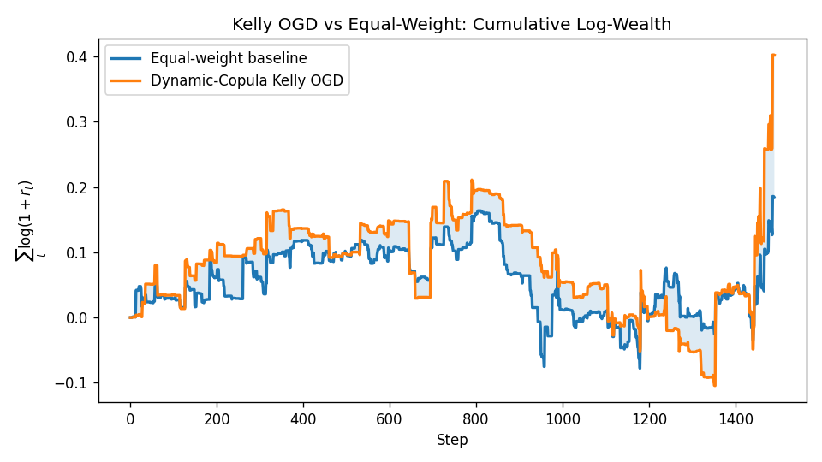
**Figure 4:** Holdout cumulative log wealth for `week14_M_seed7`. The plot supports the main Kelly finding: expected-log-wealth optimization can produce a durable growth edge in selected windows, but the path is not monotone and should be evaluated alongside drawdown.

4.3.3 Turnover and Fee Fragility Across Kelly Variants
The Kelly family is highly sensitive to turnover. The earlier K10C run had a strong gross log-wealth edge but was too fee-fragile: once a 10 bps turnover cost was deducted, high churn erased the advantage. K10D adds a stronger turnover penalty and preserves more of its gross edge net of fees. This is why the project should emphasize fee-aware training, not just fee-aware reporting.
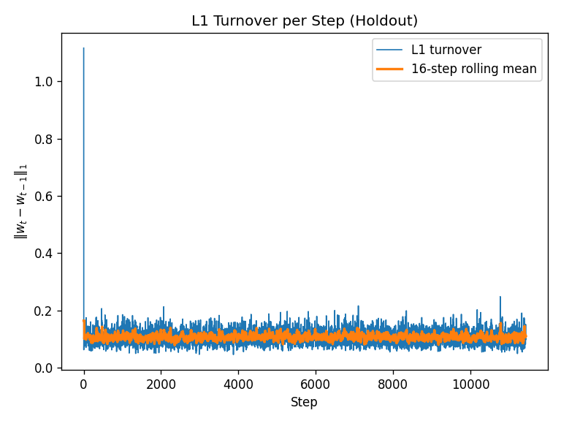
**Figure 5:** K10C turnover per step. This run demonstrates the failure mode: a Kelly optimizer can look strong before costs but lose most of the edge when trading is too frequent.
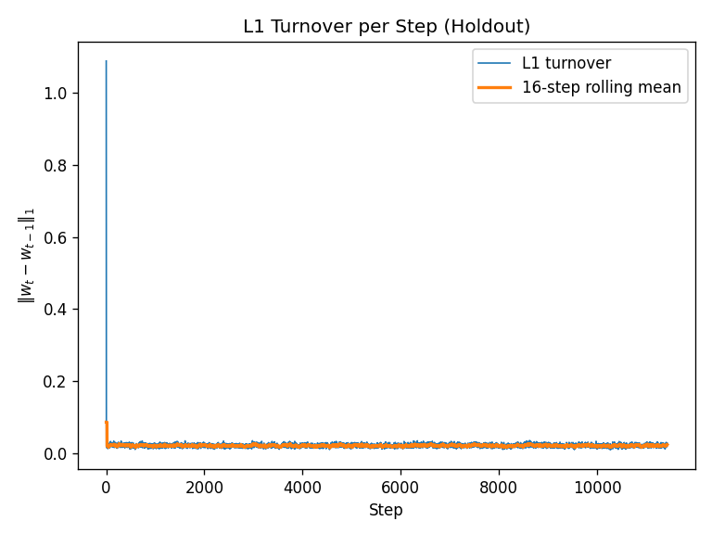
**Figure 6:** K10D turnover per step. Adding turnover control reduces churn relative to K10C and makes the Kelly result more plausible after fees.

4.3.4 Dynamic Copula Diagnostics
The dynamic copula is included because Polymarket contracts are not independent. Many markets share latent event drivers, such as election news, sports outcomes, crypto shocks, or AI announcements. The learned correlation heatmap is therefore a diagnostic tool: it tells us whether the Kelly model is detecting dependence structure rather than treating every contract as an unrelated bet.
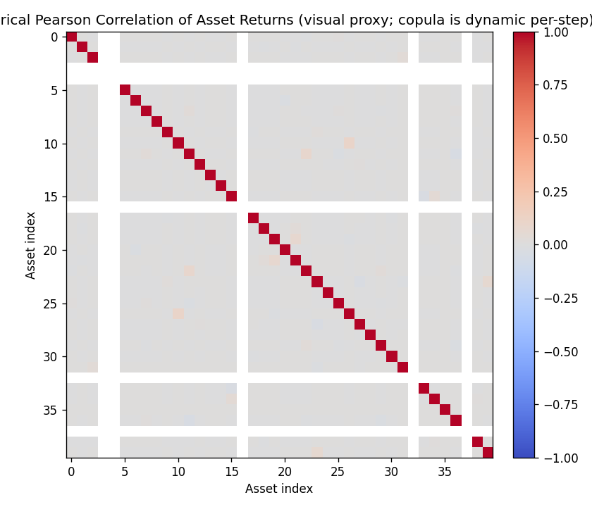
**Figure 7:** K10D copula correlation heatmap. The off-diagonal structure supports the modeling choice that binary markets should not be treated as independent assets.
Overall, the Kelly experiments suggest that expected log wealth is the right direction, but not yet a solved strategy. The best completed run beats the fee-aware baseline, the turnover-controlled variants are more believable than the high-churn variants, and the copula layer gives a principled way to model shared event risk. The remaining challenge is robustness: the result needs multi-seed, multi-window validation before it can be treated as a stable trading edge.

4.4 Why Equal Weight Is Hard to Beat
Across the experiments, equal weight remains a strong null hypothesis for three reasons. First, the selected PM universe often has a dominant latent risk factor, so many markets move together. Second, the domain-balanced baseline benefits from resolution events without paying model risk. Third, optimizers can overfit noisy short histories, especially when a single market resolution explains most of the return. The Week 17 constrained run is the clearest example: one `best-of-2025` contract accounted for roughly 98.2% of total contribution.
This diagnosis does not mean optimization is useless. Rather, it changes the target. A useful optimizer should improve compounded growth after costs, maintain tolerable drawdowns, and remain stable across seeds and market windows. The Kelly family is the closest to that target, but still requires stronger robustness checks.

5 Conclusion and Future Work
This project began with a simple optimization question: can a differentiable domain-constrained optimizer beat equal weight on Polymarket? The answer for mean-downside and MVO-style methods is mostly no. Baseline equal-domain weighting is already strong, and most constrained variants either collapse toward it or take more risk without improving Sortino or drawdown. Macro and stock-market information helped as diagnostics and regime context, but the Week 17 best trial turned off the equity-signal reward channel, suggesting that the topic-to-stock link was not strong enough in the available data.
The strongest methodological direction is Kelly optimization with dynamic dependence modeling. Expected log wealth matches the binary, multiplicative nature of prediction-market payoffs better than a variance proxy. Dynamic copulas also provide a principled way to condition correlation on macro features. However, the Kelly results are not yet decisive. They are fee-sensitive, drawdown-prone, and need multi-seed confirmation. The latest fee-aware comparisons show why: gross gains can look spectacular, but realistic turnover fees, resolution outliers, and missing stock data can change the interpretation.
Future work should focus on six concrete improvements:
- Keep the original YES-token equal-domain baseline as the primary benchmark, since the optimizer and data pipeline are built around YES-token price histories.
- Treat NO-token baselines as a robustness and symmetry diagnostic rather than as a replacement benchmark; a future extension should test paired YES/NO portfolios where executable NO prices or spreads are available.
- Train with transaction fees inside every objective, not only as a post-hoc comparison.
- Run multi-seed and multi-window validation for Kelly, K10D, and momentum-filtered Kelly variants.
- Build a more reliable stock/ETF feature store so the stock/PM combined strategy can be tested with non-zero equity legs over matching timestamps.
- Add outlier and resolution-event diagnostics so short-window gains are separated into repeatable alpha versus one-off settlement jumps.
Overall, the final lesson is methodological rather than purely performance-based. Equal weight is not a strawman in prediction markets; it is a serious benchmark. Beating it requires objectives that match binary settlement, friction-aware rebalancing, and evidence that survives more than one lucky resolution window.

References and Artifacts
- `src/baseline.py` — fee-aware equal-domain-weight baseline.
- `src/constrained_optimizer.py` — projected-simplex online mean-downside optimizer.
- `src/kelly_copula_optimizer.py` — dynamic-copula Kelly OGD implementation.
- `src/stock_oil_hedge.py` — stock/PM sleeve and transaction-fee-aware combination logic.
- `docs/final_presentation_guide.md` and `docs/final_presentation_technical_primer.md` — final narrative, formulas, and result interpretation.
- `data/processed/week17_stock_pm_7d_feeaware_summary.json` — latest stock/PM fee-aware comparison.
- `data/processed/kelly_feeaware_comparison_summary.json` — Kelly fee-aware comparison across completed runs.
- `data/processed/week14_M_seed7_kelly_best_metrics.json` and `data/processed/week14_M_seed7_kelly_best_timeseries.csv` — source model and holdout data for the second-draft Kelly finding.
- `figures/kelly_feeaware_comparison_week14_M_seed7_comparison.png` — report-ready fee-aware Kelly vs baseline plot.
- `figures/week14_M_seed7_iteration_kelly_vs_baseline_log_wealth.png` — selected Kelly run log-wealth diagnostic.
- `figures/week10_kelly_C_iteration_turnover_per_step.png`, `figures/week10_kelly_D_iteration_turnover_per_step.png`, and `figures/week10_kelly_D_iteration_copula_corr_heatmap.png` — Kelly turnover and dependence diagnostics.

Editing Notes for Team
- Replace or add any required course metadata on the title page.
- Decide whether to keep the extreme Week 17 7-day result in the main text or move it to an appendix; it is honest but needs caveats.
- If the final submission requires citations, add formal references for Kelly (1956), Markowitz (1952), Adam, Optuna/Sobol, and Gaussian copulas.
- If exporting this Markdown to Word or PDF, use a serif body font such as Times New Roman, Computer Modern, or Latin Modern Roman at 11 pt to match the sample report style.

