|  |
| --- |
| Deleum Berhad - Oil & Gas Integrated Solutions Provider |
| **Tool String Editor** |

Frequently Asked Questions

# How to use the Deleum Tool String Editor?

1. Select the desired tool from the tool library on the left.

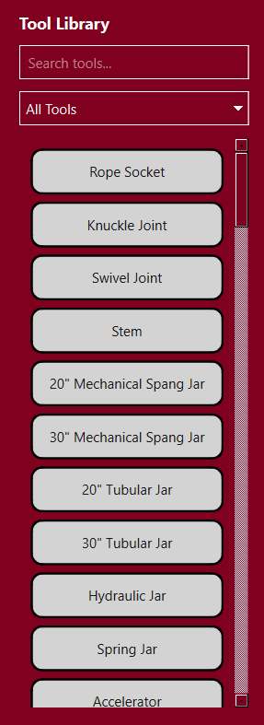

* 1. You may search for a specific tool using the search bar.
  2. Alternatively, search by category by using the filter.

1. Click and drag the tool towards the “drop zone”.

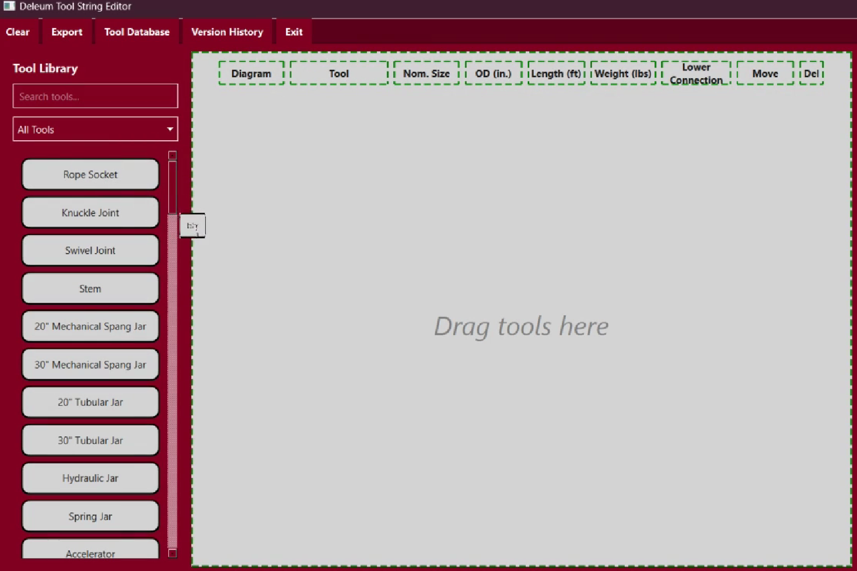

1. Select the nominal size.

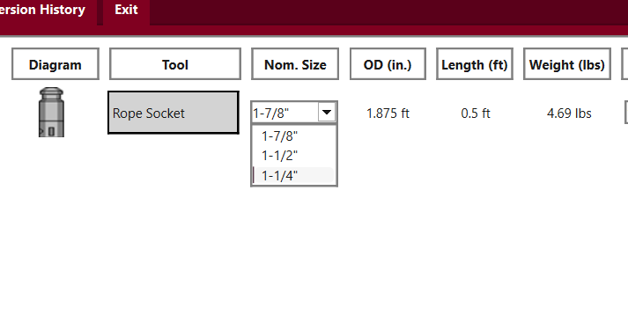

* 1. The OD, length, and weight will appear automatically.

1. Select the connection type (if more than one type of connection is available).

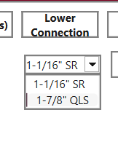

1. Add more tools to complete the tool string configuration.

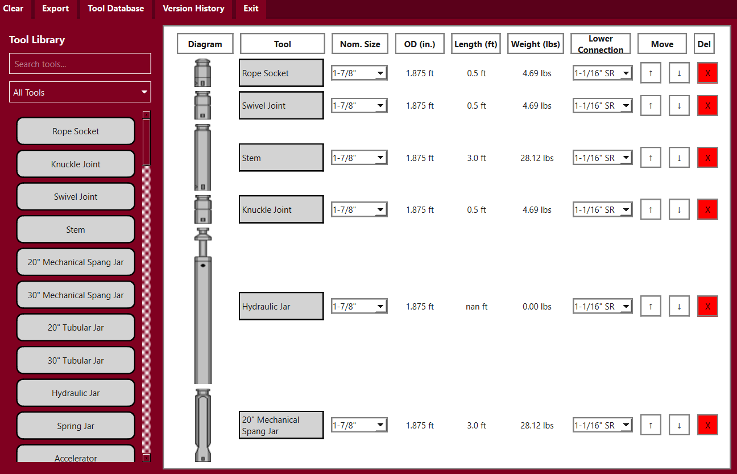

1. Rearrange tool positions/delete tools as desired.

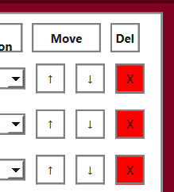

* 1. Click “Clear all” to delete all tools at once.

1. Enter the job details: Client, Location, Well No., Well Type, and Operation Details.

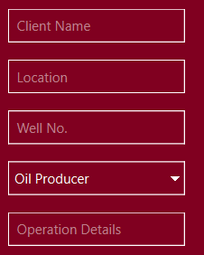 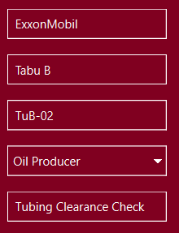

* 1. These details will appear in the generated tool string schematic diagram.
  2. These details will also be used as the filename when exporting.

1. Take note of the maximum OD, total length, and total weight.

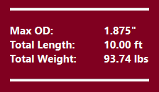

1. Export to Excel and PDF.

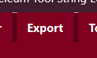

Or



* 1. View generated files in folder named after job details.

1. Save current tool configuration for future edits.

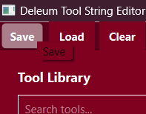

* 1. Work is saved in a “.json” format file.

1. Load from previously saved tool configurations when needed.

________________________________________________________

For any further inquiries or suggestions, send an email to Adam.MohdTaufik@deleum.com