I have three simulated time series of biomass (logistic growth models), each subject to a disturbance regime with the same mean, variance and frequency. The three time series only differ in the per capita growth rate *r* (thus, I have a slow-growing, medium-, and a fast-growing organism).

CV is lower for the fast-growing organism, because less time is spent far away from equilibrium:

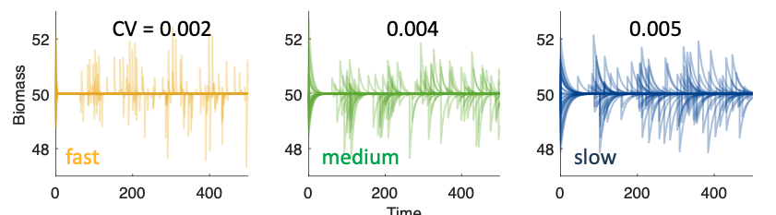

Now what I’d like to do is find a way to retrospectively correct CV for growth rate, in other words: apply some correction to the three CV’s to make them the same (later, I want to use this for correcting CV from case studies for growth rate).

To do this, I wanted to apply your Equation 6:

var(x) = (μ2 + σ2) λ/(2r)

First, I calculated the time series of x for my three cases (x(t) = N(t)-K).

Because the disturbance properties are the same in the three time series, I thought:

var(x)*r = (μ2 + σ2) λ/2 = const.

But: It’s not true.

var(x)*r is much higher for the fast growing organism.

**What am I doing wrong?**

For CV I thought it would be similar:

CVx = stdx/meanx = sqrt(varx)/meanx

(CV(x) * mean(x))2 = (μ2 + σ2) λ/(2r)

And, in the case of my three time series with the same disturbance regime:

CV(x) 2 * r = (μ2 + σ2) λ/(2 * mean(x)2) = const.

But: this does not work either of course. I assumed it’s because the mean approaches zero and thus the equation would not be defined.