Accounting for the effect of growth rate in measures of ecological stability

Ecology Letters: Ideas and Perspectives

Andrea Mentges1,2*, Shane A. Blowes1,2, Adam T. Clark1, Dorothee Hodapp4,5, Helmut Hillebrand3,4,5, Jonathan M. Chase1,2

1 German Centre for Integrative Biodiversity Research (iDiv) Halle-Jena-Leipzig, Deutscher Platz 5e, 04103 Leipzig, Germany

2 Institute of Computer Science, Martin Luther University Halle-Wittenberg, Von-Seckendorff-Platz 1, 06120 Halle (Saale), Germany

3 Institute for Chemistry and Biology of the Marine Environment (ICBM), Carl-von-Ossietzky University Oldenburg, Schleusenstraße 1, 26382 Wilhelmshaven, Germany

4 Helmholtz Institute for Functional Marine Biodiversity at the University of Oldenburg (HIFMB), Ammerländer Heerstraße 231, 26129 Oldenburg, Germany

5 Alfred Wegener Institute, Helmholtz-Centre for Polar and Marine Research (AWI), Am Handelshafen 12, 27570 Bremerhaven, Germany

8 / 10 Figures, tables, and boxes

5250 / 7500 words (main text only)

## Abstract

In light of the global changes induced by humans, the stability of ecological populations to disturbances is of interest for decision makers and conservation management. Using simulations, we illustrate how growth rate influences four stability metrics: resilience, recovery, resistance, and temporal stability. We find that resilience and temporal stability depend on the growth rate itself; recovery depends on the relation between growth rate and sampling duration; and resistance depends on the relation between growth rate and sampling interval. We present simple methods to partition the four stability metrics into realized stability, which is strongly affected by growth rate, and intrinsic stability, which is mostly influenced by other factors, such as differences in the disturbance regime or in a population’s response to that regime. We propose to consider standard measures of realized stability alongside with the new measures of intrinsic stability. This allows to better disentangle differences in ecological stability when comparing across species, ecosystems, or realms.

156/200 words

# Introduction

## Why is stability important, and why now?

Ecological stability relates to a family of metrics and concepts that describe how a population, community or ecosystem can be resistant to, or recover from, a disturbance (Box 1). Understanding the factors that influence ecological stability has been of particular interest and importance in light of global changes due to human impact (De Vries *et al.* 2012; Hautier *et al.* 2014; Čuhel *et al.* 2019; Hiddink *et al.* 2019; Li *et al.* 2020). Indeed, ecological stability concepts play a key role for policy, decision makers, and conservation management within programs such as the Intergovernmental Science-Policy Platform on Biodiversity and Ecosystem Services (Díaz *et al.* 2019), and is a crucial part of the United Nations Sustainable Development Goals (United Nations 2015).

## Comparing stability across ecosystems

The study of ecological stability is usually discussed in a comparative context, such as whether certain types of communities or ecosystems (e.g., more diverse, more spatially connected) are more stable than others (Pimm 1984; Tilman 1996; De Vries & Shade 2013; Lambert *et al.* 2014; van de Leemput *et al.* 2018). As a result, it is critical to be able to develop measures for how to compare ecological stability both within and among systems. However, most studies of ecological stability limit their scope to include only few types of species and ecosystems, such as grassland communities (Proulx *et al.* 2010; Hautier *et al.* 2014; Zhang *et al.* 2018; Isbell *et al.* 2019)), crops (Knapp & van der Heijden 2018; Smith *et al.* 2019), or soil microbes (De Vries *et al.* 2012; Holden & Treseder 2013; Čuhel *et al.* 2019). Likewise, stability is multi-dimensional and can be quantified using many different metrics (Pimm 1984; Hillebrand *et al.* 2018) (see Box 1) which can sometimes show contrasting trends (Domínguez-García *et al.* 2019). For example, the heathland shrub *Calluna vulgaris* re-sprouts vigorously after burning (i.e. high resilience), but it is highly flammable (i.e. low resistance).

Even though differences in stability among populations, communities, and ecosystems is often implicated, only a few studies have explicitly compared stability across ecosystems (Jones & Schmitz 2009; Hillebrand *et al.* 2018; Huang & Xia 2019; Hillebrand & Kunze 2020). For example, recovery appears to be generally slower in terrestrial than in aquatic systems (Jones & Schmitz 2009; Hillebrand & Kunze 2020) and in forested systems than in steppe and shrub-land (Geng *et al.* 2019). Several factors impede straightforward interpretations of differences in stability from empirical studies. First, observed stability depends on the properties of the disturbance regime. For example, stability depends on the type of disturbance (e.g., abiotic vs. biotic; (Holden & Treseder 2013), whether disturbances are pulse (i.e. single disturbance events, such as a chemical spill or a flood) or press disturbances (i.e. lasting changes to the ecosystem, such as climate change or extinction), as well as disturbance magnitude, frequency, and duration (Donohue *et al.* 2016; Radchuk *et al.* 2019). Second, the scale of sampling influences observed stability for example via the chosen spatial grain (Wang *et al.* 2017), sampling duration (Bengtsson *et al.* 1997), and taxonomic resolution (Clark *et al.* 2020). Third, an ecosystems’ stability crucially depends on the community growth rate (Bodmer *et al.* 1997). Here, we focus primarily on this latter issue, as it is critical for understanding how to compare/contrast estimates of stability within and across ecosystem types in the context of synthesis.

Species can differ in growth rates by several orders of magnitude, and this will strongly influence the rates at which they can recover from disturbances. For example, the relative growth rate of tropical forest trees is about 0.003 d-1 (Inman-Narahari *et al.* 2014), whereas microbe communities can reach growth rates of more than 5 d-1 (Lankiewicz *et al.* 2016). Even within a species, the realized growth rate of individuals can differ considerably due to demographic plasticity (Taylor *et al.* 2019) and environmental context (e.g. community growth rate of ﻿microbes can increase up to 700% due to nutrient addition, in comparison to controls; (Degerman *et al.* 2012)). It is undisputed that this variation in population growth rates affects the derived stability measures. Fast-growing, short-lived species typically show higher recovery (Lambert *et al.* 2014; Hillebrand *et al.* 2018) and resilience (Lobón-Cerviá 2009; Hillebrand *et al.* 2018; Čuhel *et al.* 2019; Hiddink *et al.* 2019; McLaverty *et al.* 2020) than longer-living, slower growing species. Although such differences lead to differences in stability measures such as resilience, where a forest may take centuries to recover from a disturbance that microbes can recover from in days. But, does this mean that microbe populations are inherently more stable than tree populations? Or can the difference be explained simply by differences in growth rates, such that if this difference were controlled for, they will be more similar in their stability measures.

## Knowledge gap

It has long been recognized that growth rate or life-span affect aspects of stability (Frank 1968; Connell & Sousa 1983; Pimm 1984; Falk *et al.* 2019). Some attempts have been made to address the impact of growth rate. For example, to account for differences in longevity among groups, Hillebrand and Kunze (2020) normalized the sampling time by study duration. This transformation relies on the assumption that study durations are chosen proportional to the organism’s longevity across studies. However, many synthetic or comparative studies do not explicitly account for the influence of growth rate (Ospina *et al.* 2012; Knapp & van der Heijden 2018; Huang & Xia 2019; Matos *et al.* 2020).Thus, approaches for formalizing how different aspects of stability scale with growth rate, and how to control for these differences to develop synthetic comparisons, are needed.

## Aims of the study

Here, we develop an approach that partitions stability into two classes of measures: standard, “realized” stability, which can be strongly driven by growth rate, and the proposed “intrinsic” stability, which controls for differences in growth rate. The intrinsic stability can be interpreted as most influenced by other factors, such as inherent ecological differences in the disturbance regime or in a population’s response to that regime. The intrinsic stability measures proposed here are not designed or intended to replace the realized stability measures. Instead, we propose to use them in concert together when comparing ecosystem stability in a synthetic context.

Realized stability is the most informative for questions relating to the management of ecosystems. For the purpose of comparing and contrasting ecosystems with more abstract questions in mind (e.g. do marine and terrestrial systems differ fundamentally in their stability), however, the intrinsic stability tells us about whether the observed stability differences reflect inherent, fundamental differences between populations or can be simply explained by differences in growth rate. For example, it would be interesting to see whether the intrinsic stability is relatively constant across species for a particular disturbance type, as this would potentially allow to extrapolate from observations of stability of one species for a given disturbance type to other species using their growth rates.

Specifically, in what follows, we: i) show how growth rate affects stability, using a simple conceptual model of a fast- and a slow-growing organism, ii) present a method to partition the four functional stability metrics into realized and intrinsic stability, and iii) apply our methods to an empirical data set to demonstrate how realized and intrinsic stability differ in empirical data. We focus on four measures of functional stability (based on biomass): temporal stability, recovery, resilience, and resistance (Box 1).

Box 1: Glossary of terms related to stability.

**System**: A group of organisms whose performance is of interest (e.g. a population, community, or ecosystem)

**Function**: A measure of performance of the system (e.g. biomass)

**Disturbance**: An event that changes the function or composition of a system (e.g. drought, fertilization, or pathogen infection)

**Pulse disturbance**: A single, short term disturbance event (e.g. a storm)

**Press disturbance**: A lasting disturbance (e.g. extinction of a species)

**Environmental stochasticity**: Random fluctuations in environmental conditions that influence the function (e.g. fluctuations in temperature)

**Functional stability**: The ability of a system to overcome the changes in function induced by a disturbance (e.g. their resilience, resistance, recovery, and temporal stability)

**Resilience**: The speed at which the system returns to function as before a pulse disturbance (e.g. measured as rate of return to pre-disturbance biomass)

**Resistance**: The ability of a system to withstand a pulse disturbance (e.g. measured as how strongly biomass is reduced right after the disturbance)

**Recovery**: The degree to which the system re-establishes its function after a pulse disturbance (e.g. measured as biomass at the end of the sampling relative to pre-disturbance biomass)

**Temporal stability**: The strength of fluctuations in function due to environmental stochasticity (e.g. measured as mean of biomass relative to standard deviation of biomass)

# Methods

All simulations and analyses were performed using MATLAB R2017b, its Statistics and Machine Learning Toolbox and differential equation solver ode45 (MathWorks2017).

## Simulation details

To conceptually illustrate the impact of growth rate, we simulated a logistic growth of a fast and a slow growing organism, with growth rate *rfast*=0.5 and *rslow*=0.1, respectively, and carrying capacity *K* = 50. At the start of the simulation, the biomass *N* of both organisms were in equilibrium (*N=K*). To simulate a pulse disturbance, we reduced the biomass *N* by 40 (i.e. the disturbance strength is 80% of carrying capacity) at the time point *tdist*=4. For calculation of temporal stability, we simulated stochastic disturbance events (positive or negative, i.e. increasing and decreasing *N*) at random time points, corresponding to environmental stochasticity. We used a Gillespie algorithm (Gillespie 1992), with a fixed integration step-width of 0.1. We drew event strength from a normal distribution with mean *μ* = 0, standard deviation *σ* = 10, and waiting times between disturbance events from an exponential distribution with frequency *λ* = 0.03 (i.e. Poisson distributed waiting times). The slow and fast-growing organisms experienced the same stochastic disturbance regime.

## Stability metrics

Temporal stability is defined here as the inverse coefficient of variation: *mean(N)/std(N)*). Recovery is defined as the ratio of biomass at the end of the simulation to the carrying capacity: *Nend/*K. Resilience is measured as the maximum linear slope in biomass between two sampling points. Resistance is defined as the ratio of biomass at the first sampling point after the disturbance to carrying capacity: *Ndist/K*.

## Treatment of the empirical data

As an empirical example we use the published data by Hillebrand and Kunze (2020). Information on the studied organism, habitat, etc. for each observation were taken from Appendix S1 of the original study. The log-response ratios of treatment to control are available online at *datadryad.org/stash/dataset/doi:10.5061/dryad.cz8w9gj09.* We took the exponential of the log-response ratios to convert them to treatment/control ratios. The treatment corresponds to the time series of biomass in our conceptual simulations (i.e. *N*); the control corresponds to the carrying capacity (i.e. *K*, the equilibrium in the absence of disturbance). The treatment/control ratios can thus be interpreted as the ratio of *N/K* in our conceptual simulations.

### Data cleaning

We restricted the data set to functional data (i.e. biomass, abundance, or cover). Two organism classes were considered too broad to assign a common growth rate to all contained organisms and were therefore sub-classified by using information from the original studies. These were vertebrates (sub-classified to fish and birds) and plants (sub-classified to forbs, grasses, marsh plants, algae, woody plants, and mixed). We excluded all organisms with less than ten observations in the data set (see supplement, Table S1). We also excluded the category “mixed plants”, as in this category both woody and non-woody plants were sampled, which differ strongly in growth rates. Our restricted data set thus included seven organism groups: microbes, phytoplankton, periphyton, macroinvertebrates, zooplankton, grasses, and macrophytes. We identified three observations as outliers, based on unusually high resistance (>50 times greater than the median). This was a macroinvertebrate sample from a stream that receives toxic water discharge from an active mine (case ID ‘CK036_1’; (Battaglia *et al.* 2005)), a microbe sample from a mesocosm with a strong pesticide treatment (case ID ‘CK030_9’; (Downing *et al.* 2008)), and a periphyton sample from an Arctic stream with nutrient addition of both N and P (case ID ‘HH024_3’; (Benstead *et al.* 2007)). We excluded these three observations from our analyses, however, including them does not change general patterns (supplement, **Figure S 1**). After data treatment, our data set comprised a total of 345 observations from marine, freshwater, and terrestrial habitats (175, 149, and 21 observations, respectively).

### Growth rates of organism groups

We compiled estimates of growth rates for the seven organism groups from the published literature. We searched for estimates of relative growth rate (sometimes called “instantaneous growth rate”) following the definition of Hunt & Cornelissen and Lugert et al. (Hunt & Cornelissen 1997; Lugert *et al.* 2016), with the formula *RGR = (ln(wt) – ln(wi))/(Δt)*, where *wt* is biomass at the end of the sampling, *wi* is initial biomass, and *Δt* is the sampling duration. For each organism group, we derived at least three independent estimates from at least two different studies (supplement, Table S 3). We derived the mean of the collected estimates and used this for our analyses (supplement, Table S 4).

# Conceptual illustration: How is stability affected by growth rate?

We use a simple conceptual model to illustrate how stability estimates are affected by growth rate. In Figure 1, we show the biomass of two organisms that follow the same logistic growth function (*dN/dt = rN(1-N/K)*, where *N* is the biomass, *r* is the growth rate and *K* is the carrying capacity. The species differ in their growth rates (Figure 1): a slow-grower (*r*=0.1) and a fast-grower (*r*=0.5). The two organisms are subjected to either long-term environmental stochasticity (Figure 1a), or a single pulse disturbance (Figure 1b, c). Stability is measured in the form of four simple stability metrics: temporal stability (measured as the inverse coefficient of variation; *mean(N)/std(N)*), recovery (ratio of biomass at the end of the simulation to carrying capacity), resilience (maximum linear slope in biomass between two sampling points), and resistance (ratio of biomass at the first sampling point after the disturbance to carrying capacity). After disturbance, the organism’s biomass increases (with rate *r*) back to the equilibrium, *K*.

Although the two organisms are subjected to the same disturbance regime, after each disturbance event, the fast-grower approaches equilibrium faster and fewer sampling points lie far from equilibrium. Thus, the fast-grower shows higher temporal stability in the face of repeated disturbances (Figure 1a). The fast-grower also shows higher recovery and resilience following a single pulse disturbance (Figure 1b). Resistance (the amount of biomass loss immediately after the disturbance) is in theory the same for the two organisms (i.e. if the response to disturbance is measured instantaneously, see grey solid lines in Figure 1c). However, in practice, estimates of resistance are discrete and strongly depend on the time passed between the disturbance and the first sampling event (i.e. the sampling interval). At a constant sampling interval, the fast-grower will be able to re-build more biomass before the first sample is taken and thus appears to be more resistant (see circles indicating the sampling events in Figure 1c).

Overall, then, all else equal, fast-growing organisms appear to show higher stability than slow-growing organisms, and this propagates from the individual- to the community-level. This illustrates why measures of stability are not directly comparable across populations, communities and ecosystems, without confounding the outcomes with differences in growth rate.

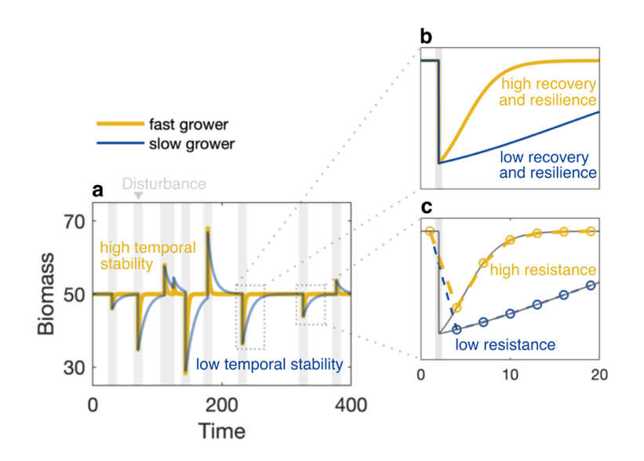

**Figure 1: Realized stability depends on growth rate.** Time series of biomass for two organisms showing logistic growth, a fast-grower (yellow) and a slow-grower (blue). Grey bars indicate a disturbance (i.e. a sudden change in biomass) due to environmental stochasticity or an external impact. Realized stability is illustrated in the form of (**a**) temporal stability, (**b**) recovery and resilience, and (**c**) resistance based on discrete sampling points (circles). The fast-grower is more stable compared to the slow-grower for all four considered realized stability aspects.

**Table 1: Stability for a slow-grower (r=0.1) and a fast-grower (r=0.5), corresponding to Figure 1.** The realized stability is based on standard measures of stability, where high values indicate high stability. The intrinsic stability refers to estimates which account for the influence of growth rate by applying our proposed methods. Bold printed numbers indicate which of the two organisms shows considerably higher stability.

|  |  |  |  |  |  |
| --- | --- | --- | --- | --- | --- |
|  | Realized stability | |  | Intrinsic stability | |
|  | *Slow-grower* | *Fast-grower* |  | *Slow-grower* | *Fast-grower* |
| Temporal stability | 11.57 | **24.61** |  | 36.57 | 34.80 |
| Recovery | 0.60 | **1.00** |  | 0.60 | 0.60 |
| Resilience | 1.25 | **6.25** |  | 12.50 | 12.50 |
| Resistance | 0.23 | **0.40** |  | 0.40 | 0.40 |

# Partitioning: How to derive intrinsic stability from realized stability

Next, we present simple methods to derive intrinsic stability from measures of realized stability, i.e. calculate intrinsic temporal stability, recovery, resilience, and resistance. These measures of intrinsic stability account for the effect of growth rate, and can be used, for example, when doing meta-analyses or other syntheses comparing stability across systems. In our conceptual illustration, the slow-grower and the fast-grower, which differ in realized stability, show similar intrinsic stability (Table 1).

## Intrinsic temporal stability

To control for growth rate when calculating temporal stability, we first define temporal stability as the inverse of coefficient of variation. We then make use of the known relationship between the temporal variance of biomass *N* (i.e. the mean squared distance of the organism’s biomass from equilibrium) and properties of the disturbance regime for a univariate, linear system. Several previous studies have demonstrated that this simple correction performs remarkably well even for more complex systems, such as logistic growth or Lokta-Volterra competition with many interacting species: (Arnoldi *et al.* 2016, 2019; Clark *et al.* 2020), where *μ* is the average disturbance strength, *σ* is the standard deviation of disturbances, and *λ* is the frequency of the exponential distribution from which disturbance strength is drawn. Assuming that these properties of the disturbance regime (*μ*, *σ*, and *λ*) are the same across time series, Because , it follows that Thus, provided that similar disturbance regimes apply to the time series of interest, we can account for the effect of growth rate in estimates of temporal stability by dividing them by the square root of growth rate (Figure 2b):

.

(Eq. 1)

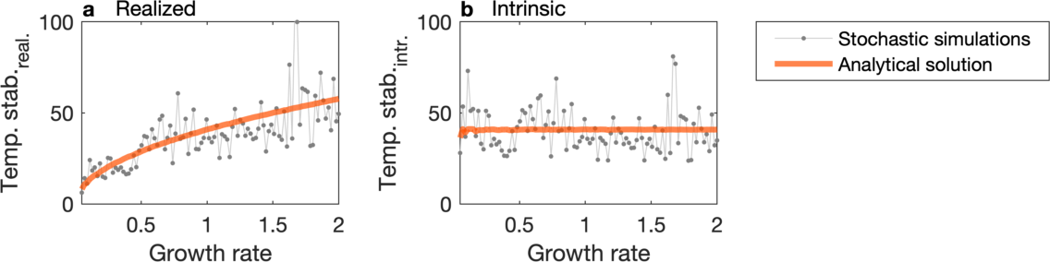

**Figure 2: Partitioning of temporal stability estimates**. (a) Realized temporal stability increases with growth rate, whereas (b) intrinsic temporal stability is on average constant across growth rates. Intrinsic stability is derived by dividing by the square root of growth rate. The solid orange lines indicate the analytical relationships between temporal stability and growth rate (eq. 1) across a range of growth rates between 0.05 and 2. The dots indicate realized and intrinsic temporal stability of 100 independent stochastic time series, which deviate from the general trend due to the stochasticity in the time series.

## Intrinsic recovery and resilience

For recovery and resilience, data can be re-scaled by “stretching” the time axis relative to the growth rates of the faster and slower growers to create a joint time axis. Then, we can restrict comparisons to the time frame that is available for all organisms. This is done by normalizing the time axis asuch that all organisms grow according to a growth curve with *r=1*, i.e. per unit rescaled time, the organisms grow the same amount (unless some other factor changes their growth). From the logistic growth function *dN/dt = rN*(K-N)/K* the effect of growth rate is removed by dividing by *r*, i.e. the time axis is multiplied by *r*: dN/dt/r = dN/(dt*r), resulting in a dimensionless time axis. Also, the rescaled time axis is measured in units since disturbance (*t-tdist*). It follows that: *tintr* = (*t - tdist*) *r*, where *t* is sampling time and *tdist* is the time point of the disturbance. The re-scaling shows that, relatively speaking, the fast-grower was sampled longer and was therefore able to recover more completely. On the re-scaled joint time axis, however, both organisms have the same stability (Figure 3b).

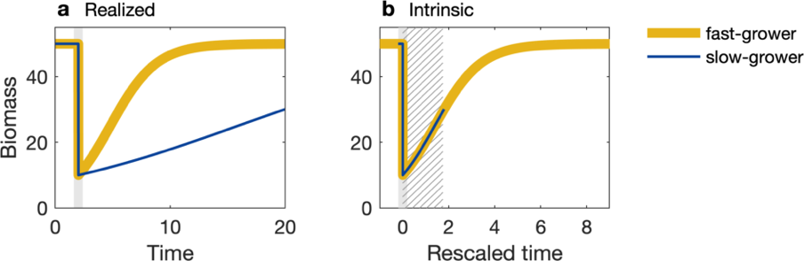

**Figure 3: Partitioning of resilience and recovery estimates**. Realized resilience and recovery are derived based on the (a) original time series. To derive intrinsic resilience and recovery, the original time series needs to be (b) re-scaled. First, the time series is shifted to begin at zero. Then the time points are multiplied by growth rate. The rescaling illustrates that the time span sampled for the slow-grower is effectively shorter. For the derivation of intrinsic resilience and recovery, only the time span shared by all organisms is used (hatched region).

## Intrinsic resistance

For resistance, re-scaling the time axis does not help because the differences in stability are introduced through imperfect sampling via the sampling interval. The sampling interval describes the time passed between the disturbance and the first sampling event. If this time span is too long relative to the growth rate, it allows the organism to recover partially before the first sample is taken, falsely reducing the perceived impact of the disturbance (Figure 4a). To account for this and derive intrinsic resistance, the sampling interval needs to be adapted by the growth rate (Figure 4b). This is done by using a later time point for the intrinsic resistance calculation of the slow-grower (to give it time to “catch up”). The change in biomass following the disturbance is described for the fast-grower as *dNfast/dtfast = rfast Nfast (K-Nfast)/K* and, for the slow-grower, *dNslow/dtslow = rslow Nslow (K-Nslow)/K*, respectively. Now, we want to know during which time span the slow-grower experiences the same change in biomass as the fast-grower, i.e. we want to know the interval *dtslow* for which *dNfast = dNslow*. This time span is *dtslow = (rfast Nfast (K-Nfast)/K)/(rslow Nslow (K-Nslow)/K) dtfast*, and thus *dtslow = rfast/rslow dtfast*. This method assumes that the two organisms differ only in growth rate, while the properties of the disturbance etc are the same. In existing time series with more than two classes of organisms, the time point that should be used to estimate intrinsic resistance *tx* is for each organism class *x* the time of disturbance plus the adapted sampling interval, i.e. *tx* = *tdist* + *dtx* = *tdist* + *rfast/rx dtfast*, where *dtfast* is the minimum sampling interval for the fastest-growing organism and *rx* is the growth rate of the organism class at hand. The biomass at this time point can be approximated using simple interpolation. This method implicitly assumes that the sampling interval is similar across samples of organisms that share the same growth rate. Accordingly, variation in sampling interval length within an organism classes is not addressed here. The method we present here to derive intrinsic resistance assumes that the two species differ exclusively in growth rate. Of course, species can differ in other parameters too, such as *K* (see supplement for how to derive intrinsic resistance for species differing in *K*).

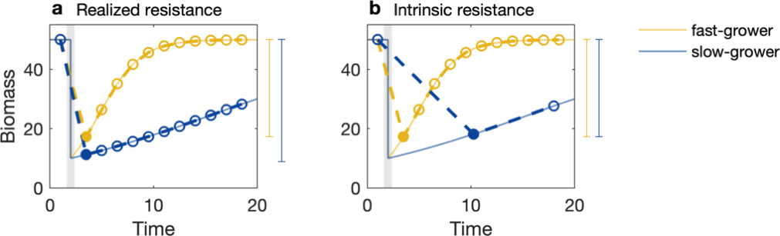

**Figure 4: Partitioning resistance estimates**. Realized resistance is calculated based on the amount of biomass lost at the (a) first time point after the disturbance (filled circle), which depends on the sampling interval. To derive Intrinsic resistance, (b) the standard sampling interval is adapted proportional to growth rate. This is done by relating the growth rate of the slowest to the fastest growing organism. After adapting the sampling interval, intrinsic resistance of the fast- and slow-grower is the same (see vertical bars, indicating the inverse of resistance, i.e. the decrease in function due to the disturbance). The solid lines indicate the time series that would be observed for perfect sampling (i.e. very small sampling intervals).

# Application: Intrinsic and realized stability in empirical data

Based on our conceptual illustration above, we expect all four realized stability metrics (recovery, resilience, resistance and temporal stability) to increase with growth rate. Here, we revisit the meta-analysis by Hillebrand and Kunze (2020) to examine how differences in growth rate influences observed empirical patterns of stability. We chose this data set because it contains a wide range of organism groups from both aquatic and terrestrial ecosystems, it is freely available online, and we could estimate relative growth rate from published estimates for each of the organism groups (supplement, Table S 3). The data set is highly heterogeneous, comprising samples from a wide geographic range (from -150 to 180° W), from open and closed systems (i.e. high and low dispersal), from field and mesocosm studies, and from a variety of disturbance types (e.g. flood, fire, harvesting, land use). Here, we focus only on controlling for the variability introduced through growth rate differences, while the other heterogeneities influencing stability remain. The available data comprises treatment (i.e. disturbed) to control (i.e. undisturbed) ratios of functional response variables (i.e. biomass, abundance, or cover).

## Realized stability in the empirical data

For each of the seven organism classes (microbes, phytoplankton, periphyton, macroinvertebrates, zooplankton, grasses, and macrophytes), we calculated stability measures that are comparable to our conceptual illustration, based on the time series of treatment/control ratios. We measured temporal stability as the inverse coefficient of variance of the ratios, resilience as the maximum linear slope between two successive ratios after the disturbance, recovery as the ratio at the end of the experiment, and resistance as the ratio at the first time point after disturbance. For each organism class, we then derived a mean estimate of relative growth rate from the literature; ranging from 0.08 d-1 for macrophytes to 1.38 d-1 for microbes (supplement, **Table S 4**).

We found that, in the empirical data, recovery did not change systematically with growth rate (Figure 5a). In contrast, resilience, resistance, and temporal stability tended to increase with growth rate (Figure 5b, c, d).

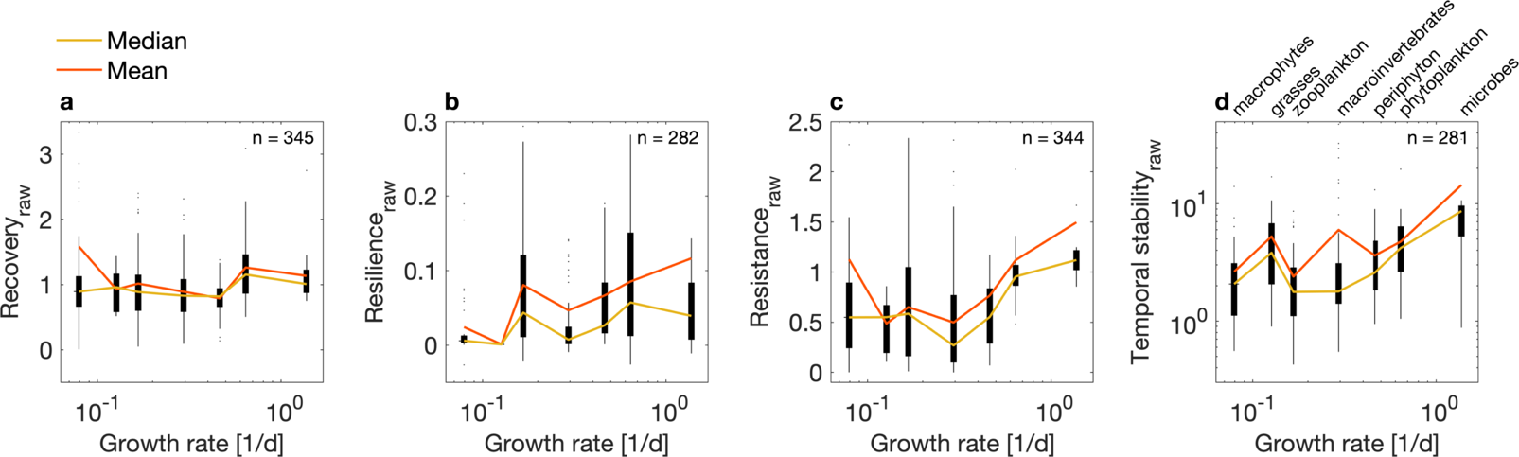

**Figure 5: Realized stability across growth rates in an empirical data set (Hillebrand & Kunze 2020).** Growth rates of seven organism groups are shown against stability measures, (a) recovery, (b) resilience, (c) resistance, and (d) temporal stability (on logarithmic scale). These measures of realized stability do not account for growth rate. Variability of stability measures is visualized as a boxplot, where the edges of the black boxes indicate the 25th and 75th percentiles. The colored lines indicate the median (yellow) and mean (orange) stability per organism group. We report here the stability measures we calculated as specified in the methods. These metrics correspond to our conceptual illustration, but differ from the stability measures reported in the original study.

## Intrinsic stability in the empirical data

Next, we derive estimates of intrinsic stability, by accounting for growth rate using our proposed methods (see Solution section). We do not wish to imply that these intrinsic stability measures carry more ecological meaning than the realized stability measures, but simply that the influence of growth rate is reduced. To derive intrinsic temporal stability, we divided each estimate by the respective growth rate of the sampled organism. For intrinsic resilience and recovery, we re-scaled the time axis by subtracting the time point of disturbance and then multiplying by growth rate. For resistance, we derived an adjusted sampling interval, based on the minimum sampling interval of the fastest-growing organism (in this case microbes) times the ratio of growth rate of microbes to the growth rate of each organism. We then derived intrinsic resistance as the treatment/control ratio at the adjusted sampling interval via linear interpolation.

We found that trends in intrinsic stability in the empirical data differed from trends in realized stability (Figure 6). Specifically, intrinsic recovery increased with growth rate (whereas realized recovery was rather constant). Intrinsic temporal stability does not show a clear trend (whereas realized temporal stability largely increased). For intrinsic resilience, the direction of the trend was even reversed: realized resilience increased, whereas intrinsic stability decreased. Resistance was the only stability aspect that showed a similar trend irrespective of whether growth rate was accounted for or not (largely increasing in both cases).

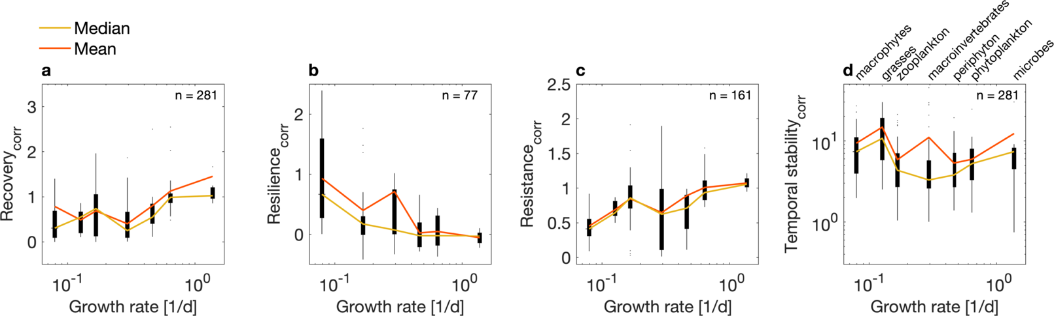

**Figure 6: Intrinsic stability in an empirical data set (Hillebrand & Kunze 2020).** Intrinsic stability is derived by accounting for the influence of growth rate, (a) intrinsic recovery, (b) intrinsic resilience, (c) intrinsic resistance, and (d) intrinsic temporal stability (on logarithmic scale). Variability of stability measures is visualized as a boxplot, where the edges of the black boxes indicate the 25th and 75th percentiles. The colored lines indicate the median (yellow) and mean (orange) stability per organism group.

# Discussion

## Conceptual illustration

Our simple model illustrates how all four realized stability measures (recovery, resilience, resistance, and temporal stability) should critically depend on the rates of growth of the organisms being studied. Indeed, growth rates have been empirically linked to both recovery (Lambert *et al.* 2014; Hillebrand *et al.* 2018) and resilience (Lobón-Cerviá 2009; Hillebrand *et al.* 2018; Čuhel *et al.* 2019; Hiddink *et al.* 2019). Empirical evidence for resistance is more mixed, where some studies report that fast-growers are more resistant to harvesting (Bodmer *et al.* 1997; Hiddink *et al.* 2019), whereas others suggest that resistance is lower in short-lived, fast-growing species due to a trade-off between resilience and resistance (De Vries *et al.* 2012; De Vries & Shade 2013). Such a negative correlation between resilience and resistance has been reported several times (Orwin *et al.* 2006; Hillebrand *et al.* 2018; Li *et al.* 2020) and could be explained by differences in species metabolic strategies (Li *et al.* 2020). Such physiological trade-offs are not captured by our conceptual model.

## Trends of realized stability with growth rate in the empirical data

As expected, realized resilience, resistance, and temporal stability increase with growth rate in the empirical data set. While resilience increased with growth rate, the pattern depended on how resilience is calculated (supplement, **Figure S 2**), emphasizing the importance of the metric used when making generalizations. Resistance increases with growth rate, indicating that fast-growers are often studied using a sampling interval that is too large, relative to the sampling interval applied to study slow-growers. The large sampling interval gives the fast-growers effectively more time to recover before the first sampling point, which results in higher observed resistance. Recovery, however, did not behave as expected, but instead was largely independent of growth rate. One possible explanation for this is that the authors of the original studies generally allowed near full recovery following disturbance, regardless of organism growth rate (longer experiments for longer lived organisms (Hillebrand & Kunze 2020). Such *a priori* adaption of the sampling duration effectively removes the effect of growth rate from recovery estimates.

While we find a signal that most stability measures are influenced by growth rate, which can be accounted for using our methods, there is nevertheless considerable variability remaining. This is not surprising, however, as there are many factors other than growth rates that can have a large influence on measures of stability, such as disturbance type, the size of the species pool, and sampling effort. In addition, other life-history traits can also affect multiple measures of stability. For example, in the supplement, we show how the carrying capacity (*K*) influences stability measures (supplement, Figure S 3). Although *K* is a phenomenological parameter, it is underlain by a number of life history characteristics (e.g., body size, energy use) that influence measures of stability. Nevertheless, our main focus here remains on growth rate, because this parameter can be measured in a relatively straightforward way by comparing the difference in function between two time points.

## Trends in intrinsic stability in the empirical data

We found that the direction of trends in the empirical data changed when growth rate was accounted for. This means, that there are other factors changing systematically along the growth-rate axis. Indeed, studies of the fast-growers (e.g. microbes and phytoplankton) and slow-growers (e.g. macrophytes and grasses) differ in many aspects other than growth rate (supplement, **Figure S 4**). For example, they differ in the studied habitat (coastal hard substrate vs. lentic), main disturbance type (removal vs. deposition/toxicity), response variable (cover vs. abundance/biomass), and experimental set-up (open vs. closed to dispersal). These differences underlie variation in the intrinsic stability estimates.

After accounting for growth rate, the greater levels of resistance we observed for groups with higher growth rates may be because the main types of disturbances change from experimental removal (for longer-lived macrophytes and grasses) to deposition or toxicity (for shorter-lived microbes and phytoplankton). Negative effects of experimental removal are unavoidable for the organisms, whereas deposition and toxicity can be buffered by physiological defense mechanisms, leading to higher resistance. The greater intrinsic resilience and recovery in studies of macrophytes and grasses, could be explained by i) the negative effects of experimental removal cease faster, while deposition/toxicity have longer-lasting effects; ii) studies of macrophytes and grasses were mainly field studies where the set-up was open for dispersal, thus connectivity was likely higher, enhancing resilience and recovery, whereas microbes and phytoplankton were often studied in closed microcosms.

Additional points to consider in discussion:

* Scaling from populations to community level
* Relevance for current marine reseach: lots of interest in how deep-sea mining affects the communities, imprints of mining can be still seen after decades (low temperatures of 4°C and little nutrients) – but does that mean that these communities are instable? Or are they just on another time scale than the one we are used to?

## Conclusions

We show how stability can be partitioned into realized stability, which is strongly affected by growth rate, and intrinsic stability, which accounts for differences in growth rate.

Realized stability is affected by the life-history of individuals in the population or community, even when sampling is relatively standardized (e.g., the same time span sampled), and independent of the metric used (i.e. temporal stability, resilience, recovery, and resistance are all affected by growth rate). Thus, the influence of temporal dynamics depends on the relative growth rates of the organisms within, such that stability is temporally scale-dependent. We aim to raise awareness of this temporal scale-dependence of stability introduced by the growth rate. For example, it has been suggested that slow growing organisms could serve as indicators for sensitivity to disturbance (i.e. bottom trawling), because faster growers might mask the effects of disturbance due to their higher resilience (McLaverty *et al.* 2020). However, in reality, the fast growers do not falsely downplay the effects of disturbance, they but rather show sensitivity to trawling on a different time scale than the slow-growers. Overall, our findings highlight the critical role that temporal scale-dependence, in addition to spatial scale-dependence (Wang *et al.* 2017), plays for stability measures, particularly when comparing across species, ecosystems, or realms.

We advocate to acknowledge the effect of growth rate in all studies comparing stability. To do so, we suggest to consider both realized and intrinsic stability, as described in our methods. This allows to better disentangle differences in stability between populations and communities. For example, Matos and colleagues observed differences in grassland stability that were not explained by properties of the disturbance or environmental conditions (Matos *et al.* 2020). They discuss whether the differences could be explained by possible differences in the proportion of annuals to perennials; our approach could be used to directly evaluate this hypothesis.

Acknowledgements: A.M., S.A.B., A.C., and J.M.C. were supported by the German Centre for Integrative Biodiversity Research (iDiv) Halle‐Jena‐Leipzig (funded by the German Research Foundation; DFG FZT 118). H.H. and D.H. were supported by HIFMB, a collaboration between the Alfred-Wegener-Institute, Helmholtz-Center for Polar and Marine Research, and the Carl-von-Ossietzky University Oldenburg, initially funded by the Ministry for Science and Culture of Lower Saxony and the Volkswagen Foundation through the “Niedersächsisches Vorab” grant program (grant number ZN3285).

# Supplement

### Intrinsic resistance II: Alternative method suggested by Adam

The method from the main text to derive intrinsic resistance assumes that the two organisms differ only in growth rate, while the carrying capacity and properties of the disturbance are shared. If, however, this is not the case, an alternative method can be used to determine intrinsic resistance. This method estimates the biomass immediately after the disturbance *Ndist*, based on the growth rate *r*, the biomass at the first sampling point after disturbance *Nafter*, and the time passed since disturbance *tsince* by assuming linear growth: *Ndist = Nafter exp(r*tsince)*.



Figure X: Intrinsic resistance based on the method suggested by Adam. The thin grey line indicates the analytical solution, i.e. the actual time series that would be observed for perfect sampling (i.e. very small sampling intervals). The dashed lines indicate the sampled time series, with circles indicating sampling events. The dotted lines indicate the approximation used for the intrinsic resistance, with triangles indicating biomass immediately after disturbance happens. The advantage of this approximation is that it also works if the disturbance strength differs between the two organisms. However, even in this simple case, the intrinsic resistance of the two organisms is not the same (see Table 1). *Ndist* of the fast grower is underestimated by the assumption of perfectly linear growth (yellow triangle is lower than the analytical solution indicated by the grey solid line).

### Stability in the empirical data set

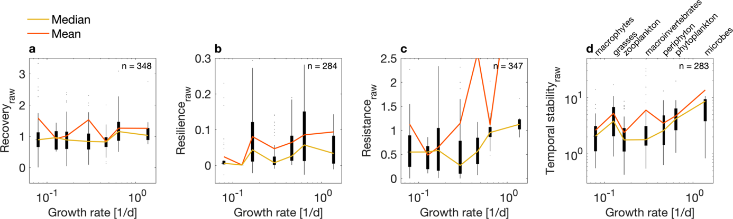

**Figure S 1: Realized stability from the empirical data, including observations identified as outliers.** Growth rates of seven organism groups are shown against stability measures, (**a**) recovery, (**b**) resilience, (**c**) resistance, and (**d**) temporal stability (on logarithmic scale). These measures correspond to standard, “realized” estimates, i.e. are not accounting for growth rate. Variability of stability measures is visualized as a boxplot, where the edges of the black boxes indicate the 25th and 75th percentiles. The colored lines indicate the median (yellow) and mean (orange) stability per organism group. We identified three observations as outliers, based on unusually high resistance (>50 times the median), as described in the methods section.

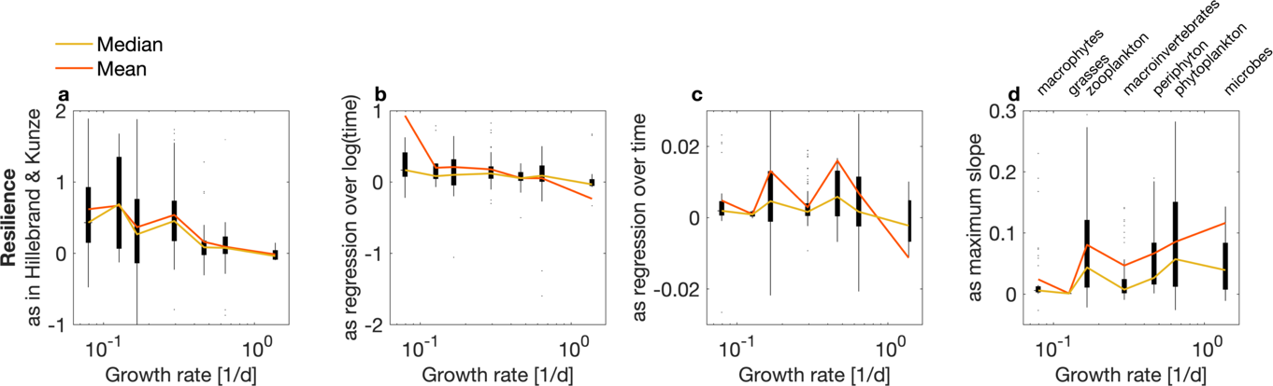

**Figure S 2: Four different realized resilience metrics.** Resilience is calculated for the same data as either (**a**) ﻿the slope of a weighted regression over log-transformed time (as reported in Hillebrand & Kunze 2020), (**b**) the slope of a regression over log-transformed time, (**c**) the slope of a regression over time, and (**d**) the maximum slope between two successive time points.

### Conceptual illustration: Influence of carrying capacity on stability

Similar to growth rate, stability is also affected by the carrying capacity. Here, we illustrate this by showing two organisms with the same growth rate, but different carrying capacity. This scenario could represent for example two organisms of the same species growing in a “good” (*Khigh* = 80) and a “bad” (*Klow* = 50) environment. Both organisms experience a disturbance of the same absolute strength (i.e. biomass is reduced by the same amount in the two cases). Stability is measured by the same metrics as in the conceptual simulation on the influence of growth rate (see main text).

The high-carrying capacity organism shows higher stability in all four metrics. It recovers faster, more fully and is more resistant, because the disturbance is relatively seen less severe, removing only about half the biomass (versus 80% in the low carrying capacity case). The high-capacity organism is also more temporally stable because, while the standard deviation of its biomass is the same as in the bad environment, the mean is higher (*temp. stab. =* *mean(N)/std(N)*).

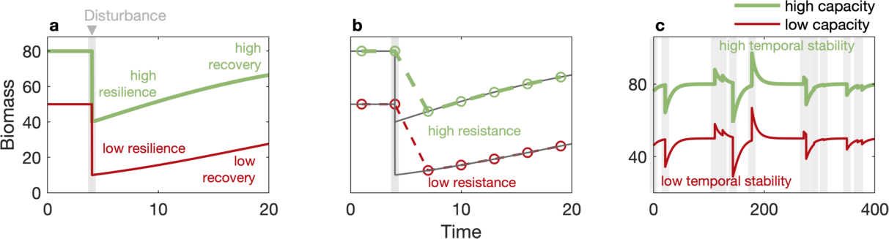

**Figure S 3: Effect of carrying capacity on stability estimates.** Time series of biomass *N* for two organisms showing logistic growth, one with a low carrying capacity (red, *K* = 50) and one with a high carrying capacity (light green, *K* = 80). Grey bars indicate a disturbance, i.e. a sudden change in biomass. Stability is illustrated in the form of (**a**) resilience and recovery, (**b**) resistance, based on discrete sampling points, and (**c**) temporal stability in the face of a stochastic disturbance regime over a longer time period. For the organism with high carrying capacity, stability to these disturbances is higher for all four considered stability aspects (see Table S4).

**Table S 1: Stability for an organism with low carrying capacity (*K*=50) and one with high capacity (*K*=80), corresponding to Figure S4**.Realized stability is derived using simple measures of stability, where high values indicate high stability: resilience = maximum linear slope in biomass between two sampling points, recovery = ratio of biomass at the end of the simulation to carrying capacity, resistance = ratio of biomass at the first sampling point after the disturbance to carrying capacity, and temporal stability = inverse coefficient of variation.

|  |  |  |  |  |
| --- | --- | --- | --- | --- |
|  | Realized stability | |  | |
|  | *Low capacity* | *High capacity* | |  |
| Resilience | 1.25 | **2.00** |  | |
| Recovery | 0.55 | **0.83** |  | |
| Resistance | 0.25 | **0.57** |  | |
| Temporal stability | 11.78 | **19.62** |  | |

### Summary statistics of empirical data set

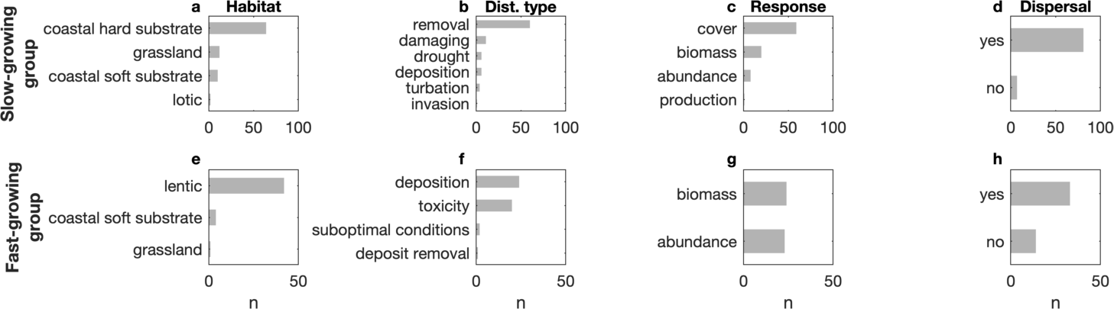

**Figure S 4: Differences in studies of fast- and slow growing organisms.** Histograms show the number of observations per category for slower growing organisms (i.e. macrophytes and grasses; first row of panels) and faster growing organisms (i.e. microbes and phytoplankton; second row of panels). Studies of slow- and fast-growers differ in (**a,e**) studied habitat, (**b,f**) disturbance type, (**c,g**) response variable, and (**d,h**) whether experimental set-up is open to dispersal.

**Table S 2: Number of observations for each organism group in the empirical data set (Hillebrand & Kunze 2020).** Gray text indicates that the organisms were excluded from the analyzed data set because they comprised less than ten observations or the category was too broad to assign a common growth rate (in the case of “mixed plants”, that contains both woody and non-woody plants).

|  |  |
| --- | --- |
| **No. observations** | **Organism group** |
| 126 | Macroinvertebrates |
| 76 | Macrophytes |
| 58 | Mixed plants |
| 58 | Zooplankton |
| 31 | Phytoplankton |
| 28 | Periphyton |
| 17 | Microbes |
| 12 | Grasses |
| 9 | Small aquatic |
| 8 | Woody plants |
| 7 | Fish |
| 5 | Birds |
| 5 | Forbs |
| 4 | Marsh plants |
| 3 | Algae |
| 3 | Invertebrates |

### Growth rate estimates for the seven organism groups

**Table S 3: Growth rate estimates for the seven organism groups from published studies**. Estimates refer to relative growth rates as defined by Hunt & Cornelissen (Hunt & Cornelissen 1997). The columns “org. estimate”, “org. unit”, and “org. measure” give the growth rate estimate, unit, and metric as published in the original studies. The column “conv. estimate” refers to the converted estimate, if applicable. References of original studies: (Reddy & DeBusk 1984; Benke & Jacobi 1986; Nielsen & Sand-Jensen 1991; Møhlenberg 1995; Liang & Uye 1997; Levang-Brilz & Biondini 2003; Calbet & Landry 2004; Ramírez & Pringle 2006; Ahn *et al.* 2013; Houghton *et al.* 2013; Lankiewicz *et al.* 2016; McConville *et al.* 2017; Piwosz *et al.* 2018; Schmidt *et al.* 2019). For summary statistics for each organism group, see Table S 4.

|  |  |  |  |  |  |  |
| --- | --- | --- | --- | --- | --- | --- |
| **Organism** | **Org. estimate** | **Org. unit** | **Treatment** | **Org. measure** | **Reference** | **Conv. estimate** |
|  |  |  |  |  |  |  |
| 'microbes' | 1.12 | '1/d' | 'initial rate in bacterivore-free treatment' | 'Specific growth rate' | 'Piwosz2018' | NaN |
| 'microbes' | 0.88 | '1/d' | 'long-term rate in bacterivore-free treatment' | 'Specific growth rate' | 'Piwosz2018' | NaN |
| 'microbes' | 0.4 | '1/d' | 'exponential phase, Ca. P.' | 'Maximum growth rate' | 'Lankiewicz2016' | NaN |
| 'microbes' | 1 | '1/d' | 'exponential phase, SAR92' | 'Maximum growth rate' | 'Lankiewicz2016' | NaN |
| 'microbes' | 2.1 | '1/d' | 'exponential phase, R. pomer' | 'Maximum growth rate' | 'Lankiewicz2016' | NaN |
| 'microbes' | 6.2 | '1/d' | 'exponential phase, MED152' | 'Maximum growth rate' | 'Lankiewicz2016' | NaN |
| 'microbes' | 0.06 | '1/d' | 'stationary phase, Ca. P.' | 'Maximum growth rate' | 'Lankiewicz2016' | NaN |
| 'microbes' | 0.2 | '1/d' | 'stationary phase, Ca. P.' | 'Maximum growth rate' | 'Lankiewicz2016' | NaN |
| 'microbes' | 0.3 | '1/d' | 'stationary phase, Ca. P.' | 'Maximum growth rate' | 'Lankiewicz2016' | NaN |
| 'microbes' | 1.5 | '1/d' | 'stationary phase, Ca. P.' | 'Maximum growth rate' | 'Lankiewicz2016' | NaN |
| 'phytoplankton' | 0.59 | '1/d' | 'Oceanic' | 'Instantaneous growth rate' | 'Calbet2004' | NaN |
| 'phytoplankton' | 0.67 | '1/d' | 'Coastal' | 'Instantaneous growth rate' | 'Calbet2004' | NaN |
| 'phytoplankton' | 0.97 | '1/d' | 'Estuarine' | 'Instantaneous growth rate' | 'Calbet2004' | NaN |
| 'phytoplankton' | 0.72 | '1/d' | 'Tropical' | 'Instantaneous growth rate' | 'Calbet2004' | NaN |
| 'phytoplankton' | 0.69 | '1/d' | 'Temperate' | 'Instantaneous growth rate' | 'Calbet2004' | NaN |
| 'phytoplankton' | 0.44 | '1/d' | 'Polar' | 'Instantaneous growth rate' | 'Calbet2004' | NaN |
| 'phytoplankton' | 0.4 | '1/d' | 'March' | 'Instantaneous growth rate' | 'Mohlenberg1995' | NaN |
| 'phytoplankton' | 0.6 | '1/d' | 'June' | 'Instantaneous growth rate' | 'Mohlenberg1995' | NaN |
| 'zooplankton' | 0.22 | '1/d' | 'Average community growth at ambient temperature' | 'Mass-specific growth rate' | 'McConville2017' | NaN |
| 'zooplankton' | 0.16 | '1/d' | 'Average community growth at 15°C' | 'Mass-specific growth rate' | 'McConville2017' | NaN |
| 'zooplankton' | 0.2 | '1/d' | 'Average growth of species Paracalanus at 20°C' | 'Instantaneous growth rate' | 'Liang1997' | NaN |
| 'periphyton' | 0.97 | '1/d' | 'Chl a NP<200' | 'Incremental growth rate' | 'Schmidt2019' | NaN |
| 'periphyton' | 0.31 | '1/d' | 'Chl a NP>1' | 'Incremental growth rate' | 'Schmidt2019' | NaN |
| 'periphyton' | 0.34 | '1/d' | 'AFDM NP<200' | 'Incremental growth rate' | 'Schmidt2019' | NaN |
| 'periphyton' | 0.26 | '1/d' | 'AFDM NP>1' | 'Incremental growth rate' | 'Schmidt2019' | NaN |
| 'periphyton' | 0.38 | '1/d' | 'Water from MW1, tile surface' | 'Instantaneous growth rate' | 'Ahn2013' | NaN |
| 'periphyton' | 0.4 | '1/d' | 'Water from MW1, concrete' | 'Instantaneous growth rate' | 'Ahn2013' | NaN |
| 'periphyton' | 0.49 | '1/d' | 'Water from MW1, pebble' | 'Instantaneous growth rate' | 'Ahn2013' | NaN |
| 'periphyton' | 0.25 | '1/d' | 'Water from HR, tile surface' | 'Instantaneous growth rate' | 'Ahn2013' | NaN |
| 'periphyton' | 0.22 | '1/d' | 'Water from HR, concrete' | 'Instantaneous growth rate' | 'Ahn2013' | NaN |
| 'periphyton' | 0.43 | '1/d' | 'Water from HR, pebble' | 'Instantaneous growth rate' | 'Ahn2013' | NaN |
| 'periphyton' | 0.18 | '1/d' | 'Water from BFW, tile surface' | 'Instantaneous growth rate' | 'Ahn2013' | NaN |
| 'periphyton' | 0.18 | '1/d' | 'Water from BFW, concrete' | 'Instantaneous growth rate' | 'Ahn2013' | NaN |
| 'periphyton' | 0.32 | '1/d' | 'Water from BFW, pebble' | 'Instantaneous growth rate' | 'Ahn2013' | NaN |
| 'macrophytes' | 0.007 | '1/d' | 'Slowest of the 14 species' | 'Slope of linear regression ln cumulated biomass' | 'Nielsen1991' | NaN |
| 'macrophytes' | 0.109 | '1/d' | 'Fastest of the 14 species' | 'Slope of linear regression ln cumulated biomass' | 'Nielsen1991' | NaN |
| 'macrophytes' | 0.06 | '1/d' | 'Water hyazinth' | 'Specific growth rate' | 'Reddy1984' | NaN |
| 'macrophytes' | 0.18 | '1/d' | 'Water lettuce' | 'Specific growth rate' | 'Reddy1984' | NaN |
| 'macrophytes' | 0.04 | '1/d' | 'Pennywort' | 'Specific growth rate' | 'Reddy1984' | NaN |
| 'macroinvertebrates' | 0.116 | 'mg/mg d' | 'Stenomena spp.' | 'Instantaneous growth rate' | 'Benke1986' | 0.116 |
| 'macroinvertebrates' | 0.565 | 'mg/mg d' | 'Arboleda <2mm' | 'Instantaneous growth rate' | 'Ramirez2006' | 0.565 |
| 'macroinvertebrates' | 0.377 | 'mg/mg d' | 'Arboleda 2-4mm' | 'Instantaneous growth rate' | 'Ramirez2006' | 0.377 |
| 'macroinvertebrates' | 0.119 | 'mg/mg d' | 'Arboleda >4mm' | 'Instantaneous growth rate' | 'Ramirez2006' | 0.119 |
| 'grasses' | 0.13 | 'g/g d' | 'Mid-succession grasses' | 'Relative growth rate of total plant biomass' | 'Levang2003' | 0.13 |
| 'grasses' | 0.1 | 'g/g d' | 'Late-succession grasses' | 'Relative growth rate of total plant biomass' | 'Levang2003' | 0.1 |
| 'grasses' | 0.15 | 'g/g d' | 'Graminoids (grasses)' | 'Relative growth rate (RGR)' | 'Houghton2013' | 0.15 |

**Table S 4: Mean and standard deviation of growth rates.** Summary statistics of growth rate estimates for the seven organism groups from the empirical data set (Hillebrand & Kunze 2020), based on the studies shown in Table S 3.

|  |  |  |
| --- | --- | --- |
| **Organism group** | **Mean growth rate [1/d]** | **Std growth rate** |
| macrophytes | 0.08 | 0.03 |
| grasses | 0.13 | 0.03 |
| zooplankton | 0.19 | 0.07 |
| macroinvertebrates | 0.29 | 0.18 |
| periphyton | 0.36 | 0.21 |
| phytoplankton | 0.64 | 0.22 |
| microbes | 1.38 | 1.81 |

# References

Ahn, C.H., Song, H.M., Lee, S., Oh, J.H., Ahn, H., Park, J.R., *et al.* (2013). Effects of water velocity and specific surface area on filamentous periphyton biomass in an artificial stream mesocosm. *Water*, 5, 1723–1740.

Arnoldi, J., Loreau, M. & Haegeman, B. (2019). The inherent multidimensionality of temporal variability: how common and rare species shape stability patterns. *Ecol. Lett.*, 1557–1567.

Arnoldi, J.F., Loreau, M. & Haegeman, B. (2016). Resilience, reactivity and variability: A mathematical comparison of ecological stability measures. *J. Theor. Biol.*, 389, 47–59.

Battaglia, M., Hose, G.C., Turak, E. & Warden, B. (2005). Depauperate macroinvertebrates in a mine affected stream: Clean water may be the key to recovery. *Environ. Pollut.*, 138, 132–141.

Bengtsson, J., Baillie, S.R. & Lawton, J. (1997). Community Variability Increases with Time. *Oikos*, 78, 249.

Benke, A.C. & Jacobi, D.I. (1986). Growth Rates of Mayflies in a Subtropical River and Their Implications for Secondary Production. *J. North Am. Benthol. Soc.*, 5, 107–114.

Benstead, J.P., Green, A.C., Deegan, L.A., Peterson, B.J., Slavik, K., Bowden, W.B., *et al.* (2007). Recovery of three arctic stream reaches from experimental nutrient enrichment. *Freshw. Biol.*, 52, 1077–1089.

Bodmer, R.E., Eisenberg, J.F. & Redford, K.H. (1997). Hunting and the likelihood of extinction of Amazonian mammals. *Conserv. Biol.*, 11, 460–466.

Calbet, A. & Landry, M.R. (2004). Phytoplankton growth, microzooplankton grazing, and carbon cycling in marine systems. *Limnol. Oceanogr.*, 49, 51–57.

Clark, A.T., Zelnik, Y.R., Arnoldi, J., Hodapp, D., Karakoç, C., König, S., *et al.* (2020). How perceived stability varies across temporal, spatial, and ecological scales.

Connell, J.H. & Sousa, W.P. (1983). On the evidence needed to judge ecological stability or persistence, 121, 789–824.

Čuhel, J., Malý, S. & Královec, J. (2019). Shifts and recovery of soil microbial communities in a 40-year field trial under mineral fertilization. *Pedobiologia (Jena).*, 77, 150575.

Degerman, R., Dinasquet, J., Riemann, L., De Luna, S.S. & Andersson, A. (2012). Effect of resource availability on bacterial community responses to increased temperature. *Aquat. Microb. Ecol.*, 68, 131–142.

Díaz, S., Settele, J., Brondizio, E.S., Ngo, H.T., Guèze, M., Agard, J., *et al.* (2019). *Summary for policymakers of the global assessment report on biodiversity and ecosystem services of the Intergovernmental Science-Policy Platform on Biodiversity and Ecosystem Services*. IPBES Secretariat, Bonn, Germany.

Domínguez-García, V., Dakos, V. & Kéfi, S. (2019). Unveiling dimensions of stability in complex ecological networks. *Proc. Natl. Acad. Sci.*, 1–7.

Donohue, I., Hillebrand, H., Montoya, J.M., Petchey, O.L., Pimm, S.L., Fowler, M.S., *et al.* (2016). Navigating the complexity of ecological stability. *Ecol. Lett.*, 19, 1172–1185.

Downing, A.L., DeVanna, K.M., Rubeck-Schurtz, C.N., Tuhela, L. & Grunkemeyer, H. (2008). Community and ecosystem responses to a pulsed pesticide disturbance in freshwater ecosystems. *Ecotoxicology*, 17, 539–548.

Falk, D.A., Watts, A.C. & Thode, A.E. (2019). Scaling Ecological Resilience. *Front. Ecol. Evol.*, 7, 1–16.

Frank, P.W. (1968). Life Histories and Community Stability. *Ecology*, 49, 355–357.

Geng, S., Shi, P., Song, M., Zong, N., Zu, J. & Zhu, W. (2019). Diversity of vegetation composition enhances ecosystem stability along elevational gradients in the Taihang Mountains, China. *Ecol. Indic.*, 104, 594–603.

Gillespie, D.T. (1992). *Markov Processes: An Introduction for Physical Scientists*. Academic Press.

Hautier, Y., Seabloom, E.W., Borer, E.T., Adler, P.B., Harpole, W.S., Hillebrand, H., *et al.* (2014). Eutrophication weakens stabilizing effects of diversity in natural grasslands. *Nature*, 508, 521–525.

Hiddink, J.G., Jennings, S., Sciberras, M., Bolam, S.G., Cambiè, G., McConnaughey, R.A., *et al.* (2019). Assessing bottom trawling impacts based on the longevity of benthic invertebrates. *J. Appl. Ecol.*, 56, 1075–1084.

Hillebrand, H. & Kunze, C. (2020). Meta-analysis on pulse disturbances reveals differences in functional and compositional recovery across ecosystems. *Ecol. Lett.*, 23, 575–585.

Hillebrand, H., Langenheder, S., Lebret, K., Lindström, E., Östman, Ö. & Striebel, M. (2018). Decomposing multiple dimensions of stability in global change experiments. *Ecol. Lett.*, 21, 21–30.

Holden, S.R. & Treseder, K.K. (2013). A meta-analysis of soil microbial biomass responses to forest disturbances. *Front. Microbiol.*, 4, 1–17.

Houghton, J., Thompson, K. & Rees, M. (2013). Does seed mass drive the differences in relative growth rate between growth forms? *Proc. R. Soc. B Biol. Sci.*, 280.

Huang, K. & Xia, J. (2019). High ecosystem stability of evergreen broadleaf forests under severe droughts. *Glob. Chang. Biol.*, 25, 3494–3503.

Hunt, R. & Cornelissen, J.H.C. (1997). Components of relative growth rate and their interrelations in 59 temperate plant species. *New Phytol.*, 135, 395–417.

Inman-Narahari, F., Ostertag, R., Asner, G.P., Cordell, S., Hubbell, S.P. & Sack, L. (2014). Trade-offs in seedling growth and survival within and across tropical forest microhabitats. *Ecol. Evol.*, 4, 3755–3767.

Isbell, F., Tilman, D., Reich, P.B. & Clark, A.T. (2019). Deficits of biodiversity and productivity linger a century after agricultural abandonment. *Nat. Ecol. Evol.*, 3, 1533–1538.

Jones, H.P. & Schmitz, O.J. (2009). Rapid recovery of damaged ecosystems. *PLoS One*, 4.

Knapp, S. & van der Heijden, M.G.A. (2018). A global meta-analysis of yield stability in organic and conservation agriculture. *Nat. Commun.*, 9, 1–9.

Lambert, G.I., Jennings, S., Kaiser, M.J., Davies, T.W. & Hiddink, J.G. (2014). Quantifying recovery rates and resilience of seabed habitats impacted by bottom fishing. *J. Appl. Ecol.*, 51, 1326–1336.

Lankiewicz, T.S., Cottrell, M.T. & Kirchman, D.L. (2016). Growth rates and rRNA content of four marine bacteria in pure cultures and in the Delaware estuary. *ISME J.*, 10, 823–832.

van de Leemput, I.A., Dakos, V., Scheffer, M. & van Nes, E.H. (2018). Slow Recovery from Local Disturbances as an Indicator for Loss of Ecosystem Resilience. *Ecosystems*, 21, 141–152.

Levang-Brilz, N. & Biondini, M.E. (2003). Growth rate, root development and nutrient uptake of 55 plant species from the Great Plains grasslands, USA. *Plant Ecol.*, 165, 117–144.

Li, X., Piao, S., Wang, K., Wang, X., Wang, T., Ciais, P., *et al.* (2020). Temporal trade-off between gymnosperm resistance and resilience increases forest sensitivity to extreme drought. *Nat. Ecol. Evol.*, 1–9.

Liang, D. & Uye, S. (1997). Population dynamics and production of the planktonic copepods in a eutrophic inlet of the Inland Sea of Japan. IV. Pseudodiaptomus marinas, the egg-carrying calanoid. *Mar. Biol.*, 128, 415–421.

Lobón-Cerviá, J. (2009). Why, when and how do fish populations decline, collapse and recover? The example of brown trout (Salmo trutta) in Rio Chaballos (northwestern Spain). *Freshw. Biol.*, 54, 1149–1162.

Lugert, V., Thaller, G., Tetens, J., Schulz, C. & Krieter, J. (2016). A review on fish growth calculation: multiple functions in fish production and their specific application. *Rev. Aquac.*, 8, 30–42.

Matos, I.S., Menor, I.O., Rifai, S.W. & Rosado, B.H.P. (2020). Deciphering the stability of grassland productivity in response to rainfall manipulation experiments. *Glob. Ecol. Biogeogr.*, 29, 558–572.

McConville, K., Atkinson, A., Fileman, E.S., Spicer, J.I. & Hirst, A.G. (2017). Disentangling the counteracting effects of water content and carbon mass on zooplankton growth. *J. Plankton Res.*, 39, 246–256.

McLaverty, C., Eigaard, O.R., Gislason, H., Bastardie, F., Brooks, M.E., Jonsson, P., *et al.* (2020). Using large benthic macrofauna to refine and improve ecological indicators of bottom trawling disturbance. *Ecol. Indic.*, 110.

Møhlenberg, F. (1995). Regulating mechanisms of phytoplankton growth and biomass in a shallow estuary. *Ophelia*, 42, 239–256.

Nielsen, S.L. & Sand-Jensen, K. (1991). Variation in growth rates of submerged rooted macrophytes. *Aquat. Bot.*, 39, 109–120.

Orwin, K.H., Wardle, D.A., Greenfield, L.G., Setälä, H., Orwin, K.H., Wardle, D.A., *et al.* (2006). Context-Dependent Changes in the Resistance and Resilience of Soil Microbes to an Experimental Distrubance for Three Primary Plant Chronosequences Published by : Wiley on behalf of Nordic Society Oikos Stable URL : http://www.jstor.or. *Oikos*, 112, 196–208.

Ospina, S., Rusch, G.M., Pezo, D., Casanoves, F. & Sinclair, F.L. (2012). More stable productivity of semi natural grasslands than sown pastures in a seasonally dry climate. *PLoS One*, 7, 1–9.

Pimm, S.L. (1984). The complexity and stability of ecosystems. *Nature*, 315, 635–636.

Piwosz, K., Shabarova, T., Tomasch, J., Šimek, K., Kopejtka, K., Kahl, S., *et al.* (2018). Determining lineage-specific bacterial growth curves with a novel approach based on amplicon reads normalization using internal standard (ARNIS). *ISME J.*, 12, 2640–2654.

Proulx, R., Wirth, C., Voigt, W., Weigelt, A., Roscher, C., Attinger, S., *et al.* (2010). Diversity promotes temporal stability across levels of ecosystem organization in experimental grasslands. *PLoS One*, 5, 1–8.

Radchuk, V., Laender, F. De, Cabral, J.S., Boulangeat, I., Crawford, M., Bohn, F., *et al.* (2019). The dimensionality of stability depends on disturbance type. *Ecol. Lett.*, 22, 674–684.

Ramírez, A. & Pringle, C.M. (2006). Fast growth and turnover of chironomid assemblages in response to stream phosphorus levels in a tropical lowland landscape. *Limnol. Oceanogr.*, 51, 189–196.

Reddy, K.R. & DeBusk, W.F. (1984). Growth Characteristics of Aquatic Macrophytes Cultured in Nutrient-Enriched Water : I . Water Hyacinth , Water Lettuce , and Pennywort. *Econ. Bot.*, 38, 229–239.

Schmidt, T.S., Konrad, C.P., Miller, J.L., Whitlock, S.D. & Stricker, C.A. (2019). Benthic Algal (Periphyton) Growth Rates in Response to Nitrogen and Phosphorus: Parameter Estimation for Water Quality Models. *J. Am. Water Resour. Assoc.*, 55, 1479–1491.

Smith, O.M., Cohen, A.L., Rieser, C.J., Davis, A.G., Taylor, J.M., Adesanya, A.W., *et al.* (2019). Organic Farming Provides Reliable Environmental Benefits but Increases Variability in Crop Yields: A Global Meta-Analysis. *Front. Sustain. Food Syst.*, 3, 1–10.

Taylor, B.M., Choat, J.H., DeMartini, E.E., Hoey, A.S., Marshell, A., Priest, M.A., *et al.* (2019). Demographic plasticity facilitates ecological and economic resilience in a commercially important reef fish. *J. Anim. Ecol.*, 1–13.

Tilman, D. (1996). Biodiversity: Population Versus Ecosystem Stability. *Ecology*, 77, 350–363.

United Nations. (2015). Transforming our world: the 2030 Agenda for Sustainable Development. *A/RES/70/1*.

De Vries, F.T., Liiri, M.E., Bjørnlund, L., Bowker, M.A., Christensen, S., Setälä, H.M., *et al.* (2012). Land use alters the resistance and resilience of soil food webs to drought. *Nat. Clim. Chang.*, 2, 276–280.

De Vries, F.T. & Shade, A. (2013). Controls on soil microbial community stability under climate change. *Front. Microbiol.*, 4, 1–16.

Wang, S., Loreau, M., Arnoldi, J.F., Fang, J., Rahman, K.A., Tao, S., *et al.* (2017). An invariability-area relationship sheds new light on the spatial scaling of ecological stability. *Nat. Commun.*, 8, 1–8.

Zhang, Y., He, N., Loreau, M., Pan, Q. & Han, X. (2018). Scale dependence of the diversity–stability relationship in a temperate grassland. *J. Ecol.*, 106, 1277–1285.