Homework 2

- Translate the following 32 bit binary number to decimal ( show how you would do that and yes you can use a calculator )
0000 0000 0000 0000 0000 0000 1010 1010

Negate the number and write it in twos compliment

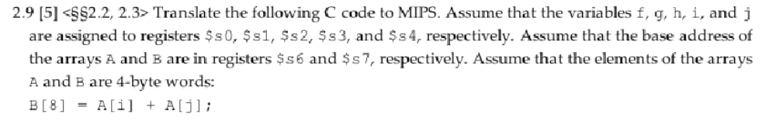

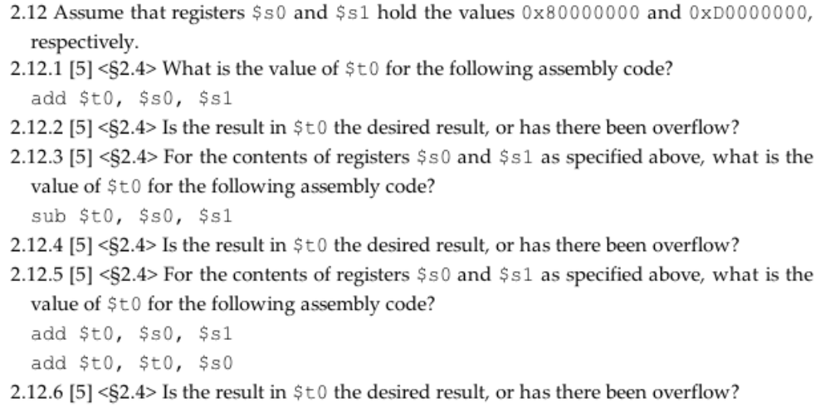

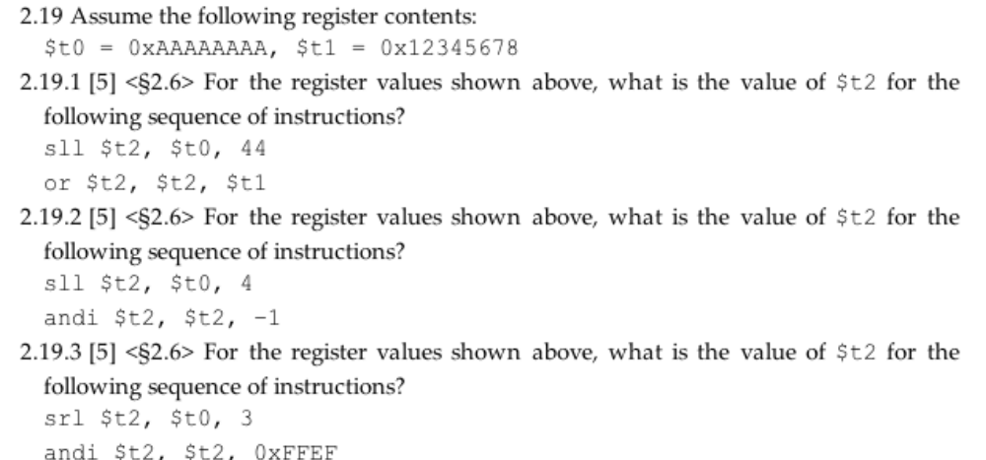

book 2.23
Assume$t0 hold the value 0x00101000 what is the value of $t2 after the following instructions?

slt $t2, $0, $t0
bne $t2, $0, ELSE
j DONE
ELSE: addi $t2, $t2, 2
DONE:

