How To Create Your Own Augmented Lesson
for Digitarium digital planetarium systems

Version 0.1
August 30, 2017

Introduction
Augmented Lessons are designed to make presenting a live lesson extremely easy through a Digitarium system using the Universal Console interface. An Augmented Lesson is like a traditional planetarium show script, but will everything you need to do included in the lesson in one place. As you deliver the lesson you can read the narration (or just use it as a reminder), tap media to display these on the dome exactly when needed, and run scripts to control the simulation.

An Augmented Lesson is used through the Universal Console software interface, which runs in a web browser on a desktop or iPad. Go to the "Lessons" tab to try out other Augmented Lessons and download more from the Digitalis Community webite at http://Community.DigitalisEducation.com.

Anatomy of an Augmented Lesson
Augmented lessons are very basic HTML (HyperText Markup Language) files and directories of related files. HTML is the native format of web pages. You can edit an existing lesson if the license permits, or create your own.

Lessons are placed as directories under /lessons/[PUBLISHER] on the user's media master drive. This is then synced to the Digitarium Control Unit internal drive for use.

Each Lesson is a child directory of the directory corresponding to its Publisher. It is strongly recommended that you create your own unique publisher directory for lessons you create.

Each Lesson is contained within its own directory. The actual Lesson file is index.html, which is the HTML document.

Example: The Sun lesson from Digitalis:
lessons/digitalis/sun/ <- discrete folder for each lesson (required)
lessons/digitalis/sun/index.html <- The lesson file (required)
lessons/digitalis/sun/media/ <- images, videos, etc. to show on dome (convention)
lessons/digitalis/sun/scripts/ <-Stratoscript files (convention)
lessons/digitalis/sun/thumbs/ <- thumbnail images viewed in the HTML (convention)

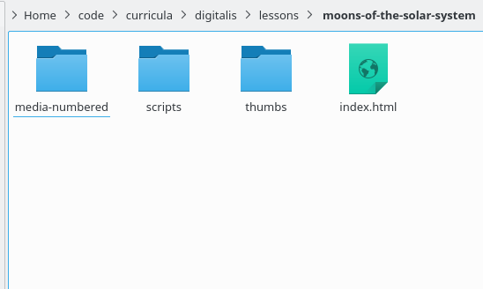

Augmented Lessons should be distributed as zip archives. When doing so, please include the top level folders "lessons/PUBLISHER/LESSON_NAME", where PUBLISHER is your name or organization and LESSON_NAME is a unique directory name for your lesson.

Basics of HTML
To create your own Augmented Lesson you need to know some basic HTML. HTML is most easily edited in a text editor for our purposes. It consists of HTML "tags" and text. HTML tags begin with a "<" and end with a ">". Many HTML tags have a start tag and a separate end tag. For example:

I am <b>bold!</b>

This makes the text "bold!" bold type. Note the matching end tag beginning with a "</".

The most important tag for lessons is the <div> tag. This is a rectangular division of the page that contains a collection of related content. Tags can have argument pairs, for example:

<div class="narration">We begin 3 hours before sunset.</div>

Note the class argument, which tells the Universal Console the content in this div is narration and should be rendered accordingly.

Other critical tags are <p> to separate paragraphs, and <img> to include a thumbnail or other image in the page. Refer to an HTML tutorial online for other useful tags, or use other lessons as examples.

An HTML file has this minimal structure:

<html>
<body>
All of your content.
</body>
</html>

As you create your own HTML file you will be able to preview it (imperfectly) as you work in a web browser. When viewed through the Universal Console some common web page features are disabled, such as scripting or external cascading style sheets (CSS). So you need to keep things simple.

Meta Tags

HTML meta tags are used as a simple way of embedding data about the lesson in the HTML lesson. For example:

<meta name="category" content="Digitalis">
<meta name="pagename" content="The Sun">
<meta name="rating" content="9+">
<meta name="language" content="en">

Meta tags with the following 'name' attributes are required to display a lesson on the main lesson tab list of lesson:

category - This is the publisher of the Lesson. Examples: "Digitalis", "Stardust Planetarium". This will show up under the 'Publisher' column of the index.
pagename - This is the name of the Lesson, displayed under the 'Lesson' column of the index.
rating - This is the age range in years of the target audience for this lesson, displayed under 'Age Range' in the index. Examples: "11+", "4-6"
language - The locale code corresponding to the language of the lesson. Example: "en", "es_MX"

The publisher and lesson title combination should be unique to avoid confusion over which lesson is which on the lesson index.

Images and Thumbnails
The author of the lesson is responsible for generating the thumbnails, just as they're responsible for generating the full size media files. Thumbnail images are best stored in their own folder, rather than the same folder as their original counterparts so as not to confuse the user browsing the media folder with the UC or Digitarium remote in Media Mode.

A thumbnail file residing at: lessons/digitalis/sun/thumbs/nebula.png

Can be referenced in the sun lesson index.html as:

<img src="thumbs/nebula.png" data-type="image" data-value="media/nebula.png" />

Note that this tag is defining both the thumbnail and the dome media file. Typically a thumbnail would be 256x256 pixels in size and a full size media file would be 1024x1024 or larger. Images do not need to be square or any particular resolution. JPEG is a good general image format, and PNG is necessary if you want transparency.

Interactive Elements
Interactive elements are images that can be clicked to play media or buttons that play StratoScript commands. The following HTML attributes are required for each interactive element:

- data-type: the type of interaction required. Possible values are:
  - command: execute a single StratoScript command
<div class="action">
<div data-value="timerate rate 1000" data-transport="false" class="effect" data-type="command">Speed up time.</div> </div>
  - script: execute a StratoScript
<div class="action">
<div data-value="scripts/zinsun.sts" data-transport="false" class="effect" data-type="script">Select and zoom in on the Sun.</div> </div>
  - audio: play audio track

  - image: display image on dome
<div class="action">
<img data-value="media/05-heliosphere.gif" data-author="NASA" data-license="CC BY-SA 3.0" data- link="http://commons.wikimedia.org/wiki/File:Heliosphere_drawing.gif" title="Heliosphere"></div>
  - video: display video on dome

- data-value
  - In the case of a command, the value is the StratoScript command itself
<div class="action">
<div data-value="timerate rate 1000" data-transport="false" class="effect" data-type="command">Speed up time.</div> </div>
  - For every other case, the value is a relative path to the media file, for example data-value="media/09-Saturn.mpg"
<div class="action">
<img data-value="media/05-heliosphere.gif" data-author="NASA" data-license="CC BY-SA 3.0" data- link="http://commons.wikimedia.org/wiki/File:Heliosphere_drawing.gif" title="Heliosphere"></div>

  - Note: A div class of 'effect' is recommended in order to have a button draw for commands or scripts.
<div class="action">
<div data-value="timerate rate 1000" data-transport="false" class="effect" data- type="command">Speed up time.</div> </div>

The following attributes are optional for image or video types. Refer to the image command documentation in the StratoScript Command Reference for parameter values.

- data-coordinate_system: Default is "dome"
- data-xpos: Default 45 degree altitude
- data-ypos: Default 180 degree azimuth
- data-scale: Default ???
- data-rotation: Default 0
- data-clone: Default "false"

By default transport controls are displayed for audio, videos, and scripts. To hide these use:

- data-transport="false"
<div class="action">
<div data-value="timerate rate 1000" data-transport="false" class="effect" data- type="command">Speed up time.</div> </div>

For images, video, and audio the thumbnail <img> tag is the best place to include the data-type and data-value attributes.

<div class="action">
<img data-value="media/05-heliosphere.gif" data-author="NASA" data-license="CC BY-SA 3.0" data- link="http://commons.wikimedia.org/wiki/File:Heliosphere_drawing.gif" title="Heliosphere"></div>

For scripts and commands, the best option is to use a <div class="effect"> along with the data-* attributes to generate a button.

Styles
The following built in styles are supported via HTML class attributes. If you want to create your own styles, you have to use inline styles rather than an external CSS file.

Class | Tags | Style
narration | div | Formats narrative text to left of screen.
action | div | Formats actions to right of screen inside a red border.
effect | div | Formats as a button if contains interactive attributes.
uc-collapsible | div | Make a section collapsible. Div must contain an H2 element for the section title.
ancillary | div | Make a section collapsed by default. Must also be class uc-collapsible.
optional-section | div | Formats as turquoise text and border.
optional | p, span | Formats as turquoise text.
question | span | Formats as gray, bold, italic text.
hint | span | Formats as purple text.
credits | table | Formats with red cell borders.
center | ??? | Center an element horizontally.

Examples
After the initial loading of a Lesson file, any elements with data-type attributes become interactive controls.

Script example: This would be removed entirely during lesson rendering and replaced with a button. The string "Select and zoom in on the Sun" would be the button text. A start and stop icon would be displayed under the button.

<div class="action">
<div class="effect" data-type="script" data-value="scripts/sun-zoomin.sts">Select and zoom in on the Sun.</div>
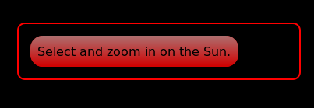
</div>

Command example. The following command example creates a div that when clicked, tells Nightshade to speed up time. The entire 'effect' div would be replaced with a button. The phrase "timerate rate 300" would be the button text. There are no transport controls displayed for a command.


<div class="effect" data-type="command" data-value="timerate rate 300">Speed up time.</div>

Image example: Images don't render transport controls. Touching or clicking the thumbnail toggles the image display on the dome. The default location is in the direction of the focal point in Nightshade NG or to the South in Legacy.

<div class="action">
<img data-value="thumbs/02-hst.jpg" data-author="NASA" data-license="Public Domain" data-link="https://en.wikipedia.org/wiki/Hubble_Space_Telescope#/media/File:Hubble_01.jpg" title="Hubble Space Telescope"> </div>
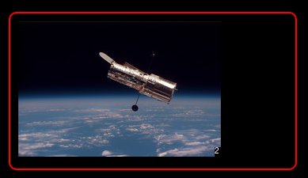

Video example:

<div class='action'>
<div class="effect">
<img src="thumbs/spacesuits.png" title='Testing Video' data-type='video' data-value='media/spacesuits.mp4'></div></div>
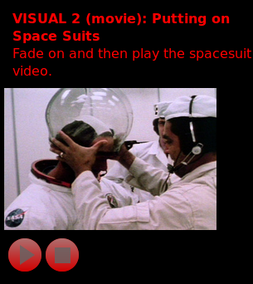

Audio is the same as video, except that you need to be creative about what to use for a thumbnail.

Distributing Augmented Lessons
We strongly recommend that you zip up everything from the lesson directory up to your single lesson. To do this you may need to place it in a temporary directory tree so as not to archive unrelated lessons.

The advantage to this approach is that the end use can just unzip in the root directory of their master media drive.

Be sure to include a copyright and license section so that users know what they can do with your lesson.

Questions?
The best thing to do is start by reviewing other existing lessons for ideas. See the Digitalis Community website for samples.

