Assignment 1-Part II: Learning Network Flow Optimization using Excel and GLPK Solvers

Prepared by [**Jay Przybyla**](mailto:jjpriz@gmail.com) **and** [**Xuesong Zhou**](mailto:xzhou99@gmail.com)

**Learning Objectives:**

1. Learn to use a transportation network with node-link structure for network flow optimization
2. Understand the three sets of constraints for network flow optimization:
   1. Flow balance constraint
   2. Demand/Supply constraint
   3. Flow capacity constraint.
3. Understand mathematical programming models for shortest path problems, minimum cost flow problems with capacity constraints, and maximum flow problems.
4. Solve the three above mentioned problems using Excel Solver.

______________________________________________________________________________

**PROBLEM (1) Node – Link Structure**

Locate input excel sample file under NEXTA Internal_release\importing_sample_data_sets\sample_data_set.xls

Use NEXTA32.exe and click on Menu -> File -> Import-> Single Excel file Load sample spreadsheet, click on import all table button, show the network.

1. Show the link length in miles for link (1->2)
2. Check input_link.csv file, confirm that they are consistent with the input.
3. Manually find the shortest path from node 1 to node 4.
4. Construct a walk, a tour, a tree and a cut starting from node 1 on the 6-node network.
5. Are link sets (1->3), (5->6) and (6->4) a cut in this network?

a/b. The length of the link from Node 1->2 is 2 as per the table below.

|  |  |  |
| --- | --- | --- |
| length_in_mile | from_node_id | to_node_id |
| 2 | 1 | 2 |
| 4 | 1 | 3 |
| 1 | 1 | 5 |
| 2 | 2 | 1 |
| 4 | 2 | 4 |
| 1 | 2 | 5 |
| 4 | 3 | 1 |
| 2 | 3 | 4 |
| 1 | 3 | 6 |
| 4 | 4 | 2 |
| 2 | 4 | 3 |
| 1 | 4 | 6 |
| 1 | 5 | 1 |
| 1 | 5 | 2 |
| 2 | 5 | 6 |
| 1 | 6 | 3 |
| 1 | 6 | 4 |
| 2 | 6 | 5 |

c. The shortest path with the link lengths given is from Node 1->5->6->4 with a total path length of 4.

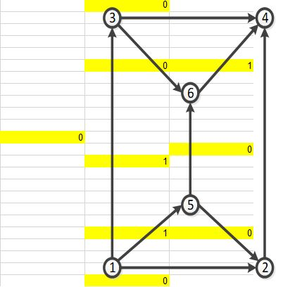

d. Starting from node 1, the following constructions are given as below:

|  |  |
| --- | --- |
| A walk or a sequence of nodes (n1, n2, ..., nk) in which each adjacent node pair is an arc. | 1->5->6->4 |
| A tour is a closed walk with no repeated nodes (path). The first node and the final node on the path are the same node on the network. | 1->5->6->3->4->2->1 |
| A tree is an acyclic (not in a cycle) connected graph. Number of links in a tree is always one less than the number of nodes. |  |
| A cut is partition in a node set in which N is split into two parts [s, $\overline{s}$], in which $\overline{s}=N-s$. Each cut defines a set of arcs consisting of those arc that have one endpoint in s and another endpoint in $\overline{s}$. | e. Link sets 1->3, 5->6, and 6->4 would not represent a cut in the network as node 2 is not accounted for. |

**PROBLEM (2) Safe Hazardous Material Transportation**

The [transportation of hazardous materials](http://phmsa.dot.gov/hazmat) is an important research topic due to the associated risks and impacts. There are a number of ways to reduce the risk of transportation hazardous material, such as driver training or better transportation route planning. This problem is interested in designing the safest route to ship hazardous materials on a transportation network.

For a hazmat shipment, we need to find a safe path from an origin to a destination that involves the smallest probability of collision. A path has a sequence of links, where driving on this path can be viewed as a probabilistic experiment, and the probability of being involved in a collision during one trip is equivalent to the opposite of the probability of no collision occurring for the duration of the trip. Translating this relationship into an equation produces the following function:



where P(crash) is the probability of collision per unit exposure, α is the measure of exposure (time or mileage), and P(crash)α is the total probability of collision due to exposure.

Can you find the safest path on this 6-node network?

Hints :

(1) The objective function can be transformed to  and further converted to sum of log(risk(e)) $\sum_{e}^{ }{log⁡(risk(e))}$ through a log transformation.

(2) Use log(risk(e)) as the edge cost function to solve the problem.

For the year 2018, the crash rate per 100 million miles traveled is 0.002 (6,734,000 crashes/ 3,240,327 million vehicle miles traveled)

<https://cdan.nhtsa.gov/tsftables/National%20Statistics.pdf>

Using the 6-node network given for the shortest path problem, log(risk(e)) was used as the link cost. risk(e) is defined as L*crash rate, where L is the length of the link and the crash rate is 0.002. The link cost therefore in log(risk(e)) is:

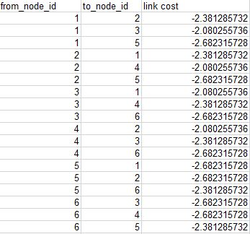 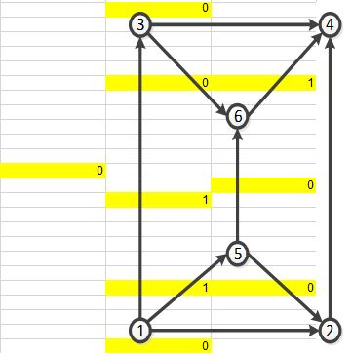

Going from node 1 to node 4, the path that will include the least amount of risk is from node 1->5->6->4. This results in the total minimized cost of -7.75, with a total crash probability of 0.04%. This is like the shortest path problem as the crash risk is proportional to the distance traveled. Minimizing risk would be to minimize the distance traveled.

**PROBLEM (3) The Transshipment Problem on 6-Node Network**

Utilizing the same 6-node network as before, a transshipment problem can be analyzed. This problem builds off the same principles as the shortest path problem but includes multiple origins and destinations. This is handled by changing the Flow Balance column in excel to match the given supply and demands. Travel time is used as the link cost and objective function. Since the given costs are assumed to be travel times for vehicles, the problems ask to increase that travel time 25% to account for the slower moving trucks.

Assume the following given inputs:

There are plants (P) with supply s(i) on nodes 1 and 2; s(1) = 3; s(2) = 3;

There are warehouses (Q) with demand d(j) on nodes 3 and 4; d(3)=4; d(4) = 2;

The travel time for the trucks is calculated by using 1.25% of the given link costs.

Include the given link capacity constraints.

Objective:

The objective is to find the cheapest shipping plan to satisfy all the demands.

Requirements:

1. Modify a min cost flow model to construct an optimization model for the transshipment problem.
2. Solve the problem using Excel Solver
3. **[unequal supply and demand]** Can you find the solution from Excel if the demand on node 4 is increased to 2.5?
4. **[link blockage]** Keeping the supply on node 4 -> 2, what happens if the capacity on link (1->3) is reduced to 2?

Demand and supply of warehouses and plants are represented as:

|  |  |
| --- | --- |
| node_id | Fixed demand /supply |
| 1 | 3 |
| 2 | 3 |
| 3 | -4 |
| 4 | -2 |
| 5 | 0 |
| 6 | 0 |

a/b. Solving for the lowest travel time, modeled as the minimized total path distance yields:

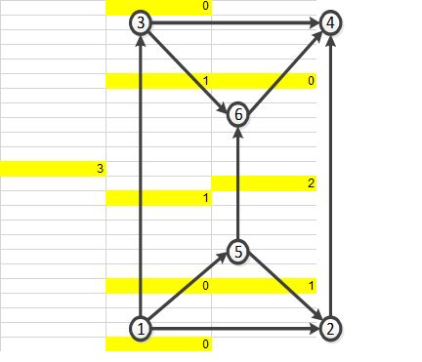

The flow path and flow of materials as outlined in the figure:

|  |  |
| --- | --- |
| Flow path | Flow of materials |
| 1->3 | 3 |
| 2->5->6->3 | 1 |
| 2->4 | 2 |

c. Changing the demand on node 4 to 2.5, would not satisfy the flow balance constraint as all demand would not be satisfied by all the supply provided.

|  |  |
| --- | --- |
| node_id | Fixed demand /supply |
| 1 | 3 |
| 2 | 3 |
| 3 | -4 |
| 4 | -2.5 |
| 5 | 0 |
| 6 | 0 |

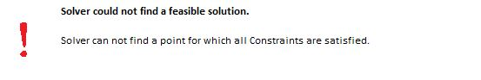

d. Setting the capacity on link 1->3 to 2, the total minimized path is:

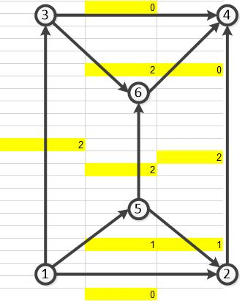

The flow path and flow of materials as outlined in the figure:

|  |  |
| --- | --- |
| Flow path | Flow of materials |
| 1->3 | 2 |
| 2->4 | 2 |
| 2->5->6->3 | 1 |
| 1->5->6->3 | 1 |

**PROBLEM (4) Optimal Delivery Problem on 6-Node Network**

Utilizing the same 6-node network as before, a delivery optimization problem can be solved. This problem also builds off the shortest path problem. In this scenario, we assume a vehicle needs to travel from an origin to a destination with several stops requested within the network. The goal for this problem is to make all the stops while minimizing the costs.

Assume the following given inputs:

A truck needs to go from node 1 to node 4.

There are delivery requests at nodes 2, 3 and 4.

The travel time for the truck is the given link costs.

Objective:

The objective is to find a delivery plan to minimize the total driving cost while satisfying all requests.

Requirement:

1. Modify a min cost flow model to construct an optimization model for the transportation problem
2. Solve the problem using Excel Solver

For the 6-node network, to ensure that the route passes through node 2 and node 3 the following constraints were made.

$$x_{12}+x_{52}+x_{42}≥1$$

$$x_{13}+x_{63}+x_{43}≥1$$

To satisfy these two constraints, the path must pass through nodes 2 and 3 as all inputs through these nodes are accounted for. These constraints allow the path to “revisit” nodes 2 and 3 once it has already passed through them, however doing so would not minimize the path as revisiting a node would not add to solving for the shortest path. Solving the shortest path problem yields the solution of:

1->2->5->6->3->4 with a total path distance of 8.

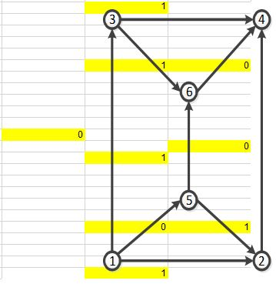

**PROBLEM (5) Most Reliable Path on 6-Node Network**

Utilizing the same 6-node network as before, we can expand the problem to include probabilistic link path reliability. Network links are subject to incidents which can affect the reliability of the link travel time. For instance, a traffic collision, weather, reoccurring congestion, etc., can cause a link to experience longer than usual travel times. This problem asks you to include a link path reliability into the shortest path problems from above.

Assume the following given inputs:

Let Pij be the probability that a link is working, and that all link is independent.

The probability that a path P is working is product of working probability over all links along a path.

Let Pij = # of lanes/5 for each link

Objective:

The objective is to find the shortest and most reliable path.

Requirement:

Construct a shortest path problem to find the most reliable path.

Hints: $max\prod_{(i,j)∈path}^{ }{ }P{(i,j)}_{ }$--> $min\prod_{(i,j)∈path}^{ }{ }\frac{1}{P(i,j)}$

$log[min\prod_{(i,j)∈path}^{ }{ }\frac{1}{P(i,j)}]$--> $\sum_{(i,j)∈P}^{ }{ }log(\frac{1}{P(i,j)})$

Use $log(\frac{1}{P(i,j)})$ as C(i,j)

The following number of lanes was determined for each link classification (in both directions)

|  |  |
| --- | --- |
| Major Arterial | 6 |
| Highway/ Express | 8 |
| Freeway | 8 |

Link cost is outlined as the reliability a link working, found from

|  |  |  |  |
| --- | --- | --- | --- |
| number of lanes | from_node_id | to_node_id | reliability |
| 6 | 1 | 2 | 0.92 |
| 8 | 1 | 3 | 0.82 |
| 6 | 1 | 5 | 0.92 |
| 6 | 2 | 1 | 0.92 |
| 8 | 2 | 4 | 0.82 |
| 6 | 2 | 5 | 0.92 |
| 8 | 3 | 1 | 0.82 |
| 6 | 3 | 4 | 0.92 |
| 6 | 3 | 6 | 0.92 |
| 8 | 4 | 2 | 0.82 |
| 6 | 4 | 3 | 0.92 |
| 6 | 4 | 6 | 0.92 |
| 6 | 5 | 1 | 0.92 |
| 6 | 5 | 2 | 0.92 |
| 8 | 5 | 6 | 0.82 |
| 6 | 6 | 3 | 0.92 |
| 6 | 6 | 4 | 0.92 |
| 8 | 6 | 5 | 0.82 |

Solving the reliability problem from node 1 to node 4, yields the path 1->2->4, with a reliability of 75% of no incident happening along this path.

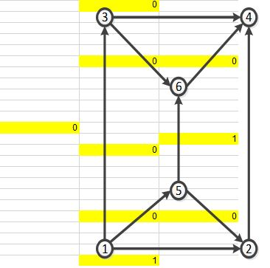

Again, this is like the shortest path problem as adding another link to the path will increase the total distance and decrease the reliability of the overall path.

**PROBLEM (6) Chinese Postman Problem**

Utilizing the same 6-node network as before, we can expand the problem to address the Chinese Postman or Route Inspection Problem. In this problem, the goal is to have the postman visit every link in a network at least once while minimizing the distance traveled. Extending the shortest path problem, this can be determined using the optimization tools. In this problem, we assume a patrol vehicle needs to travel on each link at least once during a round while minimizing the total distance traveled.

Assume the following given inputs:

A patrol vehicle is required to travel each link at least once for each of his rounds.

Objective:

The objective is to find a path for the patrol vehicle while minimizing the total travel distance.

Requirement:

Modify a min cost flow model to construct an optimization model for the Route Inspection Problem.

Hints:

Min z=∑ij cij x ij

Subject to

∑i x ij - ∑k x jk =b

x ij j≥1 $∀(i,j)∈A$

The following constraints were set to ensure that every link be visited once:

$$x_{12}+x_{21}≥1$$

$$x_{13}+x_{31}≥1$$

$$x_{15}+x_{51}≥1$$

$$x_{25}+x_{52}≥1$$

$$x_{24}+x_{42}≥1$$

$$x_{56}+x_{65}≥1$$

$$x_{36}+x_{63}≥1$$

$$x_{64}+x_{46}≥1$$

$$x_{34}+x_{43}≥1$$

This set of constraints accounts for the directionality for each link and with the flow having to be 1, each link will be visited at least once.

The shortest path therefore that the postman makes is:

1->3->4->2->1->5->2->5->6->3->6->4 with a total path distance of 20.

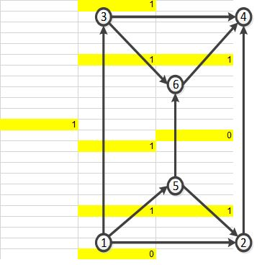The figure shows if the link was used along a single direction but does not show if the path went back against the link.

It should be noted that the additional two constraints that the flow must be an integer and <2 was set as the postman was a singular flow unit.

**Problem 7:**

Use GNU LP solver and Chicago network with capacity constraints.

<https://github.com/xzhou99/STALite/tree/master/dataset/5_Chicago_sketch>

Reference:[Modeling in GNU MathProg language - a short introduction](http://www.im.pwr.wroc.pl/~pziel/lectures/om/glpk_notes.pdf)

<http://en.wikibooks.org/wiki/GLPK>

<http://www.cs.cmu.edu/~ckingsf/bioinfo-lectures/linearp.pdf>

Source code:http://trac.astrometry.net/browser/trunk/projects/archetypes/glpk-4.31/examples/spp.mod?rev=9312

Using the online Glpk solver, the Chicago network was analyzed to solve for the shortest path problem. 933 nodes were inputted into the solver to solve for the shortest path between the two nodes chosen of 859 (start node) and 725 (end node). The output from the online Glpk solver is given below.

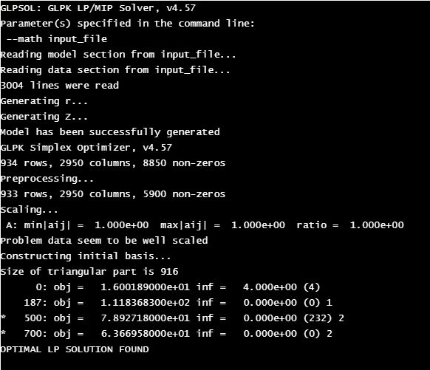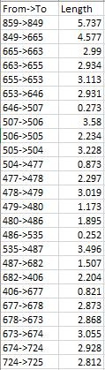

The solution found as outlined in NEXTA:

