**DESIGN AND IMPLIMENTATION OF AN ONLINE ADVERTISEMENT SYSTEM**

**(A CASE STUDY OF YALWAN MAKAMA ADVERTISEMENT WORLD)**

**BY**

**SHUAIBU YAHAYA ANKA**

**(NAS/CSC/17/1293)**

**AUGUST, 2021**

**DESIGN AND IMPLIMENTATION OF AN ONLINE ADVERTISEMENT SYSTEM**

**A CASE STUDY OF YALWAN MAKAMA ADVERTISEMENT WORLD**

**BY**

**SHUAIBU YAHAYA ANKA**

**(NAS/CSC/17/1293)**



A PROJECT

SUBMITTED TO THE DEPARTMENT OF COMPUTER SCIENCE, FACULTY OF

NATURAL AND APPLIED SCIENCE

IN PARTIAL FULFILLMENT OF THE REQUIREMENT FOR THE AWARD OF

BACHELOR OF SCIENCE (BSc.) IN COMPUTER SCIENCE ALQALAM UNIVERSITY KATSINA

AUGUST, 2021

**DECLARATION**

I, Hamza Umar Sadi, CST/17/COM/01137 hereby declare that this final year PROJECT report was written by me based on my personal experience under the supervision of Mal. Saminu M. Aliyu and has not been submitted anywhere for the award of any certificate.

______________________________ ________________________

SHUAIBU YAHAYA ANKA DATE (NAS/CSC/17/1293)

# CERTIFICATION

This is to certify that I, SHUAIBU YAHAYA ANKA, NAS/CSC/17/1293 of the Department of mathematical Science, alqalam University, Katsina conducted my PROJECT as part of the requirement for the award of Bachelor of Science (B.Sc) degree in Computer Science.

_________________________ _____________________

DR. AHMAD IBRAHIM SAFANA DATE

**(SUPERVISOR)**

_________________________ _____________________

Dr. ARMAYAU UMAR ZANGO DATE

**(HEAD OF DEPARTMENT)**

# DEDICATION

Firstly, I thanked ALLAH(S.W.T.) for this piece of work, the beneficent and merciful, the selfexisting and the supporter of all, the giver and forgiver, the hidden and plain, the king of kings, God the almighty, the giver of wisdom and understanding, for his inspiration on the course of writing this report, and to my entire caring and loving family for all their moral support, advice and courage, and their support in every aspect, courage, advice and financial support. I pray ALLAH to richly bless them all InshaAllah.

I dedicate this project to my late Mother Mal. Binta Umar(Yalwa) who passed away with full of wishes upon me, may her perfect and gentle soul rest in perfect peace Ameen, and also my dedication goes to my mentor and also a suspensor of education Alhj. Aliyu Ibrahim Dogarai (Makaman Ningi) who always supported me advisably and financially,I also extended my dedication to my living mother Haj. Sadiya Ibrahim Dogarai(Umma) who tirelessly support,encourages and motivated me and also my lovely sister Zahra,u Sadi Umar (Ummi) who always pray and supported me financially and my lecturers especially my humble level coordinator Mal. Saminu I. Aliyu and also my supervisor.

# ACKNOWLEDGEMENT

In the name of Allah the almighty, the most Gracious the most merciful, All praise is indeed due to Allah the cherisher, the sustainer, the provider and the all knower, and may Allah`s Peace and Blessing be upon the Prophet, the Prophet family and all his companions.

Firstly I would like to thank my parent especially my late Mother Mal. Binta Umar(Yalwa) who passed away with full of wishes upon me,my father Mal. Sadi Ishaq, my siblings( especially my lovely sister Zahra,u Sadi Umar (Ummi),Bashir Sadi ,Aliyu Sadi,Sumayya Sadi,Zainab Sadi ,late Abubakar Sadi ,Hassan and Hussaini Sadi, Nasir Muhammad and all my relative for their continus support throughout my studies. Not forgetting my humble, wonderful and respected supervisor and my humble level coordinator as well in parson of Malam Saminu M. Aliyu for his tolerance, support, courage and endurance in all these time and also for his endeavor to create a time in no time to review this work. I pray that may Allah continue to increases his knowledge, uplift him to the highest rank and him prosper in all his endeavor,

My immeasurable big thanks and acknowledgment goes to those people that always encourages,support,motivate and unstoppably pray for me especially Baba sadiya(Umma&and her family),Alhj. Aliyu Ibrahim Dogarai(Yaya Ali),UmmanNadaure,Zahrau(Ummi),Nasir Muhammad(NASS family)Bashir sadi (Yaya)Khalil Ibrahim Adamu(KIAs),Jamila Rabiu bello,Nafisa Rabiu bello,Sani Bashir,Abba,Alhaji,Deeni,Frank,Sage,Halifa,Pepe and my friends.

Also my special acknowledgement goes to all my classmate/coursemates especially Abubakar lukman Ibrahim,Abdurrazak Ridwan Ahmad Anas Abdussalam Lawan,Abubakar Sulaiman muhd,Muhammad Umar Muhammad,Ibrahim Yunus Muhammad, Ibrahim Ismail Umar, Nasir Muhammad,Salim,Abdullahi,Ridwan,Muzzami,Gaddafi,Abdulbasit,Abdurrahman,Musa

Ladan,Abdurrazak, NACOSS Excoss and all those that I haven’t mention, it doesn’t means that I forget with you, no you’re all the same to me as a family.

Table of Contents

CERTIFICATION iv

DEDICATION v

ACKNOWLEDGEMENT vi

TABLE OF FIGURES ix

TABALE OF TABLES x

ABSTRACT xi

CHAPTER ONE 1

INTRODUCTION 1

1.1 BACKGROUND OF THE PROBLEM 1

1.2 STATEMENT OF THE PROBLEM 2

1.3 AIMS AND OBJECTIVES 2

1.4 SIGNIFICANCE OF THE STUDY 2

1.5 SCOPE OF THE STUDY 3

1.6 LIMITATIONS OF THE STUDY 3

1.7 DEFINITION OF TERMS 3

CHAPTER TWO 6

LITERATURE REVIEW 6

2.0 INTRODUCTION 6

2.1 OVERVIEW 6

2.2 REVIEW OF INTERNET ADVERTISING 7

CHAPTER THREE 28

SYSTEM ANALYSIS AND DESIGN 28

3.1 INTRODUCTION 28

3.2.1REQUIREMENT ANALYSIS TECHNIQUE 28

3.2.2DESCRIPTION OF THE EXISTING SYSTEM 29

3.2.3SHORTCOMINGS OF THE EXISTING SYSTEM 29

3.2.4DESCRIPTION OF THE PROPOSED SYSTEM 29

3.3 SYSTEM DESIGN 29

3.3.1 USE CASE DIAGRAM: 29

3.3.2 Class Diagram 30

3.3.3Flowchart Diagram 31

3.4 FUNCTIONAL REQUIREMENTS 32

3.5 NON-FUNCTIONAL REQUIREMENTS 33

3.7SYSTEM SPECIFICATION 34

3.7.1INPUT SPECIFICATION 34

3.7.2 OUTPUT SPECIFICATION 35

3.8 DATABASE DESIGN 35

CHAPTER FOUR 38

SYSTEM IMPLEMENTATION AND TESTING 38

4.1 INTRODUCTION 38

4.1.1 System Implementation Tools 38

4.2 CHOICE OF PROGRAMMING LANGUAGE 38

4.3. HARDWARE AND SOFTWARE REQUIREMENT 39

4.3.1 Hardware Requirement 39

4.3.2 Software Requirement 39

4.4INSTALLATION / HOSTING 40

4.6 SYSTEM TESTING 45

4.6.1 Unit Testing: 45

4.6.2 Integration Testing: 45

4.6.3 System Testing: 46

4.7 MAINTENANCE AND OPERATION 46

Details 47

CHAPTER FIVE 49

SUMMARY, CONCLUSION AND RECOMMENDATIONS 49

5.1 SUMMARY 49

5.2 CONCLUSION 49

5.3 RECOMMENDATION 49

REFERENCES 50

APPENDIX 56

PROGRAM SOURCE CODE 56

Home.php 57

Database: 63

# TABLE OF FIGURES

Figure 2. 1IOTA service system (Source: Idemudia et al., 2017; Li et al., 2018) ....................... 26

Figure 3. 1: software Development life cycle 28

Figure 3. 2 Use case Diagram ....................................................................................................... 30

Figure 3. 3 Class Diagram ............................................................................................................ 31

Figure 3. 4: Flowchart Diagram .................................................................................................... 32

Figure 3. 5 Entity Relationship Diagram ...................................................................................... 37

Figure 4. 1: : Screen shot of homepage 41

Figure 4. 2: Screen shot of user registration form ........................................................................ 41

Figure 4. 3: Screen shot of admin login page. .............................................................................. 42

Figure 4. 4: Screen shot of advertisement page. ........................................................................... 42

Figure 4. 5: Screen shot of advertisement details page. ................................................................ 43

Figure 4. 6: Screen shot of advertisement details page. ................................................................ 43

Figure 4. 7: Screen shot of admin login page. .............................................................................. 44Figure 4. 8: Screen shot of admin dashboard. ............................................................................... 44

# TABALE OF TABLES

Tsble 2. 1 Samples of research methods to improve online shopping revenues and banner ad

click-through rates .......................................................................................................................... 9

Table 3. 1: Description of Processes ............................................................................................. 35

Table 3. 2: Description of Entities ................................................................................................ 36

Table 3. 3 Description of Data Stores ........................................................................................... 36

# ABSTRACT

*Online Advertisement/Marketing, which is also referred to as internet marketing, involves the utilization of intelligent, interactive, and virtual components for the advancement and promotion of business goods and business ventures on the internet. Recently, web-based communication companies have contributed to the advancement and restructuration of major economic divisions including marketing. Being financially-effective, flexible, adaptable and fast and enjoying an extraordinary global reach, internet marketing has achieved various unimaginable incredible gains for businesses. However, this effective, new technique additionally involves building an online marketing system.*

*In order to develop an online advertisement system, a number of programming technologies must be studied and understood.*

*These include multi-tiered architecture, server and client-side scripting techniques, implementation technologies such as HTML, CSS and a Server-side programming language (such as PHP) and relational databases. This is a project with the objective to develop a basic online advertisement system for Yalwan Makama Advertisement world where business goods and ventures can advertise their goods and business ventures and sell seamlessly.*

*Keywords: Internet advertisement, banner ads, click-through rates, Internet revenues, social ecommerce, information systems, online market places*

# CHAPTER ONE

# INTRODUCTION

### 1.1 BACKGROUND OF THE PROBLEM

The internet has opened a new dimension of business opportunities in the advertising arena by completely replacing conventional sources of information through its interactivity and ease of operation. Providing a widespread market-reach in cost effective manner, the internet has led to the emergence of numerous marketing advances that also breakthrough the web barrier.

Since information technologies cannot benefit organizations unless they are used, Management Information System researchers have focused a great deal of attention on factors that affect the use of information technology (Swanson, 2018). Information technology (IT) researchers have turned their attention to factors that affect the use of end-user’s systems information technology utilized directly by non-technical knowledge workers and managers most especially in multiproduct manufacturing companies in underdeveloped and developing African countries like Nigeria, Cameroon, Ghana, etc. These researchers have employed two perspectives to examine the degree to which sales workers and sales managers use various advertising techniques.

Information technology advancements have introduced a number of incredible things that were dreams in the past. The idea of web-based supermarket service is a very strong idea for today’s business and it can put valuable effects on the business of any organization in today’s competitive business environment.

The Web-based supermarket is developed for replacing the existing manual system at organizations providing facility of home delivery with online shopping capabilities. The far-off user can place order from web and from internet enabled cellular phones. It provides online Shopping facility to remote users. It would like be a point of order system. The system will capture Sales Information at POST (point of sale terminal) and Customers Information. Unlike the existing outdated largely manual Sale, and Inventory systems.

### 1.2 STATEMENT OF THE PROBLEM

Using Yalwan Makama advertisement world as the case study of this study there is much stress and a lot of problems attributed to traditional/conventional advertisements at the study area. In this method of advertising a product to the public, very few numbers of consumers are reached at a time , this kind of individual attention makes it very slow and expensive for the company to get across too many people in a competitive market. These factors influenced the developing of a web-based advertisement so as to reach very large number of consumers at the same time in very short period of time. Other problems include;

1. Limited customers are targeted in the existing system.
2. Lack digitization services.
3. Customer has to visit the physical sales location before he can make purchase.
4. Difficult data integration.

### 1.3 AIMS AND OBJECTIVES

The aim of this project is to design and develop an online advertisement management system for Yalwan Makama advertisement world to effectively use the internet medium as a means of bringing the products of the companies to the awareness of a very large number of consumers so that the company can sell quickly. The objectives of the study are:

1. To carry out preliminary investigation of the existing system.
2. To examine the traditional way of doing the existing business (System).
3. To developed and implement the proposed system. iv. To test the validity of the system.

### 1.4 SIGNIFICANCE OF THE STUDY

This project reveals not only the benefits of the computer technology that are directly making the life of human-being easier but also putting valuable impact on the environment. The project utilizes its sound experience in the web and wireless sector to craft innovative online and mobile advertising solutions for enterprises. The project portfolio encompasses development an

information-rich and enhanced graphics website for a company’s products display so as to come closer to the public at very fast rate.

### 1.5 SCOPE OF THE STUDY

The project focuses on developing a web-based system implemented on local host server for advertisement of goods and services of small and medium business, choosing Yalwan Makama advertisement world as a case study. The study samples the activities of Yalwan Makama advertisement world, Kano being an advertisement company specialized on advertisement of varieties of products and services. The case study is chosen as it satisfies the target of the research focused advertisement company.

However, the project does not cover the accounting system of the organization. The application software developed for this project is neither an inventory system nor stock monitoring application. It scope is limited to developing an that provides basic market-based information about products and as well provides an avenue for regular customers of the sales department make online orders of goods.

### 1.6 LIMITATIONS OF THE STUDY.

The limitations are;

1. The system doesn’t send a notification via email or text message.
2. The system doesn’t support cash back; the payment used is just a simulation.
3. There is no order tracking for customers.
4. The system doesn’t support multiple address delivery; it uses only a specified address provided by the customers.

### 1.7 DEFINITION OF TERMS.

**LAN**: Local Area Network is a collection of interconnected computers that can share data, applications, and resources, such as printers. Computers in a LAN are separated by distances of up to a few kilometers and are typically used in offices or across university campuses.

**IVR**: Interactive Voice Response – is a technology that automates interactions with telephone callers. Enterprises are increasingly turning to IVR to reduce the cost of common sales, service, collections, inquiry and support calls to and from their company.

**PEER-TO-PEER**: Peer-to-peer (P2P) computing or networking is a distributed application architecture that partitions tasks or workloads between peers. Peers are equally privileged, equipotent participants in the application. They are said to form a peer-to-peer network of nodes.

**CLIENT-SERVER**: Client/server describes the relationship between two computer programs in which one program, the client, makes a service request from another program, the server, which fulfills the request.

**POS**: Point of sale (POS) (also sometimes referred to as Point of purchase (POP)) or checkout is the location where a transaction occurs. A ―checkout‖ refers to a POS terminal or more generally to the hardware and software used for checkouts, the equivalent of an electronic cash register. A POS terminal manages the selling process by a salesperson accessible interface. The same system allows the creation and printing of the receipt.

**EDI**: Electronic data interchange (EDI) is the structured transmission of data between organizations by electronic means. It is used to transfer electronic documents or business data from one computer system to another computer system, i.e. from one trading partner to another trading partner without human intervention.

**1.8 ORGANISATION OF THE REPORT.**

This is the overall organizational structure of the work as presented in this project. Chapter one of this project deals with the general introduction to the work in the project. It also entails the aims and objectives of this project, the significance of the study, the methods used for data collection, the scope and limitation of the study.

Chapter two presents a review of literature. It discusses the roles of advertising agencies or departments and the impacts of advertising on the economy, politics and society. It also looks into review of past projects related to the project topic of study.

Chapter three covers the analysis of the existing system, description of the current procedure, problems of existing system (procedure) itemized, description of the proposed system and the basic advantages of the proposed web-based application for library management.

Chapter four entails design, implementation and documentation of the system. The design involves the system design, output design form, input design form, database structure and the procedure of the system. The implementation involves the implementation techniques used in details, choice of programming language used and the hardware and software support. The documentation of the system involves the operation of the system and the maintenance of the system. Chapter five deal with summary, conclusion, recommendation and references.

# CHAPTER TWO

# LITERATURE REVIEW

### 2.0 INTRODUCTION

The chapter contains review of some literatures related to the study.

Literature review is the assessment of previous work carried out on the same or related projects and extracts relevant points to serve as milestone in the project at hand. Various works were studied and analyzed. The review and the lessons learnt forthwith, informed the choice of technologies employed for the development of this research outputs.

The introduction of computer into information technology has massively improved the information need of organization; the success of this machine is dependent on the knowledge base. Therefore, one can be prompted to ask aloud ―what is a computer‖. According to (Anigbogu, 2000), A computer is an electronic device capable of accepting data and instructions, processing the data based on the instructions to generate results or output in such a manner that is yet to be equaled by any other known machine to mankind.

### 2.1 OVERVIEW

Webster and Watson (2017) argue that in the Information Systems (IS) field, there are very few published review articles. Literature reviews represent the theoretical foundation for research in the IS discipline (Webster & Watson 2017).

A strong indication that this study has important practical implication is that for the past decade there has been a consistent growth of Internet advertising revenues due to the constant increase of web users and online visitors worldwide. For example, On April 2013, the Internet Advertising Bureau (IAB) announced that the advertising revenues in the US in 2018 were $37 billion (15 percent), having increased over 2011 (IAB 2013). To glean a share from the Internet revenues, companies are investing billions of dollars on online banner ads and Internet advertising (Idemudia, 2009; Li et al., 2018). Companies are using online banner ads to advertise their products and services to web users and new online visitors (Chickering & Heckerman, 2012; IAB, 2013).

Idemudia (2009) argues while the amount of advertising revenues from banner ads have increased steadily over the last decade due to the constant increase in the number of people who have access to the Internet and shop online, the banner ad click-through rates have been decreasing steadily. The main problem with Internet advertising is that web users and online visitors currently pay very little attention to all the online banner ads that are displayed on their computer monitors, so click-through rates are low (Idemudia et al., 2017; Li et al., 2018; Kazienko& Adamski, 2017). The most common technique to measure the effectiveness of online banner ads is the click-through rates, because these rates are easy to measure and capture (Karagu et al., 2011; Li et al., 2018; Nakamura & Abe, 2015.

Currently, research on Internet advertising, social e-commerce, and online market places have focused mainly on mathematical models and data mining techniques for ad personalization and customization (Attardi et al., 2016; Chickering & Heckerman 2012; Feng et al., 2012; Feng et al., 2016; Idemudia et al., 2017b; Idemudia & Lin, 2008; Idemudia, 2009; Kazienko& Adamski, 2017; Krol, 2015; Kumar, 2011; Lacerda, 2016; Langheinrich, Nakamura, & Abe, 2018; Li et al., 2018). There are limited studies relating to animation, flashing, and moving pictures of online banner ads (Babin et al., 1997; Borse & Lang, 2010; Ellsworth & Ellsworth, 2014; Hong et al., 2016; Kalyanaraman & Oliver, 2011; Kim et al., 2012; Sundar et al., 2012; Sundar et al., 2011; Yoo et al., 2016; Yoo& Kim, 2015; Zhang, 2010), location of online banner ads on the computer monitors (Doyle, 2017), and linear programming for ad placement, personalization, and scheduling of online banner ads (Chickering & Heckerman, 2012; Langheinrich et al., 2012; Nakamura & Abe, 2015).

The rest of our paper is organized as follows: Section 2 presents a detailed comprehensive literature review of Internet advertising, social e-commerce, and online market places. Section 3 discusses the conclusions, research, and practical implications.

# 2.2 REVIEW OF INTERNET ADVERTISING

Kroenke (2011) argues that the five components that make up information systems are hardware, software, data, procedure, and people. The literature review as shown in the *Table 1* (Source: Idemudia, 2009) strongly supports the five components of information systems: (1) web users are the people, (2) cookies, or log files from e-commerce websites, are the data for the mathematical models, (3) the mathematical models for ad personalization and customization are the procedure, (4) the database for storing web users’ profiles is the software, and (5) the electronic components that make up the web users’ computers are the hardware. In this section we discuss how the literature review of Internet advertising and online market places strongly support the five components of information systems (See Table 1).

2.2.1 SOME INFLUENTIAL MATHEMATICAL

Approaches and Models to Solve Ad Personalization, Placement, and Scheduling Problems

For the past two decades, the three main problems that are associated with online banner ad click-through rates and Internet advertising are ad scheduling, ad placement, and ad personalization of online banner ads (Kazienko& Adamski, 2017). To address these problems, there have been many published studies in the information systems, information sciences, and computer science disciplines using mathematical models and data mining techniques. For example, Langheinrich et al. (2012) and Adler et al. (2017) developed linear programming models using large-scale simulated experiments to solve scheduling, ad placement, and ad personalization problems. To improve click-through rates and Internet advertising, it is essential to first address all problems relating to ad placement and scheduling (Adler et al., 2011). Solving the optimal ad placement and scheduling problems maximizes the number of web users that click online banner ads (Langheinrich, 2012). The two main sequential steps related to solving scheduling and placement of online banner ad problems are: (1) knowing the scheduling and placement of advertisement ads in advance and (2) determining the subset of advertisement that will maximize click-through rates and advertising revenues for both the advertisers and publishers that own the advertising slots (Adler et al., 2017; Langheinrich et al., 2012). Adler et al. (2017) argues that heuristic approaches can be used to solve ad placement, personalization, and scheduling problems for online banner ads. Kumar et al. (2010) argues that heuristic approaches do not provide reliable solutions for ad placement, personalization, and scheduling. Hence, Kumar et al. (2010, 2011a, 2011b) developed hybrid genetic algorithms to solve the ad personalization, placement, and scheduling.

**Tsble 2. 1 Samples of research methods to improve online shopping revenues and banner ad click-through rates**

|  |  |
| --- | --- |
| Researchers | Approach or Method to increase banner ad click-through rates by solving ad placement and scheduling problems |
| Abe and Nakamura (2012) | Adaptive methods and clustering of target attribute values which is an extension of linear programming |
| Abu-Shanab and Ghaleb (2018) | Adoption of Mobile Commerce Technology: An  Involvement of  Trust and Risk Concerns |
| Adler et al. (2017) | Heuristic Approaches |
| Agrawal and Srikant (2014) | Mining sequential patterns using web log mining |
| Ahmed and Mahmood (2018) | Web Usage Mining: Discovery and use of AIOU Web  Usage Patterns |
| Alshehri et al. (2018) | The Impact of Trust on E-Government Services  Acceptance: A Study of Users’ Perceptions by Applying  UTAUT Model |
| Amiri and Menon (2012) | Lagrangean decomposition. |
| Amiri and Menon (2012) | Cost-per-thousand-impression (CPM) model |

|  |  |
| --- | --- |
| Ayanso et al. (2011) | The Effect of Customer Service and Content Management on  Online Retail Sales Performance: The Mediating Role of  Customer Satisfaction |
| Bae et al. (2012) | Clustering analysis |
| Bhatnagar and Papatla (2011) | Effect of search and navigation records |
| Borse and Lang 2010 | Animation and moving graphics of banner ads improve affection, mental processing, and mental reasoning |
| Chen and Sharma (2013) | Understanding Member Use of Social Networking Sites:  A Value Analysis. |
| Dawande et al. (2012) | Set of heuristics to analyze average performance |
| Deitel et al., 2010; Laudon and Laudon 2016; Laudon and Traver 2015,2017;  Schneider 2016; Slyke and Belanger  2012; Turban et al., 2015, 2016 | Collecting data from web users and online visitors through online cookies, questionnaires, web logs, log files for ecommerce web sites, and web users’ input from the keyboard |
| Deng and Poole (2010) | Affect in Web Interfaces: A Study of The Impacts of  Web Page Visual  Complexity and Order |
| Djamasbi et al. (2018) | Faces and Viewing Behavior: An Exploratory  Investigation |
| Dologite et al. (2013) | Consideration of web users and online visitors’ shopping  and buying activities |
| Dologite et al. (2013) | Knowledge-based systems that assist in displaying banner ads |
| Dreze and Hussherr2012 | Are web users and online visitors watching Internet advertising? |
| Dreze and Zufryden2018 | The comparison of advertising effectiveness on the  Internet to standard media (i.e. broadcast, print etc.) |
| Dreze and Zufryden2018 | Issues relating to the accurate measurement of Internet advertising (i.e. the problem of identifying unique site visitors on the web, the problem of caching, the problem of defining and measuring ad effectiveness on the web) |

|  |  |
| --- | --- |
| Featherman et al. (2011) | The Influence of Interactivity on E-service Offerings: An Empirical Examination of Benefits and Risks, *AIS Transactions on HumanComputer Interaction* (3) 1, pp.  1-25. |

|  |  |
| --- | --- |
| Fruchter and Dou (2015) | Dynamic programming to optimize budget allocation over time by using keywords in web sites and web pages |
| Gallgher and Parson (1997) | Effect of demographic customer profiles |
| Guttman et al. (2018); Maes et al. (2012) | Association rule and collaborative filtering techniques |
| Heo and Sundar (2010); Li and Bukovac  (2012) | Banner ad animation to improve short- and long-term memory and recollection of products and services from banner ads |
| Hong et al., 2016 | Animation of banner ads to improve attention |
| Huang and Lin (2016) | The application of the negative binomial distribution on web sites that are visited by web users and online  visitors |
| Idemudia et al. (2018) | The Visual Perception Model |
| Idemudia et al. (2017b) | Linear programming |
| Idemudia and Lin (2008) | Network Advertising |
| Idemudia et al. (2013) | The Influence of IT-Related Beliefs on Emotional Trust for a Smartphone and Smartphone Continuance Usage:  An Empirical Study. |

|  |  |
| --- | --- |
| Kalyanaraman and Oliver (2011) | Animation of banner ads to improve persuasive appeals of web users and online visitors to click the ads |
| Kalyanaraman and Oliver (2011) | Banner ad animation to increase excitement and enthusiasm in web users and/or online visitors |
| Karuga et al. (2011) | AdPalette approach that enhances banner ad customization by using techniques from genetic algorithms, optimization, goal programming, and  conjoint analysis |
| Kazienko and Adamski (2017) | AdROSA techniques |
| Kim et al. (2011) | Decision-tree induction techniques |
| Kumar et al. (2010, 2011a, 2011b, 2016) | Hybrid genetic algorithms |
| Kumar et al. (2017) | Hybrid pricing models (i.e. advertiser pay is a function of the amount of banner ad exposure and the number of clicks on the ad) |
| Langheinrich et al. (2012) | Linear programming to maximize the number of clickthrough rates |
| Langheinrich et al. (2012) | Web users’ short- and long-term interests to enhance ad personalization and customization |
| Lee and Lee (2016) | Comparison challenge approach (i.e. prototype system  of  CompareMe) that uses the compare me and compare them strategies |
| Lee et al. (2018) | Can online wait be managed? The effect of filler interfaces and presentation modes on perceived waiting time online |
| Li et al. (2018) | Ranking Algorithm for Intermediated online targeted advertising and the resources of banner ad allocation |
| Li and Bukovac (2012) | Banner ad animation and moving graphics to increase excitement, concentration, and click-through rates |
| Lin and Hsu (2012) | Analytic hierarchy process and grey relational analysis |

|  |  |
| --- | --- |
| Manchanda, et al., 2016 | Using survival model to measure the impact of online ads based on customers’ probabilities of repurchase |
| Menon and Amiri (2016) | Lagrangean decomposition and column generation |
| Metwally et al. (2017) | Hit inflation techniques |
| Metwally et al. (2017) | Association rules |

|  |  |
| --- | --- |
| Nakamura (2015) | Efficient method (i.e. extending the work of Langheinrich et al., 2012) to solve the multi-impressions (more than one banner ad is impressed simultaneously) and inventory management problems |
| Nakamura and Abe (2018) | Recommendation agents with collaborative and contentbased filtering |
| Nakamura and Abe (2015) | Linear programming |
| Ngai 2017 | The application of the analytic hierarchy process (AHP) to select the best web site for Internet advertising |
| Ngai 2017 | Multi-criteria approach (i.e. impression rate, monthly cost, audience fit, content quality, and look and feel) to analyze and compare web sites for online advertising |
| Pitta and Fowler (2015); Rappa (2016) | Network advertising |
| Quinlan (2013) | Customer segmentation and classifiers using decision tree |
| Saeed et al. (2018) | Usability Evaluation of Hospital Websites in Pakistan |
| Schafer et al. (2011) | Ephemeral personal approach (i.e. using prior web users’ online shopping behavior to display different banner ads for different web users) |

|  |  |
| --- | --- |
| Schlosser et al., 2012 | Web users’ attitude toward online advertising (i.e. comparing Internet advertising to advertising in general) |
| Schlosser et al., 2012 | The examination of consumers’ perceptions and judgments of Internet advertising |
| Siew and Yi (2010) | Agent-mediated Internet advertising |
| Sheng and Joginapelly (2018) | Effects of Web Atmospheric Cues on Users’ Emotional Responses in E-Commerce. |
| Thatcher et al. (2013) | A Classification and Investigation of Trustees in B-to-C eCommerce:  General vs. Specific Trust |
| Tomlin (2010) | Statistical techniques that are derived from entropy maximization (i.e. entropy model that includes  randomization and extension of linear programming) |
| Wang and Zhang (2018) | The Evolution of Social Commerce: The People,  Management,  Technology, and Information Dimensions |
| Well et al. (2011) | What Signal Are You Sending? How Website Quality  Influences Perceptions of Product Quality and Purchase |
|  | Intentions. |
| Yager (2010) | Fuzzy approach that is based on user profiles |
| Yager (1997) | Intelligent agents |
| Yih et al. (2016) | Content and keywords of web pages and web sites to display banner ads |

The hybrid genetic algorithms are a better and more robust and reliable approach to solving ad placement, personalization, and scheduling problems compared to the heuristic approaches (Kumar et al., 2010, 2011a, 2011b). Meta-analysis of the literature review shows that different techniques can be used to solve the ad placement, personalization, and scheduling problems, for example, Chickering and Heckerman (2012) argue that linear programming can be used to solve the ad placement and scheduling problems. Statistical techniques, such as entropy maximization, can be used to solve the ad placement and scheduling problems (Tomlin, 2010). Lagrangean decomposition can also be used to solve ad personalization, placement, and scheduling problems (Amiri & Menon, 2012).

2.2. Cookies, Log Files, and Keyboard for Online Advertising and Market Places

Laudon and Laudon (2016) define cookies as ―tiny files deposited on a computer hard drive when a user visits certain Web sites‖ (p. 158). Chickering and Heckerman (2012) argue that to solve problems relating to ad personalization, placement, scheduling, and ad inventory management, the input data and information for linear programs must be accurate, reliable, updated, and valid. There are many studies in the information systems and computer science disciplines concerned with using cookies to collect data to solve ad personalization, scheduling, and placement problems so that the online banner ads that are displayed on the computer monitors address web users’ and online visitors’ immediate wants and needs (Amiri & Menon, 2011, 2012; Chickering & Heckerman, 2012;

Feng et al., 2012; Feng et al., 2016; Huang & Lin, 2016; Idemudia et al., 2017a, 2017b;

Kazienko& Adamski, 2017; Karuga et al., 2011; Lacerda, 2016; Lee & Lee, 2016; Li et al., 2017, 2018; Metwally et al., 2017; Nakamura, 2017; Pitta & Fowler, 2015; Rappa, 2016). Web usage mining improves customization and personalization of web users’ needs and wants (Ahmed & Mahmood, 2018).

Meta-analysis of the literature review in our study indicates that some of the techniques and tools used to collect data from web users and online visitors in Internet advertising and online market places are cookies, questionnaires, web logs, log files, mouse, joysticks, and keyboards (Deitel et al., 2010; Idemudia et al., 2017a, 2017b; Jessup & Valacich, 2016; Kalata, 2011; Laudon &

Laudon, 2016, 2015; Laudon & Traver, 2015, 2017; Li et al., 2018; Napier et al., 2012; Schneider, 2016; Slyke & Belanger, 2012; Turban et al., 2015, 2016). Also, some IS scholars and researchers have conducted research using cookies to monitor, screen, and capture web users’ and online visitors’ actions, shopping, and browsing behaviors (Deitel et al., 2010; Idemudia et al., 2017a, 2017b; Idemudia & Lin, 2008; Jessup& Valacich, 2016; Kalata, 2011; Li et al., 2017; Laudon & Laudon, 2016, 2015; Laudon & Traver, 2015, 2017; Napier et al., 2012; Schneider,

2016; Slyke & Belanger, 2012;Turban et al., 2015, 2016).

Most social media firms and online companies are using cookies to identify web users who used a particular computer so as to enhance ad personalization and customization in the online market places (Deitel et al., 2010; Idemudia et al., 2017a, 2017b; Idemudia & Lin, 2008; Jessup &

Valacich, 2016; Kalata, 2011; Li et al., 2017; Li et al., 2018; Laudon & Laudon, 2016, 2015;

Laudon & Traver, 2015, 2017; Napier et al., 2012; Schneider, 2016; Slyke & Belanger, 2012;Turban et al., 2015, 2016). Also, companies can use cookies, log files, and information from online questionnaires and keyboard input to form database that store web users’ and online visitors’ shopping profiles and activities (i.e. websites visited, pages viewed, banner ads that are clicked, products or services purchased, and credit cards used online for making purchases)

(Deitel et al., 2010; Idemudia et al., 2017a, 2017b; Idemudia & Lin, 2008; Jessup & Valacich,

2016; Kalata, 2011; Laudon & Laudon, 2016, 2015; Laudon & Traver, 2017; Li et al., 2017,

2018; Napier et al., 2012; Schneider, 2016; Slyke & Belanger, 2012; Turban et al., 2015, 2016). Many companies are using cookie and log files to update their databases for ad personalization and customization (Deitel et al., 2010; Jessup & Valacich, 2016; Kalata, 2011; Laudon &

Laudon, 2016, 2015; Laudon & Traver, 2015, 2017; Napier et al., 2012; Schneider, 2016; Slyke & Belanger, 2012; Turban et al., 2015, 2016).

2.2.3 Some Influential Algorithms for Internet Advertising an Online Market Places

Many studies in the information systems, information sciences, and computer science disciplines have developed mathematical models and algorithms to generate, allocate assign, personalize, and customize ads (Amiri & Menon, 2011, 2012; Dawande et al., 2012; Fruchter & Dou, 2015; Huang & Lin, 2016; Idemudia et al., 2017; Idemudia & Lin, 2008; Kazienko& Adamski, 2017; Karuga et al., 2011; Kumar et al., 2016; Kumar et al., 2017; Lee & Lee, 2016; Li et al., 2017,

2018; Lin & Hsu, 2012; Metwally et al., 2017; Nakamura 2017; Rappa, 2016). Linear programming models improve click-through rates and Internet advertising revenues (Chickering

& Heckerman, 2012; Idemudia et al., 2017b; Langheinrich et al., 2012; Nakamura & Abe, 2015). Linear program solves advertising delivery problems (Langheinrich et al., 2012). One of the main limitations of the linear program developed by Langheinrich et al. (2012) is the lack of validation and authentication in the real world setting. To address some of the limitations of the linear program developed by Langheinrich et al. (2012), Chickering and Heckerman (2012) developed a new linear program, and they validated their program in a real world setting using predictive segments and web log data. Linear programming improves click-through rates, because it displays customized and personalized ads based on web users’ shopping and browsing behaviors online (Chickering & Heckerman, 2012). Amiri and Menon (2012) extend prior linear programs using the cost-per-thousandimpression (CPM) approach and traditional optimization techniques to develop a new linear program that solves ad placement, scheduling, and personalization problems. Amiri and Menon (2012) empirically validated their model using randomly generated data.

For the past two decades, researchers and scholars have extended prior linear programs to solve ad personalization, scheduling, and placement problems. For example, Nakamura and Abe (2015), using attributes-set-driven ads, extended prior linear programs that improve clickthrough rates and banner ad optimization. Unlike prior linear programs, the linear program developed by Nakamura and Abe (2015) addressed issues relating to displaying multiple banner ads at the same time and multi-impressions. Nakamura and Abe (2015) argue that linear programming is valuable and beneficiary to both publishers and advertising because it improves click-through rates and online revenues. Also, Nakamura and Abe (2015) validate their linear programs and findings using simulated data. Compared to prior linear programs, the linear program developed by Nakamura and Abe (2015) is unique because the program includes: (1) Gittins index that predicts click-through rates using object function, (2) a semi on-line learning method for unifications, and (3) a lowering bounding technique that assigns display probabilities on all ads that are displayed on the computer monitors.

To help improve click-through rates and advertising revenues, many scholars and researchers have developed different types of mathematical models. Kazienko and Adamski (2017) developed the Advertising Remote Open Site Agents (AdROSA) to help solve ad scheduling, placement, and personalization problems. The AdROSA is beneficiary to web users because it secures and protects web users’ data, records, and information (Kazienko& Adamski, 2017). The sequential steps for AdROSA are: (1) extraction of data and information from the contents of websites and web pages, (2) the extraction of data and information from store databases that store web users’ profiles, (3) and data mining techniques and tools used for segmentation and cluster analysis to help enhance ad customization and personalization (Kazienko& Adamski, 2017). Some researchers and scholars found that click-through rates and internet advertising is improved if online banner ads displayed on the monitor are based on web users’ geographical location, age, sex, demographic, education, and work experience (Gallgher& Parson, 1997; Kazienko& Adamski, 2017).

Decision trees can be used for customers’ segmentation and breakdown to enhance target marketing (Quinlan, 2013). Knowing web users’ short- and long-term interests enhances clickthrough rates, Internet advertising, revenues, ad personalization, and customization (Langheinrich et al., 2012). Clustering of web users’ navigation paths enhances segmentation during target marketing (Bae et al., 2012). Fuzzy approach can be used to develop web users’ profiles for ad scheduling, personalization, and ad placement (Yager, 2010). Data mining techniques can be used for ad placement, ad personalization, and ad scheduling (Lai & Yang, 2010; Perner & Fiss, 2017). Karuga et al. (2011) developed the AdPalette algorithm by using techniques from genetic algorithms, optimization, goal programming, and conjoint analysis. Some of the advantages and benefits of AdPalette are: (1) an improved response rate, (2) an enhanced storage of web users’ profiles in databases, and (3) improved click-through rates (Karuga et al., 2011).

2.2.4. Behavioral Research Relating to Internet Advertising and Online Market Places

To improve Internet advertising revenues and click-through rates, there have been some studies that investigated the influence and relationship between human behavior and online banner ads. Banner animation and moving graphic draws the attention and improves the concentration of web users and online visitors (Borse & Lang, 2010; Kalyanaraman & Oliver, 2011; Reiber, 1991; Sundar et al., 2012; Sundar et al., 2011). Banner animation increases joy, excitement, interest, attention, concentration, happiness, and click-through rates (Li & Bukovac, 2012).

Banner ads involving moving graphics and animations increase web users’ and online visitors’ excitement, interest, and enthusiasm (Kalyanaraman & Oliver, 2011). Animation of online banner ads improves short- and long-term memory and retention relating to products and services displayed by the online ads (Heo& Sundar, 2010; Li & Bukovac, 2012). Banner animation and moving graphics have a positive influence on online visitors and web users’ attitudes and beliefs (Kalyanaraman & Oliver, 2011). Web users prefer moving graphics and animations compared to static and stationary objects (Sundar et al., 2011). Web users pay greater attentions to moving graphics and animations when processing relevant and important information during Internet advertising (Sundar et al., 2011). Moving graphics and animation of online banner ads draws the attention, focus, and concentration of web users and online visitors (Borse & Lang, 2010; Ellsworth & Ellsworth, 2014; Kalyanaraman & Oliver, 2011; Reiber, 1991; Sundar et al., 2012; Sundar et al., 2011). The speed of online banner ad animation and moving graphic influences the effectiveness of online ads (Zhang, 2010).

Some studies have strongly supported the effect of moving graphics and animation of online banner ads on click-through rates. For example, Hughes (2011) asserts that animation of online banner ads draws the attention and concentration of web users and online visitors. Banner animation has a positive influence on the attention and concentration of web users (Borse & Lang, 2010; Kalyanaraman & Oliver, 2011; Kim et al., 2012; Sundar et al., 2012; Yoo& Kim, 2015). Banner animation improves clickthrough rates (Li & Bukovac, 2012). Banner animation improves memory, retention, and recall (Borse & Lang, 2010). Banner animation has a positive influence on ad messages and information (Ellsworth & Ellsworth, 2014). Banner animation has a positive influence on attitude and beliefs (Kalyanaraman & Oliver, 2011). Animation of banner ads and moving graphics has a positive and linear relationship on attention, concentration, mental, and cognitive intensity (Yoo& Kim, 2015). Banner ads with flash features attract web users’ attention and concentration (Hong et al., 2016). It should be noted that some researchers and scholars have argued in their studies that animation of banner ads does not draw the attention and concentration of web users. For example, Pytlik (2017) argues that banner animation does not improve click-through rates and Internet advertising. Banner animation does not offer any value to web users and online visitors (Pytlik, 2017). Irrelevant animation reduces click-through rates, internet advertising, and distracts web users’ attention from the central task (Zhang, 2010). Abu-Shanab and Ghaleb (2018) argue that perceived trust, perceived usefulness, and perceived ease of use have a positive effect on mobile commerce adoption. Trust has a positive impact on e-government and e-commerce adoption (Alshehri et al., 2018). Usability has a positive influence on websites, e-commerce, and e-government adoption (Alshehri et al., 2018).

Finally, Hong et al. (2016) argues that it is not clear if animation and moving graphics have a positive influence on web users’ attention, concentration, and click-through rates. Hence, they encourage future researchers to investigate and examine the effect of multimedia on web users’ attention, click-through rates, and Internet revenues.

2.3 SOCIAL E-COMMERCE

2.3.1. Intermediated Online

Target Advertisement (IOTA)

Some of the objectives of prior models for target advertising and ad personalization are (1) to improve click-through rates, (2) to improve online revenues from online banner ads, (3) to improve the customization and personalization of banner ad design, (4) to improve the effective and efficient tracking of web users’ and online visitors’ shopping and browsing behaviors, (5) to improve the effective recording and tracking of web users’ online shopping and browsing behaviors, and (6) to effectively and efficiently recognize web users and online visitors. Prior models have been very helpful; however, these models failed to adequately meet each of the objectives listed above (Idemudia et al., 2017a and 2017b; Li et al., 2018). Also, currently, the lack of an adequate pricing model that satisfies both publishers and advertisers is a persistent and challenging problem (Idemudia et al., 2017a and 2017b; Li et al., 2018). To address these issues and to solve the ad placement, personalization, and scheduling problems during target advertising, Idemudia et al. (2017b) developed the intermediated online target advertisement (IOTA) service systems as shown in Figure 1. For more information on the IOTA please see Idemudia et al. (2017b) and Li et al. (2018).

Idemudia et al. (2017b) and Li et al. (2018) present that for an IOTA to function effectively and efficiently, the IOTA must include four main agents:

Online visitors and web users who use the Internet to perform daily activities and tasks such as communication, shopping online, professional development, etc.

Ad publishers who help advertisers publish their websites by providing banner slots/ spaces for ad placement and publishing. An example of a common ad publisher is Facebook.

Advertisers who sell products and services worldwide to both regular web users and online visitors; thus, advertisers serve as the main source of revenue.

The IOTA service provider that provides Internet ad services to online visitors, web users, advertisers, and publishers. An example of an IOTA service provider is DoubleClick by Google. It should be noted that it is the IOTA service provider that monitors and manages digital/online advertisement for online visitors, web users, publishers, and advertisement. Also, the IOTA service provider offers the appropriate mechanisms to improve clickthrough rates, capture the performance of online ads, and generate revenue.

The IOTA service provider is the mediator among web users, online visitors, ad publishers and advertisers (Idemudia et al., 2017; Li et al., 2018). The modules that are included in effective and efficient IOTA service providers are: (1) optimum decision modeling, (2) ad management systems, and (3) real time ad publishing (Idemudia et al., 2017b; Li et al., 2018). In the IOTA service system, it is the ad management systems that manage, regulate, and control the ad

.

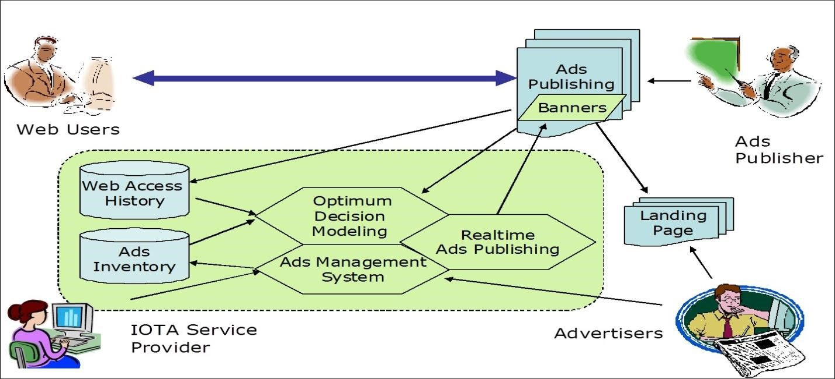

**Figure 2. 1IOTA service system (Source: Idemudia et al., 2017; Li et al., 2018)** inventory (Idemudia et al., 2017b; Li et al., 2018). The main objective of the optimum decision modeling module is to use the data stored in the web access history for ad personalization and customization based on web users’ shopping and browsing behaviors (Idemudia et al., 2017; Li et al., 2018). The concept behind ad personalization and customization is based on the principle of Web 2.0 (Idemudia et al., 2017b; Li et al., 2018). The principle of Web 2.0 is that companies are using cookies and log files from e-commerce websites to collect data from web users and online visitors; then, these online shopping behaviors are segmented into clusters with unique attributes and personalized ads are then assigned to each cluster based on web users’ shopping behaviors and activities (Idemudia, 2017a, 2017b; Li et al., 2018)1.

IOTA Service System has the ability to reduce the risk associated with information asymmetrics relating to all the agents in the IOTA by improving website quality (See Figure 1). Well et al.

(2011) argues that during e-commerce, website quality has a positive influence on consumers’ perceptions of product quality, thus affecting online purchase intentions. IOTA improves interactive e-services. Featherman et al. (2011) argue that interactive e-services have a positive impact on perceived involvement and authenticity as well as higher intangibility and risks of eservices. Also, interactive e-service has a positive intention to use eservices (Featherman et al.,

2011). IOTA improves web users’ satisfaction through ad personalization (Idemudia et al., 2017; Li et al., 2018). Ayanso et al. (2011) discuss that retailer’ efforts in online customer service and content management have a positive impact on customer satisfaction; thus, they indirectly have a positive impact on the retailers’ online sales performance. Finally, Idemudia et al. (2013) present factors that influence smartphone continuance usage to participate in future global distributed teams relevant for social e-commerce.

# CHAPTER THREE

# SYSTEM ANALYSIS AND DESIGN

### 3.1 INTRODUCTION

As a computer science-based project this chapter is intended to provide the detailed description of all that we need in terms of hardware and software materials. This chapter aimed at describing the detail description of the system, system design and the system specification.

3.2 SYSTEM ANALYSIS

System analysis simply refers to what is required of the system as well as the procedures and components required to make the system work on specification. It consists of an in-depth analysis of how the existing system worked, its strengths, weakness, benefits and above all its problem which give side to this research work. In carry out system analysis, an analyst must first define the scope within which he intends to work.

##### 3.2.1REQUIREMENT ANALYSIS TECHNIQUE

Data that was collected through the use of questionnaires, interviews and in-depth literature review enabled researchers’ study how advertisement is taken place and what is involved in the process of advertisement management system. Waterfall model is used as the software development tool for this project

Project

Planning

Maintenance

Requiremen

t Gathering

Analysi

s

Design

Implementatio

Testing

**Figure 3.**

**1**

**:**

**software Development life cycle**

##### 3.2.2DESCRIPTION OF THE EXISTING SYSTEM

The existing system used in marketing/advertisement is the use of primitive promotions channels such as press, brochure, catalogue, TV, cell phone, bill boards, etc, and several offline channels which lacks a comprehensive, harmonizing marketing framework.

##### 3.2.3SHORTCOMINGS OF THE EXISTING SYSTEM

There is much stress and a lot of problems attributed to traditional/conventional advertisements. In this method of advertising a product to the public, very few numbers of consumers are reached at a time, this kind of individual attention makes it very slow and expensive for the company to get across too many people in a competitive market. These factors influenced the developing of a web-based advertisement so as to reach very large number of consumers at the same time in very short period of time

## 3.2.4DESCRIPTION OF THE PROPOSED SYSTEM

The Advertisement Management System (AMS) application created in this project provides a common platform to do online advertising and publishing respectively, thereby helping businesses that are both advertisers and publishers. The AMS application aims to utilize the market of online advertising and publishing by providing an easy-to-use platform for ad serving. This system will benefit large and small businesses in advertising their products or services and generate revenue by publishing ads on their web pages.

### 3.3 SYSTEM DESIGN

System design is the structural implementation of the system analysis. It is a descriptive in nature of what the system is and what it does and shows how the expected program is to be operated. This project is designed to replace the old manual methods of operation thereby, enhancing its efficiency and accuracy.

3.3.1 USE CASE DIAGRAM:

A use case diagram in the Unified Modeling Language (UML) is a type of behavioral diagram defined by and created from a use-case analysis. Its purpose is to present a graphical overview of the functionality provided by a system in terms of actors, their goals (represented as use cases), and any dependencies between those use cases.

ADMIN

CUSTOME

Login

Manage advert

view advert

Manage users

Manage customers

Manage Profile

Purchase

**Figure 3. 2 Use case Diagram**

3.3.2 Class Diagram

A class diagram is an outline of the relationships and source code dependencies among classes in the Unified Modeling Language (UML). In this context, a class characterizes the methods and variables in an object, which is a particular entity in a program or the unit of code representing to that entity

ADMIN

-

id: intr(11)

-

manage ()

-

name:varchar(255)

-

username:varchar(255)

-

password:varchar(255)

ADVERT

-

id:int(255)

()

getBanner

+

-

banner:varchar(5)

-

title:varchar(255)

1..*

1..*

m

anage

make

USER/STAFF

-

id: intr(11)

-

SUBmanage ()

-

name:varchar(255)

-

username:varchar(255)

-

password:varchar(255)

**Figure 3. 3 Class Diagram**

## 3.3.3Flowchart Diagram

A flowchart diagram is a connection chart that shows how procedures work with each other and in what request.

A

displayer

If displayed?

Enduser view

End

No

Yes

Start

Login

If accepted?

Process advert

A

Yes

No

Add advert

**Figure 3. 4: Flowchart Diagram**

###### 3.4 FUNCTIONAL REQUIREMENTS

These are statements of services the system should provide, how the system should react to particular inputs, and how the system should behave in particular situations. It specifies the application functionality that the developers must build into the product to enable users to accomplish their tasks.

Log in:

The system should allow admin to login to the system using their username and password.

The system shall allow admin to logout.

The system should allow students and Instructors to login to the system using their username and password.

The system should allow users to logout.

Admin:

The system should allow admin to register new users.

The system should allow admin to display all available users.

The system should allow admin to display all available adverts.

The system should allow admin to add/remove adverts.

The system should allow admin to view all uploaded adverts

Users:

The system shall allow user to add advertisement.

The system shall allow users to display all available adverts.

The system should allow users to download advert banner.

###### 3.5 NON-FUNCTIONAL REQUIREMENTS

Non-functional requirements, as the name suggests, are requirements that are not directly concerned with the specific services delivered by the system to its users. They may relate to emergent system properties such as reliability, response time, and store occupancy. Alternatively, they may define constraints on the system implementation such as the capabilities of I/O devices or the data representations used in interfaces with other systems. Non-functional requirements, such as performance, security, or availability, usually specify or constrain characteristics of the system as a whole.

The system should be easy to maintain.

The system should be compatible with different platforms.

The system should be fast as customers always need speed. iv. The system should always be available online all times.

The system should be secure.

The system should be accessible to online users.

The system should be easy to learn by both sophisticated and novice users.

The system should provide easy, navigable and user-friendly interfaces.

The system should produce reports in different forms such as tables for easy visualization by management.

The system should have a standard graphical user interface that allows for the on-line data entry, editing, and deleting of data with much ease.

## 3.7SYSTEM SPECIFICATION

##### 3.7.1INPUT SPECIFICATION

The input item specification shows the method of input, tells what data will be input to the system, and in what formation. It also tells the input devices to be used for the program include all the necessary data which forms the basic input to the system. It also includes all the necessary information to be used in the computation. The basic input to the system includes: -

Full name of the user/member

Advertisement details

Advert fee

Gender

Age

Address

Username

Password

3.7.2 OUTPUT SPECIFICATION

The output is what emerges from the computer system for the user to act upon. A program may with justification be judged by the quality of its output. The output derived and section tells the type of information to be produced, the output derived and method also shows the processing involved in the output. The output items for the new system are in form of prompt output, message output and instruction output. These output forms relate to operating the system itself. The output indicates to users that some input is required and more helpful what kind of information is required.

The message and instruction output serves as the help message and the error message encountered.

### 3.8 DATABASE DESIGN

The DBMS used was MySQl because of its simplicity and easy to use and this section includes details of the database design. The three most prominent and important tables are described below:

**Table 3. 1: Description of Processes**

|  |  |
| --- | --- |
| Process | Description |
| Validate users | Compares user input with details of registered users. |
| Process advert | Processes uploaded adverts. |
| Generate advert banner | Generate picture advert with contents. |
| Authentication | Authenticates users to access the system, and blocks unauthorized access. |
| Manage advert Updates | Processes updates to advertisement records. |
| Generate Reports | Generates reports as requested by admin Officers. |

**Table 3. 2: Description of Entities**

|  |  |
| --- | --- |
| Entity | Description |
| User | A userthat view adverts, clicked adverts, register and upload their adverts. |
| Admin | Views reports about online adverts and update records whenever necessary. |

**Table 3. 3 Description of Data Stores**

|  |  |
| --- | --- |
| Data store | Description |
| Advert Records | Store’s advertisement details. |

3.8.2 Entity Relationship Diagram (ERD)

An ERD was used to show the relationships between the entities involved in the system together with their attributes and indicate the number of occurrences an entity can exist for a single occurrence of the related entity.

ADMIN

USER_ID

First name

Last name

username

password

manage

ADVERT

ad_id

Banner

Title

View/buy

CUSTOMER

address

name

phone

cus_id

Price

Type

username

password

owner

**Figure 3. 5 Entity Relationship Diagram**

# CHAPTER FOUR

# SYSTEM IMPLEMENTATION AND TESTING

### 4.1 INTRODUCTION

System implementation is a phase where documented design description is done. Implementing a system is the process of transforming the system specifications into an executable system, it is also a stage where designed system is implemented using a computer application such as programming language.

#### 4.1.1 System Implementation Tools

These are tools used for the system implementation

Select the development language for the system.

Database support and compatibility

Height efficiency and effectiveness

User friendly and simplicity of its interface

Selecting operating system (os) system for the system windows (7 or later). Its chosen because of the following:

Rebuts memory management

Popularity and familiarity

Minimum resource requirement

Selecting Database management system for the system implementation

### 4.2 CHOICE OF PROGRAMMING LANGUAGE.

The system was developed as an interactive mechanism between the user at the interface, and the database using the web browser. It was designed using vscode and xampp server. These tools enable the admin and the user through a browser to interact with MySQL database to enter, edit, view, and retrieve data, as privilege granted. These activities were achieved using: HTML forms which offer the best layout to enter, change and view from database. This form was also kept as short and simple as possible to suit the individual who will provide data. PHP is the language used for scripting and data communication between the frontend and the backend.

The choice of programming used is top-down approach. This approach was used because the project arrangement was in linear format and linear format is always from top to-down to achieve a goal.

### 4.3. HARDWARE AND SOFTWARE REQUIREMENT

#### 4.3.1 Hardware Requirement

For the successful implementation and compatibility working with the new system. The system required a personal compiler (system unit) with the following configuration.

933 Megahertz (MHz) of processor speed or faster than that

125 Megabyte (MB) of ram or bigger than this

2 Gigabyte (GB) hard disk or larger than this at least 15MB available space is required to installed the program file.

Super VGA (800x600) monitor is recommendable

Keyboard

Mouse or compatible pointing device

CDRom or DVD derive

Printer

#### 4.3.2 Software Requirement

Windows 10 or later version

Vscode or any text editor

Xampp server

MS word

## 4.4INSTALLATION / HOSTING

This consist of the process of installing / hosting of the new system and the way of learning the system

Install Wamp server or Xamp in your computer

Copy the folder into www (for wamp) or htdocs (for xamp)

Open phpmyadmin to create the database

Import the sql file into the database created

Open localhost and locate the folder under your project

4.5 SYSTEM OPERATIONAL PROCEDURES

The system is designed with a switch board containing all the activities to be performed on the software which can be seen when either the admin or the user login based on the activities assign to them. This allows the user to navigate and use the system easily. The forms contain navigational buttons that allow user to navigate through different components of the system or through records.

4.5.1 Homepage

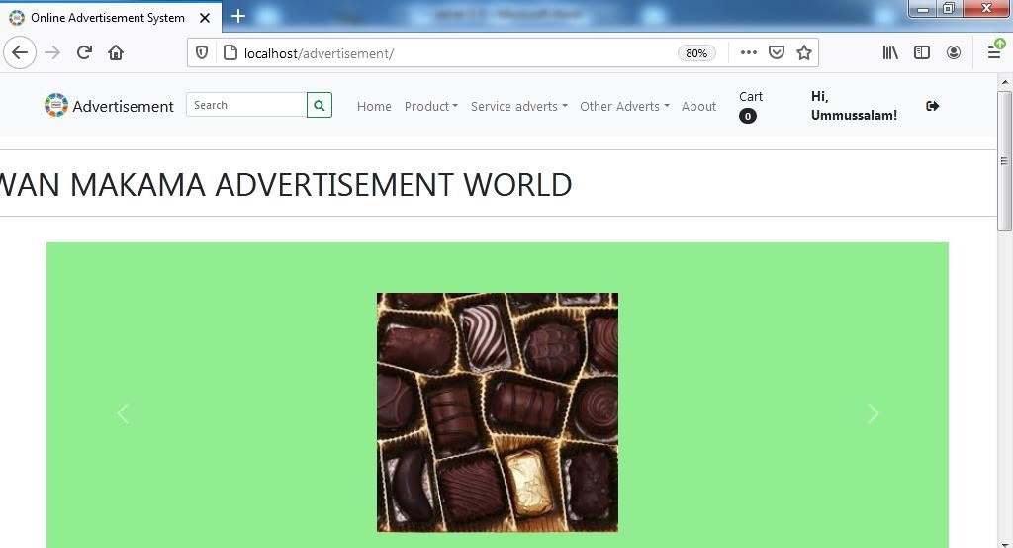

**Figure 4. 1: : Screen shot of homepage**

4.5.2 user Registration Form

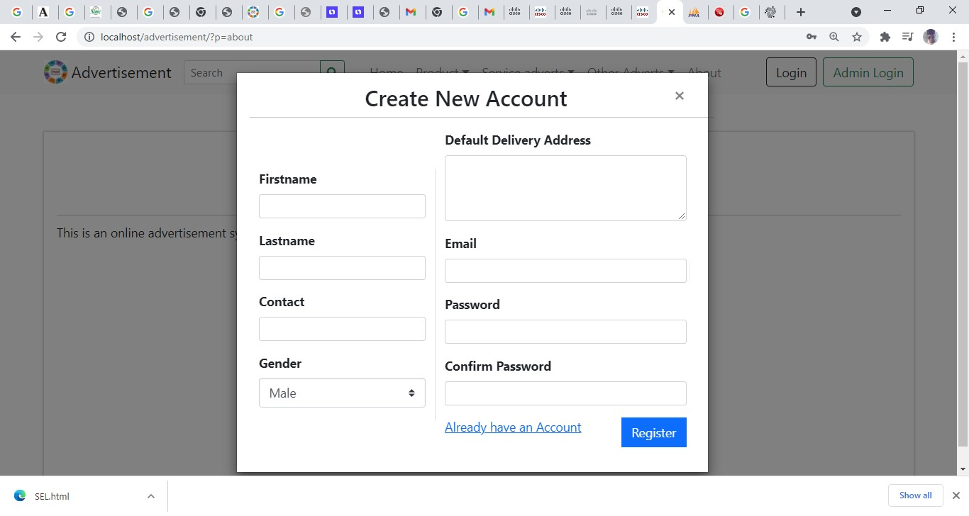

**Figure 4. 2: Screen shot of user registration form**

4.5.3 User dashboard

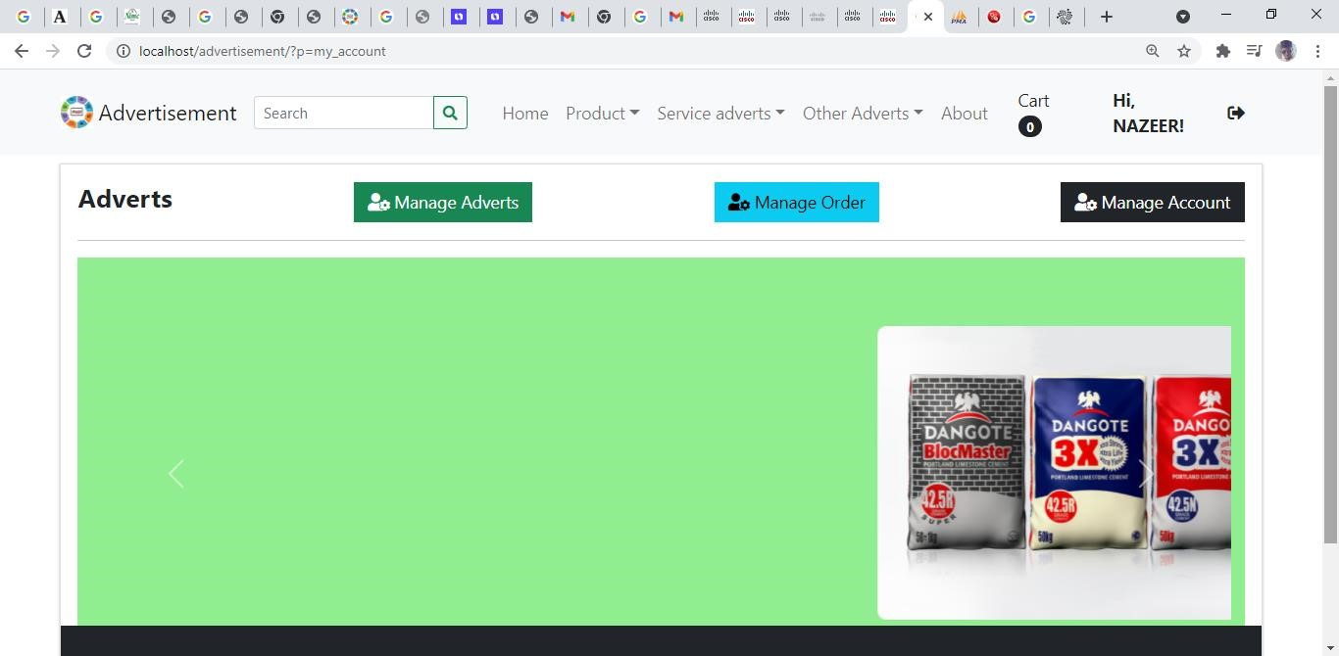

**Figure 4. 3: Screen shot of admin login page.**

4.5.4Advertisement screen

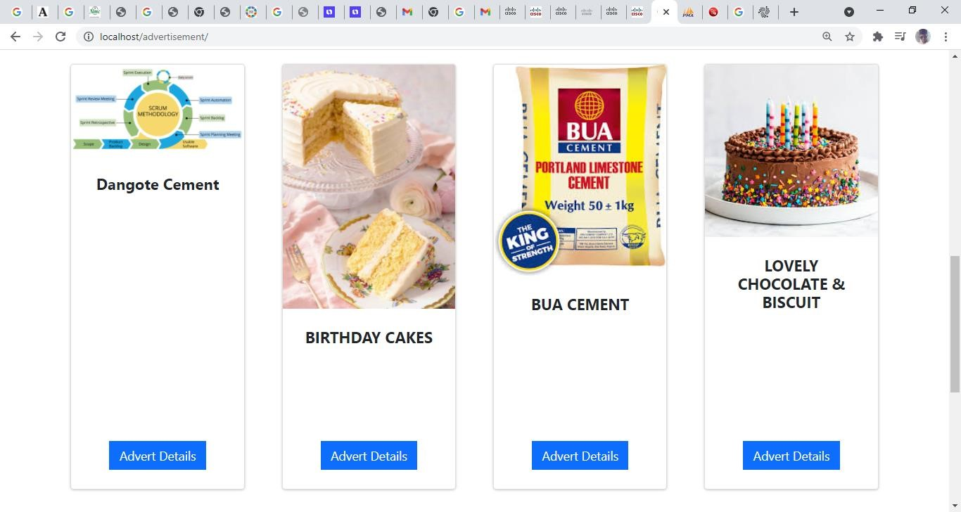

**Figure 4. 4: Screen shot of advertisement page.**

4.5.5Advertisement Details screen

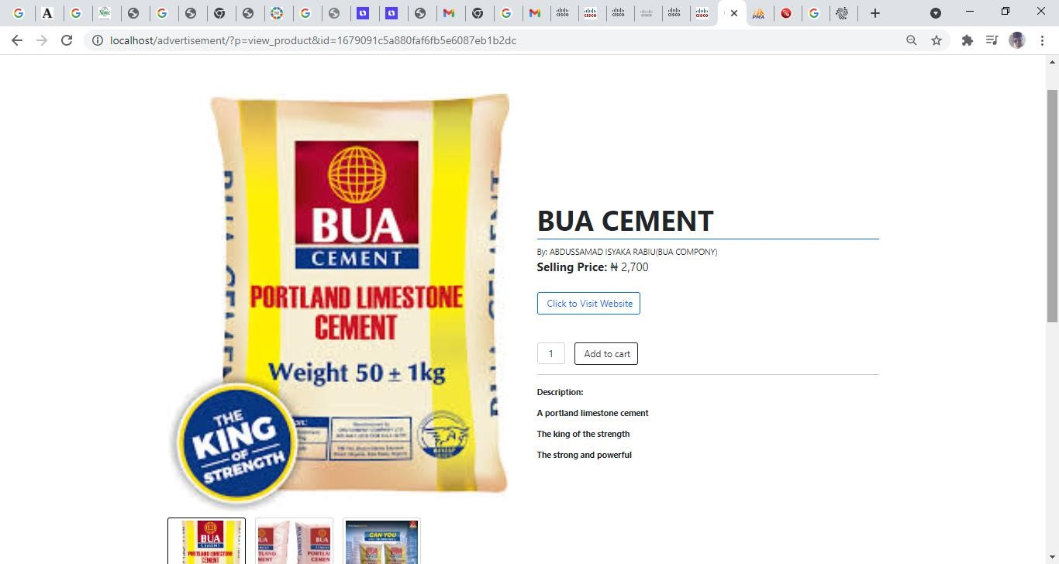

**Figure 4. 5: Screen shot of advertisement details page.**

4.5.6CustomerOrder screen

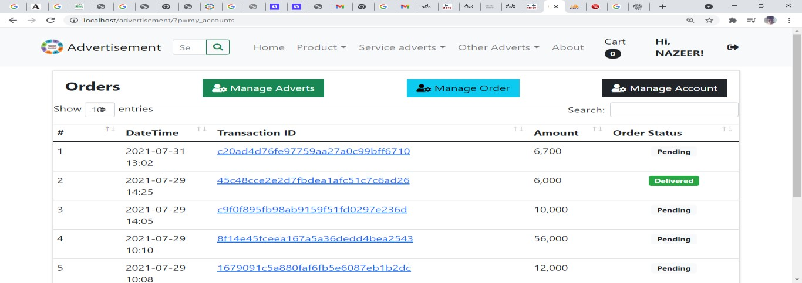

**Figure 4. 6: Screen shot of advertisement details page.**

4.5.5 Admin Login Page

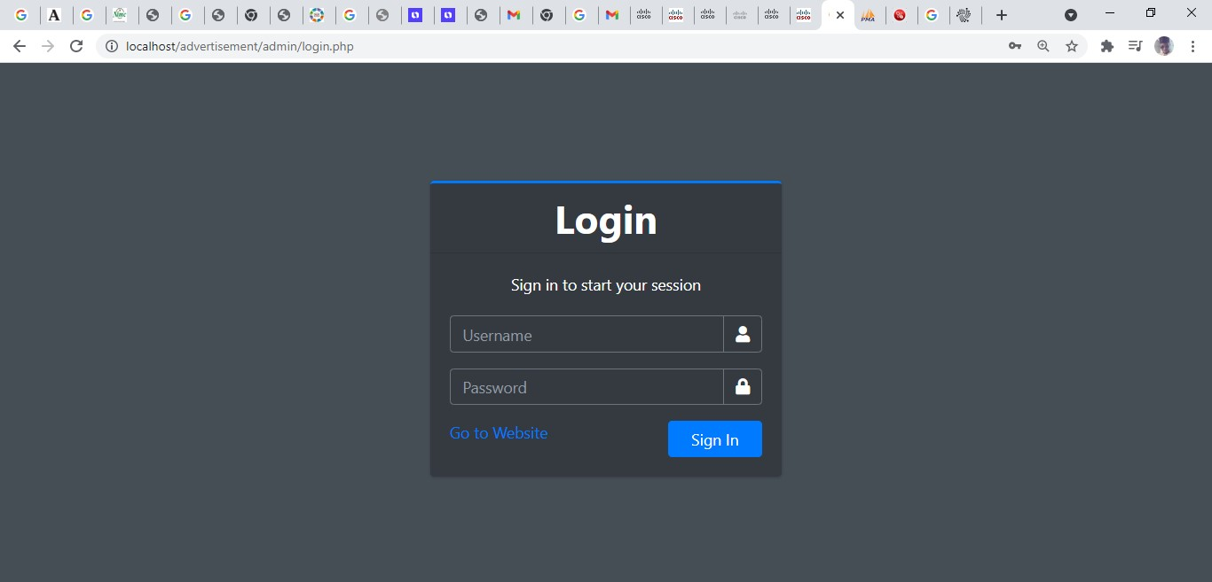

**Figure 4. 7: Screen shot of admin login page.**

4.5.6 Admin dashboard

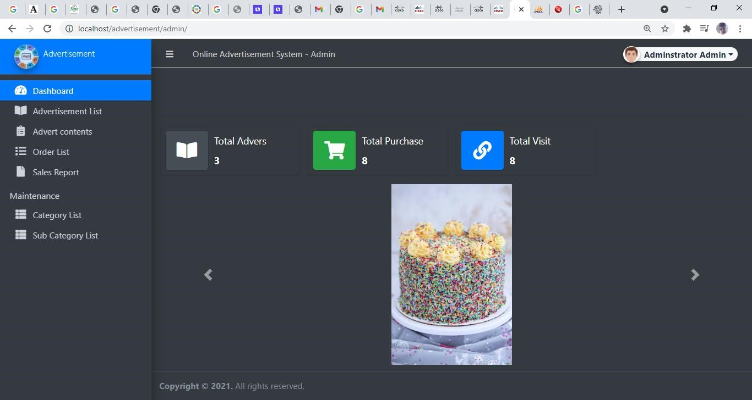

**Figure 4. 8: Screen shot of admin dashboard.**

### 4.6 SYSTEM TESTING

Many different intellectuals in the field of software engineering have given different definition of software testing some which are:

Testing is the process of demonstrating that errors are not present.

The purpose of testing is to show that a program performs its intended functions correctly.

Testing is the process of establishing confidence that a program does what it is supposed to do.

But one of the most captivating one is the one given by K.K Aggarwal & Yogesh Singh in their book (software Engineering, 2007). In the book it is explained that software is tested not to show that a system works perfectly ok but rather a system is tested to show the presence of error in the system and take adequate measure to tackle the errors.

There are quite a number of ways of testing a system but just very few will be discussed in this section, those that mostly relates directly to this application.

#### 4.6.1 Unit Testing:

This testing is conducted to test the most basic operation of the application independently.

Upload module: the input to this module is a document file; different inputs were used to see how the system will react, both the valid and invalid input were tested. Also, the final output was verified so as to ensure that the desired result was obtained.

Download module: this module enables the user to download a given material, assignments and the like.

#### 4.6.2 Integration Testing:

After the design of each module differently and the testing each independently, the different modules were then integrated one after the other to see that it meets the goal of the application. The Level and the course modules were the first to be integrated and the output was then examined. Other modules such as the session module, the activity log module and the user log module were later integrated. The inputs were tested to ensure they don’t coincide to affect the output.

#### 4.6.3 System Testing:

The final phase of the testing process; this test is conducted in order to ensure that the goal of the system is met in terms of performance. It’s a functionality test of the system; it tests the whole module as a single system. At this test phase, the usability, compatibility and dependability were tested. All the valid inputs were used to test the application and the generated output was examined with the expected output. In the event of any discrepancies between the system generated output and the expected output, the system was structurally tested through path testing to see where the error occurs and necessary measures were taken to correct the problem. The application contains quite a number of try catch exception handler to prevent the system from crashing in the case of wrong input and some other unforeseen circumstances that could cause the system to crash leading to user dissatisfaction.

### 4.7 MAINTENANCE AND OPERATION

Maintenance involves operational activities as training users and modifying the organization process in which the new system will be used and maintained. The maintenance cycle of a system applies at all times. Whenever a good system is working, there are feedbacks on the operations, when a problem is encountered or rectifications are needed, the maintenance stage comes in. it leads to control measures that may even take us back to the analysis or development phase. Because of the use of a system receive after it is fully implemented, analysts must take precaution to ensure that the need for maintenance is controlled through design and testing and the ability to perform it is provided through proper design practices.

The types of system maintenance are:

Corrective: involves emergency fixes and routine debugging

Adaptive: Accommodation of changes to data and files, and to hardware and system software.

Perfective: Includes user enhancement, improved documentation, and recording for computational efficiency.

For successful and easy operation of the system, an operational manual was drafted as follows: User Operational Manual for the application guides the user on how he/she will go about using the Software.

# Details

Start your servers

The Home page appears

On the left side and right side of the home page are menus that are used to manage the application.

Select any of the menus to perform various operations

Provide user certificate to access the system and perform the operations (such as uploading advertisement, adding banner and so on).

# CHAPTER FIVE

# SUMMARY, CONCLUSION AND RECOMMENDATIONS

### 5.1 SUMMARY

This project work covered the necessary details involved in designing the online advertisement System. The web-based application is aimed at capturing all the advertadded by the user and storing them in a database. The administrator can access all registered users and make an update if required, grand privileges to users to upload advert successfully in which a user can upload advert and view other adverts. The method of implementation was the use of XAMPP (Apache MySQL and PHP) application package. The basic requirements of the users of the System were given preference during the interface design. Therefore, this project would address the problems of the existing manual advertisement system.

The system was developed through a systematic use of software development methodology in which each phase was given adequate attention so that a reasonable level of reliability was achieved.

### 5.2 CONCLUSION

In conclusion, the aims and objective of this project work were achieved, a program was developed and implemented which served as a solution to the current problems associated with the online advertisement system. This technology has however, proved to be efficient and costeffective means of advertisement.

The possible suggested extensions for further development of the system are:

The system should be able to support synchronous advert

The system should be able to support dynamic location management

The prototype should be improved by implementing the click event for viewing advert.

### 5.3 RECOMMENDATION

After carefully observed the research project, I found out that the web-based advertisement system will provide a strong solution to companies and small-scale business in promoting their products. In this era of computer technology where human beings embrace any method that involves the use of computer system, it is recommended for every business to use this system for advertisement success and patronage of customers.

# REFERENCES

Abe, N., & Nakamura, A. (1999). Learning to optimally schedule internet banner advertisements. In *Proc. of the 16thInternational Conference on Machine Learning* (pp. 12-22).

Abu-Shanab, E., & Ghaleb, O. (2012). Adoption of mobile commerce technology: An involvement of trust and risk concerns. *International Journal of Technology Diffusion*, *3*(2), 36–49. doi[:10.4018/jtd.2012040104](http://dx.doi.org/10.4018/jtd.2012040104)

Adler, M., Gibbon, P., & Matias, Y. (2002). Scheduling space-sharing for Internet advertising. *Journal of Scheduling*, *5*(2), 103–119. doi[:10.1002/jos.74](http://dx.doi.org/10.1002/jos.74)

Agrawal, A., Basak, J., Jain, V., Kothari, R., Kumar, M., & Mittal, P. A. et al. (2004). Online marketing research. *IBM Journal of Research and Development*, *48*(5/6), 671–677. doi[:10.1147/rd.485.0671](http://dx.doi.org/10.1147/rd.485.0671)

Ahmed, M. U., & Mahmood, A. (2012). Web usage mining: Discovery and use of AIOU web usage patterns. *International Journal of Technology Diffusion*, *3*(3), 1–12. doi[:10.4018/jtd.2012070101](http://dx.doi.org/10.4018/jtd.2012070101)

Alshehri, M., Drew, S., Alhussain, T., & Alghamdi, R. (2012). The impact of trust on egovernment services acceptance: A study of users’ perceptions by applying UTAUT model. *International Journal of Technology Diffusion*, *3*(2), 50–61. doi[:10.4018/jtd.2012040105](http://dx.doi.org/10.4018/jtd.2012040105)

Amiri, A., & Menon, S. (2003). Efficient scheduling of Internet banner advertisement. *ACM Transactions on Internet Technology*, *3*(4), 334–346. doi[:10.1145/945846.945848](http://dx.doi.org/10.1145/945846.945848)

Attardi, G., Esuli, A., & Simi, M. (2004). Best bets: Thousand of queries in search of a client. In *Proceeding of the 13th International WWW Conference on Alternate Track Papers & Posters* (pp. 422-423), New York, NY. ACM Press.

Ayanso, A., Lertwachara, K., & Thongpapanl, N. (2011). The effect of customer service and content management on online retail sales performance: The mediating role of customer satisfaction. *AIS Transactions on Human-Computer Interaction*, *3*(3), 156–169.

Babin, L. A., & Alvin, C. (1997). Burns effect of print ad pictures and copy containing instruction on imagine on mental imagery that mediates attitudes.

*Journal of Advertising*, *26*(3), 33–44. doi[:10.1080/ 00913367.1997.10673527](http://dx.doi.org/10.1080/00913367.1997.10673527)

Bae, S. M., Park, S. C., & Ha, S. H. (2003). Fuzzy web ad selector based on web usage mining. *IEEE*

*Intelligent Systems*, *18*(6), 62–69. doi:[10.1109/MIS.2003.1249171](http://dx.doi.org/10.1109/MIS.2003.1249171)

Bhatnagar, A., & Papatla, P. (2001). Identifying locations for targeted advertising on the Internet.

*International Journal of Electronic Commerce*, *5*(3), 23–44.

Borse, J., & Lang, A. (2000). The effects of web banner advertisements: A study of the impact of animation and control on affective, cognitive, physiological responses. In *Proceedings of the Information Systems Division at the 50th Annual Conference of the International Communication Association*, Acapulco, Mexico.

Chen, R., & Sharma, S. K. (2013). Understanding member use of social networking sites: A value analysis. *Communications of the Association for Information Systems, 33*, Article 6.

Chickering, D.,& Heckerman, D. (2003). Targeted advertising on the web with inventory management. *INFORMS Journal of Interfaces*, *33*(5), 71–77.

doi[:10.1287/inte.33.5.71.19248](http://dx.doi.org/10.1287/inte.33.5.71.19248)

Dawande, M., Kumar, S., & Sriskandarajah, C. (2003). Performance bounds of algorithms for scheduling advertisements on a web page. *Journal of Scheduling*, *6*(4), 373–394.

doi[:10.1023/A:1024060710627](http://dx.doi.org/10.1023/A:1024060710627)

Deitel, H. M., Deitel, P. J., & Steinbuhler, K. (2000). eBusiness and e-commerce for manager. Prentice Hall.

Deng, L., & Poole, M. S. (2010). Affect in web interfaces: A study of the impacts of web page visual complexity and order. *Management Information Systems Quarterly*, *34*(4), 711–730.

Djamasbi, S., Siegel, M., & Tullis, T. S. (2012). Faces and viewing behavior: An exploratory investigation. *AIS Transactions on Human-Computer Interaction*, *4*(3), 190–211.

Dologite, D. G., Mockler, R. J., & Goeller, T. (1993). Developing a knowledge based system for product position advertising strategy formulation. In *Proceedings of the IEEE International Conference on Developing and Managing Intelligent System Projects,* Washington, DC (pp. 190-197).

Doyle, K., Minor, A., & Weyrich, C. (1997). *Banner ad placement study*. University of Michigan. Retrieved from[http://www.webreference.com/dev/ banners/](http://www.webreference.com/dev/banners/)

Dreze, X., & Hussherr, F. (1998). Internet advertising: Is anybody watching. *Journal of Interactive Marketing*, *17*(4), 8–23. doi[:10.1002/dir.10063](http://dx.doi.org/10.1002/dir.10063)

Dreze, X., & Zufryden, F. (1998). Is Internet advertising ready for prime time? *Journal of Advertising Research*, 7–18.

Ellsworth, J. H., & Ellsworth, M. V. (1995). *Marketing on the Internet: Multimedia strategies for the world wide web*. New York, NY: John Wiley & Sons, Inc.

Featherman, M., Wright, R. T., Thatcher, J., Zimmer, J. C., & Pak, R. (2011). The influence of interactivity on e-service offerings: An empirical examination of benefits and risks. *AIS Transactions on HumanComputer Interaction*, *3*(1), 1–25.

Feng, J., Bhargava, H., & Pennock, D. (2006). *Implementing paid placement in Web search engines: Computational evaluation of alternative mechanisms*. INFORM Journal on Computing.

Fruchter, G., & Dou, W. (2005). Optimal budget allocation over time for keyword ads in web portals. *Journal of Optimization Theory and Applications*,

*124*(1), 157–174. doi[:10.1007/s10957-004-6470-0](http://dx.doi.org/10.1007/s10957-004-6470-0)

Gallgher, K., & Parson, J. (1997). A framework for targeting banner advertising on the Internet. *Proceedings of*, *HICSS-97*, 265–274.

Heo, N., & Sundar, S. S. (2000). Emotional response to web advertising. In *Proceedings of the Advertising Division at the Annual Convention of the Association for Education in Journalism and Mass Communication Convention*, Phoenix, AZ.

Hong, W., Thong, J. Y. L., & Tam, K. Y. (2004). Does animation attract online users’ attention? The effect of flash on information search performance and perceptions. *Information Systems Research*, *15*(1), 60–86. doi[:10.1287/isre.1040.0017](http://dx.doi.org/10.1287/isre.1040.0017)

Huang, C., & Lin, C. (2006). Modeling the audience’s banner ad exposure for Internet advertising planning.

*Journal of Advertising*, *35*(2), 123–136. doi[:10.108 0/00913367.2006.10639236](http://dx.doi.org/10.1080/00913367.2006.10639236)

Hughes, L. Q. (2001). Rich media spicing up online buying choices. *Advertising Age*, *72*(9), 12– 14.

Idemudia, E., & Jones, D. (2011). *Antecedents of the intention to click an online banner ad*. Working Manuscript.

Idemudia, E. C. (2012). Visual perception model for online target marketing. In *Proceedings of the 18th Americas Conference on Information Systems 2012*, Seattle, WA.

Idemudia, E. C., Mahesh, S. R., & Olusola, S. (2013). The influence of IT-related beliefs on emotional trust for a smartphone and smartphone continuance usage: An empirical study. [IJTD]. *International Journal of Technology Diffusion*, *4*(2), 31–48. doi[:10.4018/ jtd.2013040103](http://dx.doi.org/10.4018/jtd.2013040103)

Interactive Advertising Bureau. (2013). *IAB internet advertising revenue report for full year*

*2013*. Retrieved November 1, 2013, from [http://www.iab.](http://www.iab.net/about_the_iab/recent_press_releases/press_release_archive/press_release/pr-041613)

[net/about_the_iab/recent_press_releases/press_release_archive/press_release/pr-041613](http://www.iab.net/about_the_iab/recent_press_releases/press_release_archive/press_release/pr-041613)

Jessup, L., & Valacich, J. (2006). *Information systems today: Why IS matters* (2nd ed.). Pearson Prentice Hall.

Kalata, K. (2001). *Internet programming with VBScript and JavaScript*. Course Technology Thomson Learning.

Karuga, G. G., Khraban, A. M., Nair, S. K., & Rice, D. O. (2001). AdPalette: An algorithm for customizing online advertisements on the fly. *Decision*

*Support Systems*, *32*, 85–106. doi:[10.1016/S01679236(01)00104-X](http://dx.doi.org/10.1016/S0167-9236(01)00104-X)

Kazienko, P., & Adamski, M. (2007). AdROSA— Adaptive personalization of web advertising. *Information Sciences*, *177*, 2269–2295. doi[:10.1016/j. ins.2007.01.002](http://dx.doi.org/10.1016/j.ins.2007.01.002)

Kim, K., Yoo, C. Y., & Stout, P. A. (2003). Has animation been overused in online advertising? Effects of animation and the role of affective responses in viewers’ perception of banner ads. In L. Carlson (Ed.), *Proceedings of the 2003 Conference of Americas Academy of Advertising* (pp. 100-111). Clemson, SC: American Academy of Advertising.

Kroenke, D. M. (2011). *Using MIS* (4th ed.). Prentice Hall.

Krol, C. (2005). *Zeroing in on content-targeted ads*. BtoB Online, February 2005. Retrieved February 25, 2007, from [http://www.btobonline.com/article.](http://www.btobonline.com/article.cms?articleId=23413)

[cms?articleId=23413](http://www.btobonline.com/article.cms?articleId=23413)

Kumar, S., Dawande, M., & Mookerjee, V. S. (2007). Optimal scheduling and placement of internet banner advertisements. *IEEE Transactions on Knowledge and Data Engineering*, *19*(11), 1571–1584.

doi[:10.1109/TKDE.2007.190640](http://dx.doi.org/10.1109/TKDE.2007.190640)

Kumar, S., Jacob, V., & Sriskandarajah, C. (2000). Scheduling advertising at a web site. In *Proceedings of the 10th Annual Workshop On Information Technologies and Systems,* Sydney, Australia.

Kumar, S., Jacob, V. S., & Sriskandarajah, C. (2001a). Hybrid genetic algorithms for scheduling advertising on a Web page. In *Proceedings of the 22nd International Conference on Information Systems*, New Orleans, LA (pp. 461-468).

Lacerda, A., Cristo, M., Goncalves, A., Fan, W., Ziviani, N., & Ribeiro-Neto, B. (2006, August 6-11). Learning to advertise. *SIGIR,* Seattle, WA.

Lai, H., & Yang, T. C. (2000). A group-based inference approach to customized marketing on the web—integrating clustering and association rules techniques. In *Proceedings of the 33rd Annual Hawaii International Conference on Systems Science (HICSS-33)*, Track 6: Internet and the Digital Economy. IEEE Computer Society.

Langheinrich, M. A., Nakamura, N., Abe, T.,& Kamba, Y. K. (1999). Unintrusive customization technique for Web advertising. In *Proc. 8th Internat. World Wide Web Conf.*, Toronto, Ontario, Canada (pp. 181-194).

Laudon, K. C., & Traver, G. C. (2007). e-Commerce—Business ● technology ● society (3rd ed.). Upper Saddle River, NJ: Prentice Hall.

Laudon, K. C., & Laudon, J. P. (2004). *Management information systems: Managing the digital firm* (9th ed.). Pearson Prentice Hall.

Laudon, K. C., & Laudon, J. P. (2005). *Essentials of business information systems* (7th ed.). Pearson Prentice Hall.

Lee, J. W., & Lee, K. J. (2006). Online advertising by the comparison challenge approach.

*Electronic Commerce Research and Applications*, *5*, 282–294. doi[:10.1016/j.elerap.2006.05.002](http://dx.doi.org/10.1016/j.elerap.2006.05.002)

Li, H., & Bukovac, J. L. (1999). Cognitive impact of banner ad characteristics: An experimental study. *Journalism & Mass Communication Quarterly*,

*76*(2), 341–353. doi[:10.1177/107769909907600211](http://dx.doi.org/10.1177/107769909907600211)

Li, K., Idemudia, E. C., Lin, Z., & Yu, Y. (2012). A framework for intermediated online targeted advertising with banner ranking mechanism. *Inf Syst E-Bus Manage Journal*, *10*(2), 183– 200. doi:[10.1007/s10257-010-0134-4](http://dx.doi.org/10.1007/s10257-010-0134-4)

Li, K., Lin, Z., Jin, K., & Idemudia, E. (2007). Theoretical approach to implementing intermediated online targeted advertising. In Web.

Lin, C., & Hsu, P. (2003). Selection of internet advertising networks using an analytic hierarchy process and grey relational analysis. *Information and Management Sciences*, *14*(2), 1–16.

Maes, P., Guttman, R., & Moukas, A. (1999). Agents that buy and sell: Transforming commerce as we know it. *Communications of the ACM*, *42*(3), 81–91. doi[:10.1145/295685.295716](http://dx.doi.org/10.1145/295685.295716)

Manchanda, P., Dube, J., Goh, K. Y., & Chintagunta, P. K. (2006). The effect of banner advertising on the Internet purchasing. *JMR, Journal of Marketing Research*, *XLIII*, 98–108. doi[:10.1509/jmkr.43.1.98](http://dx.doi.org/10.1509/jmkr.43.1.98)

Menon, S., & Amiri, A. (2004). Scheduling banner advertisements on the web. *INFORMS Journal on Computing*, *16*(1), 95–105. doi:[10.1287/ijoc.1020.0003](http://dx.doi.org/10.1287/ijoc.1020.0003)

Metwally, A., Agrawal, D., & Abbadi, A. E. (2007b). Detectives: Detecting coalition hit inflation attacks in advertising network stream. *WWW* 2007b / Track: E*-Application.

Metwally, A., Agrawal, D., Abbadi, A. E., & Zheng, Q. (2007). On hit inflation techniques and detection in streams of web advertising networks. In *Proceedings of the 27th International Conference on Distributed Computing Systems (ICDCS’07a)*.

Nakamura, A., & Abe, N. (2005). Improvements to the linear programming based scheduling of web advertisements. *Electronic Commerce Research*, *5*, 75–98. doi[:10.1023/B:ELEC.0000045974.88926.88](http://dx.doi.org/10.1023/B:ELEC.0000045974.88926.88)

Napier, H. A., Judd, P. J., River, O. N., & Adams, A. (2003). e-Business technologies. *Thomson Course Technology*.

Ngai, E. W. T. (2002). Selection of web sites for online advertising using the AHP. *Information & Management*, 1–10.

Perner, P., & Fiss, G. (2002). Intelligent e-marketing with web mining, personalization, and useradapted interface. Advances in data mining: Application in e-commerce, medicine, and knowledge management (pp. 37-52). LNAI 2394. Springer Verlag.

Pitta, D. A., & Fowler, D. (2005). Internet community forums: An untapped resource for consumer marketers. *Journal of Consumer Marketing*, *22*(5), 265–274. doi[:10.1108/07363760510611699](http://dx.doi.org/10.1108/07363760510611699)

Pylik, G. (2002). Flash those big baby blues. *Marketing Magazine*, *107*(24), 18–19.

Quinlan, R. (1993). *C4.5: Programming for machine learning*. San Mateo, CA: Morgan Kaufman.

Rappa, M. A. (2004). The utility business model and the future of computing services. *IBM Systems Journal*, *43*(1). doi[:10.1147/sj.431.0032](http://dx.doi.org/10.1147/sj.431.0032)

Rieber, L. P. (1991). Animation, incidental learning, and continuing motivation. *Journal of Educational Psychology*, *83*, 318–328. doi[:10.1037/00220663.83.3.318](http://dx.doi.org/10.1037/0022-0663.83.3.318)

Saeed, S., Jamshaid, I., & Sikander, S. (2012). Usability evaluation of hospital websites in Pakistan. *International Journal of Technology Diffusion*, *3*(4), 29–35.

doi[:10.4018/jtd.2012100103](http://dx.doi.org/10.4018/jtd.2012100103)

Schafer, J. B., Konstan, J. A., & Riedl, J. (2001). e-Commerce recommendation applications. *Data Mining and Knowledge Discovery*, *5*(1/2), 115–153.

doi[:10.1023/A:1009804230409](http://dx.doi.org/10.1023/A:1009804230409)

Schlosser, A. E., Shavitt, S., & Kanfer, A. (1999). Survey of Internet users’ attitudes toward internet advertising. *Journal of Interactive Marketing*, *13*(3), 34–54.

doi:[10.1002/(SICI)15206653(199922)13:3<34::AID-DIR3>3.0.CO;2-R](http://dx.doi.org/10.1002/(SICI)1520-6653(199922)13:3%3C34::AID-DIR3%3E3.0.CO;2-R)

Schneider, G. (2006). Electronic commerce (6th Annual ed.). Thomson, Course Technology.

Sheng, H., & Joginapelly, T. (2012). Effects of web atmospheric cues on users’ emotional responses in e-commerce. *AIS Transactions on Human-Computer Interaction*, *4*(1), 1–24.

Siew, D., & Yi, X. (2000). Agent-mediated Internet advertising. In *Proceedings of the IEEE 2nd International Workshop on WECWIS,* Milpitas, CA (pp. 102-108).

Slyke, C. V., & Belanger, F. (2003). e-Business technologies: Supporting the net-enhanced organization. John Wiley & Sons, Inc.

Sundar, S. S., Kalyanaraman, S., Martin, C., & Wagner, C. B. (2001). Arousal, memory, and impression-foundation effect of animation speed in web advertising. In *Proceedings of the Information Systems Division at the 51st Annual Conference of the International Communication Association*, Washington, DC.

Thatcher, J. B., Carter, M., Li, X., & Rong, G. (2013). A classification and investigation of trustees in B-to-C e-commerce: General vs. specific trust. *Communications of the Association for Information Systems, 32*, Article 4.

Tomlin, J. (2000). An entropy approach to unintrusive targeted advertising on the web. *Computer Networks*, *33*, 767–774. doi[:10.1016/S1389-1286(00)00062-1](http://dx.doi.org/10.1016/S1389-1286(00)00062-1)

Turban, E., King, D., Viehland, D., & Lee, J. (2006). *Electronic commerce 2006—A managerial perspective*. Upper Saddle River, NJ: Pearson Prentice Hall.

Turban, E., Rainer, K. R., & Potter, R. E. (2005). Introduction to information technology (3rd ed.). John Wiley & Son, Inc.

Wang, C., & Zhang, P. (2012). The evolution of social commerce: The people, management, technology, and information dimensions. *Communications of the Association for Information Systems, 31*, Article 5.

Webster, J., & Watson, R. (2002). Analyzing the past to prepare for the future: Writing a literature review. *Management Information Systems Quarterly*, *26*(2), xiii–xxiii.

Well, J. D., Valacich, J. S., & Hess, T. J. (2011). What signal are you sending? How website quality influence perceptions of product quality and purchase intentions. *Management Information Systems Quarterly*, *35*(2), 373–396.

Yager, R. R. (2000). Targeted e-commerce marketing using fuzzy intelligent agents. *IEEE Intelligent Systems*, *15*(6), 42–45. doi[:10.1109/5254.895859](http://dx.doi.org/10.1109/5254.895859)

Yager, R. R. (19997). Intelligent agents for World Wide Web advertising decisions. *International Journal of*

*Intelligent Systems*, *12*(5), 379–390. doi:[10.1002/(SICI)1098-111X(199705)12:5<379::AIDINT2>3.0.CO;2-K](http://dx.doi.org/10.1002/(SICI)1098-111X(199705)12:5%3C379::AID-INT2%3E3.0.CO;2-K)

Yih, W. T., Goodman, J., & Carvalho, V. R. (2006). Finding advertising keywords on web pages. [ACM.]. *Proceedings of the WWW*, *2006*, 213–222.

Yoo, C., & Kim, K. (2005). Processing of animation in online banner advertising: The roles of cognitive and emotional responses. *Journal of Interactive Marketing*, *19*(4).

Yoo, C. Y., Kim, K., & Stout, P. A. (2004). Assessing the effect of animation in online banner advertising: Hierarchy of effect model. *Journal of Interactive Advertising*, *4*(2). Retrieved from [http://jiad.org/ vol4/no2/yoo/index.htm d](http://jiad.org/vol4/no2/yoo/index.htm)oi:[10.1080/15252019.2 004.10722087](http://dx.doi.org/10.1080/15252019.2004.10722087)

Zhang, P. (2000). The effect of animation on information seeking performance on the world wide web: Securing attention or interfering with primary tasks? *Journal of the Association for Information Systems*.

# APPENDIX

## PROGRAM SOURCE CODE

<?php require_once('config.php'); ?>

<!DOCTYPE html>

<html lang="en">

<?php require_once('inc/header.php') ?>

<body>

<?php require_once('inc/topBarNav.php') ?>

<?php $page = isset($_GET['p']) ? $_GET['p'] : 'home'; ?>

<?php

if(!file_exists($page.".php") && !is_dir($page)){ include '404.html';

}else{ if(is_dir($page))

include $page.'/index.php'; else

include $page.'.php';

}

?>

<?php require_once('inc/footer.php') ?>

<div class="modal fade" id="confirm_modal" role='dialog'>

<div class="modal-dialog modal-md modal-dialog-centered" role="document">

<div class="modal-content">

<div class="modal-header">

<h5 class="modal-title">Confirmation</h5>

</div>

<div class="modal-body">

<div id="delete_content"></div>

</div>

<div class="modal-footer">

<button type="button" class="btn btn-primary" id='confirm' onclick="">Continue</button><button type="button" class="btn btn-secondary" data-dismiss="modal">Close</button>

</div>

</div>

</div>

</div>

<div class="modal fade" id="uni_modal" role='dialog'>

<div class="modal-dialog rounded-0 modal-md modal-dialog-centered" role="document">

<div class="modal-content rounded-0">

<div class="modal-header">

<h5 class="modal-title"></h5>

</div>

<div class="modal-body">

</div>

<div class="modal-footer">

<button type="button" class="btn btn-primary" id='submit' onclick="$('#uni_modal form').submit()">Save</button><button type="button" class="btn btn-secondary" data-dismiss="modal">Cancel</button>

</div>

</div>

</div>

</div>

<div class="modal fade" id="uni_modal_right" role='dialog'>

<div class="modal-dialog rounded-0 modal-full-height modal-md" role="document">

<div class="modal-content rounded-0">

<div class="modal-header">

<h5 class="modal-title"></h5>

<button type="button" class="close" data-dismiss="modal" aria-label="Close">

<span class="fa fa-arrow-right"></span>

</button>

</div>

<div class="modal-body">

</div>

</div>

</div>

</div>

<div class="modal fade" id="viewer_modal" role='dialog'>

<div class="modal-dialog modal-md" role="document">

<div class="modal-content">

<button type="button" class="btn-close" data-dismiss="modal"><span class="fa fa-times"></span></button><img src="" alt="">

</div>

</div>

</div>

</body></html>

## Home.php

<!-- Header-->

<hr><center>

<img src="HoUw.gif" width="100%" height="200">

<hr>

<hr>

<div class="container" style="background:lightgreen; height:400px;">

<?php

$files = array();

$products = $conn->query("SELECT * FROM `products` order by rand() "); while($row = $products->fetch_assoc()){ if(!is_dir(base_app.'uploads/product_'.$row['id'])) continue;

$fopen = scandir(base_app.'uploads/product_'.$row['id']); foreach($fopen as $fname){ if(in_array($fname,array('.','..'))) continue;

$files[]= validate_image('uploads/product_'.$row['id'].'/'.$fname);

}

}

?><br><p><br>

<div id="tourCarousel" class="carousel slide" data-ride="carousel" data-interval="3000">

<div class="carousel-inner h-100">

<?php foreach($files as $k => $img): ?>

<div class="carousel-item h-100 <?php echo $k == 0? 'active': '' ?>">

<img class="d-block w-100 h-100" style="object-fit:contain" src="<?php echo $img ?>" alt=""></div>

<?php endforeach; ?>

</div>

<a class="carousel-control-prev" href="#tourCarousel" role="button" data-slide="prev">

<span class="carousel-control-prev-icon" aria-hidden="true"></span>

<span class="sr-only">Previous</span>

</a>

<a class="carousel-control-next" href="#tourCarousel" role="button" data-slide="next">

<span class="carousel-control-next-icon" aria-hidden="true"></span>

<span class="sr-only">Next</span>

</a>

</div>

</div>

<hr>

<!-- Section-->

<style> .book-cover{

object-fit:contain !important;

height:auto !important;

}

</style>

<section class="py-5">

<div class="container px-4 px-lg-5 mt-5">

<div class="row gx-4 gx-lg-5 row-cols-md-3 row-cols-xl-4 justify-content-center"><?php

$products = $conn->query("SELECT * FROM `products` where status = 1 order by rand() limit 8 "); while($row = $products->fetch_assoc()):

$upload_path = base_app.'/uploads/product_'.$row['id'];

$img = "";

if(is_dir($upload_path)){

$fileO = scandir($upload_path);

if(isset($fileO[2]))

$img = "uploads/product_".$row['id']."/".$fileO[2];

// var_dump($fileO);

}

foreach($row as $k=> $v){

$row[$k] = trim(stripslashes($v));

}

$inventory = $conn->query("SELECT * FROM inventory where product_id = ".$row['id']);

$inv = array();

while($ir = $inventory->fetch_assoc()){

$inv[] = number_format($ir['price']);

}

?>

<div class="col mb-5">

<div class="card product-item"><!-- Product image-->

<img class="card-img-top w-100 h-100 book-cover" src="<?php echo validate_image($img) ?>" height="100" alt="..." />

<!-- Product details-->

<div class="card-body p-4">

<div class="">

<!-- Product name-->

<h5 class="fw-bolder"><?php echo $row['title'] ?></h5>

<!-- Product price-->

</div>

</div>

<!-- Product actions-->

<div class="card-footer p-4 pt-0 border-top-0 bg-transparent">

<div class="text-center">

<a class="btn btn-flat btn-primary " href=".?p=view_product&id=<?php echo md5($row['id']) ?>">Advert Details</a>

</div>

</div>

</div>

</div>

<?php endwhile; ?>

</div>

</div>

<hr><center>

<img src="tenor.gif" width="100%" height="200">

<hr>

</section>

Admin

<?php require_once('../config.php'); ?>

<!DOCTYPE html>

<html lang="en" class="" style="height: auto;">

<?php require_once('inc/header.php') ?>

<body class="sidebar-mini layout-fixed control-sidebar-slide-open layout-navbar-fixed dark-mode sidebar-mini-md sidebar-mini-xs" data-new-gr-c-s-check-loaded="14.991.0" data-gr-ext-installed="" style="height: auto;"><div class="wrapper">

<?php require_once('inc/topBarNav.php') ?>

<?php require_once('inc/navigation.php') ?>

<?php $page = isset($_GET['page']) ? $_GET['page'] : 'home'; ?>

<!-- Content Wrapper. Contains page content -->

<div class="content-wrapper bg-dark pt-3" style="min-height: 567.854px;">

<!-- Main content -->

<section class="content text-dark">

<div class="container-fluid">

<?php

if(!file_exists($page.".php") && !is_dir($page)){ include '404.html';

}else{

if(is_dir($page)) include $page.'/index.php'; else

include $page.'.php';

}

?>

</div>

</section>

<!-- /.content -->

<div class="modal fade" id="confirm_modal" role='dialog'>

<div class="modal-dialog modal-md modal-dialog-centered" role="document">

<div class="modal-content">

<div class="modal-header">

<h5 class="modal-title">Confirmation</h5>

</div>

<div class="modal-body">

<div id="delete_content"></div>

</div>

<div class="modal-footer">

<button type="button" class="btn btn-primary" id='confirm' onclick="">Continue</button><button type="button" class="btn btn-secondary" data-dismiss="modal">Close</button>

</div>

</div>

</div>

</div>

<div class="modal fade" id="uni_modal" role='dialog'>

<div class="modal-dialog modal-md modal-dialog-centered" role="document">

<div class="modal-content">

<div class="modal-header">

<h5 class="modal-title"></h5>

</div>

<div class="modal-body">

</div>

<div class="modal-footer">

<button type="button" class="btn btn-primary" id='submit' onclick="$('#uni_modal form').submit()">Save</button><button type="button" class="btn btn-secondary" data-dismiss="modal">Cancel</button>

</div>

</div>

</div>

</div>

<div class="modal fade" id="uni_modal_right" role='dialog'>

<div class="modal-dialog modal-full-height modal-md" role="document">

<div class="modal-content">

<div class="modal-header">

<h5 class="modal-title"></h5>

<button type="button" class="close" data-dismiss="modal" aria-label="Close">

<span class="fa fa-arrow-right"></span>

</button>

</div>

<div class="modal-body">

</div>

</div>

</div>

</div>

<div class="modal fade" id="viewer_modal" role='dialog'>

<div class="modal-dialog modal-md" role="document">

<div class="modal-content">

<button type="button" class="btn-close" data-dismiss="modal"><span class="fa fa-times"></span></button><img src="" alt="">

</div>

</div>

</div>

</div>

<!-- /.content-wrapper -->

<?php require_once('inc/footer.php') ?>

</body>

</html>

<h1>Welcome to <?php echo $_settings->info('name') ?></h1>

<hr>

<div class="row">

<div class="col-12 col-sm-6 col-md-3">

<div class="info-box">

<span class="info-box-icon bg-light elevation-1"><i class="fas fa-book-open"></i></span>

<div class="info-box-content">

<span class="info-box-text">Total Advers</span>

<span class="info-box-number">

<?php

$inv = $conn->query("SELECT count(id) as total FROM inventory ")->fetch_assoc()['total'];

$sales = $conn->query("SELECT sum(quantity) as total FROM order_list where order_id in (SELECT order_id FROM sales) ")->fetch_assoc()['total']; echo number_format($inv);

?>

<?php ?>

</span>

</div>

<!-- /.info-box-content -->

</div>

<!-- /.info-box -->

</div>

<!-- /.col -->

<!-- /.col -->

<!-- fix for small devices only -->

<div class="clearfix hidden-md-up"></div>

<div class="col-12 col-sm-6 col-md-3">

<div class="info-box mb-3">

<span class="info-box-icon bg-success elevation-1"><i class="fas fa-shopping-cart"></i></span>

<div class="info-box-content">

<span class="info-box-text">Total Purchase</span>

<span class="info-box-number">

<?php

$sales = $conn->query("SELECT count(id) as total FROM `orders`")->fetch_assoc()['total']; echo number_format($sales);

?>

</span>

</div>

<!-- /.info-box-content -->

</div>

<!-- /.info-box -->

</div>

<div class="col-12 col-sm-6 col-md-3">

<div class="info-box mb-3">

<span class="info-box-icon bg-primary elevation-1"><i class="fas fa-link"></i></span>

<div class="info-box-content">

<span class="info-box-text">Total Visit</span>

<span class="info-box-number">

<?php

$sales = $conn->query("SELECT count(id) as total FROM `orders`")->fetch_assoc()['total']; echo number_format($sales);

?>

</span>

</div>

<!-- /.info-box-content -->

</div>

<!-- /.info-box -->

</div>

</div>

<div class="container">

<?php

$files = array();

$products = $conn->query("SELECT * FROM `products` order by rand() "); while($row = $products->fetch_assoc()){ if(!is_dir(base_app.'uploads/product_'.$row['id'])) continue;

$fopen = scandir(base_app.'uploads/product_'.$row['id']); foreach($fopen as $fname){ if(in_array($fname,array('.','..'))) continue;

$files[]= validate_image('uploads/product_'.$row['id'].'/'.$fname);

}

}

?>

<div id="tourCarousel" class="carousel slide" data-ride="carousel" data-interval="3000">

<div class="carousel-inner h-100">

<?php foreach($files as $k => $img): ?>

<div class="carousel-item h-100 <?php echo $k == 0? 'active': '' ?>">

<img class="d-block w-100 h-100" style="object-fit:contain" src="<?php echo $img ?>" alt=""></div>

<?php endforeach; ?>

</div>

<a class="carousel-control-prev" href="#tourCarousel" role="button" data-slide="prev">

<span class="carousel-control-prev-icon" aria-hidden="true"></span>

<span class="sr-only">Previous</span>

</a>

<a class="carousel-control-next" href="#tourCarousel" role="button" data-slide="next">

<span class="carousel-control-next-icon" aria-hidden="true"></span>

<span class="sr-only">Next</span>

</a>

</div>

</div>

## Database:

-- phpMyAdmin SQL Dump

-- version 5.0.4

-- https://www.phpmyadmin.net/

--

-- Host: 127.0.0.1

-- Generation Time: Jul 29, 2021 at 06:55 PM

-- Server version: 10.4.17-MariaDB

-- PHP Version: 8.0.0

SET SQL_MODE = "NO_AUTO_VALUE_ON_ZERO";

START TRANSACTION;

SET time_zone = "+00:00";

/*!40101 SET @OLD_CHARACTER_SET_CLIENT=@@CHARACTER_SET_CLIENT */;

/*!40101 SET @OLD_CHARACTER_SET_RESULTS=@@CHARACTER_SET_RESULTS */;

/*!40101 SET @OLD_COLLATION_CONNECTION=@@COLLATION_CONNECTION */;

/*!40101 SET NAMES utf8mb4 */;

--

-- Database: `adverts`

--

-- --------------------------------------------------------

--

-- Table structure for table `cart`

--

CREATE TABLE `cart` (

`id` int(30) NOT NULL,

`client_id` int(30) NOT NULL,

`inventory_id` int(30) NOT NULL,

`price` double NOT NULL,

`quantity` int(30) NOT NULL,

`date_created` datetime NOT NULL DEFAULT current_timestamp()

) ENGINE=InnoDB DEFAULT CHARSET=utf8mb4;

-- --------------------------------------------------------

--

-- Table structure for table `categories`

--

CREATE TABLE `categories` (

`id` int(30) NOT NULL,

`category` varchar(250) NOT NULL,

`description` text DEFAULT NULL,

`status` tinyint(1) NOT NULL DEFAULT 1,

`date_created` datetime NOT NULL DEFAULT current_timestamp()

) ENGINE=InnoDB DEFAULT CHARSET=utf8mb4;

--

-- Dumping data for table `categories`

--

INSERT INTO `categories` (`id`, `category`, `description`, `status`, `date_created`) VALUES

(5, 'Product', '&lt;p&gt;advertise product&lt;/p&gt;', 1, '2021-07-23 10:49:52'),

(6, 'Service adverts', '&lt;p&gt;Advertise your services&lt;/p&gt;', 1, '2021-07-23 10:50:12'),

(7, 'Other Adverts', '&lt;p&gt;others&lt;/p&gt;', 1, '2021-07-23 10:50:47');

-- --------------------------------------------------------

--

-- Table structure for table `clicks`

--

CREATE TABLE `clicks` (

`id` int(255) NOT NULL,

`advert_id` varchar(255) NOT NULL,

`user_id` varchar(255) NOT NULL,

`status` varchar(255) NOT NULL

) ENGINE=InnoDB DEFAULT CHARSET=utf8mb4;

-- --------------------------------------------------------

--

-- Table structure for table `clients`

--

CREATE TABLE `clients` (

`id` int(30) NOT NULL,

`firstname` varchar(250) NOT NULL,

`lastname` varchar(250) NOT NULL,

`gender` varchar(20) NOT NULL,

`contact` varchar(15) NOT NULL,

`email` varchar(250) NOT NULL,

`password` text NOT NULL,

`cpassword` varchar(255) NOT NULL,

`default_delivery_address` text NOT NULL,

`date_created` datetime NOT NULL DEFAULT current_timestamp()

) ENGINE=InnoDB DEFAULT CHARSET=utf8mb4;

--

-- Dumping data for table `clients`

--

INSERT INTO `clients` (`id`, `firstname`, `lastname`, `gender`, `contact`, `email`, `password`, `cpassword`, `default_delivery_address`, `date_created`) VALUES

(1, 'John', 'Smith', 'Male', '091023456789', 'jsmith@sample.com', '1254737c076cf867dc53d60a0364f38e', '', 'Sample Address', '2021-07-16 10:34:48'),

(2, 'NAZEER', 'ISMAIL', 'Male', '0803344556', 'issameeer@gmail.com', '20a021e6a88516ec0c134e0ae9aa96ba', '', '85/86 Zainab plaza Maiduguri Road\r\nKwanar Maggi Street', '2021-07-23 11:12:48'),

(3, 'NURA', 'MUHAMMAD', 'Male', '0803344556', 'admin@admin.com', '827ccb0eea8a706c4c34a16891f84e7b',

'827ccb0eea8a706c4c34a16891f84e7b', 'Murtala Muhammad International Airport', '2021-07-29 16:44:32');

-- --------------------------------------------------------

--

-- Table structure for table `inventory`

--

CREATE TABLE `inventory` (

`id` int(30) NOT NULL,

`product_id` int(30) NOT NULL,

`quantity` text NOT NULL,

`price` float NOT NULL,

`date_created` datetime NOT NULL DEFAULT current_timestamp(),

`date_updated` datetime DEFAULT NULL ON UPDATE current_timestamp()

) ENGINE=InnoDB DEFAULT CHARSET=utf8mb4;

--

-- Dumping data for table `inventory`

--

INSERT INTO `inventory` (`id`, `product_id`, `quantity`, `price`, `date_created`, `date_updated`) VALUES

(5, 5, 'http://www.dangote.com', 2500, '2021-07-23 11:01:49', '2021-07-29 15:48:05'),

(6, 6, 'http://www.buaproduct.com', 2700, '2021-07-29 15:50:26', '2021-07-29 15:51:00'), (7, 7, 'http://www.zahracakesworld.com', 2000, '2021-07-29 15:54:06', NULL);

-- --------------------------------------------------------

--

-- Table structure for table `orders`

--

CREATE TABLE `orders` (

`id` int(30) NOT NULL,

`client_id` int(30) NOT NULL,

`delivery_address` text NOT NULL,

`payment_method` varchar(100) NOT NULL,

`order_type` tinyint(1) NOT NULL COMMENT '1= pickup,2= deliver',

`amount` double NOT NULL,

`status` tinyint(2) NOT NULL DEFAULT 0,

`paid` tinyint(1) NOT NULL DEFAULT 0,

`date_created` datetime NOT NULL DEFAULT current_timestamp(),

`date_updated` datetime DEFAULT NULL ON UPDATE current_timestamp()

) ENGINE=InnoDB DEFAULT CHARSET=utf8mb4;

--

-- Dumping data for table `orders`

--

INSERT INTO `orders` (`id`, `client_id`, `delivery_address`, `payment_method`, `order_type`, `amount`, `status`, `paid`, `date_created`, `date_updated`) VALUES

(5, 2, '85/86 Zainab plaza Maiduguri Road\r\nKwanar Maggi Street', 'cod', 2, 2000, 2, 0, '2021-07-23 11:13:16', '2021-07-23 11:14:27'),

(6, 2, '85/86 Zainab plaza Maiduguri Road\r\nKwanar Maggi Street', 'cod', 1, 12000, 0, 0, '2021-07-29 10:08:05',

NULL),

(7, 2, '85/86 Zainab plaza Maiduguri Road\r\nKwanar Maggi Street', 'cod', 2, 56000, 0, 0, '2021-07-29 10:10:35',

NULL),

(8, 2, '85/86 Zainab plaza Maiduguri Road\r\nKwanar Maggi Street', 'cod', 2, 10000, 0, 0, '2021-07-29 14:05:02', NULL),

(9, 2, '85/86 Zainab plaza Maiduguri Road\r\nKwanar Maggi Street', 'cod', 2, 6000, 3, 1, '2021-07-29 14:25:48', '2021-07-29 14:27:18'),

(10, 1, '', 'cod', 2, 8100, 0, 0, '2021-07-29 16:25:22', NULL),

(11, 1, '', 'cod', 2, 2000, 0, 0, '2021-07-29 16:27:31', NULL);

-- --------------------------------------------------------

--

-- Table structure for table `order_list`

--

CREATE TABLE `order_list` (

`id` int(30) NOT NULL,

`order_id` int(30) NOT NULL,

`product_id` int(30) NOT NULL,

`quantity` int(30) NOT NULL,

`price` double NOT NULL,

`total` double NOT NULL

) ENGINE=InnoDB DEFAULT CHARSET=utf8mb4;

--

-- Dumping data for table `order_list`

--

INSERT INTO `order_list` (`id`, `order_id`, `product_id`, `quantity`, `price`, `total`) VALUES (4, 5, 5, 1, 2000, 2000),

(5, 6, 5, 6, 2000, 12000),

(6, 7, 5, 28, 2000, 56000),

(7, 8, 5, 5, 2000, 10000),

(8, 9, 5, 3, 2000, 6000),

(9, 10, 6, 3, 2700, 8100),

(10, 11, 7, 1, 2000, 2000);

-- --------------------------------------------------------

--

-- Table structure for table `products`

--

CREATE TABLE `products` (

`id` int(30) NOT NULL,

`category_id` int(30) NOT NULL,

`sub_category_id` int(30) NOT NULL,

`title` varchar(250) NOT NULL,

`author` text NOT NULL,

`description` text NOT NULL,

`status` tinyint(1) NOT NULL DEFAULT 1,

`date_created` datetime NOT NULL DEFAULT current_timestamp()

) ENGINE=InnoDB DEFAULT CHARSET=utf8mb4;

--

-- Dumping data for table `products`

--

INSERT INTO `products` (`id`, `category_id`, `sub_category_id`, `title`, `author`, `description`, `status`, `date_created`) VALUES

(5, 5, 8, 'Dangote Cement', 'Dangote group of companies', '&lt;p&gt;Dangote cement good and better&lt;/p&gt;&lt;ul&gt;&lt;li&gt;cheaper than others&lt;/li&gt;&lt;li&gt;very

qualitative&lt;/li&gt;&lt;li&gt;superior&lt;/li&gt;&lt;/ul&gt;', 1, '2021-07-23 10:53:33'),

(6, 5, 8, 'BUA CEMENT', 'ABDUSSAMAD ISYAKA RABIU(BUA COMPONY)', '&lt;p&gt;A portland limestone cement&lt;/p&gt;&lt;p&gt;The king of the strength&lt;/p&gt;&lt;p&gt;The strong and powerful&lt;/p&gt;', 1, '2021-07-29 14:56:20'),

(7, 6, 9, 'BIRTHDAY CAKES', 'ZAHRAH & SON BEKRY', '&lt;p&gt;Sweet &amp;amp;

Testy&lt;/p&gt;&lt;p&gt;Lovely &amp;amp; Satisfying&lt;/p&gt;&lt;p&gt;Healthy &amp;amp; Good&lt;/p&gt;', 1, '2021-07-29 15:21:01'),

(8, 7, 10, 'LOVELY CHOCOLATE & BISCUIT', 'ZEE ANGEL', '&lt;p&gt;Good &amp;amp; Healthy&lt;/p&gt;&lt;p&gt;Sweet &amp;amp; Testy&lt;/p&gt;&lt;p&gt;Lovely &amp;amp;

Yummy&lt;/p&gt;&lt;p&gt;Romantic&lt;/p&gt;&lt;p&gt;&lt;br&gt;&lt;/p&gt;&lt;p&gt;&lt;br&gt;&lt;/p&gt;', 1, '2021-07-29 16:12:54');

-- --------------------------------------------------------

--

-- Table structure for table `sales`

--

CREATE TABLE `sales` (

`id` int(30) NOT NULL,

`order_id` int(30) NOT NULL,

`total_amount` double NOT NULL,

`date_created` datetime NOT NULL DEFAULT current_timestamp()

) ENGINE=InnoDB DEFAULT CHARSET=utf8mb4;

--

-- Dumping data for table `sales`

--

INSERT INTO `sales` (`id`, `order_id`, `total_amount`, `date_created`) VALUES

(1, 3, 8500, '2021-07-16 11:18:12'),

(3, 5, 2000, '2021-07-23 11:13:16'),

(4, 6, 12000, '2021-07-29 10:08:05'),

(5, 7, 56000, '2021-07-29 10:10:36'),

(6, 8, 10000, '2021-07-29 14:05:02'),

(7, 9, 6000, '2021-07-29 14:25:48'),

(8, 10, 8100, '2021-07-29 16:25:23'),

(9, 11, 2000, '2021-07-29 16:27:31');

-- --------------------------------------------------------

--

-- Table structure for table `sub_categories`

--

CREATE TABLE `sub_categories` (

`id` int(30) NOT NULL,

`parent_id` int(30) NOT NULL,

`sub_category` varchar(250) NOT NULL,

`description` text NOT NULL,

`status` tinyint(1) NOT NULL DEFAULT 1,

`date_created` datetime NOT NULL DEFAULT current_timestamp()

) ENGINE=InnoDB DEFAULT CHARSET=utf8mb4;

--

-- Dumping data for table `sub_categories`

--

INSERT INTO `sub_categories` (`id`, `parent_id`, `sub_category`, `description`, `status`, `date_created`) VALUES

(1, 1, 'Programming', '&lt;p&gt;Sample Sub Category&lt;/p&gt;', 1, '2021-07-16 09:10:44'),

(2, 1, 'Grammar', '&lt;p&gt;Sample Sub 102&lt;/p&gt;', 1, '2021-07-16 09:11:05'),

(3, 2, 'Literary', '&lt;p&gt;Sample Sub 103&lt;/p&gt;', 1, '2021-07-16 09:11:36'),

(4, 2, 'Historical', '&lt;p&gt;Sample 104&lt;/p&gt;', 1, '2021-07-16 09:12:51'),

(5, 3, 'Fantasy', '&lt;p&gt;Sample Sub 105&lt;/p&gt;', 1, '2021-07-16 09:13:28'),

(6, 3, 'Action and Adventure', '&lt;p&gt;Sample Sub 106&lt;/p&gt;', 1, '2021-07-16 09:13:49'),

(7, 4, 'Sub Cat 101', '&lt;p&gt;Sample Sub 107&lt;/p&gt;', 1, '2021-07-16 11:34:22'),

(8, 5, 'Cements', '&lt;p&gt;Dangote Cements&lt;/p&gt;', 1, '2021-07-23 10:51:12'),

(9, 6, 'Logistics', '&lt;p&gt;Logistics&lt;/p&gt;', 1, '2021-07-23 10:51:32'),

(10, 7, 'Chocolates & Biscuits', '&lt;p&gt;ROXY&lt;/p&gt;', 1, '2021-07-29 15:42:49');

-- --------------------------------------------------------

--

-- Table structure for table `system_info`

--

CREATE TABLE `system_info` (

`id` int(30) NOT NULL,

`meta_field` text NOT NULL,

`meta_value` text NOT NULL

) ENGINE=InnoDB DEFAULT CHARSET=utf8mb4;

--

-- Dumping data for table `system_info`

--

INSERT INTO `system_info` (`id`, `meta_field`, `meta_value`) VALUES

(1, 'name', 'Online Advertisement System'),

(6, 'short_name', 'Advertisement'),

(11, 'logo', 'uploads/1627574700_images.png'),

(13, 'user_avatar', 'uploads/user_avatar.jpg'),

(14, 'cover', 'uploads/1627574580_images.jpg');

-- --------------------------------------------------------

--

-- Table structure for table `users`

--

CREATE TABLE `users` (

`id` int(50) NOT NULL,

`firstname` varchar(250) NOT NULL,

`lastname` varchar(250) NOT NULL,

`username` text NOT NULL,

`password` text NOT NULL,

`avatar` text DEFAULT NULL,

`last_login` datetime DEFAULT NULL,

`type` tinyint(1) NOT NULL DEFAULT 0,

`date_added` datetime NOT NULL DEFAULT current_timestamp(),

`date_updated` datetime DEFAULT NULL ON UPDATE current_timestamp()

) ENGINE=InnoDB DEFAULT CHARSET=utf8mb4;

--

-- Dumping data for table `users`

--

INSERT INTO `users` (`id`, `firstname`, `lastname`, `username`, `password`, `avatar`, `last_login`, `type`, `date_added`, `date_updated`) VALUES

(1, 'Adminstrator', 'Admin', 'admin', '21232f297a57a5a743894a0e4a801fc3', 'uploads/1624240500_avatar.png', NULL, 1, '2021-01-20 14:02:37', '2021-07-23 09:40:57'),

(4, 'John', 'Smith', 'jsmith', '1254737c076cf867dc53d60a0364f38e', NULL, NULL, 0, '2021-06-19 08:36:09', '2021-

06-19 10:53:12'),

(5, 'Claire', 'Blake', 'cblake', '4744ddea876b11dcb1d169fadf494418', NULL, NULL, 0, '2021-06-19 10:01:51', '202106-19 12:03:23');

--

-- Indexes for dumped tables

--

--

-- Indexes for table `cart`

--

ALTER TABLE `cart`

ADD PRIMARY KEY (`id`);

--

-- Indexes for table `categories`

--

ALTER TABLE `categories`

ADD PRIMARY KEY (`id`);

--

-- Indexes for table `clicks`

--

ALTER TABLE `clicks`

ADD PRIMARY KEY (`id`);

--

-- Indexes for table `clients`

--

ALTER TABLE `clients`

ADD PRIMARY KEY (`id`);

--

-- Indexes for table `inventory`

--

ALTER TABLE `inventory`

ADD PRIMARY KEY (`id`);

--

-- Indexes for table `orders`

--

ALTER TABLE `orders`

ADD PRIMARY KEY (`id`);

--

-- Indexes for table `order_list`

--

ALTER TABLE `order_list`

ADD PRIMARY KEY (`id`);

--

-- Indexes for table `products`

--

ALTER TABLE `products`

ADD PRIMARY KEY (`id`);

--

-- Indexes for table `sales`

--

ALTER TABLE `sales`

ADD PRIMARY KEY (`id`);

--

-- Indexes for table `sub_categories`

--

ALTER TABLE `sub_categories`

ADD PRIMARY KEY (`id`);

--

-- Indexes for table `system_info`

--

ALTER TABLE `system_info`

ADD PRIMARY KEY (`id`);

--

-- Indexes for table `users`

--

ALTER TABLE `users`

ADD PRIMARY KEY (`id`);

--

-- AUTO_INCREMENT for dumped tables

--

--

-- AUTO_INCREMENT for table `cart`

--

ALTER TABLE `cart`

MODIFY `id` int(30) NOT NULL AUTO_INCREMENT, AUTO_INCREMENT=12;

--

-- AUTO_INCREMENT for table `categories`

--

ALTER TABLE `categories`

MODIFY `id` int(30) NOT NULL AUTO_INCREMENT, AUTO_INCREMENT=8;

--

-- AUTO_INCREMENT for table `clicks`

--

ALTER TABLE `clicks`

MODIFY `id` int(255) NOT NULL AUTO_INCREMENT;

--

-- AUTO_INCREMENT for table `clients`

--

ALTER TABLE `clients`

MODIFY `id` int(30) NOT NULL AUTO_INCREMENT, AUTO_INCREMENT=4;

--

-- AUTO_INCREMENT for table `inventory`

--

ALTER TABLE `inventory`

MODIFY `id` int(30) NOT NULL AUTO_INCREMENT, AUTO_INCREMENT=8;

--

-- AUTO_INCREMENT for table `orders`

--

ALTER TABLE `orders`

MODIFY `id` int(30) NOT NULL AUTO_INCREMENT, AUTO_INCREMENT=12;

--

-- AUTO_INCREMENT for table `order_list`

--

ALTER TABLE `order_list`

MODIFY `id` int(30) NOT NULL AUTO_INCREMENT, AUTO_INCREMENT=11;

--

-- AUTO_INCREMENT for table `products`

--

ALTER TABLE `products`

MODIFY `id` int(30) NOT NULL AUTO_INCREMENT, AUTO_INCREMENT=9; --

-- AUTO_INCREMENT for table `sales`

--

ALTER TABLE `sales`

MODIFY `id` int(30) NOT NULL AUTO_INCREMENT, AUTO_INCREMENT=10;

--

-- AUTO_INCREMENT for table `sub_categories`

--

ALTER TABLE `sub_categories`

MODIFY `id` int(30) NOT NULL AUTO_INCREMENT, AUTO_INCREMENT=11;

--

-- AUTO_INCREMENT for table `system_info`

--

ALTER TABLE `system_info`

MODIFY `id` int(30) NOT NULL AUTO_INCREMENT, AUTO_INCREMENT=15;

--

-- AUTO_INCREMENT for table `users`

--

ALTER TABLE `users`

MODIFY `id` int(50) NOT NULL AUTO_INCREMENT, AUTO_INCREMENT=6;

COMMIT;

/*!40101 SET CHARACTER_SET_CLIENT=@OLD_CHARACTER_SET_CLIENT */;

/*!40101 SET CHARACTER_SET_RESULTS=@OLD_CHARACTER_SET_RESULTS */;

/*!40101 SET COLLATION_CONNECTION=@OLD_COLLATION_CONNECTION */;