Operational Database Documentation

Overview
The RentalOrderOperationalDB supports the daily operations of a rental business. It stores information about rental items, customers, locations, employees, and rental transactions.

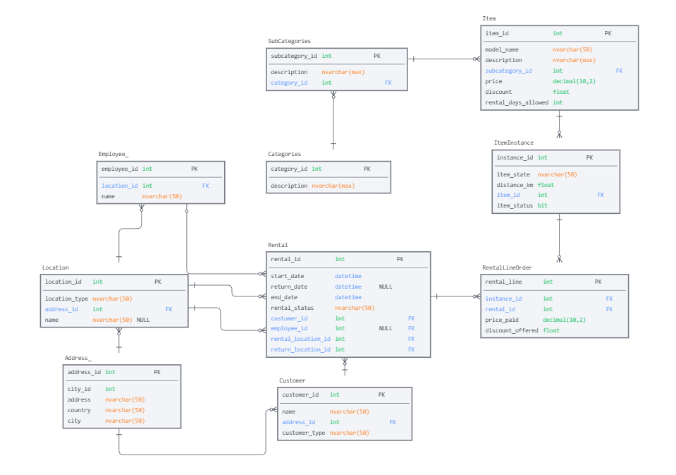

Tables

Category
Stores the main categories of rental items.
Column | Description
category_id | Unique category identifier
description | Category description

SubCategory
Stores subcategories belonging to a category.
Column | Description
subcategory_id | Unique subcategory identifier
subcat_description | Subcategory description
category_id | Reference to Category

Item
Stores rentable products.
Column | Description
item_id | Unique item identifier
models_name | Item model name
item_description | Item description
price | Rental price per rental
discount | Discount percentage
rental_days_allowed | Maximum rental period
subcategory_id | Reference to SubCategory

ItemInstance
Stores individual physical instances of an item.
Column | Description
instance_id | Unique instance identifier
item_state | Condition of the item
distance_km | Distance travelled (if applicable)
item_status | Availability status (0 = Free, 1 = Taken)
item_id | Reference to Item

Customer
Stores customers, which can be either individuals or companies.
Column | Description
customer_id | Unique customer identifier
customer_name | Customer name
customer_type | Person or company
address_id | Reference to Address

Address
Stores address information for customers and locations.
Column | Description
address_id | Unique address identifier
address | Street address
city | City
country | Country

Location
Stores rental locations and shops.
Column | Description
location_id | Unique location identifier
location_type | Type of location
location_name | Name of the shop/location
address_id | Reference to Address

Employee
Stores employee information.
Column | Description
employee_id | Unique employee identifier
employee_name | Employee name
location_id | Reference to Location

Rental
Stores rental transactions.
Column | Description
rental_id | Unique rental identifier
start_date_time | Rental start date and time
end_date_time | Planned return date and time
return_date_time | Actual return date and time
rental_status | Current rental status
customer_id | Reference to Customer
employee_id | Reference to Employee
rental_location_id | Pickup location
return_location_id | Return location

RentalLineOrder
Stores the rented item instances connected to a rental.
Column | Description
rental_line_id | Unique rental line identifier
price_paid | Final price paid
discount_offered | Discount applied
instance_id | Reference to ItemInstance
rental_id | Reference to Rental

Relationships
- Categories contain multiple SubCategories.
- SubCategories contain multiple Items.
- Items can have multiple ItemInstances.
- Customers create Rentals.
- Employees can manage Rentals at Locations, but are not needed.
- Rentals contain one or more RentalLineOrders.
- RentalLineOrders connect Rentals to ItemInstances.

