5TH APRIL 05/04/2022

NAME:ADAMYA GOWRI H K

USN:1NT19IS005

C1 batch

Command to enter MongoDB

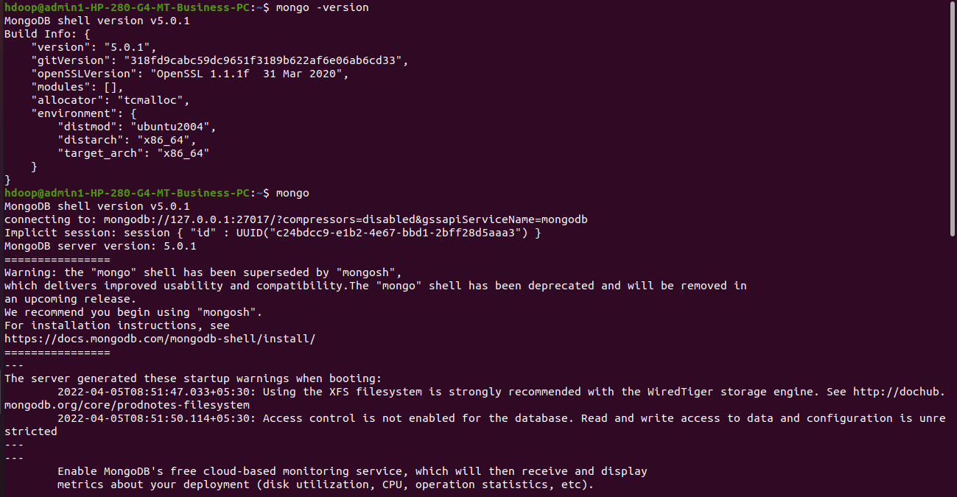

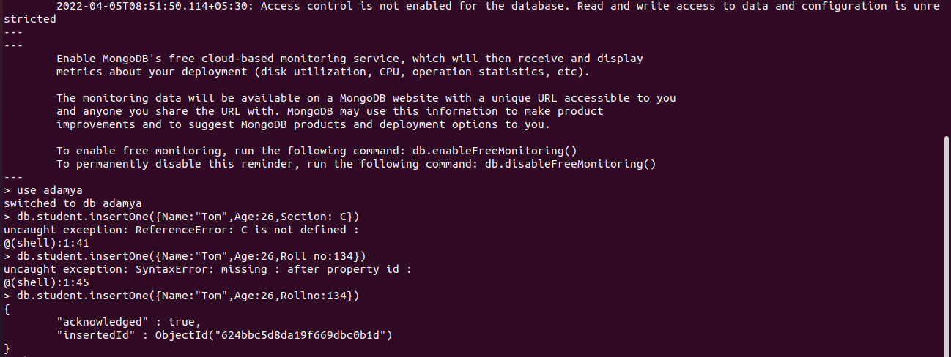

Create and use a database and inserting one data:



Show databases:

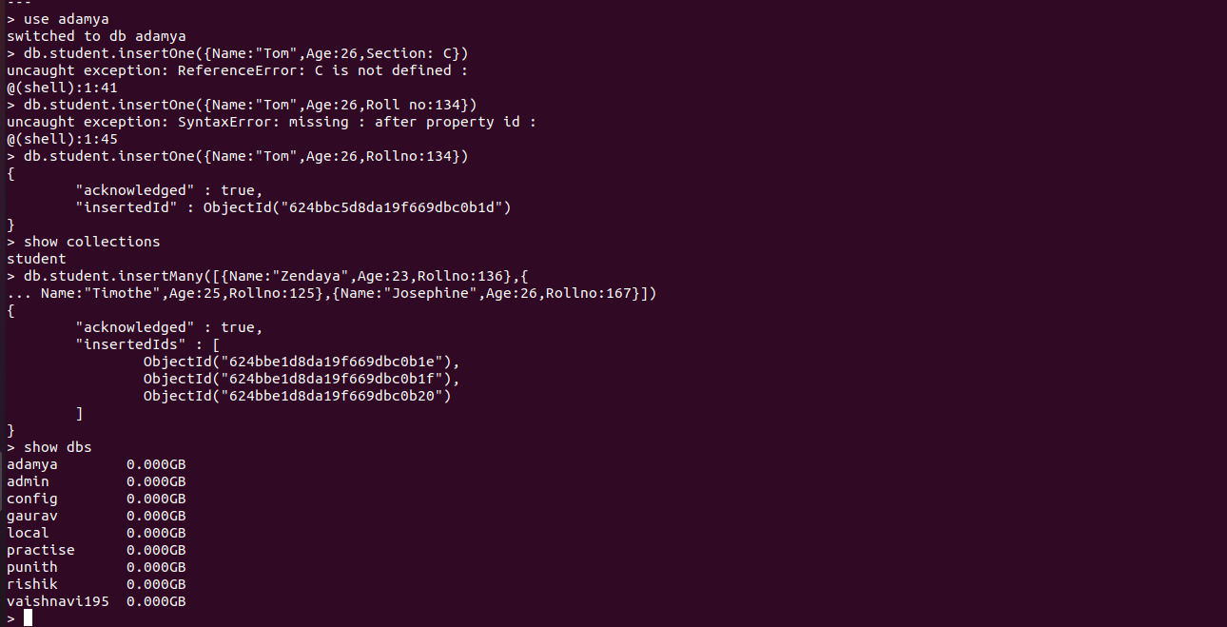

Inserting Many and displaying:

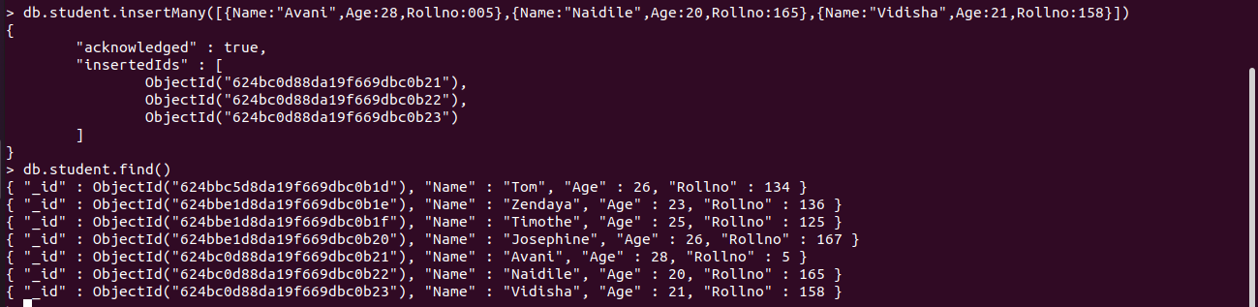

Update one record:

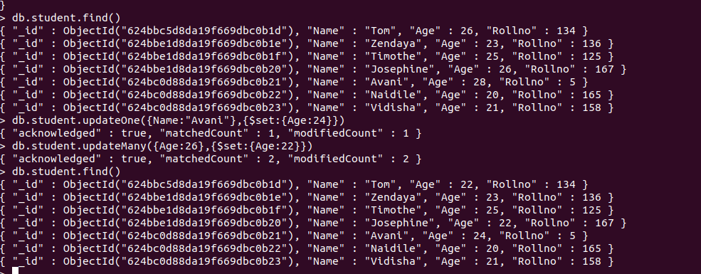

Update many records:

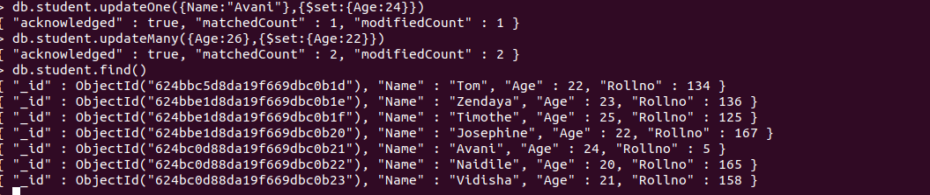

Displaying:

