NAME: ADAMYA GOWRI H K

USN : 1NT19IS005

C1 BATCH

EXERCISE 5

QUERIES:

1. Insert 5 records using Insert command in HiveQL



2. Import the dataset from the sales.csv

3. Count the number of sales done by each country

-> select count(*) as count,country from sales group by country;

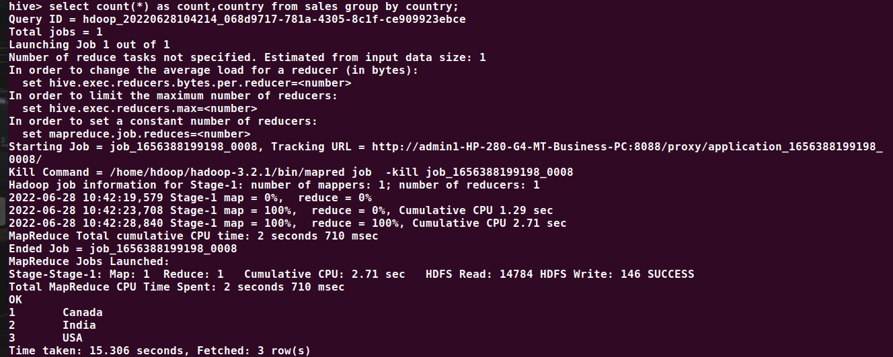

4. Count the number of sales done by each state

-> select count(*) as count,state from sales group by state;

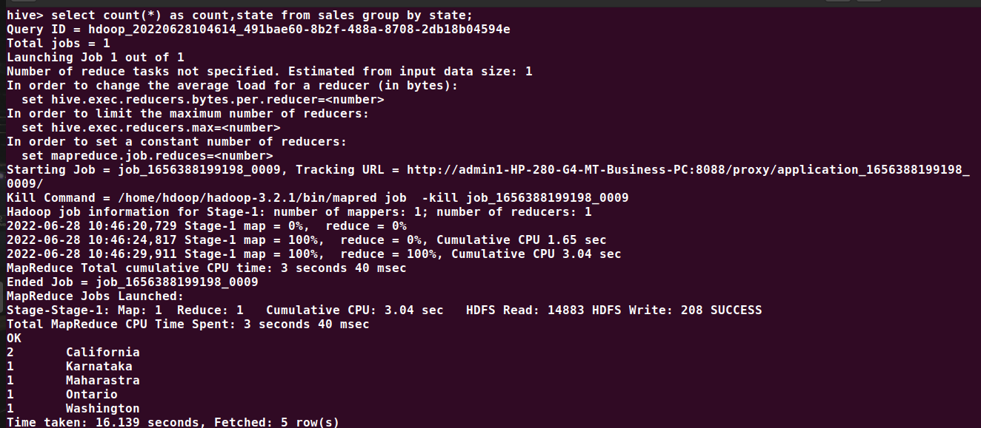

5. Display (Product, name) grouped by product

-> select product,name from sales group by product,name;

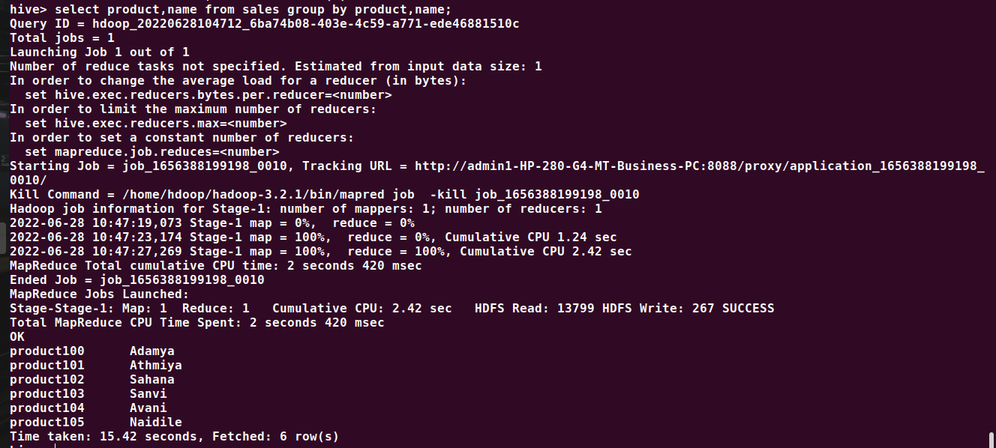

6. Create separate views for VISA and Mastercard

-> create view visaC as select * from sales where payment_type='Visa';

OK

Time taken: 0.134 seconds

hive> select * from visaC;

OK

product100 4500 Visa Adamya LA California USA

product104 3500 Visa Avani Toronto Ontario Canada

product105 1800 Visa Naidile Mumbai Maharastra India

Time taken: 0.132 seconds, Fetched: 3 row(s)

hive> create view masterC as select * from sales where payment_type='MasterCard';

OK

Time taken: 0.126 seconds

hive> select * from MasterC;

OK

product101 5000 MasterCard Athmiya Bangalore Karnataka India

product102 6000 MasterCard Sahana Santa Monica California USA

product103 2800 MasterCard Sanvi Seattle Washington USA

Time taken: 0.075 seconds, Fetched: 3 row(s)





7. Show all the transactions done in Seattle

-> select price from sales where city='Seattle';



8. Find the max number of transactions done within the state of Ontario

-> select max(price) from sales where state='Ontario' group by city;

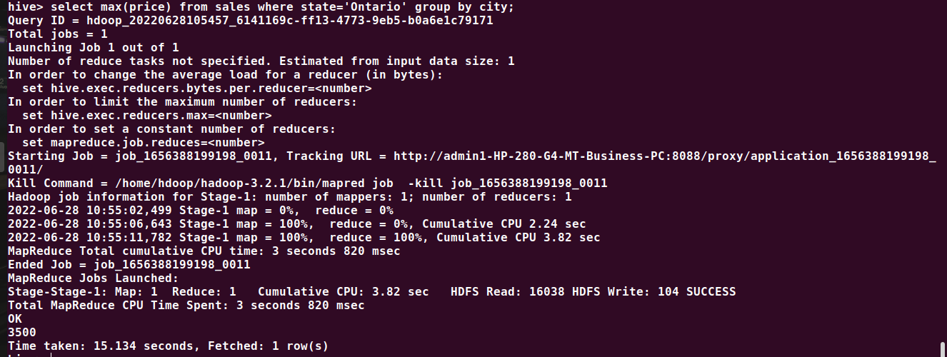

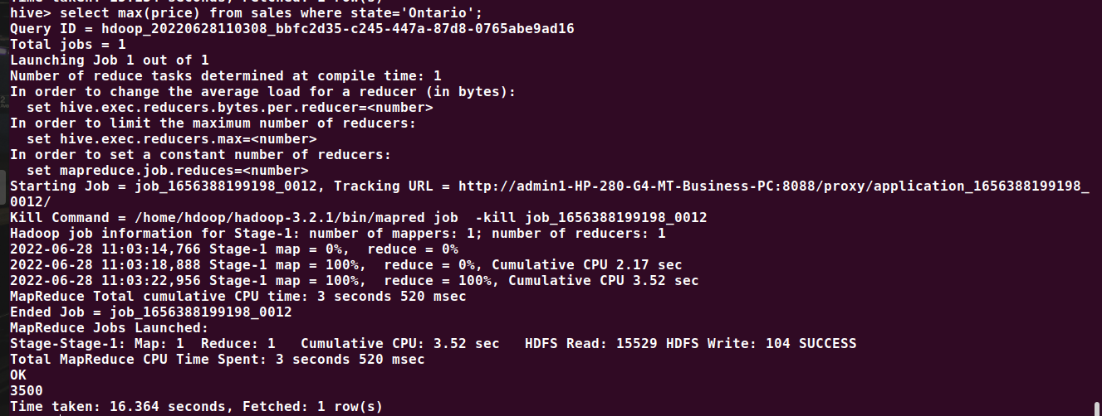

9. Find the number of transactions whose price is in between 1500-3600

-> select count(*) from sales where price between 1500 and 3600;



10. List all the transactions done in the United States using Mastercard

-> select * from sales where country='USA' and payment_type='MasterCard';

