Checking if Hadoop is installed or not

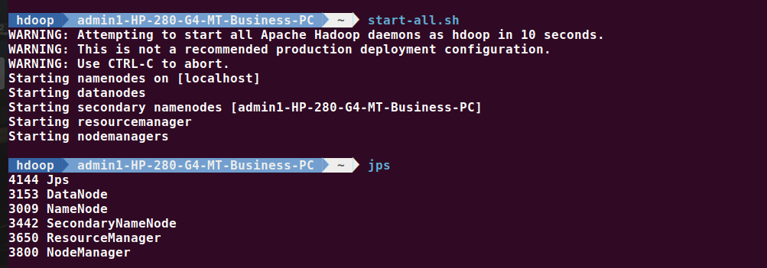

Creating directory by our name using mkdir command

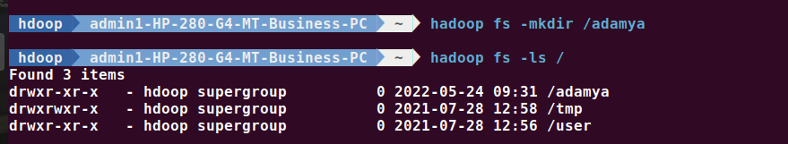

Adding two empty files using touchz command



Using ls command to all the files in directory

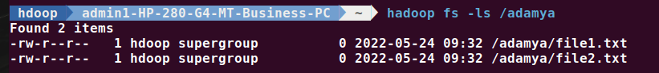

Creating one more directory by USN using mkdir command



Copy files from local using **copyFromLocal (or) put** command

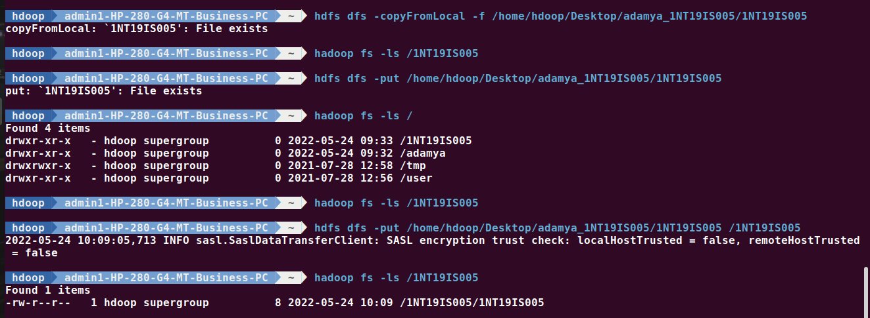



Copying from hadoop to local file system using **copyToLocal (or) get** command

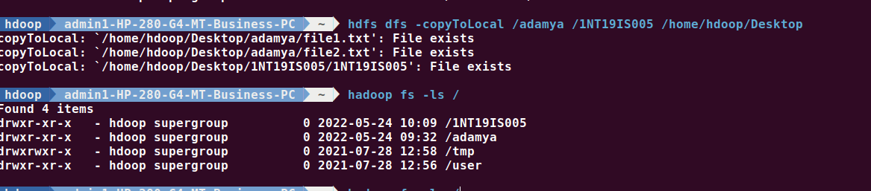

Cp command

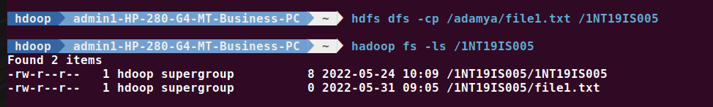

Size of the file



Stat command

