Create an Android application to demonstrate the working of Implicit Intent

Madhuri.c

1NT19IS077

SEC C

Acitivitymain.xml

*<?*xml version="1.0" encoding="utf-8"*?>*

<androidx.constraintlayout.widget.ConstraintLayout xmlns:android="http://schemas.android.com/apk/res/android"

xmlns:app="http://schemas.android.com/apk/res-auto"

xmlns:tools="http://schemas.android.com/tools"

android:layout_width="match_parent"

android:layout_height="match_parent"

tools:context=".MainActivity">

<EditText

android:layout_width="match_parent"

android:layout_height="wrap_content"

android:id="@+id/myphone"

android:hint="enter the phone number"

app:layout_constraintBottom_toBottomOf="parent"

app:layout_constraintEnd_toEndOf="parent"

app:layout_constraintHorizontal_bias="0.493"

app:layout_constraintStart_toStartOf="parent"

app:layout_constraintTop_toTopOf="parent"

app:layout_constraintVertical_bias="0.217" />

<Button

android:id="@+id/call"

android:layout_width="wrap_content"

android:layout_height="wrap_content"

android:text="call"

app:layout_constraintBottom_toBottomOf="parent"

app:layout_constraintEnd_toEndOf="parent"

app:layout_constraintHorizontal_bias="0.498"

app:layout_constraintStart_toStartOf="parent"

app:layout_constraintTop_toBottomOf="@+id/myphone"

app:layout_constraintVertical_bias="0.159" />

</androidx.constraintlayout.widget.ConstraintLayout>

Mainactivity.java

package com.example.madhuri_intent_implicit;

import androidx.appcompat.app.AppCompatActivity;

import android.content.Intent;

import android.net.Uri;

import android.os.Bundle;

import android.view.View;

import android.widget.Button;

import android.widget.EditText;

public class MainActivity extends AppCompatActivity {

EditText phonenumbertocall;

Button call;

@Override

protected void onCreate(Bundle savedInstanceState) {

super.onCreate(savedInstanceState);

setContentView(R.layout.*activity_main*);

call=findViewById(R.id.*call*);

phonenumbertocall=findViewById(R.id.*myphone*);

call.setOnClickListener(new View.OnClickListener() {

@Override

public void onClick(View view) {

Uri myuri= Uri.*parse*("tel:"+phonenumbertocall.getText().toString());

Intent it=new Intent(Intent.*ACTION_DIAL*,myuri);

startActivity(it);

}

});

}

}

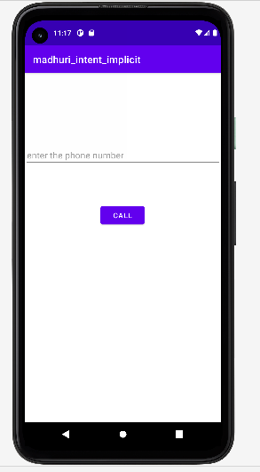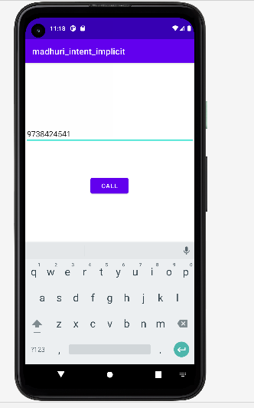

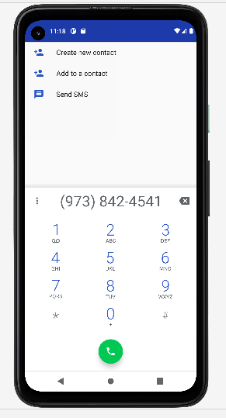

Create an Android application to demonstrate the working of Explicit Intent

Activity_main.xml

*<?*xml version="1.0" encoding="utf-8"*?>*

<androidx.constraintlayout.widget.ConstraintLayout xmlns:android="http://schemas.android.com/apk/res/android"

xmlns:app="http://schemas.android.com/apk/res-auto"

xmlns:tools="http://schemas.android.com/tools"

android:layout_width="match_parent"

android:layout_height="match_parent"

tools:context=".MainActivity">

<LinearLayout

android:id="@+id/linearLayout"

android:layout_width="417dp"

android:layout_height="743dp"

android:orientation="vertical"

app:layout_constraintBottom_toBottomOf="parent"

app:layout_constraintEnd_toEndOf="parent"

app:layout_constraintStart_toStartOf="parent"

app:layout_constraintTop_toTopOf="parent"

app:layout_constraintVertical_bias="0.0">

<EditText

android:id="@+id/name"

android:layout_width="match_parent"

android:layout_height="wrap_content"

android:hint="enter your name"

app:layout_constraintBottom_toBottomOf="@+id/linearLayout"

app:layout_constraintEnd_toEndOf="@+id/linearLayout"

app:layout_constraintStart_toStartOf="parent"

app:layout_constraintTop_toTopOf="parent" />

<Button

android:id="@+id/click"

android:layout_width="match_parent"

android:layout_height="wrap_content"

android:text="click" />

</LinearLayout>

</androidx.constraintlayout.widget.ConstraintLayout>

Mainactivity.java

package com.example.madhuri_intent;

import androidx.appcompat.app.AppCompatActivity;

import android.content.Intent;

import android.os.Bundle;

import android.view.View;

import android.widget.Button;

import android.widget.EditText;

public class MainActivity extends AppCompatActivity {

EditText name;

Button click;

@Override

protected void onCreate(Bundle savedInstanceState) {

super.onCreate(savedInstanceState);

setContentView(R.layout.*activity_main*);

name=findViewById(R.id.*name*);

click=findViewById(R.id.*click*);

click.setOnClickListener(new View.OnClickListener() {

@Override

public void onClick(View view) {

Intent it=new Intent(MainActivity.this,secondactivity.class);

Bundle b=new Bundle();

b.putString("name",name.getText().toString());

it.putExtras(b);

startActivity(it);

}

});

}

}

Activity_secondactivity.xml

package com.example.madhuri_intent;

import androidx.appcompat.app.AppCompatActivity;

import android.content.Intent;

import android.os.Bundle;

import android.view.View;

import android.widget.Button;

import android.widget.EditText;

public class MainActivity extends AppCompatActivity {

EditText name;

Button click;

@Override

protected void onCreate(Bundle savedInstanceState) {

super.onCreate(savedInstanceState);

setContentView(R.layout.*activity_main*);

name=findViewById(R.id.*name*);

click=findViewById(R.id.*click*);

click.setOnClickListener(new View.OnClickListener() {

@Override

public void onClick(View view) {

Intent it=new Intent(MainActivity.this,secondactivity.class);

Bundle b=new Bundle();

b.putString("name",name.getText().toString());

it.putExtras(b);

startActivity(it);

}

});

}

}

Secondactivity.java

package com.example.madhuri_intent;

import androidx.appcompat.app.AppCompatActivity;

import android.os.Bundle;

import android.widget.TextView;

public class secondactivity extends AppCompatActivity {

TextView myname;

String namefromfirstactivity="";

@Override

protected void onCreate(Bundle savedInstanceState) {

super.onCreate(savedInstanceState);

setContentView(R.layout.*activity_secondactivity*);

myname=findViewById(R.id.*mytext*);

namefromfirstactivity=getIntent().getStringExtra("name");

myname.setText(namefromfirstactivity);

}

}

