# M4 Group Assignment 2 – Vanderbilt Case Study

#### BU.510.650

#### Data Analytics

#### Fall 2018

#### Arnab Bisi

## M4 Group Assignment 2 Overview

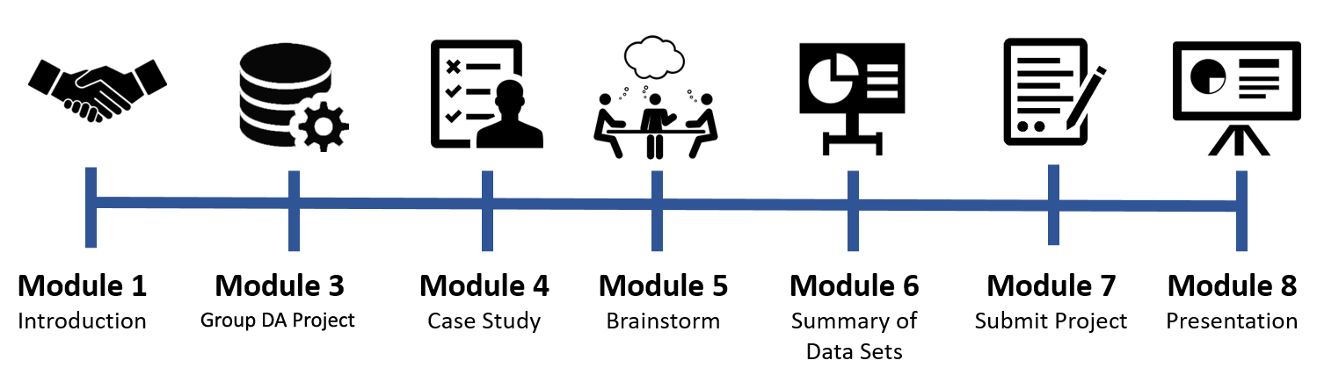

This week you get to meet back up with your group over Zoom to perform a Case Analysis of Vanderbilt Medical Center. You will work together to analyze the case and utilize data files to complete this problem set. You will then participate in a discussion about your analysis and conclusions.

It’s important for everyone to participate equally in the group and the Professor will be monitoring the collaboration to ensure that all members are fully engaged. To ensure that this is, in fact, the case, it is recommended that you meet as a group and discuss the problem set, then divide the problems among the members. Each group member completes their problems and then you reconvene and discuss the results and findings and collaborate on your final submission. If you find this is not ideal for your group, feel free to determine a process amenable to all group members.

Steps

1. Your project needs to be submitted by Saturday of this week so make sure that you schedule a meeting as soon as possible with your group. You can use Zoom to meet or any other group meeting space that you prefer.
2. Download and Read the Vanderbilt Case Study before you meet with the group. That case study can be accessed through the E-Reserves for this course.
3. Work together with your group to complete the M4 Assignment 2 Problem Set.
4. Type or neatly write your answers to each question in the problem set.
5. One person will make a single submission for the entire group. Include the name of all group members on the submission.

Prepare and Submit two files to the M4 Group Assignment 2 – Vanderbilt Medical Center activity in your course

1. The first file is this document. Type your answers to each problem below in this word file. Name your file ***GroupName*.M4A2.docx**

**Note**: You can also do an Excel file, or as a scanned handwritten file. If using Excel, each problem should be in a separate tab that is named. If your instructor finds your handwritten submission illegible, he or she may ask you to resubmit it as a typed submission. To submit handwritten work, see “[Instructions for Scanning](https://blackboard.jhu.edu/bbcswebdav/pid-3631299-dt-content-rid-16382471_2/xid-16382471_2)” document posted on blackboard.

1. The second file is your R script. Name the script ***GroupName*.M4A2.R**. We will use this file if we need more information about your answers or for verification. Both files should be submitted in the assignment in blackboard.

## Grading

* The following problems count as 5 points each. Total points 10 X 5 = 50. Problems are graded against the standards in the rubric for this activity.

## Problem Set

Download the Vanderbilt data set (VanderbiltSched.csv), from the course Blackboard page to answer the following questions.

1. Create a scatter plot of booked elective cases at T-7 vs final case volume.
2. Create a linear regression model to predict actual case count based on cases scheduled 7 days earlier and show the regression line on the scatter plot.
3. Evaluate the hypothesis that the average volume of add-on surgeries each day of the week is the same. Here add-on means those added after T-1.
4. What do you learn by creating a different model for each day of the week?
5. What do you learn by including dummy variables for each day of the week in a single model?
6. Develop the best model that you can for predicting daily case volume using the first 45 weeks of data assuming that all relevant decisions must be made by time T-7.
7. How does your model change if we can make staffing decisions 1 day in advance? Is this better?
8. Using the final three weeks of data for model validation, how confident are you in the predictions made by the model constructed for question 6?
9. Using the final three weeks of data for model validation, how confident are you in the predictions made by the model constructed for question 7?
10. How should your predictions be communicated to inform staff schedule adjustments?