Machine Learning for Trading – Project 6

Tri Nguyen  
[tnguyen497@gatech.edu](mailto:tnguyen497@gatech.edu)

# Technical Indicators

The following indicators are used to predict the movement of stocks in a manual trading strategy: momentum, price/simple moving average ratio, and Bollinger Bands Percentage. Each indicator is illustrated by JPM stock between 1st January 2008 and 31 December 2009.

## Momentum

Momentum of a stock over n days is the return of a certain day compared to n days before, specifically:

Momentum (n day) = (today price/price n days ago) – 1

Figure 1 shows the 10-day momentum of JPM and normalized price.

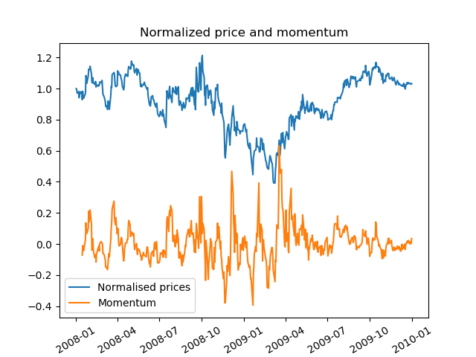

Figure 1: Momentum vs normalized price of JPM

Momentum helps filter out price fluctuation over the n-day period and show the overall movement over those days. In this example, a positive momentum shows that price has increased compared to 10 day ago, and vice versa.

This indicator can be used to show the trend in price movement over a defined period. If a short period is used, it can help predict whether the price will continue to increase or decrease.

## Price/simple moving average ratio

Simple moving average (SMA) of a stock at any given time is the mean value of the stock’s price over a previous defined period. For example, a 5-day SMA is calculated by:

SMA = (sum of prices over last 5 days) / 5

However, SMA’s value range can be very different among different stocks, and therefore is not a meaningful indicator for trading rule. A better indicator would be Price/SMA ratio.

Price/SMA shows the prices of the stock relative to its mean value. Figure 2 shows the price, SMA, and Price/SMA ratio.

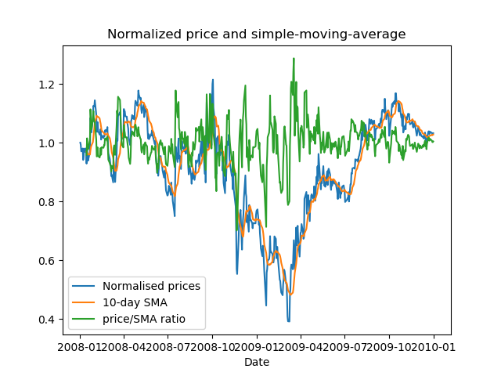

Figure 2: Price/SMA ratio indicator

A ratio greater than 1 indicates that the current price is higher than the average price, and might be expected drop back to the average. A ratio less than 1 indicates that the current price is lower than the average price, and might increase back to the average.

## Bollinger Band Percentage

Bollinger Band can be calculated first calculating the SMA as described above, then adding two standard deviations above and below the SMA. For example, given a 5-day SMA, at any particular point in time:

std = standard deviation over last 5 days.

Upper Bollinger band = SMA + 2 x std

Lower Bollinger band = SMA – 2 x std

The value range of the bands, like SMA, can vary greatly among different stocks. A more meaningful measure is the relative ratio between the price and the band. In particular.

Bollinger Band Percentage=(price–lower band)/(upper band–lower band)

Figure 3 shows the Bollinger Band and Bollinger Band Percentage for JPM.

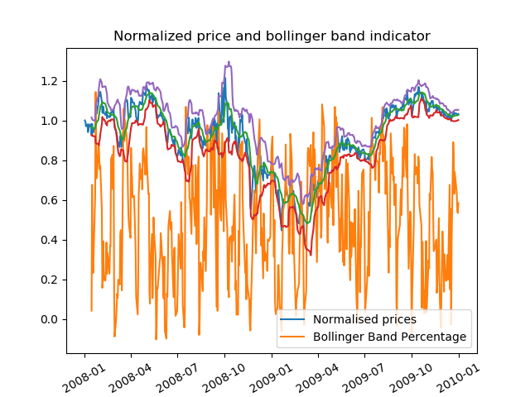

Figure 3: Bollinger Band Percentage indicator

A high percentage (>1) means the price exceeds the upper band, and low percentage (<0) means the price is less than the lower band. This can be used to show how much the price has deviated from the average.

# Theoretically Optimal Strategy

Figure 4 shows the theoretically optimal strategy return.

The strategy is simply to look ahead one trading day, if the price goes up, it is a buying signal. If it goes down, it is a selling signal. The strategy will sell or buy based on these signals, and on the current position, i.e., if the current position is already longing 1000 shares, the strategy will not buy more stocks.

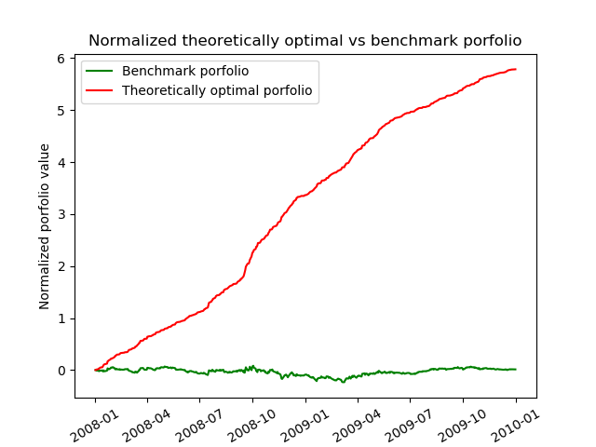

Figure 4: Theoretically Optimal Strategy return

|  |  |  |
| --- | --- | --- |
|  | Benchmark | Theoretically Optimal Strategy |
| Cumulative return | .0123 | 5.7861 |
| Std dev | 0.017 | 0.00455 |
| Mean | 0.000168 | 0.003817 |

Table 1: Performance metrics of the optimal strategy (in-sample)

# Rule-based Manual Strategy

The manual strategy utilizes the indicators described above. They rely solely on past information (price) to determine whether the stock is being overbought or oversold. The threshold used in these indicators were determined by trial and error on the in-sample dataset (JPM from 1st January 2008 to 31st December 2009) to maximize return. In particular:

Oversold – long opportunity: when any two of these conditions are met.

1. Bollinger Band Percentage <= 0.6
2. SMA ratio < 1
3. Momentum > 0.1

Overbought – short opportunity - when any two of these conditions are met.

1. Bollinger Band Percentage >= 0.8
2. SMA ratio > 1
3. Momentum < 0

If none of the conditions are met, then maintain the current position and do not trade.

It is expected that a combination of indicators will perform better than individual one. However, requiring all three conditions at the same time appeared to be very conservative, resulting in the strategy not trading very often, and yielding low return. Consequently, only two conditions are required, achieving a balance of a sufficiently strong signal without being too reluctant to trade.

Figure 5 shows the return of the rule-based manual strategy. Table 2 shows summary of in-sample performance metrics.

|  |  |  |
| --- | --- | --- |
| **In-sample** | Benchmark | Manual Strategy |
| Cumulative return | 0.0123 | 1.2201 |
| Std dev | 0.017 | 0.0106 |
| Mean | 0.000168 | 0.00164 |

Table 2: Performance metrics of the rule-based manual strategy (in-sample)

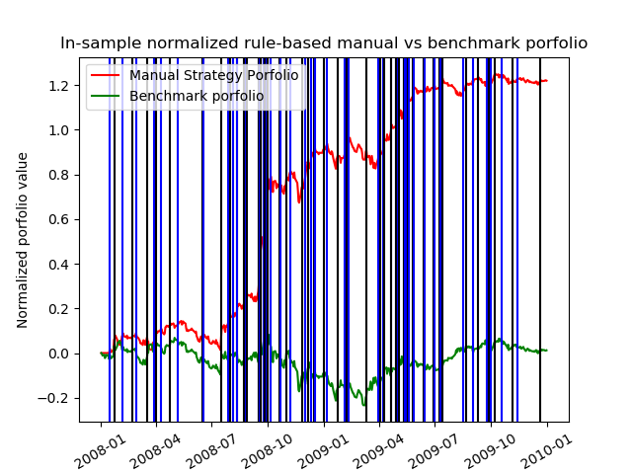

Figure 5: In-sample rule-based manual strategy vs benchmark portfolio

# Comparative Analysis

The rule-based manual strategy is trained on the in-sample period as shown in figure 5 (JPM). It is then applied to the out-sample period (1st Jan 2010, 31 Dec 2011). The result is shown in figure 6 and table 3.

|  |  |  |
| --- | --- | --- |
| **In-sample** | Benchmark | Manual Strategy |
| Cumulative return | -0.0834 | -0.0886 |
| Std dev | 0.00848 | 0.00893 |
| Mean | -0.00014 | -0.00014 |

Table 3: Performance metrics of the rule-based manual strategy (out-sample)

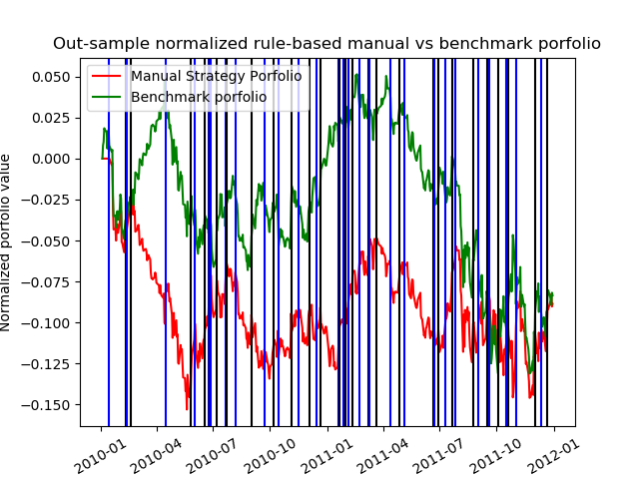

Figure 6: Out-sample rule-based manual strategy vs benchmark portfolio

With the in-sample data, the strategy performs much better than the benchmark, but this success is not replicated in the out-sample data. In fact, the out-sample performance of the strategy is slightly worse than the benchmark.

The threshold used to determine long/short position in the strategy was fine-tuned to fit the in-sample data, resulting in overfitting – the model was trained to best optimized return on in-sample data only. This can also be seen in the density of the sell/buy vertical lines. There are more buy/sell events in the in-sample data than in the out-sample.