
Reg No | Mtech-CS26034
Intern Name | Adan Fatima
Domain | Cybersecurity
Task Title | PortSwigger Lab: XSS (Legal)
Topic | Web & OWASP
Tool Used | PortSwigger Web Security Academy (free/legal)
Level | Advanced
Report Date | July 5, 2026

M-Tech Production & Marketing
Technology | Training | Marketing | Projects
Week 1 – Task Report

Internship Program — Batch 2026

Haripur Main Bazar, Khyber Pakhtunkhwa, Pakistan
mtechproductionandmarketing@gmail.com | +92 336 2222480

1. Objective
The objective of this task was to gain hands-on, beginner-level exposure to Cross-Site Scripting (XSS), a common and critical web application vulnerability, by completing two apprentice-level labs on PortSwigger's Web Security Academy — a free and legally sanctioned platform for practicing web security testing on intentionally vulnerable applications.

2. Introduction to Cross-Site Scripting (XSS)
Cross-Site Scripting (XSS) is a client-side vulnerability that allows an attacker to inject malicious JavaScript into a web page, which is then executed in the browser of another user. This can be used to steal session cookies, hijack user accounts, deface websites, or redirect users to malicious sites. XSS arises when an application includes untrusted, user-supplied input in its output without properly validating or encoding it.
There are three main types of XSS:
- Reflected XSS – the malicious script is part of the current HTTP request and is immediately reflected back in the server's response (e.g., a search field that echoes the query onto the results page).
- Stored XSS – the malicious script is permanently saved on the target server (e.g., in a comment, blog post, or database entry) and is later served to other users who view that content.
- DOM-based XSS – the vulnerability exists entirely within client-side JavaScript, where the DOM itself is manipulated using untrusted data.

3. Tool / Platform Used
PortSwigger Web Security Academy (https://portswigger.net/web-security) was used to complete this task. It is a free, industry-recognized, and legal training platform built by the makers of Burp Suite, offering realistic, sandboxed vulnerable web applications for practicing offensive security techniques without any legal or ethical risk.

4. Labs Completed
Lab 1: Reflected XSS into HTML context with nothing encoded
- Vulnerability Type: Reflected XSS
- Vulnerable Input: The search bar on the blog page, which echoed the user's query directly into the HTML response without encoding.
- Payload Used: <script>alert(1)</script>
- Result: The payload executed successfully, triggering a JavaScript alert box displaying the (1) I entered, and PortSwigger marked the lab as "Solved."
- Why it worked: The application inserted the search term directly into the page's HTML without sanitizing or encoding special characters such as < and >, allowing the injected <script> tag to be parsed and executed by the browser.

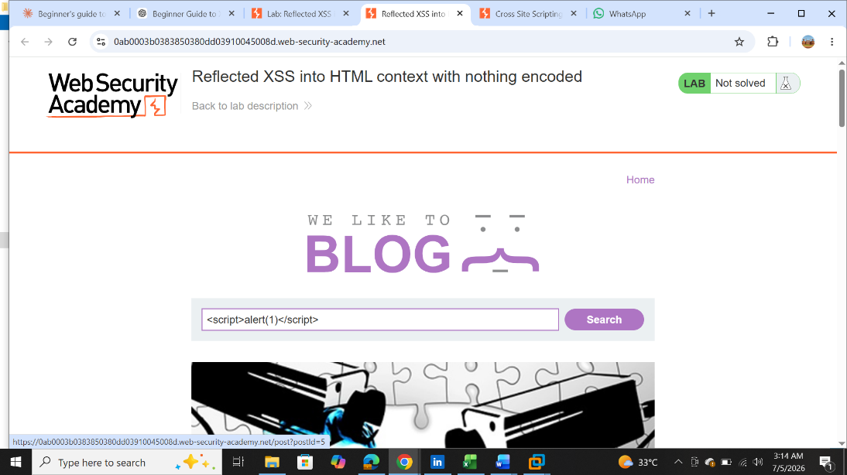

(Payload I entered)

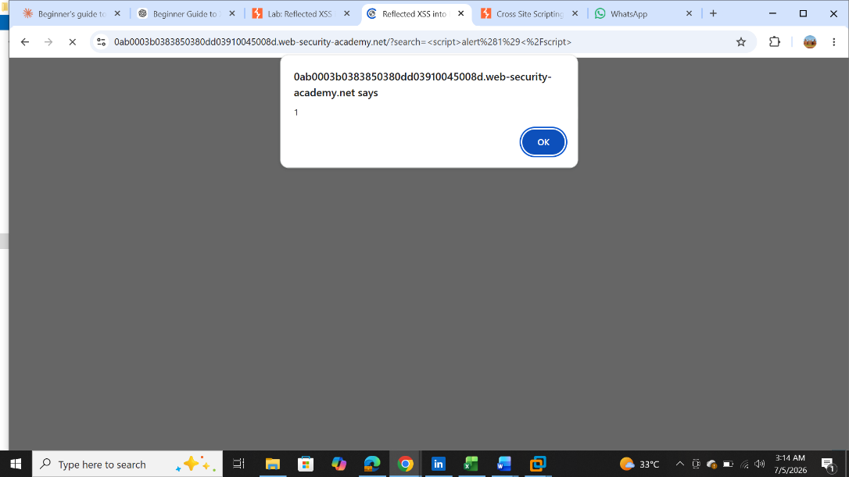

(alert box displaying the 1
i entered)

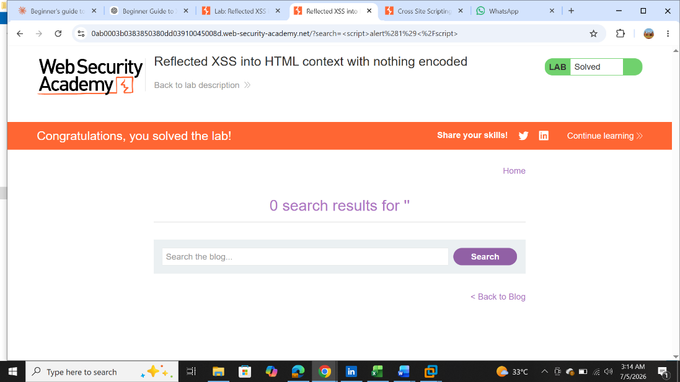

LAB SOLVED after the popup appeared

Lab 2: Stored XSS into HTML context with nothing encoded
- Vulnerability Type: Stored XSS
- Vulnerable Input: The comment submission form on a blog post (name, email, website, comment fields).
- Payload Used: <script>alert(‘HACKER’)</script> (submitted in the comment field)
- Result: The payload was stored on the server and executed automatically every time the blog post was viewed, confirming successful exploitation and marking the lab as "Solved."
- Why it worked: The comment content was stored and rendered back into the page's HTML without any output encoding or sanitization, so the injected script ran in the browser of anyone who viewed the post.
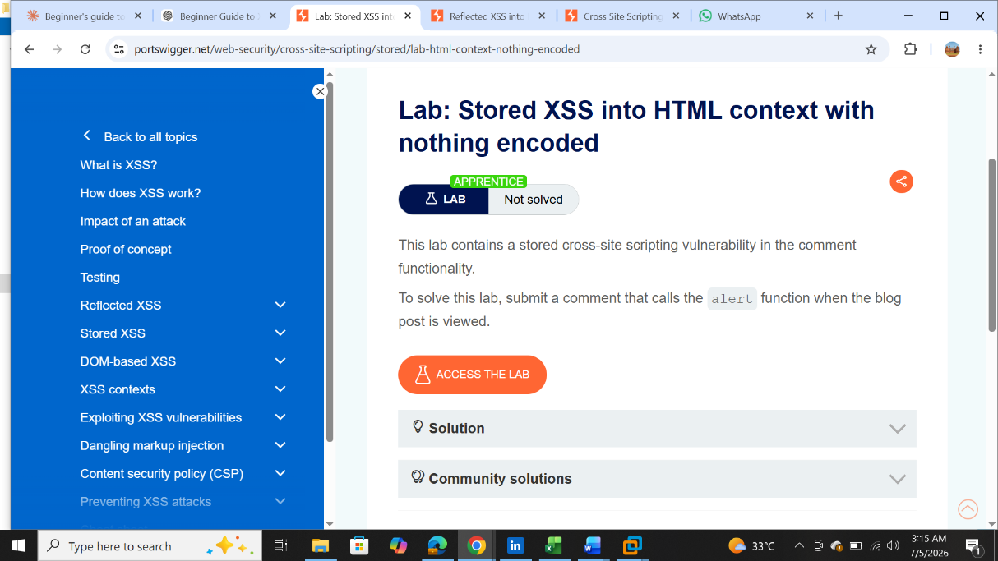

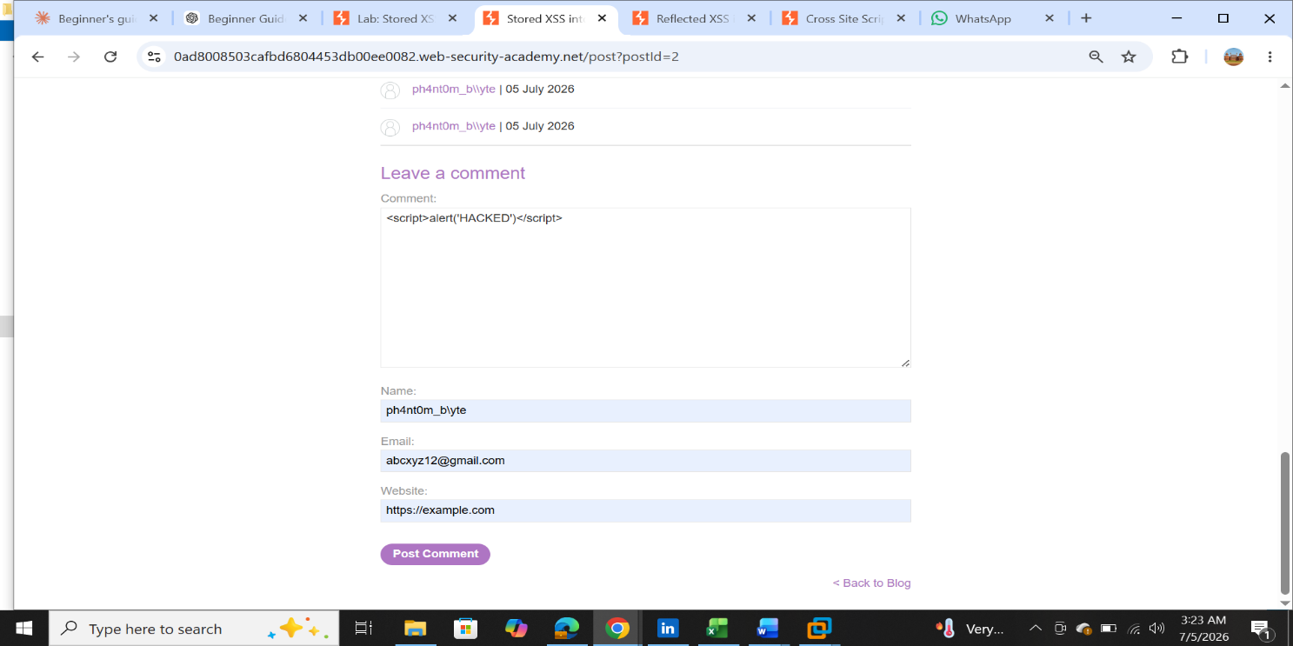

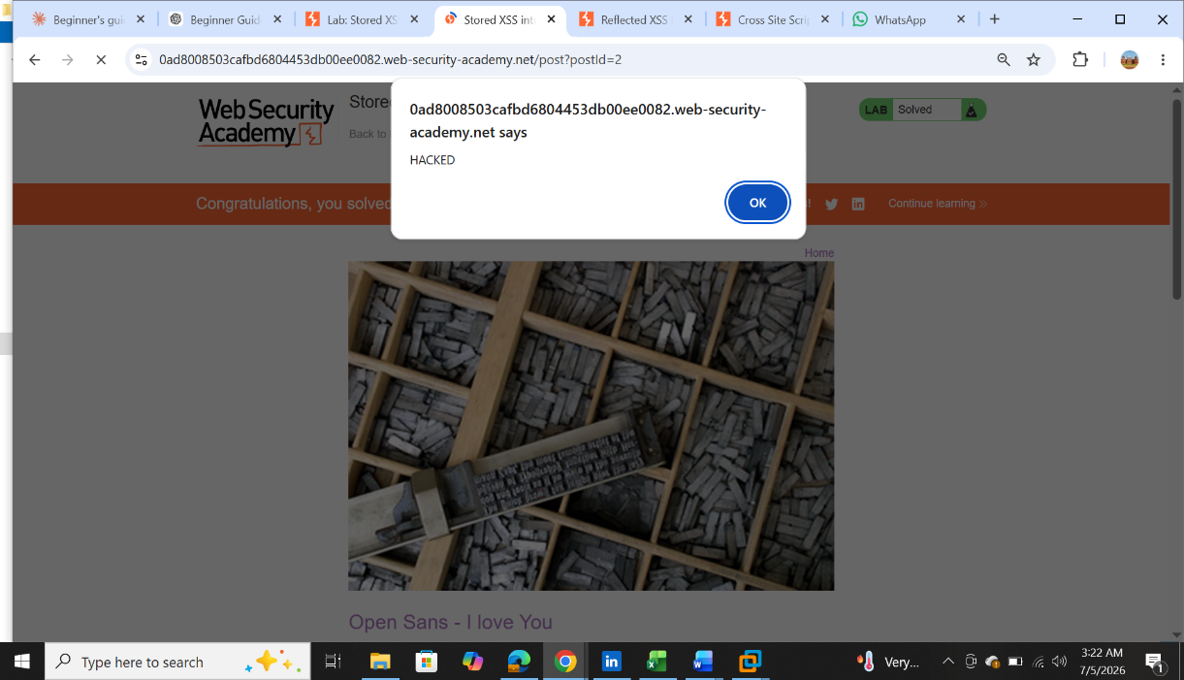

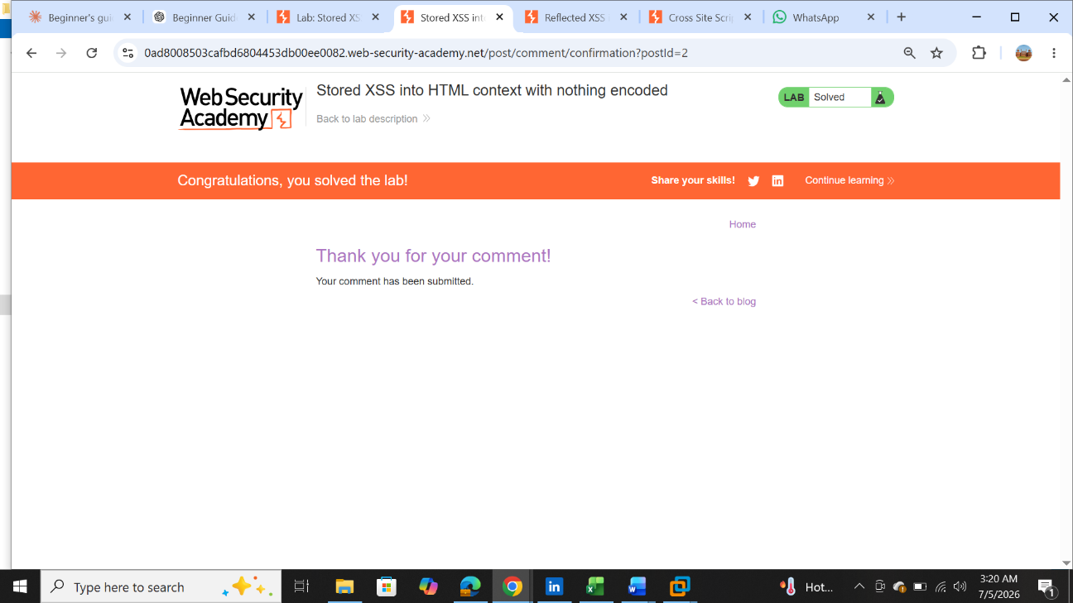

5. Learning Outcomes
- Gained a foundational understanding of what Cross-Site Scripting is and why it occurs.
- Learned to differentiate between Reflected, Stored, and DOM-based XSS.
- Practiced identifying vulnerable input fields in a web application.
- Learned how unencoded user input can lead to arbitrary JavaScript execution in a victim's browser.
- Understood the real-world impact of XSS, such as cookie/session theft, and the importance of input validation and output encoding as a defense.
- Became familiar with navigating and using PortSwigger Web Security Academy for further security research.

6. Conclusion
This task provided a solid introductory foundation in web application security, specifically Cross-Site Scripting. By completing two apprentice-level labs on PortSwigger Web Security Academy, hands-on experience was gained in identifying and exploiting both reflected and stored XSS vulnerabilities in a safe and legal environment. This lays the groundwork for exploring more advanced XSS variants and broader web security topics in subsequent tasks.
___________________________________________________________________________________________________________

