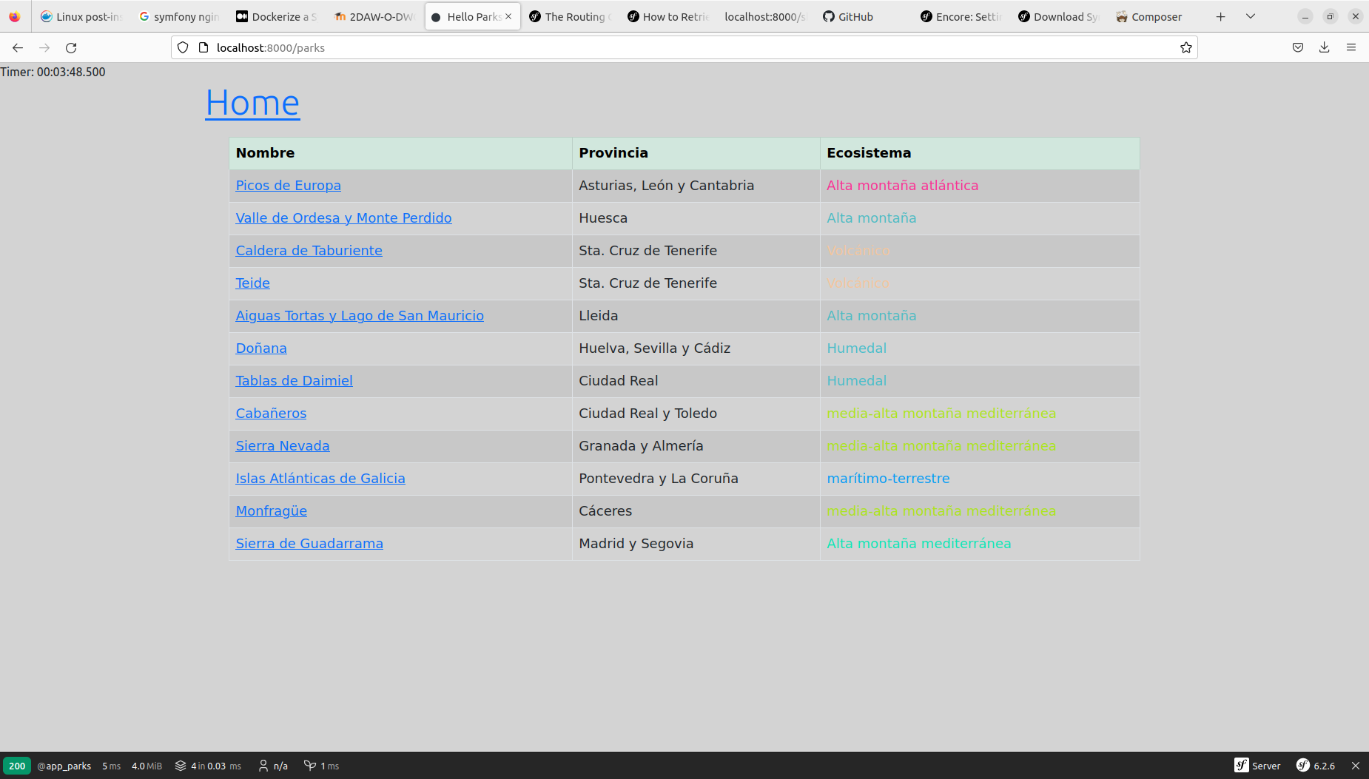
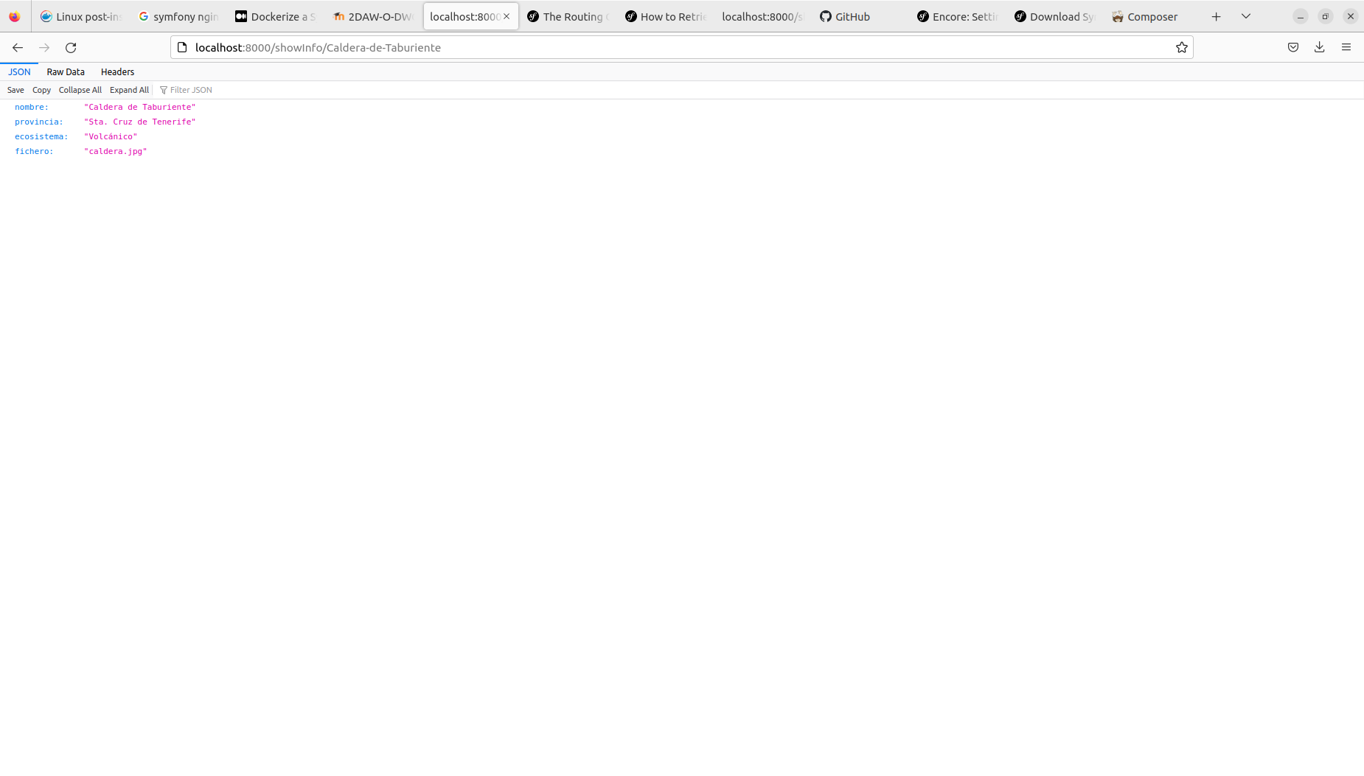
The usage of bootstrap is relatively simple, as shown in the following tree (using query selector syntax):

- div.container
  - div.row
    - div.col-12
      - a.link
    - div.col-12
      - <child containers body>
When it comes to Stimulus we have a folder called assets, which contains the javascript and css files to watch over (detect when the javascript linked to the desired html tags acts) to do particular actions, like modifying the DOM automatically. It generally follows this structure:

- controllers
  - <javascript html tag-linked controllers>
- styles
  - <css files to import>
- app.js
- bootstrap.js
- controllers.json

