Student: Alan Danque

Class: DSC 640

Git Repo: My AirlineAnalysis.pbix is located in the “Task1-Dashboard”

folder of the following address:

<https://github.com/adanque/DSC640>

Airline Fatality Trends

For my dashboard story, I chose to use Power Bi to present an interactive conversation about airline fatality trends using a combination of design strategies. My intention was to drive my audience to compare and contrast airline fatality factors using the filterable factors regarding the timing trends of the fatality counts per our competing airline operators and the type of plane involved. By using this dashboard, my hope is to highlight which type of planes may be mostly involved and therefore assist with identifying the next action steps toward either considering to decommission the use of the type of plane or corrections to the plane.

For the design of my dashboard, I incorporated the top left to right and zig zag down user experience design theory per natural eye movement patterns. Using this design, I started with a header that included my title, a total count of fatalities and count of plane types gauge chart on the top left. Then a sliding filter for the years with an area chart to the right of the filter to display the fatality results per years chosen and selectors for the airline operator and or airplane type. For the body, I chose to break into 3 columnar sections divided by a space. To establish that each chart was part of a section, I added borders for each chart and placed the proximity of each next to each other. In the first column, I chose to include a filterable table that lists country and its number of fatalities. Below that I chose to tell the story of how many total fatalities broken down by month. In the middle section, I chose to add 2 filterable horizontal bar charts sorting the fatalities in descending order so to make the highest counts per its category easily accessible and a table that lists the detail available in the category field of my dataset. The 2 filterable horizontal charts include: fatalities by airplane type and fatalities by operator. In the third section, I chose to use a donut chart to employ a compare contrast technique to tell the story between phases at the time of the airline fatality. To display the magnitude of effect by location, I added a map that displayed a bubble size relative to the number of fatalities in that country. Under the body of my dashboard, I added one row to include my sources and my student information.

The following are a few screen shots of my dashboard.

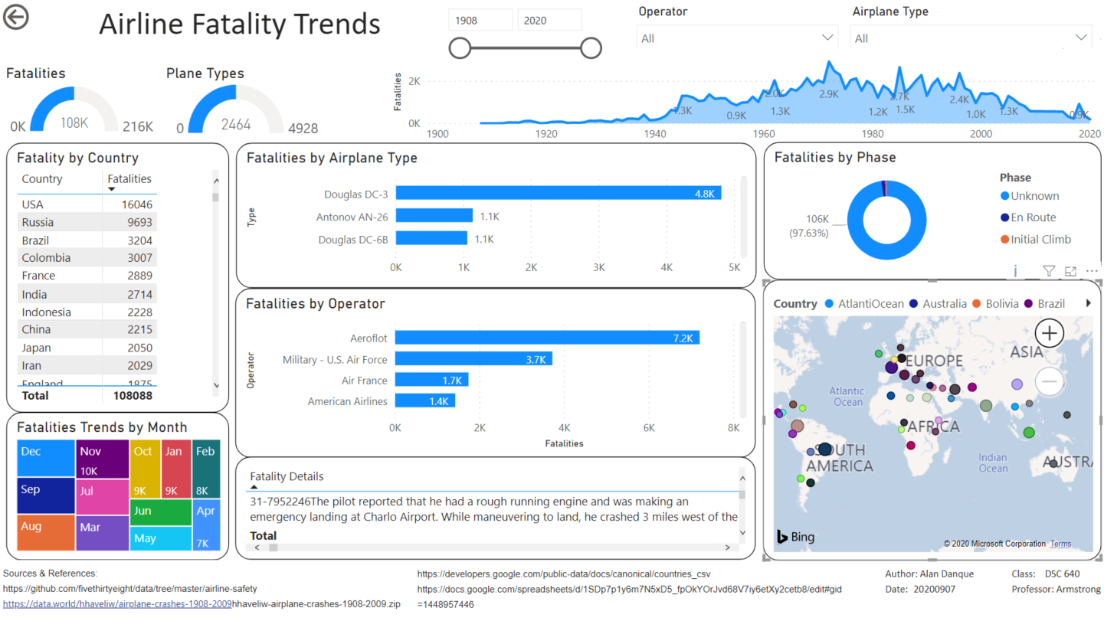

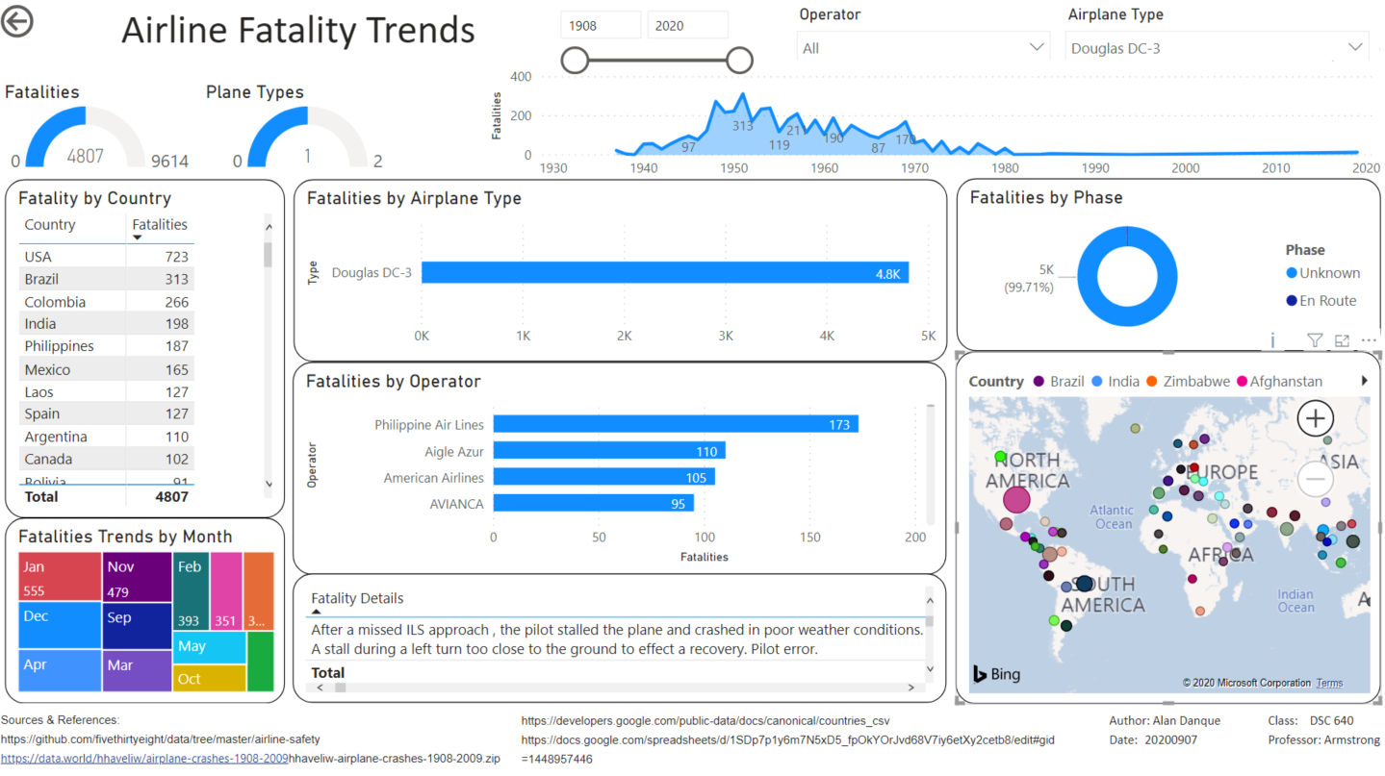

There were some interesting insights noted after creating this dashboard. One was the story told when filtering for France in 1974 where it experienced the most airline fatalities in a year at 346. There it noted that most of the fatalities regarded an airline operator named, “Turkish Airlines” using a plane of type McDonnel Douglas DC 10 only in the months of March and Jul. The fatality details included, “Crash on Takeoff after engine failure in the No 2 engine.

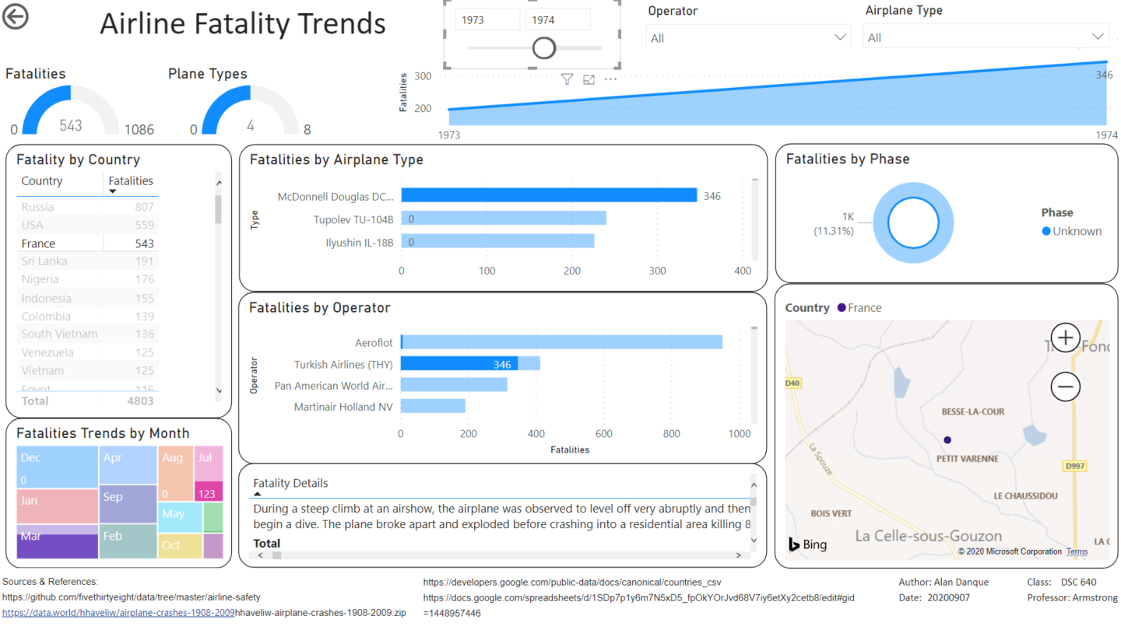

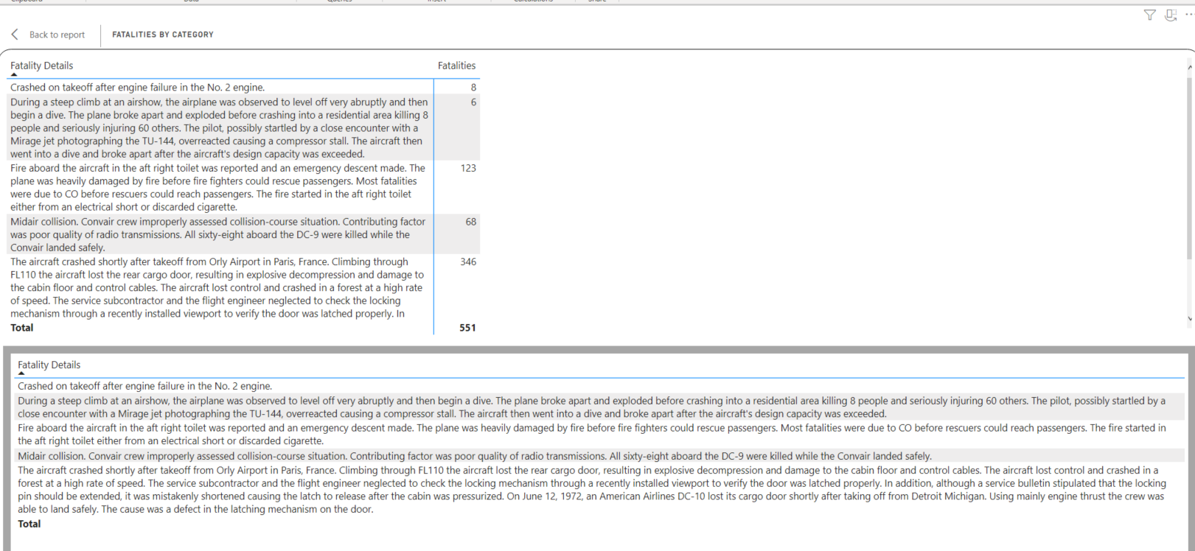

To prepare the data used for this dashboard, I created two python scripts. One for the data wrangling to clean up the data and to unify the two historical airline fatality data sets. And a second to perform the exploratory data analytics to understand the distribution and relationships of the contained fields. After pulling the dataset, I found that I needed latitudes and longitudes per country to enable a map presentation of the data. I then imported a country lat-long data file and used the Power Bi DAX language to create a formula for the country name to allowed me to join on the country name fields.

Data sources:

* [Accidents and Fatalities Pery Year](https://docs.google.com/spreadsheets/d/1SDp7p1y6m7N5xD5_fpOkYOrJvd68V7iy6etXy2cetb8/edit#gid=1448957446)

https://docs.google.com/spreadsheets/d/1SDp7p1y6m7N5xD5_fpOkYOrJvd68V7iy6etXy2cetb8/edit#gid =1448957446

Supplemental data

* [Crash Datasets](https://data.world/datasets/crash), Data.World

**Airplane Crashes 1908-2009**

**DATASET BY**[**HOZEFA HAVELIWALA**](https://data.world/hhaveliw)

<https://data.world/hhaveliw/airplane-crashes-1908-2009>

To get country lat and long addresses, I also used: countries.csv.

<https://developers.google.com/public-data/docs/canonical/countries_csv>

Below are screenshots of the python scripts created for this task.

