Student: Alan Danque

Class: DSC 640

Professor: Anthony Armstrong

Task 4: Infographic

Git repository: <https://github.com/adanque/DSC640/tree/master/Task3-BlogPost>

Blogger URL: <https://adanque.blogspot.com/2020/10/fictious-airways-commited-to-flying.html>

**Fictious Airways – Committed to flying safer.**

Fictious Airways is a world class airline serving domestic and international flights around the globe. To and from destinations including but not limited to the United States to Europe, Asia, and Africa. In the recent months, Fictious Airways has been faced with a sudden decline in air travel due to customer churn as safety concerns became paramount after a report of historical airplane crash fatalities, their locations and the company’s current survival rate has been made public. The result of this decline has caused service routes to be reduced and mass layoffs. To immediately remedy the problem, Fictious Airways decided to analyze their planes and found a list of planes with historically low survival rates below 60%. Fictious Airways also found that two of the planes we more than 30 years old and one was a little over 15 years old. To improve their current overall survival rate of 50% they decided to decommission all aircraft with a survival rate of less than 60%. With this reduction, Fictious Airways survival rate score increased to 67%. Thereby improving passenger survival should there be any future possible aircraft crashes.

To improve customer relations, Fictious Airways decided to release all information related to their analysis and plan “as publicly available” to all customers and investors. To share this good news, Fictious Airways devised a blog that displayed important information that story boarded the steps of their analysis and outcome onto an informational visual blog that can be printed onto 8.5 x 11 inch paper if needed. To structure the blog, they used a format of two columns so the try to pack as much info into the 8.5x11 inch format as cleanly as possible. And to allow for a up to down and left to right reading flow.  They used a story board tactic consisting of 3 phases, with the first phase setting the stage of Fictious Airways as a world class Airline that services domestic and international flights using a map and pie charts that help mark locations on that map and give an indication of the number of crashes in those locations. The second to present the problem they are faced with being the reduction of customer flights due to client safety concerns using a bar graph of the number of flights from last year using a blue color contrasted with a lighter blue colored bar graph for the current year. Along with a red arrow pointing to the months of the reduced flight counts. And the third being their analysis and their resulting actions to improve their service. Fictious Airways felt that by using an infographic visual within their blog, it would specifically indicate when the reduction of flights occurred comparing with the months in the year prior and the current months leading to and after the air travel reduction with a red arrow pointing to the low months. It also displayed a global map identifying the amounts of crashes broken down by the model aircraft. To further break down the analysis into each aircraft model, Fictious Airways displayed a horizontal bar graph that compared the aircraft model crash fatalities in dark blue with the number of survivors in a lighter blue with red arrows to indicate the planes identified to be decommissioned. To display the number of crashes by plane, Fictious Airways used a donut chart listing the breakdown of each aircraft model and listing the total number of crashes for all planes in the middle of the donut chart. Just below the donut, is a vertical bar graph displaying the ages of each of the aircraft models with a note on the ages of the planes and a note stating that the age of the aircraft was found to affect the survival rates again with a blue for each of the bars of the graph. To show more on the survival rate analysis, Fictious Airways displayed a table listing each aircraft model associated with color coded survival rates labeled with percentages and colors that indicate blue for good, purple transitioning from good to not so good at pink and dark red for bad followed with a total current survival rate meter below it. To further emphasize the three aircraft with lower than 60% survival rates in addition to using dark red cells, red arrows were added to highlight the targeted planes to decommission. Below the table listing the survival rate for each plane, Fictious Airways lists the specific statistics of each plane identified to be decommissioned so to make it very clear why these planes were selected for removal from service. Each of the statistics included a donut chart displaying the amount of survivors in light blue compared against the number of fatalities in a dark blue. Within the donut chart displays the total number of fatalities. Just to the right of the donut chart is a blue color fillled area chart displaying fatalities counts over a time series by year. To the right of the statistics of the three planes to decommission is an increased survival safety meter gauge to conclude improvement after removing these planes from service. Furthermore, for graph colors, Fictious Airways decided to use a pallet of mostly blue colors however, for transitional variances or categorical changes we used purple for slightly good, pink to indicate lowest acceptable value and dark reds to indicate unfavorable values. To add emphasis and to ensure to call attention to, Fictious Airways has used arrows to indicate which aircraft will be targeted for removal and indicate improvements.

Fictious Airways believes by being completely visible in their research and analysis in conjunction with their actions to improve their score card regarding survival rates, that their customers will feel safer to fly Fictious Airways.

**Source:**

[Accidents and Fatalities Pery Year](https://docs.google.com/spreadsheets/d/1SDp7p1y6m7N5xD5_fpOkYOrJvd68V7iy6etXy2cetb8/edit#gid=1448957446)

https://docs.google.com/spreadsheets/d/1SDp7p1y6m7N5xD5_fpOkYOrJvd68V7iy6etXy2cetb8/edit#gid =1448957446

**Supplemental Sources:**

**U.S. Department of Transportation**

<https://data.bts.gov/>

<https://data.bts.gov/browse?category=Aviation>

<https://data.bts.gov/Aviation/Commercial-Aviation-Departures/bpqk-hyst>

**Bureau of Aircraft Accidents Archives**

<http://www.baaa-acro.com/crash-archives>

**Blog Project Assets:**

Fictious Airways



Visuals

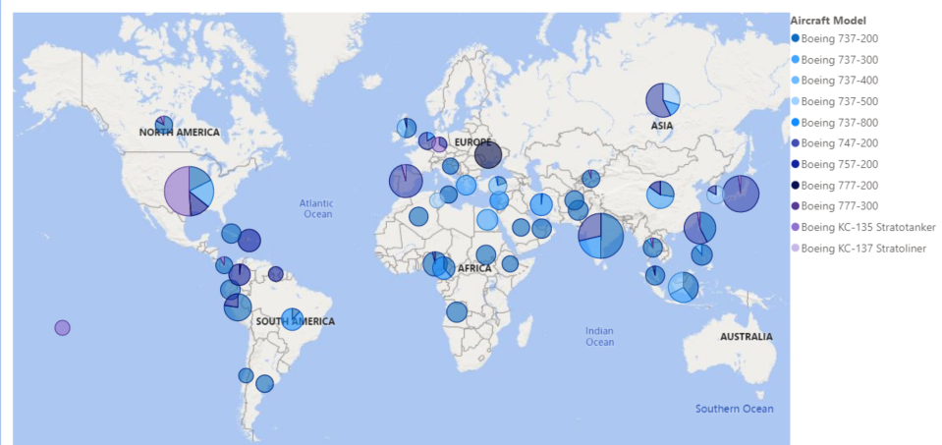

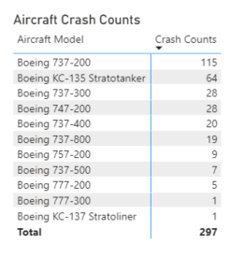

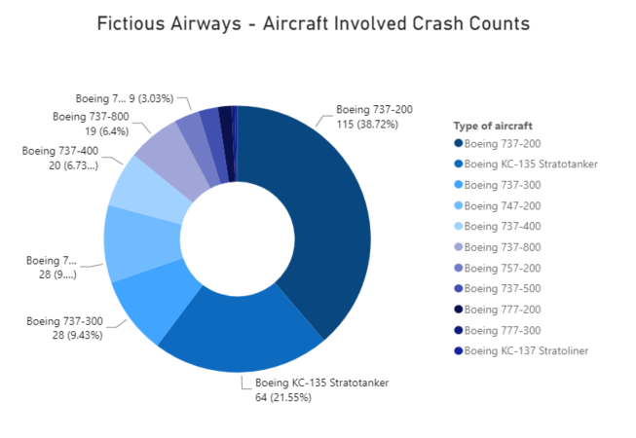

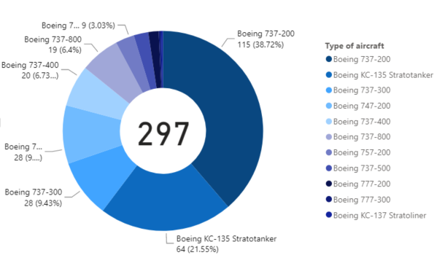

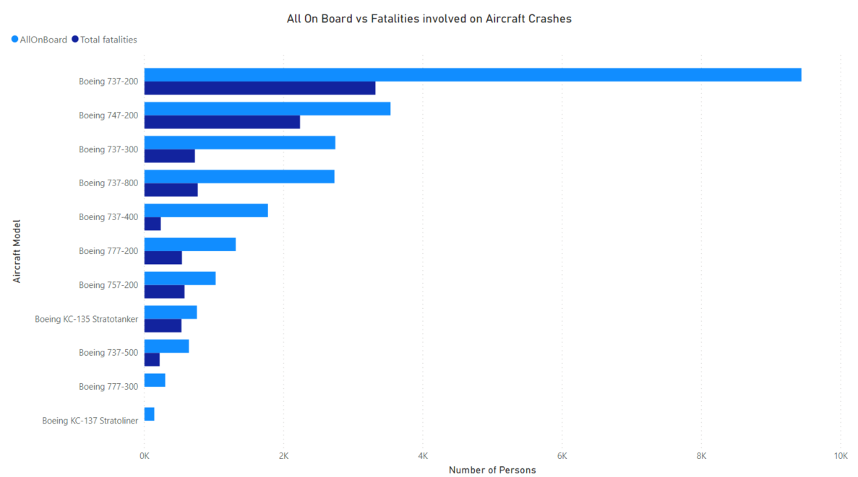

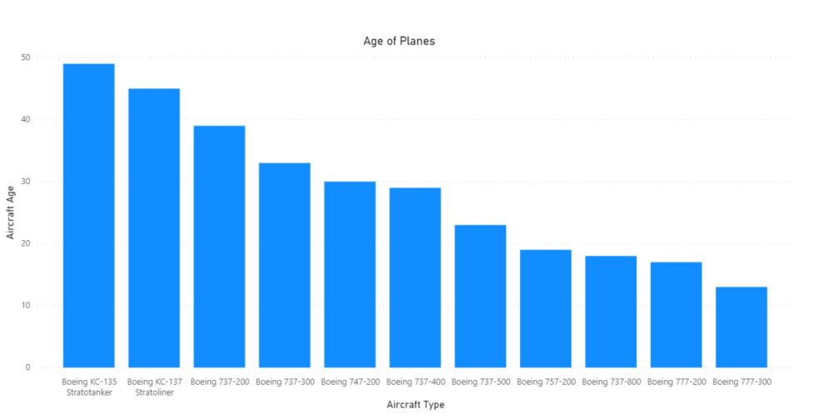

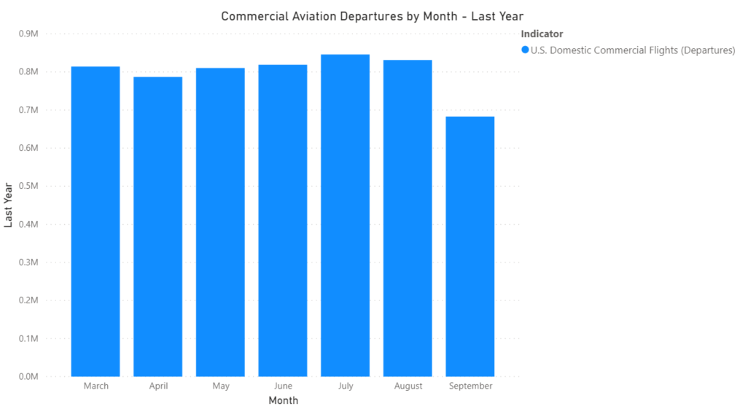

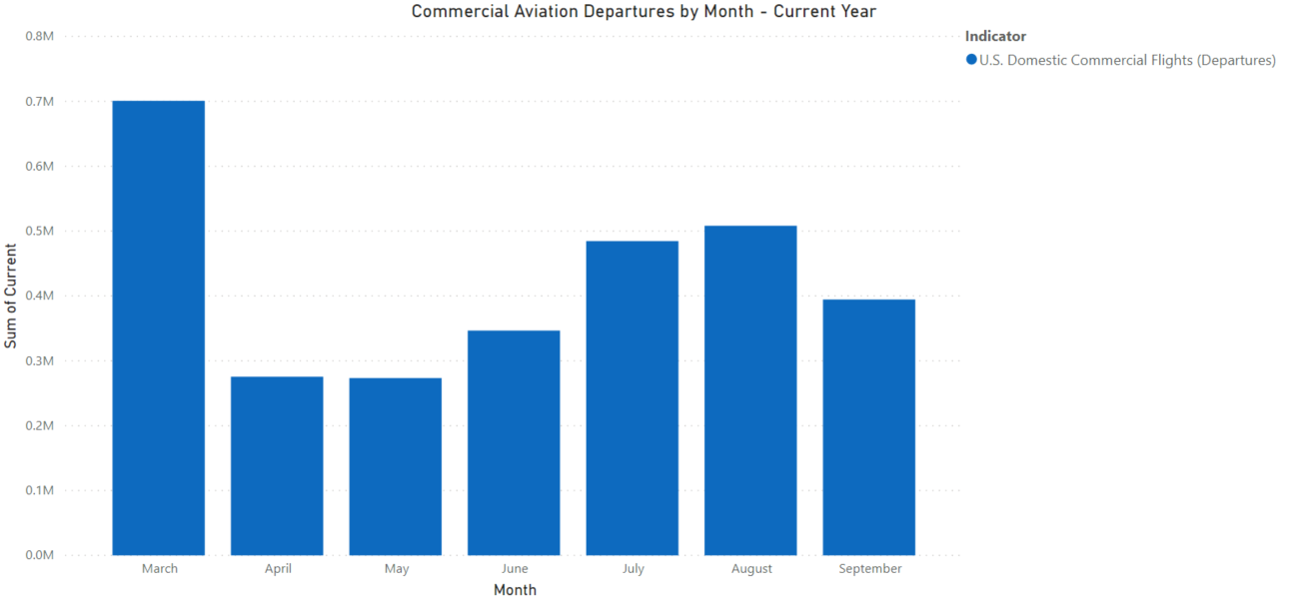

Aircraft Statistics

**737-200**

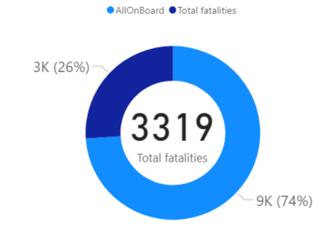 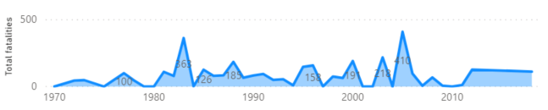

**KC-135**

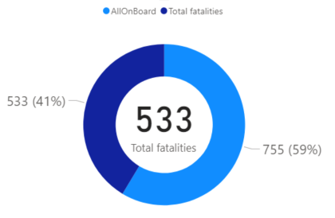 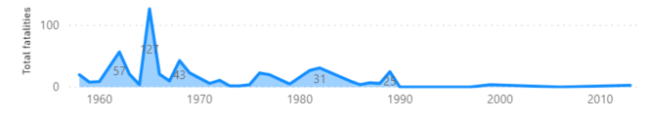

**747-200**

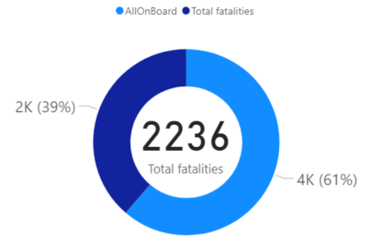 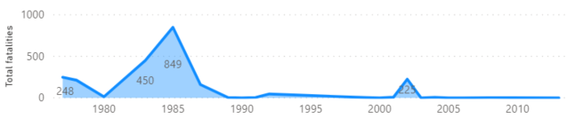

**737-400**

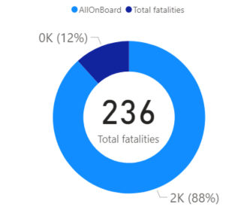 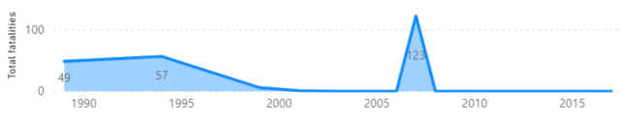

**737-800**

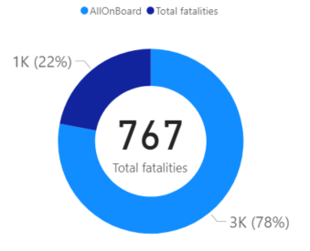 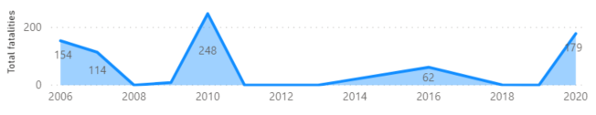

**757-200**

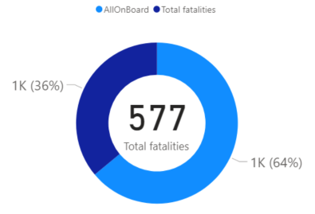 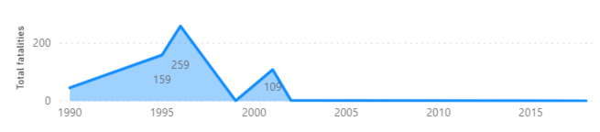

**737-500**

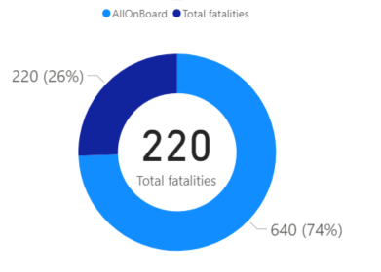 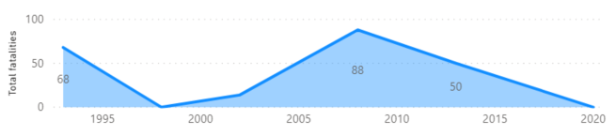

**777-200**

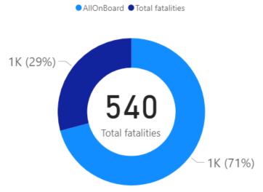 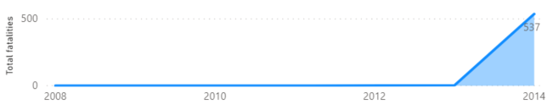

**777-300**

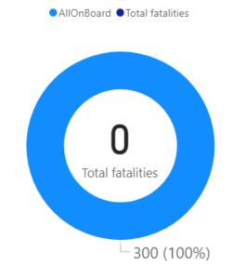 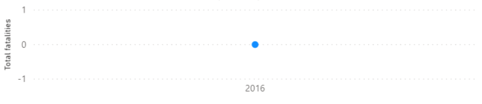

**KC-137**





