Student: Alan Danque

Class: DSC 640

Professor: Anthony Armstrong

Git repository: <https://github.com/adanque/DSC640/tree/master/Task3-BlogPost>

**Fictious Airways – Committed to flying safer.**

Fictious Airways is a world class airline serving domestic and international flights around the globe. To and from destinations including but not limited to the United States to Europe, Asia, and Africa. In the recent months, Fictious Airways has been faced with a sudden decline in air travel due to customer churn as safety concerns became paramount after a report of historical airplane crash fatalities has been made public. The result of this decline has caused massive layoffs and service routes to be reduced. To immediately remedy the problem, Fictious Airways decided to analyze their planes and found a list of planes with historically low survival rates below 60%. Fictious Airways also found that some of these planes we more than 50 years old. To improve their current overall survival rate of 50% they decided to decommission all aircraft with a survival rate of less than 60%. With this reduction, Fictious Airways survival rate score increased to 67%. Thereby improving passenger survival should there be any future possible aircraft crashes.

To improve customer relations, Fictious Airways decided to release all information related to their plan “as openly available” to all customers and investors. To share the good news, Fictious Airways devised a blog that displayed important information that story boarded the steps of their analysis and outcome. They used a story board tactic of 3 phases, with the first setting the stage of Fictious Airways as a world class Airline. The second to present the problem they are faced with being the reduction of customer flights due to client safety concerns. And the third being their analysis and their resulting actions to improve their service. Fictious Airways built their post as an infographic blog indicating when the reduction of flights occurred comparing with the months in the year prior and the current months leading to and after the air travel reduction with a red arrow pointing to the low months. It also displayed a global map identifying the amounts of crashes broken down by the model aircraft. To break down more information into the aircraft analysis, Fictious Airways displayed a horizontal bar graph that compared the aircraft model crash fatalities in dark blue with the number of survivors in a lighter blue indicating the planes identified to be decommissioned. To display the number of crashes by plane, Fictious Airways used a donut chart listing the breakdown by aircraft model and listing the total number of crashes for all planes in the middle of the donut chart. Just below the donut, is a bar graph displaying the ages of each of the aircraft models with a note on the ages of the planes and a note stating that the age of the aircraft was found to affect the survival rates. To show more on the survival rate analysis, Fictious Airways displayed a table listing each aircraft model associated with the survival rate as a percentage with a total current survival rate meter below it. It emphasized on the three aircraft with lower than 60% survival rates by using dark red cells and red arrows to highlight them. Also noted is a meter gauge displaying the improved survival rate after having decommissioned the three planes with a lower than 60% survival rate. To the right of the meters, Fictious Airways listed specific statistics of each plane identified to be decommissioned so to make it very clear why these planes were selected for removal from service. Fictious Airways believes by being completely visible in their research and analysis in conjunction with their actions to increase survival rate, that their customers will feel safer to fly Fictious Airways.

**Source:**

https://docs.google.com/spreadsheets/d/1SDp7p1y6m7N5xD5_fpOkYOrJvd68V7iy6etXy2cetb8/edit#gid =1448957446

**Supplemental Sources:**

<https://data.bts.gov/>

<https://data.bts.gov/browse?category=Aviation>

<https://data.bts.gov/Aviation/Commercial-Aviation-Departures/bpqk-hyst>

<http://www.baaa-acro.com/crash-archives>

**Blog Project Assets:**

Fictious Airways



Visuals

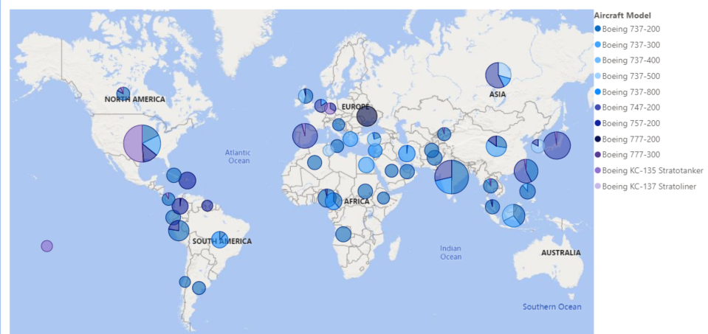

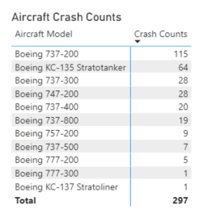

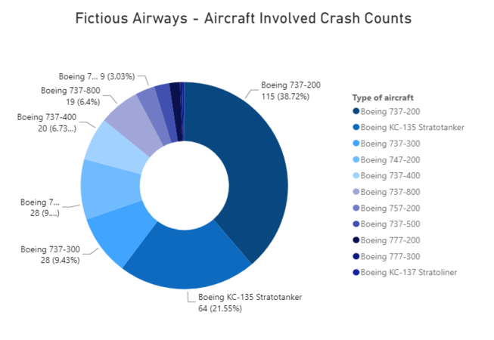

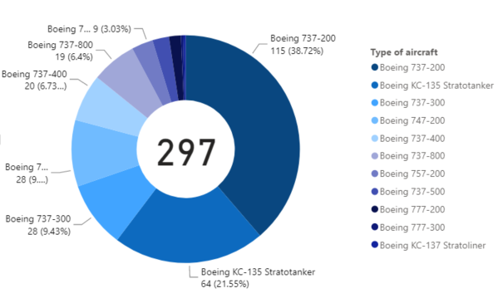

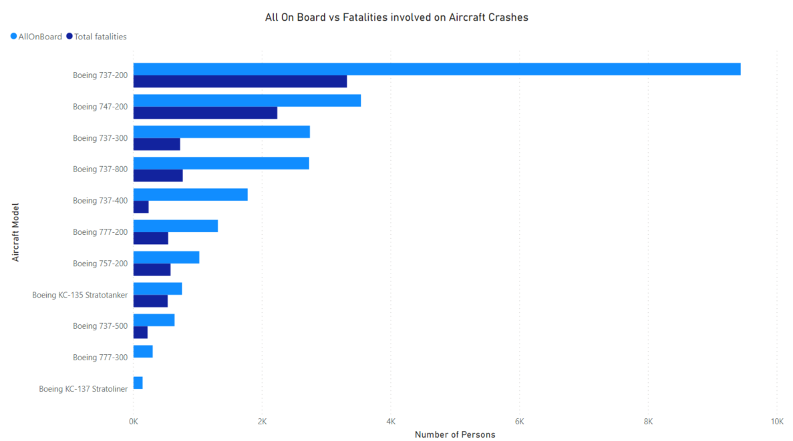

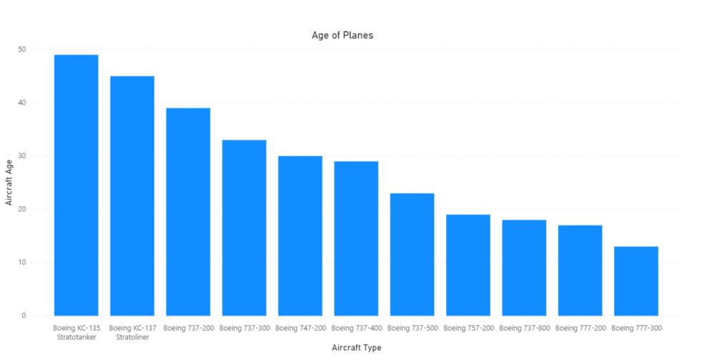

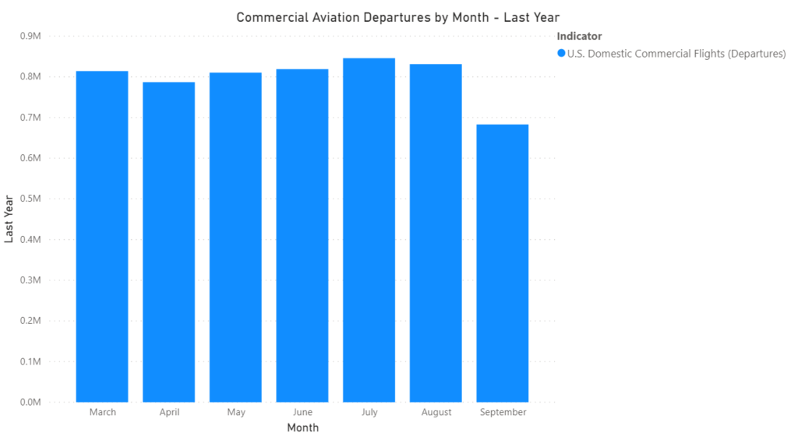

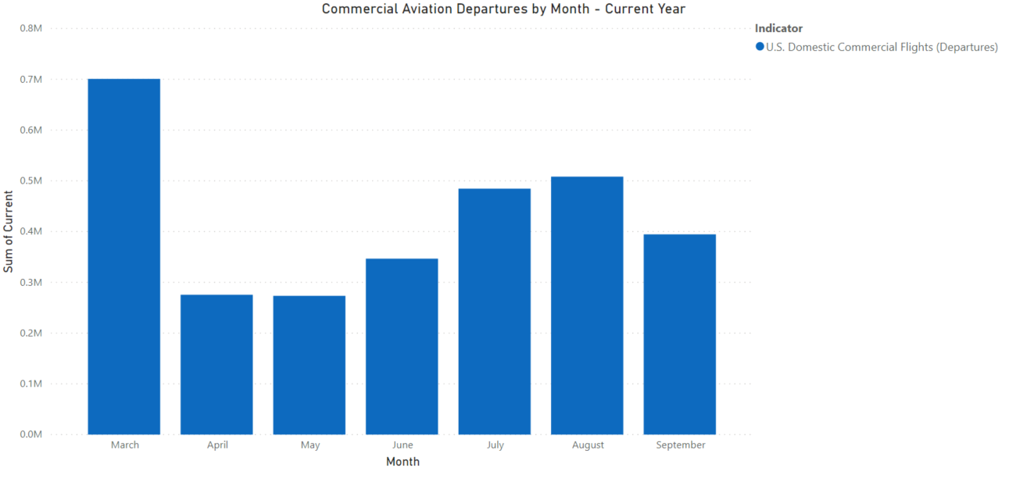

Aircraft Statistics

**737-200**

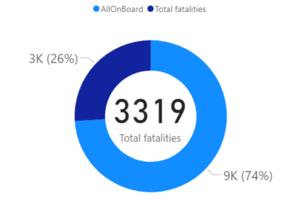 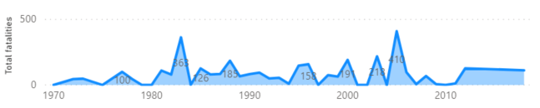

**KC-135**

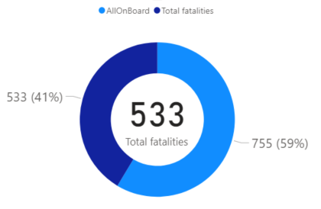 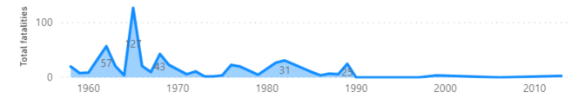

**747-200**

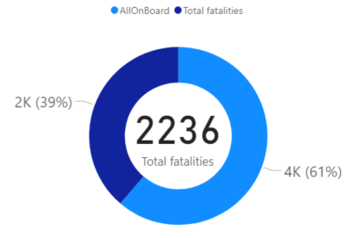 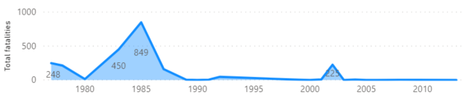

**737-400**

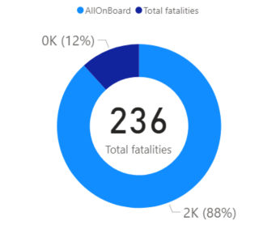 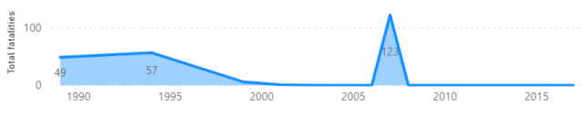

**737-800**

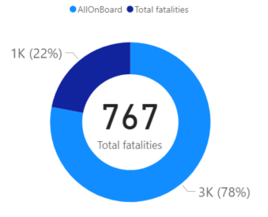 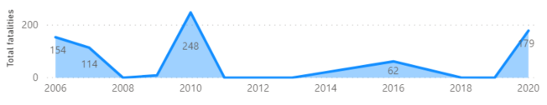

**757-200**

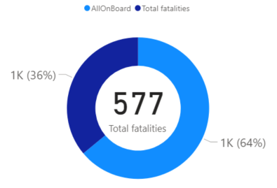 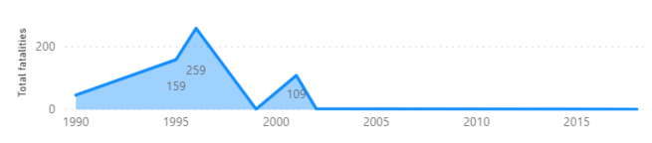

**737-500**

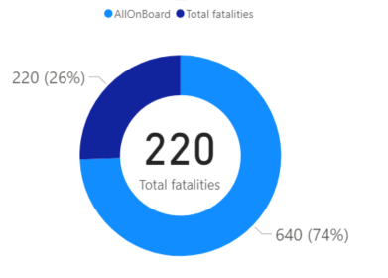 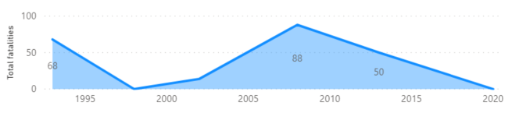

**777-200**

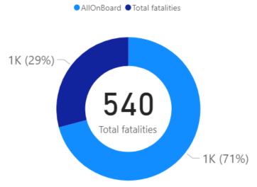 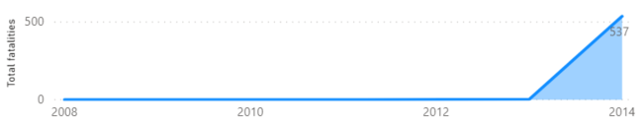

**777-300**

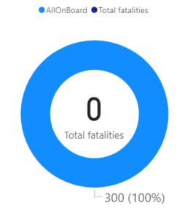 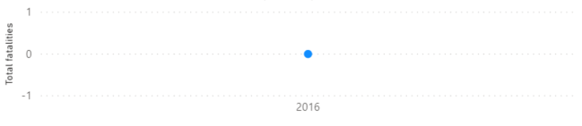

**KC-137**





