IST 263

# Lab 01

## This lab covers:

1. Install Class Software and Connecting to Github
2. Create First Web Page
3. Serving First Page to the Web

## Install Class Software

### Text Editor

Web pages are text documents. You could open a very basic text editor like Notepad on Windows to create your first web page. But, we are going to use a free application called VS Code in this class. Why VS Code? VS Code has features that you are going to love the make creating our web pages easier.

1. Go to <https://code.visualstudio.com/download> to download. Make sure to choose the correct version for you operating system.
2. Once the download is complete, launch the installer and follow the steps. The Mac may automatically install.

### Git and Github

To manage your files and post your website online we are going to use Git. Git is a tool a developer installs locally on their computer, while GitHub is an online service that stores code pushed to it from computers running the Git tool.

**Setting Up Github Account** (skip to the next section if you already have an account)

1. Go to github.com
2. Click Signup
3. Your username should be your netid-su, so mine would be laferger-su
4. You can use your SU email
5. Click 'Create an Account'
6. In the next page choose answer the questions and click the “Complete Setup” Button
7. You should have received an email from GitHub. Open the email and click 'Verify your email address' to complete the process. You now have a GitHub account.
8. You will need your GitHub username and password to access GitHub every week in this class, so make a note of them.

**Create your personal GitHub repository** (which you'll use to post homework and project files)

1. While logged in at github.com, click your user icon at the far upper right of the browser screen.
2. From the menu, choose “Your Repositories”, then click the green “New” button.  
   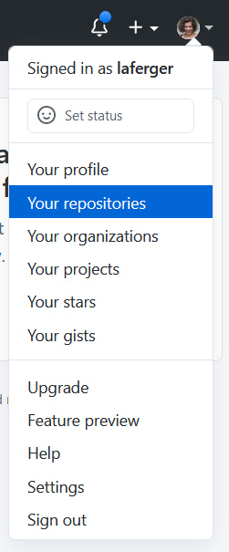
3. Enter the name ist263 for your new repository.   
   Important: Use all lowercase, no spaces, no punctuation. Follow this convention for all folders and filenames, including image files. This precaution will save you endless tedious hours debugging your code over the semester.  
   Graphical user interface, text, application, chat or text message

   Description automatically generated
4. Click the check box before "Initialize this repository with: Add a README file"
5. Leave all the other fields as is and click the “Create Repository” button.

**Enable GitHub Pages Web Display**

1. With your new GitHub repo displayed on screen, click the settings sprocket icon – there’s more than one sprocket so make sure you click the correct one at upper right to open repo Settings.

1. Click Pages from the settings nav on the left.
2. Under Branch, choose the drop-down selector and select 'main' branch.
3. Click the “Save” button.
4. We will start to put content in your github site later in the lab.

**Installing Git Desktop Client**

Warning: Below you will save files on your computer. You will need to access them every week in this class. Put them somewhere you can find them easily. Do not clone your repository a second time if you cannot find the files. If you don’t see the button to choose where you files should be located raise your hand. **You cannot move the repository folder later.**

1. Go to <http://desktop.github.com>
2. Download the program installer appropriate for your version of the OS.
3. Once the download is complete, launch it and follow the steps to install it. The Mac may install it automatically.
4. After it is installed, launch Github Desktop and connect it to your Github account by signing in.
5. If GitHub asks you to authorize, click the “Authorize desktop” button.
6. Click continue then finish.
7. On the "Let's get started!" screen, let's clone your repository. This will put a copy of the files from your repository onto your computer. Choose the repository we just made from the list on the right.   
   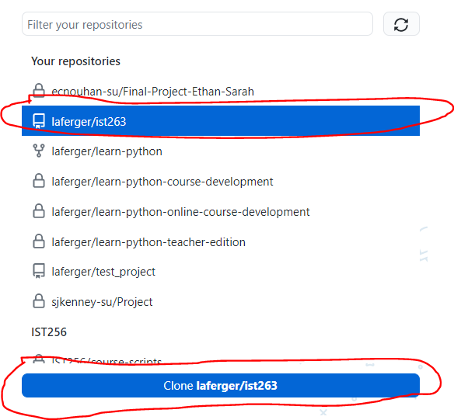
8. Click the clone button at the bottom right.
9. Graphical user interface, text, application

   Description automatically generated  
   Note: This is what the dialog box I get looks like. Depending on your computer settings you might not have the choose button (your place to change folder location may be a down arrow).   
     
   Under local path press the “Choose” button. You can save the folder anywhere you want, but I suggest you choose the Desktop for easy access.  
     
   You cannot move the folder location of repository once you click clone!!!
10. Click the “Clone” button.
11. Locate the “ist263” folder you just created and open it. Create a place for us to store our first lab files by creating a “lab01” folder inside it. On the mac you can do this by going to “File -> New Folder”. On Windows right click in the folder and choose “New -> Folder”.   
      
    Note: Do not use capital letters or spaces ever when name a file or folder for this class  
      
    Graphical user interface, application

    Description automatically generated
12. We'll be using this later in the lab so you can leave it open for now.

## Your First Web Page

Your first web page will contain a short bio of yourself. We will create the file in VS Code, put the file on GitHub and view it in your web browser.

### Your Bio

Launch Word-processing software like MS Word and write a professional biography using the guidelines below. Keep in mind you will be posting the bio to your website where the whole world can see it.

Items that must appear in your professional bio:

1. Begin writing your bio with your first and last name.
2. State your current major and what interests you have regarding that major. For example, I'm a data science major interested in examining statistics related to sports.
3. Include a list of accomplishments or skills.
4. Briefly tell your readers who you are outside of work. Like hobbies, favorite TV shows, movies, or books, information about family life, funny details about habits or interests, or unique personal history.
5. Add anything else you think you need in your bio and make sure it all flows together.

### VS Code

We downloaded and installed VS Code for the purpose of writing our web pages.

1. Launch VS Code
2. Go to File -> Open Folder
3. Located the ist263 -> lab01 folder
4. Click the “Select Folder” button
5. Go to File -> New File

### the code

We are about to write your first web page. A webpage consists of html tags/elements and the content you want to publish to users. Every web page contains the following:

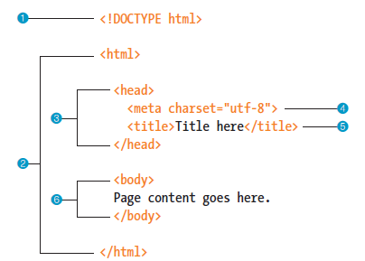

**Decoding the above HTML**

1. version of HTML you are using
2. entire HTML document should be contained in this element
3. info about your html page that will not display in main browser window
4. character encoding for your document.
5. Title that appears at the top of your browser window
6. All the content goes here

For this part type in all the html above into your new file. Where the "Title here" appears type in "Your name – Bio", where you replace “Your name” with your actual name. Replace the "Page content goes here." with the bio you wrote. When it is complete go to File -> Save As and type lastname-bio.html as the file name (replace lastname with your last name). **Do not use spaces or capital letters in file names**. Locate the lab01 folder we created and save in that location.

### Upload to your website

To view our first page on the web we are going to upload it to Github.

1. Launch Github Desktop
2. The folder and file you worked on should be listed on the left.   
   Type in a summary for the change you’re are making. This one could be “completed lab 1”. Press the "Commit to main" then "Push Origin" button to send the file to Github.
3. Now we are going to view the page. In your web browser, type the url to your website. It should be: https://your-username.github.io/ist263/lab01/lastname-bio.html

|  |
| --- |
| **Help! My bio is not displaying!**   1. **Did you save your folders and files with the correct names?**  If you look at the repository folder on your computer, you should see a folder called ist263 with a folder called lab01 inside it with a file called yourlastname-bio.html inside it. Capital letters and spaces are not allowed. If your names are not correct, fix this on your computer and re commit using Github Desktop. 2. **Did you commit your files to Github properly?** Go to github.com/yourusername and check the files you put there. The files on Github should look just like the files on your desktop. This means an ist263 folder with a lab01 folder inside it and a yourlastname-bio.html file inside that. If that is not what you see check to make sure your commit worked in github. |

Ugly Page Warning! The text on you web will display as one long paragraph. Don't despair. We will learn how to make web pages look much better.

## What will you Hand IN?

Create a word document, pdf or use the "write submission" option in blackboard to provide the following (do not use another format):

1. Submit the GitHub URL for the bio web page you create. To make sure you are submitting the correct link:
   1. Check and make sure github.io is part of the url
   2. Click on the link you pasted into the assignment to make sure it works for you