COMSATS University Islamabad

Deep Learning
Midterm Project
Task 1: DNN Model – Telecom Customer Churn Prediction
Task 2: CNN Model – Clothing Image Classification
Student Name | Adan Tariq
Registration No. | FA23-BBD-011
Class | BBD 6A
Program | BS Business Data Analytics
Submission | Project document, Jupyter notebook and saved models (.joblib)

Project Overview
For this midterm project I built two deep learning models on two different datasets. The first is a Deep Neural Network (DNN, also called an ANN) that works on a table of customer data. The second is a Convolutional Neural Network (CNN) that works on pictures. Both were written in Python using TensorFlow and Keras, and the code for both is in one Jupyter notebook (DL_Midterm_Project.ipynb) submitted along with this document. After training, each model was saved in .joblib format (churn_dnn_model.joblib and fashion_cnn_model.joblib) and then loaded again in an inference step to make predictions on new data, which is how a trained model is used in practice.
 | Task 1: DNN | Task 2: CNN
Problem | Predict whether a telecom customer will churn | Recognise the category of a clothing item from its photo
Problem type | Binary classification | Multi-class classification (10 classes)
Dataset | Telco Customer Churn | Fashion-MNIST
Data type | Tabular (7,043 customers) | Images (70,000 grayscale, 28 x 28)
Model | Dense network, 4,161 parameters | 2-block CNN, 225,034 parameters
Test accuracy | 74.7% (ROC-AUC 0.838) | 91.24%
Saved model | churn_dnn_model.joblib | fashion_cnn_model.joblib

Key Terms Used in This Report
Term | Meaning
Neuron | A small unit that takes numbers in, multiplies them by learned weights, adds them up and passes the result on.
Dense layer | A layer where every neuron is connected to every neuron in the previous layer.
ReLU | An activation function that keeps positive values and turns negative values into zero. It is the usual choice for hidden layers.
Sigmoid / Softmax | Output functions that turn a score into a probability. Sigmoid is used for two classes and Softmax for many classes.
Dropout | Randomly switching off some neurons during training so the model does not just memorise the training data.
Epoch | One full pass of the model over the whole training set.
Overfitting | When a model does very well on training data but worse on new data because it has memorised instead of learned.
Convolution / Pooling | Convolution slides small filters over an image to find patterns such as edges. Pooling shrinks the result by keeping only the strongest value in each small area.
Precision / Recall / F1 | Precision is how many predicted positives were correct. Recall is how many real positives were found. F1 combines the two.
ROC-AUC | A score from 0.5 (random guessing) to 1.0 (perfect) that shows how well the model separates the two classes.
Inference | Using a trained model to make predictions on new data it has never seen. This is the step where the model is actually put to work.
.joblib file | A file created with the Python joblib library that stores a trained model (and its preprocessing tools) so it can be loaded and used later without training again.

Part 1: DNN Model – Telecom Customer Churn Prediction

1.1 Problem Definition
A telecom company earns most of its money from monthly subscribers. Winning a new customer costs a lot more than keeping an old one, so every customer who cancels (this is called churn) is a real loss. If the company knew in advance which customers were about to leave, it could contact them early and offer a discount, a better package or a longer contract.
So the question I am answering is: using a customer's account details (contract type, how long they have been with the company, monthly bill, services taken and so on), can we predict if they will churn (1) or stay (0)? Because there are only two possible answers, this is a binary classification problem.

1.2 Dataset Description and Source Link
Dataset: Telco Customer Churn (originally published by IBM). Kaggle link: https://www.kaggle.com/datasets/blastchar/telco-customer-churn.
File used in the notebook: the same data from IBM's GitHub copy, so the notebook runs without a Kaggle login: https://raw.githubusercontent.com/IBM/telco-customer-churn-on-icp4d/master/data/Telco-Customer-Churn.csv.
The dataset has 7,043 customers and 21 columns. The column we want to predict is Churn (Yes or No). Only about 26.5% of the customers churned, so the data is imbalanced, which matters later when we judge the model. The columns can be grouped like this:
Group | Columns
Customer information | gender, SeniorCitizen, Partner, Dependents
Account information | tenure (months), Contract, PaperlessBilling, PaymentMethod, MonthlyCharges, TotalCharges
Services used | PhoneService, MultipleLines, InternetService, OnlineSecurity, OnlineBackup, DeviceProtection, TechSupport, StreamingTV, StreamingMovies
Target | Churn (Yes = customer left, No = customer stayed)

Before building the model I looked at the data (Figure 1). Most churned customers are on month-to-month contracts and have been with the company for only a few months, which makes sense: people with no long contract can leave easily.
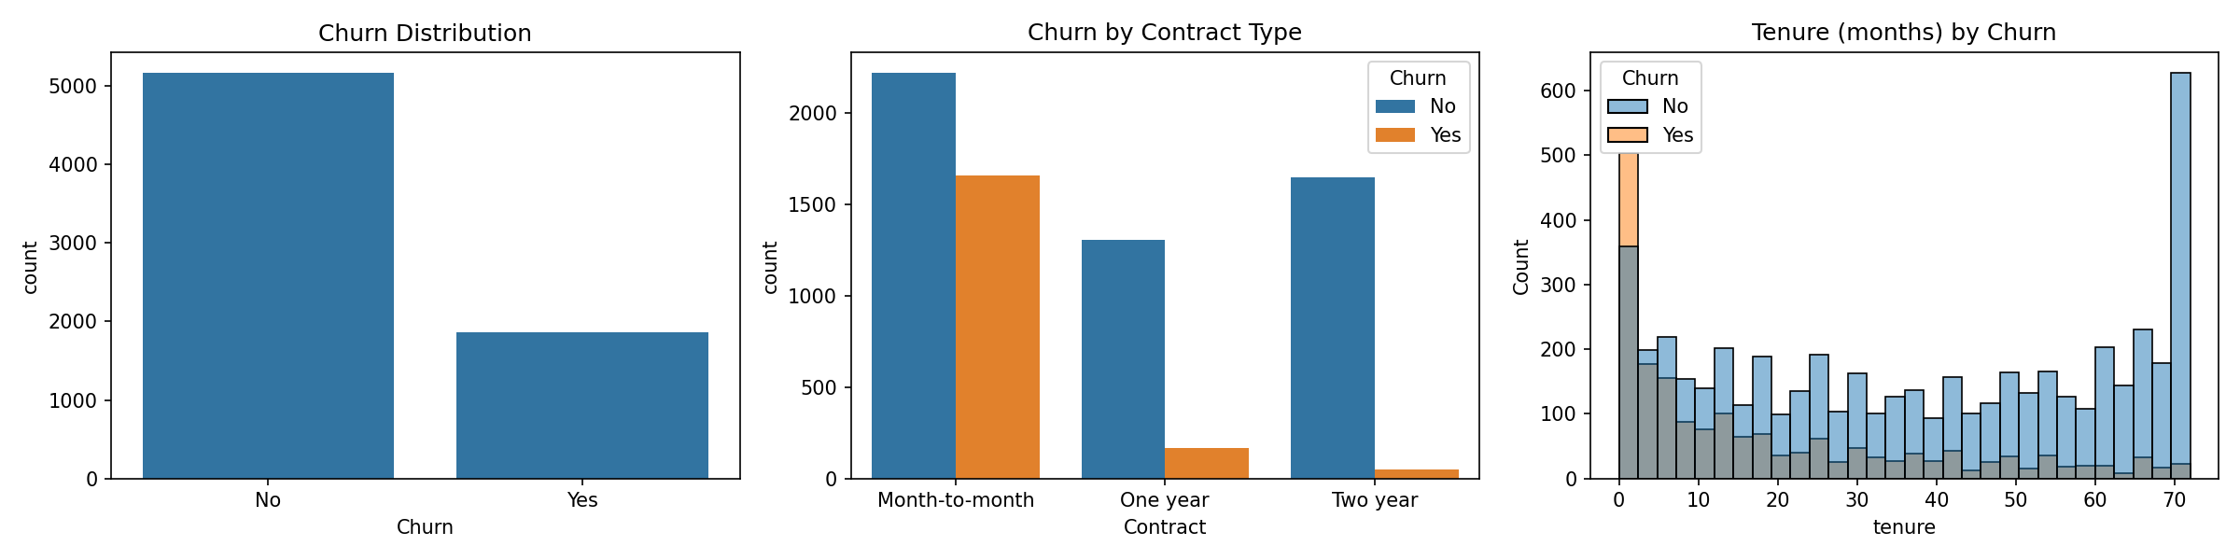
Figure 1: Churn distribution, churn by contract type, and tenure by churn

1.3 Proposed Solution
My solution is a Deep Neural Network made of fully connected (Dense) layers. For each customer it gives a probability between 0 and 1 that they will churn. The plan is:
- Clean the data and turn the text columns into numbers with one-hot encoding.
- Scale the numeric columns so that large numbers like TotalCharges do not dominate small ones.
- Train a DNN with ReLU hidden layers, Dropout to limit overfitting, and one sigmoid output neuron.
- Use class weights so the model gives extra attention to the smaller group (customers who churn).
- Test the model on customers it has never seen, using accuracy, precision, recall, F1-score, a confusion matrix and ROC-AUC.
- Save the trained model as a .joblib file and use it in an inference step to predict churn for new customers.

1.4 Data Preprocessing
- Removed the customerID column. It is just a label for each row and says nothing about whether the customer leaves.
- TotalCharges was stored as text, so I converted it to numbers. This showed 11 missing values. All 11 customers have a tenure of 0 months (they just joined and have not been billed), so filling them with 0 is the sensible choice.
- Changed the target column Churn from Yes/No to 1/0 so the network can use it.
- Replaced "No internet service" and "No phone service" with "No", because they mean the same thing for these columns.
- One-hot encoded every text column (each category becomes its own 0/1 column, with one dropped to avoid repetition). This gives 23 input features.
- Split the data into 80% for training (5,634 customers) and 20% for testing (1,409 customers). The split is stratified, so both parts keep the same churn rate of about 26.5%.
- Standardised the features with StandardScaler. It was fitted on the training data only, so no information from the test set leaks into training.
- Calculated class weights from the training data: 0.68 for customers who stayed and 1.88 for customers who churned, so mistakes on churners count more.

1.5 Model Architecture
The network takes the 23 input features and passes them through three hidden layers of 64, 32 and 16 neurons. The sizes get smaller so the model gradually squeezes the information down. Two Dropout layers switch off 30% of the neurons at random during training. The last neuron uses a sigmoid function, so its output is a churn probability between 0 and 1.
Layer | Details | Output Shape | Parameters
Input | 23 features | (23) | 0
Dense | 64 neurons, ReLU | (64) | 1,536
Dropout | rate = 0.3 | (64) | 0
Dense | 32 neurons, ReLU | (32) | 2,080
Dropout | rate = 0.3 | (32) | 0
Dense | 16 neurons, ReLU | (16) | 528
Dense (output) | 1 neuron, Sigmoid | (1) | 17
Total |  |  | 4,161

Training Setting | Value
Optimiser | Adam
Loss function | Binary cross-entropy
Metrics | Accuracy, AUC
Batch size | 32
Maximum epochs | 100 (with EarlyStopping, patience = 10, monitoring validation loss)
Validation split | 20% of the training data (4,507 train / 1,127 validation)
Class weights | Stayed = 0.68, Churned = 1.88

1.6 Training Results and Evaluation
I let the model train for up to 100 epochs, but EarlyStopping ended it after 29 because the validation loss had stopped improving. The best result (validation loss 0.5042) came at epoch 19, and the model went back to those weights. In Figure 2 the training loss keeps going down while the validation loss stays almost flat. That gap means a little overfitting (about 77% training accuracy against 73% validation accuracy), but nothing serious.
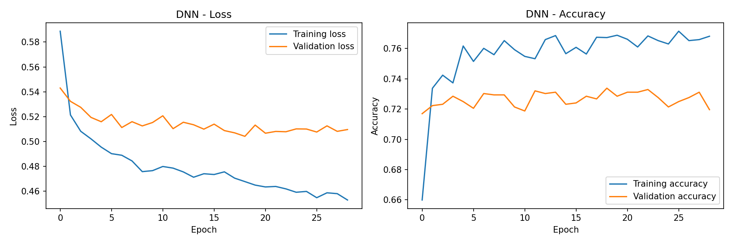
Figure 2: DNN training and validation loss and accuracy
Performance on the 1,409 unseen test customers:
Metric | Value
Test loss | 0.4848
Test accuracy | 74.66%
Test ROC-AUC | 0.8378

Class | Precision | Recall | F1-score | Support
Stayed | 0.89 | 0.74 | 0.81 | 1,035
Churned | 0.52 | 0.75 | 0.61 | 374
Macro average | 0.70 | 0.75 | 0.71 | 1,409
Weighted average | 0.79 | 0.75 | 0.76 | 1,409

 | Predicted: Stayed | Predicted: Churned
Actual: Stayed | 770 (True Negatives) | 265 (False Positives)
Actual: Churned | 92 (False Negatives) | 282 (True Positives)
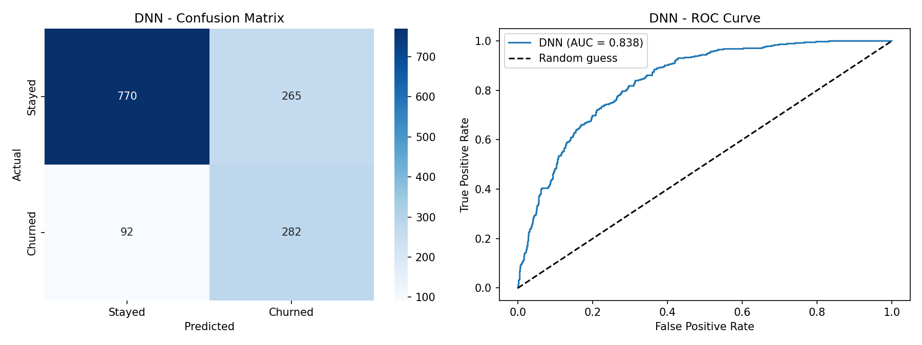
Figure 3: DNN confusion matrix and ROC curve on the test set
Out of the 374 customers who really churned, the model caught 282 (recall of 75%). The downside is 265 false alarms, which is why churn precision is only 52%. This is the trade-off created by the class weights: the model prefers to warn about a customer who may stay rather than miss one who will leave. Accuracy by itself is a weak measure here. A lazy model that always says "Stayed" would get 73.5% accuracy and still find zero churners, so recall, F1 and AUC tell us more. The ROC-AUC of 0.838 shows the model separates the two groups reasonably well.

1.7 Saving the Model and Inference
After training, I saved the model in .joblib format as churn_dnn_model.joblib (about 85 KB). The file stores everything needed to use the model later without training it again: the trained DNN, the fitted StandardScaler, the list of the 23 feature columns and the 0.5 decision threshold. Saving the scaler and the column list is important, because a new customer must be prepared in exactly the same way as the training data or the predictions would be wrong.
For the inference step, the notebook loads the .joblib file again and passes new data through a predict_churn() function. It takes customer records in the same raw format as the original CSV file, applies the same preprocessing as in section 1.4 (fixing TotalCharges, merging "No internet service" and "No phone service" into "No", one-hot encoding, matching the 23 training columns and scaling) and returns the churn probability and the predicted label. As a check, the loaded model gave exactly the same predictions as the original model on the test set (74.66% accuracy). I then used it on three new customers:
Customer | Profile | Churn probability | Prediction
A | 2 months, month-to-month, fibre optic, 95.70 per month, electronic check | 0.907 | Churned
B | 60 months, two-year contract, DSL with all add-on services, automatic bank transfer | 0.029 | Stayed
C | 18 months, one-year contract, phone only (no internet), 20.25 per month | 0.036 | Stayed
The predictions agree with what the data analysis showed. The new customer on a month-to-month contract with a high bill is flagged as very likely to leave, while the long-term customers on fixed contracts are predicted to stay. In practice, the company could run this inference step every month on its customer list and contact the high-risk customers first.

1.8 Conclusion
The DNN works as a practical churn detector: 74.7% test accuracy, 0.838 ROC-AUC and 75% recall on the churn class. A company could use the predicted probabilities to send retention offers to the riskiest customers first, especially those on month-to-month plans with short tenure. Because the model is saved as churn_dnn_model.joblib, it can be loaded and applied to new customers at any time without retraining, as the inference step showed. The main weakness is the number of false alarms. This could be improved by changing the 0.5 decision threshold, creating better features, or comparing with other models such as Random Forest or XGBoost.

Part 2: CNN Model – Clothing Image Classification

2.1 Problem Definition
Online shops like Daraz receive thousands of product photos from different sellers every day. Putting each photo into the right category (shirt, shoes, bag and so on) by hand takes a lot of time, people make mistakes, and a wrongly listed product is hard for customers to find.
The question here is: given a photo of a clothing item, can a computer tell us which of 10 categories it belongs to? Since there are more than two possible answers, this is a multi-class image classification problem.

2.2 Dataset Description and Source Link
Dataset: Fashion-MNIST by Zalando Research. Kaggle link: https://www.kaggle.com/datasets/zalando-research/fashionmnist.
Files used in the notebook: the official GitHub copy, which needs no Kaggle login: https://github.com/zalandoresearch/fashion-mnist.
Fashion-MNIST has 70,000 grayscale pictures, each only 28 x 28 pixels. 60,000 are meant for training and 10,000 for testing. There are 10 clothing classes with exactly the same number of images in each (6,000 for training and 1,000 for testing), so the dataset is perfectly balanced and accuracy is a fair measure.
Label | Class | Label | Class
0 | T-shirt/top | 5 | Sandal
1 | Trouser | 6 | Shirt
2 | Pullover | 7 | Sneaker
3 | Dress | 8 | Bag
4 | Coat | 9 | Ankle boot
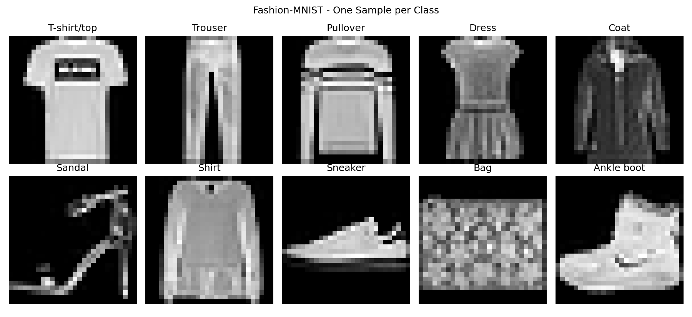
Figure 4: One sample image from each of the 10 classes

2.3 Proposed Solution
I used a Convolutional Neural Network (CNN) because it is built for images. Its convolution filters learn visual patterns by themselves, starting with simple edges and moving on to textures and shapes, and its pooling layers make the model less sensitive to exactly where the item sits in the picture. The network has two Convolution + MaxPooling blocks to find features, then Dense layers to decide the class, and Dropout to reduce overfitting. I tested it on the 10,000 unseen test images using accuracy, precision, recall and F1-score for each class, and a confusion matrix. Finally, I saved the trained model as a .joblib file and used it in an inference step to classify new images.

2.4 Data Preprocessing
- Loaded the compressed image files and converted them into NumPy arrays of shape (60,000, 28, 28) for training and (10,000, 28, 28) for testing.
- Divided every pixel value (0 to 255) by 255 so it lies between 0 and 1. Small values like these make training faster and more stable.
- Added a channel dimension, so each image is 28 x 28 x 1. The 1 means a single grayscale channel (colour images would have 3).
- The labels are already whole numbers from 0 to 9, so I used sparse categorical cross-entropy and did not need one-hot encoding.
- Kept 10% of the training images (6,000) aside as a validation set to watch for overfitting, leaving 54,000 images to train on.

2.5 Model Architecture
Layer | Details | Output Shape | Parameters
Input | Grayscale image | (28, 28, 1) | 0
Conv2D | 32 filters, 3x3, ReLU | (26, 26, 32) | 320
MaxPooling2D | 2x2 | (13, 13, 32) | 0
Conv2D | 64 filters, 3x3, ReLU | (11, 11, 64) | 18,496
MaxPooling2D | 2x2 | (5, 5, 64) | 0
Flatten |  | (1600) | 0
Dense | 128 neurons, ReLU | (128) | 204,928
Dropout | rate = 0.3 | (128) | 0
Dense (output) | 10 neurons, Softmax | (10) | 1,290
Total |  |  | 225,034

Training Setting | Value
Optimiser | Adam
Loss function | Sparse categorical cross-entropy
Metric | Accuracy
Batch size | 128
Maximum epochs | 15 (with EarlyStopping, patience = 3, monitoring validation loss)
Validation split | 10% of the training data (54,000 train / 6,000 validation)

2.6 Training Results and Evaluation
Training ran for all 15 epochs. The lowest validation loss (0.2238) was at epoch 13, so EarlyStopping restored those weights. By the end, training accuracy was about 94% and validation accuracy about 92% (Figure 5). That small gap is mild overfitting, and Dropout together with EarlyStopping kept it under control.
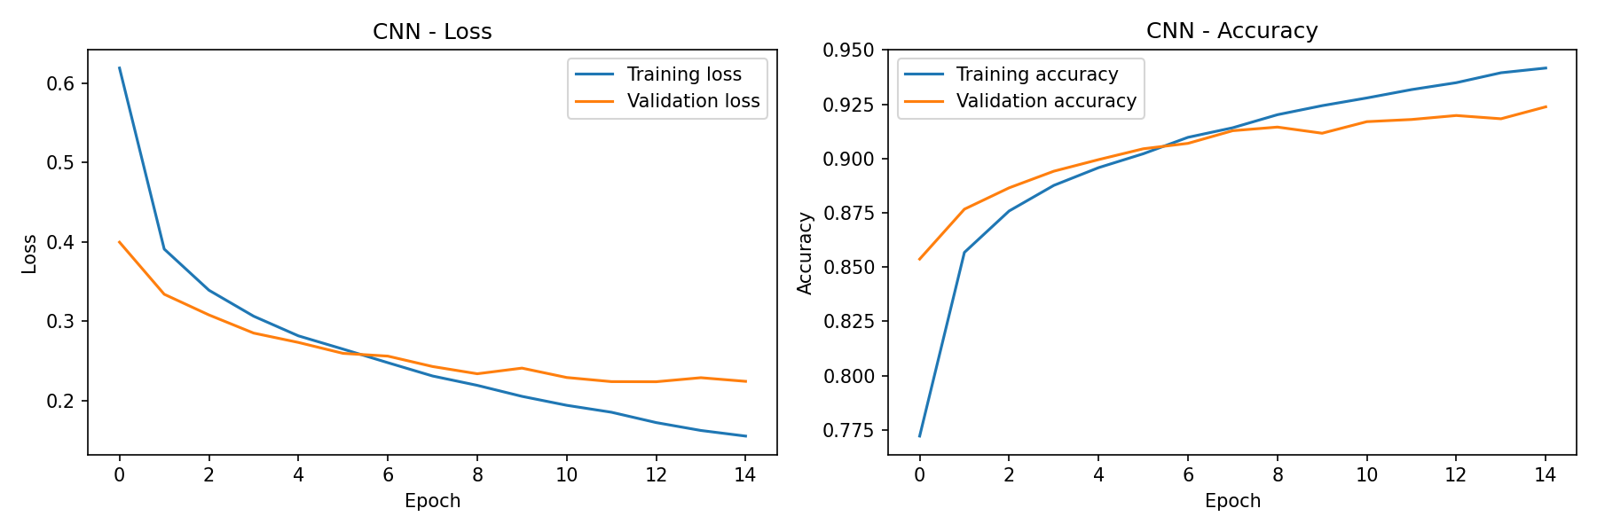
Figure 5: CNN training and validation loss and accuracy
On the 10,000 test images the CNN reached an accuracy of 91.24% with a test loss of 0.2431. The results for each class are below.
Class | Precision | Recall | F1-score | Support
T-shirt/top | 0.843 | 0.870 | 0.856 | 1,000
Trouser | 0.998 | 0.976 | 0.987 | 1,000
Pullover | 0.863 | 0.881 | 0.872 | 1,000
Dress | 0.900 | 0.922 | 0.911 | 1,000
Coat | 0.839 | 0.895 | 0.866 | 1,000
Sandal | 0.960 | 0.992 | 0.976 | 1,000
Shirt | 0.795 | 0.697 | 0.743 | 1,000
Sneaker | 0.962 | 0.953 | 0.957 | 1,000
Bag | 0.983 | 0.977 | 0.980 | 1,000
Ankle boot | 0.978 | 0.961 | 0.969 | 1,000
Macro average | 0.912 | 0.912 | 0.912 | 10,000
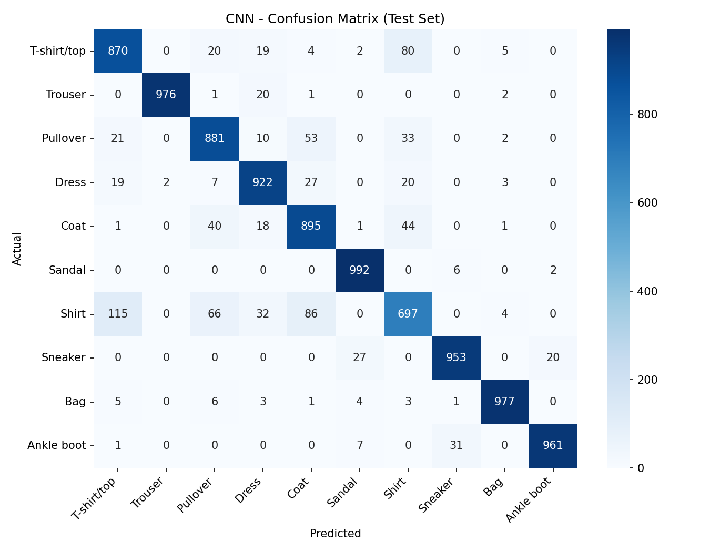
Figure 6: CNN confusion matrix on the test set
The easiest classes are Sandal, Trouser, Bag, Ankle boot and Sneaker (recall between 95.3% and 99.2%) because their shapes are very different from everything else. The hardest class is Shirt, with a recall of only 69.7%. The biggest mistakes were Shirt predicted as T-shirt/top (115 images) and as Coat (86), T-shirt/top predicted as Shirt (80), Shirt predicted as Pullover (66) and Pullover predicted as Coat (53). All of these are tops with sleeves, and at 28 x 28 pixels they really do look alike.
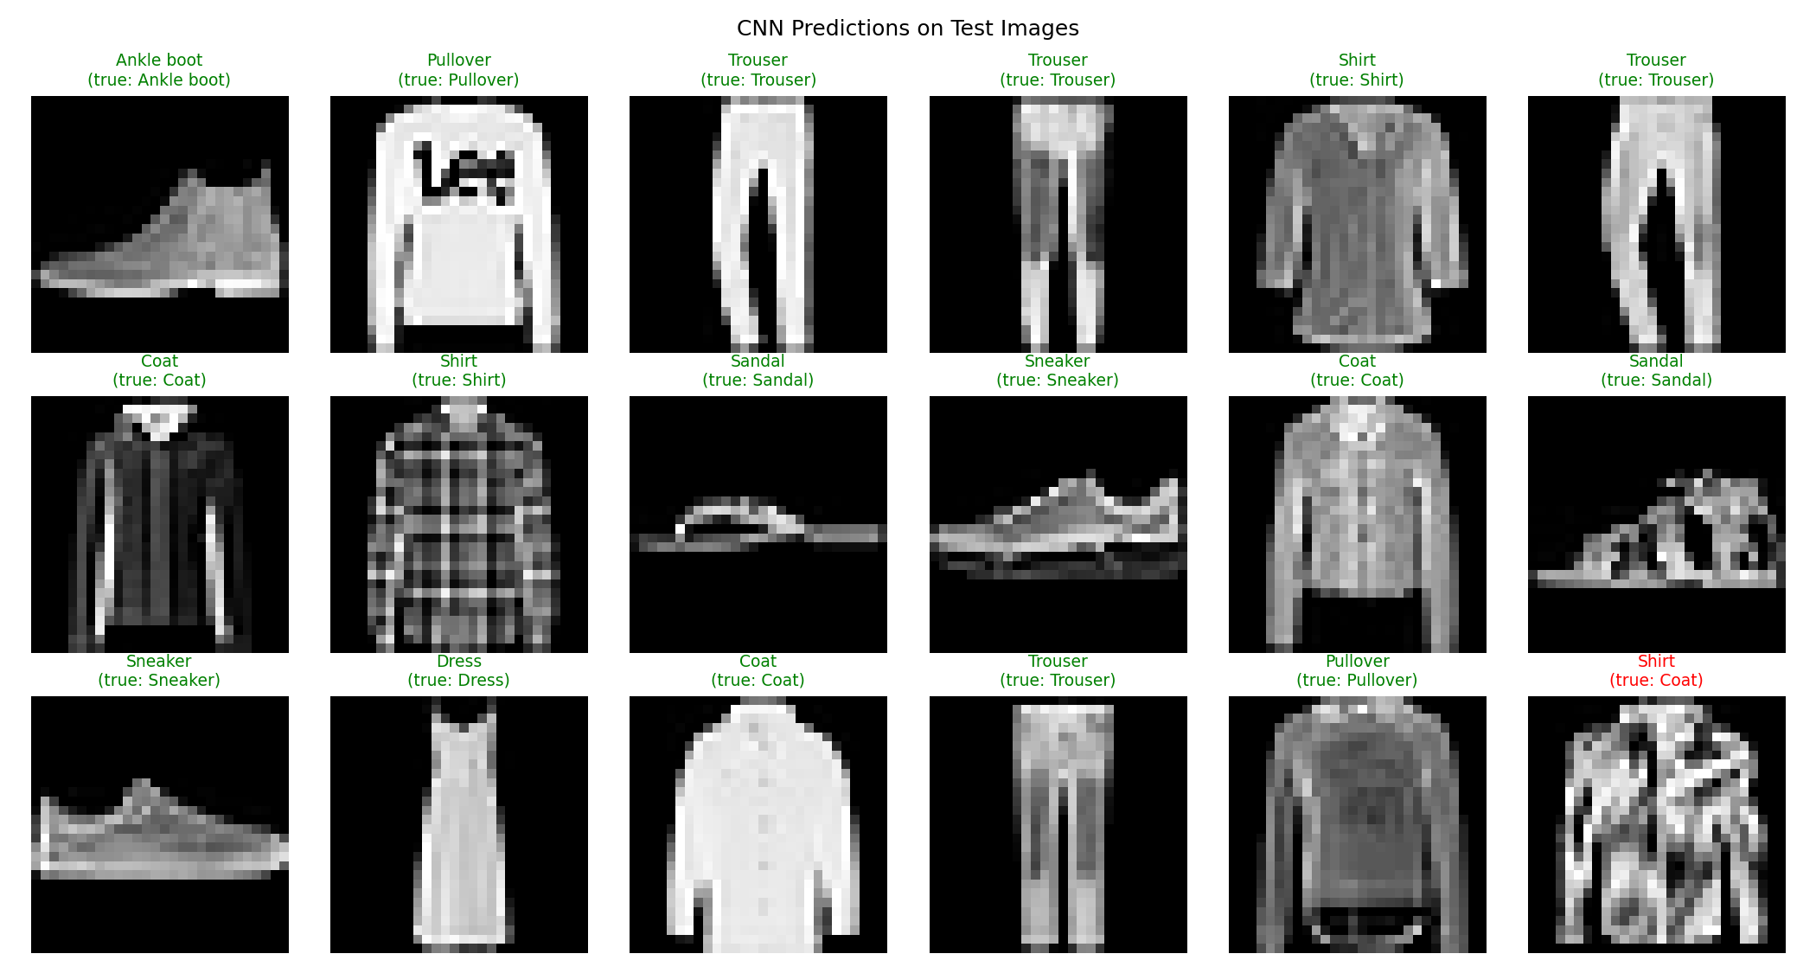
Figure 7: Sample CNN predictions (green = correct, red = wrong)

2.7 Saving the Model and Inference
The trained CNN was saved as fashion_cnn_model.joblib (about 2.6 MB) together with the list of class names, so the file alone is enough to turn the model's output (a number from 0 to 9) into a readable category such as "Sneaker".
In the inference step the notebook loads this file and uses a predict_clothing() function. It accepts raw images with pixel values from 0 to 255, exactly as they would come from a camera or a website, applies the same preprocessing as in training (dividing by 255 and adding the channel dimension) and returns the predicted category together with the model's confidence. The loaded model gave exactly the same predictions as the original one (91.24% test accuracy). Figure 8 and the table below show it classifying eight random test images.
Test image | True class | Prediction | Confidence
7755 | Sneaker | Ankle boot | 97.1%
8335 | Trouser | Trouser | 100.0%
2252 | Coat | Coat | 78.9%
8968 | Coat | Coat | 99.7%
5781 | Sandal | Sandal | 100.0%
6247 | Sneaker | Sneaker | 100.0%
6838 | Trouser | Trouser | 100.0%
9442 | Trouser | Trouser | 100.0%
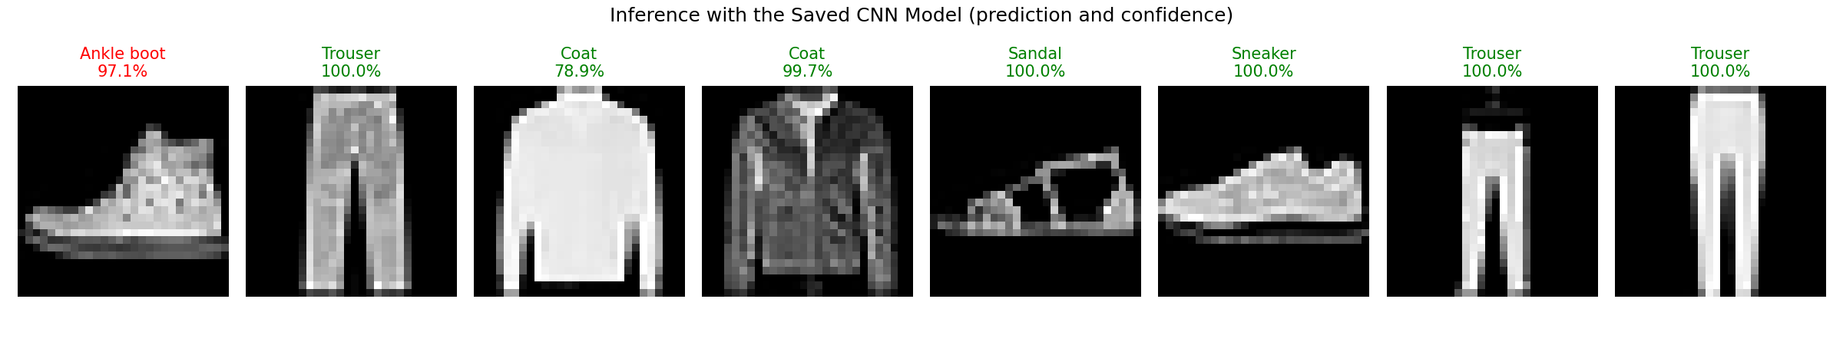
Figure 8: Inference with the saved CNN model (prediction and confidence; green = correct, red = wrong)
Seven of the eight images were classified correctly, most of them with a confidence above 97%. The one mistake was a sneaker predicted as an ankle boot with 97.1% confidence, which shows that the model can be confidently wrong on similar-looking footwear. The coat in image 2252 received a lower confidence (78.9%); in a real shop, images below a chosen confidence level could be sent to a person to check.

2.8 Conclusion
The CNN reached 91.24% test accuracy, far above the 10% you would get by guessing. It is very reliable for footwear, bags and trousers and weakest on tops that look alike, mainly Shirt. An online store could use a model like this to suggest the category for every uploaded photo and send only the low-confidence ones to a person for checking. The saved fashion_cnn_model.joblib file and the predict_clothing() function are exactly what such a system would use. To improve it further, I would try data augmentation (flips and small shifts), a deeper CNN with Batch Normalisation, or transfer learning with higher-resolution images.

Overall Conclusion
In this project I built two deep learning models for two different kinds of data. The DNN worked on customer records and gave a churn detector that finds 75% of the customers who leave (74.7% accuracy, 0.838 ROC-AUC) even though the data is imbalanced. The CNN worked on images and reached 91.24% accuracy on Fashion-MNIST. Both trained models were saved as .joblib files and reloaded in an inference step, where they gave the same results as before saving and made sensible predictions on new data. The two results show why the model type matters: fully connected networks suit rows of numbers and categories, while convolutional networks suit images because they learn patterns from the pixels directly.
Submitted files: this document; the notebook DL_Midterm_Project.ipynb, which has the code for both models, including the saving and inference steps, with all outputs already displayed; and the two saved models churn_dnn_model.joblib and fashion_cnn_model.joblib.

