**Molecular Evolution of the Meiotic Recombination Pathway in Mammals**

*Investigations*

Amy L. Dapper1,2* and Bret A. Payseur1

1 Laboratory of Genetics, University of Wisconsin, Madison, WI 53706, USA

2 Department of Biological Sciences, Mississippi State University, Mississippi State, MS 39762, USA

Running Title: Evolution of the Recombination Pathway

Keywords: (up to 5)

* Corresponding Author : Amy L. Dapper

Address: 295 E. Lee Blvd., P.O. Box GY, Mississippi State, MS 39762

Phone: (662) 325-7575

Email: dapper@biology.msstate.edu

## Abstract

Meiotic recombination, the exchange of genetic material between homologous chromosomes during meiosis, is required for successful gametogenesis in most sexually reproducing species. Recombination is also a fundamental evolutionary force, influencing the fate of new mutations and determining the genomic scale over which selection shapes genetic variation. Despite the central importance of recombination, basic questions about its evolution have yet to be addressed. Although many genes that play roles in recombination have been identified, the molecular evolution of most of these genes remains uncharacterized. Using a phylogenetic comparative approach, we measure rates of evolution in 32 recombination pathway genes across 16 mammalian species, spanning primates, murids, and laurasithians. By analyzing a carefully-selected panel of genes involved in key components of recombination – spanning double strand break formation, strand invasion, the crossover/non-crossover decision, and resolution – we generate a comprehensive picture of the evolution of the recombination pathway in mammals. Recombination genes exhibit marked heterogeneity in the rate of protein evolution, both across and within genes. We report signatures of rapid evolution and positive selection that could underlie species differences in recombination rate. **[NEEDS WORK HERE]**

Abstract Word Count : (< 250)

## Introduction

The reciprocal exchange of DNA between homologous chromosomes during meiosis – recombination – is required for successful gametogenesis in most species that reproduce sexually (Hassold and Hunt 2001). The rate of recombination is a major determinant of patterns of genetic diversity in populations, influencing the fate of new mutations (Hill and Robertson 1966), the efficacy of selection (Felsenstein 1974; Charlesworth, Morgan, and Charlesworth 1993; Comeron, Kreitman, and Aguadé 1999; Gonen et al. 2017), and important features of the genomic landscape (Begun and Aquadro 1992; Charlesworth, Jarne, and Assimacopoulos 1994; Duret and Arndt 2008).

Although recombination rate is often treated as a constant, this fundamental parameter evolves over time. Genomic regions ranging in size from short sequences to entire chromosomes vary in recombination rate – both within and between species (Burt and Bell 1987; Broman et al. 1998; Jeffreys et al. 2005; Coop and Przeworski 2007; Kong et al. 2010; Smukowski and Noor 2011; Dumont et al. 2011; Comeron, Ratnappan, and Bailin 2012; Segura et al. 2013; Dapper and Payseur 2017; Stapley et al. 2017).

Genome-wide association studies are beginning to reveal the genetic basis of differences in recombination rate within species. Individual recombination rates have been associated with variation in specific genes in populations of *Drosophila melanogaster* (Hunter et al. 2016), humans (Kong et al. 2008, 2014; Chowdhury et al. 2009; Fledel-Alon et al. 2011), domesticated cattle (Sandor et al. 2012; Ma et al. 2015; Kadri et al. 2016; Shen et al. 2018), domesticated sheep (Petit et al. 2017), Soay sheep (Johnston et al. 2016), and red deer (Johnston, Huisman, and Pemberton 2018). Variants in several of these genes correlate with recombination rate in multiple species, including: *Rnf212* (Kong et al. 2008; Chowdhury et al. 2009; Fledel-Alon et al. 2011; Sandor et al. 2012; Johnston et al. 2016; Kadri et al. 2016; Petit et al. 2017), *Rnf212B* (Johnston et al. 2016; Kadri et al. 2016; Johnston, Huisman, and Pemberton 2018), *Rec8* (Sandor et al. 2012; Johnston et al. 2016; Johnston, Huisman, and Pemberton 2018), *Hei10/Ccnb1ip1* (Kong et al. 2014; Petit et al. 2017), *Msh4* (Kong et al. 2014; Ma et al. 2015; Kadri et al. 2016; Shen et al. 2018), *Cplx1* (Kong et al. 2014; Ma et al. 2015; Johnston et al. 2016; Shen et al. 2018) and *Prdm9* (Fledel-Alon et al. 2011; Sandor et al. 2012; Kong et al. 2014; Ma et al. 2015; Shen et al. 2018).

In contrast, the genetics of recombination rate variation among species remains poorly understood. Divergence at the di-cistronic gene *mei-217/mei-218* explains much of the disparity in genetic map length between *D. melanogaster* and *D. mauritiana* (Brand et al. 2018). *mei-217/mei-218* is the only gene known to confer a recombination rate difference between species, though quantitative trait loci that contribute to shifts in rate among subspecies of house mice have been identified (Dumont and Payseur 2010; Murdoch et al. 2010; Balcova et al. 2016).

One strategy for understanding how species diverge in recombination rate is to inspect patterns of molecular evolution at genes involved in the recombination pathway. This approach incorporates knowledge of the molecular and cellular determinants of recombination and is motivated by successful examples. *mei-217/mei-218* was targeted for functional analysis based on its profile of rapid evolution between *D. melanogaster* and *D. mauritiana* (Brand et al. 2018). *Prdm9*, a protein that positions recombination hotspots in house mice and humans through histone methylation (Myers et al. 2010; Parvanov, Petkov, and Paigen 2010; Grey et al. 2011; Paigen2018; Grey, Baudat, and Massy 2018), shows accelerated divergence across mammals (Oliver et al. 2009). The rapid evolution of *Prdm9* – which localizes to its zinc-finger DNA binding domain (Oliver et al. 2009) – appears to be driven by selective pressure to recognize new hotpot motifs as old ones are destroyed via biased gene conversion (Myers et al. 2010; Ubeda and Wilkins 2011; Lesecque et al. 2014; Latrille, Duret, and Lartillot 2017). Although these examples demonstrate the promise of signatures of molecular evolution for illuminating recombination rate differences between species, patterns of divergence have yet to be reported for most genes involved in meiotic recombination.

Mammals provide a useful system for dissecting the molecular evolution of the recombination pathway for several reasons. First, the evolution of recombination rate has been measured along the mammalian phylogeny (Dumont and Payseur 2008; Segura et al. 2013). Second, recombination rate variation has been associated with specific genes in mammalian populations (Kong et al. 2008, 2014; Chowdhury et al. 2009; Sandor et al. 2012; Ma et al. 2015; Johnston et al. 2016; Kadri et al. 2016; Petit et al. 2017; Johnston, Huisman, and Pemberton 2018; Shen et al. 2018). Third, laboratory mice have proven to be instrumental in the identification and functional characterization of recombination genes (Vries et al. 1999; Yang et al. 2006; Ward et al. 2007; Baudat et al. 2000; Romanienko and Camerini-Otero 2000; La Salle et al. 2012; Schramm et al. 2011; Bisig et al. 2012; Bolcun-Filas and Schimenti 2012; Kumar et al. 2015; Finsterbusch et al. 2016; Stanzione et al. 2016) .

Work in mice indicates that the mammalian recombination pathway is roughly divided into five major steps, each of which is regulated by a handful of genes. The first step is the formation of hundreds of double strand breaks (DSBs) throughout the genome (Keeney, Giroux, and Kleckner 1997; Bergerat et al. 1997; Baudat et al. 2000; Romanienko and Camerini-Otero 2000; Baudat and Massy 2007; Finsterbusch et al. 2016; Lange et al. 2016). After formation, DSBs are identified, processed, and paired with their corresponding location on the homologous chromosome through the processes of homology search and strand invasion (Keeney 2007; Cloud et al. 2012; Brown and Bishop 2014; Oh et al. 2016; Kobayashi et al. 2016; Finsterbusch et al. 2016; Xu et al. 2017). The pairing of homologous chromosomes is then stabilized by a proteinaceous structure referred to as the synaptonemal complex (SC) (Meuwissen et al. 1992; Schmekel and Daneholt 1995; Costa et al. 2005; Vries et al. 2005; Hamer et al. 2006; Yang et al. 2006; Schramm et al. 2011; Fraune et al. 2014; Hernández-Hernández et al. 2016). The SC also forms a substrate on which the eventual crossover events will take place [**citations**]. It is at this point that a small subset of DSBs is designated to mature into crossovers, leaving the majority of DSBs to be resolved as non-crossovers (Snowden et al. 2004; Yang et al. 2008; Reynolds et al. 2013; Finsterbusch et al. 2016; Rao et al. 2017). Finally, this designation is followed, and each DSB is repaired as a crossover or a non-crossover (Baker et al. 1996; Edelmann et al. 1996; Lipkin et al. 2002; Rogacheva et al. 2014; Xu et al. 2017).

In this article, we examine the molecular evolution of 32 key recombination genes, evenly distributed across each major step in the recombination pathway, in 16 mammalian species spanning Primates, Rodents and Laurasiatherians. In addition to revealing patterns of divergence across diverse mammalian species, we leverage human polymorphism data to make robust evolutionary inferences. Our results provide a comprehensive picture of evolution in the recombination pathway in mammals and identify steps of the pathway most likely to contribute to differences in recombination rate between species.

## Materials and Methods

### Data Acquisition & Processing

We selected a focal panel of 32 recombination genes (See Table1). The panel was constructed to: (1) cover each major step in the recombination pathway as evenly as possible, (2) contain genes that have integral functions in each step, and (3) include genes that have been associated with inter-individual differences in recombination rate within mammalian populations. Reference sequences were downloaded for each gene in 16 110 mammalian species from both NCBI and Ensembl (Release-89)(Wheeler et al. 2006; Zerbino et al. 2017).

Alternative splicing is widespread and presents a challenge for molecular evolution studies (Pan et al. 2008; Barbosa-Morais et al. 2012). To focus our analyses on coding sequences that are transcribed during meiosis and to validate the computational annotations for each gene in each species, we used available testes expression datasets. We downloaded raw testes expression data for each mammalian species from NCBI Gene Expression Omnibus (GEO) (Table S1)(Barrett et al. 2012). We converted the SRA files into FASTQ files using SRAtoolkit (Leinonen et al. 2010). The reads were mapped to an indexed reference genome (Table S2,3) (Bowtie2, (Langmead and Salzberg 2012)) using TopHat (Trapnell, Pachter, and Salzberg 2009). The resulting bam files were sorted using Samtools (Li et al. 2009) and visualized using IGV 2.4.10 (Thorvaldsdóttir, Robinson, and Mesirov 2013). This allowed us to: (1) identify the transcript expressed in testes, (2) check the reference transcript for errors, and (3) revise the reference transcript based upon the transcript data.

We compared expression data to annotations from both Ensembl and NCBI (Wheeler et al. 2006; Zerbino et al. 2017). When both transcripts were identical, we selected the NCBI transcript. The Ensembl transcript was used instead when: (1) the NCBI reference sequences was not available for a given gene in a given species, (2) when none of the NCBI transcripts matched the expression data, or (3) when there were sequence differences between the two transcripts and the Ensembl transcript was more parsimonious - i.e. had the fewest differences when compared to the rest of sequences in the alignment. **The use of testes expression data was a key data processing step and the inclusion of species in this study was primarily determined by the availability of testes expression data.**

### Phylogenetic Comparative Approach in Mammals

For each gene, we used phylogenetic analysis by maximum likelihood (PAML 4.8) to measure the rate of evolution across the mammalian phylogeny and to search for molecular signatures indicative of positive selection (Table 2) (Yang 1997, 2007). This approach requires a sequence alignment and a phylogenetic tree. For each gene, sequences were aligned using Translator X, a codon-based alignment tool, powered by MUSCLE v3.8.31 (Edgar 2004; Abascal, Zardoya, and Telford 2010). Each alignment was examined by hand and edited as necessary. We used a species tree that reflects current understanding of the phylogenetic relationships of the species included in our study (Figure 1)(Prasad et al. 2008; Perelman et al. 2011; Fan et al. 2013; Chen, Liang, and Zhang 2017).

Due to the ambiguity in the relationship between Laurasithians and the placement of tree shrews, we also inferred gene trees using MrBayes (Ronquist et al. 2012; Fan et al. 2013; Chen, Liang, and Zhang 2017). This approach also allowed us to control for effects of incomplete lineage sorting (ILS) (Pamilo and Nei 1988; Rosenberg 2002; Scornavacca and Galtier 2017). Using gene trees and using the consensus species tree produced highly similar results (Table S4).

For the majority of genes, transcripts from all 16 species were used (19 genes). However, for a number of genes, the chimpanzee and bonobo sequences were identical, in which case only the chimpanzee sequence was included in the analyses (11 genes). In one case, the chimpanzee, bonobo and human sequences were all identical, in which case only the human sequence was included in the analyses. In only a small number of instances, a suitable reference sequence could not be identified for a given species.

We estimated rates of synonymous and non-synonymous substitutions per site using the CODEML program in PAML4.8 (Yang 2007). This program considers multiple substitutions per site, different rates of transitions and transversions, and effects of codon usage (Yang 2007). Rates of substitution were computed for 6 different models of molecular evolution (Table 2). The fit of each model was compared using a likelihood ratio test. Reported substitution rates assume the best-fit model for each gene.

### Identifying Signatures of Selection

To test for positive selection, we compared the fit of models including a class of sites with greater than 1 to the fit of models in which all classes of sites have values equal to, or less than, 1. Specifically, we report three comparisons: M1 vs. M2, M7 vs. M8, M8 vs. M8a (Table 2). The first comparison, M1 vs. M2, compares a model with two classes of sites ( < 1, = 1) to a model with a third class of sites where is greater than 1, indicative of positive selection (Yang 2007). More complex models (M7 & M8) were developed to take into account variation in less than one among sites within genes and thus, include 10 site classes drawn from a beta distribution between 0 and 1 (Yang 2007). In this case, Model 8 includes an additional 11 class of sites in which is greater than 1, allowing for the identification of signatures of positive selection (Yang 2007). In cases in which a large fraction of sites within a gene are evolving neutrally ( = 1), Model 8 will fit significantly better due to a very poor fit of Model 7 rather than a signature of positive selection. To avoid incorrectly identifying signature of positive selection, Model 8 is also compared to Model 8a which contains a larger fraction of neutrally evolving sites than Model 7 [citations].

### Multinucleotide Mutations

Multi-nucleotide mutations (MNMs) occur when two mutations happen simultaneously in close proximity (Schrider, Hourmozdi, and Hahn 2011; Besenbacher et al. 2016). MNMs violate the PAML assumption that the probability of two simultaneous mutations in the same codon is 0 (Yang 2007; Venkat, Hahn, and Thornton 2018). Recent work has shown that MNMs can falsely detect positive selection when using branch-site tests in PAML (Venkat, Hahn, and Thornton 2018). Although we did not use branch-site tests, it is possible that MNMs contributed to some of the signatures of positive selection we observed. We could not directly identify MNMs in our dataset. Instead, we identified codons with multiple differences (CMDs) that likely arose on a single branch of the phylogeny. We used PAML to reconstruct the ancestral sequence at each node in the phylogeny (Yang 2007). For the reconstruction, Model 8 was chosen because we specifically re-analyzed genes that showed evidence for positive selection when comparing Model 7 with Model 8. From the ancestrally reconstructed sequences, we identified any codons in which PAML inferred more than 1 substitution on a single branch. All identified CMDs were removed from the sequences in which they occurred. For example, if a CMD was identified in an external branch, that codon was replaced with ‘—’ only in the sequence of that species. If a CMD was inferred on an internal branch, the codon was replaced with ‘—’ in all species descended from that internal branch. For each gene that showed evidence of positive selection using the unedited sequences, we also conducted PAML analyses using sequences from which all CMDs were removed.

### Polymorphism & Divergence in the Primate Lineage

To further examine evidence for selection on recombination genes, we compared divergence between humans and macaque to polymorphism within humans in 29 recombination genes. Human polymorphism data was downloaded from ExAC database. Polymorphism data was not available for 3 genes (*RNF212, MEI4,* and *REC8*), and thus these genes were not included in this analysis. By comparing counts of non-synonymous and synonymous polymorphisms to counts of non-synonymous and synonymous substitutions using the McDonald-Kreitman test, we can identify either an excess of non-synonymous substitutions, indicative of positive selection, or a paucity of non-synonymous substitutions, indicative of negative selection [**citation**]. Additionally, pairwise divergence between humans and macaques was calculated using yn00 package in PAML (Yang 2007).

### Identifying Evolutionary Patterns

To identify evolutionary patterns among our recombination genes, we compared the rate of evolution and the proportion of genes experiencing positive selection among groups of interest. We asked: (1) Do genes that function in different steps of the pathway exhibit different rates of evolution? (2) Do genes that function post-synapsis evolve more rapidly than genes that function pre-synapsis? and (3) Do genes associated with between-individual variation in recombination rate diverge more rapidly between species? All statistical analyses were performed in R [**citation**].

Evolutionary rate covariation (ERC) metric is the correlation coefficient between branch-specific rates between two proteins (Clark, Alani, and Aquadro 2012). ERC is typically elevated among interacting proteins and is assumed to result from: (1) concordance in fluctuating evolutionary pressures, (2) parallel evolution of expression level, or (3) compensatory changes between co-evolving genes (Clark, Alani, and Aquadro 2012, 2013). We used a publicly available ERC dataset (https://csb.pitt.edu/erc_analysis/index.php) to compare the median ERC-value among a subset of our focal recombination genes (N = 25) to the genome as a whole, as described in (Priedigkeit, Wolfe, and Clark 2015).

To control for this general elevation in ERC among recombination genes and test for relationships between specific groups between them, we calculated ERC values for only our focal set of 32 recombination genes. Branch lengths were calculated using aaML package in PAML (Yang 2007) and pairwise ERC values were calculated following the methods of (Clark, Alani, and Aquadro 2012). Using this approach, we specifically compared the 211 ERC values among three of the most rapidly evolving recombination genes (*TEX11, SHOC1, and SYCP2*).

## Results

### Heterogeneity in evolutionary rate among recombination genes

We observed substantial heterogeneity in the rate of evolution of recombination genes, spanning a range of 0.0268 – 0.8483 (mean = 0.3275, SD = 0.1971, median = 0.30945) (Figure 2A, Figure 3, Table 3). Four genes exhibit particularly rapid evolution compared to other recombination genes, having evolutionary rates greater than 1 SD above mean (*SYCP2, TEX11, SHOC1, IHO1*). At the other end of the spectrum, five genes have evolutionary rates more than 1 SD below mean and are highly conserved across the mammalian phylogeny (*BRCC3, HEI10, DMC1, RAD51, RAD50*). In general, there is very high concordance between evolutionary rate across mammals and pairwise divergence between humans and macaques (mean = 0.3301, SD = 0.2370, median = 0.30925) (Figure 2B, Table 4). It should be noted, however, that these two measures are not independent - divergence between human and macaque sequences is incorporated in the phylogenetic analysis. Six genes have evolutionary rates more than 1 SD above mean (*CNTD1, TEX11, SHOC1, IHO1, MEI4, RAD21L*). Likewise, six genes have evolutionary rates more than 1 SD below mean (*HORMAD1, MRE11, RAD50, DMC1, RAD51, MLH1*).

The genes that show the most rapid and most conserved rates of divergence between humans and macaques largely, but not completely, overlaps with the genes showing extreme evolutionary rates across the mammalian phylogeny.There are a few notable outliers that show much more rapid divergence between humans and macaques than across the mammalian phylogeny as a whole. These include MEI4 (mammals = 0.4332, human-macaque = 0.7252), CNTD1 (mammals = 0.2496, human-macaque = 0.6803), and HEI10 (mammals = 0.1226, human-macaque = 0.3235).

### Elevated evolutionary rate among recombination genes

Gradnigo et al. (2016) measured the rate of divergence between human and macaque for 3,606 genes throughout the genome. We used this dataset to ask whether the rate of evolution of recombination genes as a group is different than expected from the genome-wide distribution. We randomly sampling 32 values from this larger dataset and asked how frequently we observed average evolutionary rates as high or higher than observed among our focal set of recombination genes (mean = 0.3301). We found evidence for a significantly elevated evolutionary rate among recombination genes, observing a mean as high (or higher) than the value observed among recombination genes less than 1% of the time (*p* = 0.0075, sample size = 10,000) (Figure 4).

### Evidence of positive selection across the mammalian phylogeny

We identified signatures of positive selection in 10 recombination genes (31.25%) using site models in CODEML. These genes include: *IHO1, MRE11, SYCP1, SYCP2, REC8, RAD21L, RNF212, TEX11, MSH4, SHOC1* (Table 2). For each of these genes, models that include a fraction of sites where the rate of non-synonymous substitutions is estimated to be greater than the rate of synonymous substitutions ( > 1, Model 8) had a significantly better fit than models that did not include such a class of sites (Model 7, 8a). Due to the potential for multi-nucleotide mutations to produce erroneous signatures of positive selection, we re-analyzed this subset of genes removing any codons inferred to have accumulated multiple changes on a single branch (CMDs). After removing all CMDs, 1 gene (*TEX11*) retained a significant signature of positive selection (Table 5).

Comparing polymorphism within humans to divergence between humans and macaques revealed a general pattern of negative selection among recombination genes in the primate lineage. A majority of the recombination genes (16 genes, 55.17%) had a significant paucity of non-synonymous substitutions, indicative of negative (purifying) selection (Fisher’s Exact Test, Table 4). None of the genes had a significant excess of non-synonymous substitutions, which would indicate a significant signature of positive selection. Only one gene (*TEX11*) had a positive alpha score ( = 0.2929) and a corresponding neutrality index less than 1 (*NI* = 0.7071), indicating a higher fraction of non-synonymous substitutions than non-synonymous polymorphisms (Table 4).

### Recombination genes associated with inter-individual differences do not diverge more rapidly between species

We did not find evidence that recombination genes associated with inter-individual differences in recombination rate evolve more rapidly than other recombination genes. While we observed a higher mean evolutionary rate among genes associated with inter-individual differences ( = 0.3943 v. = 0.2925, respectively), the difference was not significant (*p* = 0.2381, Mann-Whitney U Test). Likewise, we observed a greater proportion of genes associated with inter-individual variation exhibited signatures of positive selection (5/11 vs. 5/21, respectively), this difference was also not significant (*p* = 0.210, Chi-Squared Test). The difference in evolutionary rates between these two classes of genes was greater when considering only divergence between humans and macaques ( = 0.4181 vs. = 0.2839)(*p* = 0.08816, Mann-Whitney U Test).

### Genes that function post-synapsis are more likely to exhibit signatures of positive selection

We did not find evidence that recombination genes that in different steps of the pathway exhibit different evolutionary rates. This was the case both when comparing the 6 major steps in the recombination pathway (*p* = 0.1422, Kruskal-Wallis Test)(Figure 6) and when comparing more generally between genes that function pre- and post-synapsis ( = 0.3762 vs. = 0.2723, respectively)(*p* = 0.1425, Mann-Whitney U Test). Likewise, we didn’t observed significant differences between recombination genes by step in the pathway when comparing just divergence between humans and macaques (*p* = 0.1422, Kruskal-Wallis Test). However, the rate of divergence between humans and macaques of post-synapsis genes was borderline significantly higher when compared to pre-synapsis recombination genes ( = 0.3994 v. = 0.2514, respectively)(*p* = 0.05827, Mann-Whitney U Test). Interestingly, we did observe that a significantly higher fraction of post-synapsis recombination genes exhibited signatures of positive selection in comparison with pre-synapsis recombination genes (8/17 v. 2/15, respectively) (*p* = 0.03998, Chi-Squared Test).

### Evolutionary rates among recombination genes are correlated

Meiotic genes have been shown to exhibit statistically significant, but not strong, ERC among mammals (Clark, Alani, and Aquadro 2013). Similarly, we identified significant evidence for correlated evolution among genes in the recombination pathway (mean ERC = 0.134, permutation *p* = 0.000358). After factoring out the general elevation of ERC values among recombination genes, the mean ERC value among our focal set of genes was approximately zero (mean ERC = 0.000358). Among recombination genes, we detected strong signature of correlated evolution between our three genes of interest: *SHOC1, TEX11, SYCP2* (mean ERC = 0.42369, permutation *p* = 0.025). Thus, the coevolutionary pattern among these three genes is statistically stronger than that observed generally among recombination genes.

## Discussion

**Table 1** : List of 32 recombination genes surveyed by step in the recombination pathway. Genes in bold have been associated with inter-individual differences in recombination rate in at least one species of mammals.

|  |  |
| --- | --- |
| **Pathway Step** | **Genes** |
| DSB Formation | *HORMAD1, MEI4,* ***REC114****, IHO1, SPO11* |
| DSB Processing | *HORMAD2, MRE11, NBS1, RAD50, BRCC3* |
| Strand Invasion | *DMC1, RAD51, SPATA22, MEIOB, MCMDC2* |
| Homologous Pairing | ***REC8****,* ***RAD21L****, SYCP1, SYCP2, TEX11* |
| CO vs. NCO Decision | ***TEX11****, SHOC1,* ***RNF212****,* ***RNF212B****,* ***MSH4****,* ***MSH5*** |
| Resolution | ***MER3****, CNTD1,* ***HEI10****, MLH1,* ***MLH3****, MUS81* |

**Table 2**: Six PAML site models used to measure evolutionary rate and test for positive selection. Models varied in the number of classes, the range of for each of these classes, and whether a class of sites subject to positive selection was included.

|  |  |  |  |
| --- | --- | --- | --- |
| **Model** | **# Site Classes** | **Range** | **Pos. Selection?** |
| 0 | 1 | <1 | No |
| 1 | 2 | <1, =1 | No |
| 2 | 3 | <1, =1, >1 | Yes |
| 7 | 10 | 0-1 | No |
| 8 | 11 | 0-1, >1 | Yes |
| 8a | 6 | 0-1, =1 | No |

**Figure 1**: Species tree assumed in analyses of molecular evolution.

Figure 1

**Figure 2**:Distribution of for 32 recombination genes. Bar shows the mean +/- 1 standard deviation. (A) Divergence estimated across the mammalian phylogeny. (B) Pairwise divergence between human and macaque.

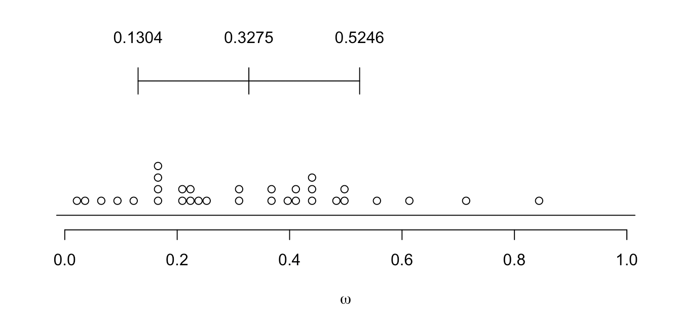

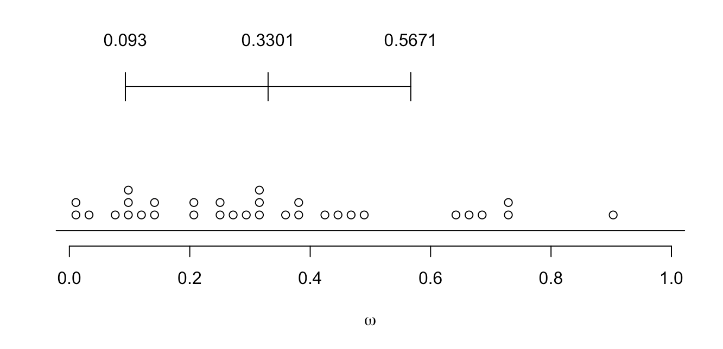

**Figure 3**: **Pathway Figure Description** The color of each gene represents its evolutionary rate relative to the average rate of evolution of recombination genes ( = 0.3275): more rapidly evolving genes are depicted in darker shades of red and the more conserved genes are depicted in darker shades of blue. Genes that exhibit a signature of positive selection are in bold.

Figure 3

**Figure 4**: Distribution of the mean divergence () between human and macaque of 10,000 random draws from the entire genome. Mean among these random draws was observed to be equal to or greater than that observed among recombination genes less than 1% of the time (*p* = 0.0075, 10,000 random draws).

Figure 4

**Figure 5**: High concordance between there rate of evolution of recombination gene between human and macaques and the rate of evolution among mammals. The linear regression is shown in red and the 1:1 line is shown as a dashed line.

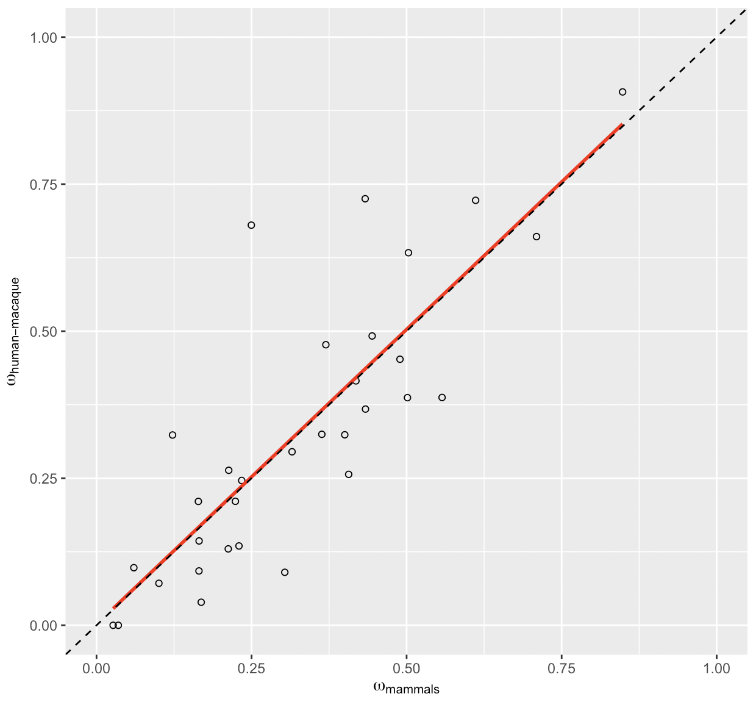

**Figure 6**: Boxplot of by step in recombination pathway.

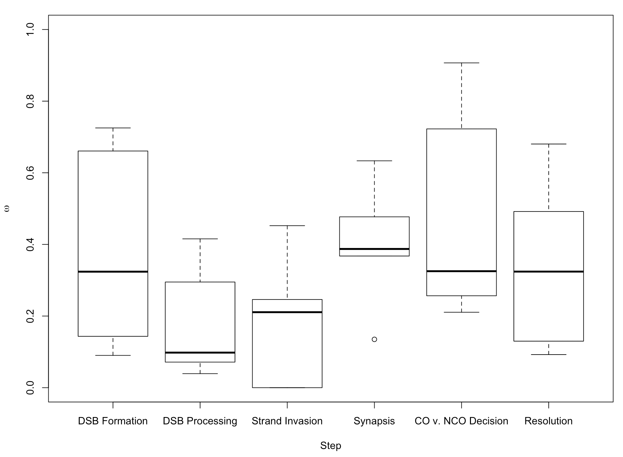

**Table 3**: PAML analysis of 32 recombination genes in mammals (Yang 2007).

|  |  |  |  |  |  |  |  |  |  |  |
| --- | --- | --- | --- | --- | --- | --- | --- | --- | --- | --- |
| ***Gene*** | ***bp*** | ***N*** |  | ***M*** | ***M1-M2*** | ***p-value*** | ***M7-M8*** | ***p-value*** | ***M8a-M8*** | ***p-value*** |
| **A)** |  |  |  |  |  |  |  |  |  |  |
| *HORMAD1* | 1212 | 16 | 0.3036 | 7 | 0 | *1.000* | 1.795 | *0.4076* | — | — |
| *MEI4* | 1170 | 16 | 0.4332 | 7 | 0 | *1.000* | 0.005 | *0.9976* | — | — |
| *REC114* | 870 | 15 | 0.4003 | 7 | 0 | *1.000* | 5.384 | *0.0677* | — | — |
| *IHO1* | 1824 | 16 | 0.7095 | **8** | 13.061 | ***0.0015*** | 17.571 | ***0.0002*** | 14.527 | ***0.0001*** |
| *SPO11* | 1188 | 15 | 0.1654 | 7 | 0 | *1.000* | 4.648 | *0.0980* | — | — |
| **B)** |  |  |  |  |  |  |  |  |  |  |
| *HORMAD2* | 981 | 15 | 0.3153 | 7 | 0 | *1.000* | 3.650 | *0.1612* | — | — |
| *MRE11* | 2136 | 16 | 0.1688 | **8** | 0.363 | *0.8342* | 11.931 | ***0.0026*** | 4.706 | ***0.0301*** |
| *NBS1* | 2289 | 15 | 0.4183 | **8** | 0 | *1.000* | 12.763 | ***0.0017*** | 4.087 | ***0.0432*** |
| *RAD50* | 3936 | 16 | 0.1006 | 7 | 0 | *1.000* | 0.301 | *0.8605* | — | —- |
| *BRCC3* | 954 | 15 | 0.0602 | 7 | 0 | *1.000* | 0.250 | *0.8826* | — | — |
| **C)** |  |  |  |  |  |  |  |  |  |  |
| *DMC1* | 1020 | 15 | 0.0351 | 1 | 0.488 | *0.7835* | 5.000 | *0.0821* | — | — |
| *RAD51* | 1017 | 16 | 0.0268 | 7 | 0 | *1.000* | 0 | *1.000* | — | — |
| *SPATA22* | 1101 | 16 | 0.4893 | 7 | 0 | *1.000* | 0.429 | *0.8070* | — | — |
| *MEIOB* | 1425 | 16 | 0.2341 | 7 | 0 | *1.000* | 0.665 | *0.7172* | — | — |
| *MCMDC2* | 2052 | 16 | 0.2239 | 7 | 0 | *1.000* | 0.628 | *0.7307* | — | — |
| **D)** |  |  |  |  |  |  |  |  |  |  |
| *REC8* | 1833 | 16 | 0.3698 | **8** | 0 | *1.000* | 14.690 | ***0.0006*** | 5.927 | ***0.0149*** |
| *RAD21L* | 1686 | 15 | 0.503 | **8** | 12.124 | ***0.0023*** | 32.050 | ***>0.0001*** | 12.049 | ***0.0005*** |
| *SYCP1* | 3015 | 16 | 0.4337 | **8** | 8.711 | ***0.0128*** | 26.860 | ***>0.0001*** | 9.243 | ***0.0024*** |
| *SYCP2* | 4650 | 16 | 0.5572 | **8** | 11.584 | ***0.0031*** | 37.200 | ***>0.0001*** | 15.838 | ***0.0001*** |
| *TEX12* | 369 | 14 | 0.2297 | 7 | 0.0565 | *0.9721* | 1.549 | *0.4610* | — | — |
| **E)** |  |  |  |  |  |  |  |  |  |  |
| *TEX11* | 2844 | 15 | 0.8483 | **8** | 60.872 | ***>0.0001*** | 82.665 | ***>0.0001*** | 61.141 | ***>0.0001*** |
| *SHOC1* | 4644 | 16 | 0.6113 | **8** | 12.447 | ***0.0020*** | 30.561 | ***>0.0001*** | 15.645 | ***0.0001*** |
| *RNF212* | 948 | 16 | 0.5014 | **8** | 0 | *1.000* | 16.366 | ***0.0003*** | 5.202 | ***0.0226*** |
| *RNF212B* | 906 | 14 | 0.4066 | 7 | 0 | *1.000* | 0.500 | *0.7788* | — | — |
| *MSH4* | 2814 | 16 | 0.2132 | **8** | 16.608 | ***0.0002*** | 39.447 | ***>0.0001*** | 23.238 | ***>0.0001*** |
| *MSH5* | 2565 | 15 | 0.1642 | 7 | 0 | *1.000* | 4.214 | *0.1216* | — | — |
| **F)** |  |  |  |  |  |  |  |  |  |  |
| *MER3* | 4458 | 16 | 0.3633 | 8a | 0 | *1.000* | 12.838 | ***0.0016*** | 3.109 | *0.0779* |
| *CNTD1* | 1026 | 15 | 0.2496 | 7 | 0 | *1.000* | 0.936 | *0.6263* | — | — |
| *HEI10* | 831 | 15 | 0.1226 | 7 | 0 | *1.000* | 0.250 | *0.8826* | — | — |
| *MLH1* | 2313 | 15 | 0.1652 | 8a | 0 | *1.000* | 12.221 | ***0.0022*** | 0.280 | *0.5970* |
| *MLH3* | 4419 | 16 | 0.4444 | 7 | 0 | *1.000* | 3.757 | *0.1528* | — | — |
| *MUS81* | 1665 | 16 | 0.2124 | 7 | 0 | *1.000* | 0.628 | *0.7304* | — | — |

**Table 5**: Polymorphism & Divergence Data

|  |  |  |  |  |  |  |  |  |  |  |  |
| --- | --- | --- | --- | --- | --- | --- | --- | --- | --- | --- | --- |
| ***Gene*** |  | ***Pn*** | ***Ps*** | ***Pn/Ps*** | ***Dn*** | ***Ds*** | ***Dn/Ds*** | ***MK Test*** |  | ***NI*** |  |
| **A)** |  |  |  |  |  |  |  |  |  |  |  |
| *HORMAD1* | 0.0901 | 84 | 35 | 2.4000 | 5 | 12 | 0.4167 | ***0.0018*** | -4.7600 | 5.7600 | Neg. |
| *MEI4* | 0.7252 | 15 | 7 | 2.1429 | 24 | 9 | 2.6667 | *0.7679* | 0.1964 | 0.8036 | — |
| *REC114* | 0.3239 | 76 | 37 | 2.0541 | 11 | 14 | 0.7857 | ***0.0392*** | -1.6143 | 2.6143 | Neg. |
| *IHO1* | 0.6608 | 130 | 64 | 2.0313 | 36 | 19 | 1.8947 | *0.8718* | -0.0720 | 1.0720 | — |
| *SPO11* | 0.1434 | 118 | 52 | 2.2692 | 11 | 22 | 0.5000 | ***0.0001*** | -3.5385 | 4.5385 | Neg. |
| **B)** |  |  |  |  |  |  |  |  |  |  |  |
| *HORMAD2* | 0.295 | 80 | 31 | 2.5806 | 7 | 9 | 0.7778 | ***0.0404*** | -2.3180 | 3.3180 | Neg. |
| *MRE11* | 0.0392 | 211 | 86 | 2.4535 | 5 | 35 | 0.1429 | ***>0.0001*** | -16.1744 | 17.1744 | Neg. |
| *NBS1* | 0.4155 | 221 | 93 | 2.3763 | 34 | 25 | 1.3600 | *0.0666* | -0.7473 | 1.7473 | — |
| *RAD50* | 0.0714 | 303 | 118 | 2.5678 | 8 | 43 | 0.1860 | ***>0.0001*** | -12.8019 | 13.8019 | Neg. |
| *BRCC3* | 0.0979 | 13 | 21 | 0.6190 | 2 | 6 | 0.3333 | 0.6888 | -0.8571 | 1.8571 | — |
| **C)** |  |  |  |  |  |  |  |  |  |  |  |
| *DMC1* | 0.000 | 72 | 42 | 1.7143 | 0 | 11 | 0.0000 | ***>0.0001*** | — | — | Neg. |
| *RAD51* | 0.000 | 50 | 48 | 1.0417 | 0 | 13 | 0.0000 | ***>0.0001*** | — | — | Neg. |
| *SPATA22* | 0.4523 | 114 | 45 | 2.5333 | 21 | 10 | 2.1000 | *0.6700* | -0.2063 | 1.2063 | — |
| *MEIOB* | 0.2462 | 91 | 40 | 2.2750 | 20 | 22 | 0.9091 | ***0.0200*** | -1.5025 | 2.5025 | Neg. |
| *MCMDC2* | 0.2108 | 165 | 54 | 3.0556 | 16 | 26 | 0.6154 | ***>0.0001*** | -3.9653 | 4.9653 | Neg. |
| **D)** |  |  |  |  |  |  |  |  |  |  |  |
| *REC8* | 0.477 | 147 | 76 | 1.9342 | 38 | 31 | 1.2258 | *0.1164* | -0.5779 | 1.5779 | — |
| *RAD21L* | 0.6334 | 51 | 17 | 3.000 | 27 | 13 | 2.0769 | *0.5051* | -0.4444 | 1.4444 | — |
| *SYCP1* | 0.3676 | 213 | 100 | 2.1300 | 33 | 37 | 1.2222 | *0.0546* | -0.7427 | 1.7427 | — |
| *SYCP2* | 0.3676 | 429 | 154 | 2.8506 | 74 | 53 | 1.3962 | ***0.0005*** | -1.0417 | 2.0417 | Neg. |
| *TEX12* | 0.1349 | 31 | 16 | 1.9375 | 2 | 4 | 0.5000 | 0.1836 | -2.875 | 3.875 | — |
| **E)** |  |  |  |  |  |  |  |  |  |  |  |
| *TEX11* | 0.9068 | 126 | 81 | 1.5556 | 55 | 25 | 2.200 | *0.2234* | 0.2929 | 0.7071 | — |
| *SHOC1* | 0.7225 | 368 | 124 | 2.9677 | 85 | 37 | 2.2973 | *0.2521* | -0.2918 | 1.2918 | — |
| *RNF212* | 0.387 | — | — | — | 17 | 18 | 0.9444 | — | — | — | — |
| *RNF212B* | 0.2566 | 368 | 124 | 2.9677 | 8 | 12 | 0.6667 | ***0.0013*** | -3.4516 | 4.4516 | Neg. |
| *MSH4* | 0.2635 | 260 | 94 | 2.7660 | 24 | 29 | 0.8276 | ***>0.0001*** | -2.3422 | 3.3422 | Neg. |
| *MSH5* | 0.2106 | 197 | 104 | 1.8942 | 19 | 33 | 0.5758 | ***0.0002*** | -2.2900 | 3.2900 | Neg. |
| **F)** |  |  |  |  |  |  |  |  |  |  |  |
| *MER3* | 0.3247 | 402 | 143 | 2.8112 | 54 | 44 | 1.2273 | ***0.0004*** | -1.2906 | 2.2906 | Neg. |
| *CNTD1* | 0.6803 | 81 | 47 | 1.7234 | 13 | 8 | 1.6250 | *1.0000* | -0.0606 | 1.0606 | — |
| *HEI10* | 0.3235 | 73 | 33 | 2.2121 | 4 | 5 | 0.8000 | *0.1541* | -1.7652 | 2.7652 | — |
| *MLH1* | 0.0924 | 255 | 90 | 2.8333 | 9 | 29 | 0.3103 | ***>0.0001*** | -8.1296 | 9.1296 | Neg. |
| *MLH3* | 0.4919 | 437 | 167 | 2.6168 | 77 | 57 | 1.3509 | ***0.0012*** | -0.9370869 | 1.937087 | Neg. |
| *MUS81* | 0.1299 | 208 | 81 | 2.5679 | 17 | 40 | 0.4250 | ***>0.0001*** | -5.0421 | 6.0421 | Neg. |

**Table 4**: PAML - MNM Analysis

|  |  |  |  |  |  |  |  |  |  |  |
| --- | --- | --- | --- | --- | --- | --- | --- | --- | --- | --- |
| ***Gene*** | ***bp*** | ***N*** |  | ***M*** | ***M1-M2*** | ***p-value*** | ***M7-M8*** | ***p-value*** | ***M8a-M8*** | ***p-value*** |
| *IHO1* | 1824 | 16 | 0.6104 | 7 | 0 | *1.000* | 0.258 | *0.8789* | — | — |
| *MRE11* | 2136 | 16 | 0.1330 | 7 | 0.226 | *0.8930* | 3.056 | *0.2169* | — | — |
| *NBS1* | 2289 | 15 | 0.3413 | 7 | 0 | *1.000* | 1.956 | *0.3761* | — | — |
| *REC8* | 1833 | 16 | 0.2905 | 7 | 0 | *1.000* | 5.321 | *0.0699* | — | — |
| *RAD21L* | 1686 | 15 | 0.4271 | 8a | 2.329 | *0.3121* | 9.497 | ***0.0087*** | 1.620 | *0.2031* |
| *SYCP1* | 3015 | 16 | 0.3731 | 8a | 3.328 | *0.1893* | 13.440 | ***0.0012*** | 2.122 | *0.1452* |
| *SYCP2* | 4650 | 16 | 0.4752 | 7 | 0 | *1.000* | 1.758 | *0.4151* | — | — |
| *TEX11* | 2844 | 15 | 0.7287 | **8** | 9.989 | ***0.0068*** | 18.776 | ***0.0001*** | 10.656 | ***0.0011*** |
| *SHOC1* | 4644 | 16 | 0.5519 | 8a | 0 | *1.000* | 7.439 | ***0.0242*** | 0.292 | *0.5887* |
| *RNF212* | 948 | 16 | 0.3685 | 7 | 0 | *1.000* | 0 | *1.000* | — | — |
| *MSH4* | 2814 | 16 | 0.1509 | 7 | 0 | *1.000* | 2.079 | *0.3536* | — | — |

## 

## Acknowledgements

A.L.D. was supported by NHGRI Training Grant to the Genomic Sciences Training Program 5T32HG002760. B.A.P. was supported by NIH grant R01 GM100426A and NSF grant DEB 1353737.

## 

## References

Abascal, Federico, Rafael Zardoya, and Maximilian J Telford. 2010. “TranslatorX: Multiple Alignment of Nucleotide Sequences Guided by Amino Acid Translations.” *Nucleic Acids Research* 38 (suppl_2): W7–W13.

Baker, Sean M, Annemieke W Plug, Tomas A Prolla, C Eric Bronner, Allie C Harris, Xiang Yao, Donna-Marie Christie, et al. 1996. “Involvement of Mouse Mlh1 in Dna Mismatch Repair and Meiotic Crossing over.” *Nature Genetics* 13 (3): 336.

Balcova, Maria, Barbora Faltusova, Vaclav Gergelits, Tanmoy Bhattacharyya, Ondrej Mihola, Zdenek Trachtulec, Corinna Knopf, et al. 2016. “Hybrid Sterility Locus on Chromosome X Controls Meiotic Recombination Rate in Mouse.” *PLoS Genetics* 12 (4): e1005906.

Barbosa-Morais, Nuno L, Manuel Irimia, Qun Pan, Hui Y Xiong, Serge Gueroussov, Leo J Lee, Valentina Slobodeniuc, et al. 2012. “The Evolutionary Landscape of Alternative Splicing in Vertebrate Species.” *Science* 338 (6114): 1587–93.

Barrett, Tanya, Stephen E Wilhite, Pierre Ledoux, Carlos Evangelista, Irene F Kim, Maxim Tomashevsky, Kimberly A Marshall, et al. 2012. “NCBI Geo: Archive for Functional Genomics Data Sets—Update.” *Nucleic Acids Research* 41 (D1): D991–D995.

Baudat, Frédéric, Katia Manova, Julie Pui Yuen, Maria Jasin, and Scott Keeney. 2000. “Chromosome Synapsis Defects and Sexually Dimorphic Meiotic Progression in Mice Lacking Spo11.” *Molecular Cell* 6 (5): 989–98.

Baudat, Frédéric, and Bernard de Massy. 2007. “Regulating Double-Stranded Dna Break Repair Towards Crossover or Non-Crossover During Mammalian Meiosis.” *Chromosome Research* 15 (5): 565–77.

Begun, David J, and Charles F Aquadro. 1992. “Levels of Naturally Occurring Dna Polymorphism Correlate with Recombination Rates in d. Melanogaster.” *Nature* 356 (6369): 519.

Bergerat, Agnes, Bernard de Massy, Danielle Gadelle, Paul-Christophe Varoutas, Alain Nicolas, and Patrick Forterre. 1997. “An Atypical Topoisomerase Ii from Archaea with Implications for Meiotic Recombination.” *Nature* 386 (6623): 414.

Besenbacher, Søren, Patrick Sulem, Agnar Helgason, Hannes Helgason, Helgi Kristjansson, Aslaug Jonasdottir, Adalbjorg Jonasdottir, et al. 2016. “Multi-Nucleotide de Novo Mutations in Humans.” *PLoS Genetics* 12 (11): e1006315.

Bisig, C Gaston, Michel F Guiraldelli, Anna Kouznetsova, Harry Scherthan, Christer Höög, Dean S Dawson, and Roberto J Pezza. 2012. “Synaptonemal Complex Components Persist at Centromeres and Are Required for Homologous Centromere Pairing in Mouse Spermatocytes.” *PLoS Genetics* 8 (6): e1002701.

Bolcun-Filas, Ewelina, and John C Schimenti. 2012. “Genetics of Meiosis and Recombination in Mice.” *International Review of Cell and Molecular Biology* 298: 179–227.

Brand, Cara L, M Victoria Cattani, Sarah B Kingan, Emily L Landeen, and Daven C Presgraves. 2018. “Molecular Evolution at a Meiosis Gene Mediates Species Differences in the Rate and Patterning of Recombination.” *Current Biology* 28 (8): 1289–95.

Broman, Karl W, Jeffrey C Murray, Val C Sheffield, Raymond L White, and James L Weber. 1998. “Comprehensive Human Genetic Maps: Individual and Sex-Specific Variation in Recombination.” *The American Journal of Human Genetics* 63 (3): 861–69.

Brown, M Scott, and Douglas K Bishop. 2014. “DNA Strand Exchange and Reca Homologs in Meiosis.” *Cold Spring Harbor Perspectives in Biology*, a016659.

Burt, Austin, and Graham Bell. 1987. “Red Queen Versus Tangled Bank Models.” *Nature* 330 (6144): 118.

Charlesworth, Brian, Philippe Jarne, and Stavroula Assimacopoulos. 1994. “The Distribution of Transposable Elements Within and Between Chromosomes in a Population of Drosophila Melanogaster. III. Element Abundances in Heterochromatin.” *Genetics Research* 64 (3): 183–97.

Charlesworth, Brian, MT Morgan, and Deborah Charlesworth. 1993. “The Effect of Deleterious Mutations on Neutral Molecular Variation.” *Genetics* 134 (4): 1289–1303.

Chen, Meng-Yun, Dan Liang, and Peng Zhang. 2017. “Phylogenomic Resolution of the Phylogeny of Laurasiatherian Mammals: Exploring Phylogenetic Signals Within Coding and Noncoding Sequences.” *Genome Biology and Evolution* 9 (8): 1998–2012.

Chowdhury, Reshmi, Philippe RJ Bois, Eleanor Feingold, Stephanie L Sherman, and Vivian G Cheung. 2009. “Genetic Analysis of Variation in Human Meiotic Recombination.” *PLoS Genetics* 5 (9): e1000648.

Clark, Nathan L, Eric Alani, and Charles F Aquadro. 2012. “Evolutionary Rate Covariation Reveals Shared Functionality and Coexpression of Genes.” *Genome Research*.

———. 2013. “Evolutionary Rate Covariation in Meiotic Proteins Results from Fluctuating Evolutionary Pressure in Yeasts and Mammals.” *Genetics* 193 (2): 529–38.

Cloud, Veronica, Yuen-Ling Chan, Jennifer Grubb, Brian Budke, and Douglas K Bishop. 2012. “Rad51 Is an Accessory Factor for Dmc1-Mediated Joint Molecule Formation During Meiosis.” *Science* 337 (6099): 1222–5.

Comeron, Josep M, Martin Kreitman, and Montserrat Aguadé. 1999. “Natural Selection on Synonymous Sites Is Correlated with Gene Length and Recombination in Drosophila.” *Genetics* 151 (1): 239–49.

Comeron, Josep M, Ramesh Ratnappan, and Samuel Bailin. 2012. “The Many Landscapes of Recombination in Drosophila Melanogaster.” *PLoS Genetics* 8 (10): e1002905.

Coop, Graham, and Molly Przeworski. 2007. “An Evolutionary View of Human Recombination.” *Nature Reviews Genetics* 8 (1): 23.

Costa, Yael, Robert Speed, Rupert Öllinger, Manfred Alsheimer, Colin A Semple, Philippe Gautier, Klio Maratou, et al. 2005. “Two Novel Proteins Recruited by Synaptonemal Complex Protein 1 (Sycp1) Are at the Centre of Meiosis.” *Journal of Cell Science* 118 (12): 2755–62.

Dapper, Amy L, and Bret A Payseur. 2017. “Connecting Theory and Data to Understand Recombination Rate Evolution.” *Phil. Trans. R. Soc. B* 372 (1736): 20160469.

Dumont, Beth L, and Bret A Payseur. 2010. “Evolution of the Genomic Recombination Rate in Murid Rodents.” *Genetics*.

Dumont, Beth L, Michael A White, Brian Steffy, Tim Wiltshire, and Bret A Payseur. 2011. “Extensive Recombination Rate Variation in the House Mouse Species Complex Inferred from Genetic Linkage Maps.” *Genome Research* 21 (1): 114–25.

Duret, Laurent, and Peter F Arndt. 2008. “The Impact of Recombination on Nucleotide Substitutions in the Human Genome.” *PLoS Genetics* 4 (5): e1000071.

Edelmann, Winfried, Paula E Cohen, Michael Kane, Kirkland Lau, Bernice Morrow, Samuel Bennett, Asad Umar, et al. 1996. “Meiotic Pachytene Arrest in Mlh1-Deficient Mice.” *Cell* 85 (7): 1125–34.

Edgar, Robert C. 2004. “MUSCLE: Multiple Sequence Alignment with High Accuracy and High Throughput.” *Nucleic Acids Research* 32 (5): 1792–7.

Fan, Yu, Zhi-Yong Huang, Chang-Chang Cao, Ce-Shi Chen, Yuan-Xin Chen, Ding-Ding Fan, Jing He, et al. 2013. “Genome of the Chinese Tree Shrew.” *Nature Communications* 4: 1426.

Felsenstein, Joseph. 1974. “The Evolutionary Advantage of Recombination.” *Genetics* 78 (2): 737–56.

Finsterbusch, Friederike, Ramya Ravindranathan, Ihsan Dereli, Marcello Stanzione, Daniel Tränkner, and Attila Tóth. 2016. “Alignment of Homologous Chromosomes and Effective Repair of Programmed Dna Double-Strand Breaks During Mouse Meiosis Require the Minichromosome Maintenance Domain Containing 2 (Mcmdc2) Protein.” *PLoS Genetics* 12 (10): e1006393.

Fledel-Alon, Adi, Ellen Miranda Leffler, Yongtao Guan, Matthew Stephens, Graham Coop, and Molly Przeworski. 2011. “Variation in Human Recombination Rates and Its Genetic Determinants.” *PloS One* 6 (6): e20321.

Fraune, Johanna, Manfred Alsheimer, Josef Redolfi, Céline Brochier-Armanet, and Ricardo Benavente. 2014. “Protein Sycp2 Is an Ancient Component of the Metazoan Synaptonemal Complex.” *Cytogenetic and Genome Research* 144 (4): 299–305.

Gonen, Serap, Mara Battagin, Susan E Johnston, Gregor Gorjanc, and John M Hickey. 2017. “The Potential of Shifting Recombination Hotspots to Increase Genetic Gain in Livestock Breeding.” *Genetics Selection Evolution* 49 (1): 55.

Grey, Corinne, Pauline Barthès, Chauveau-Le FriecGaëlle, Francina Langa, Frédéric Baudat, and De MassyBernard. 2011. “Mouse Prdm9 Dna-Binding Specificity Determines Sites of Histone H3 Lysine 4 Trimethylation for Initiation of Meiotic Recombination.” *PLoS Biology* 9 (10): e1001176.

Grey, Corinne, Frédéric Baudat, and Bernard de Massy. 2018. “PRDM9, a Driver of the Genetic Map.” *PLoS Genetics* 14 (8): e1007479.

Hamer, Geert, Katarina Gell, Anna Kouznetsova, Ivana Novak, Ricardo Benavente, and Christer Höög. 2006. “Characterization of a Novel Meiosis-Specific Protein Within the Central Element of the Synaptonemal Complex.” *Journal of Cell Science* 119 (19): 4025–32.

Hassold, Terry, and Patricia Hunt. 2001. “To Err (Meiotically) Is Human: The Genesis of Human Aneuploidy.” *Nature Reviews Genetics* 2 (4): 280.

Hernández-Hernández, Abrahan, Sergej Masich, Tomoyuki Fukuda, Anna Kouznetsova, Sara Sandin, Bertil Daneholt, and Christer Höög. 2016. “The Central Element of the Synaptonemal Complex in Mice Is Organized as a Bilayered Junction Structure.” *J Cell Sci* 129 (11): 2239–49.

Hill, William G, and Alan Robertson. 1966. “The Effect of Linkage on Limits to Artificial Selection.” *Genetics Research* 8 (3): 269–94.

Hunter, Chad M, Wen Huang, Trudy FC Mackay, and Nadia D Singh. 2016. “The Genetic Architecture of Natural Variation in Recombination Rate in Drosophila Melanogaster.” *PLoS Genetics* 12 (4): e1005951.

Jeffreys, Alec J, Rita Neumann, Maria Panayi, Simon Myers, and Peter Donnelly. 2005. “Human Recombination Hot Spots Hidden in Regions of Strong Marker Association.” *Nature Genetics* 37 (6): 601.

Johnston, Susan E, Camillo Bérénos, Jon Slate, and Josephine M Pemberton. 2016. “Conserved Genetic Architecture Underlying Individual Recombination Rate Variation in a Wild Population of Soay Sheep (Ovis Aries).” *Genetics*, genetics–115.

Johnston, Susan E, Jisca Huisman, and Josephine M Pemberton. 2018. “A Genomic Region Containing Rec8 and Rnf212b Is Associated with Individual Recombination Rate Variation in a Wild Population of Red Deer (Cervus Elaphus).” *G3: Genes, Genomes, Genetics*, g3–200063.

Kadri, Naveen Kumar, Chad Harland, Pierre Faux, Nadine Cambisano, Latifa Karim, Wouter Coppieters, Sébastien Fritz, et al. 2016. “Coding and Noncoding Variants in Hfm1, Mlh3, Msh4, Msh5, Rnf212, and Rnf212b Affect Recombination Rate in Cattle.” *Genome Research*.

Keeney, Scott. 2007. “Spo11 and the Formation of Dna Double-Strand Breaks in Meiosis.” In *Recombination and Meiosis*, 81–123. Springer.

Keeney, Scott, Craig N Giroux, and Nancy Kleckner. 1997. “Meiosis-Specific Dna Double-Strand Breaks Are Catalyzed by Spo11, a Member of a Widely Conserved Protein Family.” *Cell* 88 (3): 375–84.

Kobayashi, Wataru, Motoki Takaku, Shinichi Machida, Hiroaki Tachiwana, Kazumitsu Maehara, Yasuyuki Ohkawa, and Hitoshi Kurumizaka. 2016. “Chromatin Architecture May Dictate the Target Site for Dmc1, but Not for Rad51, During Homologous Pairing.” *Scientific Reports* 6: 24228.

Kong, Augustine, Gudmar Thorleifsson, Michael L Frigge, Gisli Masson, Daniel F Gudbjartsson, Rasmus Villemoes, Erna Magnusdottir, Stefania B Olafsdottir, Unnur Thorsteinsdottir, and Kari Stefansson. 2014. “Common and Low-Frequency Variants Associated with Genome-Wide Recombination Rate.” *Nature Genetics* 46 (1): 11.

Kong, Augustine, Gudmar Thorleifsson, Daniel F Gudbjartsson, Gisli Masson, Asgeir Sigurdsson, Aslaug Jonasdottir, G Bragi Walters, et al. 2010. “Fine-Scale Recombination Rate Differences Between Sexes, Populations and Individuals.” *Nature* 467 (7319): 1099.

Kong, Augustine, Gudmar Thorleifsson, Hreinn Stefansson, Gisli Masson, Agnar Helgason, Daniel F Gudbjartsson, Gudrun M Jonsdottir, et al. 2008. “Sequence Variants in the Rnf212 Gene Associate with Genome-Wide Recombination Rate.” *Science* 319 (5868): 1398–1401.

Kumar, Rajeev, Norbert Ghyselinck, Kei-ichiro Ishiguro, Yoshinori Watanabe, Anna Kouznetsova, Christer Höög, Edward Strong, et al. 2015. “MEI4: A Central Player in the Regulation of Meiotic Dna Double Strand Break Formation in the Mouse.” *J Cell Sci*, jcs–165464.

Lange, Julian, Shintaro Yamada, Sam E Tischfield, Jing Pan, Seoyoung Kim, Xuan Zhu, Nicholas D Socci, Maria Jasin, and Scott Keeney. 2016. “The Landscape of Mouse Meiotic Double-Strand Break Formation, Processing, and Repair.” *Cell* 167 (3): 695–708.

Langmead, Ben, and Steven L Salzberg. 2012. “Fast Gapped-Read Alignment with Bowtie 2.” *Nature Methods* 9 (4): 357.

La Salle, Sophie, Kristina Palmer, O’BrienMarilyn, John C Schimenti, John Eppig, and Mary Ann Handel. 2012. “Spata22, a Novel Vertebrate-Specific Gene, Is Required for Meiotic Progress in Mouse Germ Cells.” *Biology of Reproduction* 86 (2): 45–41.

Latrille, Thibault, Laurent Duret, and Nicolas Lartillot. 2017. “The Red Queen Model of Recombination Hot-Spot Evolution: A Theoretical Investigation.” *Phil. Trans. R. Soc. B* 372 (1736): 20160463.

Leinonen, Rasko, Hideaki Sugawara, Martin Shumway, and International Nucleotide Sequence Database Collaboration. 2010. “The Sequence Read Archive.” *Nucleic Acids Research* 39 (suppl_1): D19–D21.

Lesecque, Yann, Sylvain Glémin, Nicolas Lartillot, Dominique Mouchiroud, and Laurent Duret. 2014. “The Red Queen Model of Recombination Hotspots Evolution in the Light of Archaic and Modern Human Genomes.” *PLoS Genetics* 10 (11): e1004790.

Li, Heng, Bob Handsaker, Alec Wysoker, Tim Fennell, Jue Ruan, Nils Homer, Gabor Marth, Goncalo Abecasis, and Richard Durbin. 2009. “The Sequence Alignment/Map Format and Samtools.” *Bioinformatics* 25 (16): 2078–9.

Lipkin, Steven M, Peter B Moens, Victoria Wang, Michelle Lenzi, Dakshine Shanmugarajah, Abigail Gilgeous, James Thomas, et al. 2002. “Meiotic Arrest and Aneuploidy in Mlh3-Deficient Mice.” *Nature Genetics* 31 (4): 385.

Ma, Li, O’ConnellJeffrey R, Paul M VanRaden, Botong Shen, Abinash Padhi, Chuanyu Sun, Derek M Bickhart, et al. 2015. “Cattle Sex-Specific Recombination and Genetic Control from a Large Pedigree Analysis.” *PLoS Genetics* 11 (11): e1005387.

Meuwissen, RL, Hildo H Offenberg, AJ Dietrich, Anne Riesewijk, Martijn van Iersel, and Christa Heyting. 1992. “A Coiled-Coil Related Protein Specific for Synapsed Regions of Meiotic Prophase Chromosomes.” *The EMBO Journal* 11 (13): 5091.

Murdoch, Brenda, Nichole Owen, Sofia Shirley, Sara Crumb, Karl W Broman, and Terry Hassold. 2010. “Multiple Loci Contribute to Genome-Wide Recombination Levels in Male Mice.” *Mammalian Genome* 21 (11-12): 550–55.

Myers, Simon, Rory Bowden, Afidalina Tumian, Ronald E Bontrop, Colin Freeman, Tammie S MacFie, Gil McVean, and Peter Donnelly. 2010. “Drive Against Hotspot Motifs in Primates Implicates the Prdm9 Gene in Meiotic Recombination.” *Science* 327 (5967): 876–79.

Oh, Julyun, Amr Al-Zain, Elda Cannavo, Petr Cejka, and Lorraine S Symington. 2016. “Xrs2 Dependent and Independent Functions of the Mre11-Rad50 Complex.” *Molecular Cell* 64 (2): 405–15.

Oliver, Peter L, Leo Goodstadt, Joshua J Bayes, Zoë Birtle, Kevin C Roach, Nitin Phadnis, Scott A Beatson, Gerton Lunter, Harmit S Malik, and Chris P Ponting. 2009. “Accelerated Evolution of the Prdm9 Speciation Gene Across Diverse Metazoan Taxa.” *PLoS Genetics* 5 (12): e1000753.

Pamilo, Pekka, and Masatoshi Nei. 1988. “Relationships Between Gene Trees and Species Trees.” *Molecular Biology and Evolution* 5 (5): 568–83.

Pan, Qun, Ofer Shai, Leo J Lee, Brendan J Frey, and Benjamin J Blencowe. 2008. “Deep Surveying of Alternative Splicing Complexity in the Human Transcriptome by High-Throughput Sequencing.” *Nature Genetics* 40 (12): 1413.

Parvanov, Emil D, Petko M Petkov, and Kenneth Paigen. 2010. “Prdm9 Controls Activation of Mammalian Recombination Hotspots.” *Science* 327 (5967): 835–35.

Perelman, Polina, Warren E Johnson, Christian Roos, Hector N Seuánez, Julie E Horvath, Miguel AM Moreira, Bailey Kessing, et al. 2011. “A Molecular Phylogeny of Living Primates.” *PLoS Genetics* 7 (3): e1001342.

Petit, Morgane, Jean-Michel Astruc, Julien Sarry, Laurence Drouilhet, Stéphane Fabre, Carole Moreno, and Bertrand Servin. 2017. “Variation in Recombination Rate and Its Genetic Determinism in Sheep Populations.” *Genetics*, genetics–300123.

Prasad, Arjun B, Marc W Allard, NISC Comparative Sequencing Program, and Eric D Green. 2008. “Confirming the Phylogeny of Mammals by Use of Large Comparative Sequence Data Sets.” *Molecular Biology and Evolution* 25 (9): 1795–1808.

Priedigkeit, Nolan, Nicholas Wolfe, and Nathan L Clark. 2015. “Evolutionary Signatures Amongst Disease Genes Permit Novel Methods for Gene Prioritization and Construction of Informative Gene-Based Networks.” *PLoS Genetics* 11 (2): e1004967.

Rao, HBD Prasada, Huanyu Qiao, Shubhang K Bhatt, Logan RJ Bailey, Hung D Tran, Sarah L Bourne, Wendy Qiu, et al. 2017. “A Sumo-Ubiquitin Relay Recruits Proteasomes to Chromosome Axes to Regulate Meiotic Recombination.” *Science* 355 (6323): 403–7.

Reynolds, April, Huanyu Qiao, Ye Yang, Jefferson K Chen, Neil Jackson, Kajal Biswas, J Kim Holloway, et al. 2013. “RNF212 Is a Dosage-Sensitive Regulator of Crossing-over During Mammalian Meiosis.” *Nature Genetics* 45 (3): 269.

Rogacheva, Maria V, Carol M Manhart, Cheng Chen, Alba Guarne, Jennifer Surtees, and Eric Alani. 2014. “Mlh1-Mlh3, a Meiotic Crossover and Dna Mismatch Repair Factor, Is a Msh2-Msh3-Stimulated Endonuclease.” *Journal of Biological Chemistry*, jbc–M113.

Romanienko, Peter J, and R Daniel Camerini-Otero. 2000. “The Mouse Spo11 Gene Is Required for Meiotic Chromosome Synapsis.” *Molecular Cell* 6 (5): 975–87.

Ronquist, Fredrik, Maxim Teslenko, Van Der MarkPaul, Daniel L Ayres, Aaron Darling, Sebastian Höhna, Bret Larget, Liang Liu, Marc A Suchard, and John P Huelsenbeck. 2012. “MrBayes 3.2: Efficient Bayesian Phylogenetic Inference and Model Choice Across a Large Model Space.” *Systematic Biology* 61 (3): 539–42.

Rosenberg, Noah A. 2002. “The Probability of Topological Concordance of Gene Trees and Species Trees.” *Theoretical Population Biology* 61 (2): 225–47.

Sandor, Cynthia, Wanbo Li, Wouter Coppieters, Tom Druet, Carole Charlier, and Michel Georges. 2012. “Genetic Variants in Rec8, Rnf212, and Prdm9 Influence Male Recombination in Cattle.” *PLoS Genetics* 8 (7): e1002854.

Schmekel, Karin, and Bertil Daneholt. 1995. “The Central Region of the Synaptonemal Complex Revealed in Three Dimensions.” *Trends in Cell Biology* 5 (6): 239–42.

Schramm, Sabine, Johanna Fraune, Ronald Naumann, Abrahan Hernandez-Hernandez, Christer Höög, Howard J Cooke, Manfred Alsheimer, and Ricardo Benavente. 2011. “A Novel Mouse Synaptonemal Complex Protein Is Essential for Loading of Central Element Proteins, Recombination, and Fertility.” *PLoS Genetics* 7 (5): e1002088.

Schrider, Daniel R, Jonathan N Hourmozdi, and Matthew W Hahn. 2011. “Pervasive Multinucleotide Mutational Events in Eukaryotes.” *Current Biology* 21 (12): 1051–4.

Scornavacca, Celine, and Nicolas Galtier. 2017. “Incomplete Lineage Sorting in Mammalian Phylogenomics.” *Systematic Biology* 66 (1): 112–20.

Segura, Joana, Luca Ferretti, Sebastián Ramos-Onsins, Laia Capilla, Marta Farré, Fernanda Reis, Maria Oliver-Bonet, et al. 2013. “Evolution of Recombination in Eutherian Mammals: Insights into Mechanisms That Affect Recombination Rates and Crossover Interference.” *Proceedings of the Royal Society of London B: Biological Sciences* 280 (1771): 20131945.

Shen, Botong, Jicai Jiang, Eyal Seroussi, George E Liu, and Li Ma. 2018. “Characterization of Recombination Features and the Genetic Basis in Multiple Cattle Breeds.” *BMC Genomics* 19 (1): 304.

Smukowski, CS, and MAF Noor. 2011. “Recombination Rate Variation in Closely Related Species.” *Heredity* 107 (6): 496.

Snowden, Timothy, Samir Acharya, Charles Butz, Mark Berardini, and Richard Fishel. 2004. “HMSH4-hMSH5 Recognizes Holliday Junctions and Forms a Meiosis-Specific Sliding Clamp That Embraces Homologous Chromosomes.” *Molecular Cell* 15 (3): 437–51.

Stanzione, Marcello, Marek Baumann, Frantzeskos Papanikos, Ihsan Dereli, Julian Lange, Angelique Ramlal, Daniel Tränkner, et al. 2016. “Meiotic Dna Break Formation Requires the Unsynapsed Chromosome Axis-Binding Protein Iho1 (Ccdc36) in Mice.” *Nature Cell Biology* 18 (11): 1208.

Stapley, Jessica, Philine GD Feulner, Susan E Johnston, Anna W Santure, and Carole M Smadja. 2017. “Variation in Recombination Frequency and Distribution Across Eukaryotes: Patterns and Processes.” *Phil. Trans. R. Soc. B* 372 (1736): 20160455.

Thorvaldsdóttir, Helga, James T Robinson, and Jill P Mesirov. 2013. “Integrative Genomics Viewer (Igv): High-Performance Genomics Data Visualization and Exploration.” *Briefings in Bioinformatics* 14 (2): 178–92.

Trapnell, Cole, Lior Pachter, and Steven L Salzberg. 2009. “TopHat: Discovering Splice Junctions with Rna-Seq.” *Bioinformatics* 25 (9): 1105–11.

Ubeda, F, and JF Wilkins. 2011. “The Red Queen Theory of Recombination Hotspots.” *Journal of Evolutionary Biology* 24 (3): 541–53.

Venkat, Aarti, Matthew W Hahn, and Joseph W Thornton. 2018. “Multinucleotide Mutations Cause False Inferences of Lineage-Specific Positive Selection.” *Nature Ecology & Evolution* 2 (8): 1280.

Vries, Femke AT de, Esther de Boer, Mike van den Bosch, Willy M Baarends, Marja Ooms, Li Yuan, Jian-Guo Liu, Albert A van Zeeland, Christa Heyting, and Albert Pastink. 2005. “Mouse Sycp1 Functions in Synaptonemal Complex Assembly, Meiotic Recombination, and Xy Body Formation.” *Genes & Development* 19 (11): 1376–89.

Vries, Sandra S de, Esther B Baart, Marleen Dekker, Ariaan Siezen, Dirk G de Rooij, Peter de Boer, and Hein te Riele. 1999. “Mouse Muts-Like Protein Msh5 Is Required for Proper Chromosome Synapsis in Male and Female Meiosis.” *Genes & Development* 13 (5): 523–31.

Ward, Jeremy O, Laura G Reinholdt, William W Motley, Lisa M Niswander, Dekker C Deacon, Laurie B Griffin, Kristofor K Langlais, et al. 2007. “Mutation in Mouse Hei10, an E3 Ubiquitin Ligase, Disrupts Meiotic Crossing over.” *PLoS Genetics* 3 (8): e139.

Wheeler, David L, Tanya Barrett, Dennis A Benson, Stephen H Bryant, Kathi Canese, Vyacheslav Chetvernin, Deanna M Church, et al. 2006. “Database Resources of the National Center for Biotechnology Information.” *Nucleic Acids Research* 35 (suppl_1): D5–D12.

Xu, Yang, Roger A Greenberg, Ernst Schonbrunn, and P Jeremy Wang. 2017. “Meiosis-Specific Proteins Meiob and Spata22 Cooperatively Associate with the Single-Stranded Dna-Binding Replication Protein a Complex and Dna Double-Strand Breaks.” *Biology of Reproduction* 96 (5): 1096–1104.

Yang, Fang, De La FuenteRabindranath, N Adrian Leu, Claudia Baumann, K John McLaughlin, and P Jeremy Wang. 2006. “Mouse Sycp2 Is Required for Synaptonemal Complex Assembly and Chromosomal Synapsis During Male Meiosis.” *The Journal of Cell Biology* 173 (4): 497–507.

Yang, Fang, Katarina Gell, Van Der HeijdenGodfried W, Sigrid Eckardt, N Adrian Leu, David C Page, Ricardo Benavente, et al. 2008. “Meiotic Failure in Male Mice Lacking an X-Linked Factor.” *Genes & Development* 22 (5): 682–91.

Yang, Ziheng. 1997. “PAML: A Program Package for Phylogenetic Analysis by Maximum Likelihood.” *Bioinformatics* 13 (5): 555–56.

———. 2007. “PAML 4: Phylogenetic Analysis by Maximum Likelihood.” *Molecular Biology and Evolution* 24 (8): 1586–91. <https://doi.org/10.1093/molbev/msm088>.

Zerbino, Daniel R, Premanand Achuthan, Wasiu Akanni, M Ridwan Amode, Daniel Barrell, Jyothish Bhai, Konstantinos Billis, et al. 2017. “Ensembl 2018.” *Nucleic Acids Research* 46 (D1): D754–D761.