UNIVERSITY OF BERKELY PROJECT
SPECIFICATIONS

Project Description:

The requirement is to build a central repository for all sub-sites in order to enable a centralized search system for posts and categories. The central repository and sub sites are wordpress sites.

Strategy:

The strategy adopted by Abacies to meet the above requirement is as follows:

- A plug-in will be developed and distributed for sub-sites (clients) . Upon installing the plug-in, the posts from client will be synced to the main site (server) via a rest call. A similar request will be made upon the addition/modification or deletion of new/existing posts.
- The client operations at the server side will also be managed by a server side installable plug-in. Custom tables will be added to the central wordpress database to facilitate the plug-in operations and to allow a hassle free updating of wordpress versions.

So, the whole project can be divided into three milestones:

- Database design and plug-in architecture set up
- Database has to be designed with all proper care. Since the core feature is all about searching the posts, database design should aim at minimizing the search time. It is highly recommended not to use metatable for search values as it would be a tedious process. However, if wordpress is recommending hassle free search with its own custom methods, you can adopt a different strategy.

- Post syncing
- This should be based on a license system to make it secure. Server plug-in would be generating a license key upon its installation on the main site. Upon installing a client plug-in to any of the sub-site, it should be asking for a license key and upon the success validation only, post syncing should happen.
- The site admin should have the option to reset the license key at any time.
- Upon successful registration, a unique key should be generated at the server side and it should be stored at the client side for further transactions.
- For all requests to the main site, the sites unique should be validated.
- Post data, post-meta data and post category details are the data that has to be essentially fetched to the central site.
- Site details should also be stored inside a table with auto-incremented primary key.
- Kindly avoid get requests to ensure the security of the system.

- Search Implementation
- A search form should be implemented to search all the posts from all the sites.
- The possible search fields are
- Post title
- Author
- Category
- Type and so on..
- Upon clicking the search results, the end user should be taken to the client site.
- In future, these redirections can be logged in the system to count the referrals.

Screens

UC-Server Plug-in

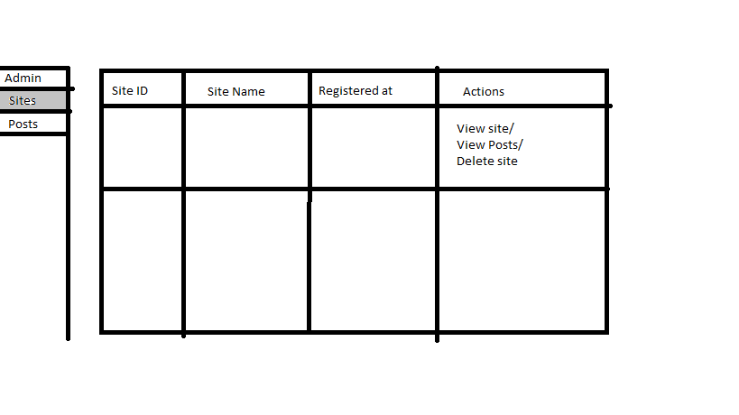
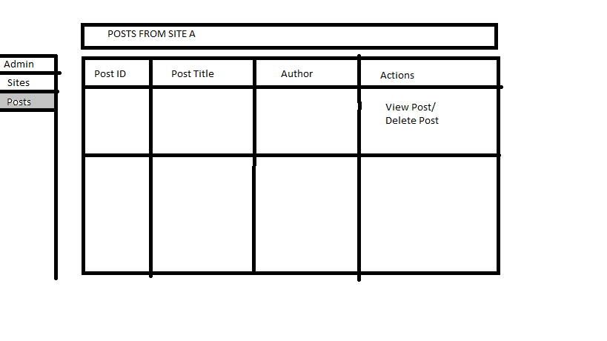
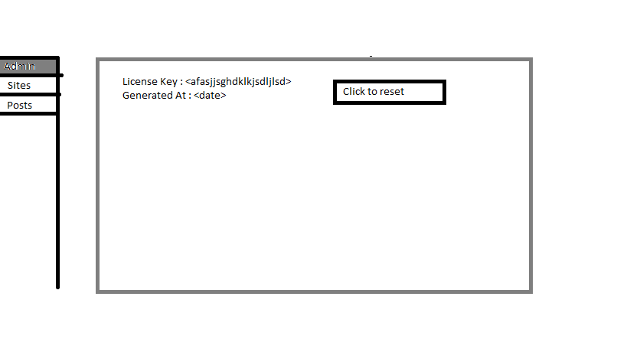
UC – Client Plug-in

It can have a basic screen showing how many posts are synced to the server.

