INTRODUCTION TO DATA MANAGEMENTPROJECT REPORT
(Project Semester January-April 2025)

Dashboard for Spotify History

Submitted by

Adarsh Aryan

Registration No 12307615

B-tech CSE K23GS
INT 375

Under the Guidance of

Baljinder Kaur Mam (27952)

Discipline of CSE/IT

Lovely School of Computer Science

Lovely Professional University, Phagwara

CERTIFICATE

This is to certify that Adarsh Aryan bearing Registration no. 12307615 has completed INT 375 project titled, “Spotify History” under my guidance and supervision. To the best of my knowledge, the present work is the result of his/her original development, effort and study.

Signature and Name of the Supervisor

Designation of the Supervisor

School of Computer Science
Lovely Professional University
Phagwara, Punjab.

Date:

DECLARATION

I, Adarsh Aryan, student of Btech under CSE/IT Discipline at, Lovely Professional University, Punjab, hereby declare that all the information furnished in this project report is based on my own intensive work and is genuine.

Date: 13-04-2025 Signature
Registration No. 12307615 Adarsh Aryan

Acknowledgement

I would like to express my heartfelt gratitude to Ms. Baljinder Kaur, whose unwavering support, insightful feedback, and continuous encouragement were instrumental throughout the duration of this project. Her expertise and commitment to excellence greatly inspired me to push my boundaries and deliver my best work. I sincerely thank her for guiding me through the technical and analytical aspects of data analysis using Excel.
I am especially grateful for her mentorship and invaluable suggestions that helped shape the direction of my work and made a significant difference in the final outcome of this report. Her tireless dedication to student success and commitment to excellence in teaching served as a source of motivation throughout this academic endeavor. I have learned not just the technical tools, but also how to think analytically and present data in a meaningful way because of her influence.
I also extend my appreciation to Maven Analytics for offering the data download facility, which provided a real-world dataset essential for this project. This practical exposure enabled me to explore actual user behavior and translate raw data into meaningful visualizations and insights.
A special thanks goes to my classmates and friends for their moral support and helpful discussions, which kept me motivated. I am deeply grateful to my family, whose patience and encouragement gave me the strength to complete this work. Their belief in me has always been a pillar of my academic journey.

Table of Contents
- Introduction
- Source of Dataset
- EDA Process
- Analysis on Dataset
  - Top 10 Most Played Songs
  - Top 5 Most Frequently Played Artists
  - Monthly Listening Trends
  - Most Used Platform
  - Skipped vs Fully Played Songs
- Conclusion
- Future Scope
- References

1. Introduction
The goal of this project is to analyze personal Spotify streaming data using Excel and create an interactive dashboard that visually represents listening behavior, habits, and patterns over time. Music streaming services like Spotify generate massive amounts of user interaction data. This dataset provides insights into the types of songs a user listens to, their favorite artists, the platforms used to stream, and how frequently songs are skipped or played in full.
The dashboard allows the user to dynamically explore the dataset using slicers for artists, time, and platform. This empowers users to uncover personalized insights through filtering and interaction with charts and graphs. The project demonstrates the power of Excel in handling, analyzing, and visualizing real-world data.

2. Source of Dataset
The dataset used in this project was downloaded from Maven Analytics, a well-known platform that offers high-quality datasets for data analytics and business intelligence training. The dataset provided represents Spotify streaming history and includes critical fields for analysis such as:
- track_name – The name of the song played
- artist_name – The artist who performed the song
- ms_played – The number of milliseconds the song was played
- platform – The device or app used to stream the song (e.g., Android, iOS, web player)
- ts – The timestamp when the song was played
- reason_end – Indicates whether the song was skipped or played fully
This dataset enabled a detailed chronological understanding of streaming behavior, offering a solid foundation for building analytical visuals in Excel.

3. EDA Process
Exploratory Data Analysis (EDA) was a crucial step before building the dashboard. It involved the following processes:
a. Data Cleaning
- Removed entries with missing track_name or artist_name.
- Standardized platform names and removed any blank entries.
b. Formatting Timestamps
- The ts column (timestamp) was converted to a Month-Year format to allow for monthly trend analysis.
- Extracted quarters and years for time-based filtering.
c. Calculated Columns
- Created a new column minutes_played = ms_played / 60000 to represent listening duration in a human-readable format.
d. Pivot Table Creation
- Created multiple PivotTables for:
  - Total listening time per song
  - Play frequency per artist
  - Monthly total streaming
  - Platform-based usage
  - Skipped vs played songs
e. Preparing for Dashboard
- Applied filters and slicers using Insert Slicer on PivotTables to create interactivity.
- Connected slicers across charts using Report Connections.

4. Analysis on Dataset
i. Top 10 Most Played Songs
Introduction: This analysis focuses on identifying the songs with the highest total listening time.
Description: The total milliseconds played for each song were summed using a PivotTable. The top 10 songs were selected by sorting this total in descending order.
Formulas/Functions:
- PivotTable with track_name in Rows, and ms_played in Values (Summarized).
- Sorted the table to show top 10 songs.
Result:
- The top songs included titles like “The Return of the King” and “Ode to the Mets.”
- These songs had significantly higher engagement times.
Visualization: A bar chart was used to represent the top 10 songs based on total listening time.
ii. Top 5 Most Frequently Played Artists
Introduction: Determines which artists appeared most often in the streaming history.
Description: By counting the number of entries for each artist_name, we can determine how often their songs were played.
Formulas/Functions:
- PivotTable with artist_name in Rows, and track_name as count.
- Sorted by highest play count.
Result:
- Artists like The Beatles and John Mayer were among the top.
Visualization: A horizontal bar chart displays the top 5 artists by frequency.

iii. Monthly Listening Trends
Introduction: Analyzes changes in listening patterns over time.
Description: Streaming data was grouped by month to observe spikes or declines in activity.
Formulas/Functions:
- Extracted month from ts using date formatting.
- PivotTable with month-year in Rows and ms_played summed.
Result:
- There were noticeable peaks in early 2023.
- Drop-off during specific months indicated seasonal or academic influence.
Visualization: Line chart showing monthly ms_played.

iv. Most Used Platform
Introduction: This analysis identifies the most common platforms used for streaming.
Description: Data was grouped by the platform field, and the number of entries or total time was calculated.
Formulas/Functions:
- PivotTable with platform in Rows and count or sum in Values.
Result:
- Android and web player platforms were used most frequently.
Visualization: Vertical bar chart with each platform and usage.

v. Skipped vs Fully Played Songs
Introduction: Explores how many songs were skipped vs played entirely.
Description: The reason_end field was used to identify skipped entries.
Formulas/Functions:
- Pivot by reason_end with count of entries.
Result:
- Most songs were played in full, but a small percentage were skipped.
Visualization: Pie chart showing percentage split between skipped and completed songs.

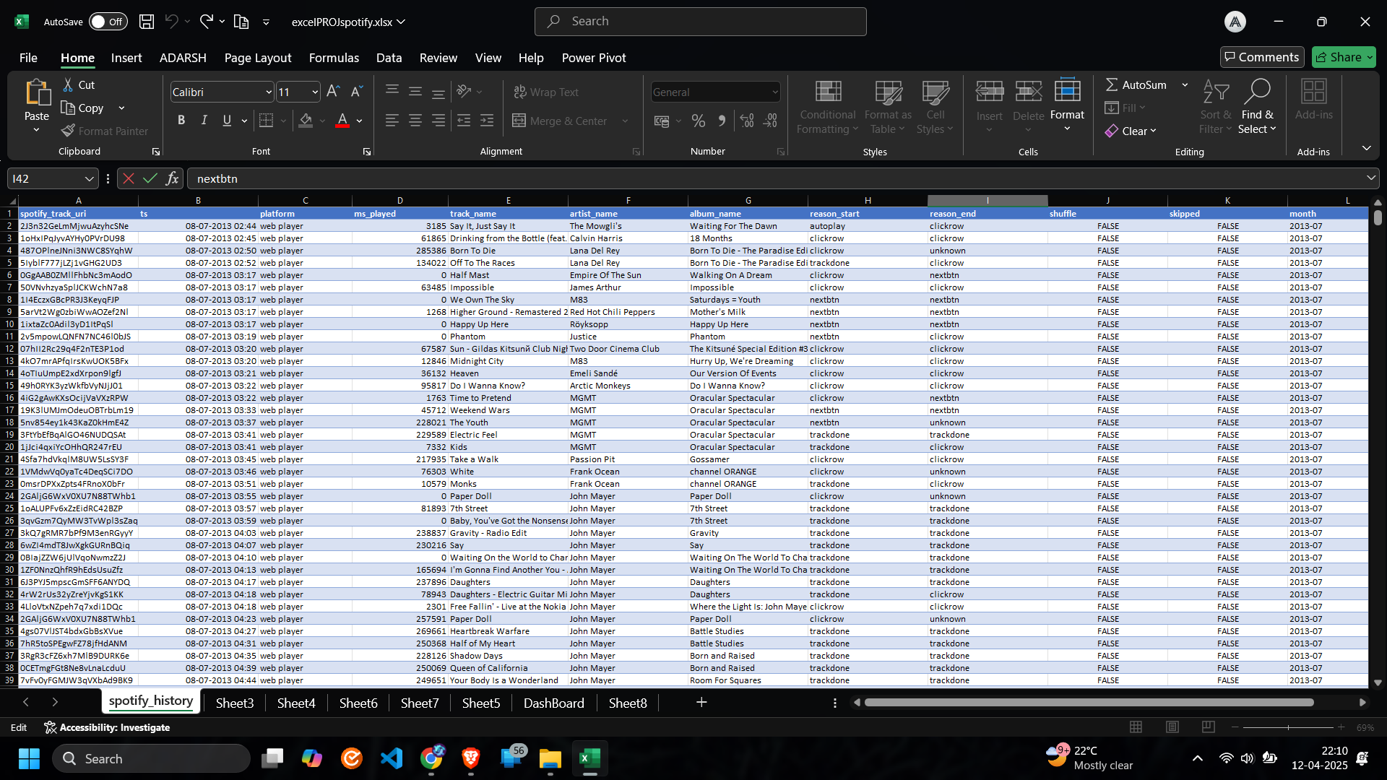

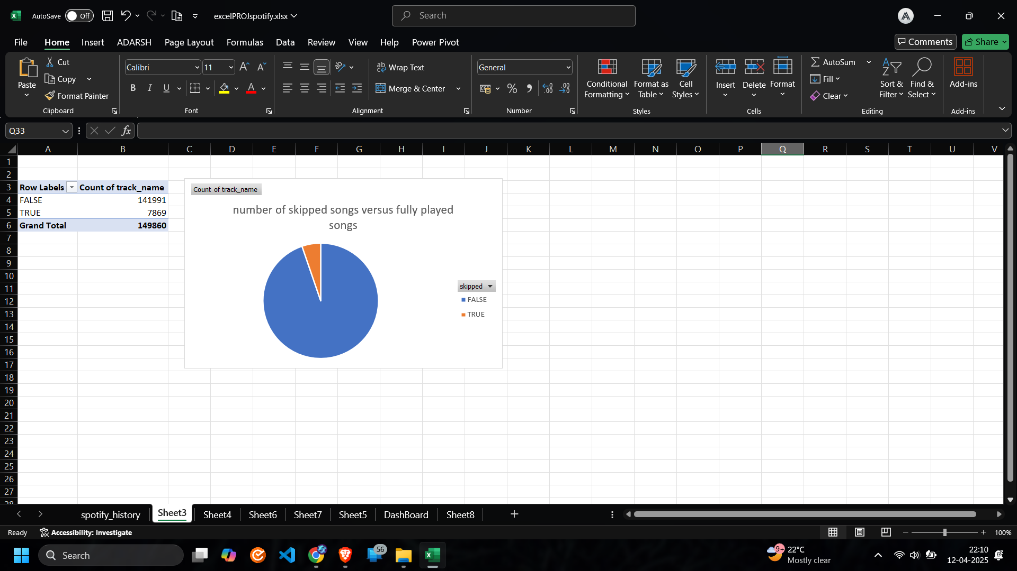

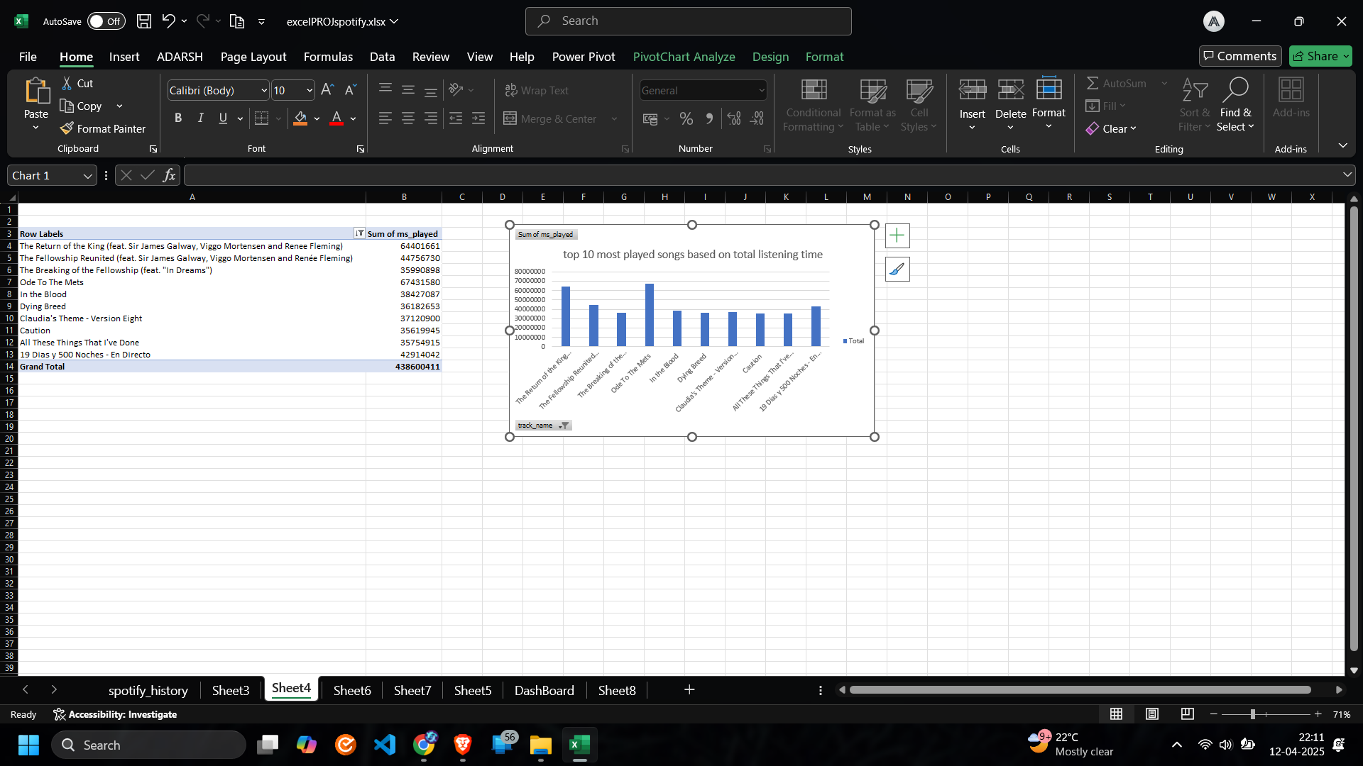
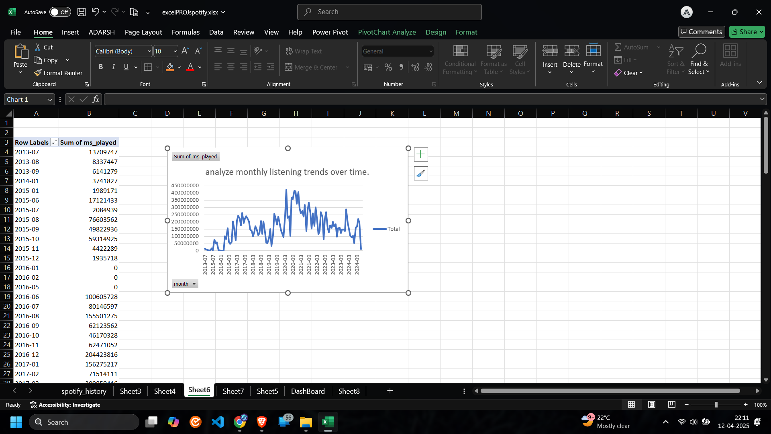

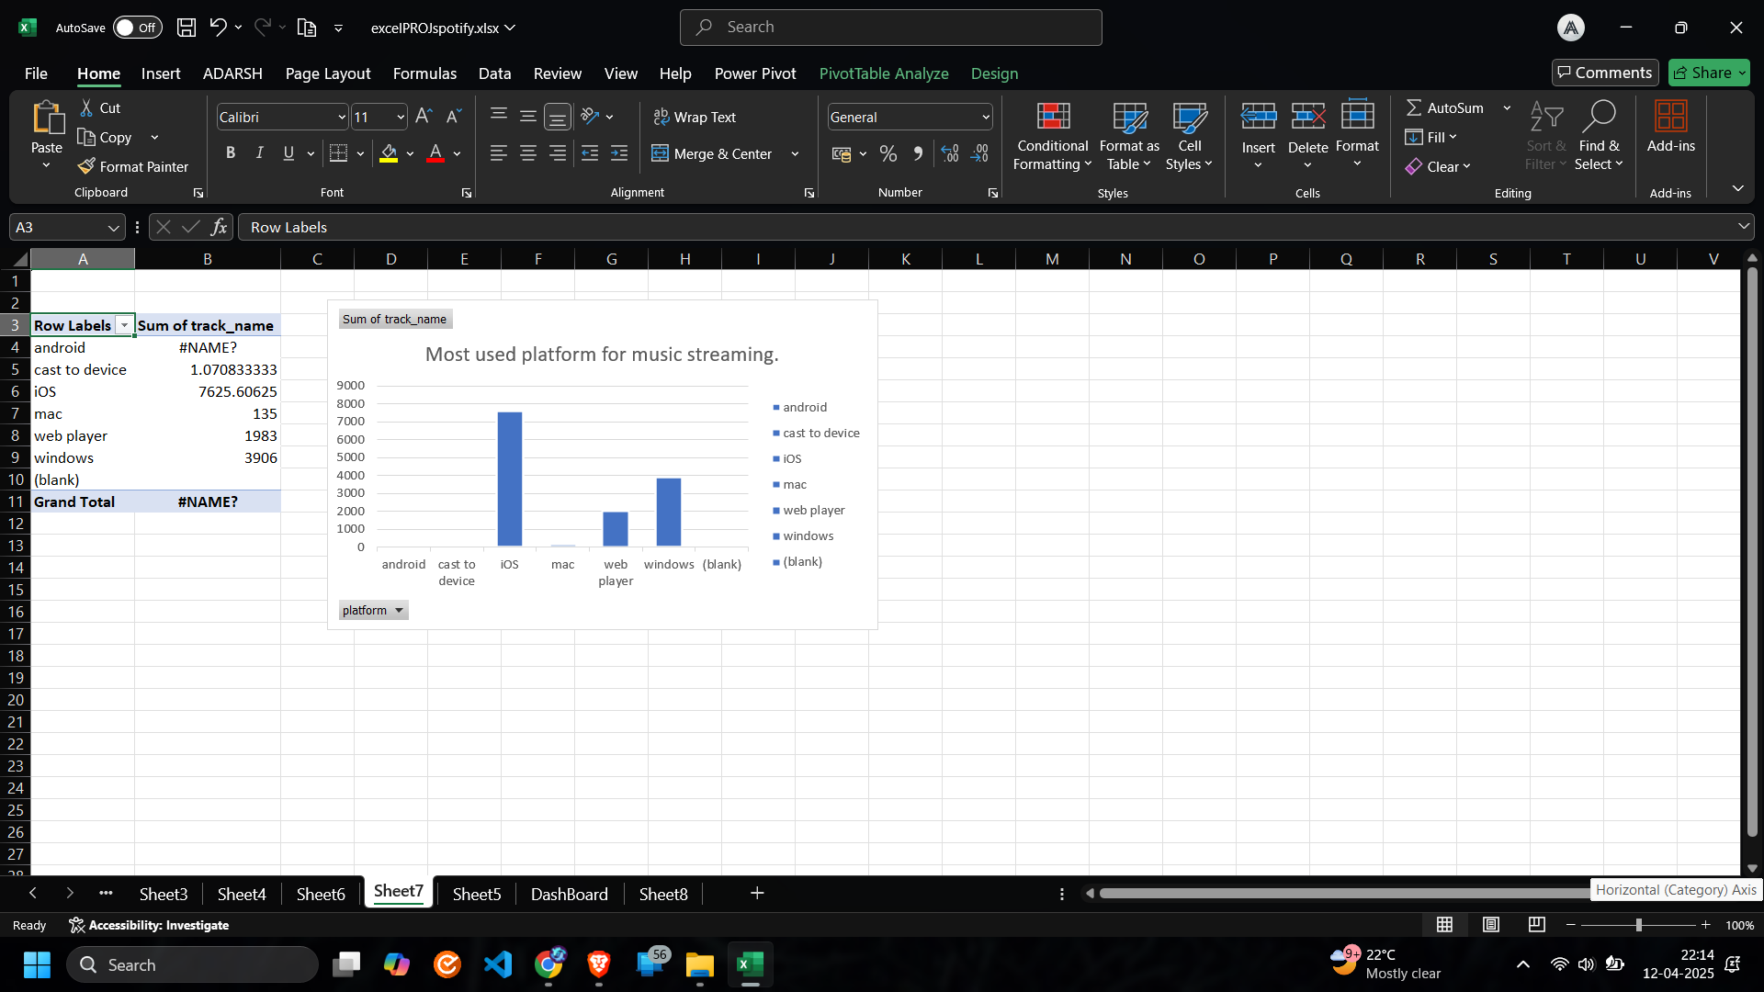
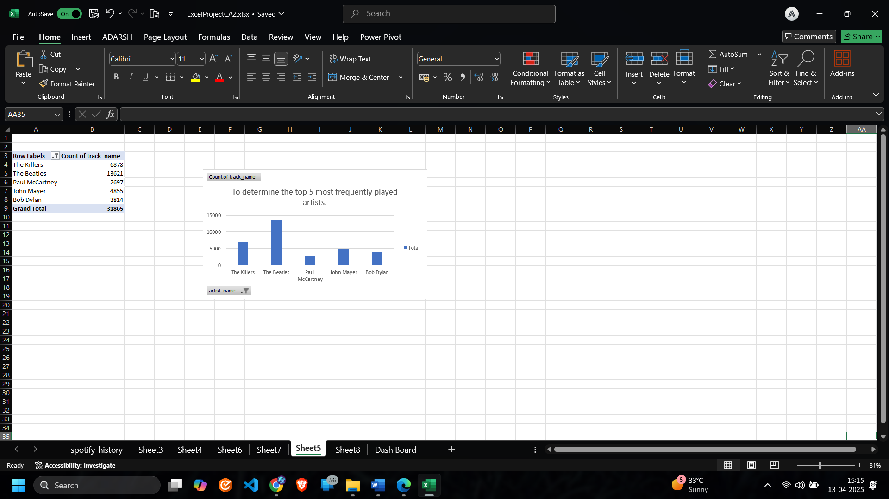

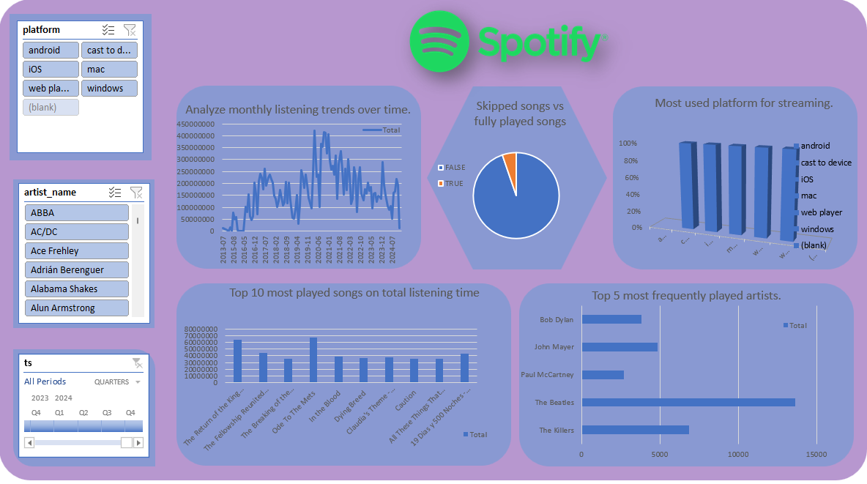

5. Conclusion
The dashboard effectively visualizes streaming behavior using interactive charts and slicers. Key takeaways include:
- Preferred songs and artists
- Most active streaming periods
- Common devices used
- Skipping behavior and user engagement
The project demonstrates the practical use of Excel in analyzing and visualizing personal datasets.

6. Future Scope
- Integrate Spotify API for real-time data updates.
- Compare multiple user datasets.
- Use Python (pandas + matplotlib/seaborn) for advanced visualizations.
- Predict user preferences based on historical trends.

7. References
- Spotify Data Export Portal
- Maven Analytics Datasets
- Microsoft Excel Official Documentation
- Online tutorials and community forums

