

2022-2023

Computer Networks

Adar Sönmez

Company Network Project in Cisco Packet Tracer

# Description and Requirements

Apple Inc. has hired you to set up a LAN for their new headquarters in Krakow. The following are the requirements for the Network you will establish in the new building.

1. Use Cisco Packet Tracer to implement solution.
2. The network address that the company allocated is 192.168.1.0/20
3. Various departments work on each floor of the 4-storey building. Each of these departments will have different VLANs and different subnetworks.
4. On the third floor, there will be a wireless access point to which a maximum of 1000 devices can be connected. The details of the floors and departments are given below.

1. floor:

Administration and HR: 90 devices needed

Sales and marketing: 200 devices needed

2. floor:

Finance: 80 devices needed

Public Relations: 100 devices needed

3. floor:

IT and Communications: 200 devices needed

Access Point: Maximum 1000 device should connect

4. floor:

Server Room: 20 devices needed

1. There should be a core router connected to the ISP, and two multilayer switches connected to this core router.

Network address between Core Router and ISP: 193.168.16.0/30

Network address between Multilayer S1 and Core Router: 192.168.19.164/30

Network address between Multilayer S2 - Core Router: 192.168.19.168/30

1. Devices in all departments are required to communicate with each other with the respective multilayer switch configured for inter-VLAN routing.
2. The multilayer switches are expected to carry out both routing and switching.
3. All devices in the network are expected to obtain an IP address dynamically from the DHCP server located at server room.
4. Devices in the server room are to be allocated IP addresses statically.
5. Use OSPF as the routing protocol to advertise routes between routers and multilayer switches.
6. Configure NAT on core router.

# Subnetting

Base Network: 192.168.16.0/20

11000000.10101000.00010000.00000000 / 11111111.11111111.1111 0000.00000000

Administration and HR Department

Network: 192.168.16.0/25

Broadcast: 192.168.16.127

Devices Needed: 90

Allocated IP addresses for Hosts: 126

Finance Department

Network: 192.168.16.128/25

Broadcast: 192.168.16.255

Devices Needed: 90

Allocated IP addresses for Hosts: 126

Sales and Marketing Department

Network: 192.168.17.0/24

Broadcast: 192.168.17.255

Devices Needed: 200

Allocated IP Addresses for Hosts: 254

IT and Communications Department

Network: 192.168.18.0/24

Broadcast: 192.168.18.255

Devices Needed: 200

Allocated IP Addresses for Hosts: 254

Public Relations Department

Network: 192.168.19.0/25

Broadcast: 192.168.19.127

Devices Needed: 90

Allocated IP Addresses for Hosts: 126

Server Room

Network: 192.168.19.128/27

Broadcast: 192.168.19.159

Devices Needed: 20

Allocated IP Addresses for Hosts: 30

Wireless Network Information

Network: 192.168.20.0/22

Broadcast: 192.168.23.255

Devices Needed: 1000

Allocated IP Addresses for Hosts: 1022

# Topology

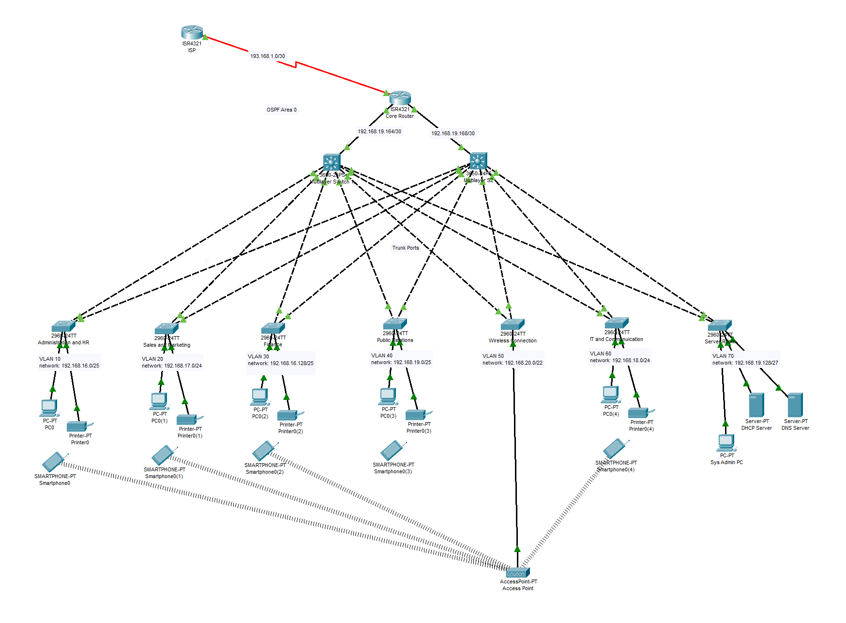

* OSPF used as routing protocol on the routers and multi-layer switches.
* NAT configured on core router.
* Multi-layer switches configured for inter-VLAN routing.
* Ports between multi-layer switches and 2960 model switches configured as trunk ports.
* Ports between 2960 model switches and end-devices configured as access ports.
* Access Point has a password on WPA2-PSK Authentication. Since smart phone in public relations department doesn’t have correct password, it’s not connected to the wireless network.

# Screenshots of Configurations

## ISP Router

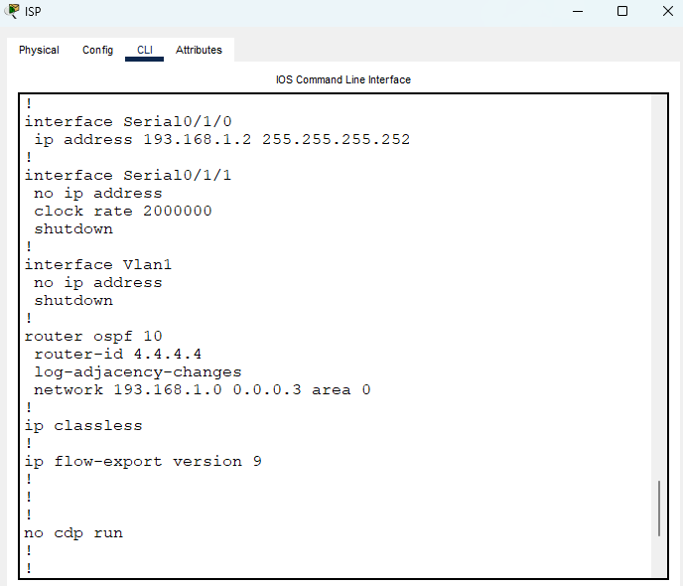

Figure 1: Statically typed IP addresses of Serial interfaces and OSPF configuration

## Core Router

Figure 2: Statically typed IP addresses

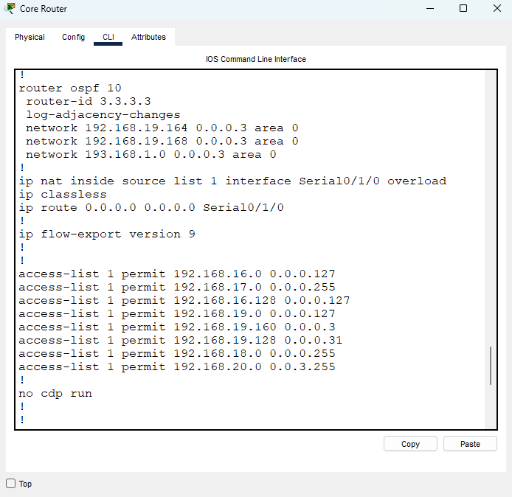

Figure 3: OSPF and NAT configuration

## Multi-Layer Switches

Figure 4: Statically typed IP on Gig1/0/1 and trunk interfaces

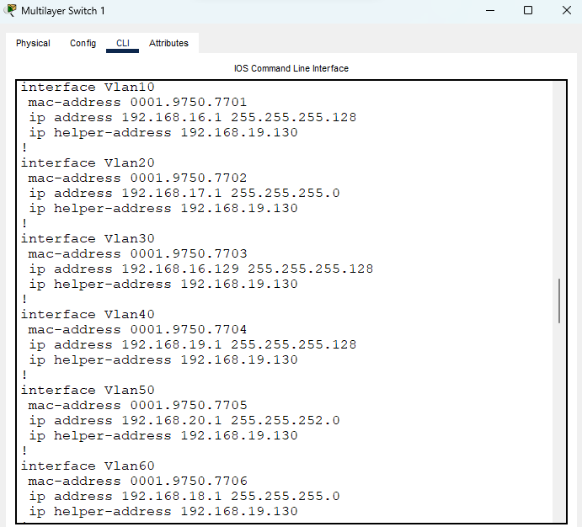

Figure 5: inter-VLAN routing and IP DHCP helper-addresses

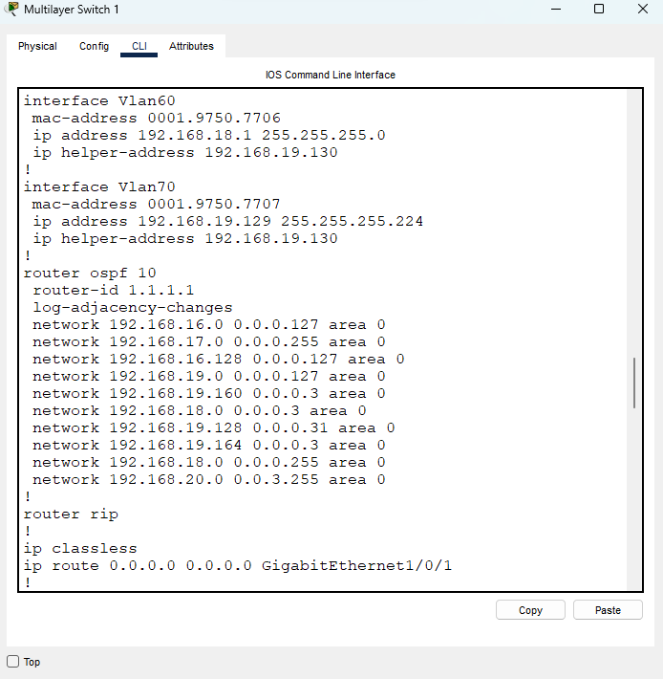

Figure 6: OSPF configuration

* Multi-layer S2 has similar configuration as Multilayer S1

## Layer 2 Switches

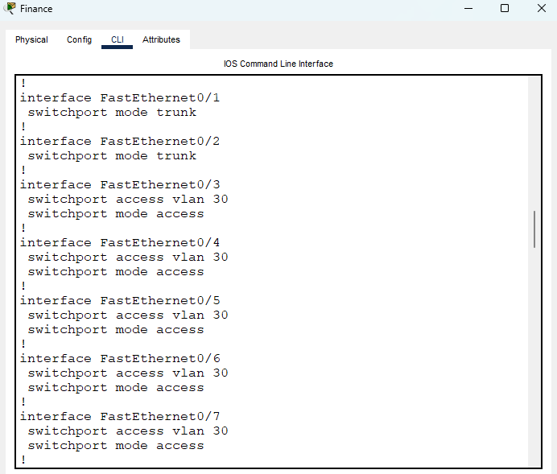

Figure : Access and trunk ports

## DHCP Server

Figure : Pools of DHCP server

# Testing

## Testing DHCP

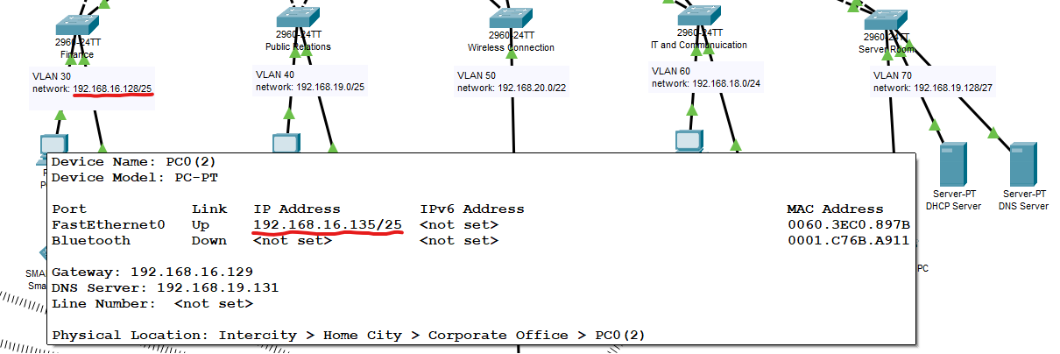

Figure : As soon as packet tracer opened all devices get IP addresses from DHCP server

## Ping Testing

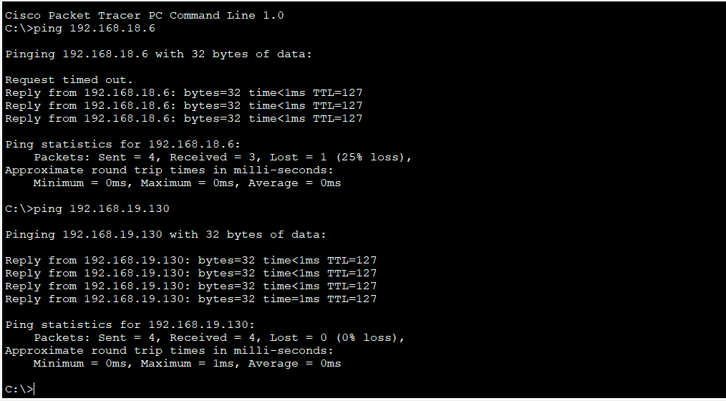

Figure : First ping is from finance dep. to IT dept.

Second ping is from finance dept. to the DHCP server

## Testing NAT

Figure : NAT translation in core router

## Testing DNS

Figure : Searching www.test.com on a PC

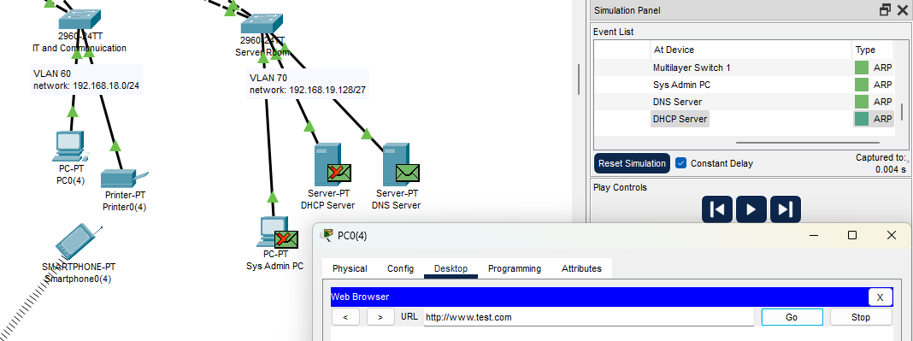

Figure : Our query goes to the DNS server to get an IP address for specified domain