**BIODATA**

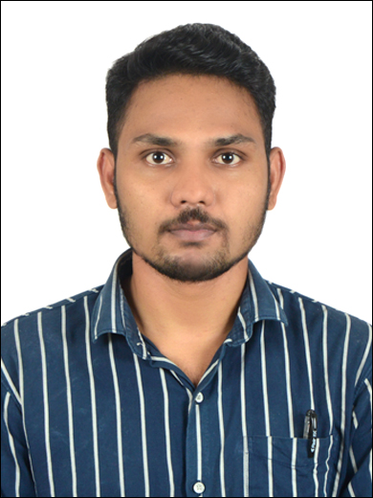ix Photograph

Full Name : Pradip Gurappa Chavan

Date of Birth :07/06/1995-Age-26

Cast : Banjara

Birth Time : 7:30 AM

Place of Birth : Narsinhpur,Tal-Walwa,Dist-Sangli

Height :5 ft 7”, Weight-65

Body type : Muscular

Blood Group :o+

Education :BE Mechanical-SGI Kolhapur

Occupation :Job-O2F info solutions as a Python Developer-Work from home

Package : 9.6 LPA

Other Details : Currently staying in Karvenagar Pune as bachelors.

Eating Habits : Non-Vegetarian

Addictions : No Any

**Family Details**

Father : Expired

Mother : Kamal Chavan-Housewife

Brothers/Sister :1 Brother -non-married-Education-final year MBBS

Family Properties : No any properties owned by Pradip-Family Properties-home in Narsinhpur(in 4guntha),Pune-3 story building(in 2 guntha-given on rent),1bhk flat,1/2 guntha land,5-two wheelers,1-six seater Renaut triber.

Contact No. : Dr.Tukaram Rathod-8007424573, Pradip-7620233186

Residential Address : a/p Narsinhpur,Tal-Walwa,Dist-Sangli,State-Maharastra.

Additional Information: In Narsinhpur we are staying with grandfather and

Grandmother ie-Mothers Parents Along with my 2 uncles both are in pune. 1 is govt-doctor-married-aunt is fashion designer,other is entrepreneur-married-aunt housewife.