**MEEM 5700 Dynamic measurements and signal analysis**

10/15/2013

**Frequency Domain Measurements**

**Assignment 04**

**Arjun Darbha**

Instructor: Dr.Jason Blough

TA: Craig Reynolds

***Abstract***

*The purpose of this experiment is to make frequency domain measurements using an oscilloscope and NI-Data acquisition system(NI-cDAQ). Measurements made in this experiment are limited to FRFs, phase and coherence. Source-response characteristics of a speaker microphone configuration are measured at ‘high-tone’ and ‘low-tone’ amplifier setting. In order to measure response characteristics at different frequencies, a series of 21 sine-waves at 50Hz and 1 to 20kHz have been used to measure the response gain and phase using the oscilloscope. On the NI system, Gaussian noise is generated as it contains all frequencies. It is assumed initially that frequency response function(FRF) should possess similar characteristics when measured using any measurement system and this assumption is confirmed by overlaying FRF’s of NI and oscilloscope on top of each other. It is known that FRF of NI system is a H1 formulation and this is tested by programming logic pertaining to H1 in matlab, running this program on time-history acquired using NI-cDAQ and overlaying plots only to identify insignificant differences in matlab’s H1 measurement and NI-cDAQ’s FRF. Coherence measurements are also tested in a same manner. Careful investigation of FRF and coherence for high/low tone data also revealed a dip at the same frequency in all the plots, owing to an anti resonance frequency of the system.*

**Introduction**

Results of a fast fourier transform can be single or double-sided. Single sided spectrum usually measured as Gx or Gxx gets rid of the negative frequencies where as the double sided spectrum, denoted by Sx or Sxx shows the complete spectrum from –N/2 to N/2 where N is the block-size. The discrete fourier equations are given by equations 1 and 2

|  |  |  |
| --- | --- | --- |
|  |  |  |

|  |  |  |
| --- | --- | --- |
|  |  |  |

Here the subscript x denotes channel. If a single channel measurement is made then one subscript is used. However, when a double channel measurement is made, double subscripts, such as Gxy are used. All the measurements and analysis in this report are based on the assumption that the spectrum is single sided.

Frequency domain measurements

As the linear spectrum is obtained by performing an fft, there are several measurements that can be made in order to analyze the signal. Some the measurements that are discussed in this report are

* Linear Spectrum
* Auto power spectrum
* Cross power spectrum
* Frequency response function – H1, H2
* Coherence

Linear spectrum – A frequency domain is created at the first place using an fft. It is just a Fourier transform of the time history. The result of a Fourier transform is a complex number, and hence possesses real and imaginary parts. Real parts correspond to ‘cosine’ frequencies in a signal and imaginary parts denote ‘sine’ frequencies. The result displayed by the measurement systems is the magnitude of these complex numbers. It is also worth mentioning that if an fft is performed on a time history captured at a sampling rate Fs, in terms of a single sided spectrum, all the frequencies upto Fs/2, which is Nyquist frequency are displayed. The frequencies closest to Nyquist display high variance as the anti-alias filter meddles with these frequencies. This can be identified in all the spectral measurements made while performing this experiment.

Auto-power spectrum – It is defined as the product of linear spectrum multiplied by its complex conjugate. Let Gx be the linear spectrum of interest-the auto-power is mathematically defined as,

|  |  |  |
| --- | --- | --- |
|  | $$G_{xx}=G_{x}^{*}{\left(ω\right)G}_{x}(ω)$$ |  |

The subscript denotes that spectrum from a single channel is used to compute this spectrum. Let Gx be denoted by a+jb, its complex conjugate is then denoted by a-jb. Then by using equation 3,

|  |  |  |
| --- | --- | --- |
|  | $$G_{xx}=\left(a-jb\right)\left(a+jb\right)=a^{2}+b^{2}$$ |  |

It can be concluded from equation 4 that auto-power spectrum can never be negative. It can also be concluded that auto-power has no phase. Result of an auto-power is a real valued function with magnitude of linear spectrum squared. As auto-power spectrums of n number of blocks are analyzed, the data which is not periodic gets averaged out. Hence as the number of averages increases, the frequencies of interest tend to stand out in the spectrum. There is also a term called linear auto power, in connection to auto power which is defined as $√G_{xx}$, which is consistent with the units of the measurement made.

Cross power spectrum – Cross power spectrum is defined for two channels (x and y). If the linear spectrum on one channel is Gx and spectrum on the other channel is Gy, then auto power is defined as

|  |  |  |
| --- | --- | --- |
|  | $$G_{xy}=G_{x}^{*}\left(ω\right)G_{y}(ω)$$ |  |

Let Gx be defined by a complex number a+jb and Gy be defined by a complex number c+jd, from equation 6

|  |  |  |
| --- | --- | --- |
|  | $$G_{xy}=ac-bd+jbc+jad$$ |  |

From equation 8 it is clear that the result of cross spectrum is a complex number and hence a phase is defined. This phase defined by cross-power is relative and indicates mutual powers. If signals on two channels are correlated to each other then phase difference is consistent and such frequencies are carried by cross-powers. It is generally assumed that noise components are uncorrelated and hence noise averages out when the signal is averaged.

Frequency response function (FRF) – FRF is defined as a ratio of output spectrum to the input spectrum. If a force, $F(jω)$ is applied to a system which generates a response of $X(jω)$ then FRF is defined as

|  |  |  |
| --- | --- | --- |
|  | $$FRF=\frac{X\left(jω\right)}{F\left(jω\right)}$$ |  |

FRF measurement is not the same as measuring transfer function. It represents the frequency axis of a transfer function. However, transfer function cannot be measured experimentally. From equation 8 it can be concluded that in frequency domain, response is related to force through FRF. However, in the time domain, response is related to force through an impulse transfer function. Equation 8 represents the mathematical relationship in the time domain

|  |  |  |
| --- | --- | --- |
|  | $$x\left(t\right)=h\left(t\right)⊗f\left(t\right)$$ |  |

where

|  |  |  |
| --- | --- | --- |
|  | $$h\left(t\right)= F^{-1}(H\left(ω\right))$$ |  |

In equation 9, $F^{-1}$ denotes an inverse fft operation. However, FRF measurements are not made in time domain because it is difficult to generate and reconstruct impulse responses.

FRF is measured using different formulas obtained by mathematically manipulating the basic FRF equation denoted by equation 9. Basic FRF equation with response on channel X and force on channel F is

|  |  |  |
| --- | --- | --- |
|  | $$H_{XF}\left(ω\right)=\frac{G_{X}\left(ω\right)}{G_{F}\left(ω\right)}$$ |  |

Equation 10 is simple to measure but not suitable for ideal case because of possibility of noise in real world signals. Equation 10 does not mitigate noise on either channel so measuring FRF using this equation would not result in a reliable measurement. In order to minimize the effects of noise on FRF, H1 and H2 formulations are used. H1 formulation is calculated from 9

|  |  |  |
| --- | --- | --- |
|  |  |  |

|  |  |  |
| --- | --- | --- |
|  |  |  |

|  |  |  |
| --- | --- | --- |
|  |  |  |

In equation 15, numerator denotes a cross-power of source and response; hence uncorrelated noise components are mitigated. However, the denominator denotes an auto-power which carries noise components. Hence H1 formulation averages out noise on the response side.

Equation 9 can be used to formulate H2 as

|  |  |  |
| --- | --- | --- |
|  |  |  |

|  |  |  |
| --- | --- | --- |
|  |  |  |

|  |  |  |
| --- | --- | --- |
|  |  |  |

Equation 16 has a cross power in the denominator hence, unlike H1, H2 mitigates noise on the source side. Also, as the phase comes from cross power and H1 and H2 have a cross power involved, they do possess phase. However as $G_{FX}$ is a mathematical conjugate of $G_{XF}$, H1 and H2 formulations have same phase.

Real-world signals which possess noise are modeled using equation 17 (bivariate model)

|  |  |  |
| --- | --- | --- |
|  | $$G_{X}\left(ω\right)+ G_{n}\left(ω\right)= H(ω)[G_{F}\left(ω\right)+G_{m}\left(ω\right)]$$ |  |

where $G_{n}(ω)$ and $G_{m}(ω)$ denote noise. This equation is used to formulate H1 and H2 which include noise components.

|  |  |  |
| --- | --- | --- |
|  |  |  |

|  |  |  |
| --- | --- | --- |
|  |  |  |

Equation 20 has unavoidable noise component in the denominator. Hence measurement made by H1 with noise is always biased low. On the other hand, equation 21 has noise on the numerator. This measurement accordingly is biased high when there is noise.

There are other formulations of FRFs like H1, H2, H3, Hv, Hc and so on. The scope of this experiment is limited only to H1 and H2.

**Coherence**

Coherence is a mathematical causality function that measures how much of response is from the source. It is a fraction of output that is linearly related to input. Coherence is defined as

|  |  |  |
| --- | --- | --- |
|  | $$γ^{2}\left(ω\right)=\frac{G_{FX}(ω)G_{XF}\left(ω\right)}{\left[G_{FF}\left(ω\right)+G_{mm}\left(ω\right)\right][G_{XX}\left(ω\right)+G_{nn}\left(ω\right)]}$$ |  |

The numerator is a real number as it is a multiplication of complex conjugates. Denominator is also a real number as it involves auto-powers. Hence $γ^{2}$ is always a real number. Also,

|  |  |  |
| --- | --- | --- |
|  | $$0≤γ^{2}≤1$$ |  |

Ideally, coherence measurement should be 1. Coherence values less than 1 can be explained by

* Non-linear relationship between the signals measured
* Unmeasured inputs to the system
* No output from the system
* Biased error like noise and leakage

If coherence function contains valleys, it should be due to one of the four reasons mentioned above. Coherence measure should always be analyzed in conjunction to FRF plots. If valleys in the coherence plot line up with valleys in FRF, these frequencies denote anti resonance frequencies. As this is a system characteristic these valleys cannot be avoided. However, if valleys in coherence line-up with peaks in FRF, there is leakage at that frequency and the sampling parameters have to change before making any conclusions about the signal.

Objectives

The objectives of this experiment are to

* Measure the gain and phase characteristic of sine-waves at 50 Hz and all the frequencies from 1 kHz to 20 kHz at high and low tone settings
* Make the same measurement using NI-cDAQ for a noise signal which contains all the frequencies. Measure FRF and coherence using sound and vibration assistant
* Compare the gain measurements made by the oscilloscope with FRF measurements made by NI. Also compare the mutual phases measured by two systems for two tone settings
* Make an FRF measurement without using the speaker microphone configuration and by directly connecting the output of the amplifier to the response channel of the acquisition system
* Acquire a time-history of block size 2048 and data worth 30 blocks. Export this time history, for two tone settings to MATLAB. Program H1, H2 and coherence using the data exported. Overlay these plots on top of each other and also the measurements made by NI for two tone settings and report differences. Also verify the hypothesis that H2 is biased high and H1 biased low if there is noise in the measurement

**Apparatus**

The apparatus used in this experiment is listed below

* Signal generator – Sony Tektronix AFG310
* Data Acquisition System – National Instruments – NI-cDAQ-9234
* Signal generator – NI-9263
* Microphone-PCB Piezotronics ICP SN 23957
* Amplifier – RCA SA155 Integrated stereo
* Speaker – Optimus XTS-40
* Piezoelectric coupler – Kistler 5112
* Signal splitter

The experiment is performed in two steps. Data is collected using the oscilloscope in the first step and a signal generator is used to generate the signal. The schematic of the apparatus used is presented in figure 1.

Figure 1 Apparatus used for collecting data from oscilloscope

Signal generator is used to generate signals in this case at different frequencies. Amplitude is not adjusted in the generator. This signal is split before it enters the amplifier by a signal splitter (one – input, two – outputs). One of the outputs is directly captured by the oscilloscope. This is the source signal. The other output gets amplified in the amplifier and the signal is captured through the microphone and a speaker. Microphone is powered using a piezoelectric coupler whose output is captured through the oscilloscope. This is the response signal. Amplitudes of both the signals are directly measured using one of the functions in the ‘Quick measure’- in the oscilloscope. The same function can be used to measure relative phase between the signals.

In the second step, signal is generated and acquired by different modules in the NI-system through a microphone-speaker configuration.

Figure 2 Apparatus used for collecting data from NI system (amplifier-speaker configuration)

By referring to figure 2, it can be seen that signal generator module is connected to the amplifier through a splitter. One of the outputs of the splitter is acquired on channel 1 of the acquisition system. This is the source signal. The other output is sent to the speaker microphone configuration to capture the sound wave. The piezoelectric coupler used to power the microphone is also used to measure the voltage. The signal generated by the coupler is acquired on channel 2 of the acquisition system, as a response signal.

In figure 3, schematic of amp-only configuration is presented.

Channel 2

Channel 1

Figure 3 Apparatus used for collecting data from NI system (amp-only configuration)

In this step, signal generated by the generator is sent to the signal splitter where one of the signals is captured as a source signal and the other signal is branched off into the amplifier. Output of the amplifier is directly connected to response channel of the DAQ and the required measurements are made.

Experimental procedure

A Oscilloscope measurement

Signal of amplitude 2.5V is generated with a frequency of 50Hz; and all the frequencies between 1kHz to 20kHz. The volume knob on the amplifier is set to the middle. Data is collected at two-tones – high and low. For measuring gain and phase, quick measure tool on the oscilloscope is used. Peak to peak amplitude is measured for both signals whose ratio is calculated as gain, for each frequency. Relative phase is also measured using the same function of the oscilloscope.

B NI measurements

This experiment used an NI system for both signal generation and acquisition. Signal generation is accomplished using NI-9263. The entire experimental procedure from this step is controlled through the Sound and Vibration assistant software. The apparatus is set up as the schematic presented in figure 2. The experiment is split into four parts denoted by separate blocks in the software. The first block is used to create the signal. Noise signal, as white Gaussian noise is created with Vrms of 1V. Then a signal generator block is created and a proper channel is chosen to generate the signal. Sampling rate of this signal is set to 100 kHz. It is important to sample this signal at a high sampling rate as it is supposed to mimic an analog signal which is continuous. The block size for this signal is set to 2048*30. Also the signal is set to be ‘Continuously sampled’. The sampling frequency of DAQ is set to the highest possible sampling frequency at 51.2 kHz with a Nyquist frequency of 25.6 kHz. As the signals in the oscilloscope are tested up to a frequency of 20 kHz, this value is appropriate for sampling frequency. The Analysis block is then added to make FRF measurements. It must be ensured that coherence option is checked. Signal is now generated with the set parameters. The analysis block has to be carefully monitored for current number of averages and has to be stopped exactly after set number of averages-30- is reached; so that the log does not contain extra data which is not required for processing. The log is then collected and exported to matlab for analysis and processing. FRF, coherence and phase spectra are also exported to matlab for further analysis. Generator and acquisition settings are summarized in Table 1

Table 1 Generator and acquisition settings

|  |  |  |
| --- | --- | --- |
| Parameter | Signal Generator | Acquisition system |
| Sampling frequency | 100kHz | 51.2kHz |
| Samples to read(per sec) | 2048*30 | 2048 |

**Measurement data summary**

Gain and phase are measured using the oscilloscope. The data collected using the oscilloscope is presented in tables 2 and 3. Table 2 represents data collected for an amplifier setting of ‘high-tone’ and table 3 represents the data for a ‘low-tone’ setting

Table 2 Gain and phase measured using the oscilloscope (At high-tone)

|  |  |  |
| --- | --- | --- |
| **Frequency(Hz)** | **Gain(Vout/Vin)** | **Phase(Degrees)** |
| 50 | 0.389864 | -36.4 |
| 1000 | 0.518519 | -67 |
| 2000 | 0.289017 | -81 |
| 3000 | 0.450292 | -30 |
| 4000 | 0.481481 | 65 |
| 5000 | 0.506823 | -239 |
| 6000 | 0.54191 | -148 |
| 7000 | 0.610136 | 298 |
| 8000 | 0.450292 | 0 |
| 9000 | 0.346979 | -310 |
| 10000 | 0.384016 | 110 |
| 11000 | 0.28655 | -200 |
| 12000 | 0.304094 | 230 |
| 13000 | 0.481481 | -20 |
| 14000 | 0.237817 | 70 |
| 15000 | 0.146199 | -250 |
| 16000 | 0.109162 | 190 |
| 17000 | 0.152047 | 240 |
| 18000 | 0.177388 | -30 |
| 19000 | 0.109162 | 70 |
| 20000 | 0.17154 | 140 |

Table 3 Gain and phase measured using the oscilloscope (At low-tone)

|  |  |  |
| --- | --- | --- |
| **Frequency(Hz)** | **Gain(Vout/Vin)** | **Phase(degrees)** |
| 50 | 0.372319688 | -33.7 |
| 1000 | 0.561403509 | -59 |
| 2000 | 0.210526316 | -50 |
| 3000 | 0.296296296 | 16 |
| 4000 | 0.261208577 | 108 |
| 5000 | 0.282651072 | -189 |
| 6000 | 0.304093567 | -98 |
| 7000 | 0.358381503 | -13 |
| 8000 | 0.177387914 | 60 |
| 9000 | 0.140350877 | 100 |
| 10000 | 0.152046784 | 180 |
| 11000 | 0.072124756 | -120 |
| 12000 | 0.130604288 | -50 |
| 13000 | 0.161793372 | 20 |
| 14000 | 0.159649123 | 140 |
| 15000 | 0.057309942 | 204 |
| 16000 | 0.038986355 | -102 |
| 17000 | 0.050097466 | 313 |
| 18000 | 0.059844055 | 50 |
| 19000 | 0.037816764 | -231 |
| 20000 | 0.072124756 | -164 |

Data presented in tables 2 and 3 is plotted figure 1 with gain in dB on the y-axis and frequency in the x-axis.

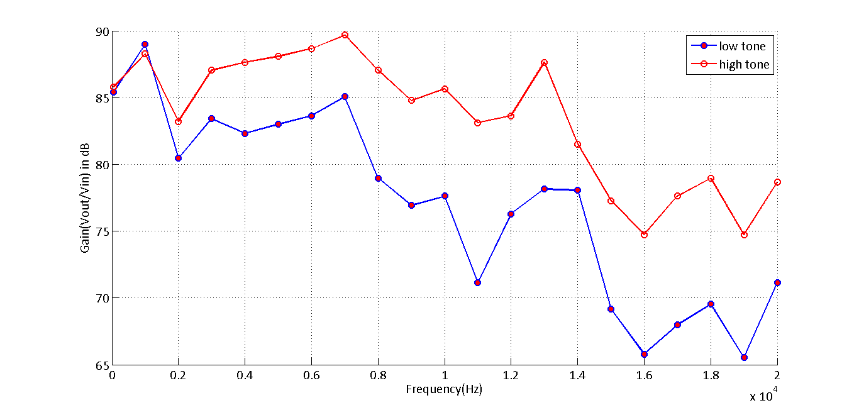

Figure 3 Frequency v/s gain in db for low-tone and high tone settings

Volume of the amplifier is set in the middle for both the settings. It is evident from these plots that gain for a high tone setting is higher than gain for a low tone setting. It can also be seen that the two lines have a similar trend – corresponding peaks and valleys in the two plots match each other.

Mutual phase is also measured by using oscilloscope for both high tone and low tone. The data measured has been presented in tables 1 and 2 for the two tones. Figure 4 represents relative phase between the two signals.

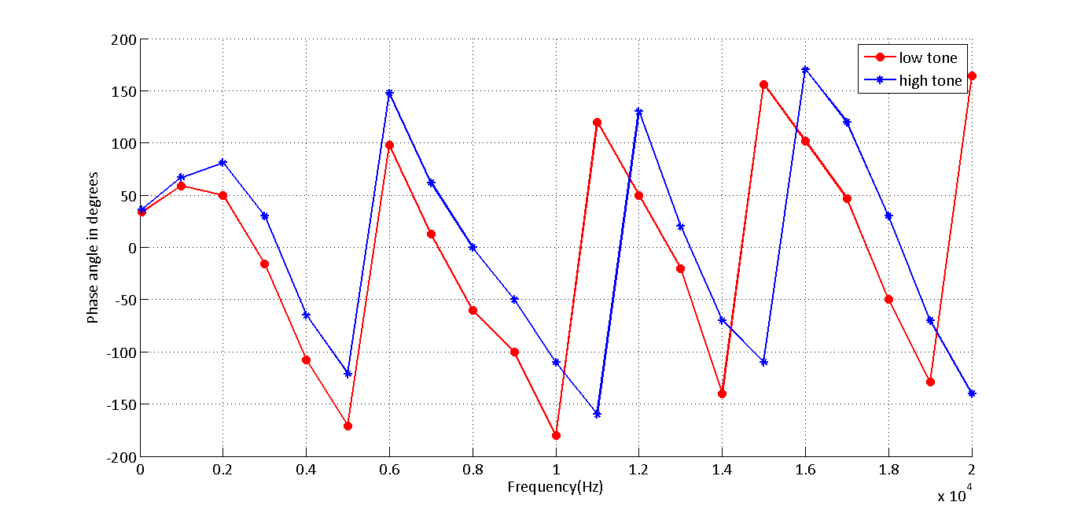

Figure 4 Mutual phase of the signals captured on the oscilloscope (High tone - *, low tone o)

The phase difference in figure 5 is plotted as wrapped phase between -180 and 180 degrees. This is done in order to compare and contrast between NI and oscilloscope as the software plots are unwrapped.

**Data analysis and interpretation**

FRF(Frequency response function) measurements have been made using the NI system. Gaussian noise signal captured by the acquisition system of NI-cDAQ generates an FRF as shown by figure 4.

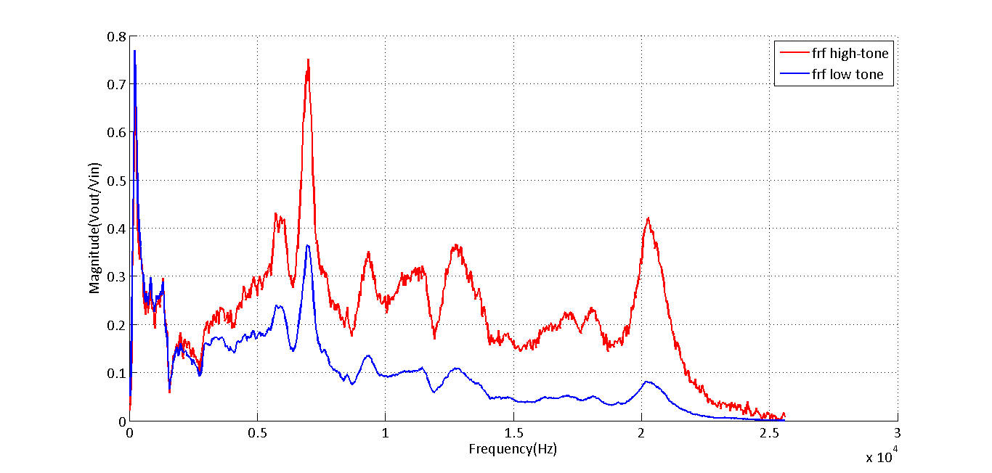

Figure 5 FRFs measured using NI-cDAQ system for both high and low tones

Figure 5 represents the FRFs captured by the NI c-DAQ with high tone and low tone FRFs overlaid on top of each other. This plot has similar characteristics to the plot generated by oscilloscope readings. Similar to the oscilloscope’s case, Low tone and high tone have similar characteristics high-tone possessing higher gain when compared to low-tone, especially at higher frequencies. It is worth mentioning that FRFs are formulated in H1 formulation.

Phase difference is also measured using the NI-cDAQ system. The plots for low tone and high tone for the NI-system are presented in figure 6.

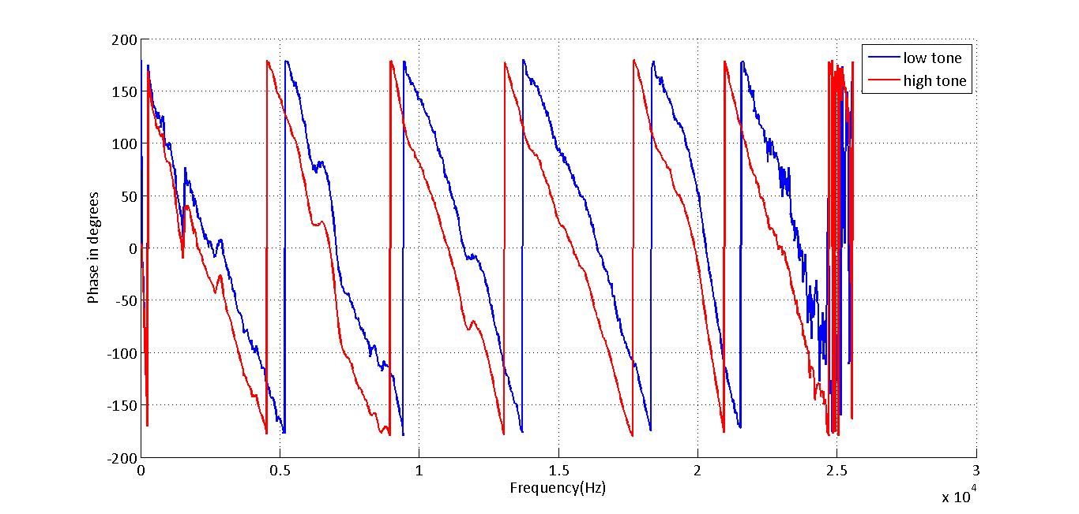

Figure 6 Mutual phase of the signals captured on NI system (Red-high, blue – low)

Oscilloscope has no function for generating a coherence plot. However, coherence is plotted using the NI system and presented in figure 7

.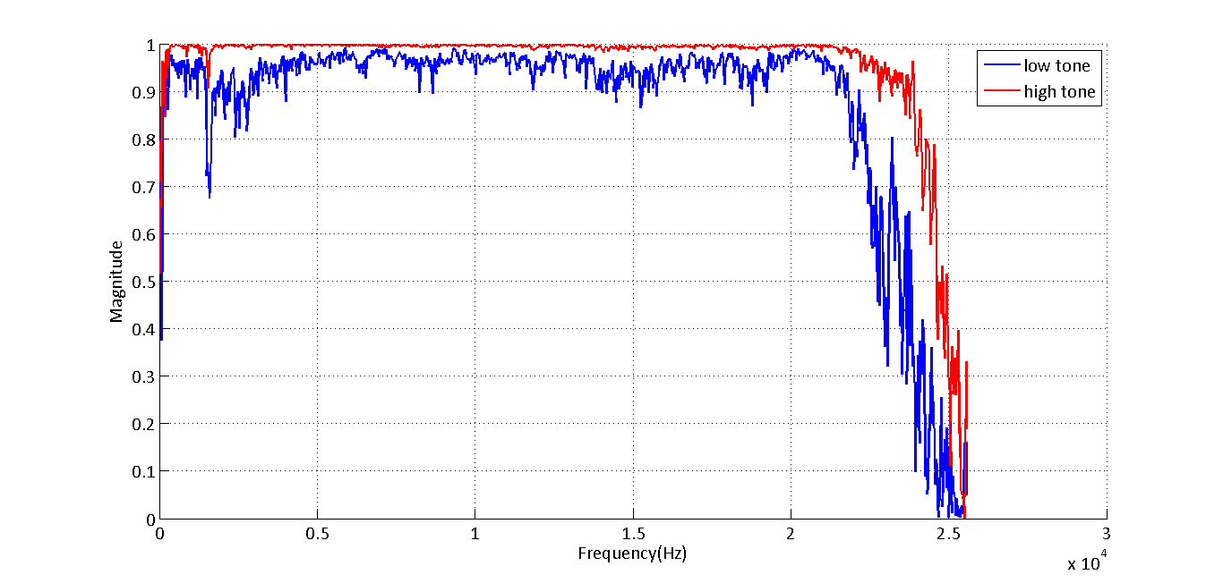

Figure 7 Coherence plots for the signals captured on NI system (Red-high, blue-low)

It can be seen from the plots that high exhibits a high degree of coherence when compared to low tone.

Two important inferences can be drawn by looking at the figures 1- 7

* High tone exhibits higher gain at higher frequencies when compared to low tone
* Anti-alias filter effects can be clearly seen in the plots at frequencies closer to Nyquist frequencies because of which all the plots from NI system exhibit high variance at the end of the spectrum

Because high-tone and low tone have different gains at different frequencies, these are analyzed separately for NI and oscilloscope measurements.

Gain comparison:

Gain calculated using the oscilloscope is converted into a dB measurement so that the results can be compared with NI system. The two spectrums are overlaid on each other in figure 8 to compare the characteristics of both the measurement systems

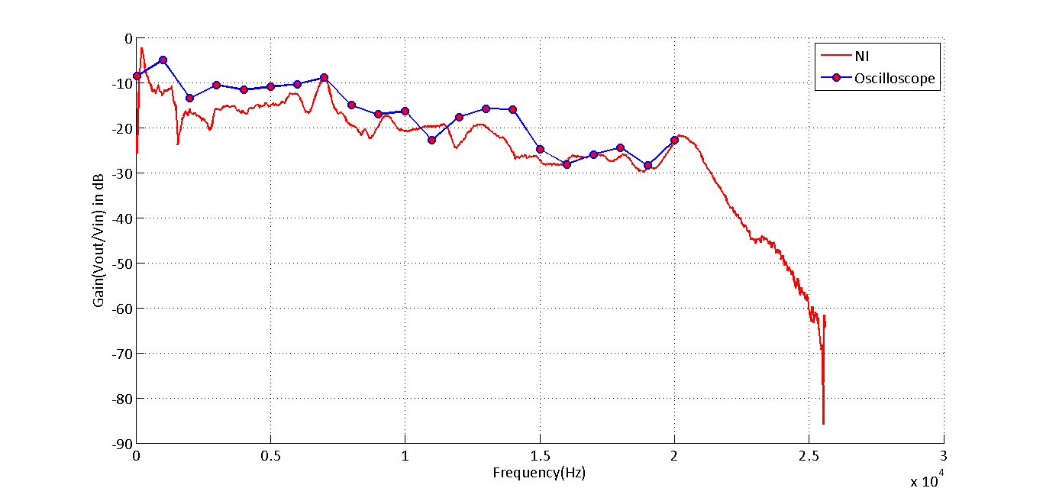

Figure 8 Comparison of gains(low-tone) measured by oscilloscope and NI-system

From figure 8 it can be seen that data measured by oscilloscope follows a similar trend as the NI measurement follows. The data collected using the oscilloscope is discrete and also the FRF is calculated by merely calculating the gain and obtaining a dB value. Therefore, it is not expected to follow the FRF measured by NI system, closely. Moreover, the signal captured by NI system is signal averaged to remove noise significantly. Oscilloscope data contains noise, hence peaks/valleys are not prominent. FRF measured by NI system is an H1 formulation. It is also evident from figure 8 that response of the system at higher frequencies is slightly lower. Similar comparison is made using figure 9 which represents FRFs measured using high-tone data

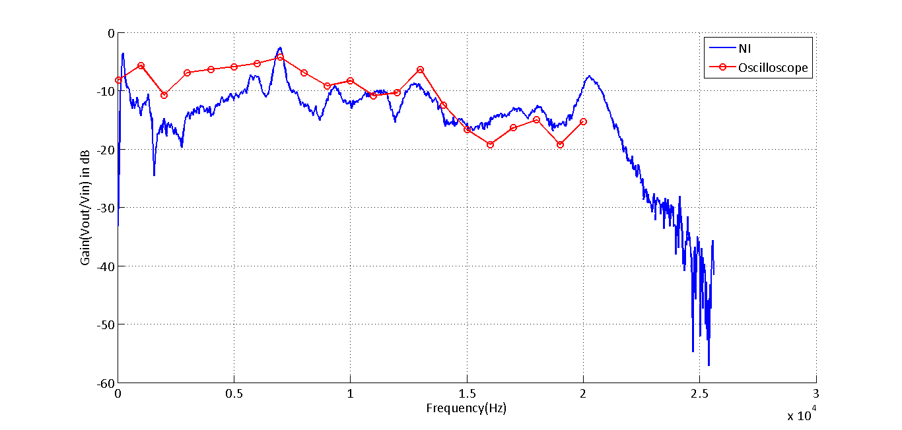

Figure 9 Comparison of gains (high-tone) measured by oscilloscope and NI-system

Even in this case it is evident that data follows a similar trend. Unlike the low-tone case, this high tone has a consistent gain for all the frequencies. It can also be seen that FRFs estimated by NI system are lower in the range of 0-5000Hz when compared to the oscilloscope. This trend is observed in case of low tone and high tone. H1 is a good estimator of the FRF when compared to crude way of calculating FRF directly from the gain. Hence it can be concluded that measurements of the oscilloscope, for this setting, is more reliable at higher frequencies. In figures 8 and 9 a deep valley can be spotted at a frequency of about 2000Hz. This is a point of interest and can be analyzed with coherence plots to make some conclusions.

Figure 10 compares mutual phase difference when measured by oscilloscope and the NI system. This figure analyzes low-tone data

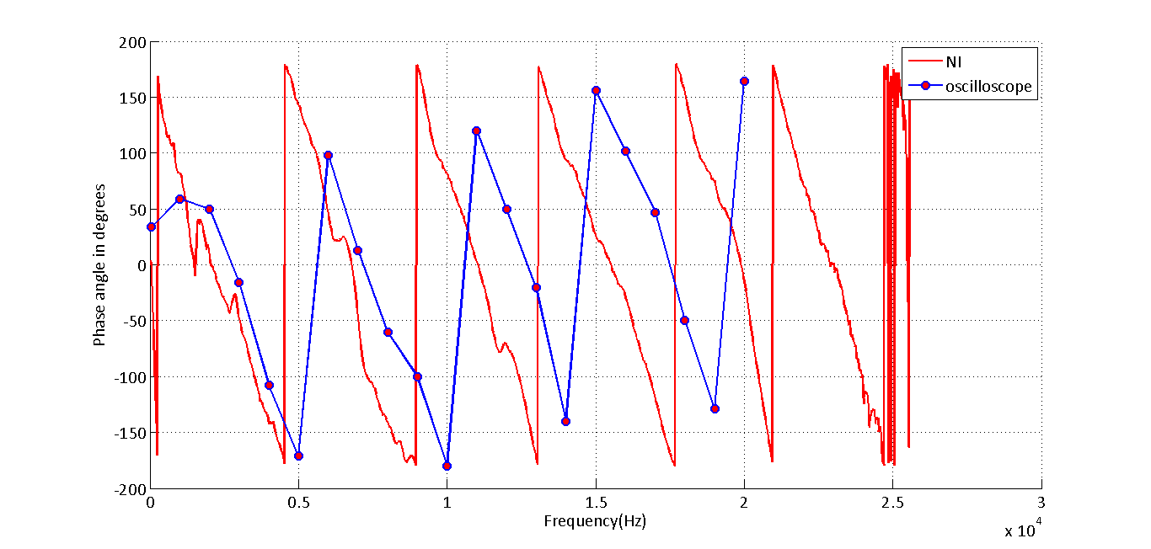

Figure 10 Comparison of phase (low-tone) measured by oscilloscope and NI-system

Phase difference measured by the NI system reveals the phase difference is consistently increasing as the frequency increases. The point of interest, around 2000Hz previously discussed has a depression in the phase difference measurement also. The slope of all the other lines is consistent indicating a linear relationship between frequency and the mutual phase. The pattern of wrapped phase generated by the oscilloscope is close to that generated by NI system. However, NI system has a lag in terms of the frequency it measures, when compared to the phases measured by the oscilloscope. It is evident that from the figure that a particular frequency occurs at a lower value of frequency when measured by the NI system, compared to the oscilloscope measurement. It is also evident from figure 10 that the maximum value of phase denoted by oscilloscope is much lower when compared to the phase denoted by the oscilloscope.

Similar analysis is repeated for high-tone data and the results are plotted in figure 11.

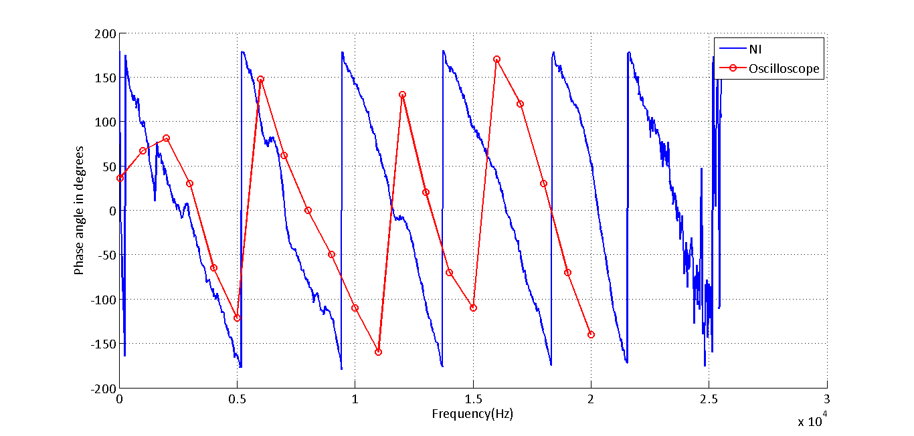

Figure 11 Comparison of phase (high-tone) measured by oscilloscope and NI-system

Similar results repeat even in the case of high tone data. When data measured NI-system for high-tone and low-tone are compared, it is evident that there is not much of a difference in terms of mutual phase. Anti-alias filter effects are prominent in this case as frequencies closer to Nyquist have high variance. Phase measured by NI system is more consistent even in this case and possesses a linear characteristic.

In order to analyze the depression at point of interest, coherence plots and FRFs plots have been plotted in figures 12 and 13 for low tone and high tone respectively.

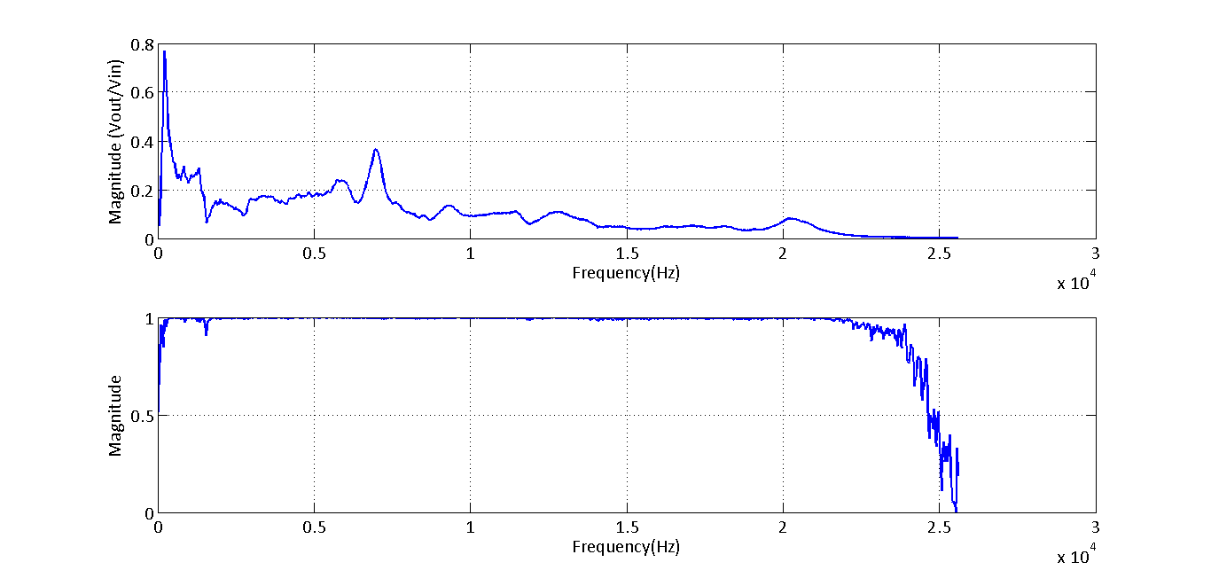

Figure 12 Comparison of FRF (top) and coherence (bottom) plots at low tone

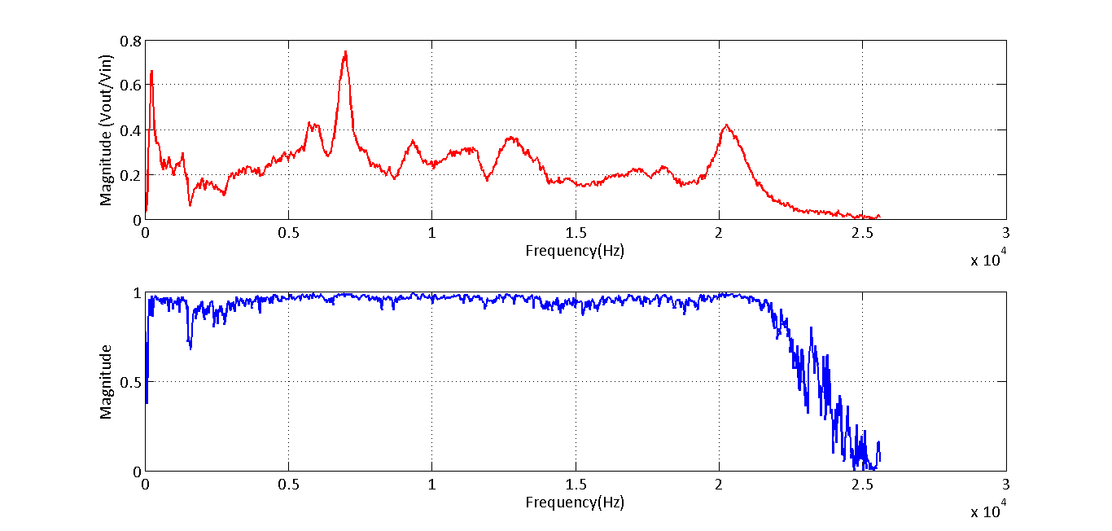

Figure 13 Comparison of FRF (top) and coherence (bottom) plots at high tone

It is evident from these plots that, the dip is prevalent in all the plots irrespective of the tone and magnitude of fall is higher in case of high-tone data. This can be considered as anti-resonance frequency. The frequency at which the dip occurs is around **1500Hz**. Coherence plots also denote that the variance is higher in case of high tone.

Amplifier only signal

By referring to figure 14, it is evident that FRF of amplifier only configuration is smooth when compared to measurement made at different frequencies. Speaker-mic configuration responds differently to different frequencies. In case of amplifier only signal, the response is linear at almost all frequencies. On referring to the specifications of similar devices on PCB’s web-page, it is mentioned that the tolerance limit on micro-phones changes for different frequencies. For example, a tolerance of +/-2dB from 0-10kHz and +/-5dB from 10-20kHz. A similar relationship exists even for the phase and hence figure 15. This is definitely one of the contributing factors for non linearity in the signal measured by the amplifier. Similar non-linearity can be assumed to be present even in the speaker which would introduce more variation. Also from XTS-140s manual it’s found that it has an impedance of 8-ohms and an FRF range of 170Hz-20kHz. Though FRFs range is not an issue, impedance is an issue and reduces the gain by a considerable proportion. It also specifies a 0.05% harmonic distortion. Harmonic distortion is a direct measure of inability to generate a wave. This is one of contributing factors for speaker’s non-linearity.

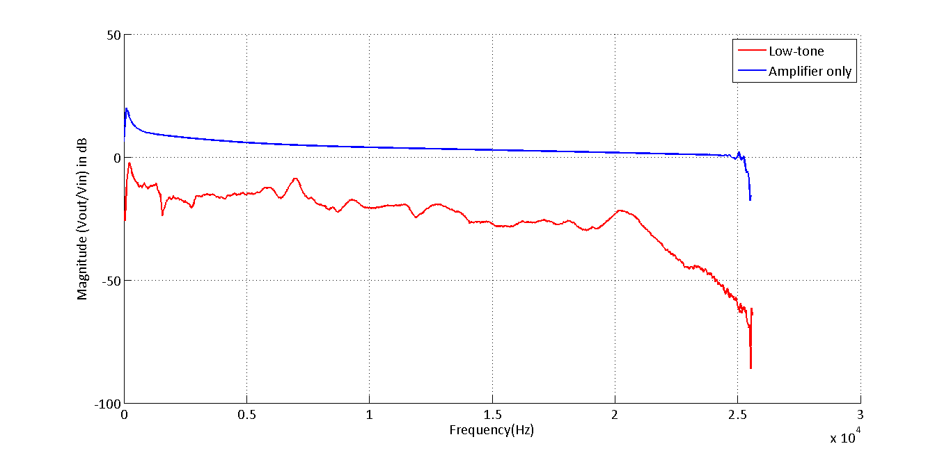

Figure 14 Comparison of FRFs low-tone and amplifier only configuration

Figure 15 represents an overlay of mutual phase difference between low-tone and amp-only configuration.

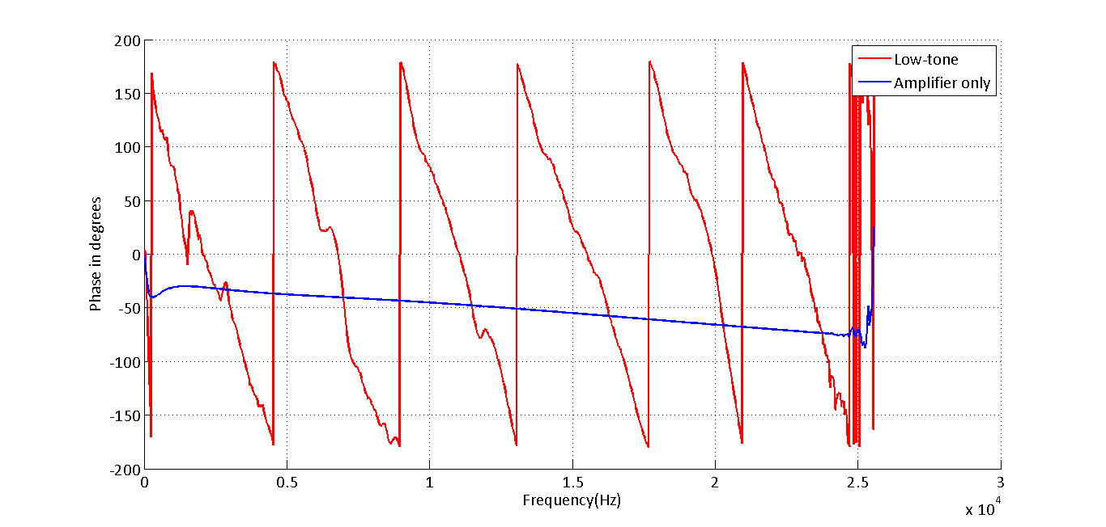

Figure 15 Comparison of mutual phase low-tone and amplifier only configuration

It can be seen that though phase-lag is high in the case of speaker-mic configuration when compared to amp-only configuration. This can be attributed to the physical characteristics of the speaker mic configuration .

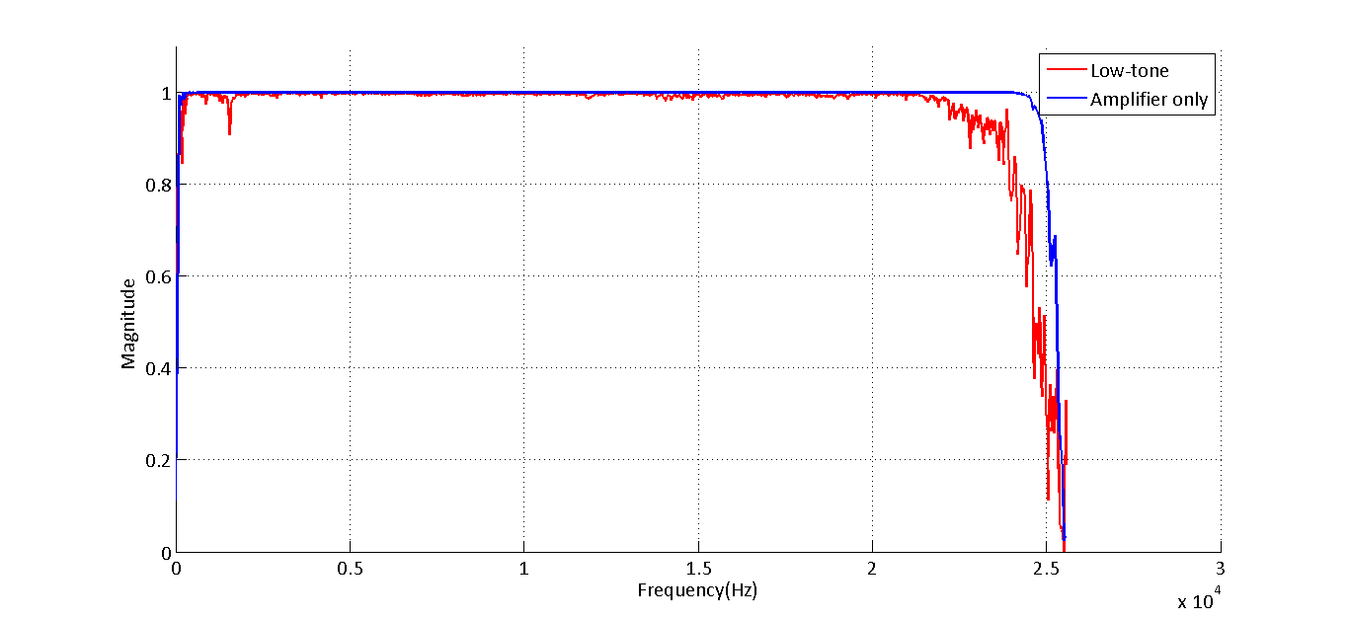

Figure 16 Comparison of coherence low-tone and amplifier only configuration

Figure 16 represents coherence of amp-only signal plotted against coherence of low-tone signal. Amp-only has an ideal coherence of 1 exhibiting perfect correlation between the signals. However, low-tone signal has a small variation, which can be explained due to non-linearity due to reason discussed above.

Figure 17 denotes FRF measurements made by NI system overlaid on top of H1 and H2 formulations programmed in MATLAB

Figure 17 H1, H2 programmed in matlab when compared to NI data - low-tone. Figures from top to bottom represent plots zoomed in to different levels

As the first plot demonstrates, it is difficult to visually detect any differences between Matlab’s H1 formulation and NI’s FRF which is also a H1 formulation. When further zoomed into a peak, differences between H1 and H2 formulations can noticed. As theorized by H1, H2 formulations for data with noise, H1 is biased low and H2 is biased high. This can be clearly noticed at peaks and valleys where H2 is above H1 at peaks and at valleys H1 is below H2. When further zoomed into, differences between NI and H1 formulation can be noticed. The difference is clearly not significant and matlab’s H1 formulations can be deemed reliable.

Plots denoted by figure 17 are similar to the plots presented in the previous case, but for high-tone data.

Figure 18 H1, H2 programmed in matlab when compared to NI data - low-tone. Figures from top to bottom represent plots zoomed in to different levels

These plots have similar features when compared to plots demonstrated in previous case. H2 formulation is biased high, H1 formulation, biased low, as denoted by the second plot. Zooming in further reveals that there is a small difference even in this case but the difference is insignificant.

Figure 19 compares coherence measured by NI system to that of coherence obtained by programming in matlab. It denotes low-tone coherence

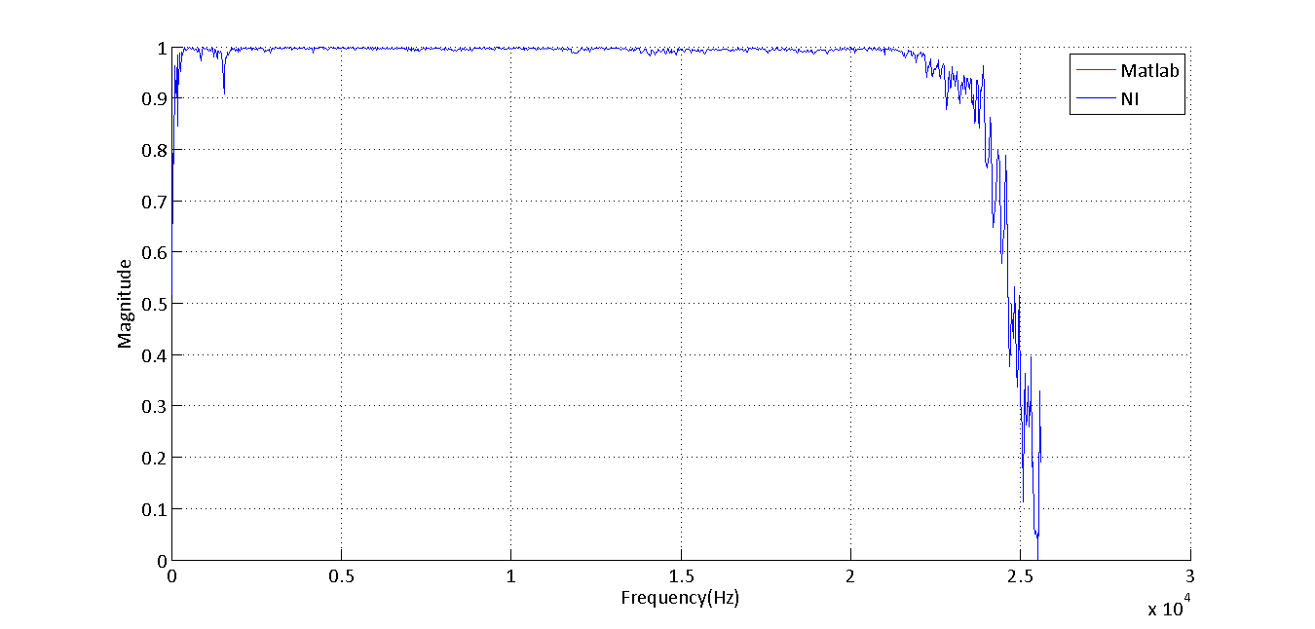

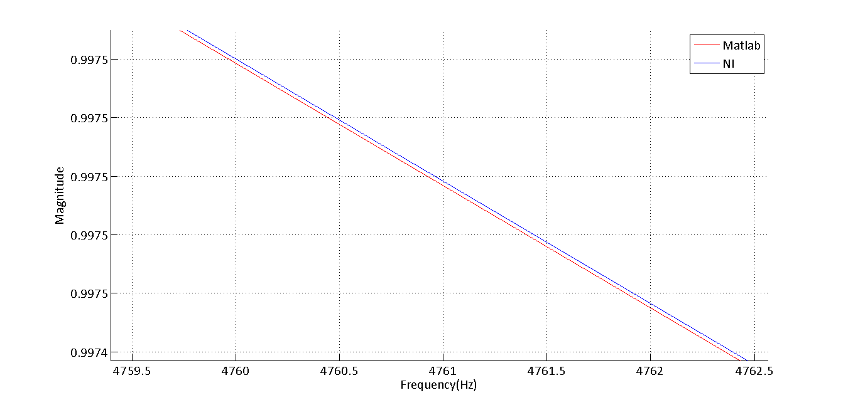

Figure 19 Coherence programmed in matlab when compared to NI data – low-tone. Figures from top to bottom represent plots zoomed in to different levels

The first figure demonstrates that it is not possible to tell the two measurements apart. However, high level of zooming in reveals an insignicant lag in the measurement made by matlab. It is evident that matlab plotting is incapable displaying the differences at such a level of zooming in, as the values on y-axis are constant.

Figure 20 is plotted for high-tone data

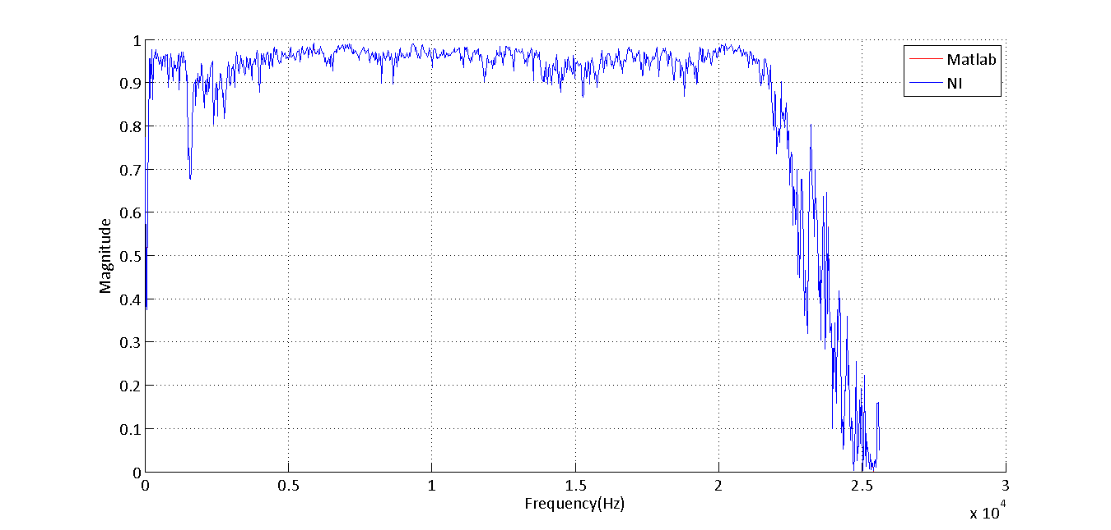

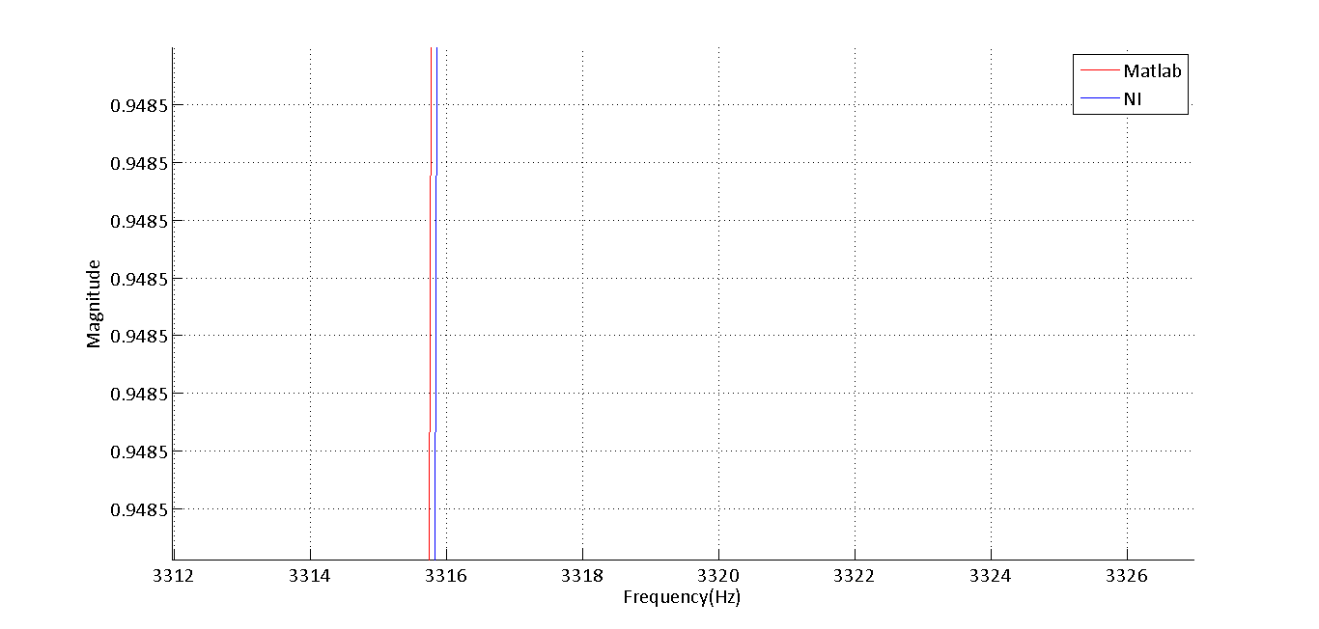

Figure 20 Coherence programmed in matlab when compared to NI data - low-tone. Figures from top to bottom represent plots zoomed in to different levels

These plots have similar features when compared to plots in the previous case and the difference between the plots is insignificant. Even in this case, there is an insignificant lag in matlab generated data.

**Summary and conclusions:**

One of the important conclusions that can be made is that frequency domain measurements exhibit high variance as they approach Nyquist frequency. It can also be concluded that, for this experiment, H1 is a better estimate of FRF when compared to H2; as the signal has noise on the response channel. It can also be concluded that phase. From the amp-only experiment, it is evident that response signal acquired over the micro-phone has a phase lag when compared to the signal which is acquired through the speaker which can be attributed to the physical characteristics of the speaker. By analyzing corresponding peaks and valleys in FRF and coherence plots, it is concluded that the speaker microphone configuration has an anti-resonance point at 1500Hz.

**References**

1. S.W.Smith, Digital Signal Processing for scientists and engineers,, Newness, 2003

**Appendix A**

Matlab code used for formulating FRF and coherence

1. H1,H2 and coherence formulation

%Clean and purge%

clc;

clear all;

%Data extraction step%

voltage_source = xlsread('C:\Accost\Mich Tech\Course work\Dynamic Systems and measurements\Lab Assignments\Assignment-4\high tone\time high.xls',1);

voltage_response = xlsread('C:\Accost\Mich Tech\Course work\Dynamic Systems and measurements\Lab Assignments\Assignment-4\high tone\time high.xls',2);

%Creating the matrices

source_mat = reshape(voltage_source(1:61440,2),2048,30);

res_mat = reshape(voltage_response(1:61440,2),2048,30);

%Applying windows

hanning_mat = repmat(hann(2048),1,30);

ACF = 1/mean(hanning_mat(:,1));

ECF = 1/rms(hanning_mat(:,1));

source_mat_w = source_mat.*hanning_mat;

res_mat_w = res_mat.*hanning_mat;

%Performing ffts on the matrices%

source_fft = fft_function(source_mat_w);

res_fft = fft_function(res_mat_w);

auto_source = mean((conj(source_fft).*source_fft),2);

auto_res = mean((conj(res_fft).*res_fft),2);

cross_response_source = mean((((conj(res_fft).*source_fft))),2);

cross_source_response = mean((((conj(source_fft).*res_fft))),2);

coherence = (cross_source_response.*cross_response_source)./(auto_source.*auto_res);

H1 = cross_response_source./auto_source;

H2 = auto_res./cross_response_source;

frequency_axis = (51200/2)*linspace(0,1,2048/2);

%

hold on

plot(frequency_axis,20*log10(abs(H1)));

plot(frequency_axis,20*log10(abs(H2)),'-g');

fft_function.m

function [ output_mat ] = fft_function( input_mat )

%UNTITLED2 Summary of this function goes here

% Detailed explanation goes here

N = size(input_mat);

ECF = 1/rms(hann(N(1)))

N(1)

fft_interim = fft(input_mat)./N(1);

output_mat = 2*ECF*((fft_interim(1:N(1)/2,:)));

end

rms_function.m

function [ out ] = rms( in )

%UNTITLED4 Summary of this function goes here

% Detailed explanation goes here

sum = in.^2;

out = sqrt(mean(sum));

end

Code used for plotting and comparison

% FRF plots

FRF_high = xlsread('C:\Accost\Mich Tech\Course work\Dynamic Systems and measurements\Lab Assignments\Assignment-4\high tone 13 oct\FRF high.xls');

FRF_low = xlsread('C:\Accost\Mich Tech\Course work\Dynamic Systems and measurements\Lab Assignments\Assignment-4\new data 13 oct\FRF low.xlsx');

hold on

subplot(2,1,1)

pl1 = plot(frequency_axis,(FRF_high(:,2)),'r');

pl2 = plot(frequency_axis,(FRF_low(:,2)),'r');

legend('FRF high-tone','FRF low tone')

set(gca, 'fontname', 'Calibri', 'fontsize', 16);

set(pl1,'linewidth',2)

set(pl2,'linewidth',2)

xlabel('Frequency(Hz)')

ylabel('Magnitude in dB')

legend('H1','H2','NI')

grid

% Phase plots

phase_high = xlsread('C:\Accost\Mich Tech\Course work\Dynamic Systems and measurements\Lab Assignments\Assignment-4\high tone\phase high.xls');

phase_low = xlsread('C:\Accost\Mich Tech\Course work\Dynamic Systems and measurements\Lab Assignments\Assignment-4\low tone\phase low.xlsx');

hold on

pl1 = plot(phase_high(:,1),(phase_high(:,2)));

pl2 = plot(phase_low(:,1),(phase_low(:,2)),'r');

legend('phase high-tone','phase low tone')

set(gca, 'fontname', 'Calibri', 'fontsize', 16);

set(pl1,'linewidth',2)

set(pl2,'linewidth',2)

xlabel('Frequency(Hz)')

ylabel('Phase in degrees')

legend('low tone','high tone')

grid

% Coherence plots

coherence_high = xlsread('C:\Accost\Mich Tech\Course work\Dynamic Systems and measurements\Lab Assignments\Assignment-4\high tone\coherence high.xls');

coherence_low = xlsread('C:\Accost\Mich Tech\Course work\Dynamic Systems and measurements\Lab Assignments\Assignment-4\low tone\coherence low.xlsx');

hold on

subplot(2,1,2)

co1 = plot(frequency_axis,(coherence_high(:,2)));

co2 = plot(frequency_axis,(coherence_low(:,2)),'b');

legend('phase high-tone','phase low tone')

set(gca, 'fontname', 'Calibri', 'fontsize', 16);

set(co1,'linewidth',2)

set(co2,'linewidth',2)

xlabel('Frequency(Hz)')

ylabel('Magnitude')

legend('Matlab','NI')

grid

legend('H1','H2','NI')

coherence_actual = xlsread('C:\Accost\Mich Tech\Course work\Dynamic Systems and measurements\Lab Assignments\Assignment-4\high tone\coherence high.xls');

plot(frequency_axis,(coherence),'-r')

plot(frequency_axis,(coherence_actual(:,2)))

FRF_actual = xlsread('C:\Accost\Mich Tech\Course work\Dynamic Systems and measurements\Lab Assignments\Assignment-4\phase_darbha.xlsx');

f_act = plot(FRF_actual(:,1),FRF_actual(:,2));

set(gca, 'fontname', 'Calibri', 'fontsize', 16);

set(pl1,'linewidth',2)

set(f_act,'linewidth',2)

xlabel('Frequency(Hz)')

ylabel('Magnitude in dB')

legend('Low-tone','Amplifier only')

grid

Oscilloscope plots and comparison

%Oscilloscope data

odata_low = xlsread('C:\Accost\Mich Tech\Course work\Dynamic Systems and measurements\Lab Assignments\Assignment-4\Oscilloscope data.xlsx',1);

odata_high = xlsread('C:\Accost\Mich Tech\Course work\Dynamic Systems and measurements\Lab Assignments\Assignment-4\Oscilloscope data.xlsx',2);

%Extracting parameters of interest

frequency_low = odata_low(:,1);

gain_low = 20*log10(odata_low(:,2));

phase_low = (odata_low(:,3));

frequency_high = (odata_high(:,1));

gain_high = 20*log10(odata_high(:,2));

phase_high = odata_high(:,3);

%% Phase plots

for i=1:length(phase_low)

if phase_low(i) < -180

phase_low(i) = 360 + phase_low(i);

elseif phase_low(i) > 180

phase_low(i) = phase_low(i) - 360;

end

end

for i=1:length(phase_low)

if phase_high(i) < -180

phase_high(i) = 360 + phase_high(i);

elseif phase_high(i) > 180

phase_high(i) = phase_high(i) - 360;

end

end

% hold on

% ph1 = plot(frequency_low,-phase_low,'-bo','MarkerFaceColor','r','MarkerSize',8);

ph2 = plot(frequency_high,-phase_high,'-ro','MarkerSize',8);

set(gca, 'fontname', 'Calibri', 'fontsize', 16);

% set(ph1,'linewidth',2)

set(ph2,'linewidth',2)

xlabel('Frequency(Hz)')

ylabel('Phase angle in degrees')

% legend('low tone','high tone')

grid

**End of document**