**Michigan Tech Name: _____________________**

**MEEM/EE 5295 Advanced Propulsion for HEV**

**Student Questionnaire – Survey**

This questionnaire and will help us guide the course instructional activities.

**Educational Background**

What is your educational background?

Insert  
portrait  
here

* Electrical Engineering
* Mechanical Engineering
* Material Science / Engineering
* Chemical Engineering
* Other _____________________________________

The highest degree you have received is:

* BS
* MS
* PhD
* Other _____________________________________

I have taken the following courses (mark all that apply):

* MEEM/EE 4295 Introduction to Propulsion Systems for HEV’s
* MEEM/EE 4296 Introduction to Propulsion Systems for HEV’s Laboratory
* MEEM 5990 Advance Propulsion for HEV (Semester ____________)

Are you currently taking the lab class MEEM/EE 5296?

* Yes
* No

Are you in the HEV Enterprise?

* Yes, If yes in what capacity / area _____________________________________
* No

Have you or are you now involved in other enterprises?

* Yes, If yes in what enterprise(s) and when _____________________________________
* No

How many semesters of thermodynamics have you had?

* 0 or don’t recall
* Included as part of a physics course
* 1
* 2
* More than 2

How many semesters of controls and other related course material have you had?

* 0 or don’t recall
* Included as part of another course
* 1
* 2
* More than 2

How many semesters of circuits have you had?

* 0 or don’t recall
* Included as part of a physics course
* 1
* 2
* More than 2

How many semesters of E-Machines and/or power electronics have you had?

* 0 or don’t recall
* Included as part of another course
* 1
* 2
* More than 2

How many semesters of batteries or other related course material have you had?

* 0 or don’t recall
* Included as part of another course
* 1
* 2
* More than 2

How many semesters of IC Engines have you had?

* 0 or don’t recall
* Included as part of a thermodynamics or other course
* 1
* 2
* More than 2

**Experience and Work Background**

What best represents your current or most recent position?

* Undergraduate Student
* Graduate Student
* Work in Strategy Development (Area ____________)
* Work in Software Development (Area ____________)
* Work in Calibration (Area ____________)
* Work in Validation (Area ____________)
* Work in Research (Area ____________)
* Work in Program Management (Area ____________)
* Other ____________________________________

If you are involved hybrid development, what subsystem are you involved in?

* Not involved / Not Applicable
* Vehicle
* Batteries
* Powertrain
* E-Machines
* Other __________________________

What programming languages have you worked in (mark all that apply)?

* Assembly
* C
* Fortran
* Basic
* MathWorks (Matlab/Simulink)
* Other ___________________________________?

What is your experience level in MathWork’s Matlab?

* Have not used
* Limited
* Moderate Experience
* Expert

What is your experience level in MathWork’s Simulink?

* Have not used
* Limited
* Moderate Experience
* Expert

Do you have access to MathWorks Matlab/Simulink software (Mark all that apply)?

* No
* Yes at school
* Yes at work
* Yes at home

**General questions on modeling and HEV’s**

Given the following equation:

$$\ddot{x}+b\dot{x}+cx=f(t)$$

Did you recognize this as a second-order, ordinary linear differential equation in x?

* + Yes
  + No

Could you solve the homogeneous equation analytically?

* + Yes
  + Yes with a bit of review
  + Not without significant review or instruction

Could you solve the equation numerically?

* + Yes
  + Yes with a bit of review
  + Not without significant review or instruction

Could you write the transfer function for this?

* + Yes
  + Yes with a bit of review
  + Not without significant review or instruction

Could you write this in state-space notation?

* + Yes
  + Yes with a bit of review
  + Not without significant review or instruction

Could you solve the equation in Simulink?

* + Yes
  + Yes with a bit of review
  + Not without significant review or instruction

What additional information is needed in addition to *b*, *c* and f(t) to solve this initial value problem? ___________________________________________________________________

The powertrain below is an example of what type (architecture) of hybrid? ____________________

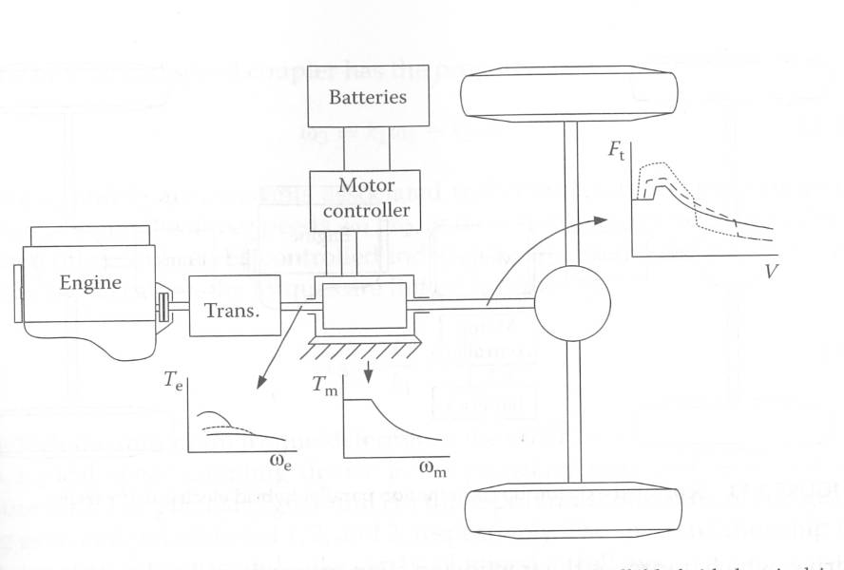

For an IC Engine BSFC stands for what? ______________________

For a battery what does SOC stand for? ______________________

In a hybrid such as the Toyota Prius what fraction   
of the energy originally comes from the battery? _______________________________

In the following equation for the drag force on a vehicle, Cd is the _______________________________, and a typical value or range for a light duty vehicle would be ______ to ________.



**Course Expectations**

What are your expectations from this course?

List two specific learning objectives you would like to satisfy as an outcome of this course?

(1)

(2)

How many hours per week outside of class do you expect to commit to this course ___________.

Please provide additional input to assist in delivering the course and team generation.

What is your favorite interest outside of work/school (*optional*).