***Internal Combustion Engines – Cycles, Work, Torque and Power***

***Assignment – 8 (22nd Mar 2013)***



***Arjun Darbha***

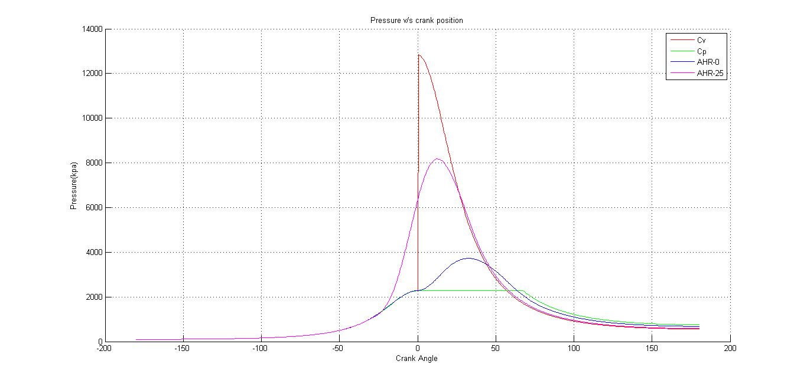

Figure 1 Graph indicating variation in Pressure with respect to change in Crank Angle for four different cycles for Compression and Expansion strokes

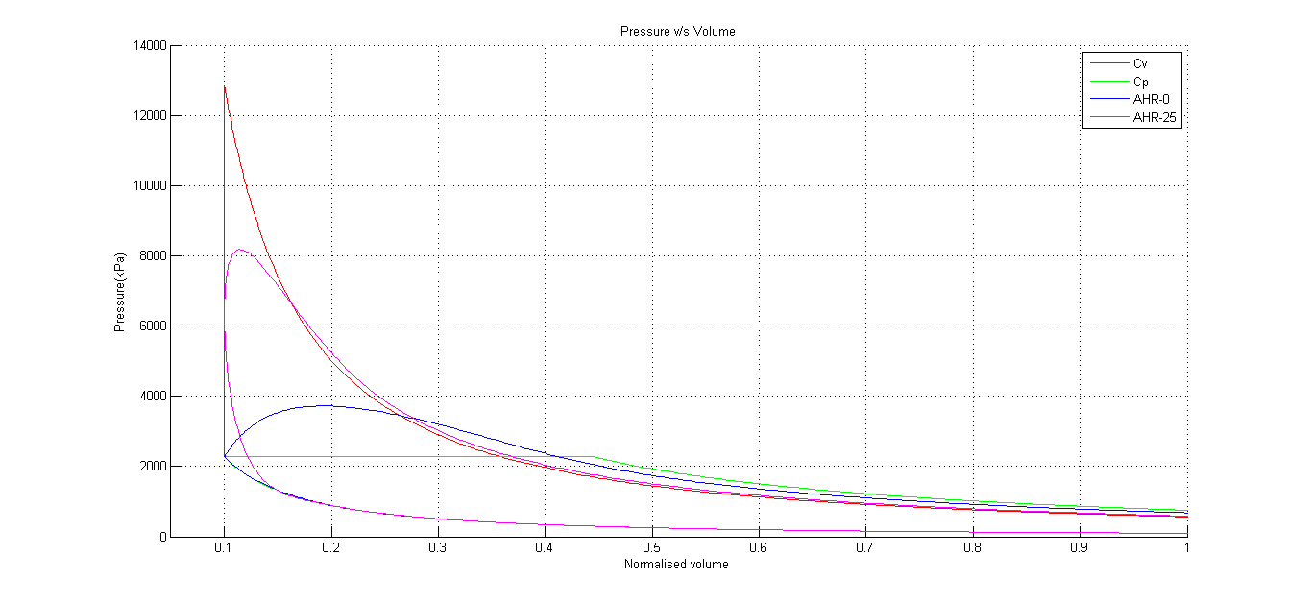

Figure 2 Graph indicating variation in Pressure with respect to change in normalized Volume for four different cycles

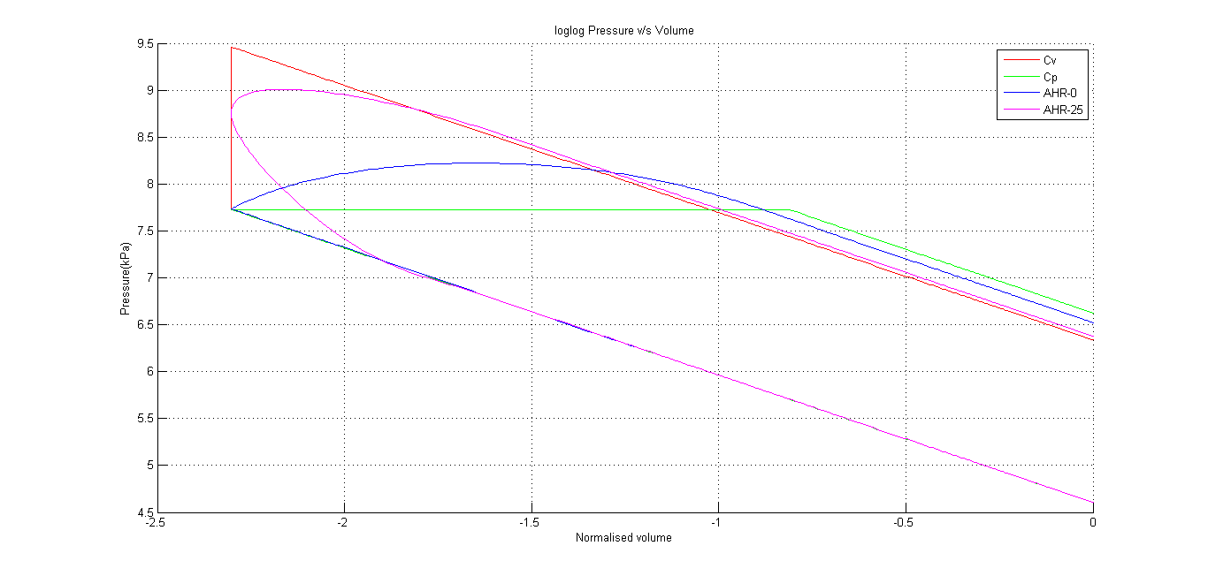

Figure 3 log-log plot representing variation in P with respect to change in Volume (normalized)

**Conclusions**

* From Fig.1 it can be concluded that maximum pressure developed within a cylinder is greater in the case of Constant Volume cycle
* This fact is also justified by Fig.2. Also, since Work done is the closed integral of Pdv which means the area of the PV diagram of a particular cycle represents work done. It can be clearly concluded that Work done in the case of Constant Volume combustion is the highest
* This can appreciated more comprehensively from Fig.3 where a log-log plot of P v/s V demonstrates the work done in terms of area of the plot. It can be clearly seen that Constant Volume produces maximum work while constant pressure produces least work, the other cycles producing intermediate values

Table 1 Engine parameters calculated for different types of combustion

|  |  |  |  |  |  |
| --- | --- | --- | --- | --- | --- |
| **Cycle** | **Work/cycle(kJ)** | **Average Torque/cycle (kN-m)** | **IMEP(bar)** | **Power(hp)** | **Efficiency** |
| Cv | 0.90 | 0.072 | 19 | 121 | 0.56 |
| Cp | 0.61 | 0.049 | 13 | 82 | 0.38 |
| AHR-0 | 0.73 | 0.058 | 15 | 97 | 0.45 |
| AHR-10 | 0.79 | 0.063 | 16 | 106 | 0.49 |
| AHR-20 | 0.84 | 0.067 | 18 | 113 | 0.53 |
| AHR-25 | 0.86 | 0.068 | 18 | 115 | 0.53 |
| AHR-30 | 0.87 | 0.069 | 18 | 116 | 0.54 |
| AHR-35 | 0.86 | 0.069 | 18 | 116 | 0.54 |
| AHR-40 | 0.86 | 0.068 | 18 | 115 | 0.53 |

**Conclusions**

* This table summarizes the conclusions from the plots in previous activities and provides justification in terms of numbers
* For a given heat input, constant volume generates maximum work/cycle, torque/cycle, and efficiency. Consequently it has the highest IMEP numbers and also power generated
* The corresponding values are lowest in the case of Constant Pressure Combustion
* Apparent heat release(AHR) for ignition timing of 30 and 35 seconds seem to be as efficient as Cv and Cp processes
* It can also be seen that all the columns are related to efficiency. Hence, for two combustion events, is any of the column values are known, the one with higher number can be concluded to posses maximum efficiency

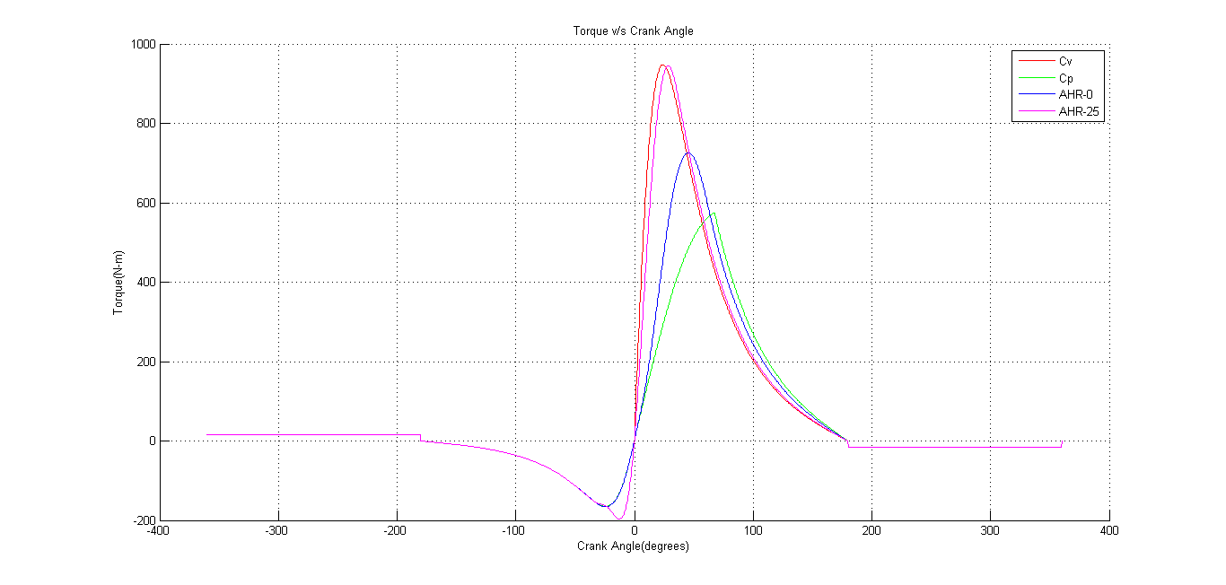

Figure 4 Graph indicating cylinder Torque with respect to crank position for various cycles

**Conclusions**

* It can be seen that on the negative side almost all the cycles have similar instantaneous torques while on the positive, where it actually matters, Cv has the highest instantaneous torque
* It can also be seen that AHR with ignition timing of 25 sec closely mimics Cp but also has the lowest instantaneous torque
* Cp has the lowest value of instantaneous torque