*MEEM5295*

*Assignment 09*

Behavior and Modeling Batteries in Series and Parallel

*Arjun Sai Santosh Darbha*

*Akshay Kolte*

*Brittany Voshol*

*Ke Xu*



**Modeling Two Cells in Series**

In order to model two cells in series, the governing equation that relate two cells in series must first be determined. In Figure 1, a diagram of cells in series is shown.

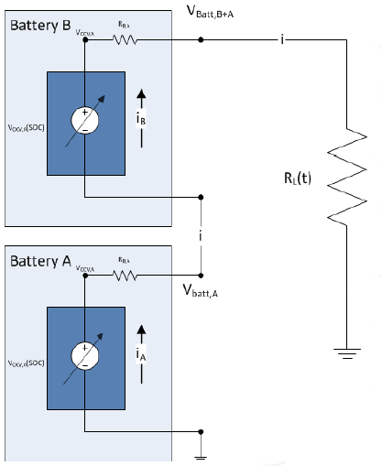

Figure 1 - Batteries in Series

Analyzing this circuit with Kirchoff's voltage and current laws allows for the following governing equations to be determined:

$$i=\frac{V_{OCV,A}+V_{OCV,B}}{R_{A}+R_{B}+R_{L}}$$

$$V_{L}=V_{A}+V_{B}$$

This is the governing equation for the series model and can be used to determine the current values in the circuit.

The model for two cells in series is shown in Appendix A. This model solves the governing equation derived above in Simulink . For the model,as the current for the cell is an input and an output, a delay was used in order to allow for the model to be functional.The series model for identical batteries condition was simulated using the parameters as mentioned in Table 1. and the results of this simulation are shown in the subsequent Figure 2.

Table 1 - Values for Identical series cells model

|  |  |  |
| --- | --- | --- |
|  | Capacity (Ah) | Battery Resistance (Ohm) |
| Battery A | 1 | 0.01 |
| Battery B | 1 | 0.01 |

C:\Users\akshay_kolte\Desktop\New Graphs\Figure2.emf

Figure 2 – Voltage, Current, and SOC for identical series cells

When the battery conditions are identical, the voltages of battery A and B overlap each other. Also the current drawn from both the batteries is same at all times. Both the batteries have the same discharge time and attain the lowest SOC at the same time.

**Impact of Reduced Capacity of Cell in Series**

For reduced capacitance in the case of series batteries, the capacitance of battery A was reduced to 0.5 Ah, other parameter being same. These parameters are in Table 2. The results are plotted in Figure 3.

Table 2 - Values for reduced capacity series cells model

|  |  |  |
| --- | --- | --- |
|  | Capacity (Ah) | Battery Resistance (Ohm) |
| Battery A | 0.5 | 0.01 |
| Battery B | 1 | 0.01 |

C:\Users\akshay_kolte\Desktop\New Graphs\Figure3.emf

Figure 3 - Series cells with reduced capacitance

Reduction in capacitance reduces the amount of energy that can be stored n a cell. It can be seen from the figure that at about 220 seconds, the SOC of battery A.This is a direct result of its reduced capacitance.The reduction in SOC causes the voltage of battery A to drop down. When this happens, the overall voltage of the system drops from 8.4V to 4.2V. Eventually at about 750s, when the battery B SOC drops down to about zero the voltage of the entire system drops down to zero.This being a series model, current is a direct function of voltage, as the resistances remain constant. Hence, the plots denoting voltage of the system and current assume a similar character.

Figure 4 indicates the impact of reduced capacitance on voltage characteristic.

C:\Users\akshay_kolte\Desktop\New Graphs\Figure4.emf

Figure 4 - Reduced capacitance voltage comparison

When the capacity of A is reduced, since the current drawn though it is the same, it discharges at a faster rate.As the SOC of battery A drops, the current delivered by it also reduces. This results in the reduction of current through the entire circuit. After this point, since the current in the circuit decreases, battery B is able to sustain itself for a longer period of time.Hence its voltage falls to a minimum value at a later time.

Figure 5 shows the relationship of current with a reduced capacity cell, compared to identical cells.

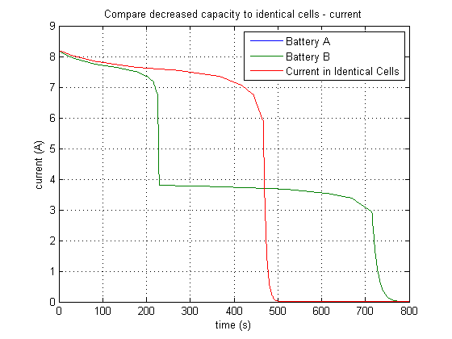

Figure 5 - Reduced capacitance current comparison

From Figure 5 it can be observed that in the case of identical cells, the a single current drop occurs at approximately 500 sec. However in case of reduced capacitance cell, the current has two drops, the first one occurring at approximately 220 seconds followed by a second drop at 720 seconds. These variations in the currents can be explained by decrease in the SOC of the individual battery cells. When the battery A runs out of charge, the current passing throughout the circuit decreases and is drawn majorly from battery B. Eventually when the battery B runs out, the overall current falls down to zero.

Finally, Figure 6 compares the SOC of a reduced capacity cell with identical cells.

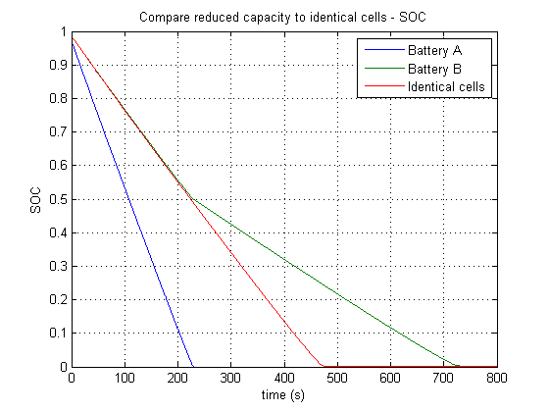

Figure 6 - Reduced capacitance SOC comparison

With the reduced capacity to store energy, battery A SOC drops down to zero quicker as compared to ideal case. With reduced overall current in the circuit, battery B lasts longer and reaches zero SOC much later in comparison to the ideal condition.

**Impact of Increased Battery Resistance in Series**

For increased resistance in the case of series batteries, the resistance of battery A was increased to 0.1 Ohm, other parameter being same as seen in Table 3. The results are plotted in Figure 7.

Table 3 - Values for increased resistance series cells model

|  |  |  |
| --- | --- | --- |
|  | Capacity (Ah) | Battery Resistance (Ohm) |
| Battery A | 1 | 0.1 |
| Battery B | 1 | 0.01 |

C:\Users\akshay_kolte\Desktop\New Graphs\Figure7.emf

Figure 7 - Series cells with increased resistance of battery A

The first graph in Figure 7 shows the impact of increased resistance on individual battery cell.Due to higher internal resistance, the voltage across battery A drops below 4.2 V. At the same time the total time for SOC to reach zero is higher than in identical cell case. This can be explained by by considering the fact that as the total current drawn through the battery decreases, the capacitance remains the same.Thus the time for which the batter can operate without the SOC reaching zero value increases.

In order to understand the impact that increasing the resistance of a cell has, the comparisons to the identical cell values are in Figure 8, Figure 9, and Figure 10.

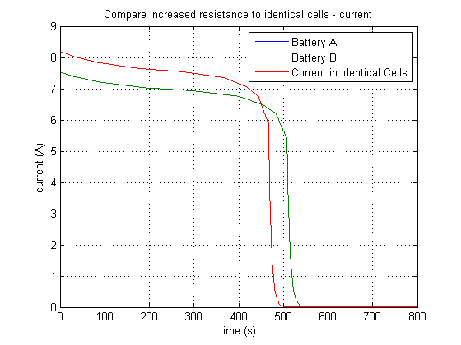

Figure 8 - Increased resistance current comparison

As per the governing equations, the increase in internal resistance of the battery reduces the current that flows through the circuit. This phenomenon is depicted in Figure 8, where the current in the increases resistance case is lower than that in identical batteries case. Also the lower value of current allows the batteries to last longer.

C:\Users\akshay_kolte\Desktop\New Graphs\Figure9.emf

Figure 9 - Increased resistance Voltage comparison

Figure 9 shows the comparison of the voltage of individual batteries in identical batteries and increased resistance models. The Increased internal resistance of battery A, reduces the voltage available across it. As discussed before, it can also be seen that, it takes longer time to totally discharged the batteries.

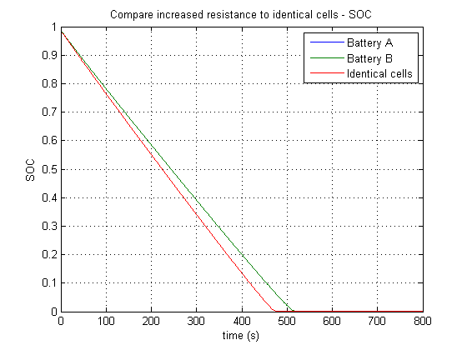

Figure 10 - Increased resistance SOC comparison

Since the increased resistance reduces the current drawn through each battery,the batteries are able to discharge at a slower rate. As a result, the SOC reaches a near zero value at a later time.

**Modeling Two Cells in Parallel**

To model two cells in parallel, like modeling of two cells in series, equations relating the cells need to be determined. Two cells connected in parallel are shown in Figure 11.

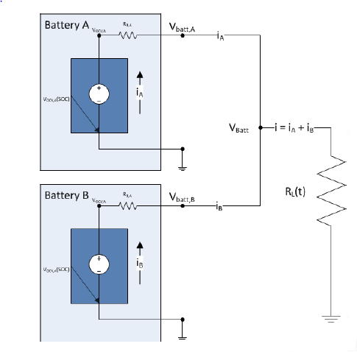

Figure 11 - Two Cells in Parallel

Once again, using Kirchoff's voltage and current laws, the following equations were determined:

$$V_{OCV,A}=(R_{L}+R_{A}{)i}_{A}+R_{L}i_{B}$$

$$V_{OCV,B}=\left(R_{L}\right)i_{A}+\left(R_{L}+R_{B}\right)i_{B}$$

$$i=i_{A}+i_{B}=\frac{V_{Batt}}{R_{L}}$$

Using these equations and the previously mentioned cell model, a model in Simulink could be created. The model used in this discussion was provided. The model can be found in Appendix B.

In the parallel model, the voltage, current, and SOC when both cells are identical are shown in Figure 12. The values of the capacity and battery resistance are in Table 4.

Table 4 - Values for Identical cell test

|  |  |  |
| --- | --- | --- |
|  | Capacity (Ah) | Battery Resistance (Ohm) |
| Battery A | 1 | 0.01 |
| Battery B | 1 | 0.01 |

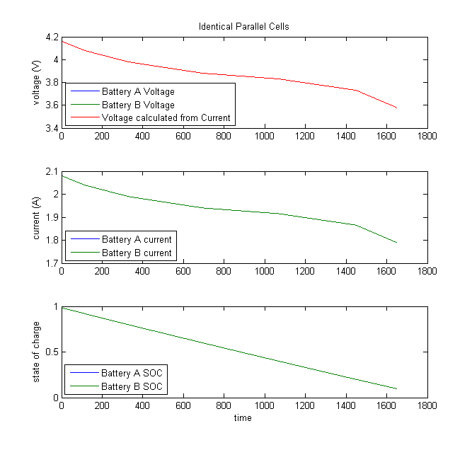

Figure 12 - Voltage, Current, and SOC for identical parallel cells

**Impact of Reduced Capacity of Cell in Parallel**

When the capacity of one cell is reduced, the results are shown in Figure 13. The values for each cell are shown in Table 5.

Table 5 - Values for Reduced Capacity

|  |  |  |
| --- | --- | --- |
|  | Capacity (Ah) | Battery Resistance (Ohm) |
| Battery A | 0.5 | 0.01 |
| Battery B | 1 | 0.01 |

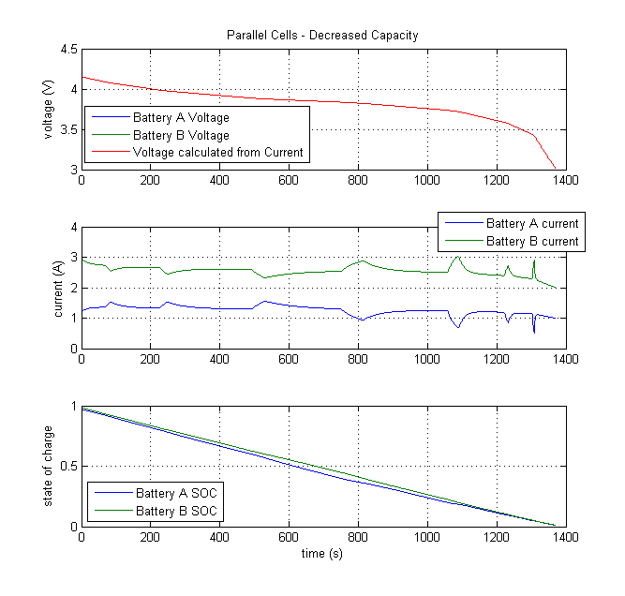

Figure 13 - Parallel cells, battery A capacity 0.5 Ah, battery B capacity 1 Ah

An important change that can be seen is that the time it taken by the state of charge to go down to zero. It is approximately 280 seconds faster in case of reduced capacity model. This is to be expected as the reduction in capacitance reduced the available energy in the battery. The voltage values are very similar, but slightly less than the identical cells. This again is the direct result of the reduced capacitance. The individual voltage of battery A and B are identical since they are connected in parallel.

The comparisons of the voltage to the identical cell voltage can be seen in Figure 14.

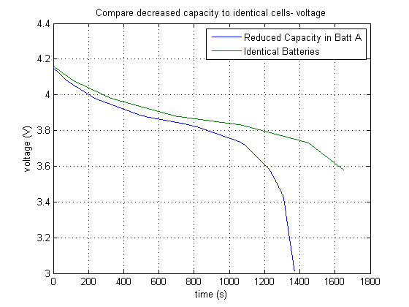

Figure 14 - Voltage of Reduced capacity in battery A compared to identical cells

The values of the voltage for the parallel system with reduced capacitance are close to that in identical cell case up till a certain time. It begins to deviate from the identical case when its SOC reaches lower and lower values. And finally, it reaches the lowest point at nearly 1400 seconds.

A plot showing the change current is in Figure 15.

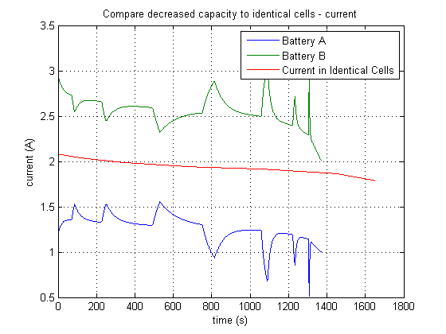

Figure 15 - Comparison of Reduced capacity in Battery A with identical cells

The current is shown as jagged, however that jagged form is a Simulink solver issue rather than an accurate representation of what actually would happen. However, it is quite clear that the current of battery A is lower than before and the current of battery B is higher.

The comparison of the SOC levels is shown in Figure 16.

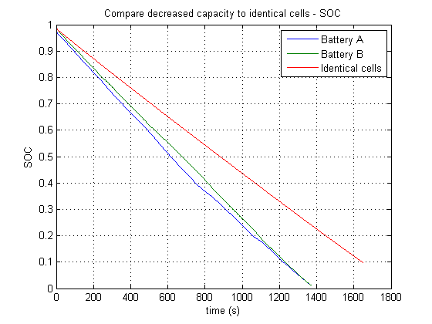

Figure 16 - SOC comparison of reduced capacity and identical cells

Finally, it can be seen that the SOC of each battery is slightly different. Generally, due to the reduction of capacitance, the SOC of battery A is less than that of battery B. Also, the rate of change of the SOC is less in the reduced capacity model opposed to that of the model with identical cells.

**Impact of Increased Battery Resistance in Parallel**

The resistance of battery A was greatly increased and set a 0.1 Ohm. The results of this are shown in Figure 17. The values for the cells are shown in Table 6.

Table 6 - Values for Increased Resistance

|  |  |  |
| --- | --- | --- |
|  | Capacity (Ah) | Battery Resistance (Ohm) |
| Battery A | 1 | 0.1 |
| Battery B | 1 | 0.01 |

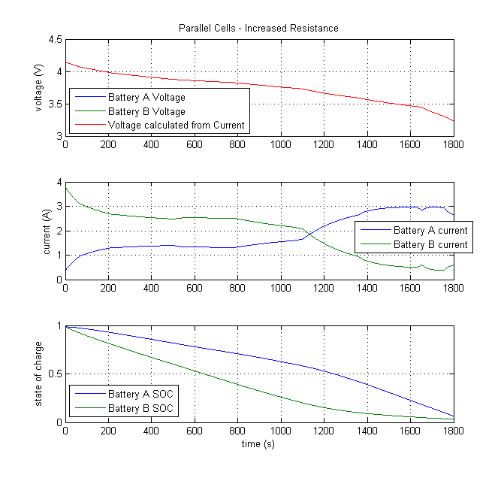

Figure 17 - Parallel Cells with increased resistance of Battery A

Once again, plots comparing the identical cell model with the increased resistance cell model are plotted in Figure 18, Figure 19, and Figure 20.

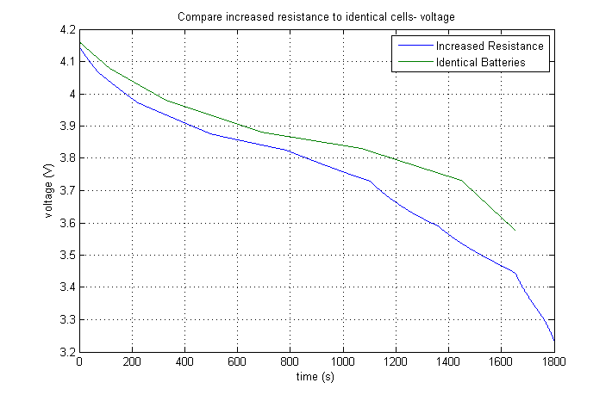

Figure 18 - Increased Resistance voltage comparison

It can be seen that increased internal resistance model shows lower voltage values than that in two identical cells. That is because with the increase in inner resistance, the output voltage of the battery reduces. Also, it is worth noting that the time required for the cells to discharge is more in case of increased resistance model.

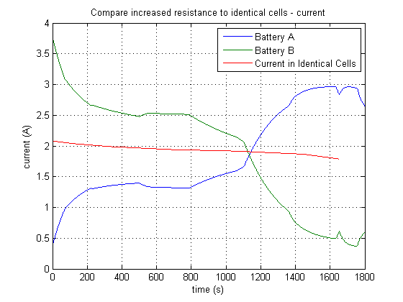

Figure 19 - Increased Resistance current comparison

The current curve for battery A with increased resistance is quite interesting. The currents from the two batteries differ as the current of battery B is higher than the current of battery A. This then trend changes at approximately 1100 seconds and the current of battery A becomes higher than that of battery B. This is because when the voltage of battery A is lower than battery B, battery B generates a compensating current for battery A at the beginning of the simulation as current of battery A continues to increase and current of battery B decreases. And then when the voltage of battery A is higher than battery B, this trend inverses as seen towards the end of the figure.

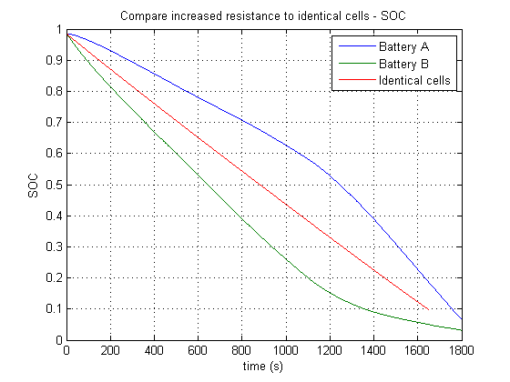

Figure 20 - Increased resistance SOC comparison

Finally, the SOC is slightly different from the identical cells, as seen before. That battery A has a higher SOC than the identical cells is not surprising due to the increased internal resistance. This resistance makes it 'more difficult' for electricity to flow, and the battery will then hold onto its initial charge longer. The SOC of battery B then has to 'make up' for the energy that is not being released by battery A.

**Advantages and Disadvantages of Series and Parallel**

From the previous model results, it can be seen that there are several different advantages and disadvantages for cells in series and parallel.

Parallel configuration has the advantage of increased current for a particular value of voltage. This is because the currents get added to each other before they reach the load. If the cells are connected in parallel their capacity increases. However, if one of the cell fails as a short circuit, other cells try to dump their energy into the cell that has shorted which could lead to heat management problems

Series configuration has the advantage of increased voltage for a particular current. However, the capacitance of the system is reduced when cells are connected in series. Also, the internal resistance of all the cells connected in series increases.

**Detecting a Low Capacity Cell**

The time required for the SOC to drop to its lowest values can be used to identify a low capacity cell.In some of the models, the capacity of one cell was reduced to see how the overall battery would then function. From these runs, we can see how to detect a low capacity cell.

In the parallel model, reducing the capacity resulted in a higher rate of SOC discharge, as well as a lower current, while causing the unaffected cell to have a higher current. In the series model, a much higher rate of SOC discharge as well as a possible sudden drop in current and voltage if a cell is completely depleted is seen. Therefore, in order to detect a low capacity cell, the best way is to detect the rate of SOC discharge and compare with the expected. If it’s lower than expected, there may be a cell that has reduced capacity.

Detecting unusually high or low currents may also be an indication of a cell with reduced capacity - low current in a cell in parallel could indicate a low capacity cell.

**Impact of Low Capacity Cell With Respect to SOC Limits**

A low capacity cell affects the functioning of a battery. This can affect the SOC limits of the battery.

This is particularly relevant for cells connected in series. When a low capacity cell is connected in series, the SOC of the low capacity cell rapidly decreases (see Figure 6). At the point when the SOC of cell A is zero, the SOC of cell B is about 50%, this means that, in order to not damage cell A by completely draining it, the SOC of cell B must stay above 50%. This does not allow for the energy stored in cell B to be used.

**Compensating for Low Capacity Cell**

Because we know low capacity cells increase the rate of SOC discharge, in order to compensate for a low capacity cell, the reverse effects must be induced. This can be done by increasing the resistance of the cell that has a low capacity. It’s seen that through raising the resistance on a cell, the SOC discharge rate decreases (see Figure 10 and Figure 20). If variable resistances could be controlled in order to reduce the effects of a low capacity cell, the SOC discharge rate could be returned to typical and the battery would function more as expected.

**How A Battery Pack Functions**

Battery packs are usually made up of modules. These modules can be made of individual cells connected in series and modules connected in parallel which is called a Series Cell Module (SCM). Individual cells can be connected in parallel and modules connected in series which is called Parallel Cell Module (PCM). While PCM has the advantage of easy maintenance in case of breakdown of an individual cell as it just requires replacement of a particular module, SCMs give superior performance, higher current ratings for a particular voltage rating. SCMs are also considered unbalanced in the sense that, if either capacity or resistance of any individual cell changes, it has a relatively larger impact on the entire battery when compared to PCMs. In case of PCMs, the differences tend to show an average effect in the battery pack level. Also, PCMs are relatively easier to control in case of failure of individual cells. Most EVs in the market follow a PCM approach because of cost issues as compared to SCMs and ease of control through effective battery management systems. [1]

**Reference :**

[1] Plett, G.,Klien M. J.,"Simulating Battery Packs Comprising Parallel Cell Modules and Series Cell Modules",EVS24,2009

**Appendix A**

This is the model of two cells in series

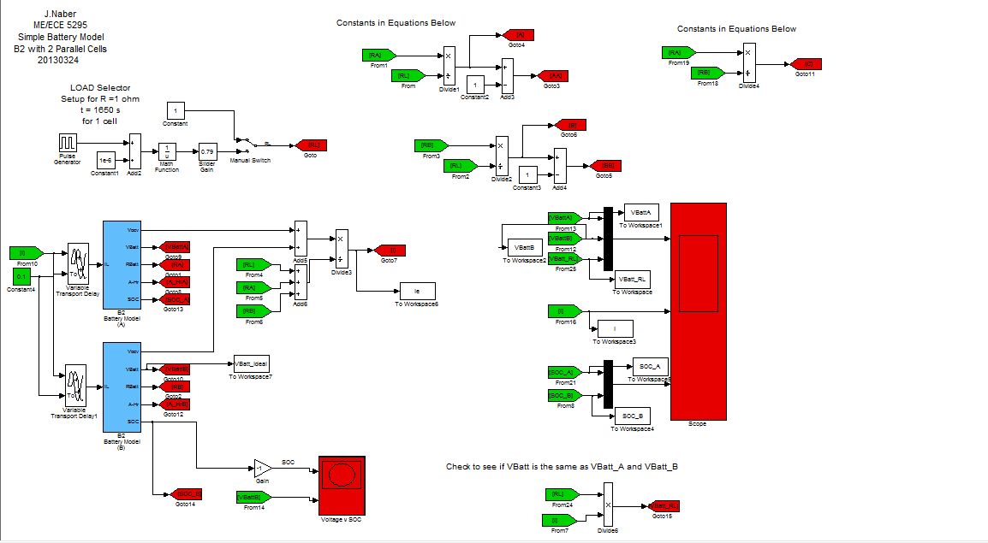

**Appendix B**

This is the model provided of two cells in parallel.

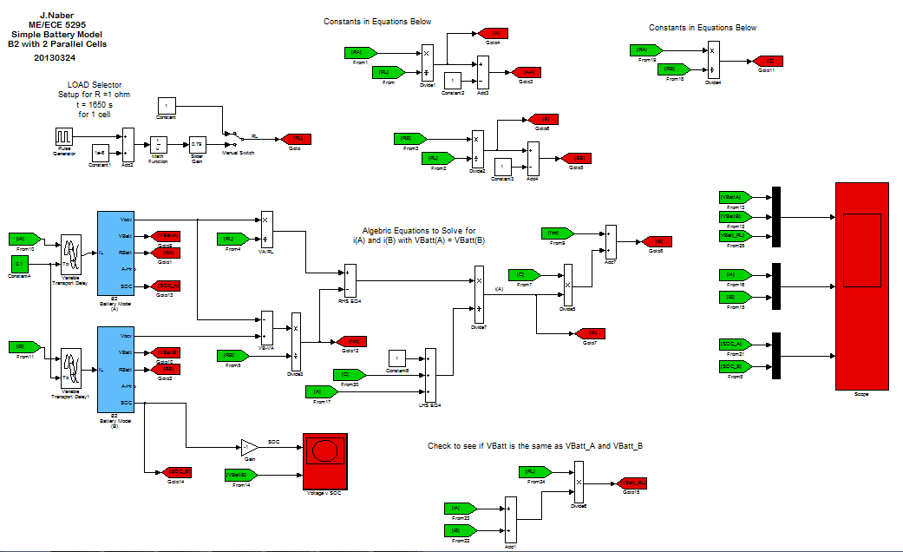

**Evaluation Sheet (Attach to the end of the assignment)**

Students Names

|  |
| --- |
| *Arjun Sai Santosh Darbha* |
| *Akshay Kolte* |
| *Brittany Voshol* |
| *Ke Xu* |

|  |  |  |
| --- | --- | --- |
| **Section/Question** | **Points** | **Score** |
| **Part 1** | 10 |  |
| **Part 2** | 10 |  |
| **Part 3** | 10 |  |
| **Part 4** | 10 |  |
| **Part 5** | 10 |  |
| **Part 6** | 10 |  |
| **Part 7** | 10 |  |
| **Part 8** | 10 |  |
| **Part 9** | 10 |  |
| **Part 10** | 10 |  |
| **Part 11** | 10 |  |
| **Format of figures and discussion** | 10 |  |
| **Total =** | **120** |  |