A report on solution of Laplace equation using Successive Over Relaxation (SOR) approach

*Arjun Darbha*

# 1 Introduction

Laplace equation (Eq.1) is one of the most important equations in engineering. The variable which is solved in Laplace equation can be anything from temperature to velocity, depending on the physics. In this report, Laplace equation is solved for obtaining a stream function (ψ) over the geometry specified in the problem statement

$\frac{∂^{2}ψ}{∂x^{2}}+ \frac{∂^{2}ψ}{∂y^{2}}=0$ Eq.1

Eq.1 is clearly an elliptical equation. This implies that the boundary conditions are necessary to evaluate a solution to this problem, numerically. The boundary conditions are as described in fig.1 which is also presents detailed geometry for which the solution needs to be evaluated.

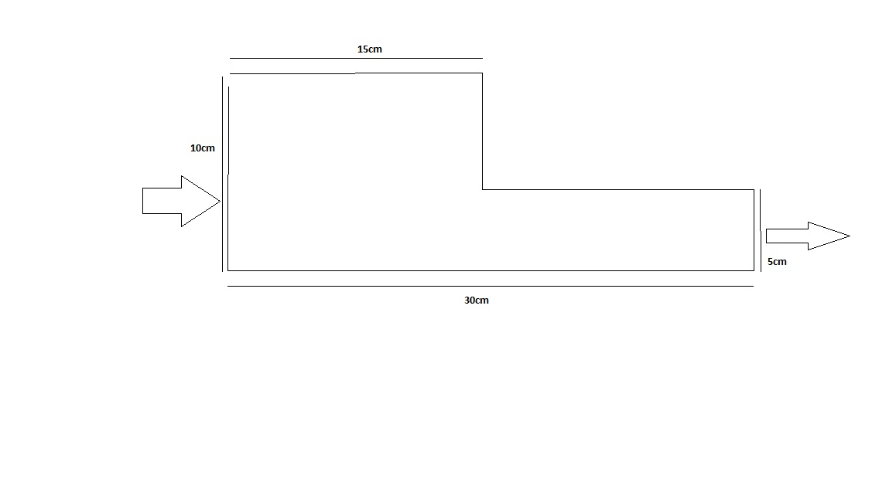

ψ = 1

ψ = 0

Linearly varying ψ at inlet and outlet

Fig.1 Geometry for which the solution needs to be evaluated

Also from the knowledge of fluid mechanics it can be deduced that

$\frac{dψ}{dy}=u and-\frac{∂ψ}{∂x}=v$ Eq.2

This means that the value of u an v velocity can also be obtained if the value of ψ – stream function is evaluated in the entire geometry. As the problem statement specifies the entire 2-D domain has been numerically solved using Successive Over Relaxation scheme of solving an elliptical equation

# 2 Iterative Methods for solving elliptic equations

Some of the Iterative methods commonly use to solve an elliptical equation are

* Jacobian
* Gauss-Sidel
* Successive Over Relaxation