Michigan Tech
Advanced Propulsion for Hybrid Electric Vehicles
Assignment #08 (Individual)
Internal Combustion Engines – Cycles, Work, Torque and Power

Instructor: Dr. J.Naber
Email: jnaber@mtu.edu
Tel: 906.487.1938

Date Assigned: March 8, 2013
Date Due: March 22, 2013 10:00 AM
Instructions: This is an individual assignment to be turned into
Canvas and a hardcopy in class.
Overview:
The operation of and internal combustion reciprocating engine (ICE) is based upon a completing a number of separate processes (strokes) to complete the cycle. In a 4 stroke engine there are the intake, compression, expansion and exhaust with combustion occurring during compression and expansion strokes.
In this assignment you will used engine simulated pressure data (P [kPa]) versus engine position in Crank-Angle (CA°) and engine cylinder volume (V [m³]). This data is stored in matrices in a Matlab “.mat” file ICE_Cycles.mat. Data is only provided for compression and expansion strokes (-180 to 180°). Assume the pressure during the intake and exhaust is constant and 100 kPa. Figure 1 shows 9 runs of simulation under the conditions given in Table 1. Additional information and plots are given in the appendix.
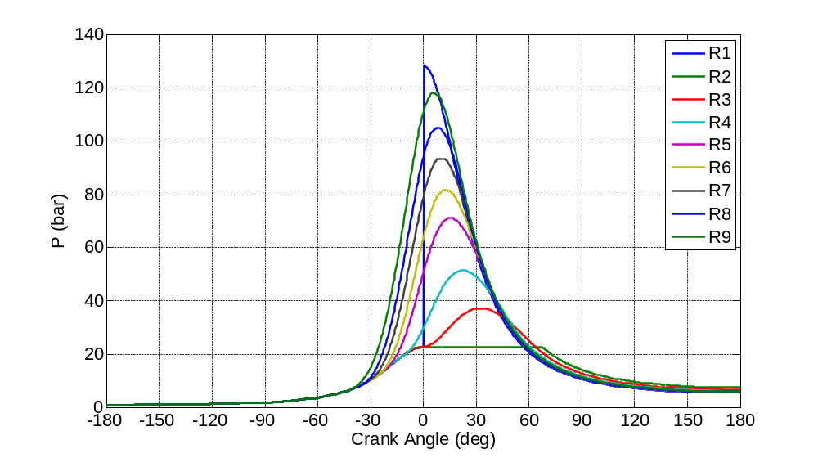
Figure 1. Simulation runs 1-9 with cylinder pressure versus engine positions (CA) coordinates.

Table 1. Engine simulation conditions
(CV = constant volume, CP = constant pressure, AHR = apparent heat release).
Run | Combustion  Type | Ignition  Timing | Burn  Duration
# | Mode | (DBTDC) | (DEG)
1 | CV | N/A | N/A
2 | CP | N/A | N/A
3 | AHR | 0 | 60
4 | AHR | 10 | 60
5 | AHR | 20 | 60
6 | AHR | 25 | 60
7 | AHR | 30 | 60
8 | AHR | 35 | 60
9 | AHR | 40 | 60
10 | AHR | 25 | 60

Assignment:

- Plot runs 1, 2, 3 and 6 to determine matrix configuration
- Plot pressure versus engine position with overlapping cycles
- Plot pressure versus volume with overlapping cycles
- Plot in log-log coordinates pressure versus volume/max(volume)
- Discuss plotted results

- Compute the following show formulas for determination for all runs
- Work per cycle (W_{cycl}) (kN-m)
- Average torque per cycle (kN-m)
- Indicated Mean Effective Pressure (Wcyc/Vd) (bar)
- Given and engine speed of 3000 rpm and a 4 cylinder engine compute the power (hp)
- Knowing the thermal efficiency of the constant volume cycle is 56%
compute the efficiencies of the other cycles
- Tabulate these values and discuss

- For runs 1, 2, 3 and 6, compute the instantaneous cylinder torque as a function of engine position and plot over the entire -360 to 360 degree (4-strokes of the engine). Derive and show formulas. Discuss plotted results

Submit a hard copy in class and submit an electronic version with the filename

LastName.MEEM 5250.ASSIGNMENT-8.pdf

to Canvas by the date and time indicated on the first page. Distance learning students only need to submit the electronic version.

Content
I. Cover sheet
Assignment title and number
Names
Date
Portrait picture of group.
II. Sections as identified above.
Include your group number and page number at the bottom of the page in the footer.
Include the grade sheet (below) as the last page of your submission.

Evaluation Sheet (Attach to the end of the assignment)

Student Name ____________________________

Area | Points | Score
Part A | 30
Part B | 40
Part C | 40
Format of figures and discussion | 10
Total = | 120

Appendix

Table 2. Additional engine parameters.
Parameter | Value | Unit
Compression Ratio (CR) | 10:1 | (-)
Bore (B) | 85 | (mm)
Stroke (S) | 85 | (mm)
Displacement Volume (Vd) | 0.482 | (l)
Connect Rod/Crank Radius (R) | 3 | (-)
Ratio of Specific Heats (γ) | 1.36 | (-)
CV Thermal Efficiency (η_{th}) | 56 | (%)
To | 323.15 | (K)
Po | 100 | (kPa)
Residual Fraction (x_{r}) | 6 | (%)
Fuel | Iso-octane | (-)
Lower Heating Value (Q_{LHV}) | 44,300 | (kJ/kg)
MW_{fuel} | 114.23 | (kg/kgmol)
Air/Fuel Ratio (AFR) | 15.13 | (kg_{air}/kg_{fuel})
Heat Addition (Q_{in}) | 2752 | (kJ/kg)

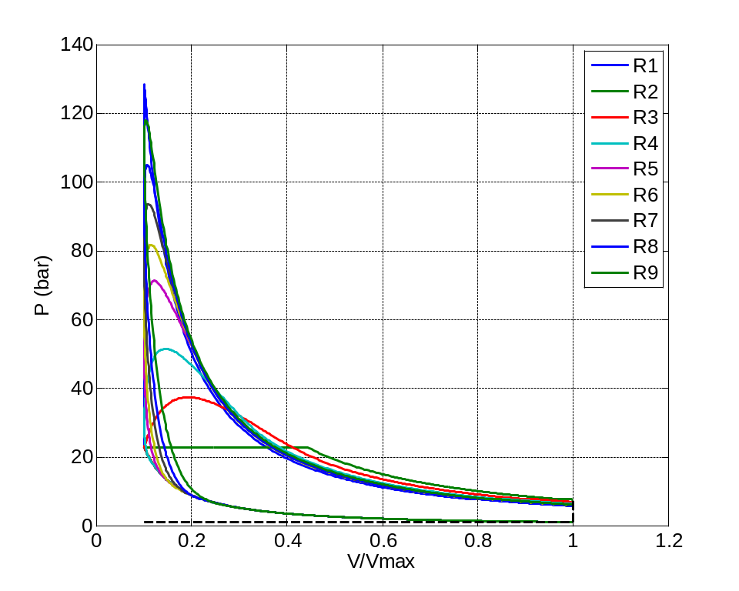
Figure 2. Cylinder Pressure versus normalized volume.
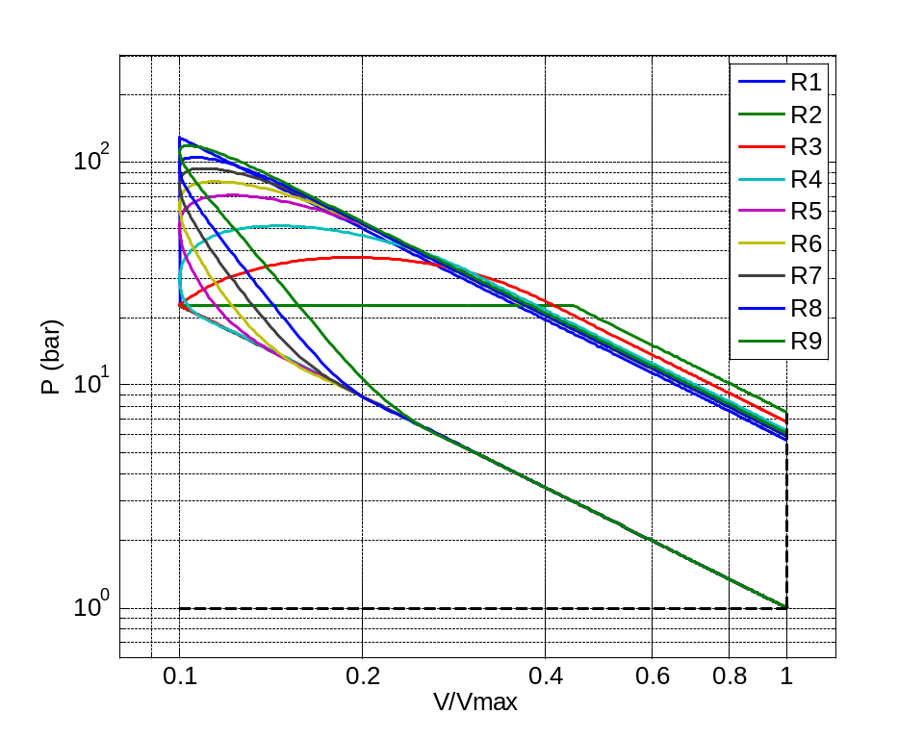
Figure 2. Cylinder Pressure versus normalized volume in log-log coordinates.

This is a normalized output (work/torque) Vd is the displacement volume

