**PAPER TEMPLATE FOR ISMIR 2016**

|  |  |  |
| --- | --- | --- |
| **First author** | **Second author** | **Third author** |
| Affiliation1  author1@ismir.edu | **Retain these fake authors in  submission to preserve the formatting** | Affiliation3  author3@ismir.edu |

**ABSTRACT**

The abstract should be placed at the top left column and should contain about 150–200 words.

1. **INTRODUCTION**

This template includes all the information about formatting manuscripts for the ISMIR 2016 Conference. Please follow these guidelines to give the final proceedings a uniform look. Most of the required formatting is achieved automatically by using the supplied style file (LATEX) or template (Word). If you have any questions, please contact the Program Committee (ismir2016-papers@ismir.net). This template can be downloaded from the ISMIR 2016 web site (<http://ismir2016.ismir.net>).

1. **PAPER LENGTH & File Size**

Instead of the strict limit of six pages (last used for ISMIR 2014), we adopt a “(6+1)-page policy” for ISMIR 2016. This means, the paper may have a maximum of 6 pages for technical content including figures and possible references with one additional optional 7th page containing only references. Note that this is a strict requirement. The seventh page (if used at all) must not contain any other material except for references.

Paper should be submitted as PDFs and the file size is limited to 2MB. Please compress images and figures as necessary before submitting.

1. **PAGE size**

The proceedings will be printed on portrait A4-size paper (21.0cm x 29.7cm). All material on each page should fit within a rectangle of 17.2cm x 25.2cm, centered on the page, beginning 2.0cm from the top of the page and ending with 2.5cm from the bottom. The left and right margins should be 1.9cm. The text should be in two 8.2cm columns with a 0.8cm gutter. All textmust be in a two-column format. Text must be fully justified.

1. **Typeset Text**
   1. **Normal or Body Text**

Please use a 10pt (point) Times font. Sans-serif or non-proportional fonts can be used only for special purposes, such as distinguishing source code text.

The first paragraph in each section should not be indented, but all other paragraphs should be.

* 1. **Title and Authors**

The title is 14pt Times, bold, caps, upper case, centered. Authors’ names are omitted when submitting for double-blind reviewing. The following is for making a camera-ready version. Authors’ names are centered. The lead author’s name is to be listed first (left-most), and the co-authors’ names after. If the addresses for all authors are the same, include the address only once, centered. If the authors have different addresses, put the addresses, evenly spaced, under each authors’ name.

* 1. **First Page Copyright Notice**

Please include the copyright notice exactly as it appears here in the lower left-hand corner of the page. It is set in 8pt Times. You will need to insert the appropriate author names and paper title in the copyright notice.

* 1. **Page Numbering, Headers and Footers**

Do not include headers, footers or page numbers in your submission. These will be added when the publications are assembled.

1. **First level headings**

First level headings are in Times 10pt bold, centered with 1 line of space above the section head, and 1/2 space below it. For a section header immediately followed by a subsection header, the space should be merged.

* 1. **Second Level Headings**

Second level headings are in Times 10pt bold, flush left, with 1 line of space above the section head, and 1/2 space below it. The first letter of each significant word is capitalized.

* + 1. *Third Level Headings*

Third level headings are in Times 10pt italic, flush left, with 1/2 line of space above the section head, and 1/2 space below it. The first letter of each significant word is capitalized.

Using more than three levels of headings is highly discouraged.

1. **Footnotes and Figures**
   1. **Footnotes**

Indicate footnotes with a number in the text.[1] Use 8pt type for footnotes. Place the footnotes at the bottom of the page on which they appear. Precede the footnote with a 0.5pt horizontal rule.

|  |  |
| --- | --- |
| String value | Numeric value |
| Hello ISMIR | 2016 |

**Table 1.** Table captions should be placed below the table.

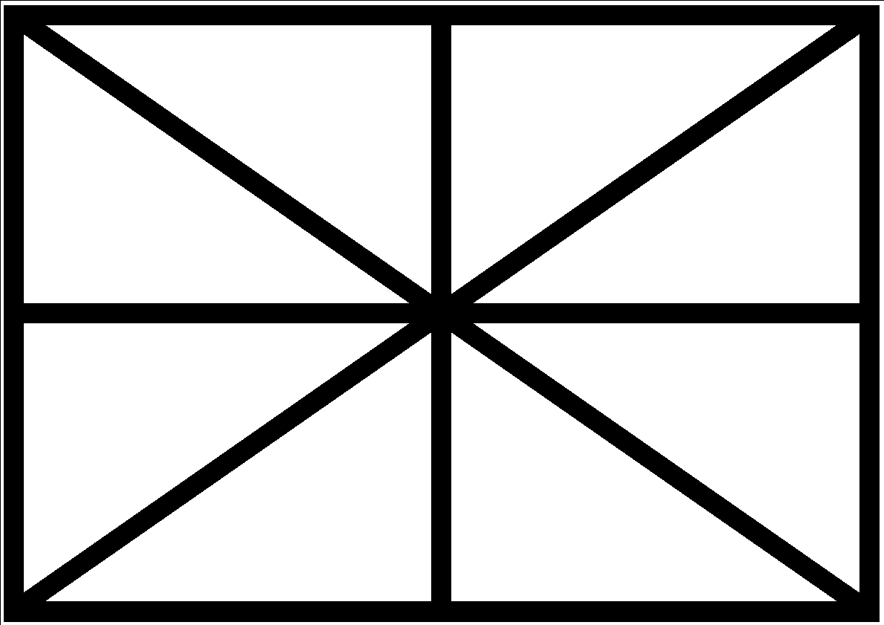

**Figure 1**. Figure captions should be placed below the figure.

* 1. **Figures, Tables, and Captions**

All artwork must be centered, neat, clean, and legible. All lines should be very dark for purposes of reproduction and art work should not be hand-drawn. The proceedings are not in color, and therefore all figures must make sense in black-and-white form. Figure and table numbers and captions always appear below the figure. Leave 1 line space between the figure or table and the caption. Each figure or table is numbered consecutively. Captions should be Times 10pt. Place tables/figures in text as close to the reference as possible. References to tables and figures should be capitalized, for example: see Figure 1 and Table 1. Figures and tables may extend across both columns to a maximum width of 17.2cm.

1. **Equations**

Equations should be placed on separate lines and numbered. The number should be on the right side, in parentheses, as in Eqn (1).

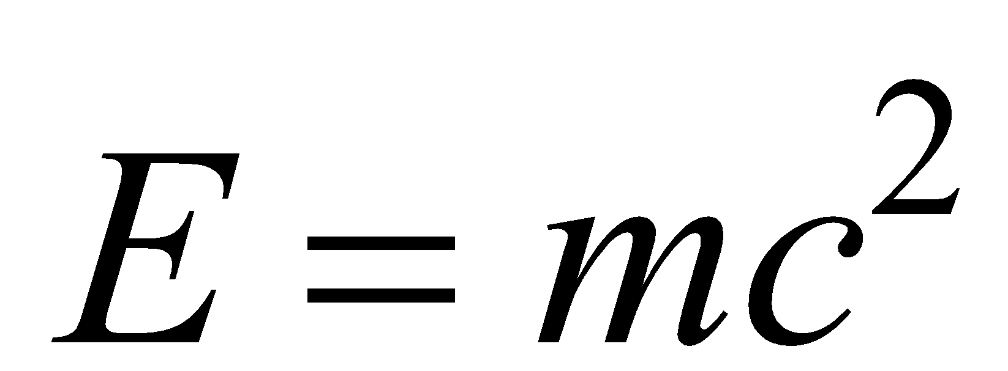 (1)

1. **Citations**

All bibliographical references should be listed at the end, inside a section named “REFERENCES,” numbered and in alphabetical order according to IEEE formatting. All references listed should be cited in the text. When referring to a document, type the number in square brackets [1], or for a range [1-4]. When the following words appear in the conference publication titles, please abbreviate them: Proceedings -> Proc.; Record -> Rec.; Symposium -> Symp.; Technical Digest -> Tech. Dig.; Technical Paper -> Tech. Paper; First -> 1st; Second -> 2nd; Third -> 3rd; Fourth/nth -> 4th/nth.

1. **REFERENCES**
2. E. Author: “The Title of the Conference Paper,” *Proceedings of the International Symposium on Music Information Retrieval*, pp. 000–111, 2000.
3. A. Someone, B. Someone, and C. Someone: “The Title of the Journal Paper,” *Journal of New Music Research*, Vol. A, No. B, pp. 111–222, 2010.
4. X. Someone and Y. Someone: *Title of the book*, Editorial Acme, Porto, 2012.

1. This is a footnote.