COURSE: DATABASE SYSTEMS ENGINEERING AND DISTRIBUTED BACKEND DEVELOPMENT

NAME: ADA ROHAN
ROLL NO: 2520030195
The Scenario:

A local library currently tracks its books and members in a physical notebook. Books are being lost, and there is no way to know who has which book. The goal is to build the SQL foundation for "BookFlow" so that every book has a unique ISBN and no member can sign up without a valid (unique) email. The requirements are: • Create a database named bookflow_db. • Create a books table (book_id, title, isbn UNIQUE, published_year) and a members table (member_id, full_name, email UNIQUE). • Enforce PRIMARY KEY on both IDs, NOT NULL on title, and a CHECK constraint so published_year is not in the future (< 2027). • Seed 3 books and 3 members, then test that the rules actually reject bad data.

Screenshots of the Scenario:
1)Creating the database and books table:
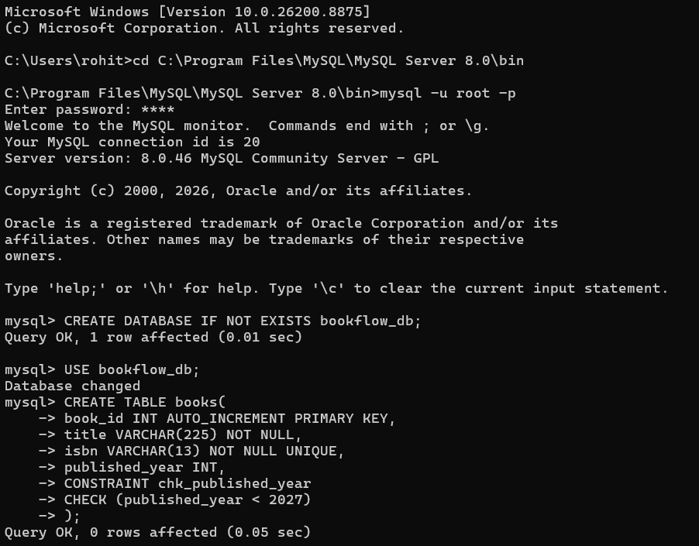
2)Creating table for table “members”:
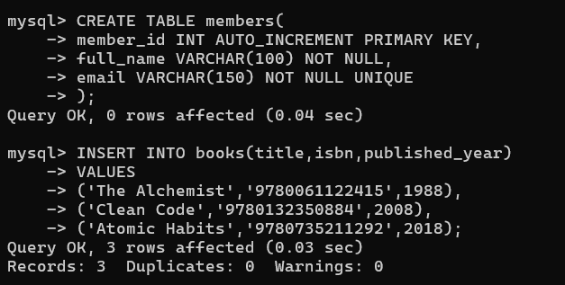

3)Inserting values of books and members
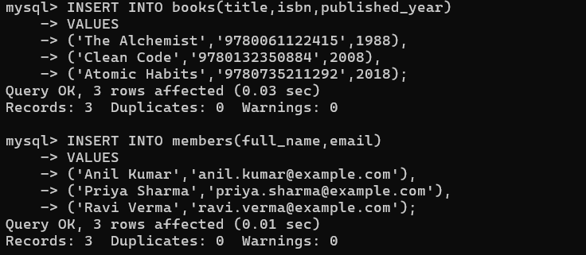
Verification: Inspect the table structures
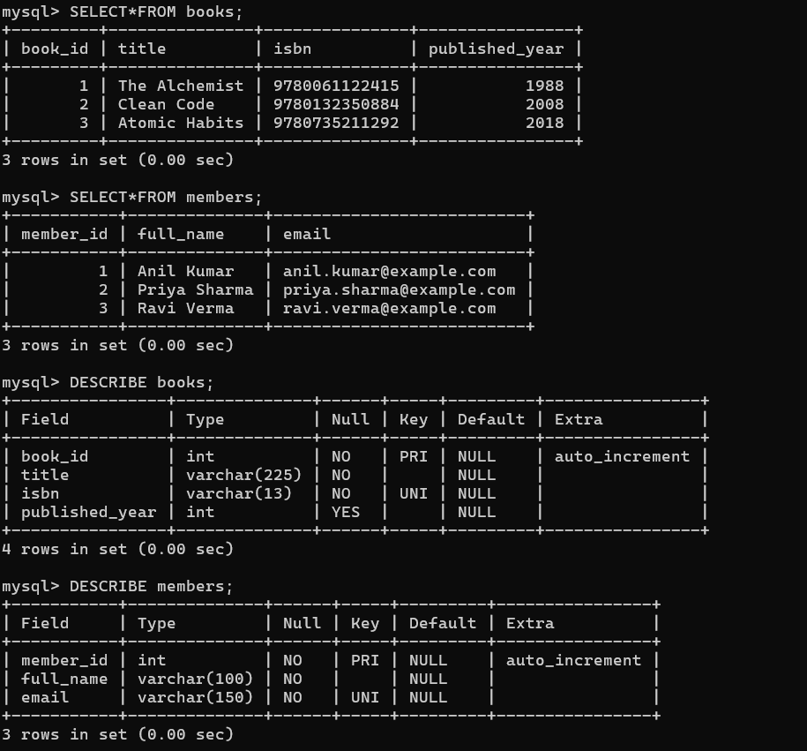
Test 1:
Duplicate ISBN (UNIQUE violation) INSERT INTO books (title, isbn, published_year) VALUES ('Fake Copy', '9780061122415', 2000);
Test 2:
NULL title (NOT NULL violation) INSERT INTO books (title, isbn, published_year) VALUES (NULL, '9999999999999', 2010);
Test 3:
Future publication year (CHECK violation) INSERT INTO books (title, isbn, published_year) VALUES ('Time Traveler', '8888888888888', 2030);
Test 4:
Duplicate email (UNIQUE violation) INSERT INTO members (full_name, email) VALUES ('Anil Clone', 'anil.kumar@example.com');

Output of Test1, Test2, Test3, Test4:
