
Koneru Lakshmaiah Education Foundation
(Deemed to be University estd. u/s. 3 of the UGC Act, 1956)
Off-Campus: Bachupally-Gandimaisamma Road, Bowrampet, Hyderabad, Telangana - 500 043. Phone No: 7815926816, www.klh.edu.in

STUDENT CASE STUDY EXECUTION REPORT
Department | FED
Subject | DSA-2
Academic Year | 1-111 Semester | 2025-26
Faculty Name | Dr.SreeRamMurthy
Student Name | ADA ROHAN
Roll Number | 2520030195
Branch | CSE
Course Outcome | CO-1

Case Study 1: Quiz Clash -Live tournament leaderboard.
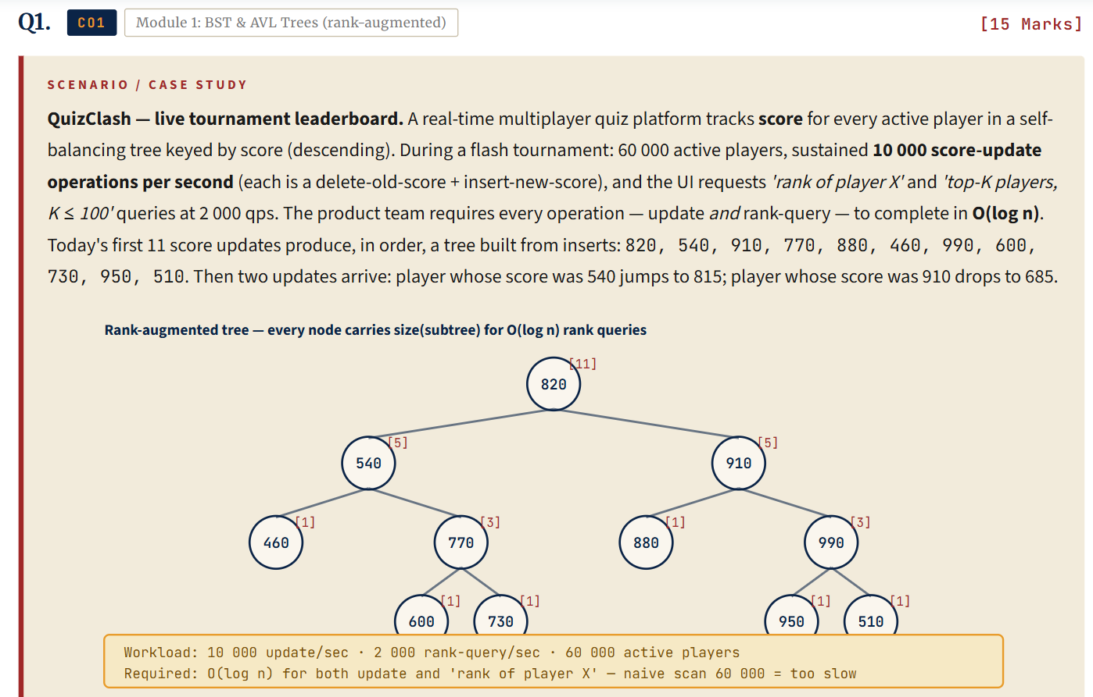
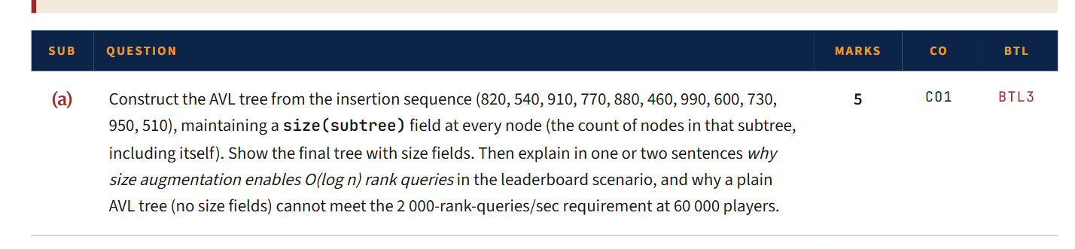
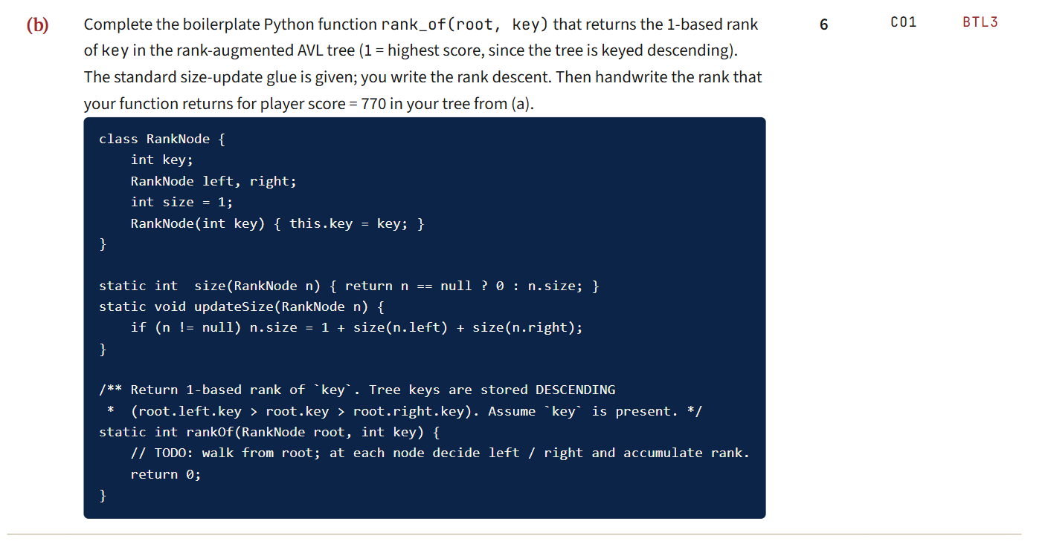
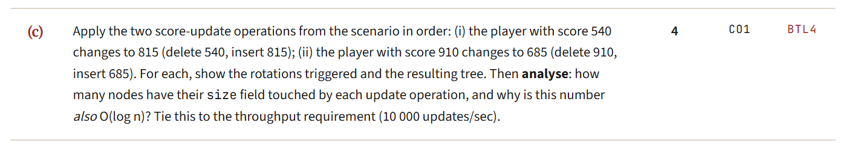
Work Done Summary:
In this case study, we implemented a Rank-Augmented AVL Tree for the Quiz Clash live tournament leaderboard system. The AVL tree stores player scores while maintaining self-balancing properties to support high-frequency score updates efficiently.
We also implemented rank queries and Top-K player retrieval using subtree sizes, enabling leaderboard operations to execute within the required performance constraints.
Implementation Details:
- Inserted the initial player scores into the AVL Tree:
820, 540, 910, 770, 880, 460, 990, 600, 730, 950, 510
- Maintained AVL balance factors and subtree sizes during every insertion.
- Stored the size of each subtree at every node to support efficient rank calculations.
- Processed score updates as:
- Delete old score.
- Insert new score.
- Update subtree sizes.
- Perform AVL rebalancing if necessary.
- Updated leaderboard data:
- 540 → 815
- 910 → 685
- Implemented Rank (Player X) operation using subtree sizes.
- Implemented Top-K Players query using reverse inorder traversal.
- Ensured all leaderboard operations satisfy the required O(log n) complexity.
- Verified that AVL balancing maintains optimal tree height even under continuous score updates.
- Concluded that Rank-Augmented AVL Trees are suitable for real-time gaming leaderboards with frequent updates and ranking requests.

Result: Screenshots / Output:

1b)
static int size(RankNode n) {
return n == null ? 0 : n.size;
}

static int rankOf(RankNode root, int key) {
int rank = 1;
RankNode current = root;

while (current != null) {

if (key == current.key) {
return rank + size(current.left);
}

else if (key > current.key) {
current = current.left;
}

else {
rank = rank + size(current.left) + 1;
current = current.right;
}
}

return -1;
}

Overall Complexity:
Best Case: : O(log n)
Average Case : O(log n)
Worst Case : O(log n)

GitHub link:

Student Signature Faculty Signature

