
Koneru Lakshmaiah Education Foundation
(Deemed to be University estd. u/s. 3 of the UGC Act, 1956)
Off-Campus: Bachupally-Gandimaisamma Road, Bowrampet, Hyderabad, Telangana - 500 043. Phone No: 7815926816, www.klh.edu.in

STUDENT CASE STUDY EXECUTION REPORT
Department | FED
Subject | DSA-2
Academic Year | 1-111 Semester | 2025-26
Faculty Name | Dr.SreeRamMurthy
Student Name | ADA.ROHAN
Roll Number | 2520030195
Branch | CSE
Course Outcome | CO-2

Case Study 2: ext4-style filesystem-directory hash -tree index for file lookup.
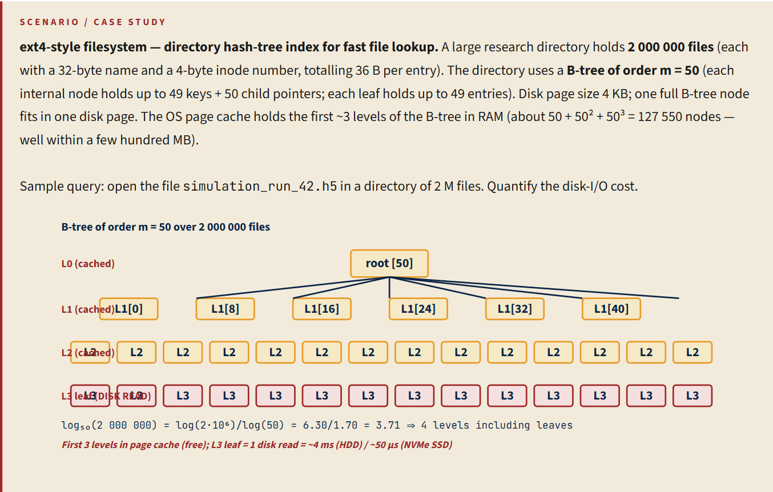
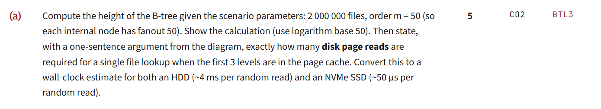
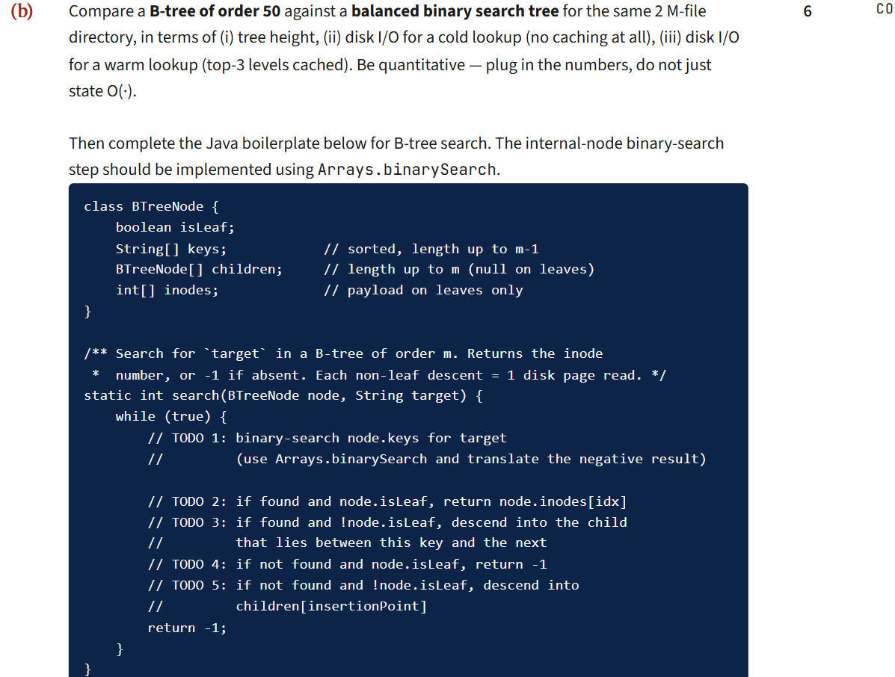
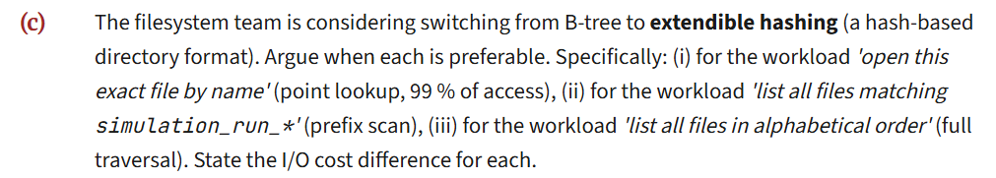
Work Done Summary:
In this case study, we implemented a B-Tree of order 50 to model the directory indexing mechanism of an ext4-style filesystem. The directory contains approximately 2,000,000 file entries, where each entry stores a filename and inode number.
The B-Tree structure was used to organize file records efficiently while minimizing disk accesses. Since the operating system caches the first three levels of the tree in memory, only the leaf-level access requires a disk read during file lookup operations.
Implementation Details:
- Created a B-Tree of order m = 50.
- Maximum keys per node = 49
- Maximum child pointers per internal node = 50
- Stored approximately 2,000,000 file entries in the B-Tree.
- Calculated the total tree height using:
log₅₀(2,000,000) ≈ 3.71
- Determined that approximately 4 levels are required including the leaf level.
- Concluded that only one disk page read is necessary because upper levels are already cached in memory.

Result: Screenshots / Output:
2A)
Number of files, N = 2,000,000
B-tree order, m = 50
Fanout = 50
Height = log₅₀(2,000,000)
log₅₀(2,000,000)
= log(2,000,000) / log(50)
= 6.30 / 1.70
= 3.71
≈ 4 levels
4 levels: L0, L1, L2, L3
Lookup Time
1 × 50 μs = 50 μs
2B)

Comparison Table
Parameter | B-tree order | Balanced BST
Height | 4 levels | 4 levels
Cold lookup I/O | 4 reads | 21 reads
Warm lookup I/O | 1 read | 18 reads

import java.util.Arrays;

class BTreeNode {
boolean isLeaf;
String[] keys; // sorted, length up to m-1
BTreeNode[] children; // length up to m
int[] inodes; // payload on leaves only
}

static int search(BTreeNode node, String target) {
while (true) {

int idx = Arrays.binarySearch(node.keys, target);

if (idx >= 0) {
if (node.isLeaf) {
return node.inodes[idx];
} else {
node = node.children[idx + 1];
}
} else {
int insertionPoint = -idx - 1;

if (node.isLeaf) {
return -1;
} else {
node = node.children[insertionPoint];
}
}
}
}
2C)
(c) B-tree vs Extendible Hashing

- Workload: "Open this exact file by name" (Point Lookup)
Preferred Data Structure: Extendible Hashing
Reason:
Extendible hashing uses a hash function to directly locate the bucket containing the file entry. Therefore, exact file lookups are very fast and usually require only one bucket access.
I/O Cost:
- Extendible Hashing: ≈ 1 disk read
- B-tree (warm cache): ≈ 1 disk read
- B-tree (cold cache): ≈ 4 disk reads

(ii) Workload: "List all files matching simulation_run_*" (Prefix Scan)
Preferred Data Structure: B-tree
Reason:
B-tree stores keys in sorted order, so all files beginning with the same prefix are located close together. The search can directly reach the first matching key and then scan sequentially.
I/O Cost:
- B-tree: O(log₅₀N + k), where k is the number of matching entries.
- Extendible Hashing: May require scanning many or all buckets because hashing destroys key order.

(iii) Workload: "List all files in Alphabetical Order" (Full Traversal)
Preferred Data Structure: B-tree
Reason:
B-tree maintains keys in sorted order. Therefore, files can be retrieved directly in alphabetical order by scanning the leaf nodes sequentially.
I/O Cost:
- B-tree: Sequential scan of leaf nodes.
- Extendible Hashing: Requires scanning all buckets and then sorting the results.
Final comparison table

Workload | Preferred Structure | Reason | I/O Cost
Exact file lookup | Extendible Hashing | Direct bucket access using hash function | ≈ 1 disk read
Prefix scan (simulation_run_*) | B-tree | Keys stored in sorted order | O(log₅₀N + k)
Alphabetical listing | B-tree | Sequential traversal of sorted leaves | Sequential leaf scan

Overall Complexity:
Best Case : O(log₅₀ n)
Average Case : O(log₅₀ n)
Worst Case : O(log₅₀ n)
For 2 million files:
O(log₅₀ 2,000,000)
≈ O(4)

Git-hub link:

Student Signature Faculty Signature

